Exploiting the Functionality of Cerium Oxide-Modified Carbon Nanohorns catalysts towards Enhanced CO₂ Reduction Performance

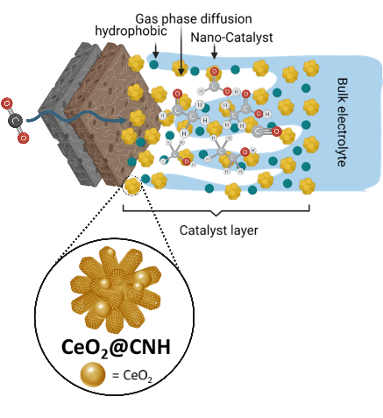

Supporting Information

Exploiting the Functionality of Cerium Oxide-Modified Carbon Nanohorns catalysts towards Enhanced CO₂ Reduction Performance

Alessia Pollice,± Michele Cacioppo,± Miriam Marchi, Miriam Moro, Francesco Paolucci, Marcella Bonchio, Maurizio Prato, Giovanni Valenti,* Michele Melchionna,* Paolo Fornasiero

- TEM characterization
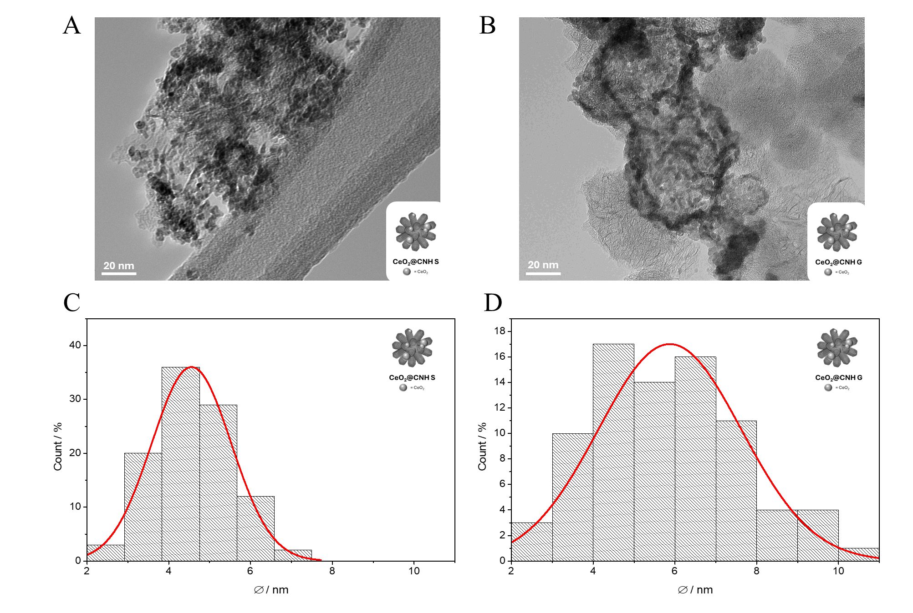
Figure S1. TEM images of CeO₂@oxCNHs S (A) and CeO₂@oxCNHs G (B); CeO₂ nanoparticles size distribution histograms for CeO₂@oxCNHs-S (C) and CeO₂@oxCNHs-G (D). Nanoparticle size analysis was performed on 100 nanoparticle units for each sample using ImageJ v1.54g software.

- XPS Characterization
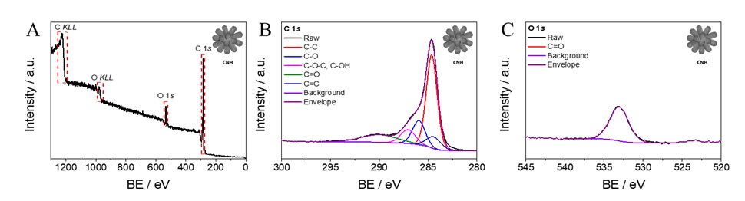Figure S2. XPS of Pristine Carbon Nanohorns (CNHs): full survey scan (A); deconvolution analysis of the XPS spectrum of C 1s (A) and O 1s (C) orbitals.
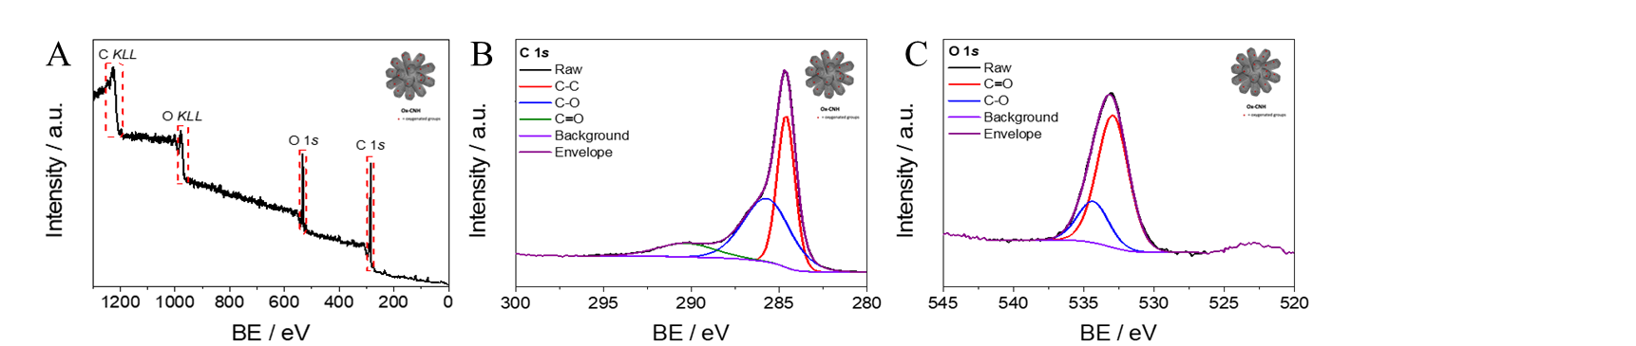
Figure S3. XPS of oxidized Carbon Nanohorns (oxCNHs): full survey scan (A); deconvolution analysis of the XPS spectrum of C 1s (B) and O 1s (C) orbitals.
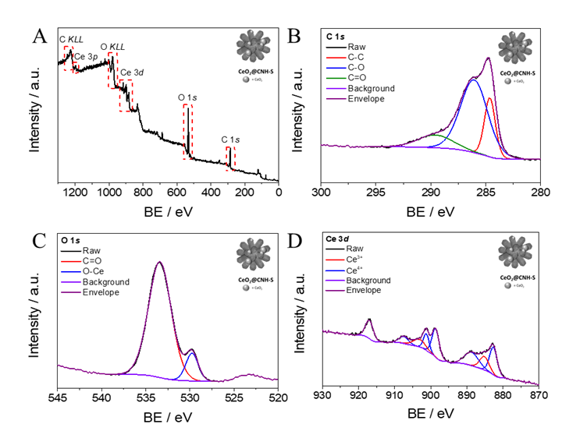

Figure S4. XPS of CeO₂@oxCNH S (solvothermal method): full survey scan (A); deconvolution analysis of the XPS spectrum of the C 1s (B), O 1s (C) and Ce 3d (D) orbitals.

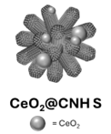 | Component | Binding Energy (eV) | FWHM | % Area
 | Ce 3d 3/2 u''' | 916.9 | 2.495 | 9117.5
 | Ce 3d 3/2 u'' | 907.4 | 3.026 | 4202.9
 | Ce 3d 3/2 u' | 903.2 | 3.984 | 5993.6
 | Ce 3d 3/2 u | 901.2 | 1.833 | 6053.5
 | Ce 3d 3/2 u0 | 898.6 | 2.366 | 13214.6
 | Ce 3d 5/2 v' | 888.7 | 4.524 | 11970.8
 | Ce 3d 5/2 v' | 885.1 | 2.994 | 7968.0
 | Ce 3d 5/2 v | 882.6 | 2.504 | 13606.3
Table S1. XPS Integrated area of peak individual components of the Ce 3d spectra for the CeO₂@oxCNHs S samples. Data was collected and analysed by CasaXPS software.
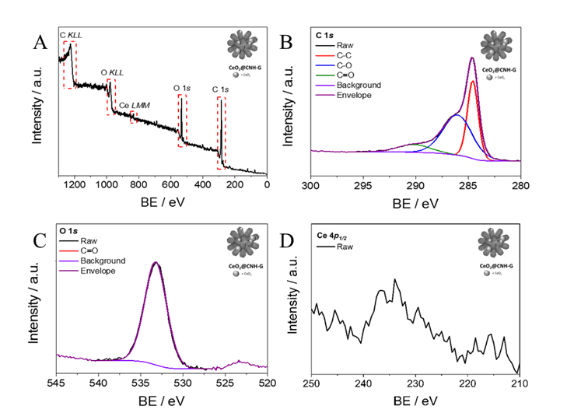
Figure S5. XPS of CeO₂@oxCNH G (Sol-Gel method): full survey scan (A); deconvolution analysis of the XPS spectrum of the C 1s (B), O 1s (C) and Ce 4p_{1/2} (D) orbitals.
- XRD Characterization
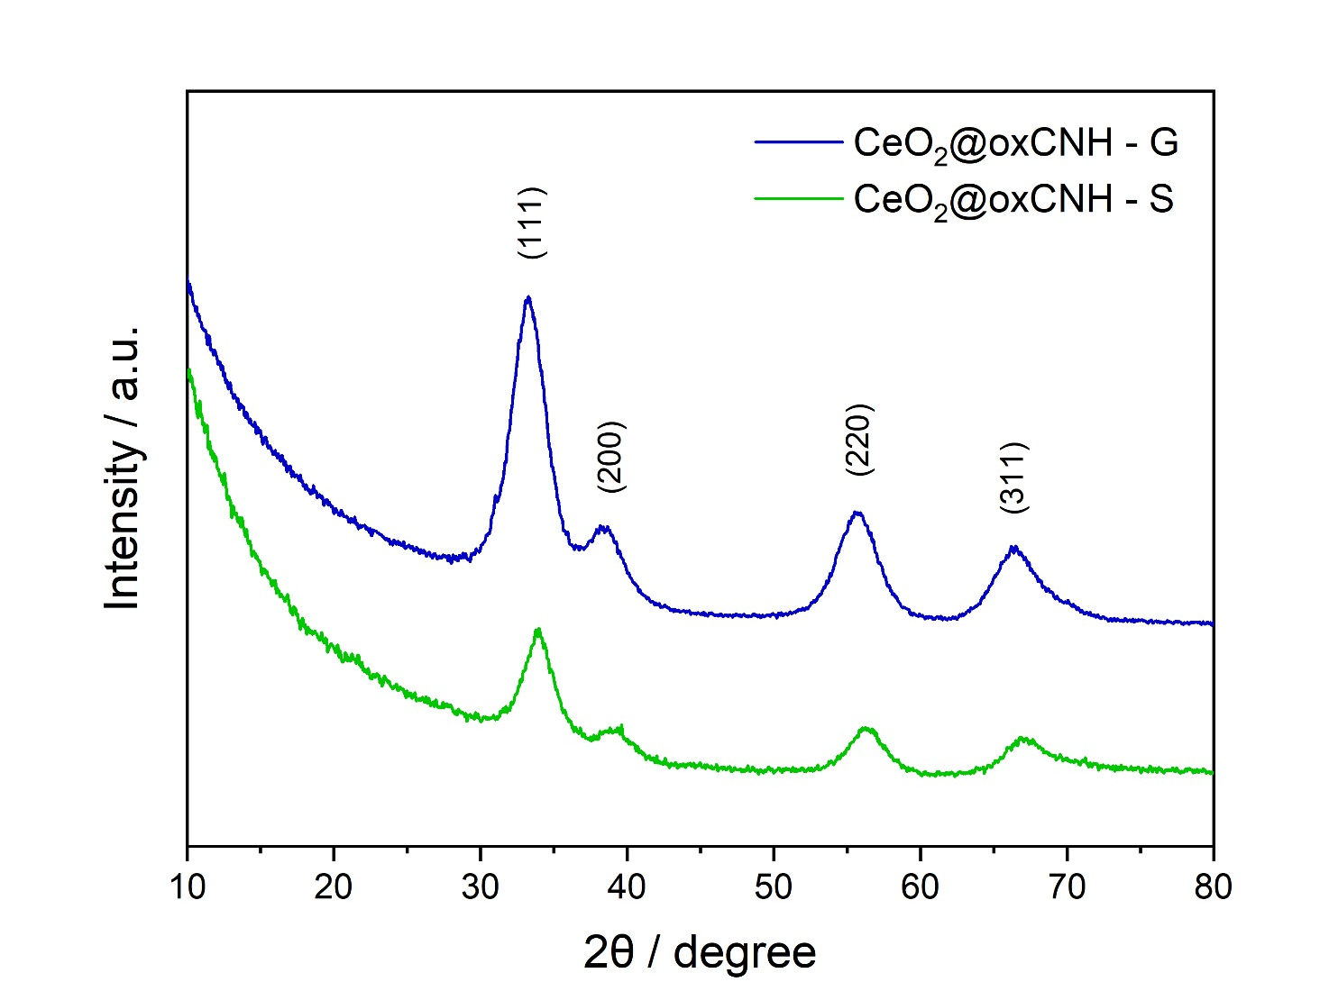
Figure S6. XRD spectra for CeO₂@oxCNH-G (blue line) and CeO₂@oxCNH-S (green line).

- Quantification of the surface area of CNT, CNH and oxCNH

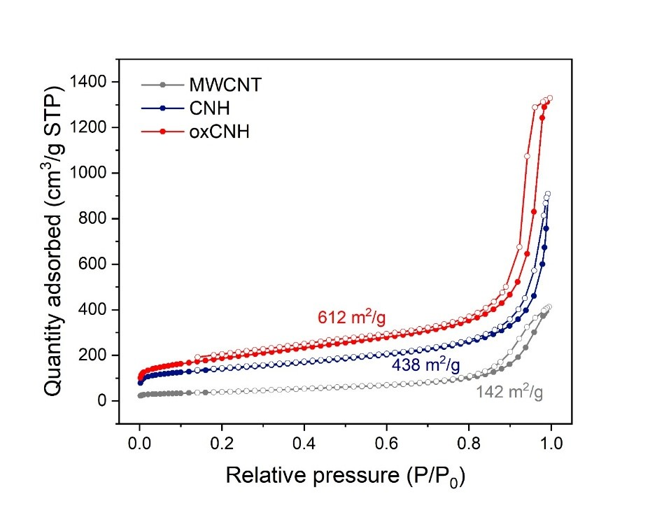
Figure S7. Isotherms of the measured the surface area of the oxCNH (both pristine and oxidized) and of the CNT by means of N₂ physisorption.
- Electrochemistry
The material behaviour was investigated through detailed electrochemical characterization, with a specific focus on the CO₂ reduction reaction (CO₂RR).
The measurements were conducted on an SP-300 workstation (Biologic Instruments) employing methods such as Cyclic Voltammetry (CV) and Electrochemical Impedance Spectroscopy (EIS). All potentials are iR corrected trough EIS. A three-electrode cell configuration was used, featuring a MiniHydroFlex® Reversible Hydrogen Electrode (RHE) from Biologic Instruments as the reference electrode, a platinum wire as the counter electrode, and a catalyst-coated glassy carbon electrode (GCE) with a 3 mm diameter and a geometric surface area of 0.071 cm² as the working electrode.
The electrochemical properties of the CeO₂@oxCNHs composite materials were examined by preparing a thin film on the glassy carbon electrode via drop-casting, ensuring a constant electrocatalyst loading of 505 μg cm⁻². The nanoparticles were dispersed in a solvent mixture consisting of one-part Milli-Q water and two parts 2-propanol, with 0.5% Nafion added to achieve a concentration of 1.6 mg mL⁻¹. All electrochemical measurements were referenced against the RHE.

5.1. Cyclic Voltammetry Characterization: differences between Solvothermal and Sol-Gel sample
The electrochemical experiments were performed in an Ar-saturated 0.5 M KHCO₃ pre-electrolyzed electrolyte. To maintain high electrolyte purity, the solution underwent pre-electrolysis to remove metal impurities, which can interfere with surface reactions. The pre-electrolysis process involved a two-electrode setup, with a platinum (Pt) wire as the counter electrode and a Pt mesh as the working electrode. Electrolysis was performed for at least 24 hours at a current of 0.1 mA, while the solution was stirred and saturated with argon (Ar).
Cyclic Voltammetry (CV) analysis revealed that the solvothermally synthesized sample exhibited a current response twenty times higher than that of the sol-gel sample, leading to the decision to focus further investigations on the solvothermal sample. This approach allowed for a more in-depth evaluation of the material's performance in CO₂RR.
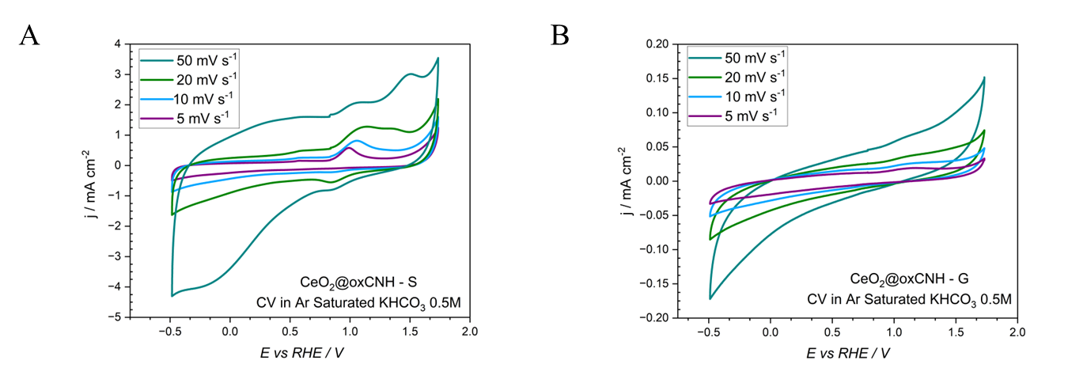

Figure S8. Cyclic voltammetry (CV) analysis of CeO₂@oxCNHs materials (A) CeO₂@oxCNH – S and (B) CeO₂@oxCNH – G in Ar-saturated 0.5 M KHCO₃ electrolyte. The CV curves were recorded at different scan rates (5–50 mV s⁻¹). The solvothermally synthesized sample exhibits a significantly higher current response compared to the sol-gel sample, indicating enhanced electrochemical activity and justifying its selection for further CO₂ reduction reaction (CO₂RR) studies.

5.2. CO₂RR catalytic performance of the solvothermal sample
The performance of the solvothermal sample was evaluated using a custom-made H-type three-electrode electrochemical cell. In this setup, the working electrode was positioned at the bottom of the cell, facing upwards, while the counter electrode (CE), a platinum mesh, was separated from the catholyte by a porous frit. This configuration allowed gas products to be directly channelled to the gas chromatograph (GC) for detection, while the separate compartment prevented liquid products from reacting with the CE. A MiniHydroFlex® Reversible Hydrogen Electrode (RHE) from Biologic Instruments was used as the reference electrode, ensuring that the potential was locally corrected for pH, thus accounting for the pH dependence of RHE potential.[1]
The experiments were conducted in a nearly neutral bicarbonate buffer containing 0.5 M potassium bicarbonate (KHCO₃), saturated with carbon dioxide (CO₂).
For the CO₂RR performances evaluation, the same catalyst inks and material loadings were employed as in the cyclic voltammetry characterization, though a glassy carbon electrode with a geometric area of 1 cm² was used. The electrode surface and the electrolyte volume were reduced to achieve higher product concentrations, ensuring more accurate and quantifiable measurements. This approach helped surpass the instrument detection limits, thereby improving the reliability and reproducibility of the results.
Subsequently, experiments were conducted using a GDE-System, specifically the commercial MicroFlowCell from ElectroCell (PTFE), optimized for online detection of gas-phase products and equipped with a reference electrode compartment.
These features applied in a GDE configuration, which can sustain higher current densities, leads to the production of a wider variety of products. The MicroFlowCell was connected to a peristaltic pump to regulate the electrolyte flow over the electrode surface at a rate of 6 mL min⁻¹. In these systems, the catholyte, anolyte, and CO₂ are continuously looped through the two liquid compartments, constituted by two different solutions of 0.5M KHCO₃. [2] The two compartments are devided by a Sustainion® X37-50 membrane. A typical gas diffusion layer (GDL) comprises a porous matrix that facilitates gas transport, ensuring optimal CO₂ distribution along the catalyst surface. Structurally, the GDL is composed of a carbon fiber substrate (CFS), a microporous layer (MPL) containing a mixture of carbon nanoparticles and PTFE, and a catalyst layer (CL). The catalyst layer serves as the centre of the reaction, creating a three-phase system involving CO₂ (gas), bicarbonate (liquid), and the catalyst (solid). In this work, a commercial gas diffusion layer (GDL) made of Sigracet 39BB carbon paper, featuring a microporous layer (MPL) treated with 5 wt% PTFE and a total thickness of 315 μm, was employed in the cell. Analogously to the static measurements, the 1 cm² GDE was coated with a CeO₂@oxCNHs nanostructure via drop casting.
The CO₂RR activity in both the H-type Cell and GDE Cell was evaluated through chronoamperometry (CA) for 1 hour and 51 minutes in CO₂-saturated electrolytes, using a SP-150 workstation (Biologic Instruments). Gas products were analysed in real-time during electrolysis by in-line gas chromatography (GC), with the electrochemical cell directly connected to the sample loop of the GC. Gas phase samples were collected every 15 minutes, for a total of eight samples during each experiment. Liquid products were analysed post-electrolysis using Ion Chromatography (IC) and Nuclear Magnetic Resonance (NMR) spectroscopy.
The Faradaic efficiency (FE) for gas-phase products was calculated using the Equation S1, already used in our previous works[3-5]:
$FE=\frac{nFφF_{m}}{I}$ (S1)
where n is the number of electrons involved in the CO₂RR, F is the Faraday constant, φ is the volume fraction of the gas, I is the current, and Fm is the molar CO₂ gas flow rate.
The analysis of liquid products was made using Ion Chromatography and Nuclear Magnetic Resonance Spectroscopy.
The IC, used to detect formate and acetate, was performed using a Metrohm 850 Professional IC Ion Chromatograph, equipped with a Metrosep a Supp 4-250/4.0 anion column and a conductivity detector. The eluent consisted of 0.5 mM H₂SO₄ with 15% acetone.
Nuclear Magnetic Resonance (NMR) spectroscopy was employed to detect and quantify methanol, ethanol, and acetaldehyde in the liquid phase, following and adapting the methodologies of Babij et al., Chatterjee et al. and Iglesias van Montfort et al. [2,6,7] In our approach, 0.4 mM of dimethyl sulfoxide (DMSO) was added as an internal standard to accurately quantify the reaction products. The analysis was conducted using a mixture of 500 µL of the liquid phase sample and 100 µL of deuterium oxide (D₂O), ensuring reliable product identification and quantification. The Faradaic efficiency (FE) for the liquid phase was quantified using the following Equation S2:
$FE=\frac{Q\left({HCOO}^{-}\right)}{Q_{TOT}}x 100$ (S2)
This comprehensive experimental approach enabled accurate evaluation of both gas and liquid products, improving the understanding of CO₂RR mechanisms and product selectivity.
5.3. Statistical Analysis
All data were obtained from at least three independent measurements per condition (N = 3). All the chronoamperometries curves were normalized on the geometrical area of the electrode.
For each applied potential, chronoamperometric experiments were repeated three times. Gaseous products were quantified eight times per experiment using gas chromatography (GC), while liquid-phase products were collected and analyzed three times by ion chromatography (IC) and three times by nuclear magnetic resonance (NMR) spectroscopy. Data are presented as mean ± standard deviation (SD).
All statistical analyses were carried out using Excel and data visualizations were carried out using Origin 2024.

5.4. Loading Test
To determine the optimal catalyst loading, tests were conducted with 200 µg cm⁻², 500 µg cm⁻², and 1000 µg cm⁻². The highest faradaic efficiency was achieved at 200 µg cm⁻², while the highest current density was observed at 500 µg cm⁻². To maintain consistency with the static cell loading, chosen to enable a correct formic acid quantification, 500 µg cm⁻² was the selected loading. [4,5]
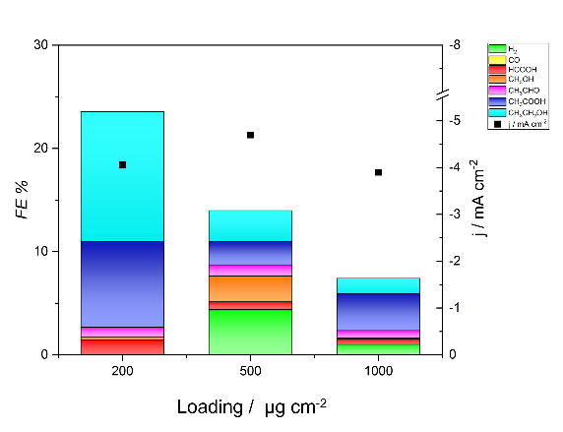
Figure S9. Optimization of catalyst loading for CO₂ reduction reaction (CO₂RR). Performances in a flow cell device at 200 µg cm⁻², 500 µg cm⁻², and 1000 µg cm⁻². Left axis: Faradaic efficiency (FE) of detectable CO₂RR products in CO₂-saturated 0.5 M KHCO₃ (pH 7.5), with color-coded products: H₂ (green), CO (yellow), HCOOH (red), CH₃OH (orange), CH₃CHO (pink), CH₃COOH (blue), CH₃CH₂OH (light blue). Right axis: Current density at the corresponding potential, represented by black squares.
5.5. Stability Test
To evaluate the stability of the gas diffusion electrode system with the CeO₂@CNH nanostructure, a 24-hour electrolysis was conducted. The test demonstrated the system’s ability to perform consistently over an extended period. Current density remained stable, and the concentration of formic acid, carbon monoxide and hydrogen increased steadily over time. Methanol, Ethanol, Acetate and Acetaldehyde undergo to a drop in concentration after 4 hours due to volatility-related losses and for this reason their detection becomes less reliable after several hours.
The current density remained stable, while the concentration of all products increased over time. Notably, formic acid has been widely employed as a benchmark for stability, [8,9] with its production steadily increasing over 24-hour electrolysis while maintaining a nearly constant FE. In contrast, methanol, ethanol, acetate, and acetaldehyde increase their production and maintain constant the FE over 4 hours and then exhibited a decline in concentration, primarily due to volatility-related losses. Consequently, their detection becomes less reliable over extended periods. In order to reduce the cross-over, for the long-term stability test was adopted an 80 $μm$ PiperION Membrane.
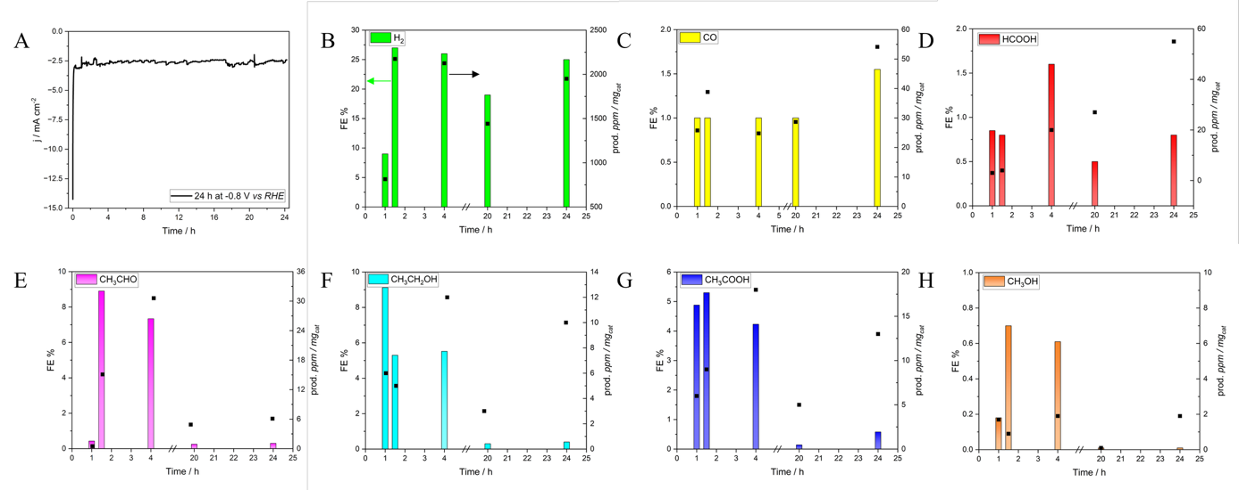

Figure S10. Stability test. (A) CA for CeO₂@oxCNH-S for 24h at -0.8 V vs RHE. Electrolyte: 0.5 M KHCO₃. (B) Hydrogen (green) in FE (left axis) and ppm concentration normalized for the catalyst loading (right axis). (C) Carbon Monoxide production (yellow) in FE (left axis) and ppm concentration normalized for the catalyst loading (right axis). (D) Formic Acid production (red) in FE (left axis) and ppm concentration normalized for the catalyst loading (right axis). (E) Methanol production (orange) in FE (left axis) and ppm concentration normalized for the catalyst loading (right axis). (F) Acetaldehyde production (pink) in FE (left axis) and ppm concentration normalized for the catalyst loading (right axis). (G) Ethanol production (light blue) in FE (left axis) and ppm concentration normalized for the catalyst loading (right axis). (H) Acetate production (blue) in FE (left axis) and ppm concentration normalized for the catalyst loading (right axis) on the GDE39BB 1 cm² as a function of the performances of the system during the measure.
5.6. Chronoamperometries of the Static Cell and Flow Cell
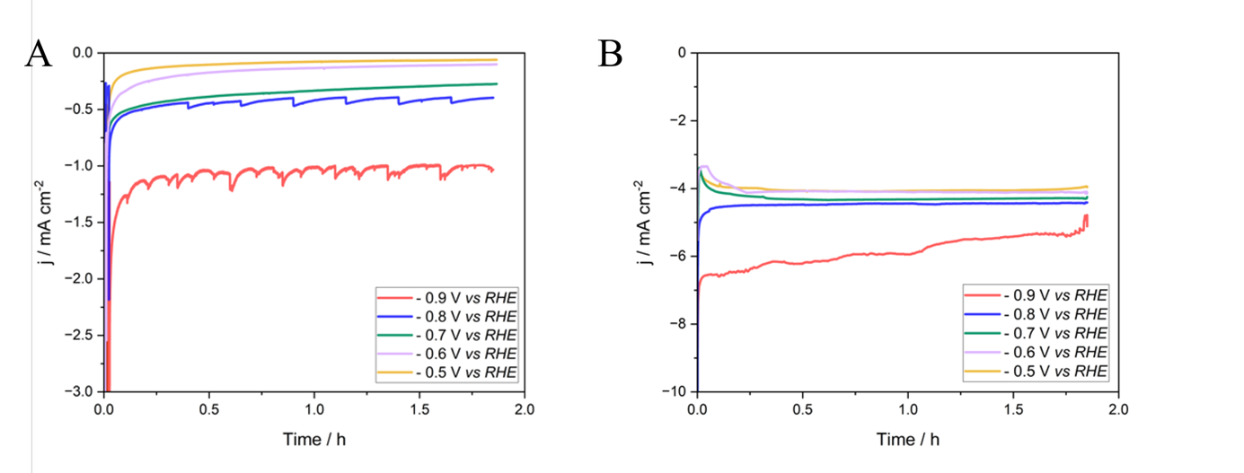
Figure S11. Chronoamperometries of the CeO₂@oxCNH-S in 0.5 M KHCO₃ CO₂ saturated. All the j-t curves are registered at -0.9V vs RHE (red), -0.8V vs RHE (blue), -0.7V vs RHE (green), -0.6V vs RHE (lillac), -0.5V vs RHE (yellow). (A) Static Cell. (B) Flow Cell.

References
1. Jerkiewicz, G., “Standard and Reversible Hydrogen Electrodes: Theory, Design, Operation, and Applications,” ACS Catalysis 10, no. 15 (2020): 8409–8417. https://doi.org/10.1021/acscatal.0c02046
2. Iglesias van Montfort, H. P., Subramanian, S., Irtem, E., et al., “An Advanced Guide to Assembly and Operation of CO₂ Electrolyzers,” ACS Energy Letters 8, no. 10 (2023): 4156–4161. https://doi.org/10.1021/acsenergylett.3c01561
3. Lu, Q., and Jiao, F., “Electrochemical CO₂ Reduction: Electrocatalyst, Reaction Mechanism, and Process Engineering,” Nano Energy 29 (2016): 439–456. https://doi.org/10.1016/j.nanoen.2016.04.009
4. Melchionna, M., Moro, M., Adorinni, S., et al., “Driving up the Electrocatalytic Performance for Carbon Dioxide Conversion through Interface Tuning in Graphene Oxide–Bismuth Oxide Nanocomposites,” ACS Applied Energy Materials 5, no. 11 (2022): 13356–13366. https://doi.org/10.1021/acsaem.2c02013
5. Valenti, G., Melchionna, M., Montini, T., et al., “Water-Mediated Electrohydrogenation of CO₂ at Near-Equilibrium Potential by Carbon Nanotubes/Cerium Dioxide Nanohybrids,” ACS Applied Energy Materials 3, no. 9 (2020): 8509–8518. https://doi.org/10.1021/acsaem.0c01145
6. Chatterjee, T., Boutin, E., and Robert, M., “Manifesto for the Routine Use of NMR for the Liquid Product Analysis of Aqueous CO₂ Reduction: From Comprehensive Chemical Shift Data to Formaldehyde Quantification in Water,” Dalton Transactions 49, no. 14 (2020): 4257–4265. https://doi.org/10.1039/C9DT04749B
7. Babij, N. R., McCusker, E. O., Whiteker, G. T., et al., “NMR Chemical Shifts of Trace Impurities: Industrially Preferred Solvents Used in Process and Green Chemistry,” Organic Process Research & Development 20, no. 3 (2016): 661–667. https://doi.org/10.1021/acs.oprd.5b00417
8. Kuang, Y., Rabiee, H., Ge, L., et al., “High-Concentration Electrosynthesis of Formic Acid/Formate from CO₂: Reactor and Electrode Design Strategies,” Energy and Environmental Materials 6, no. 6 (2023): e12596. https://doi.org/10.1002/eem2.12596
9. Álvarez-Gómez, J. M., and Varela, A. S., “Review on Long-Term Stability of Electrochemical CO₂ Reduction,” Energy & Fuels 37, no. 20 (2023): 15283–15308. https://doi.org/10.1021/acs.energyfuels.3c01847

