Supplemental material
Probing the DOS Band Tail in Amorphous Thin-Film Transistors via Capacitance–Voltage Analysis
by Nikolas Franke¹, Luca Fabbri¹, Lorenzo Margotti¹, Jinhui Cho², Kristofer Paetow², Yang-Wen Chen², Agus Widjaja², Beatrice Fraboni¹, Tobias Cramer¹
¹ Department of Physics and Astronomy, University of Bologna, Viale Berti Pichat 6/2, 40127 Bologna (Italy)
² InnovaFlex® Foundry, 1635 Aeroplaza Dr, Colorado Springs, CO 80916, USA

Full derivation of MIS junction model with exponential DOS
Figure 1 illustrates the energy level diagram relevant for the MIS junction. The left side depicts the energy levels at the flat band potential, while the right side displays depletion condition. This visualization encompasses all parameters crucial to our model. Our derivation is divided into two parts: first, we delve into the semiconductor's band-bending phenomenon; second, we establish a connection between band bending and experimental observables, namely the gate voltage $U_{G}$ and the total specific capacitance c. The model is derived for a n-type semiconductor, but the same argumentation is valid for a p-type semiconductor. As a final part, we describe the LinFit and FullFit procedure used to derive the model parameters. Here we include the prove of equivalence of our model to the Mott-Schottky equation under the assumption of depletion condition of the channel.
Semiconductor capacitance with exponential DOS
The degree of band bending in the semiconductor is quantified by the function $ϕ\left(x\right)$, which determines the vacuum level shift in the semiconductor as a function of the distance from the semiconductor-dielectric interface (defined to be at $x=0$).
In the initial step, we derive the differential equation of $ϕ\left(x\right)$, and its correlation to the semiconductor's DOS. Alterations in the vacuum level are attributed to the accumulation of space charge $ρ$ in the semiconductor, as defined by the Poisson equation:
$$\begin{aligned}\frac{d^{2}ϕ\left(x\right)}{dx^{2}}=-\frac{ρ\left(x\right)}{εε_{0}}\#\left(S1\right)\end{aligned}$$
where $ε$ denotes the specific permittivity of the semiconductor.
The space charge originates from the Fermi-Dirac integral
$$\begin{aligned}ρ\left(E_{F}\right)={{ q}_{0}N}_{D}{- q}_{0}\int_{-∞}^{∞}{g\left(E\right)f\left(E,E_{F}\right)dE }\#\left(S2\right)\end{aligned}$$
where $g\left(E\right)=N_{0}\exp\left(\frac{E}{E_{t}}\right)$ represents the exponential density of states of the conduction band tail, $f\left(E,E_{F}\right)$ is the Fermi-Dirac distribution and $N_{D}$ denotes the doping density of oxygen vacancies. For an IGZO semiconductor, the DOS is shown in Figure 2 where the red area corresponds to $g\left(E\right)$ while the green area corresponds to the density of occupied state that is the product of $g\left(E\right)*f\left(E,E_{F}\right)$. The signs in the derivation are set for a n-doped semiconductor with an exponential tail of the conduction band.
For the case of $E_{t}>k_{B}T$ a solution to the Fermi-Dirac integral can be found in the literature:
$$DOOS(E_{F})=\frac{N_{0}πk_{B}T}{\sin\left(π\frac{k_{B}T}{E_{t}}\right)}\exp\left(\frac{E_{F}}{E_{t}}\right)$$
Next, we introduce, that in the bulk, far from interfaces, there's no space charge $ρ\left(E_{F}\right)=0$ to obtain
$$\begin{aligned}N_{0}=N_{D}\frac{\sin\left(π\frac{kT}{E_{t}}\right)}{πkT}\exp\left(-\frac{E_{F,bulk}}{E_{t}}\right)\#\left(S3\right)\end{aligned}$$
We note that $E_{F,bulk}$ is dependent on temperature and this will lead to a temperature dependence of the flatband voltage. Instead the analytical shape of the local charge density function $ρ\left(E_{F}\right)$ is independent of temperature for the condition of $E_{t}>k_{B}T$. It explicit form is obtained by introducing (S3) into eqn. (1) of the manuscript
$$\begin{aligned}ρ\left(E_{F}\right)=q_{0}N_{D}\left[1-exp\left(\frac{E_{F,bulk}-E_{F}\left(x\right)}{E_{t}}\right)\right]\#\left(S4\right)\end{aligned}$$
Equation (4) explains how local Fermi level variations relate to the accumulation of space charge in the semiconductor. Finite temperatures are accounted for by a temperature induced shift in the flat band voltage, as seen in Figure 3. These Fermi level variations are directly linked to the vacuum level shift, where the electrostatic potential $ϕ\left(x\right)$ is defined as:
$$\begin{aligned}ϕ\left(x\right)=E_{F,bulk}-E_{F}\left(x\right)\#\left(S5\right)\end{aligned}$$
By substituting equations (3) and (4) into (1), we obtain the complete nonlinear Poisson equation containing DOS parameters $E_{t}$, $N_{D}$ and indirectly $N_{0}$:
$$\begin{aligned}\frac{d^{2}ϕ\left(x\right)}{dx^{2}}=\frac{q_{0}N_{D}}{εε_{0}}\left[1-exp\left(\frac{ϕ}{E_{t}}\right)\right]\#\left(S6\right)\end{aligned}$$
Equation (5) represents a nonlinear, second-order differential equation that cannot be solved analytically so far. However, we can solve some important parts of the differential equation. In particular one can obtain an analytic expression for the first derivative of the potential $\frac{dϕ\left(x\right)}{dx}$. It is also important to realize that two boundary conditions are necessary to determine the potential with the differential equation. In our case we will start with a simple scenario in the CV measurements, that is an infinitely thick semiconductor. For such a case we can define boundary conditions
$$\begin{aligned}\left\{\begin{aligned}ϕ\left(x=∞\right)=0 \\ \frac{dϕ\left(x=∞\right)}{dx}=0\end{aligned}\right.\#\left(S7\right)\end{aligned}$$
We introduce new variables $α=\frac{{q_{0}N}_{D}}{εε_{0}}$ and $β=\frac{q_{0}}{E_{t}}$ to obtain:
$$\begin{aligned}\frac{d^{2}ϕ}{dx^{2}}=α\left[exp\left(βϕ\right)-1\right]\#\left(S8\right)\end{aligned}$$
We can then further simplify $βϕ=y$ and introduce a new variable $κ= \sqrt{βα}$ to get
$$\begin{aligned}\frac{d^{2}y}{dx^{2}}=κ^{2}\left[exp\left(y\right)-1\right]\#\left(S9\right)\end{aligned}$$
For this differential equation we can do a first integration step
$$\begin{aligned}{\left(\frac{dy}{dx}\right)}^{2}=2κ^{2}\int{\left[exp\left(y\right)-1\right]dy}=2κ^{2}\left[exp\left(y\right)-y\right]+C_{1}\#\left(S10\right)\end{aligned}$$
Now we use the boundary conditions from (7), which allows to determine the integration constant $C_{1}=-2κ^{2}$. It follows:
$$\begin{aligned}\frac{dy}{dx}=±κ\sqrt{2\left[exp\left(y\right)-y\right]-2}\#\left(S11\right)\end{aligned}$$
A further integration step of this equation to obtain $y\left(x\right)$ is not possible. However, for CV measurements the knowledge of $\frac{dy}{dx}\left(x\right)$ is already sufficient. We resubstitute:
$$\begin{aligned}\frac{dϕ}{dx}=±\frac{κ}{β}\sqrt{2\left[exp\left(βϕ\right)-βϕ\right]-2}\#\left(S12\right)\end{aligned}$$
From Gauss law on electrostatic charges, we know:
$$\begin{aligned}σ=εε_{0}\int{\frac{d^{2}ϕ}{dx^{2}}dx} =-εε_{0}{\left.\frac{dϕ}{dx}\right|}_{x = 0}\#\left(S13\right)\end{aligned}$$
This effectively removes any screening-induced shift of ϕ, thus justifying our assumption of infinite semiconductor thickness. Figure 4 shows thickness dependent CV measurements in linear and log scale, proving this point.
Therefore, our solution provides the surface charge present in the semiconductor
$$\begin{aligned}σ=±\frac{εε_{0}\sqrt{αβ}}{β}\sqrt{2\left[exp\left(βϕ_{0}\right)-βϕ_{0}\right]-2}\#\left(S14\right)\end{aligned}$$
Here $ϕ_{0}$ denotes the value of the potential $ϕ$ at $x=0$. This value is also called the surface potential. It is the value of the electrostatic potential at the interface between semiconductor and gate dielectric. In Figure 5a and b the influence of $E_{t}$ and $N_{D}$ on the $σ$ are shown. As seen, by increasing $E_{t}$, the slope of the surface charge function for accumulation is decreasing while for the depletion region no effect can be seen. Increasing $N_{D}$ on the other side, corresponds to a constant offset of the whole function affecting both the depletion and accumulation regime.
Since we are interested in calculating the capacitance, we need
$$\begin{aligned}c_{s} = \frac{dσ}{dϕ_{0}} = εε_{0\sqrt{αβ}}\frac{\exp\left(βϕ_{0}\right)-1}{\sqrt{2\left[\exp\left(βϕ_{0}\right)-βϕ_{0}\right]-2}}\#\left(S15\right)\end{aligned}$$
Relation of band bending to experimental parameters
The remaining step is now to correlate the calculated capacitance c_{s}($ϕ_{0}$), to the measured capacitance c($U_{G})$. Therefore, the transistor consists of the following layers: the electrodes, the dielectric with its oxide capacitance $c_{ox}$ and the semiconductor with its capacitance c_{s}. This results in the following equation
$$\begin{aligned}c= \frac{c_{s}c_{ox}}{c_{s}+c_{ox}}\#\left(S16\right)\end{aligned}$$
So far, our expression describes c_{s} in dependence of $ϕ_{0}$ but to compare with experimental measurements we need the gate potential $U_{G}$. The correlation between the two potentials is given by the energy diagram shown in Figure 1. On the left side the flat band condition is displayed while the right side shows the energy diagram in depletion condition for an applied potential U_{G} < U_{FB}. Thereby, U_{FB} is the flat band potential and E_{F,bulk} is the fermi level of the bulk as calculated above.
According to the energy diagram, the applied gate voltage is the serial combination of U_{FB}, the potential drop over the dielectric $U_{Ox}$ and the actual surface potential $ϕ_{0}$. We can write the correlation as
$$\begin{aligned}U_{G}=U_{FB}+U_{Ox}+ϕ_{0}\#\left(S17\right)\end{aligned}$$
Here $U_{Ox}=\frac{σ}{c_{ox}}$ is the potential drop across the dielectric determined by $c_{ox}$, the capacitance per unit area of the dielectric. In differential notation this simplifies to
$$\begin{aligned}\frac{d ϕ_{0}}{dU_{G}}=1-\frac{d}{dU_{G}}\frac{σ}{c_{ox}}=1-\frac{c}{c_{ox}}\#\left(S18\right)\end{aligned}$$
Now we can rewrite the differential notation in integral notation
$$\begin{aligned}ϕ_{0}=\int{1-\frac{c\left(U_{G}\right)}{c_{ox}}dU_{G} }+const\#\left(S19\right)\end{aligned}$$
The constant is determined so that $ϕ_{0}\left(U_{G}-U_{FB}\right)=0$. We note that when $U_{G}=U_{FB}$ (flatband condition) then also $σ=0$ applies.

Procedure to obtain parameters $N_{D}$, $U_{FB}$and $E_{t}$ based on linear fitting (LinFit)
In order to perform the linear fitting procedure (LinFit), we first calculate $c_{s}$ according to equation (S16). To do so, we assume $c_{ox}$ to be the mean value of $c$in accumulation at $U_{G}=9V$. This assumption is justified as in strong accumulation, $c_{s}$ can be neglected and the measured capacitance is fully dominated by $c_{ox}$.
For the depletion condition we can simplify our derived model to obtain the Mott-Schottky equation and obtain $N_{D}$ and $U_{FB}$ therefrom. Using equation S15 for $c_{s}$, for depletion region: $βϕ_{0}≪0$ the equation simplifies to
$$\begin{aligned}c_{s} = εε_{0}\sqrt{\frac{α}{2}}\frac{-1}{\sqrt{-ϕ_{0}-\frac{1}{β}}}\#\left(S20\right)\end{aligned}$$
Resubstituting $α=\frac{{q_{0}N}_{D}}{εε_{0}}$, $β=\frac{q_{0}}{E_{t}}$ and taking the square of the capacitance we obtain
$$\begin{aligned}\frac{1}{{c_{s}}^{2}} = \frac{2}{{{εε_{0}q}_{0}N}_{D}}\left(ϕ_{0}-\frac{E_{t}}{q_{0}}\right)\#\left(S21\right)\end{aligned}$$
Using equation (S17), the potential is given as $ϕ_{0}= U_{G}-U_{FB}-U_{Ox}$. For $U_{Ox}$, since $c_{Ox}≫c_{s}$ we can assume that $U_{Ox}\sim 0$. Reason being that due to the low concentration of charge carriers the tail in the IGZO being long and thus in comparison the potential drop over the oxide can be neglected. Assuming further that $\frac{E_{t}}{q_{0}}\sim 0$, we obtain the Mott-Schottky equation given by
$$\begin{aligned}\frac{1}{{c_{s}}^{2}} = \frac{2}{{{εε_{0}q}_{0}N}_{D}}\left(U_{G}-U_{FB}\right)\#\left(S22\right)\end{aligned}$$
Remember that finite temperature is accounted for by a shift in flat band potential $U_{FB}$. Thus, for depletion condition, our model is in accordance with the theory of Mott-Schottky, allowing us to derive the parameters $N_{D}$ and $U_{FB}$.
The determined parameters $N_{D}$ and $U_{FB}$ are now used to evaluate the missing parameter $E_{t}$ by performing a liner fit of equation (13). We therefore compute $σ$ from the measured capacitance $c$ according to the equation for total accumulated charge
$$\begin{aligned}σ(U_{G})=\int_{U_{FB}}^{U_{G}}{c\left(U\right)}dU\#\left(S23\right)\end{aligned}$$
We then convert $U_{G}$ into $ϕ_{0}$ using equation (S17). The fitting of equation (S14) to our data is now performed in the accumulation regime only ($ϕ_{0}>0$), with the sole parameter evaluated being $E_{t}$. The remaining parameters are adopted from the Mott-Schottky analysis and remain unchanged.
Procedure to obtain parameters $N_{D}$, $U_{FB}$and $E_{t}$ based on non-linear numerical optimization (FullFit)
In order to perform the non-linear optimization a good initial guess of parameters $N_{D}$, $U_{FB}$, $E_{t}$ and $c_{ox}$ is needed. To obtain the guess, we first calculate $ϕ_{0}$ from the measured data using equation (S19). The initial guess for the flatband potential $U_{FB}$ is determined by $ϕ_{0}\left(U_{G}-U_{FB}\right)=0$. Starting values for $N_{D}$, $E_{t}$ and $c_{ox}$ are then obtained following the LinFit procedure described above. Then we calculate a first value for $c_{s}$ from equation (S15) and for $c_{sim}$ according to equation (S16). Now we calculate the mean absolute error between measured capacitance $c$ and the calculated $c_{sim}$:
$$\begin{aligned}err=\sum_{i}{{\left({c_{i}-c}_{sim,i}\right)}^{2}}\#\left(S24\right)\end{aligned}$$
Using matlab “fmin” function to minimize the mean absolute error by iterating over the whole process (equations S19, S15 and S16) using $N_{D}$, $U_{FB}$, $E_{t}$ and $c_{ox}$ as optimization parameters.

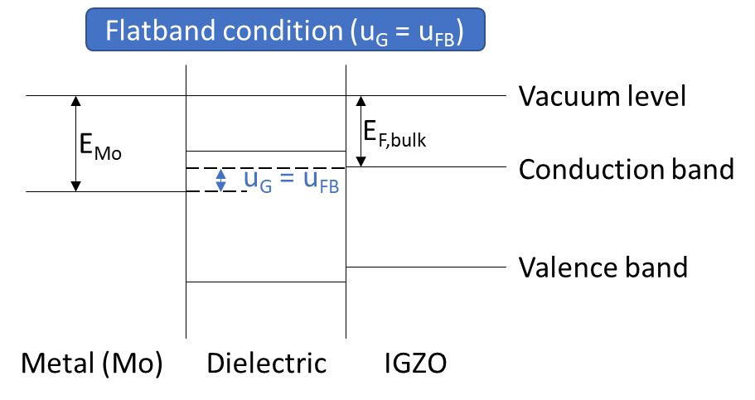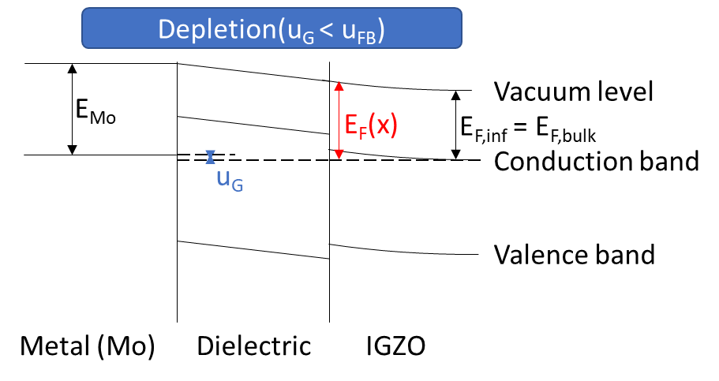
Figure 1: Schematic band diagram of the MIS junction in a transistor with IGZO. Depletion condition is shown on the left while flat band condition is shown on the right.

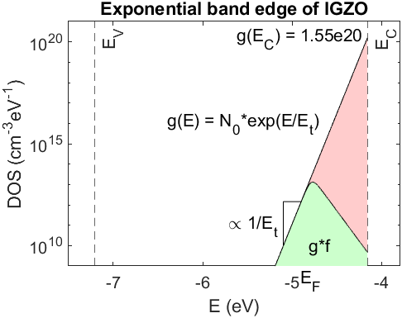
Figure 2: Schematic diagram of the band edge in an IGZO semiconductor. The DOS is shown in red while the DOS with respect to the Fermi Dirac Distribution is shown in green. For this plot $E_{F} = E_{F,bulk}$ was calculated using N_{D} = 1e12 cm⁻³ and E_{t} = 0.04 eV based on evaluation results and N₀ = 1.55e20 cm⁻³ from literature. A temperature of 300 K was assumed. E_{C} and E_{V} were taken from literature.

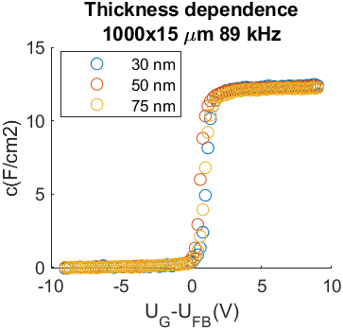
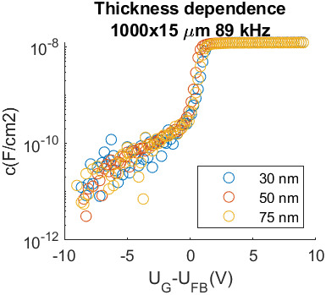
Figure 3: Thickness dependence of CV measurements in lin and log scale. No dependence of the measured capacitance on the thickness could be observed.

Figure 4: Surface potential – surface charge plots in dependence of Et (a) and ND (b)

