Identification of a Diastereomer of Penicilloic Acid during Acid-Mediated Degradation of 6-Aminopenicillanic Acid

Sofia Sontacchi,ª Giulia Martelli,^{b} Sofia Martello,ª Simone Raimondi,^{c} Ivan de Paola,ª Angelo Viola,^{a*} Andrea Milelli^{d}*

ª SUANFARMA Italia S.p.A., Corso Verona, 165, 38068, Rovereto, Italy.
^{b} Department of Industrial Chemistry "Toso Montanari", Alma Mater Studiorum-University of Bologna, Via Piero Gobetti 85, 40129, Bologna Italy.
^{c} Department for Life Quality Studies, Alma Mater Studiorum-University of Bologna, Corso d'Augusto 237, 47921, Rimini, Italy.
^{d} Department of Pharmacy and Biotechnology, Alma Mater Studiorum - University of Bologna, Corso d'Augusto 237, 47921, Rimini, Italy.

* andrea.milelli3@unibo.it; angelo.viola@suanfarma.com.

Table SI1. ¹H-NMR chemical shifts, multiplicities, and assignments of 6-APA and degradation products

Compound | δ (ppm) | Multiplicity | J (Hz) | Integral | Assignement
6-APA | 1.43 s | s |  | 3 | CH₃
 | 1.55 s | s |  | 3 | CH₃
 | 4.52 s | s |  | 1 | H_{c}
 | 4.97 d | d | 4.2 | 1 | H_{b}
 | 5.54 d | d | 4.2 | 1 | H_{a}
Compound 1 | 1.27 s | s |  | 3 | CH₃
 | 1.52 s | s |  | 3 | CH₃
 | 4.10 s | s |  | 1 | H_{c}
 | 4.39 d | d | 5.0 | 1 | H_{b}
 | 5.22 d | d | 5.1 | 1 | H_{a}
Compound 2 | 1.35 s | s |  | 3 | CH₃
 | 1.62 s | s |  | 3 | CH₃
 | 4.43 s | s |  | 1 | H_{c}
 | 4.67 | d | 8.2 | 1 | H_{b}
 | 5-44 | d | 8.2 | 1 | H_{a}

Figure SI1. Expanded ¹H NMR spectral regions of 6-APA and its degradation products recorded under acidic conditions. All detectable resonances are assigned and labeled for 6-APA (red), compound 1 (green), and compound 2 (blue). Proton assignments (Hₐ, H_b, H_c, H₃d, etc.) correspond to the positions indicated in the molecular structures. These spectra provide the complete set of signals used for structural characterization. Experimental conditions: DCl/D₂O, 25 °C

Table SI2. Relative percentage of 6-APA and degradation products (compounds 1 and 2) obtained from normalized ¹H NMR integrals at different reaction times and acid concentrations (0.75–2.5 M). Data illustrate the evolution of product distribution during acid-induced degradation of 6-APA.
Time  (min) | Relative compound percentage %
Time  (min) | 0.75 M |  |  | 1.0 M |  |  | 1.5 M |  |  | 2.0 M |  |  | 2.5 M
Time  (min) | 6-APA | 1 | 2 | 6-APA | 1 | 2 | 6-APA | 1 | 2 | 6-APA | 1 | 2 | 6-APA | 1 | 2
0 | 96.96 | 3.03 | 0 | 94.89 | 5.11 | 0 | 80.89 | 19.10 |  | 80.00 | 20.00 | 0 | 66.67 | 33.59
15 | 91.67 | 8.33 | 0 | 83.94 | 15.32 | 0 | 63.44 | 32.35 | 3.57 | 42.19 | 51.56 | 6.25 | 22.4 | 68.8 | 8.8
30 | 87.87 | 12.12 | 0.76 | 74.45 | 21.17 | 2.19 | 45.10 | 46.38 | 8.51 | 24.8 | 63.2 | 12.0 | 9.16 | 75.57 | 15.27
60 | 77.27 | 18.93 | 3.79 | 54.01 | 35.77 | 8.03 | 21.27 | 58.72 | 18.30 | 7.38 | 67.21 | 25.41 | 7.26 | 66.43 | 17.74
90 | 69.69 | 24.24 | 4.54 | 41.60 | 39.41 | 10.94 | 14.15 | 60.27 | 25.57 | 3.30 | 61.98 | 34.71 | 0 | 70.17 | 29.82
120 | 62.12 | 28.03 | 7.57 | 35.77 | 41.60 | 15.32 | 8.25 | 60.19 | 31.55 | 0 | 58.47 | 41.52 | 0 | 60.00 | 40.00
240 | 48.48 | 33.33 | 12.12 | 21.90 | 44.52 | 21.90 | 2.90 | 56.04 | 41.06 | ndª | ndª | ndª | 0 | 55.83 | 44.17
270 | 43.94 | 34.84 | 14.39 | 17.51 | 45.98 | 24.82 | 1.48 | 54.95 | 43.56 | ndª | ndª | ndª | ndª | ndª | ndª
330 | 34.84 | 37.12 | 17.40 | 10.94 | 45.25 | 28.45 | 0 | 52.97 | 47.03 | ndª | ndª | ndª | ndª | ndª | ndª
ª nd. not determined

Table SI3. Time-dependent evolution of the diagnostic ¹H NMR integrals of 6-APA and degradation products during acid-induced hydrolysis at different acid concentration. Signal intensities were normalized using maleic acid as an internal standard. The fraction of remaining 6-APA relative to the initial concentration (t₀) and the corresponding natural logarithm values were calculated and used for pseudo-first-order kinetic analysis.
a) 0.75 M
Time (min) | Integral  6-APA | Integral Compound 1 | Integral Compound 2 | Integral Maleic Acid | 6-APA normalized (vs maleic) | Compound 1 normalized | Compound 2 normalized | 6-APA fraction vs t0 | ln(6-APA fraction)
0 | 2.57 | 0.08 | 0 | 2 | 2.57 | 0.08 | 0 | 1 | 0
15 | 2.42 | 0.22 |  | 2 | 2.42 | 0.22 | 0 | 0.941634241 | -0.06014
30 | 2.32 | 0.31 | 0.03 | 2 | 2.32 | 0.31 | 0.03 | 0.902723735 | -0.10234
60 | 2.05 | 0.5 | 0.08 | 2 | 2.05 | 0.5 | 0.08 | 0.79766537 | -0.22607
90 | 1.84 | 0.63 | 0.13 | 2 | 1.84 | 0.63 | 0.13 | 0.715953307 | -0.33414
120 | 1.63 | 0.73 | 0.21 | 2 | 1.63 | 0.73 | 0.21 | 0.634241245 | -0.45533
240 | 1.28 | 0.89 | 0.33 | 2 | 1.28 | 0.89 | 0.33 | 0.498054475 | -0.69705
270 | 1.16 | 0.92 | 0.37 | 2 | 1.16 | 0.92 | 0.37 | 0.451361868 | -0.79549
330 | 0.52 | 0.52 | 0.47 | 2 | 0.52 | 0.52 | 0.47 | 0.20233463 | -1.59783

b) 1.0 M

Time (min) | Integral 6-APA | Integral Compound 1 | Integral Compound 2 | Integral Maleic Acid | 6-APA normalized (vs maleic) | Compound 1 normalized | Compound 2 normalized | 6-APA fraction vs t0 | ln(6-APA fraction)
0 | 2.61 | 0.14 | 0 | 2 | 2.61 | 0.14 | 0 | 1 | 0
15 | 2.31 | 0.41 | 0 | 2 | 2.31 | 0.41 | 0 | 0.885057471 | -0.1221
30 | 2.05 | 0.57 | 0.07 | 2 | 2.05 | 0.57 | 0.07 | 0.785440613 | -0.24151
60 | 1.48 | 0.23 | 0.98 | 2 | 1.48 | 0.23 | 0.98 | 0.567049808 | -0.56731
90 | 1.23 | 1.08 | 0.31 | 2 | 1.23 | 1.08 | 0.31 | 0.471264368 | -0.75234
120 | 0.97 | 1.14 | 0.42 | 2 | 0.97 | 1.14 | 0.42 | 0.37164751 | -0.98981
240 | 0.59 | 1.22 | 0.6 | 2 | 0.59 | 1.22 | 0.6 | 0.22605364 | -1.48698
270 | 0.47 | 1.26 | 0.67 | 2 | 0.47 | 1.26 | 0.67 | 0.180076628 | -1.71437
330 | 0.38 | 1.28 | 0.76 | 2 | 0.38 | 1.28 | 0.76 | 0.14559387 | -1.92693

c) 1.5 M
Time (min) | Integral 6-APA | Integral Compound 1 | Integral Compound 2 | Integral Maleic Acid | 6-APA normalized (vs maleic) | Compound 1 normalized | Compound 2 normalized | 6-APA fraction vs t0 | ln(6-APA fraction)
0 | 3.97 | 0.94 | 0 | 2 | 3.97 | 0.94 | 0 | 1 | 0
15 | 3.01 | 1.54 | 0 | 2 | 3.01 | 1.54 | 0 | 0.758186398 | -0.27683
30 | 2.13 | 2.17 | 0.4 | 2 | 2.13 | 2.17 | 0.4 | 0.536523929 | -0.62264
60 | 0.99 | 2.76 | 0.86 | 2 | 0.99 | 2.76 | 0.86 | 0.249370277 | -1.38882
90 | 0.62 | 2.64 | 1.13 | 2 | 0.62 | 2.64 | 1.13 | 0.156171285 | -1.8568
120 | 0.17 | 1.24 | 0.65 | 2 | 0.17 | 1.24 | 0.65 | 0.042821159 | -3.15072
240 | 0.12 | 2.32 | 1.7 | 2 | 0.12 | 2.32 | 1.7 | 0.0302267 | -3.49903
270 | 0.07 | 2.22 | 1.75 | 2 | 0.07 | 2.22 | 1.75 | 0.017632242 | -4.03803
330 | 0 | 2.26 | 1.88 | 2 | 0 | 2.26 | 1.88 | 0

c) 2.0 M
Time (min) | Integral 6-APA | Integral Compound 1 | Integral Compound 2 | Integral Maleic Acid | 6-APA normalized (vs maleic) | Compound 1 normalized | Compound 2 normalized | 6-APA fraction vs t0 | ln(6-APA fraction)
0 | 2.08 | 0.51 | 0 | 2 | 2.08 | 0.51 | 0 | 1 | 0
15 | 1.08 | 1.31 | 0.17 | 2 | 1.08 | 1.31 | 0.17 | 0.519230769 | -0.65541
30 | 0.61 | 1.58 | 0.31 | 2 | 0.61 | 1.58 | 0.31 | 0.293269231 | -1.22666
60 | 0.17 | 1.63 | 0.62 | 2 | 0.17 | 1.63 | 0.62 | 0.081730769 | -2.50432
90 | 0.08 | 1.5 | 0.84 | 2 | 0.08 | 1.5 | 0.84 | 0.038461538 | -3.2581
120 | 0 | 1.38 | 0.97 | 2 | 0 | 1.38 | 0.97 | 0

c) 2.5 M
Time (min) | Integral 6-APA | Integral Compound 1 | Integral Compound 2 | Integral Maleic Acid | 6-APA normalized (vs maleic) | Compound 1 normalized | Compound 2 normalized | 6-APA fraction vs t0 | ln(6-APA fraction)
0 | 1.73 | 0.86 | 0.02 | 2 | 1.73 | 0.86 | 0.02 | 1 | 0
15 | 0.55 | 1.72 | 0.21 | 2 | 0.55 | 1.72 | 0.21 | 0.317919075 | -1.14596
30 | 0.19 | 1.85 | 0.45 | 2 | 0.19 | 1.85 | 0.45 | 0.10982659 | -2.20885
60 | 0 | 1.59 | 0.68 | 2 | 0 | 1.59 | 0.68 | 0
90 | 0 | 1.44 | 0.96 | 2 | 0 | 1.44 | 0.96 | 0
120 | 0 | 1.33 | 1.06 | 2 | 0 | 1.33 | 1.06 | 0

Table SI4. Sample Concentration table (NMR) and corresponding pD values
Concentrations (M) | D₂O (ml) | DCl (ml) | pD value
0.75 | 0.92 | 0.075 | -0.20
1.0 | 0.90 | 0.10 | -0.24
1.5 | 0.85 | 0.15 | -0.30
2.0 | 0.80 | 0.20 | -0.34
2.5 | 0.25 | 0.75 | -0.45

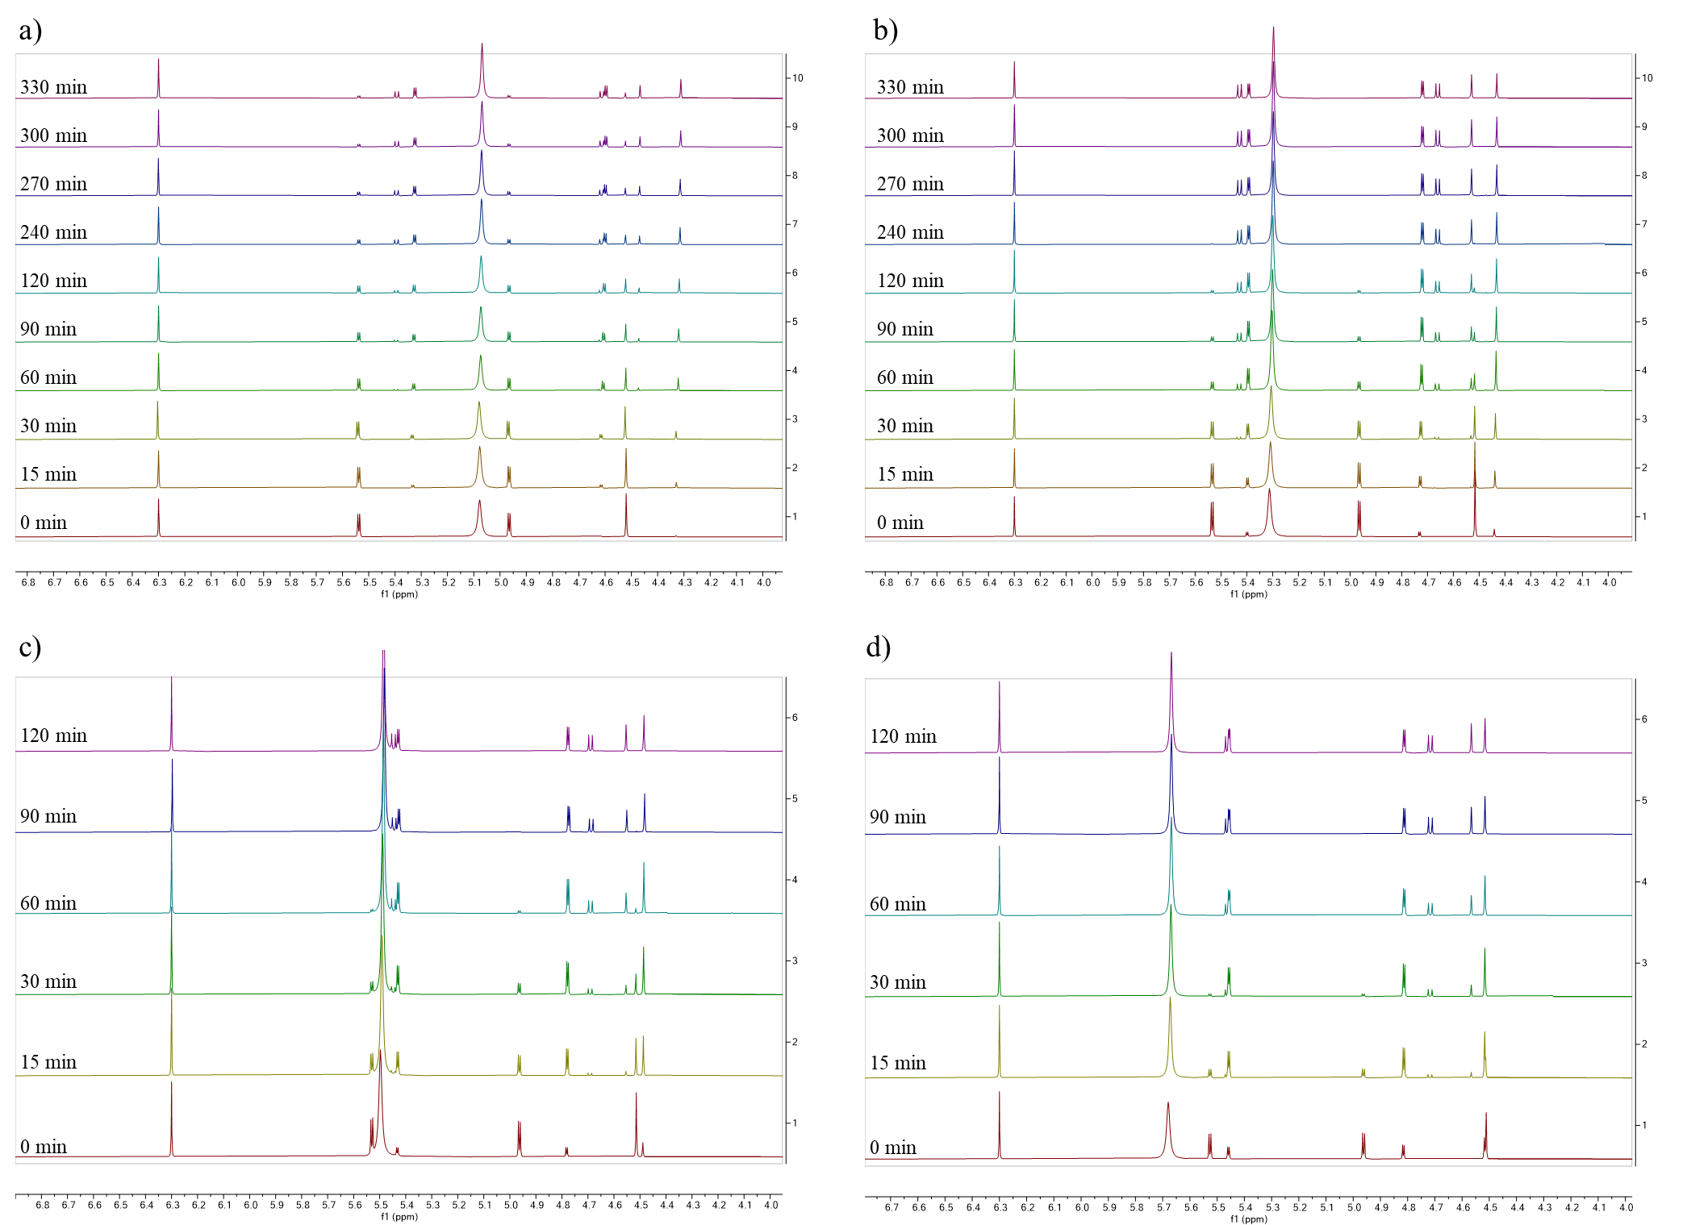
Figure SI2. Section of the time-dependent ¹H-NMR of 6-APA at different acidic concentration recorded at 25 °C; a) 1.0 M of 6-APA in DCl/D₂O recorded at different time points; b) 1.5 M of 6-APA in DCl/D₂O recorded at different time points; c) 2.0 M of 6-APA in DCl/D₂O recorded at different time points; d) 2.5 M of 6-APA in DCl/D₂O recorded at different time points.

Figure SI3. Time-resolved ¹H NMR spectra (600 MHz, D₂O, 25 °C) recorded at different reaction times during the acid-induced degradation of 6-APA in the presence of DCl. The figure shows an expanded spectral region (δ ≈ 4.5–6.5 ppm) highlighting the decrease of 6-APA and the formation of degradation products (compounds 1 and 2). Maleic acid was used as internal standard for signal normalization. The following figures show the same spectral region for experiments performed at different DCl concentrations.
0.75 M
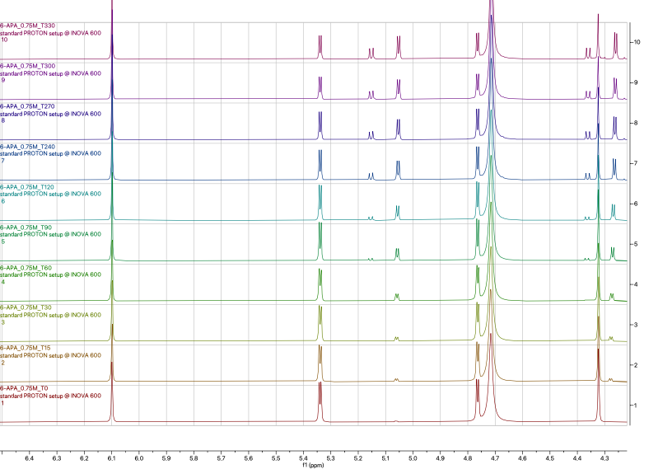

1.0 M

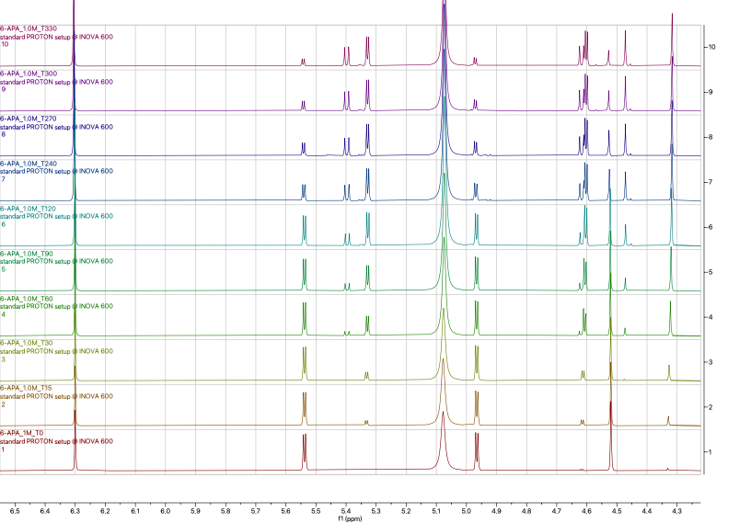

1.5 M

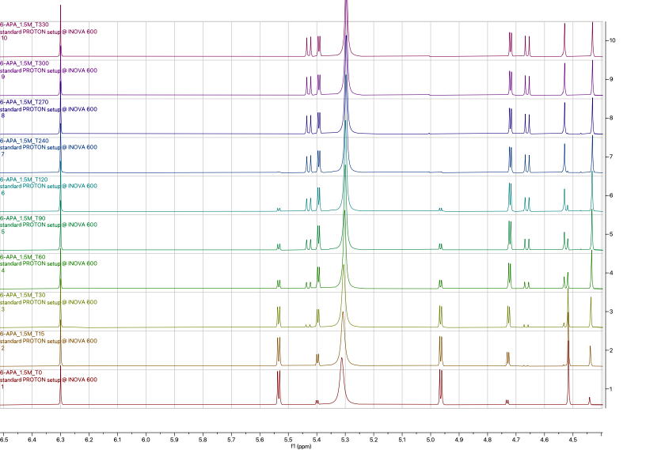
2.0 M
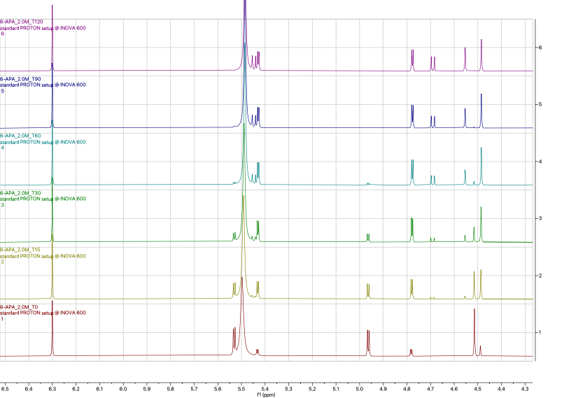

2.5 M

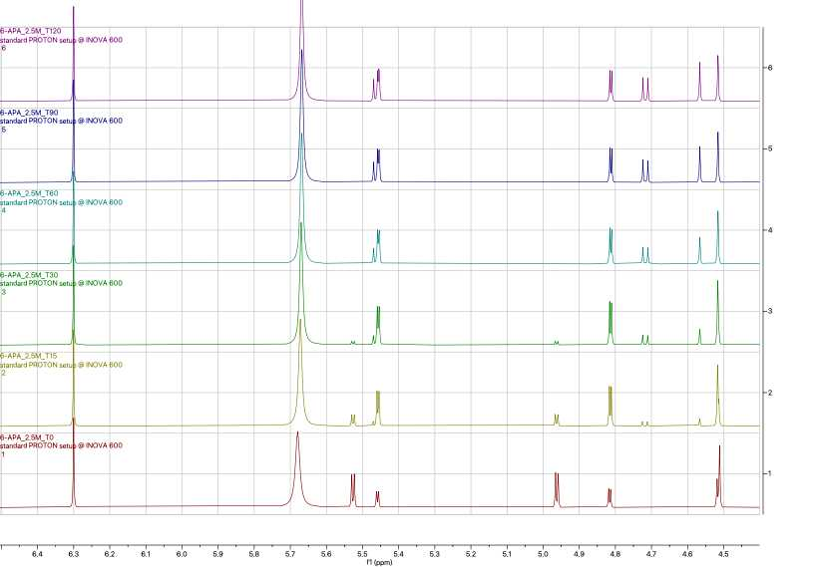

Figure SI4. Stacked ¹H NMR spectra (600 MHz. D₂O. 25 °C) recorded at different reaction times during the acid-induced degradation of 6-APA in the presence of DCl. The figure shows an expanded spectral region (δ ≈ 4.0–6.5 ppm) highlighting the decrease of 6-APA and the formation of degradation products (compounds 1 and 2). Maleic acid was used as internal standard for normalization of the signal integrals.
T0
T15

T30

T60

T90
T120

Complete ¹H NMR spectra recorded during the acid-induced degradation of 6-APA

- 0.75 M

T0
T15

T30
T60

T90
T120

T240
T270

T300
T330

-

1.0 M

T0
T15

T30
T60

T90
T120

T240
T270

T300
T330

- 1.5 M

T0
T15

T30
T60

T90
T120

T240
T270

T300
T330

- 2.0 M

T0
T15

T30
T60

T90
T120

- 2.5 M

T0
T15

T30
T60

T90
T120

Figure SI5.
a) ¹H-NMR spectrum (600 MHz, D₂O, 25 °C) of the reaction mixture containing 6-APA during acid-induced degradation in 2.5M DCl after 24h.
a1) full spectra;

a2) Section of the ¹H-NMR spectra 5.8-4.4 ppm;

a3) Section of the ¹H-NMR spectra 1.8-1.0 ppm.

b) ¹H-NMR spectrum (600 MHz, D₂O, 25 °C) of the reaction mixture containing 6-APA during acid-induced degradation in 2.5M DCl after 48h.
b1) full spectra;

b2) Section of the ¹H-NMR spectra 5.8-4.4 ppm;

b3) Section of the ¹H-NMR spectra 1.8-1.0 ppm.

Figure SI6. COSY NMR spectra of 6-APA in 2.5 M DCl/D₂O after 24h exposure at 25 °C.

Table SI5. Sample Concentration table (HPLC)
 | weight/volume | diluition (ml) | Concentration
0.75 M
6-APA (99.6%) | 1079.87 mg | 20 | 53.78 mg/ml
HBr 8.7M | 1.7 ml | 20 | 0.74 M
1.0 M
6-APA (99.6%) | 1079.44 mg | 20 | 53.76 mg/ml
HBr 8.7M | 2.5 ml | 20 | 1.09 M
1.5 M
6-APA (99.6%) | 1079.51 mg | 20 | 53.76 mg/ml
HBr 8.7M | 3.5 ml | 20 | 1.52 M
2.0 M
6-APA (99.6%) | 1080.90 mg | 20 | 53.83 mg/ml
HBr 8.7M | 4.5 ml | 20 | 1.96 M
2.5 M
6-APA (99.6%) | 1080.42 mg | 20 | 53.80 mg/ml
HBr 8.7M | 5.7 ml | 20 | 2.48 M

Analysis of HPLC data
- 0.75 M

- 1.0 M

- 1.5 M

- 2.0 M

- 2.5 M
Figure SI67. Time-dependent degradation of 6-APA monitored by HPLC at different acid concentrations. Data are reported as percentage change of the peak area relative to the initial value.

Chromatogram copies
Blank

- 0.75 M
T0
T15
T30

T45
T60

T90
T120

T240
- 1.0 M
T0

T15

T30

T45
T60

T90
T120

T240
- 1.5 M
T0

T15
T30

T45
T60

T90
T120

T240
- 2.0 M
T0

T15
T30

T45
T60

T90
T120

T240
- 2.5 M
T0

T15
T30

T45
T60

T90
T120

T240
HPLC-MS

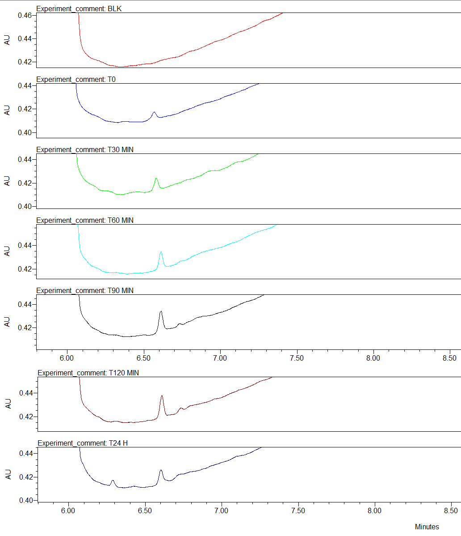

Peak RT = 6.5 min
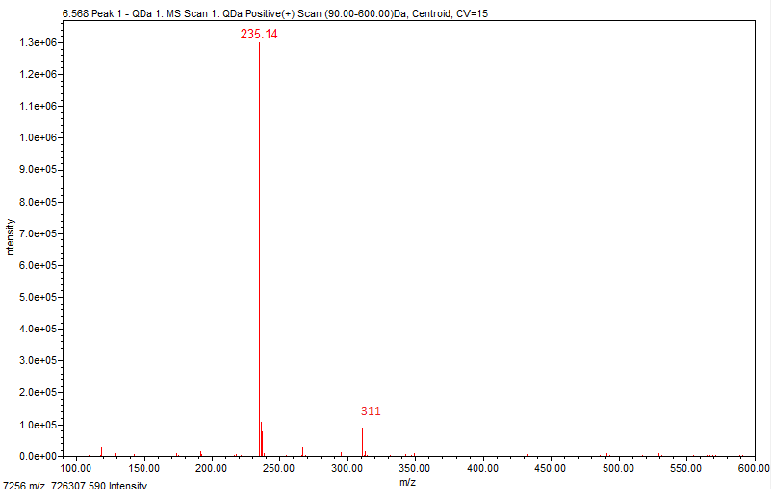

Peak RT = 6.7 min

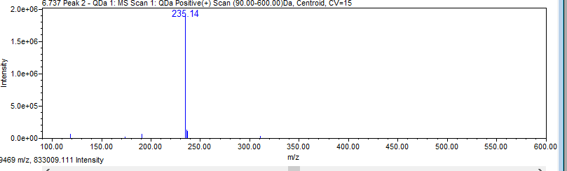

Peak RT = 6.25 min

