Appendix
Effects of acute stress on reward processing: A comprehensive meta-analysis of rodent and human studies
Martino Schettino, Valeria Tarmati, Paola Castellano, Valeria Gigli, Luca Carnevali, Simona Cabib, Cristina Ottaviani, Cristina Orsini

Appendix A. Rodent studies included in the meta-analyses and comparisons used to derive effect sizes.
Study | n | n Induction Group | n Control Group | Wo (%) | Species | Strain | Phase | Food restricted | Stress manipulation | Stressor duration (min) | Time Lag  (min) | Reward task | Positive Valence Systems
Amemiya et al. 2020 | 20 | 10 | 10 | 0 | Rat | Wistar | Light | Yes | Restraint | 30 | 0 | High reward choice | Valuation
Atsak et al. 2016 | 25 | 11 | 14 | 0 | Rat | Sprague-Dawley | Light | No | Cortisol | / | 60 | Cue-response maze | Responsiveness
Bai et al. 2019a | 19 | 10 | 9 | 0 | Rat | Sprague-Dawley | Dark | No | Foot shock | 10 | 30 | Sucrose consumption | Responsiveness
Bai et al. 2019b | 20 | 10 | 10 | 0 | Rat | Sprague-Dawley | Dark | No | Foot shock | 10 | 30 | Sucrose consumption | Responsiveness
Bai et al. 2019c | 21 | 11 | 10 | 0 | Rat | Sprague-Dawley | Dark | No | Foot shock | 10 | 30 | Sucrose consumption | Responsiveness
Bai et al. 2019d | 15 | 8 | 7 | 0 | Rat | Sprague-Dawley | Light | Yes | Foot shock | 10 | 30 | FR1 performance | Valuation
Bai et al. 2019e | 20 | 10 | 10 | 0 | Rat | Sprague-Dawley | Light | Yes | Foot shock | 10 | 30 | FR1 performance | Valuation
Bai et al. 2019f | 16 | 9 | 7 | 0 | Rat | Sprague-Dawley | Light | Yes | Foot shock | 10 | 30 | FR1 performance | Valuation
Bai et al. 2019g | 14 | 7 | 7 | 0 | Rat | Sprague-Dawley | Light | Yes | Foot shock | 10 | 30 | PR performance | Valuation
Bai et al. 2019h | 20 | 10 | 10 | 0 | Rat | Sprague-Dawley | Light | Yes | Foot shock | 10 | 30 | PR performance | Valuation
Bai et al. 2019i | 16 | 8 | 8 | 0 | Rat | Sprague-Dawley | Light | Yes | Foot shock | 10 | 30 | PR performance | Valuation
Bai et al. 2019l | 26 | 10 | 16 | 0 | Rat | Sprague-Dawley | Light | Yes | FST | 5 | 30 | PR performance | Valuation
Barret et al. 2021 | 18 | 9 | 9 | 0 | Mouse | C57BL/6J | Light | Yes | Restraint | 30 | 0 | Food consumption | Responsiveness
Boggiano et al. 2007 | 18 | 9 | 9 | 0 | Rat | Sprague-Dawley | Dark | No | Foot shock | 1.27 | 0 | Food consumption | Responsiveness
Bowers et al. 1999 | 16 | 8 | 8 | 0 | Rat | Long Evans | Light | Yes | Foot shock | 30 | 0 | Runaway maze | Responsiveness
Braun et al. 2013a | 22 | 11 | 11 | 0 | Rat | Lister-Hooded | Light | Yes | Cortisol + Yohimbine | / | 0 | Two-lever choice (sucrose vs chow) | Valuation
Braun et al. 2013b | 18 | 9 | 9 | 0 | Rat | Lister-Hooded | Light | Yes | Restraint | 60 | 0 | Two-lever choice (sucrose vs chow) | Valuation
Bryce et al. 2016 | 18 | 9 | 9 | 0 | Rat | Long Evans | / | Yes | Restraint | 60 | 10 | Effort discounting | Valuation
Calvez et al. 2011a | 14 | 7 | 7 | 0 | Rat | Wistar | Dark | Yes | Restraint | 180 | 30 | Food consumption | Responsiveness
Calvez et al. 2011b | 14 | 7 | 7 | 0 | Rat | Wistar | Dark | Yes | FST | 10 | 30 | Food consumption | Responsiveness
Carter et al. 2020 | 28 | 16 | 12 | 0 | Rat | Sprague-Dawley | Light | No | Restraint | 120 | 3240 | SA acquisition | Learning
Chu et al. 2021a | 15 | 8 | 7 | 0 | Mouse | C57BL/6J | Light | No | Restraint | 30 | 0 | Conditioned place preference | Valuation
Chu et al. 2021b | 15 | 7 | 8 | 0 | Mouse | C57BL/6J | Light | No | Restraint | 30 | 0 | Conditioned place preference | Valuation
Cifani et al. 2013a | 18 | 9 | 9 | 100 | Rat | / | Light | No | HPF exposition | 15 | 0 | HPF consumption | Responsiveness
Cifani et al. 2013b | 18 | 9 | 9 | 100 | Rat | / | Light | Yes | HPF exposition | 15 | 0 | HPF consumption | Responsiveness
Cozzoli et al. 2014a | 6 | 6 | 0 | 0 | Mouse | C57BL/6J | Dark | No | Restraint | 30 | 0 | Two-bottle choice | Valuation
Cozzoli et al. 2014b | 12 | 12 | 0 | 0 | Mouse | C57BL/6J | Dark | No | Predator Odor | 30 | 0 | Two-bottle choice | Valuation
Cozzoli et al. 2014c | 9 | 9 | 0 | 100 | Mouse | C57BL/6J | Dark | No | Restraint | 30 | 0 | Two-bottle choice | Valuation
Cozzoli et al. 2014d | 12 | 12 | 0 | 100 | Mouse | C57BL/6J | Dark | No | Predator Odor | 30 | 0 | Two-bottle choice | Valuation
Del Rosario Capriles & Cancela 2002 | 18 | 9 | 9 | 0 | Rat | Wistar | Light | No | Restraint | 120 | 1440§ | Conditioned place preference | Learning
Der-Avakian et al. 2007a | 15 | 7 | 8 | 100 | Rat | Sprague-Dawley | Light | No | Tail shock | Variabile (yocked) | 4320 | Conditioned place preference | Learning
Der-Avakian et al. 2007b | 14 | 7 | 7 | 100 | Rat | Sprague-Dawley | Light | No | Tail shock | Variabile (yocked) | 7200 | Conditioned place preference | Learning
Der-Avakian et al. 2010 | 20 | 10 | 10 | 0 | Rat | Long Evans | Dark | No | Social defeat | 60# | 7.5# | Intracranical self-stimulation | Responsiveness
Enkell et al. 2010a | 8 | 8 | 0 | 0 | Rat | NLH | Light | Yes | Foot shock | 4.13# | 10080 | Food consumption | Responsiveness
Enkell et al. 2010b | 13 | 13 | 0 | 0 | Rat | NLH | / | Yes | Foot shock | 4.13# | 10080 | Food consumption | Responsiveness
Farook et al. 2009 | 25 | 20 | 5 | 0 | Mouse | C57BL/6J | Light | No | Restraint | 60 | / | Two-bottle choice | Valuation
Fatahi et al. 2014 | 14 | 7 | 7 | 0 | Rat | Wistar | Light | Yes | FST | 6 | 10 | Conditioned place preference | Valuation
Fuentes et al. 2018a | 16 | 8 | 8 | 0 | Rat | Long-Evans | Light | Yes | Immobilization stress on boards | 120 | 20160 | Pavlovian conditioned approach (Test at day 5) | Learning
Fuentes et al. 2018b | 20 | 10 | 10 | 100 | Rat | Long-Evans | Light | Yes | Immobilization stress on boards | 120 | 20160 | Pavlovian conditioned approach (Test at day 5) | Learning
Goebel-Stengel et al. 2014 | 16 | 8 | 8 | 0 | Rat | Sprague–Dawley | Light | No | Tail-pinch | 5 | 0 | Food consumption | Responsiveness
Ghasemzadeh et al. 2020 | 12 | 6 | 6 | 0 | Rat | Wistar | Light | Yes | Elevated platform stress | 30 | 1440 | Conditioned place preference (Test at day 5) | Learning
Haghparast et al. 2013 | 15 | 8 | 7 | 0 | Rat | Wistar | Light | Yes | FST | 6 | 10 | Conditioned place preference | Valuation
Hart et al. 2017 | 12 | 12 | / | 0 | Rat | Sprague–Dawley | Light | Yes | Restraint + Tail shock | 143 | 1440 | Effortful choice | Valuation
Hebb et al. 2003 | 12 | 6 | 6 | 0 | Mouse | CD-1 | Light | No | TMT fox odor | 10 | 5 | Intracranial self-stimulation | Responsiveness
Hotta et al. 1999a | 16 | 8 | 8 | 0 | Rat | Wistar | Light | Yes | Vicarious stress | 60 | 0 | Food consumption | Responsiveness
Hotta et al. 1999b | 10 | 5 | 5 | 0 | Rat | Wistar | Light | Yes | Vicarious sress | 60 | 0 | Food consumption | Responsiveness
Javadi et al. 2017a | 12 | 6 | 6 | 0 | Rat | Wistar | Light | No | Elevated platform stress | 30 | 1440 | Conditioned place preference (Test at day 5) | Learning
Javadi et al. 2017b | 12 | 6 | 6 | 0 | Rat | Wistar | Light | No | Elevated platform stress | 30 | 1440 | Conditioned place preference (Test at day 5) | Learning
Katz et al. 1979 | 9 | 9 | 0 | 0 | Rat | Sprague–Dawley | Light | No | Tail-pinch | 0.5 | 0 | Intracranical self stimulation | Responsiveness
Krahn et al. 1986a | 20 | 10 | 10 | 0 | Rat | Sprague–Dawley | Light | Yes | CRF | / | 0 | Food consumption | Responsiveness
Krahn et al. 1986b | 15 | 7 | 8 | 0 | Rat | Sprague–Dawley | Light | Yes | Restraint | 60 | 0 | Food consumption | Responsiveness
Makhijani et al. 2021 | 24 | 12 | 12 | 0 | Rat | Long-Evans | Light | No | TMT fox odor | 10 | 14400 | Sweetened alcohol SA | Responsiveness
Matthews et al. 2008a | 18 | 9 | 9 | 0 | Mouse | C57BL/6J | Dark | No | Foot shock | 15 | 0 | Two-bottle choice | Valuation
Matthews et al. 2008b | 20 | 10 | 10 | 0 | Mouse | DBA/2J | Dark | No | Foot shock | 15 | 0 | Two-bottle choice | Valuation
Matthews et al. 2008c | 25 | 12 | 13 | 0 | Mouse | A/J | Dark | No | Foot shock | 15 | 0 | Two-bottle choice | Valuation
Mor et al. 2017 | 31 | 15 | 16 | 0 | Rat | Sprague-Dawley | Dark | Yes | Restraint | 15 | 0 | Devaluation test | Valuation
Pecoraro et al. 2005 | 14 | 7 | 7 | 0 | Rat | Sprague-Dawley | Light | No | Cortisol | / | 0 | Sucrose consumption | Responsiveness
Pielock et al. 2013a | 45 | 23 | 22 | 0 | Rat | Lister hooded | Light | Yes | Restraint | 60 | 0 | PIT | Valuation
Pielock et al. 2013b | 27 | 12 | 15 | 0 | Rat | Lister hooded | Dark | Yes | Restraint | 60 | 0 | PIT | Valuation
Ramsey et al. 1993a | 33 | 17 | 16 | 0 | Rat | Wistar | Dark | Yes | Hot plate | 0.5 | 0 | SA acquisition | Responsiveness
Ramsey et al. 1993b | 14 | 9 | 5 | 0 | Rat | Wistar | Dark | Yes | Foot shock | 10 | 5 | SA acquisition | Responsiveness
Ramsey et al. 1993c | 20 | 12 | 8 | 0 | Rat | Wistar | Dark | Yes | Emotional | 10 | 5 | SA acquisition | Responsiveness
Reed et al. 2021a | 12 | 6 | 6 | 0 | Rat | Fischer | / | No | Tail shock | 50+ | 4320 | Food consumption | Responsiveness
Reed et al. 2021b | 53 | 26 | 27 | 0 | Rat | Fischer | Dark | No | Tail shock | 50+ | 2880 | Food consumption | Responsiveness
Rolstch et al. 2014 | 20 | 14 | 6 | 0 | Rat | Wistar | Dark | Yes | TMT fox odor | 15 | 2880 | Two-lever choice | Valuation
Rozeske et al. 2011 | 14 | 6 | 8 | 0 | Rat | / | Light | No | Tail shock | 107# | 1440 | Conditioned place preference | Learning
Rybkin et al. 1997a | 32 | 16 | 16 | 0 | Rat | Sprague-Dawley | Dark | No | Restraint | 180 | 0 | Food consumption | Responsiveness
Rybkin et al. 1997b | 32 | 16 | 16 | 0 | Rat | Sprague-Dawley | Light | No | Restraint | 180 | 0 | Food consumption | Responsiveness
Schippers et al. 2016a | 24 | 12 | 12 | 0 | Rat | Wistar | Light | Yes | Yohimbine | / | 30 | Delayed reward task | Valuation
Sekino et al. 2004a | 18 | 9 | 9 | 0 | Rat | Wistar | Light | Yes | Restraint | 60 | 0 | Food consumption | Responsiveness
Sekino et al. 2004b | 18 | 9 | 9 | 0 | Rat | Wistar | Light | Yes | Restraint | 60 | 0 | Food consumption | Responsiveness
Sekino et al. 2004c | 16 | 8 | 8 | 0 | Rat | Wistar | Light | Yes | Foot shock | 60 | 0 | Food consumption | Responsiveness
Sekino et al. 2004d | 16 | 8 | 8 | 0 | Rat | Wistar | Light | Yes | Vicarious stress | 60 | 0 | Food consumption | Responsiveness
Sekino et al. 2004e | 22 | 11 | 11 | 0 | Rat | Wistar | Light | Yes | Restraint | 60 | 0 | Food consumption | Responsiveness
Shafiei et al. 2012a | 8 | 8 | 0 | 0 | Rat | Long Evans | Dark | No | Restraint | 60 | 10 | Reward magnitude discrimination task | Valuation
Shafiei et al. 2012b | 13 | 13 | 0 | 0 | Rat | Long Evans | Dark | No | Restraint | 60 | 10 | Effort discounting task with equivalent delays | Valuation
Shibasaki et al. 1988a | 37 | 15 | 22 | 0 | Rat | Wistar | Light | Yes | Restraint | 90 | 0 | Food consumption | Responsiveness
Shibasaki et al. 1988b | 20 | 11 | 9 | 0 | Rat | Wistar | Light | Yes | Restraint | 90 | 0 | Food consumption | Responsiveness
Shibasaki et al. 1988c | 18 | 9 | 9 | 0 | Rat | Wistar | Light | Yes | Restraint | 90 | 0 | Food consumption | Responsiveness
Shibasaki et al. 1988d | 20 | 11 | 9 | 0 | Rat | Wistar | Light | Yes | Restraint | 90 | 0 | Food consumption | Responsiveness
Shimizu et al. 1989 | 10 | 5 | 5 | 0 | Rat | Wistar | Dark | No | Restraint | 120 | 30 | Food consumption | Responsiveness
Smagin et al. 1999 | 10 | 5 | 5 | 0 | Rat | Sprague-Dawley | Light | No | Restraint | 180 | 0 | Food consumption | Responsiveness
Stelly et al. 2020a | 19 | 10 | 9 | 0 | Rat | Sprague-Dawley | Light | No | Restraint | 25# | 240 | Pavlovian reward learning | Learning
Stelly et al. 2020b | 37 | 21 | 16 | 0 | Rat | Sprague-Dawley | Light | No | Restraint | 25# | 20 | Pavlovian reward learning | Learning
Tambour et al. 2008a | 14 | 14 | 0 | 100 | Mouse | VSC-1 | Dark | No | Restraint | 60 | 0 | Two-bottle choice | Valuation
Tambour et al. 2008b | 14 | 14 | 0 | 0 | Mouse | VSC-1 | Dark | No | Restraint | 60 | 0 | Two-bottle choice | Valuation
Tovar-Diaz et al. 2018a | 16 | 8 | 8 | 0 | Rat | Sprague-Dawley |  | No | Social defeat | 30 | 1440 | Conditioned place preference | Learning
Tovar-Diaz et al. 2018b | 18 | 9 | 9 | 0 | Rat | Sprague-Dawley |  | No | Social defeat | 30 | 1440 | Conditioned place preference | Learning
Wada et al. 2020 | 18 | 10 | 8 | 0 | Mouse | C57BL/6J |  | No | Restraint | 30 | 0 | Conditioned place preference | Valuation
Wanat et al. 2013 | 23 | 11 | 12 | 0 | Rat | Sprague-Dawley |  | No | Restraint | 20 | 0 | Motivation to work for food rewards in operant task | Valuation
Zorilla et al. 2004a | 9 | 9 | 0 | 0 | Rat | Wistar | Dark | No | CRF |  | 30 | Food consumption | Responsiveness
Zorilla et al. 2004b | 9 | 9 | 0 | 0 | Rat | Wistar | Dark | No | CRF |  | 30 | Food consumption | Responsiveness
Zurita et al. 1996a | 8 | 8 | 0 | 0 | Rat | Wistar | Light | No | Restraint | 60 | 0 | Sucrose preference test | Valuation
Zurita et al. 1996b | 8 | 8 | 0 | 0 | Rat | Wistar | Light | No | Restraint | 120 | 0 | Sucrose preference test | Valuation

Notes. NLH: noHelplessness; FST: Forced Swim Test; HPF: High Palatable Food; TMT: Trimethylthiazoline; FR: Fixed-Ratio; PR: Progressive Ratio; PIT: Pavlovian Instrumental Transfer; SA: Self-Administration, CRF: corticotropin-releasing factor. / = not reported; # = estimated value; § = pre-conditioning.

Appendix B. Coding of the stressors adopted in the rodent studies included in the meta-analyses.
Systemic | Stress manipulation | Definition | Duration (min) | Studies
Systemic | Pharmacological induction (Cortisol, Yombinhe, CRF) | Administration of compounds mimicking the physiological stress response | // | Atsak et al. 2016  Braun et al. 2013  Krahn et al. 1986  Pecoraro et al. 2005  Schippers et al. 2016  Zorilla et al. 2004
Systemic | Foot/tail shock | Noxious/painful stimulus application | 10-60 | Bai et al. 2019  Boggiano et al. 2007  Bowers et al. 1999  Der-Avakian et al. 2007  Enkell et al. 2010  Hart et al. 2017  Matthews et al. 2008  Ramsey et al. 1993  Reed et al. 2021  Rozeske et al. 2011  Sekino et al. 2004
Systemic | Tail-pinch | Exposition to mild noxious/painful stimulation | 0.5-5 | Goebel-Stengel et al. 2014  Katz et al. 1979
Systemic | Hot plate | Paws exposition to noxious/painful stimulus (50 C°) | 0.5 | Ramsey et al. 1993
Psychogenic | Restraint | Forced immobility in a narrow transparent cylindrical tube | 15-180 | Amemiya et al. 2020  Barret et al. 2021  Braun et al. 2013  Bryce et al. 2016  Calvez et al. 2011  Capriles et al. 2002  Carter et al. 2020  Chu et al. 2021  Cozzoli et al. 2014  Farook et al. 2009  Fuentes et al. 2018  Hart et al. 2017  Krahn et al. 1986  Mor et al. 2017  Pielock et al. 2013  Rybkin et al. 1997  Sekino et al. 2004  Shafiei et al. 2012  Shibasaki et al. 1988  Shimizu et al. 1989  Smagin et al. 1999  Stelly et al. 2020  Tambour et al. 2008  Wada et al. 2020  Wanat et al. 2013  Zurita et al. 1996
Psychogenic | Forced Swimming Test (FST) | Inescapable exposure to water filled transparent tank (23-25°C) | 5-10 | Bai et al. 2019  Calvez et al. 2011  Fatahi et al. 2014  Haghparast et al. 2013
Psychogenic | High Palatable Food (HPF) Exposition | Exposition to not accessible high palatable food | 15 | Cifani et al. 2013
Psychogenic | Predator Odor | Exposition to a natural fearful stimulus | 10-30 | Cozzoli et al. 2014  Hebb et al. 2003  Makhijani et al. 2021  Rolstch et al. 2014
Psychogenic | Social Defeat | Exposition to a male aggressive conspecific | 30-60 | Der-Avakian et al. 2010  Tovar-Diaz et al. 2018
Psychogenic | Elevated platform stress | Exposition to anxiogenic environment | 30 | Ghasemzadeh et al. 2020  Javadi et al. 2017
Psychogenic | Vicarious stress | Exposition to a conspecific receiving foot shocks | 10-60 | Hotta et al. 1999  Ramsey et al. 1993  Sekino et al. 2004

Appendix C. Coding of the reward tasks employed in the rodent studies included in the meta-analyses.
 | Reward Task | Measure of | Positive Valence System | Studies
Pavlovian appetitive behaviors | Cue-response maze: Cue-induced choice of a rewarded arm in 8-arms radial maze | Reward attractiveness | Responsiveness | Atsak et al. 2016
Pavlovian appetitive behaviors | Conditioned Place Preference (CPP): Free choice for a reward associated context | Reward conditioning  Conditioned reward attractiveness | Learning  (Stressor before conditioning)  Valuation  (Stressor after conditioning) | Capriles et al. 2002  Der-Avakian et al. 2007  Ghasemzadeh et al. 2020  Javadi et al. 2017  Rozeske et al. 2011  Tovar-Diaz et al. 2018  Chu et al. 2021  Fatahi et al. 2014  Haghparast et al. 2013  Wada et al. 2020
Pavlovian appetitive behaviors | Pavlovian conditioned approach (sign-tracking): Approach to a reward associated cue | Conditioned reward attractiveness | Learning  (Stressor before conditioning) | Fuentes et al. 2018  Stelly et al. 2020
Appetitive instrumental behaviors | Fixed-ratio 1 (FR1): Fixed instrumental contingency linking action and reward | Maintenance of instrumental responding  Acquisition of instrumental responding  First instrumental responding | Valuation  (Stressor after baseline performance)  Learning  (Stressor before instrumental training)  Responsiveness  (Stressor before instrumental training) | Bai et al. 2019  Carter et al. 2020  Ramsey et al. 1993 Makhijani et al. 2021
Appetitive instrumental behaviors | Progressive ratio (PR): Variable (increasing) instrumental contingency linking action and outcome | Effort to maintain instrumental responding (breaking point) | Valuation  (Stressor after baseline performance) | Bai et al. 2019  Wanat et al. 2013
Appetitive instrumental behaviors | Intracranial self-stimulation (ICSS): Instrumental responding to obtain electrical stimulation of the brain reward system | Hedonic threshold | Responsiveness | Der-Avakian et al. 2010  Hebb et al. 2003  Katz et al. 1979
Appetitive instrumental behaviors | Pavlovian-instrumental transfer (PIT): Cue-modulated instrumental responding | Conditioned reward attractiveness | Valuation | Pielock et al. 2013
High reward choice behaviors | Y-maze: Choice between low- and high-reward arms | Reward choice based on its magnitude  Reward choice based on effort requirement | Valuation  Valuation | Amemiya et al. 2020  Hart et al. 2017
High reward choice behaviors | Two lever-choice: Choice between two instrumental manipulanda with low- and high- reward contingencies | Reward choice based on its magnitude  Reward choice based on effort requirement | Valuation  Valuation | Shafiei et al. 2012  Bryce et al. 2016  Shafiei et al. 2012
High reward choice behaviors | Two-lever choice after devaluation: Instrumental choice test after devaluation of one reward value (by satiety) | Sensitivity to reward devaluation (goal-directedness) | Valuation | Braun et al. 2013  Rolstch et al. 2014  Mor et al. 2017
High reward choice behaviors | Two-bottle choice: Choice between two free drinking solution with low- and high- reward value | Reward choice based on its valence | Valuation | Cozzoli et al. 2014  Farook et al. 2009  Matthews et al. 2008  Tambour et al. 2008 Zurita et al. 1996
High reward choice behaviors | Delayed reward task: Choice between two instrumental manipulanda giving access to small-immediate or large-delayed rewards | Reward choice based on its valence | Valuation | Schippers et al. 2016
Reward consumption | Consumption of standard or high palatable food: Free intake in home or test cage | Reward consumption | Responsiveness | Bai et al. 2019  Barret et al. 2021  Boggiano et al. 2007  Calvez et al. 2011  Cifani et al. 2013  Enkell et al. 2010  Goebel-Stengel et al. 2014  Hotta et al. 1999  Krahn et al. 1986  Pecoraro et al. 2005  Reed et al. 2021  Rybkin et al. 1997  Sekino et al. 2004  Shibasaki et al. 1988  Shimizu et al. 1989  Smagin et al. 1999  Zorilla et al. 2004
Reward consumption | Runaway maze: Latency to reward gain | Reward attractiveness | Responsiveness | Bowers et al. 1999

Appendix D. Human studies included in the meta-analyses and comparisons used to derive effect sizes.
Studies | n | n exp. | n control | Wo  (%) | Age (years) | Stressor Type | Stressor duration  (min) | Time Lag  (min) | Subjective stress assessment | Cortisol increase° | Physiological vars | Behavioral reward task | Positive Valence Systems
Banis and Lorist 2017 | 18 | 18 | 0 | 100 | 20.7 | Distressing movie clips | 3.05# | 0 | PANAS | Yes (Induction group: 0.53; Control group: −.29) | HR | MID | Responsiveness
Berghorst et al. 2013 | 95 | 68 | 27 | 100 | 21.4 | Threat of shock | 13 | 0 | STAI-S, PANAS | No (Induction group: 1.56; Control group: 0.95) | NA | Probabilistic Stimulus Selection Task | Learning
Berghorst et al. 2016 | 15 | 15 | / | 66.7 | 31.7 | Negative feedback | / | 0 | PANAS | NA | NA | MID | Responsiveness
Bogdan and Pizzagalli 2006 | 38 | 38 | 0 | 100 | 22.1 | Threat of shock | 17.5 | 0 | STAI, PANAS | NA | NA | PRT | Learning
Bogdan et al. 2010 | 53 | 53 | 0 | 100 | 22.3# | Threat of shock | 14 | 0 | STAI, PANAS | NA | SCR | PRT | Learning
Bogdan et al. 2011 | 75 | 75 | 0 | 100 | 22.3 | Threat of shock | 14 | 0 | STAI, PANAS | NA | SCR | PRT | Learning
Brunelin and Fecteau 2021 | 14 | 14 | 0 | 50 | 28.2 | MAST | 10 | 5 | NA | Yes (Induction group: 0.12) | NA | Delay Discounting Task | Valuation
Byrne et al. 2019a | 50 | 25 | 25 | 66 | 19.2 | SECPT | ≤3 | 10 | NA | NA | NA | Two Choice Task | Learning
Byrne et al. 2019b | 50 | 25 | 25 | 66 | 19.8 | SECPT | ≤3 | 10 | NA | Yes | NA | Two Choice Task | Learning
Carvalheiro et al. 2021a | 62 | 62 | 0 | 0 | 21.9 | Predictable but uncontrollable auditory stimulus | 16 | 0 | Likert scale for stress | NA | SCR | Reinforcement-learning Task | Learning
Carvalheiro et al. 2021b | 23 | 23 | 0 | 0 | 23 | Predictable but uncontrollable auditory stimulus | 16 | 0 | Likert scale for stress | NA | NA | Reinforcement-learning Task | Learning
Cavanagh et al. 2011 | 50 | 26 | 26 | 52 | 18.9 | Social evaluation | 25# | 0 | PANAS | NA | HR | PLT | Learning
Corral Frías et al. 2016 | 127 | 67 | 60 | 57.5 | 21.4# | TSST | 20 | 4 | PANAS | Yes (Induction group: 4.5) | HR | MID | Responsiveness
De Berker et al. 2016 | 60 | 30 | 30 | 50 | / | SECPT | ≤3 | 10 | VAS | Yes | BP, HR, Pupil diameter | GoNANo Go Task with a monetary gain or loss | Learning
Dinter et al. 2020 | 30 | 15 | 15 | 50 | 28.7 | Aggressive face (IAPS) + disturbing acoustic stimulus | NA | 1440 | VAS | Yes | EDA, ECG | Reward Learning Paradigm | Valuation
Gaillard et al. 2020 | 31 | 31 | 0 | 75 | 24.2 | Threat of shock | 20# | 0 | VAMS | No | NA | Fribourg Reward Task | Responsiveness
Gaillard et al. 2019 | 23 | 23 | 0 | 60.9 | 24.7 | Threat of shock | 20# | 0 | VAMS | No | NA | Fribourg Reward Task | Responsiveness
Gerhardsson et al. 2021 | 32 | 32 | 0 | 56.3 | 29 | Sleep restriction | 480§ | 450# | Sleep diary | No | NA | PST | Learning
Glienke et al. 2015 | 39 | 18 | 20 | 0 | / | SECPT | ≤3 | 15 | Subjective ratings | Yes | BP | Learning Task with contingent and no-contingent monetary reward | Learning
Goldfield et al. 2008 | 18 | 18 | 0 | 100 | 19.2 | Social evaluation | 3 | 0 | STAI | No | NA | Reinforcing Value of Food Task | Valuation
Kimura et al. 2013 | 39 | 39 | 0 | 23.1 | 21.2 | TSST | 20 | 10 | VAS | Yes (Induction group: 4.26) | ECG, HR | Delay Discounting | Valuation
Kinner et al. 2016 | 60 | 30 | 30 | 50 | 24 | Cortisol administration | NA | 60 | Arousal ratings | Yes (Induction group: 308.26; Control group: 1.69) | NA | MID | Responsiveness
Klatzkin et al. 2019 | 43 | 43 | 0 | 100 | 19.5 | TSST | 15 | 25 | Stress intensity, PANAS, VAS | Yes | BP, HR | Snack Intake | Responsiveness
Kruse et al. 2018 | 56 | 27 | 29 | 0 | 23.7# | TSST | 20 | 20 | PANAS | Yes (Induction group: 11.2; Control group: 1.08) | SCR | MID | Responsiveness
Kumar et al. 2014 | 15 | 15 | 0 | 66.7 | / | Negative feedback | / | 0 | Affective ratings | NA | SCR | MID | Responsiveness
Kumar et al. 2015 | 10 | 10 | 0 | 80 | 30.1 | Negative feedback | / | 0 | Affective ratings | NA | NA | MID | Responsiveness
Lim et al. 2020 | 25 | 25 | 0 | 40 | 29.1 | Threat of shock | 65 | 0 | NA | NA | NA | Real time Smoking Choice within Dual-task Paradigm | Valuation
Liu et al. 2011 | 44 | 44 | 0 | 52.3# | 27 | Negative feedback | 15.7 | 0 | STAI, PANAS | NA | NA | PRT | Learning
Massaccesi et al. 2021 | 67 | 33 | 34 | 100 | 22 | TSST | 27§ | 35 | STAI, PANAS, VAS | Yes (Induction group: 1.81; Control group: -0.6) | Salivary alpha amylase, facial EMG | Social Reward Task | Valuation
McKee et al. 2011 | 37 | 0 | 0 | 40.5# | 37.7 | Distressing personalized imagery | 10 | 0 | VAS, DES | No | ACTH, HR, Systolic BP | Delay Task | Valuation
Montoya et al. 2014 | 20 | 20 | 0 | 0 | 23 | Cortisol administration | 13 | 50 | VAS, POMS | NA | NA | MID | Responsiveness
Ossewaarde et al. 2011 | 27 | 14 | 13 | 100 | 20.5# | Aversive movie clips | 2.2 | 28.5# | PANAS | Yes | HR, HRV | MID | Responsiveness
Paret and Bublatzy 2020 | 34 | 34 | 0 | 100 | 23.7 | Threat of shock | 11.7# | 0 | VAS | NA | HR, SCR, EDA | Reward Reversal Task | Learning
Park et al. 2017 | 52 | 26 | 26 | 51.8 | 20.4 | SECPT | ≤3 | 10 | VAS | NA | NA | Two stage Reversal Learning Task
Paul et al. 2020 | 38 | 17 | 21 | 0 | 25.4 | SECPT | ≤3 | 20 | VAS | Yes | Systolic and diastolic BP, HR | Probabilistic Reward Learning Task | Learning
Pericot-Valverde et al. 2021 | 30 | 30 | 0 | 23.3 | 19.1 | TSST | 15 | 0 | VAS | NA | HR | Dual Component Self-Administration Task | Valuation
Petzold et al. 2010 | 23 | 23 | 0 | 47.8 | 23.5 | TSST | 15 | 10 | NA | Yes | NA | PST | Learning
Pool et al. 2015 | 36 | 18 | 18 | 47.2 | 24.2 | SECPT | ≤3 | 10 | VAS | Yes (Induction group: 1.36; Control group: -2.15) | NA | PIT | Valuation
Schettino et al. 2021 | 46 | 22 | 24 | 76.1 | 22.9 | Intrusive thinking induction | 2 | 2 | VAS | NA | NA | PRT | Learning
Schwabe et al. 2010 | 51 | 28 | 23 | 45.1 | / | SECPT | ≤3 | 25 | VAS | Yes | Systolic and Diastolic BP | Instrumental Learning Task | Valuation
Schwabe et al. 2012 | 36 | 19 | 17 | / | / | Hydrocortisone + yohimbine administration | / | 50 | MBDF | Yes (Induction group: 160.9; Control group: -3.73) | Alpha-amylase | Instrumental Learning Task | Learning
Steins-Loeber et al. 2020 | 59 | 28 | 31 | 52.5 | 23.9 | SECPT | ≤3 | 15 | VAS | No (Induction group: -0.98; Control group: -5.8) | NA | PIT | Valuation
Thomas et al. 2014 | 82 | 42 | 40 | 46 | 26.7 | TSST | 15 | 15 | SUDS | Yes | HR, MAP | Taste Test | Responsiveness
van Leeuwen et al. 2019 | 39 | 20 | 19 | / | 40.3# | TSST (adapted version) | 8 | 50 | VAS | Yes | Alpha-amylase | MID  (adapted version) | Responsiveness
Zhang et al. 2020 | 24 | 24 | 0 | 29.2 | 20.9 | Threat of shock | 22# | 0 | STAI-S, PANAS, VAMS, Likert scale for stress | NA | SCR | PLT | Learning

Notes. TSST: Tries Social Stress Test; MAST: Maastricht Acute Stress Test; SECPT: Socially Evaluated Cold-Pressure Test; IAPS: International Affective Picture System; POMS: Profile of Mood States; KUSTA: Kurz-Skala Stimmung/Aktivierung; PANAS: Positive and Negative Affect Schedule; STAI: State Trait Anxiety Inventory; VAS: Visual Analogue Scale; VAMS: Visual Analogue Mood Scales; DES: Differential Emotion Scale; MBDF: Multidimensional Mood State Questionnaire; SUDS: Subjective Units of Distress Scale); HR: Heart Rate; SCR: Skin Conductance Response; BP: Blood Pressure; EMG: Electromyography; ASCTH: Adrenocorticotropic Hormone; HRV: Heart Rate Variability; EDA: Electrodermal Activity; MID: Monetary Incentive Delay; PRT: Probabilistic Reward Task; PLT: Probabilistic Learning Task; PST: Probabilistic Selection Task; PIT: Pavlovian Instrumental Transfer. # = estimated value; / = not reported; NA = not assessed; § = 2 consecutive nights of sleep restriction; # = the next day; § = TSST + preparation phase; ° = Yes/No (nmol/L increase after stress).

Appendix E. Coding of the stressors adopted in the human studies included in the meta-analyses.
Systemic | Stress manipulation | Definition | Duration (min) | Studies
Systemic | Sleep restriction | Two consecutive nocturnal limited sleeping (4 hours) | 480 | Gerhardsson et al. 2021
Systemic | Pharmacological induction (cortisol, hydrocortisone, yohimbine) | Administration of a compound mimicking the physiological stress response | NA | Kinner et al. 2016  Montoya et al. 2014  Schwabe et al. 2012
Systemic | Sensory (acustic) stress | Uncontrollable exposure to a constant loud alarm sound | 16 | Carvalheiro et al. 2021a  Carvalheiro et al. 2021b
Psychogenic | Aversive movie clips | Exposure to movie clips showing aggressive behaviors against humans | 2.2-3.05 | Banis & Lorist 2017  Ossewaarde et al. 2011
Psychogenic | Threat of shock | Anticipated occurrence of unpredicted electric shock during task | 11.7-65 | Berghorst et al. 2013  Bogdan & Pizzagalli 2006  Bogdan et al. 2010  Bogdan et al. 2011  Gaillard et al. 2019  Gaillard et al. 2020  Lim et al. 2020  Paret & Bublatzy 2020  Zhang et al. 2020
Psychogenic | Maastricht Acute Stress Test (MAST) | Hand exposure to cold water (0-2° C) during a mental arithmetic task, plus announcement of bad performance during task | 10 | Brunelin & Fecteau 2021
Psychogenic | Combined emotional stress | Exposure to a loud (60 dB) scream and an aggressive male face | NA | Dinter et al. 2020
Psychogenic | Distressing personalized imagery | Visualization of a stressful situation during its verbal description by headphones | 10 | McKee et al. 2011
Psychogenic | Intrusive thinking induction | Verbal reporting of a recent anxiogenic personal episode (happened during the last 12 months) | 2 | Schettino et al. 2021
Social | Negative feedback | Announcement of bad performance during task | 0-15.7 | Berghorst et al. 2016  Kumar et al. 2014  Kumar et al. 2015  Liu et al. 2011
Social | Socially Evaluated Cold-Pressure Test (SECPT) | Hand exposure to cold water (0-2° C) overtly filmed by an unknown person | ≤3 | Byrne et al. 2019a  Byrne et al. 2019  De Berker et al. 2016  Glienke et al. 2015  Park et al. 2017  Paul et al. 2020  Pool et al. 2015  Schwabe et al. 2010  Steins-Loeber et al. 2020
Social | Socially evaluated task performance | Overt filming of the reaction to a rude announcement of task rerun following bad performance | 3-25 | Cavanagh et al. 2011  Goldfield et al. 2008
Social | Trier Social Stress Test (TSST) | Anticipated request to perform a public speech and a mental arithmetic task in front of an evaluative committee | 8-27 | Corral Frías et al. 2016  Kimura et al. 2013  Klatzkin et al. 2019  Kruse et al. 2018  Massaccesi et al. 2021  Pericot-Valverde et al. 2021  Petzold et al. 2010  Thomas et al. 2014  van Leeuwen et al. 2019

Appendix F. Coding of the reward tasks employed in the human studies included in the meta-analyses.
 | Reward Task | Measure of | PVS | Studies
Monetary reward | Monetary Incentive Delay: Opportunity to gain or not a reward based on speed of the response | Reward attractiveness | Responsiveness | Banis & Lorist 2017  Berghorst et al. 2016  Corral Frías et al. 2016  Kinner et al. 2016  Kruse et al. 2018  Kumar et al. 2014  Kumar et al. 2015  Montoya et al. 2014  Ossewaarde et al. 2011  van Leeuwen et al. 2019  Gaillard et al. 2019  Gaillard et al. 2020
Monetary reward | Probabilistic choice task: Choice between stimuli previously associated with high and low probabilities of reward | Reward choice based on its probability | Learning | Berghorst et al. 2013  Cavanagh et al. 2011  Zhang et al. 2020  Gerhardsson et al. 2021  Petzold et al. 2010
Monetary reward | Probabilistic reward learning task: Choice between stimuli with high and low probabilities of reward | Reward learning based on its probability | Learning | Bogdan & Pizzagalli 2006  Bogdan et al. 2010  Bogdan et al. 2011  Liu et al. 2011  Schettino et al. 2021  Carvalheiro et al. 2021a  Carvalheiro et al. 2021b  Glienke et al. 2015
Monetary reward | Two choice Task: Choice between options giving access to incremental or decremental reward values across trials | Reward learning based on its value | Learning | Byrne et al. 2019
Monetary reward | Go/No Go Task: Association of stimuli with different instrumental contingencies allowing reward gain or reward loss | Reward learning | Learning | De Berker et al. 2016
Monetary reward | Reward Learning Paradigm: Learning of instrumental action to gain a reward | Reward learning  (Stressor after conditioning) | Valuation | Dinter et al. 2020
Monetary reward | Reversal reward learning Task:  Learning of both stimulus-reward and stimulus-no reward associations followed by the reversal of these associations | Reward learning | Learning | Paret & Bublatzy 2020
Monetary reward | Two stage reversal  learning task: Two sequential choices leading to different probabilities to gain a reward continuously reversed throughout the task | Reward learning strategies (model-free or model-based) | Learning | Park et al. 2017
Monetary reward | Delayed reward task: Choice between two stimuli giving access to small-immediate or large-delayed rewards | Reward learning based on its valence | Learning | Paul et al. 2020
Monetary reward | Pavlovian–instrumental transfer (PIT): Cue-modulated instrumental responding | Conditioned reward attractiveness | Valuation | Pool et al. 2015  Steins-Loeber et al. 2020
Non-monetary reward | Reinforce value task: Choice of different rewards based on their value (food) | Reward attractiveness | Valuation | Goldfield et al. 2008
Non-monetary reward | Consumption of high palatable food: Free intake in test environment (snacks)  Consumption of alcohol: Intake in test environment (beer) | Reward consumption | Responsiveness | Klatzkin et al. 2019  Thomas et al. 2014
Non-monetary reward | Two-choice task: Choice between two different rewards in short abstinence smokers  (nicotine versus money) | Reward choice based on its valence | Valuation | Lim et al. 2020  McKee et al. 2011  Pericot-Valverde et al. 2021
Non-monetary reward | Social Reward Task: Learning of instrumental action to gain low- and high-value rewards  (interpersonal touch) | Motivation to gain rewards based on effort | Valuation | Massaccesi et al. 2021
Non-monetary reward | Instrumental learning task with devaluation:  Learning of instrumental action to gain rewards with different values followed by a specific satiety-induced devaluation and a test of reward value (not rewarded)  (food) | Sensitivity to reward devaluation (goal-directedness)  Acquisition of instrumental responding | Valuation  (stressor after devaluation)  Learning  (stressor before instrumental learning) | Schwabe et al. 2010  Schwabe et al. 2012

Appendix G. PRISMA checklist.
Section and Topic | Item # | Checklist item | Location where item is reported
TITLE
Title | 1 | Identify the report as a systematic review. | page 1
ABSTRACT
Abstract | 2 | See the PRISMA 2020 for Abstracts checklist. | page 1
INTRODUCTION
Rationale | 3 | Describe the rationale for the review in the context of existing knowledge. | pages 1-2
Objectives | 4 | Provide an explicit statement of the objective(s) or question(s) the review addresses. | page 2
METHODS
Eligibility criteria | 5 | Specify the inclusion and exclusion criteria for the review and how studies were grouped for the syntheses. | pages 2-3
Information sources | 6 | Specify all databases, registers, websites, organisations, reference lists and other sources searched or consulted to identify studies. Specify the date when each source was last searched or consulted. | page 2
Search strategy | 7 | Present the full search strategies for all databases, registers and websites, including any filters and limits used. | page 2
Selection process | 8 | Specify the methods used to decide whether a study met the inclusion criteria of the review, including how many reviewers screened each record and each report retrieved, whether they worked independently, and if applicable, details of automation tools used in the process. | page 3
Data collection process | 9 | Specify the methods used to collect data from reports, including how many reviewers collected data from each report, whether they worked independently, any processes for obtaining or confirming data from study investigators, and if applicable, details of automation tools used in the process. | page 3
Data items | 10a | List and define all outcomes for which data were sought. Specify whether all results that were compatible with each outcome domain in each study were sought (e.g. for all measures, time points, analyses), and if not, the methods used to decide which results to collect. | pages 4
Data items | 10b | List and define all other variables for which data were sought (e.g. participant and intervention characteristics, funding sources). Describe any assumptions made about any missing or unclear information. | pages 3-4
Study risk of bias assessment | 11 | Specify the methods used to assess risk of bias in the included studies, including details of the tool(s) used, how many reviewers assessed each study and whether they worked independently, and if applicable, details of automation tools used in the process. | page 4
Effect measures | 12 | Specify for each outcome the effect measure(s) (e.g. risk ratio, mean difference) used in the synthesis or presentation of results. | pages 4-5
Synthesis methods | 13a | Describe the processes used to decide which studies were eligible for each synthesis (e.g. tabulating the study intervention characteristics and comparing against the planned groups for each synthesis (item #5)). | page 4
Synthesis methods | 13b | Describe any methods required to prepare the data for presentation or synthesis, such as handling of missing summary statistics, or data conversions. | page 4
Synthesis methods | 13c | Describe any methods used to tabulate or visually display results of individual studies and syntheses. | page 4
Synthesis methods | 13d | Describe any methods used to synthesize results and provide a rationale for the choice(s). If meta-analysis was performed, describe the model(s), method(s) to identify the presence and extent of statistical heterogeneity, and software package(s) used. | page 4
Synthesis methods | 13e | Describe any methods used to explore possible causes of heterogeneity among study results (e.g. subgroup analysis, meta-regression). | page 4
Synthesis methods | 13f | Describe any sensitivity analyses conducted to assess robustness of the synthesized results. | N/A
Reporting bias assessment | 14 | Describe any methods used to assess risk of bias due to missing results in a synthesis (arising from reporting biases). | N/A
Certainty assessment | 15 | Describe any methods used to assess certainty (or confidence) in the body of evidence for an outcome. | page 4
RESULTS
Study selection | 16a | Describe the results of the search and selection process, from the number of records identified in the search to the number of studies included in the review, ideally using a flow diagram. | Fig.1, Fig. 2, pages 3-4
Study selection | 16b | Cite studies that might appear to meet the inclusion criteria, but which were excluded, and explain why they were excluded. | Fig.1, Fig. 2, pages 3-4
Study characteristics | 17 | Cite each included study and present its characteristics. | Appendix A, D
Risk of bias in studies | 18 | Present assessments of risk of bias for each included study. | N/A
Results of individual studies | 19 | For all outcomes, present, for each study: (a) summary statistics for each group (where appropriate) and (b) an effect estimate and its precision (e.g. confidence/credible interval), ideally using structured tables or plots. | Appendix A, D
Results of syntheses | 20a | For each synthesis, briefly summarise the characteristics and risk of bias among contributing studies. | pages 5-8; Appendix H-M
Results of syntheses | 20b | Present results of all statistical syntheses conducted. If meta-analysis was done, present for each the summary estimate and its precision (e.g. confidence/credible interval) and measures of statistical heterogeneity. If comparing groups, describe the direction of the effect. | pages 5-8
Results of syntheses | 20c | Present results of all investigations of possible causes of heterogeneity among study results. | pages 5-8
Results of syntheses | 20d | Present results of all sensitivity analyses conducted to assess the robustness of the synthesized results. | N/A
Reporting biases | 21 | Present assessments of risk of bias due to missing results (arising from reporting biases) for each synthesis assessed. | N/A
Certainty of evidence | 22 | Present assessments of certainty (or confidence) in the body of evidence for each outcome assessed. | pages 5-8
DISCUSSION
Discussion | 23a | Provide a general interpretation of the results in the context of other evidence. | pages 8-10
Discussion | 23b | Discuss any limitations of the evidence included in the review. | pages 8-10
Discussion | 23c | Discuss any limitations of the review processes used. | pages 10
Discussion | 23d | Discuss implications of the results for practice, policy, and future research. | pages 10
OTHER INFORMATION
Registration and protocol | 24a | Provide registration information for the review, including register name and registration number, or state that the review was not registered. | page 2
Registration and protocol | 24b | Indicate where the review protocol can be accessed, or state that a protocol was not prepared. | page 2
Registration and protocol | 24c | Describe and explain any amendments to information provided at registration or in the protocol. | N/A
Support | 25 | Describe sources of financial or non-financial support for the review, and the role of the funders or sponsors in the review. | page 11
Competing interests | 26 | Declare any competing interests of review authors. | page 11
Availability of data, code and other materials | 27 | Report which of the following are publicly available and where they can be found: template data collection forms; data extracted from included studies; data used for all analyses; analytic code; any other materials used in the review. | page 11

From: Page MJ, McKenzie JE, Bossuyt PM, Boutron I, Hoffmann TC, Mulrow CD, et al. The PRISMA 2020 statement: an updated guideline for reporting systematic reviews. BMJ 2021;372:n71. doi: 10.1136/bmj.n7
Appendix H. Funnel plot for the meta-analysis on the effects of acute stress on reward responsiveness in rodents.
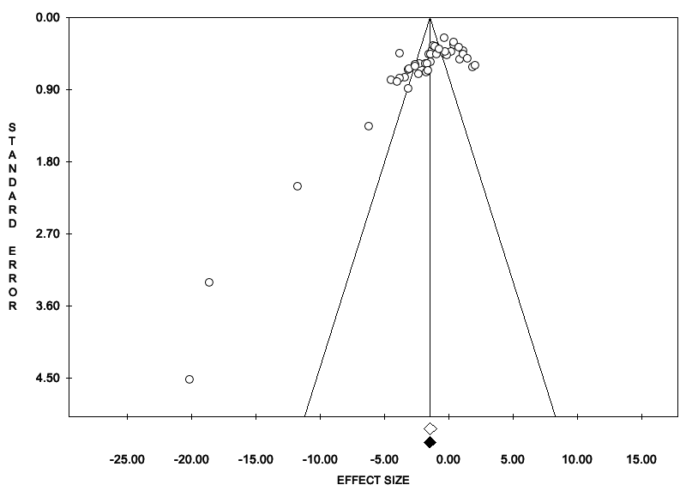

Appendix I. Funnel plot for the meta-analysis on the effects of acute stress on reward responsiveness in humans.
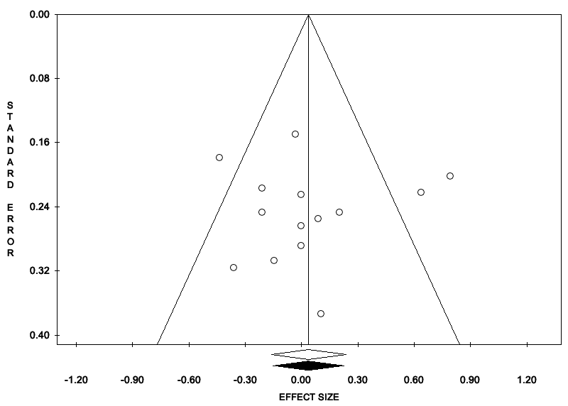

Appendix J. Funnel plot for the meta-analysis on the effects of acute stress on reward valuation in rodents.
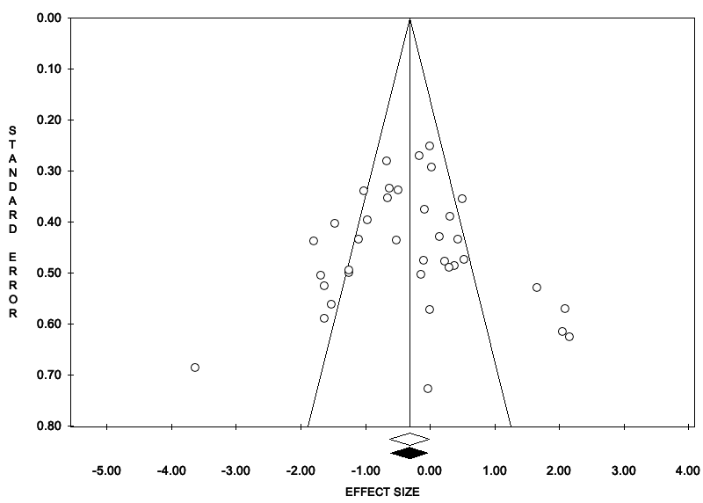

Appendix K. Funnel plot for the meta-analysis on the effects of acute stress on reward valuation in humans.
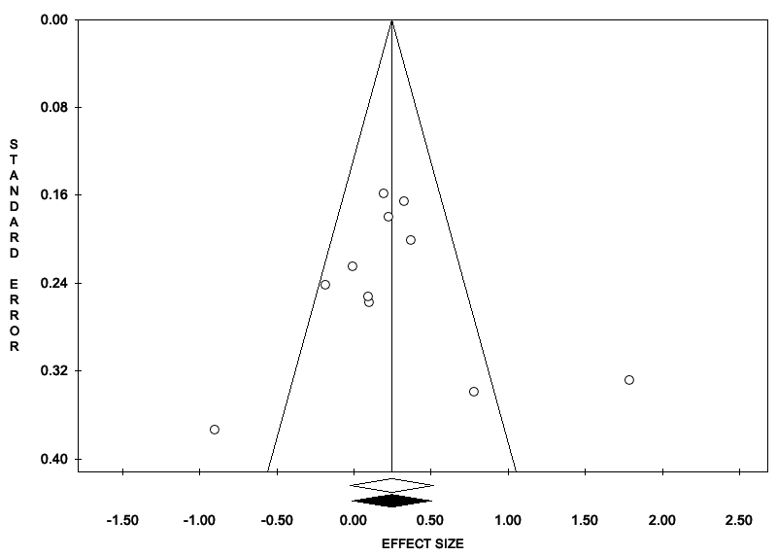

Appendix L. Funnel plot for the meta-analysis on the effects of acute stress on reward learning in rodents.
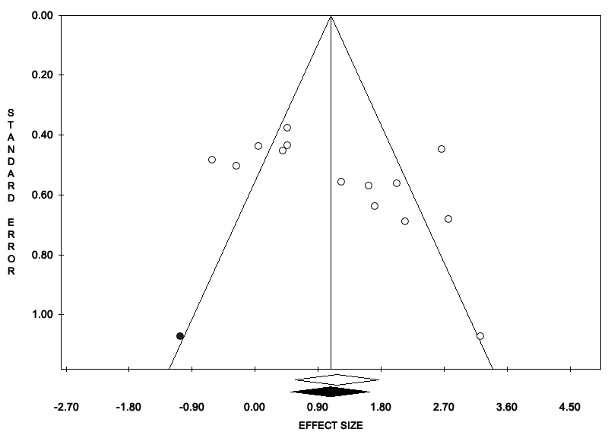

Appendix M. Funnel plot for the meta-analysis on the effects of acute stress on reward learning in rodents.
