Supporting Information

Esters of alpha-1,3-glucan: designed enzymatic polysaccharides as new matrices for sustainable packaging and membrane applications

Kseniya Papchenkoª*, Kyriaki Lampriª, Giulio Santoriª, Janice Toª, Daniel Orejonª, Natnael Behabtu^{b}, Jure Zlopasa^{b}, and Maria Grazia De Angelisª

ª School of Engineering, Institute for Materials and Processes, School of Engineering, University of Edinburgh, Sanderson Building, Robert Stevenson Road, EH9 3FB, UK
^{b} IFF Health & Biosciences, Leiden Bioscience Park, West Willem Einthovenstraat 4, Oegstgeest, 2342 BH, Netherlands

*Corresponding author: kpapchen@ed.ac.uk

S1. NMR analysis
The ¹H and ¹³C NMR spectroscopy was used to analyse the structure of glucan derivatives, as described in Section 2.1 of the main text. ¹³C spectra were recorded for α-1,3-glucan in dimethyl sulfoxide-d₆ and lithium chloride (DMSO-d₆/LiCl) mixture, while deuterated chloroform (CDCl₃) was used for glucan esters with different Degrees of Substitution (DoS), namely glucan laurate acetate (GLA), and two glucan palmitates (GP1 and GP2). ¹H spectra of glucan esters were recorded with addition of two drops of trifluoroacetic acid (TFA) to each sample and used to determine substituent’s DoS. All tests were performed at 40 °C and shown in Figure S1.
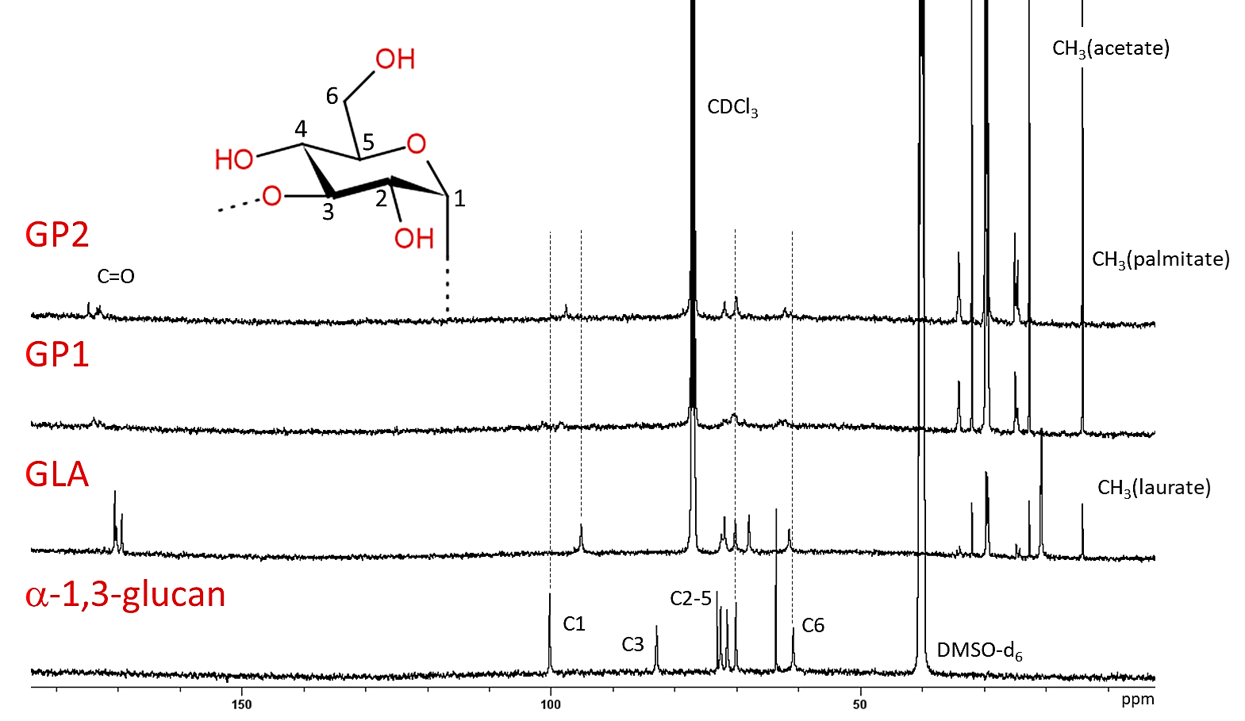
(a)
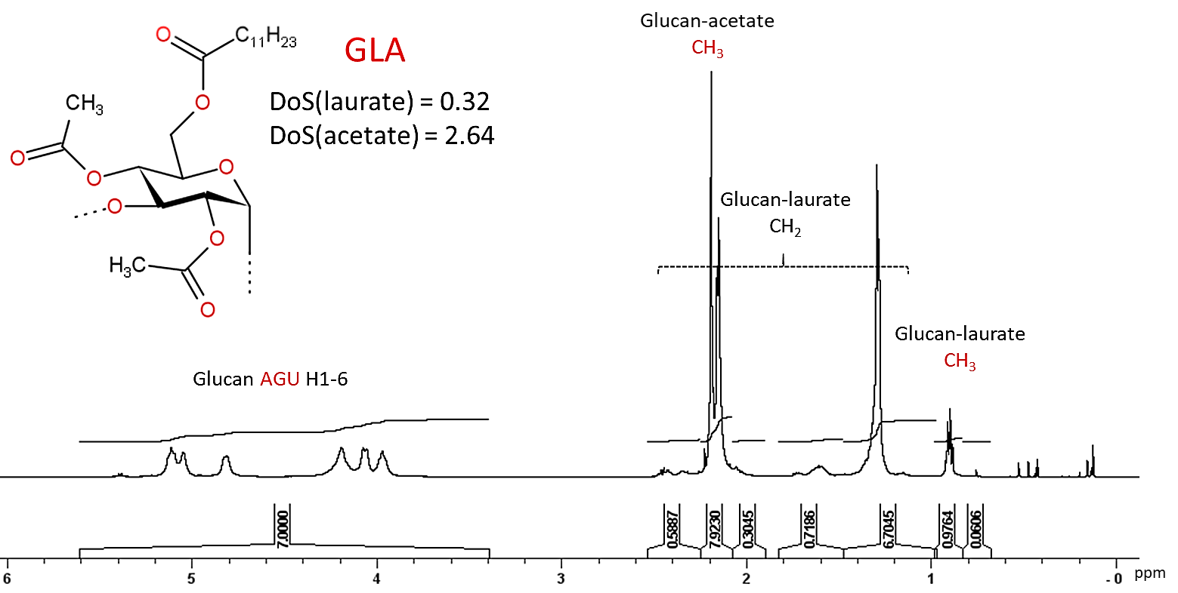
(b)
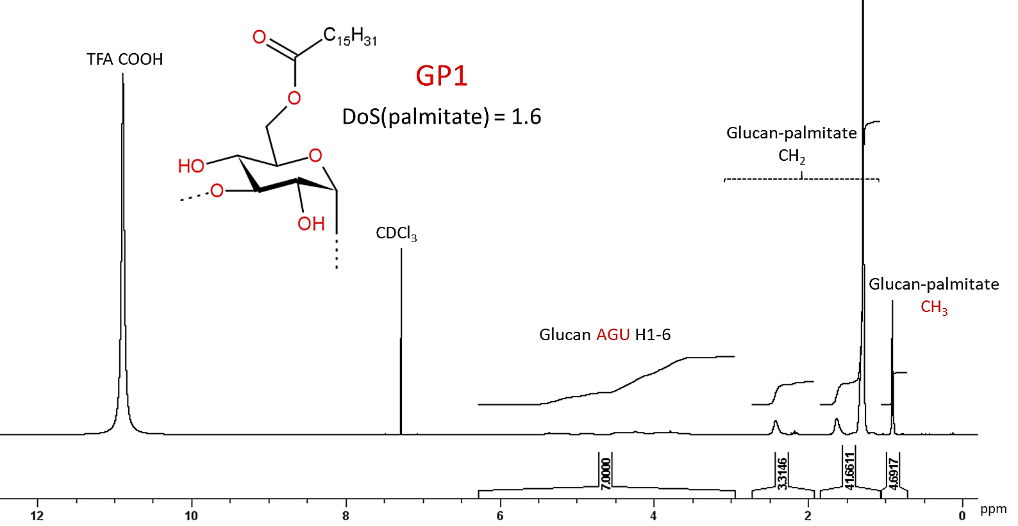
(c)
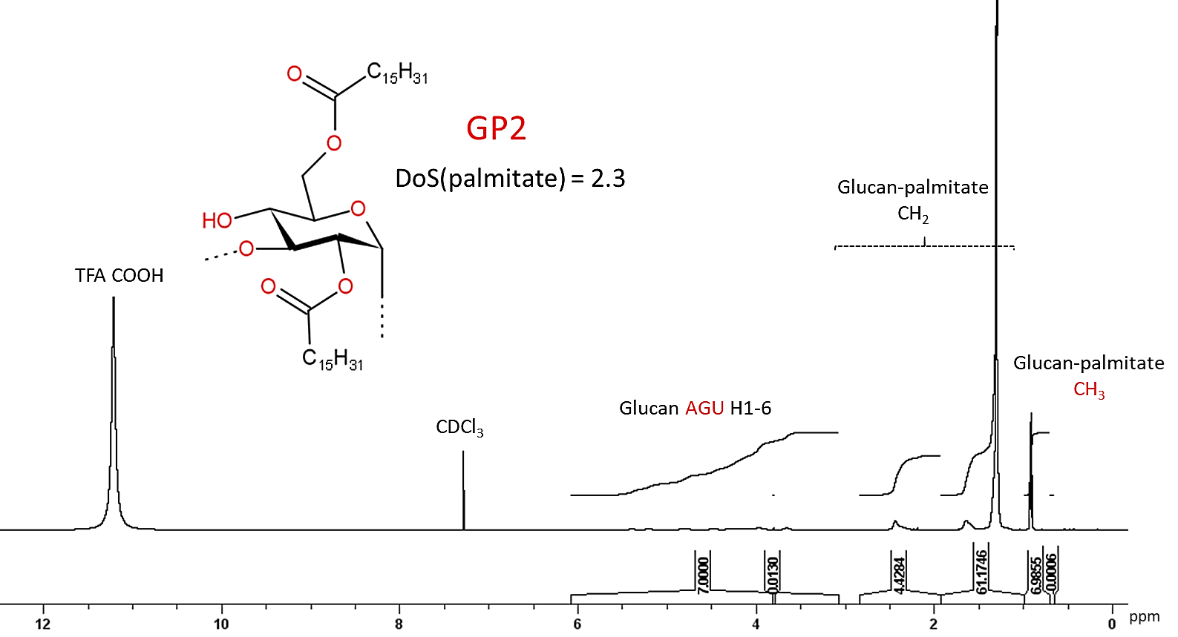
(d)
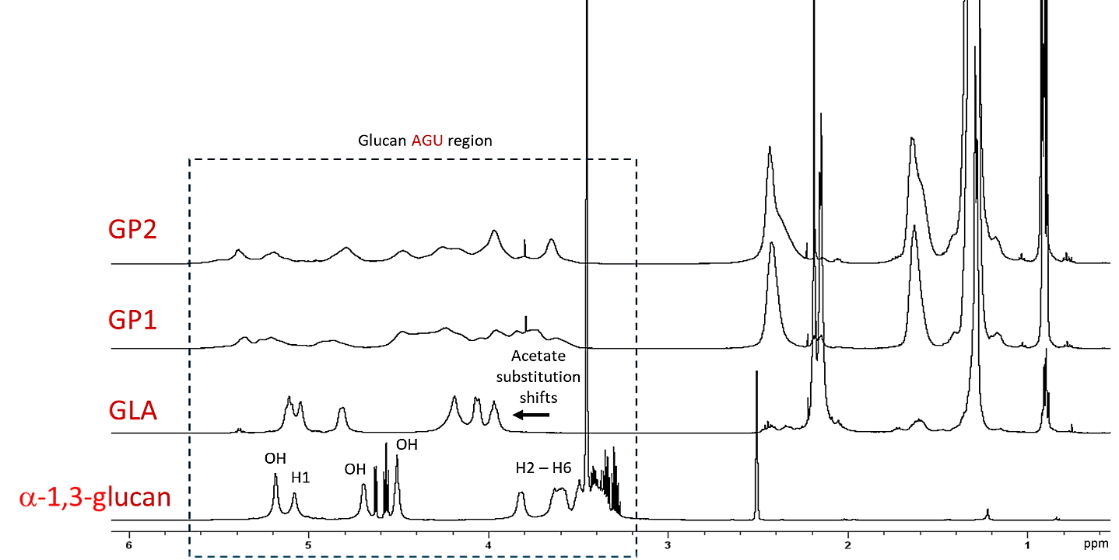
(e)
Figure S1. (a) Stack of ¹³C NMR spectra of α-1,3-glucan recorded in dimethyl sulfoxide-d₆ and lithium chloride (DMSO-d₆/LiCl) mixture at 40 °C, and of glucan esters, namely glucan laurate acetate (GLA) and glucan palmitate (GP2), recorded in deuterated chloroform (CDCl₃) at the same temperature; ¹H NMR spectra recorded at 40 °C for glucan esters, namely (b) GLA, (c) GP1, and (d) GP2, in CDCl₃ with addition of two drops of trifluoroacetic acid (TFA) per sample to shift the signals of exchangeable protons. (e) Stack of ¹H NMR spectra for the three glucan esters, compared with unmodified α-1,3-glucan.

The DoS was evaluated from the molar ratio of the substituent to that of the anhydroglucose unit (AGU) of α-1,3-gucan. The molar ratios are obtained from ¹H NMR spectra by integrating areas of the methyl group of the substituent and the entire AGU region respectively. Each area is then divided by the respective number of protons responsible for the signal, corresponding to 3 for the methyl group and to 7 for AGU (hydrogen atoms in positions 1 to 6). The DoS is hence calculated as $\frac{{\int{CH_{3}}}/{\#H_{CH_{3}}}}{{\int{AGU}}/{\#H_{AGU}}}$.
Table S1 reports the peaks used to calculate the DoS for each substituent, together with the area of the peaks.

Table S1. Parameters for calculation of DoS for esters of α-1,3-glucan. The peaks for methyl groups of each substituent (R) and for AGU are reported together with the integral of the corresponding signal.
Material | R | Peak(–CH₃) of R | Integral(–CH₃) | Peaks(AGU) | Integral(AGU)
GLA | –CH₃ | 2.160 | 7.923 | 3.970 - 5.113 | 7.000
GLA | –C₁₁H₂₃ | 0.898 | 0.976 | 3.970 - 5.113 | 7.000
GP1 | –C₁₅H₃₁ | 0.908 | 4.692 | 3.625 – 5.357 | 7.000
GP2 | –C₁₅H₃₁ | 0.916 | 6.986 | 3.651 – 5.502 | 7.000

S2. Calculation of the solubility parameter and its correlation with the C/O functional group ratio
The solubility of a gaseous penetrant can be attributed to the energetic interaction between the polymer and the penetrant (Matteucci et al., 2006). The square root of the cohesive energy density, i.e., the cohesive energy per unit of molar volume, $V_{m}$, otherwise known as Hildebrand solubility parameter $δ$, is a useful way to express the energetic interaction. Formally, the cohesive energy may be divided into three parts, to account for the three types of interaction forces: dispersion forces, $E_{d}$, polar forces, $E_{p}$, and hydrogen bonding energy, $E_{h}$. Thus, the solubility parameter can also be split in three components, $δ_{d}^{2}$,$δ_{p}^{2}$, and $δ_{h}^{2}$, as follows (Krevelen & Nijenhuis, 2009):
$$δ={\left[\frac{E_{d}+E_{p}+E_{h}}{V_{m}}\right]}^{0.5}={\left[δ_{d}^{2}+δ_{p}^{2}+δ_{h}^{2}\right]}^{0.5} Eq.S1$$
While the cohesive energy density for low molecular weight components can be estimated from their enthalpy of vaporisation, the solubility parameter of amorphous polymers is often estimated using group contribution methods. Here, the three components of the solubility parameter were calculated for α-1,3-glucan and its derivatives according to Hoftyzer – Van Krevelen group contribution method (1976), with molar volume estimated using Hoy’s group contribution method (1985) (Krevelen & Nijenhuis, 2009). The Hoftyzer – Van Krevelen method allows to predict the solubility parameter components using the following equations:
$$δ_{d}=\frac{\sum_{i}{F_{d,i} }}{V_{m}} Eq.S2$$
$$δ_{p}=\frac{{\left[\sum_{i}{F_{p,i}^{2}}\right]}^{0.5}}{V_{m}} Eq.S3$$
$$δ_{h}={\left[\frac{\sum_{i}{E_{h,i} }}{V_{m}}\right]}^{0.5} Eq.S4$$

While the molar volume is estimated, according to Hoy, as $V_{m}=\sum_{i}{V_{m,i}}$.
The values of $F_{d,i}$, $F_{p,i}$, $E_{h,i}$, and $V_{m,i}$ for each functional group present in glucan-based materials investigated here are reported in Table S2, together with values of $δ$ and its dispersion, polar, and hydrogen bonding components.

(a) | (b)
Figure S2. (a) Solubility parameter $δ$ and its components and (b) polar component of the solubility parameter, $δ_{p}$, as function of the C/O functional group ratio.

Figure S2a shows how the solubility parameter and its components vary with the C/O functional group ratio for the four polymers investigated here. Figure S2b highlights the inverse proportional correlation between the polar solubility parameter, $δ_{p}$, and $R_{C/O}$, by reporting $δ_{p}$ as a function of the C/O functional group ratio on a log-log scale, where their correlation is linear and can be written as $δ_{p}=18.6 R_{C/O}$ (R² = 0.996).

Table S2. Parameters for calculation of Hildebrand solubility parameter $δ$ and its dispersion, polar, and hydrogen bonding components, $δ_{d}$,$δ_{p}$, and $δ_{h}$, for glucan-based materials investigated in this work. Group contribution components, molar volume of the group, $V_{m,i}$, dispersion force, $F_{d,i}$, polar force, $F_{p,i}$, and hydrogen bonding energy, $E_{h,i}$, are additionally provided.
Structural Group count |  |  |  |  | Components of Group Contribution Method
Group | α-1,3-glucan | GLA | GP1 | GP2 | $$V_{m,i}$$  [cm³/mol] | $$F_{d,i}$$  [MPa^{0.5}/mol] | $$F_{p,i}$$  [MPa^{0.5}/mol] | $$E_{h,i}$$  [J/mol]
–CH₂– | 1 | 4.2 | 23.4 | 33.2 | 15.55 | 270 | 0 | 0
>CH– | 5 | 5 | 5 | 5 | 9.56 | 80 | 0 | 0
–O– | 2 | 2 | 2 | 2 | 6.45 | 100 | 400 | 3000
–OH | 3 | 0.04 | 1.40 | 0.70 | 12.45 | 210 | 500 | 20000
–COO– | 0 | 2.96 | 1.60 | 2.30 | 23.70 | 390 | 490 | 7000
–CH₃ | 0 | 2.96 | 1.60 | 2.30 | 21.55 | 420 | 0 | 0
Ring | 1 | 1 | 1 | 1 | - | 190 | - | -
$V_{m}$ [cm³/mol] | 113.6 | 260.4 | 514.4 | 689.75
$δ_{d}$ [MPa^{0.5}] | 14.9 | 16.6 | 16.9 | 17.1
$δ_{p}$ [MPa^{0.5}] | 15.0 | 6.4 | 2.6 | 2.1
$δ_{h}$ [MPa^{0.5}] | 24.1 | 10.3 | 9.4 | 7.2
$δ$ [MPa^{0.5}] | 32.0 | 20.6 | 19.5 | 18.6

S3. Diffusivity analysis in liquid and gas sorption
Both liquid and gas sorption in a film of thickness $l$ can be evaluated from the sorption transient by considering Fickian diffusion (Crank, 1979). The main difference between using Fick’s second law for the two cases lies in different boundary conditions used.
Water diffusion coefficient, $D_{W}$, is evaluated assuming constant concentration of the penetrant at the membrane interface. The moisture uptake $m_{W}\left(t\right)$ can be expressed as function of the average water diffusivity $D_{W}$ and sample thickness $l$ as follows:
$$\frac{m_{W}(t)-m_{W}(0)}{m_{W,eq}-m_{W}(0)}= 1- \sum_{n=0}^{∞}{\frac{8}{{\left(2n+1\right)}^{2}π^{2}}\exp\left\{-D_{W}\frac{{\left(n+0.5\right)}^{2}π^{2}t}{{\left(0.5 l\right)}^{2}}\right\} } Eq.S5$$
where $m_{W}(0)$ and $m_{W,eq}$ are the mass uptakes at time $t=0$ (initial uptake) and at time $t=∞$ (equilibrium uptake), respectively. The initial uptake is generally equal to 0, as in the present case. An example of the sorption curve and its fitting to Eq. S5 is shown in Figure S3a.
When the penetrant is gaseous, it is necessary to account for the variation of penetrant concentration at the film interface during sorption. Indeed, given limited volume of the sorption cell, the concentration at the interface is gradually decreasing as penetrant is absorbed from the bulk into the film. The penetrant diffusivity in the film, $D$, can be evaluated at each sorption step, and gas uptake $m\left(t\right)$ can be expressed as function of the average gas diffusivity per step and sample thickness as follows:
$$\frac{m\left(t\right)-m(0)}{m_{eq}-m(0)}=1-\sum_{n=1}^{∞}{\frac{2α\left(1+α\right)}{1+α+α^{2}q_{n}^{2}}\exp\left\{-D\frac{q_{n}^{2}t}{(0.5{ l)}^{2}}\right\} } Eq.S6$$
where $m(0)$ and $m_{eq}$ are the mass uptakes at time $t=0$ (initial uptake) and at time $t=∞$ (equilibrium uptake), respectively. The initial uptake is equal to 0 in the first step, and as equilibrium uptake of step $i-1$ for the step $i$. The parameter $α$ is the ratio between the volume of solution and that of the membrane, corrected for the partition coefficient of penetrant between the gaseous phase and the polymer, while $q_{n}$ variables are the positive, nonzero, solutions of the equation: $tg\left(q_{n}\right)=-α{ q}_{n}$. An example of CO₂ sorption curve and its fitting to Eq. S6 is shown in Figure S3b.

(a) | (b)
Figure S3. (a) Example of the output from the gravimetric liquid water sorption measurement, with experimental data fitted according to Fick’s law (Eq. S5). (b) Example of the CO₂ sorption curve, with experimental data fitted according to Eq. S6.

S4. TGA/DSC analysis
TGA/DSC heat flow measurements were performed using the STARe System TGA/DSC 3+ (Mettler Toledo). Samples of ~10 mg were heated from 25 °C to 250 °C at 10 °C/min rate in N₂ atmosphere.

(a) | (b)
Figure S4. (a) Thermal gravimetric analysis (TGA) and (b) differential scanning calorimetry (DSC) profiles for glucan-based materials investigated in this work.

S5. Derivation of CO₂/O₂ upper bound
Polymer membrane materials present an intrinsic trade-off between permeability and selectivity, where highly permeable materials generally offer poor selectivity and vice versa. This can be graphically displayed on an Upper Bound plot where the logarithm of selectivity is reported as function of the logarithm of the permeability of the most-permeable gas. The Robeson Upper Bound, the semi-empirical trade-off, is then the upper limit below virtually all polymeric membrane performance lies (Robeson, 2008).
According to Robeson, the permeability of the more permeable gas $i$ can be expressed as function of its permselectivity $α_{i/j}$ towards another gas $j$ as follows:
$$P_{i}=k_{i/j}α_{i/j}^{n_{i/j}} Eq.S7$$
where $k_{i/j}$ is the “front factor” indicating the position of the upper bound, while $n_{i/j}$ is the slope of the upper bound on the log-log plot and is correlated to the kinetic diameters of the gas molecules.
Here, we derived the CO₂/O₂ upper bound based on CO₂/N₂ and O₂/N₂ upper bounds from 2008 (Robeson, 2008), that can be described as follows:
$$P_{CO_{2}}=k_{{CO_{2}}/{N_{2}}}α_{{CO_{2}}/{N_{2}}}^{n_{{CO_{2}}/{N_{2}}}}=30967000α_{{CO_{2}}/{N_{2}}}^{-2.888} Eq.S8$$
$$P_{O_{2}}=k_{{O_{2}}/{N_{2}}}α_{{CO_{2}}/{N_{2}}}^{n_{{CO_{2}}/{N_{2}}}}=1396000α_{{O_{2}}/{N_{2}}}^{-5.666} Eq.S9$$
In order to derive the CO₂/O₂ upper bound the following steps have been followed:
- Given a range of $α_{{CO_{2}}/{N_{2}}}$, the corresponding $P_{CO_{2}}$ is calculated using the CO₂/N₂ upper bound (Eq. S8);
- The permeability of N₂, corresponding to values of $P_{CO_{2}}$, is then calculated as $P_{N_{2}}=k_{{CO_{2}}/{N_{2}}}α_{{CO_{2}}/{N_{2}}}^{(n_{{CO_{2}}/{N_{2}}}-1)}$ according to the CO₂/N₂ upper bound correlation (Eq. S8);
- The permeability of N₂ can be expressed as function of $P_{CO_{2}}$ and, analogously, as function of $P_{O_{2}}$ according to the O₂/N₂ upper bound (Eq. S9), as follows: $P_{N_{2}}=k_{{{CO}_{2}}/{N_{2}}}^{\frac{1}{n_{{{CO}_{2}}/{N_{2}}}}}P_{{CO}_{2}}^{\frac{n_{C{O_{2}}/{N_{2}}}-1}{n_{{{CO}_{2}}/{N_{2}}}}}=k_{{O_{2}}/{N_{2}}}^{\frac{1}{n_{{O_{2}}/{N_{2}}}}}P_{O_{2}}^{\frac{n_{{O_{2}}/{N_{2}}}-1}{n_{{O_{2}}/{N_{2}}}}}$.
- At this point, the permeability of O₂, corresponding to the values of $P_{N_{2}}$, can be calculated according to the O₂/N₂ upper bound (Eq. S9): $P_{O_{2}}=k_{{O_{2}}/{N_{2}}}^{-\frac{1}{n_{{O_{2}}/{N_{2}}}-1}}P_{O_{2}}^{\frac{n_{{O_{2}}/{N_{2}}}}{n_{{O_{2}}/{N_{2}}}-1}}$;
- The calculated $P_{O_{2}}$ corresponds to the values of $P_{CO_{2}}$ obtained in step 1. Thus, $α_{{CO_{2}}/{O_{2}}}$ can now be calculated as the ratio between the two permeabilities;
- $P_{CO_{2}}$ is plotted as a function of $α_{{CO_{2}}/{O_{2}}}$ on a log-log plot and the power correlation is used to extract $k_{{CO_{2}}/{O_{2}}}$ and $n_{{CO_{2}}/{O_{2}}}$;
- According to the 2008 CO₂/N₂ and O₂/N₂ upper bounds, $k_{{CO_{2}}/{O_{2}}}=776623860$ Barrer and $n_{{CO_{2}}/{O_{2}}}=-6.93$.

References
Crank, J. (1979). The Mathematics of Diffusion. Oxford University Press.
Krevelen, D. W. van, & Nijenhuis, K. te. (2009). Properties of polymers: Their correlation with chemical structure: their numerical estimation and prediction from additive group contributions (4th, completely rev. ed ed.). Elsevier.
Matteucci, S., Yampolskii, Y., Freeman, B. D., & Pinnau, I. (2006). Transport of Gases and Vapors in Glassy and Rubbery Polymers. In Y. Yampolskii, I. Pinnau, & B. Freeman (Eds.), Materials Science of Membranes for Gas and Vapor Separation (1st ed., pp. 1–47). Wiley. https://doi.org/10.1002/047002903X.ch1
Robeson, L. M. (2008). The upper bound revisited. Journal of Membrane Science, 320(1–2), 390–400. https://doi.org/10.1016/j.memsci.2008.04.030

