Supplement

Figure S1. Proportion of ECG’s, in the original dataset, recorded at various times prior to their presenting SCA event.

Figure S2. Time from ECG acquisition to emergency department visit for controls.

Figure S3. Proportion of presenting SCA rhythms in the original dataset.

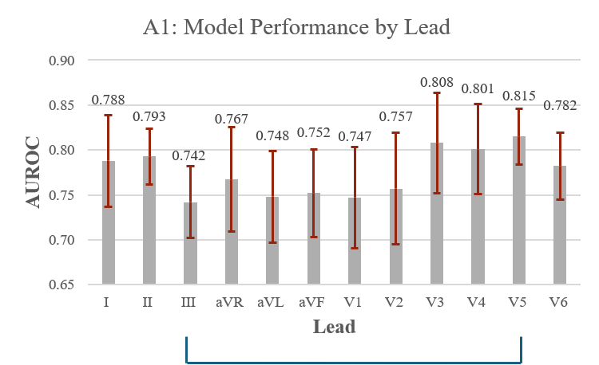
Figure S4. Model A1 performance by lead with significant differences. III ≠ V5

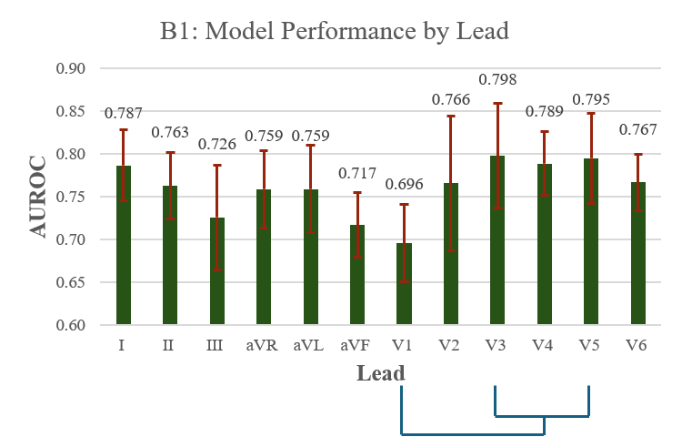
Figure S5. Model B1 performance by lead with significant differences. V1 ≠ (V3, V4, and V5)

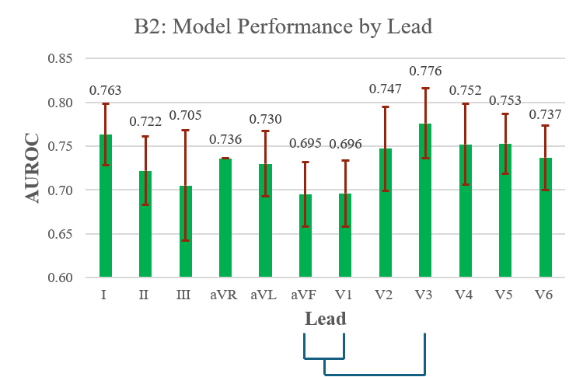
Figure S6. Model B2 performance by lead with significant differences. V3 ≠ (aVF and V1)

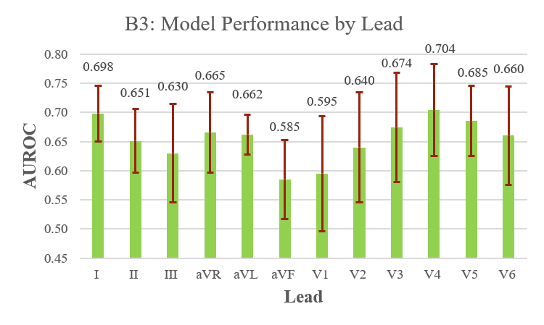
Figure S7. Model B3 performance by lead with no significant differences.

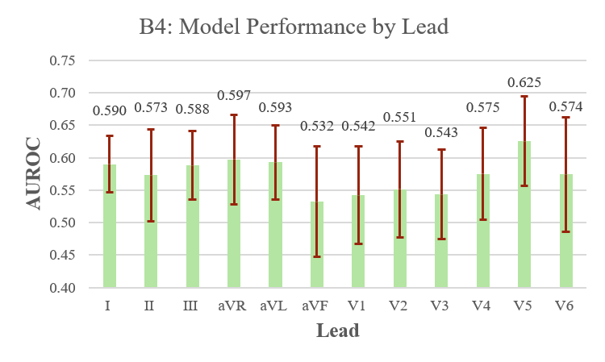
Figure S8. Model B4 performance by lead with no significant differences.

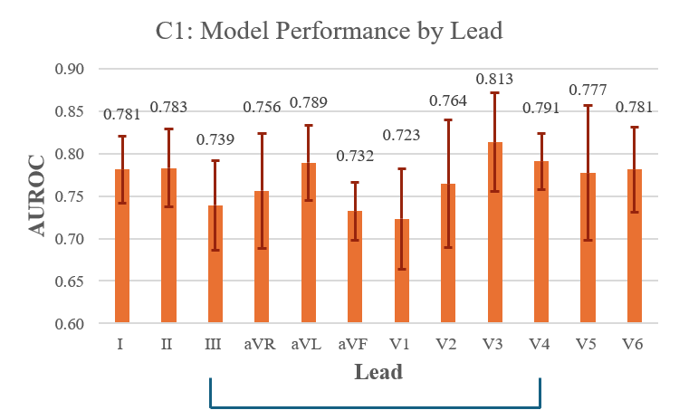
Figure S9. Model C1 performance by lead with significant differences. III ≠ V4

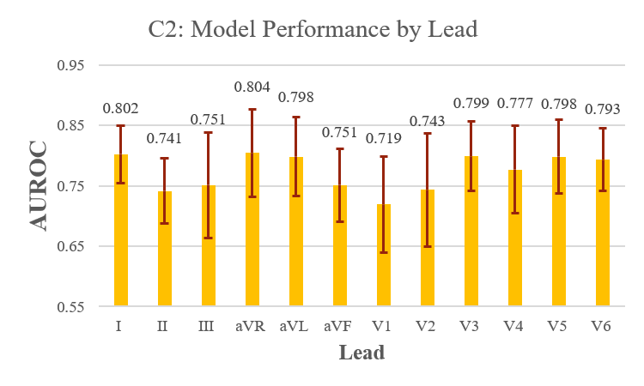
Figure S10. Model C2 performance by lead with no significant differences.

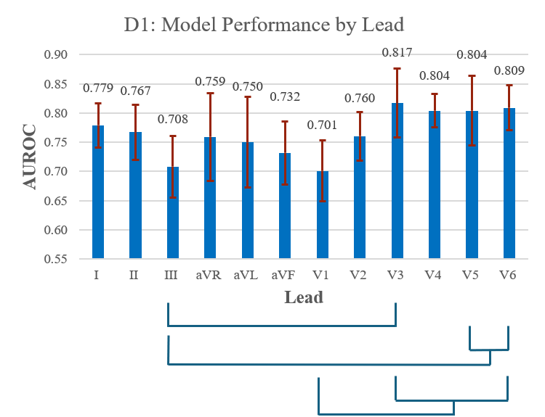
Figure S11. Model D1 performance by lead with significant differences. III ≠ (V3, V5, and V6); V1 ≠ (V3, V4, V5, and V6)

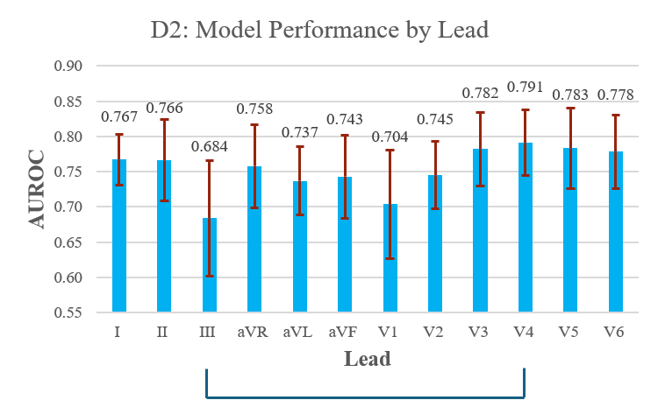
Figure S12. Model D2 performance by lead. III ≠ V4

Table S1: Measures of performance for each lead for patients with ECG prior to arrest and without age and sex, with sensitivity fixed at 95%. Values are reported as mean (standard deviation).
A1 | Lead | Accuracy [%] | F1 [%] | PPV [%] | NPV [%] | Specificity [%]
A1 | I | 86.0 (2.8) | 91.9 (1.8) | 89.1 (3.2) | 57.6 (12.6) | 39.6 (13.8)
A1 | II | 85.6 (1.4) | 91.7 (1.0) | 88.5 (1.9) | 57.0 (12.5) | 36.1 (10.4)
A1 | III | 84.2 (1.9) | 91.0 (1.3) | 87.2 (2.5) | 47.5 (17.3) | 26.0 (10.6)
A1 | aVR | 84.8 (2.8) | 91.3 (1.7) | 87.9 (3.0) | 52.3 (15.3) | 31.4 (14.9)
A1 | aVL | 85.5 (1.3) | 91.6 (0.9) | 88.5 (1.7) | 54.7 (16.9) | 34.5 (12.6)
A1 | aVF | 84.2 (2.2) | 90.9 (1.5) | 87.2 (2.7) | 50.3 (12.3) | 27.5 (8.6)
A1 | V1 | 84.3 (1.7) | 91.0 (1.2) | 87.4 (2.3) | 49.2 (13.7) | 27.0 (8.4)
A1 | V2 | 84.4 (2.9) | 91.1 (1.8) | 87.5 (3.3) | 49.6 (14.1) | 28.1 (11.9)
A1 | V3 | 86.1 (2.9) | 92.0 (1.8) | 89.1 (3.4) | 58.3 (9.4) | 39.1 (11.5)
A1 | V4 | 85.9 (3.0) | 91.9 (1.9) | 89.0 (3.6) | 57.5 (8.6) | 38.1 (11.5)
A1 | V5 | 86.5 (2.7) | 92.2 (1.7) | 89.5 (3.1) | 59.6 (12.5) | 41.7 (13.7)
A1 | V6 | 84.0 (2.7) | 90.9 (1.7) | 87.1 (3.2) | 48.9 (14.3) | 26.8 (9.4)

Table S2: Measures of performance for each lead for patients with ECG within one week of arrest, with sensitivity fixed at 95%. Values are reported as mean (standard deviation).
B1 | Lead | Accuracy [%] | F1 [%] | PPV [%] | NPV [%] | Specificity [%]
B1 | I | 82.7 (2.6) | 89.9 (1.6) | 85.2 (2.9) | 57.0 (15.6) | 30.8 (12.2)
B1 | II | 82.5 (2.2) | 89.7 (1.5) | 85.0 (2.8) | 59.7 (6.5) | 31.0 (4.3)
B1 | III | 81.5 (1.1) | 89.3 (0.7) | 84.2 (1.4) | 48.2 (22.4) | 23.0 (12.1)
B1 | aVR | 82.1 (2.9) | 89.5 (1.8) | 84.6 (3.2) | 56.4 (10.7) | 28.5 (9.7)
B1 | aVL | 81.5 (1.5) | 89.2 (1.0) | 84.1 (1.9) | 50.7 (17.2) | 23.9 (10.9)
B1 | aVF | 81.0 (2.3) | 88.9 (1.5) | 83.6 (2.7) | 49.4 (14.6) | 22.2 (9.4)
B1 | V1 | 81.1 (2.0) | 89.0 (1.4) | 83.7 (2.6) | 50.6 (8.3) | 21.9 (3.3)
B1 | V2 | 82.1 (2.2) | 89.6 (1.5) | 84.7 (2.7) | 54.7 (11.4) | 26.9 (7.4)
B1 | V3 | 83.1 (3.7) | 90.1 (2.2) | 85.7 (4.0) | 58.6 (9.9) | 32.8 (12.4)
B1 | V4 | 82.6 (3.5) | 89.8 (2.1) | 85.2 (3.9) | 57.0 (9.9) | 30.4 (9.9)
B1 | V5 | 83.7 (3.7) | 90.4 (2.2) | 86.3 (4.0) | 60.8 (12.6) | 36.4 (15.6)
B1 | V6 | 82.0 (3.2) | 89.5 (2.0) | 84.6 (3.5) | 53.3 (16.6) | 27.2 (12.9)

Table S3: Measures of performance for each lead for patients with ECG within one month of arrest, with sensitivity fixed at 95%. Values are reported as mean (standard deviation).
B2 | Lead | Accuracy [%] | F1 [%] | PPV [%] | NPV [%] | Specificity [%]
B2 | I | 79.8 (1.9) | 87.9 (1.2) | 81.7 (2.1) | 60.4 (13.3) | 27.9 (9.4)
B2 | II | 78.6 (2.7) | 87.2 (1.8) | 80.6 (3.1) | 58.5 (5.8) | 24.0 (4.6)
B2 | III | 79.0 (1.2) | 87.5 (0.9) | 81.0 (1.6) | 56.3 (14.5) | 23.7 (8.5)
B2 | aVR | 79.2 (2.5) | 87.5 (1.6) | 81.2 (2.7) | 59.4 (10.3) | 26.1 (8.2)
B2 | aVL | 78.6 (2.5) | 87.3 (1.7) | 80.3 (2.3) | 49.3 (23.8) | 20.4 (12.5)
B2 | aVF | 78.2 (2.4) | 87.0 (1.6) | 80.3 (2.9) | 55.5 (7.7) | 21.6 (5.4)
B2 | V1 | 77.9 (2.5) | 86.9 (1.7) | 80.1 (3.0) | 53.0 (9.6) | 19.9 (5.6)
B2 | V2 | 79.3 (3.4) | 87.7 (2.1) | 81.4 (3.6) | 58.2 (10.8) | 25.8 (10.3)
B2 | V3 | 80.4 (2.9) | 88.2 (1.7) | 82.3 (3.0) | 61.2 (12.1) | 29.9 (11.9)
B2 | V4 | 80.2 (2.9) | 88.1 (1.7) | 82.2 (3.1) | 60.8 (12.6) | 29.4 (11.2)
B2 | V5 | 79.9 (3.1) | 87.9 (2.0) | 81.8 (3.6) | 62.2 (6.7) | 29.0 (8.7)
B2 | V6 | 79.5 (2.5) | 87.7 (1.6) | 81.4 (3.0) | 60.3 (8.7) | 26.9 (7.8)

Table S4: Measures of performance for each lead for patients with ECG between one day and one month of arrest, with sensitivity fixed at 95%. Values are reported as mean (standard deviation).
B3 | Lead | Accuracy [%] | F1 [%] | PPV [%] | NPV [%] | Specificity [%]
B3 | I | 87.8 (1.6) | 93.4 (1.0) | 91.8 (1.9) | 25.4 (13.6) | 16.7 (8.1)
B3 | II | 87.3 (2.3) | 93.1 (1.4) | 91.3 (2.7) | 19.0 (12.3) | 12.5 (9.3)
B3 | III | 87.2 (1.8) | 93.1 (1.1) | 91.2 (2.0) | 16.5 (16.5) | 9.8 (9.5)
B3 | aVR | 88.0 (1.6) | 93.5 (1.0) | 92.0 (1.9) | 26.9 (14.8) | 18.5 (9.3)
B3 | aVL | 87.5 (3.3) | 93.2 (1.9) | 91.0 (2.9) | 13.6 (14.5) | 9.2 (9.8)
B3 | aVF | 87.2 (1.7) | 93.1 (1.0) | 91.2 (2.0) | 16.9 (16.3) | 9.8 (8.5)
B3 | V1 | 87.3 (2.5) | 93.1 (1.4) | 91.3 (2.8) | 17.2 (14.5) | 11.8 (12.8)
B3 | V2 | 87.8 (2.0) | 93.3 (1.2) | 91.7 (2.3) | 24.7 (13.9) | 16.6 (9.2)
B3 | V3 | 87.6 (2.0) | 93.2 (1.2) | 91.5 (2.4) | 22.8 (11.2) | 14.6 (7.3)
B3 | V4 | 87.9 (1.9) | 93.4 (1.1) | 91.9 (2.2) | 25.6 (14.9) | 17.9 (12.0)
B3 | V5 | 87.8 (2.4) | 93.4 (1.4) | 91.8 (2.7) | 25.1 (13.1) | 18.1 (11.8)
B3 | V6 | 87.9 (2.1) | 93.4 (1.2) | 91.9 (2.4) | 26.4 (13.5) | 18.5 (10.6)

Table S5: Measures of performance for each lead for patients with ECG between one month and one year of arrest, with sensitivity fixed at 95%. Values are reported as mean (standard deviation).
B4 | Lead | Accuracy [%] | F1 [%] | PPV [%] | NPV [%] | Specificity [%]
B4 | I | 83.6 (2.6) | 90.9 (1.6) | 86.7 (2.8) | 22.1 (18.7) | 10.9 (9.8)
B4 | II | 83.2 (1.8) | 90.7 (1.1) | 86.4 (2.4) | 19.0 (15.4) | 8.3 (7.2)
B4 | III | 83.4 (2.6) | 90.8 (1.5) | 86.9 (2.9) | 27.4 (15.2) | 13.4 (8.3)
B4 | aVR | 83.1 (1.7) | 90.6 (1.1) | 86.5 (2.1) | 24.8 (10.8) | 9.9 (4.0)
B4 | aVL | 83.9 (1.5) | 91.0 (0.9) | 86.9 (2.0) | 26.3 (18.6) | 12.2 (9.4)
B4 | aVF | 82.5 (1.9) | 90.3 (1.2) | 86.0 (2.3) | 15.7 (14.2) | 6.3 (5.8)
B4 | V1 | 82.6 (2.7) | 90.4 (1.6) | 86.2 (3.0) | 16.9 (12.5) | 7.8 (7.1)
B4 | V2 | 83.5 (2.0) | 90.8 (1.2) | 86.9 (2.3) | 27.5 (17.5) | 12.9 (10.2)
B4 | V3 | 83.2 (1.3) | 90.7 (0.8) | 86.7 (1.7) | 25.1 (16.4) | 10.6 (7.2)
B4 | V4 | 83.4 (2.6) | 90.7 (1.5) | 86.8 (2.8) | 26.9 (15.6) | 12.8 (9.9)
B4 | V5 | 84.1 (2.0) | 91.1 (1.2) | 87.5 (2.3) | 34.2 (15.0) | 17.2 (9.4)
B4 | V6 | 83.1 (2.2) | 90.6 (1.3) | 86.6 (2.5) | 23.3 (14.6) | 10.5 (9.0)

Table S6: Measures of performance for each lead for patients with ECG within one day of PEA and asystole arrests, with sensitivity fixed at 95%. Values are reported as mean (standard deviation).
C1 | Lead | Accuracy [%] | F1 [%] | PPV [%] | NPV [%] | Specificity [%]
C1 | I | 88.1 (2.2) | 93.3 (1.4) | 91.7 (2.6) | 49.2 (15.4) | 37.7 (15.3)
C1 | II | 87.6 (2.1) | 93.0 (1.4) | 91.1 (2.7) | 48.4 (9.1) | 34.4 (6.0)
C1 | III | 87.3 (1.8) | 92.9 (1.2) | 90.9 (2.3) | 46.0 (13.0) | 31.5 (8.0)
C1 | aVR | 87.5 (3.4) | 93.0 (2.0) | 91.1 (3.8) | 46.6 (16.3) | 35.1 (17.0)
C1 | aVL | 87.7 (1.5) | 93.1 (1.0) | 91.3 (2.0) | 48.1 (13.9) | 34.6 (9.5)
C1 | aVF | 86.6 (2.0) | 92.5 (1.3) | 90.2 (2.6) | 40.3 (12.7) | 25.4 (8.5)
C1 | V1 | 86.7 (2.5) | 92.6 (1.5) | 90.3 (3.0) | 41.5 (13.4) | 26.8 (9.4)
C1 | V2 | 86.8 (3.2) | 92.6 (1.9) | 90.4 (3.6) | 42.2 (11.7) | 28.3 (14.0)
C1 | V3 | 87.7 (3.4) | 93.1 (2.0) | 91.3 (3.9) | 47.5 (12.1) | 35.9 (18.0)
C1 | V4 | 87.7 (2.2) | 93.1 (1.4) | 91.3 (2.8) | 49.2 (9.0) | 35.6 (4.8)
C1 | V5 | 87.6 (3.1) | 93.0 (1.9) | 91.2 (3.6) | 47.3 (10.7) | 35.1 (14.1)
C1 | V6 | 87.9 (2.3) | 93.2 (1.5) | 91.5 (2.8) | 48.5 (15.1) | 36.6 (12.8)

Table S7: Measures of performance for each lead for patients with ECG within one day of PEA arrests, with sensitivity fixed at 95%. Values are reported as mean (standard deviation).
C2 | Lead | Accuracy [%] | F1 [%] | PPV [%] | NPV [%] | Specificity [%]
C2 | I | 90.1 (2.1) | 94.6 (1.3) | 94.1 (2.5) | 42.9 (10.6) | 40.5 (12.9)
C2 | II | 89.5 (1.9) | 94.3 (1.1) | 93.5 (2.3) | 38.8 (9.8) | 33.4 (6.3)
C2 | III | 89.1 (1.6) | 94.1 (1.0) | 93.2 (2.0) | 31.5 (22.3) | 26.1 (18.6)
C2 | aVR | 90.1 (3.3) | 94.5 (1.9) | 94.1 (3.7) | 43.0 (9.7) | 43.6 (19.7)
C2 | aVL | 89.9 (1.6) | 94.5 (1.0) | 93.9 (2.0) | 40.3 (13.7) | 36.3 (11.2)
C2 | aVF | 89.1 (2.4) | 94.1 (1.4) | 93.2 (2.8) | 35.3 (11.3) | 29.9 (11.0)
C2 | V1 | 89.1 (2.4) | 94.0 (1.4) | 93.1 (2.8) | 34.9 (11.5) | 29.1 (12.1)
C2 | V2 | 88.8 (2.6) | 93.9 (1.5) | 92.8 (2.9) | 31.6 (14.2) | 25.9 (15.0)
C2 | V3 | 89.8 (2.8) | 94.4 (1.6) | 93.8 (3.2) | 41.2 (8.4) | 39.4 (18.3)
C2 | V4 | 89.7 (2.5) | 94.4 (1.5) | 93.7 (2.9) | 40.0 (12.2) | 37.1 (14.0)
C2 | V5 | 89.8 (2.6) | 94.4 (1.5) | 93.8 (3.1) | 40.5 (10.6) | 38.0 (15.1)
C2 | V6 | 90.0 (2.0) | 94.5 (1.2) | 94.0 (2.4) | 41.4 (13.9) | 38.5 (14.0)

Table S8: Measures of performance for each lead for patients with ECG within one day of arrest and a 600ms time window around the R wave, with sensitivity fixed at 95%. Values are reported as mean (standard deviation).
D1 | Lead | Accuracy [%] | F1 [%] | PPV [%] | NPV [%] | Specificity [%]
D1 | I | 84.1 (3.8) | 90.9 (2.3) | 87.2 (4.2) | 50.1 (12) | 28.8 (11.4)
D1 | II | 84.4 (2.1) | 91.0 (1.4) | 87.4 (2.6) | 51.3 (16.5) | 29.5 (11.4)
D1 | III | 83.3 (2.0) | 90.5 (1.3) | 86.4 (2.5) | 40.5 (20.6) | 20.1 (10.8)
D1 | aVR | 84.4 (4.0) | 91.1 (2.3) | 87.5 (4.3) | 49.0 (19.3) | 30.1 (19.9)
D1 | aVL | 84.9 (2.1) | 91.3 (1.4) | 87.9 (2.5) | 52.8 (16.6) | 31.5 (10.6)
D1 | aVF | 83.5 (2.7) | 90.6 (1.8) | 86.5 (3.2) | 45.1 (18.1) | 23.4 (10.3)
D1 | V1 | 84.2 (3.6) | 91.0 (2.2) | 87.3 (4.1) | 49.6 (11.4) | 28.3 (11.4)
D1 | V2 | 84.3 (2.7) | 91.0 (1.7) | 87.4 (3.2) | 49.3 (12.7) | 27.6 (10.3)
D1 | V3 | 86.2 (4.3) | 92.0 (2.5) | 89.3 (4.7) | 58.0 (10.4) | 41.0 (15.9)
D1 | V4 | 86.1 (2.2) | 92.0 (1.4) | 89.1 (2.7) | 58.2 (9.1) | 38.3 (7.6)
D1 | V5 | 85.9 (2.6) | 91.9 (1.7) | 88.9 (3.2) | 58.5 (9.5) | 38.6 (9.7)
D1 | V6 | 85.0 (2.6) | 91.3 (1.6) | 88.0 (3.0) | 53.9 (11.4) | 32.2 (9.2)

Table S9: Measures of performance for each lead for patients with ECG within one day of arrest and a 500ms time window around the R wave, with sensitivity fixed at 95%. Values are reported as mean (standard deviation).
D2 | Lead | Accuracy [%] | F1 [%] | PPV [%] | NPV [%] | Specificity [%]
D2 | I | 84.6 (2.7) | 91.1 (1.7) | 87.6 (3.2) | 53.1 (9.4) | 30.3 (6.6)
D2 | II | 83.9 (3.2) | 90.8 (2.0) | 86.9 (3.7) | 50.3 (10.7) | 27.6 (12.1)
D2 | III | 82.7 (2.9) | 90.2 (1.8) | 85.9 (3.4) | 37.3 (16.5) | 17.7 (10.4)
D2 | aVR | 84.5 (2.9) | 91.1 (1.8) | 87.5 (3.4) | 53.1 (10.4) | 30.6 (9.7)
D2 | aVL | 84.1 (1.9) | 90.9 (1.3) | 87.1 (2.5) | 49.2 (14.2) | 26.6 (9.3)
D2 | aVF | 83.8 (2.9) | 90.7 (1.9) | 86.8 (3.4) | 49.0 (8.4) | 25.9 (7.0)
D2 | V1 | 84.3 (2.9) | 91.0 (1.8) | 87.4 (3.3) | 49.5 (13.0) | 27.8 (10.4)
D2 | V2 | 84.6 (2.5) | 91.2 (1.6) | 87.6 (3.0) | 51.7 (8.9) | 29.3 (6.3)
D2 | V3 | 85.2 (3.1) | 91.5 (1.9) | 88.2 (3.6) | 53.6 (13.5) | 33.3 (13.2)
D2 | V4 | 85.8 (1.9) | 91.8 (1.2) | 88.8 (2.3) | 55.3 (14.7) | 35.7 (11.9)
D2 | V5 | 84.8 (2.1) | 91.3 (1.3) | 87.8 (2.4) | 50.8 (17.1) | 29.8 (13.3)
D2 | V6 | 84.1 (3.3) | 90.9 (2.0) | 87.2 (3.8) | 47.5 (19.5) | 27.5 (15.1)

