Supplementary Information

Enhancing commercial SOFCs fed directly with ethanol through a modified manganite coating

F. Matos de Oliveira^{a,b}, S. Vecino-Mantilla^{b}, Z. Hafsi^{b}, M.V. Barp^{b}, F. D’Acapito^{c}, A. Puri^{c,d}, J. Perezª, E. Ticianelliª and M. Lo Faro^{b*}

ª Instituto de Quimica de São Carlos - USP, Av. Trab. São-carlense, 400, Brazil
^{b} Institute of Advanced Energy Technologies (ITAE) of the Italian National Research Council (CNR), Via Salita S. Lucia sopra Contesse 5, 98126 Messina, Italy
^{c} CNR-IOM Grenoble c/o ESRF 71 Avenue des Martyrs CS 40220 F-38043 Grenoble Cédex 9
^{d} Department of Physics and Astronomy, Alma Mater Studiorum – University of Bologna, 40127 Bologna, Italy

*Corresponding author. Tel.: +39 090 624401; fax: +39 090 624247. E-mail address: lofaro@itae.cnr.it

Figure S1 illustrates the Distribution of Relaxation Times (DRT) calculated using the DRT tool for MATLAB and related to simulated EIS spectra at 800 mV. As indicated by P1-3, there are three main frequency zones. For the H₂ experiment, two peaks were observed, whereas the DRT of experiments conducted in bioethanol showed four peaks, except for the 44-hour experiment which was terminated before completion of the EIS curve. Across all experiments, similar frequencies of P1 and P2 zones were observed, suggesting that one of these zones represents H₂ and/or CO oxidation occurring with similar kinetics in optimised cells and the other represents oxygen reduction. Considering that the reduction of oxygen involves the double number of electrons involved in the oxidation of H₂ and CO, it is normal, but not obvious, to consider that the P1 zone might be related to the oxidation of H₂ and CO, while the P2 zone might be related to the reduction of O₂. The P3 zone is instead primarily responsible for the rest of the oxidation reactions involving ethanol and its intermediates, which changed over time as the partial pressure of molecules within the anode chamber changed.
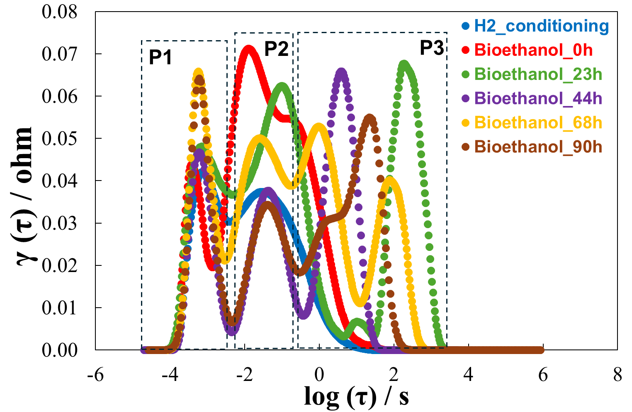
Figure S1. DRT analysis based on the fitted EIS at 800 mV.

