Supporting Information

Hierarchical paclitaxel encapsulation in microbead-embedded microparticles for sustained ovarian cancer therapy
Cristina Chirizzi^{1#,‡}, Francesca Gorini^{2#}, Ilaria Porello^{1#}, Marco Malferrari³, Maila Becconi³, Elisa D’Arrigo³, Francesco Falciani³, Emma Coschina², Stefania Rapino^{3,4}, Anna Myriam Perrone ^{5,6} Pierandrea De Iaco ^{5,6} , Pierangelo Metrangolo¹, Francesca Baldelli Bombelli¹, Gloria Ravegnini^{2,7},Francesco Cellesi^{1*}
Affiliations
¹ Department of Chemistry, Materials, and Chemical Engineering “Giulio Natta”, Politecnico di Milano, Via L. Mancinelli 7, 20131 Milan, Italy
² Department of Pharmacy and Biotechnology (FABIT), University of Bologna, Bologna, 40126, Italy
³Department of Chemistry “Giacomo Ciamician”, University of Bologna, Via Piero Gobetti 85, 40129 Bologna, Italy
⁴ IRCCS Azienda Ospedaliero-Universitaria di Bologna, 40138 Bologna, Italy
⁵ Department of Medical and Surgical Sciences, University of Bologna, Bologna, Italy
⁶ Division of Oncologic Gynecology, IRCCS Azienda Ospedaliero-Universitaria Di Bologna, Bologna, Italy.
⁷ Clinical Pharmacology Unit, IRCCS Azienda Ospedaliero-Universitaria di Bologna - Policlinico di Sant'Orsola
‡Current address: Neuroradiology Unit, Fondazione IRCCS Neurologico Carlo Besta, Milano 20100, Italy.

#Equally contributed.

*To whom correspondence should be addressed. E-mail: francesco.cellesi@polimi.it
Department of Chemistry, Materials, and Chemical Engineering “Giulio Natta”, Politecnico di Milano, Via L. Mancinelli 7, 20131 Milan, Italy.
Phone: +39-02-23993099

a)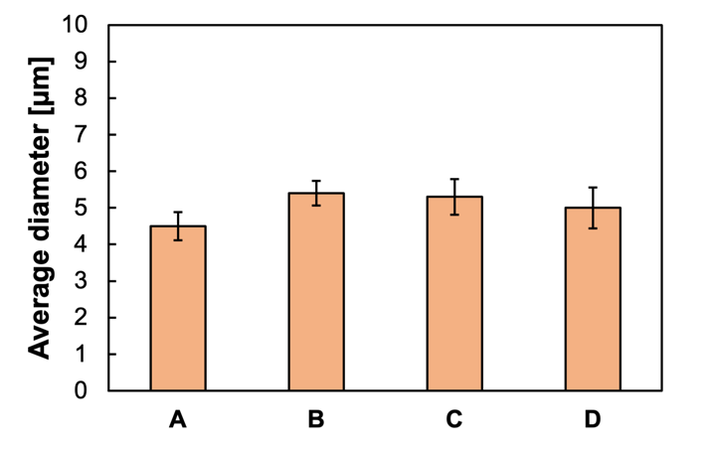 | b)  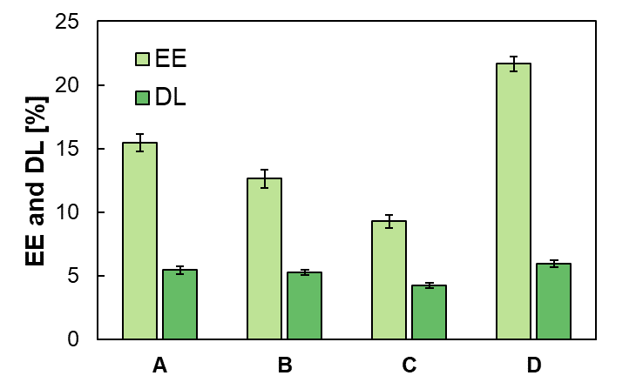
Figure S1. a) Average diameter of PTX-MPs. b) Encapsulation efficiency (EE%) and Drug loading (DL%) of PTX loaded into PLGA MPs. PLGA-MPs were prepared at different weight ratio of ester-terminated PLGA and COOH-terminated PLGA (A - 100:0, B- 75:25, C- 50:50, D- 0:100).

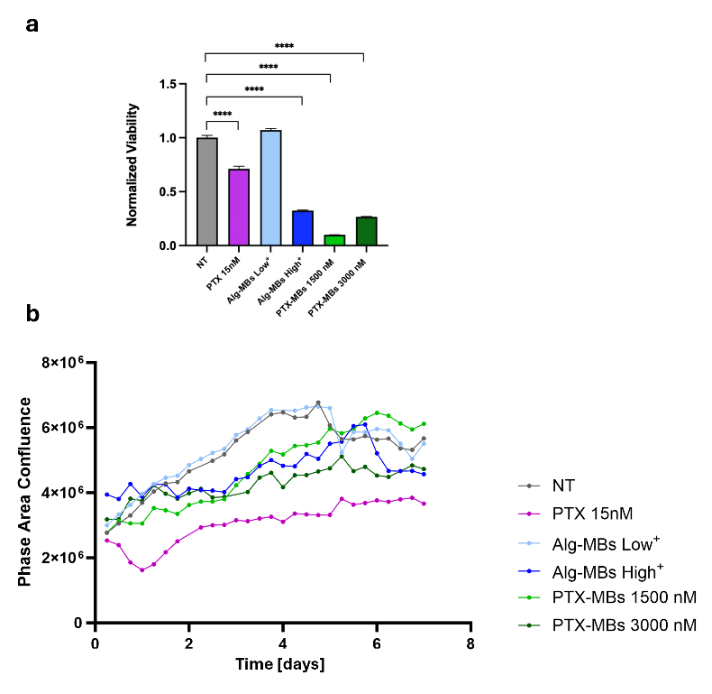
Figure S2. Pharmacological effect of PTX-MBs and Alg-MBs on 2D SKOV-3 model. a) Results obtained through the CTG assay; b) Phase Area Confluence results obtained by IncuCyte S3 (Sartorius). Free PTX at the IC50 (IC50 PTX) concentration was used as positive control; ***p < 0.001, **** p < 0.0001. “NT” (no treatment) indicates cells treated with DMSO (solvent used to resuspend PTX). PLGA-MPs: PLGA microparticles "Low" and "High" refer to the volumes of Alg-MBs used as controls in absence of drug, with "High" representing the maximum volume for the highest PTX concentration, and "Low" representing the minimum volume for the lowest PTX concentration.
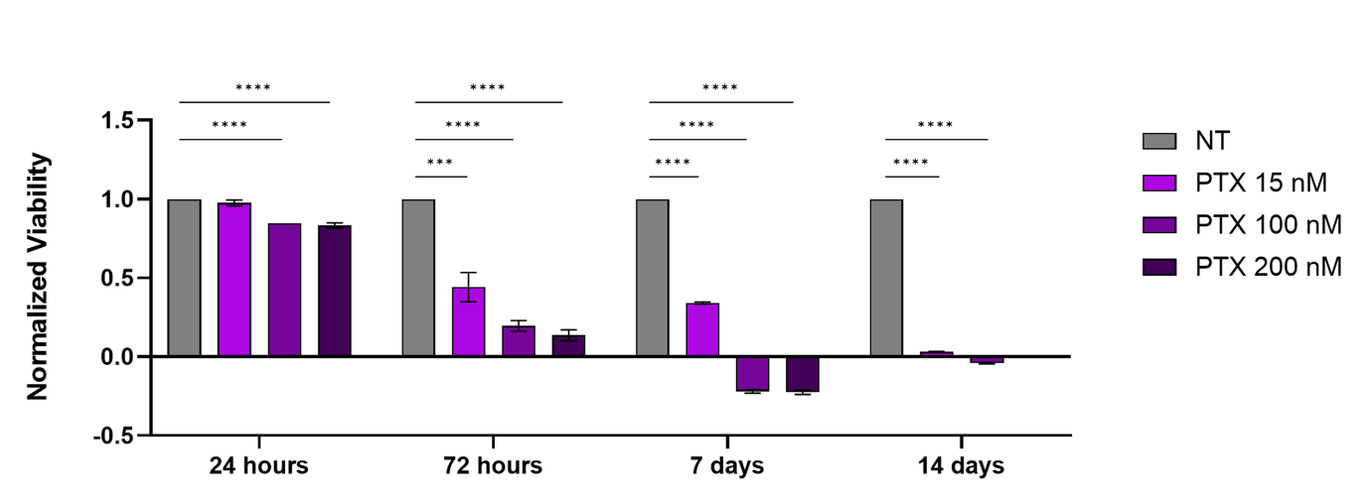
Figure S3. Viability of 3D bioprinted SKOV-3 models after treatment with different concentrations of PTX, at 24 and 72 hours, 7 and 14 days. ***p < 0.001, **** p < 0.0001. “NT” (no treatment) indicates cells treated with DMSO (solvent used to resuspend PTX). PLGA-MPs: PLGA microparticles

