Supporting Information

Population
The final dataset contained 513 chromogenic assay measurements from 16 participants (average of 32.1 measurements per participant) ranging from 4 to 42 years of age (including 2 only observations below the limit of quantification) and a total of 2889 doses (average of 180.6 doses per participant). Figure S1 shows the PK measurements and provides the 5th, 50th and 95th percentiles of the plasminogen activity as a function of time after dose. The characteristics of the population are described in Table 1. Estimation of the missing height led to a median [range] of 161 [104 – 178] cm in the population (handling of the missing values is detailed below). Which was translated in terms of BMI and fat-free mass (FFM) as 26.0 [15.7 – 36.1] kg/m2 and 41.2 [11.0 – 71.2] kg, respectively.

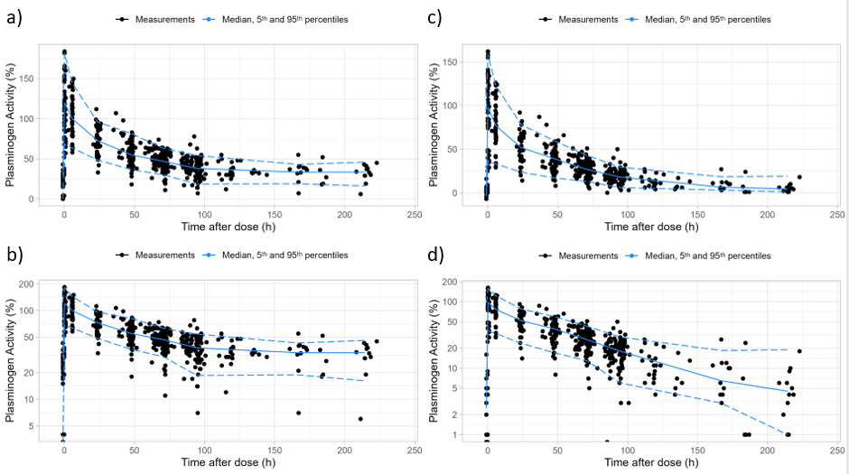
Figure S1: a) Observed plasminogen data on linear scale, and b) on logarithmic scale; c) baseline adjusted plasminogen data on linear scale, and d) on logarithmic scale.

Imputation of missing Height values was performed using a loess regression model of NHANES demographic data describing Height as a function of Age, Body Weight and Gender. The figure below shows on the top plots the recorded body weight of the participants compared to the median and 5-95th percentile range of the NHANES population as a function of Age and Gender; and on the bottom plots the height predicted from the regression compared to the median and 5-95th percentile range of the NHANES population as a function of Age and Gender.

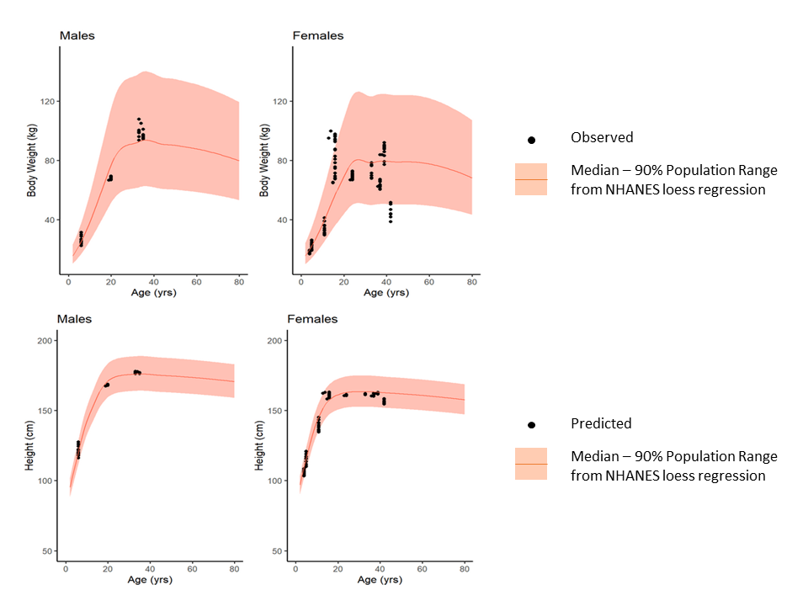
Figure S2: Observed weight and predicted height values of the study population compared to NHANES median and 90% population range. Predicted height values come from NHANES loess regression model describing height as a function of body weight, age and gender.

PopPK Model Development and Evaluations
The structural model selection process was initiated by exploring 1-, 2- and 3-compartment models without Between Subject Variability (BSV). Objective Function Value (OFV) were for 2- and 3-compartment models compared to 1-compartment model. Inclusion of BSV on clearance (CL) and central volume (V1) parameters significantly improved OFV in all structural models (dOFV>600). At that stage, the 2-compartment model with BSV on CL and V1 as well as combined RUV was significantly better than the 1-compartment model and not significantly different from the 3-compartment model with the same BSV and RUV structures. Consequently, the model was kept for testing BSV on Q/V2 parameters. Addition of BSV on V2 alone significantly decreased OFV (dOBJ>35), the decrease was associated with an acceptable η-shrinkage on each BSV parameter (in particular, 10.9% for V2). Addition of BSV on Q did not improve significantly the OFV and was associated with high shrinkage on each BSV parameter (in particular, η-shrinkage>45% for Q). Introduction of Within Subject Variability (WSV) on CL did not significantly improve the OFV. Thus, the 2-compartment model with BSV on CL, V1 and V2 as well as combined RUV was selected for covariate analysis.
Since the body weight and FFM are strongly correlated by construction, only the covariate that leads to better fits and decrease in BSV was kept. Interestingly, inclusion of FFM on CL, V1 and V2 led to a better fit and more significant reduction of BSV than body weight (dOFV=92.6 compared to structural model and dOFV=14.2 compared the model that included body weight). However, the BSV decrease in V2 was also associated with an increase of η-shrinkage showing a potential over-parametrization of the model. Since removing BSV on V2 for that selected model did not re-increase the OFV significantly, BSV on V2 was removed to prevent an over-parametrization of the model that could lead to unstable Bayesian forecasting. Inclusion of FFM on Q further decreased significantly the OFV. So was the addition of a correlation term between CL and V1. The final model developed after the covariate analysis was consequently the 2-compartment model with BSV on CL and V1, combined RUV and FFM as a covariate on CL, V1, Q and V2 (Model structure is described in equations hereafter while parameters are described in Table 2).
Standard goodness of fit plots for the final Plasminogen PopPK model showed that the model described the data well, with an R² value of 0.96 and smoothers of the data lying on the line of unity The distribution of conditional weighted residuals (CWRES) was normally distributed and centered around zero across the population prediction values and the time after dose, all values were within a range of ±4, suggesting there were no outliers. Shrinkage of the standard deviations was low for both BSV parameters with respectively 3.0 % for CL and 10.9 % for V1 distributions. Compared to the base model the coefficient of variation for every BSV parameter was significantly reduced (from 52.8% and 39.6% to 12.8% and 13.2% for CL and V1 respectively). Results of the stratified bootstrap analysis showed that, except for FFM effects on Q and V2, every parameter estimate had low standard errors and seemed to follow a normal distribution with acceptable confidence intervals (Table 2, Figure S3 and Figure S4). FFM effects on Q and V2 had a wide confidence interval mainly due to lower identifiability and small sample size. However, their estimates were within physiological range and kept to account for the physiology of young patients regarding Bayesian forecasting in this final model.
Median, 5th and 95th percentiles of observations were well described along time after dose by the data simulated from the final PopPK model as illustrated by the prediction-corrected visual predictive check (pcVPC) Figure 1 supporting the PopPK model could correctly predict the observed data.

The final PopPK model developed for the plasminogen concentrate was a 2-compartment IV PK model with fat-free mass (FFM) as covariate on each PK parameters. The parameters of the model are population clearance (${CL}_{pop}$), population central volume (${V1}_{pop}$), inter-compartment clearance ($Q_{pop}$), peripheral volume (${V2}_{pop}$), FFM effects ($θ_{FFM}$) on CL, V1, Q and V2, BSV on CL ($η_{CL}\sim N(0, σ_{CL}^{2})$) and V1 ($η_{V1}\sim N(0, σ_{V1}^{2})$).
The final model can be summarized by the following equation:
$$\left\{\begin{matrix}CL={CL}_{pop}{\left(\frac{FFM}{41.2}\right)}^{θ_{FFM-CL}}e^{η_{CL}} \\ \begin{matrix}V1={V1}_{pop}{\left(\frac{FFM}{41.2}\right)}^{θ_{FFM-V1}}e^{η_{V1}} \\ \begin{matrix}Q=Q_{pop}{\left(\frac{FFM}{41.2}\right)}^{θ_{FFM-Q}} \\ V2={V2}_{pop}{\left(\frac{FFM}{41.2}\right)}^{θ_{FFM-V2}}\end{matrix}\end{matrix}\end{matrix}\right\}$$

The values of the parameter estimates of the PopPK model are indicated in Table 2. Estimates, confidence intervals and RSE were obtained from bootstrap analysis (1000 runs stratified by age illustrated in Figure S3 and Figure S4). Every parameter estimate, except for the FFM effects on Q and V2, had low standard errors and seemed to follow a normal distribution with acceptable confidence intervals. FFM effects on Q and V2 had a wide confidence interval mainly due to lower identifiability and small sample size. However, their estimates were within physiological range and kept to account for the physiology of young patients regarding Bayesian forecasting.

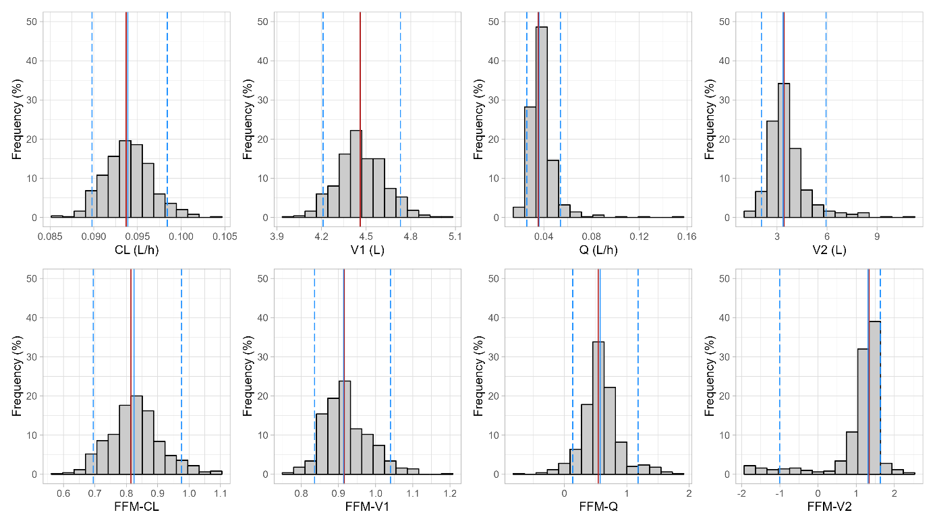

Figure S3: Bootstrap results for structural parameter estimates.

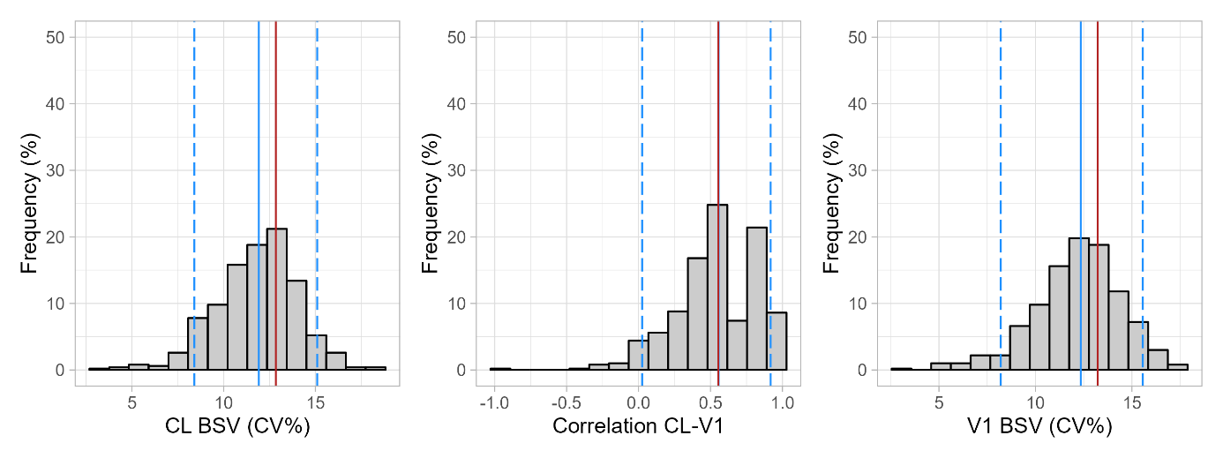
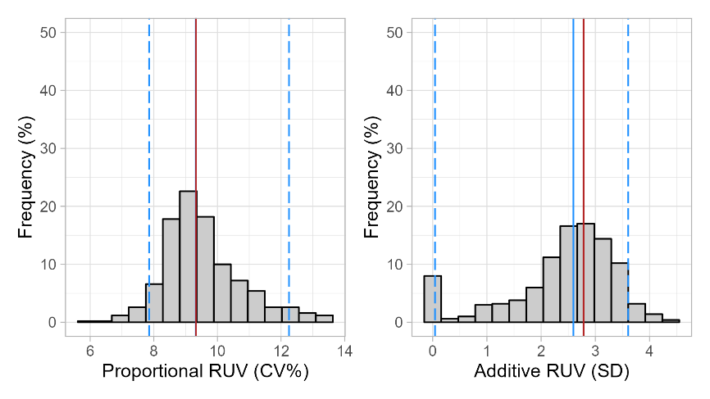
Figure S4: Bootstrap results for BSV and RUV estimates.
Distributions of the Empirical Bayesian Estimates (ηs) corresponding to BSV random effects are shown in Figure S5. The estimated random effects for $η_{CL}$ and $η_{V1}$ appear normally distributed. Shrinkage of the standard deviations was low for both BSV parameters with respectively 3.0 % for $η_{CL}$ and 10.9 % for $η_{V1}$ distributions. Spearman correlation between $η_{CL}$ and $η_{V1}$ was 0.365.

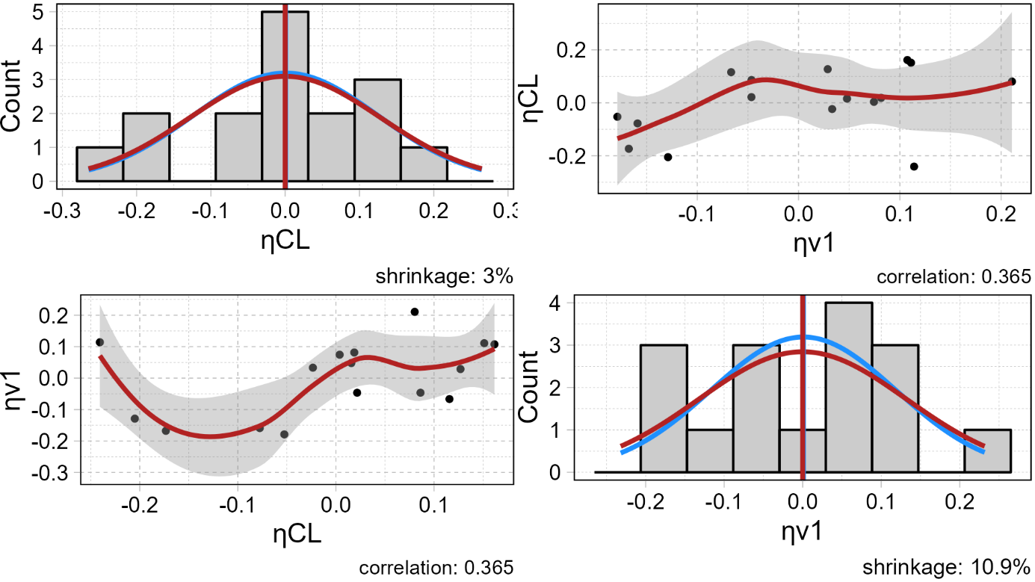
Figure S5: η-distributions and relationship of the final model (Red line: distribution expected from the model assumptions. Blue line: actual distribution of individual 𝜂s)

Standard goodness of fit plots for the final Plasminogen PopPK model are provided in Figure S6 and Figure S7. The observed versus population and individual predicted plasminogen activity show that the model described the data well, with an R² value of 0.96 and smoothers of the data lying on the line of unity (Figure S6). The distribution of CWRES (Figure S7) was approximately normally distributed and centered around zero along either the population prediction values or the time after dose, all values were within a range of ±4, suggesting the absence of outliers.
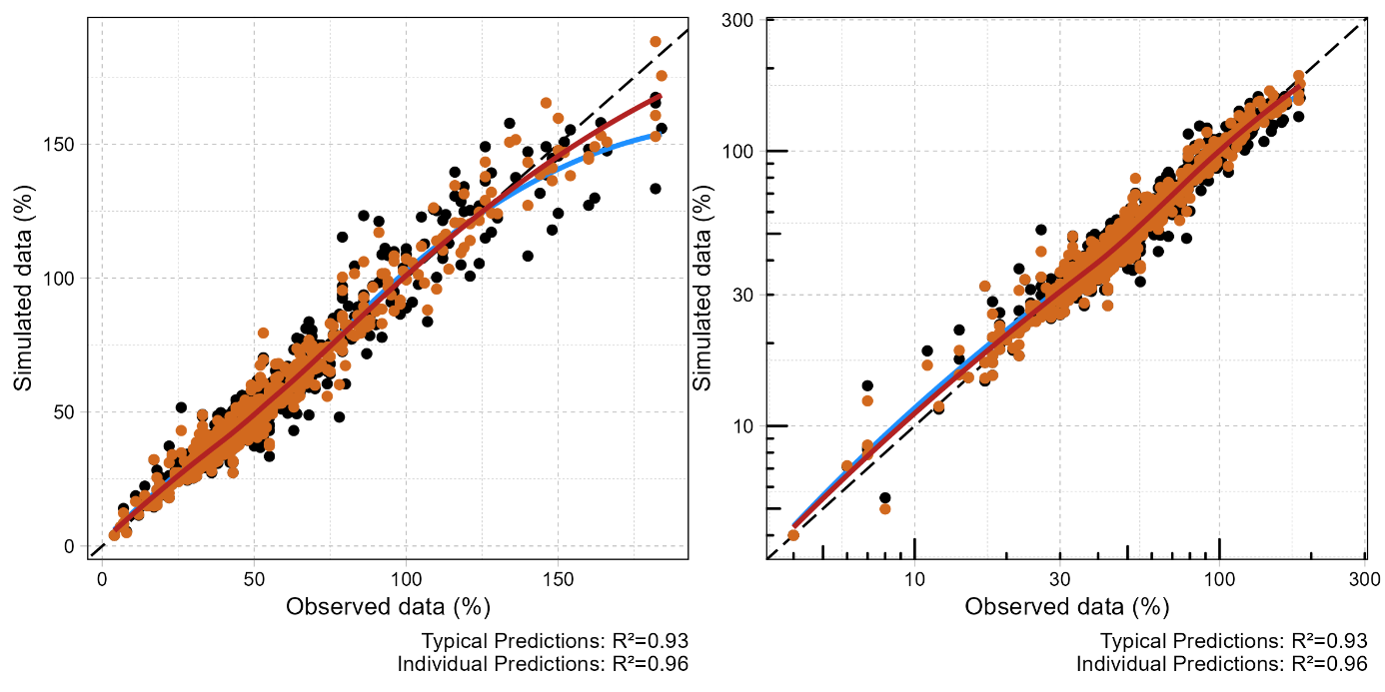
Figure S6: Goodness of fit plots on a linear (left graph) and log (right graph) scale
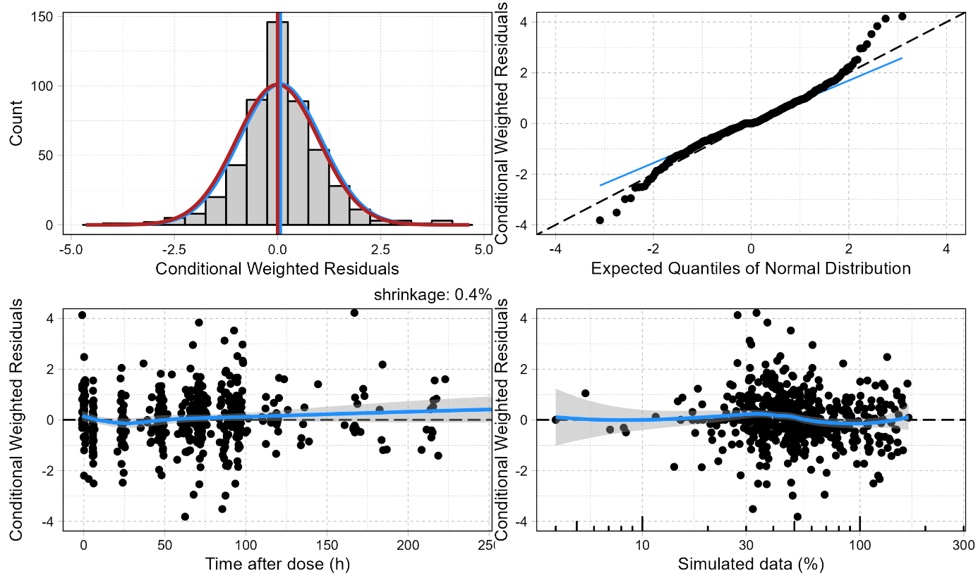
Figure S7: Conditional weighted residuals (CWRES) plots

Terminal Half-life
In this section, apparent half-life was calculated from the simulated time, plasminogen activity and plasminogen activity baseline level using the formula below:
$$t_{1/2}^{apparent}=- log\left(2\right)*\frac{∆time}{∆log⁡(activity-baseline)}$$
For the 5 participants who had rich sampled data over a 10-days period, the estimated activity vs time profile was simulated and displayed in Figure S8. On the top panel, the estimated total plasminogen activities fit very well the observed. Adjusting to baseline activity level, the middle panel shows more error variability after 5 days post infusion. Except for participant #2 whose profile is underestimated (because his PK estimate also accounts for his Phase 2/3 data), the baseline-adjusted observed data is still well fitted by the estimated. The apparent half-life profiles in the last panel for all these participants show an increase across time until reaching a plateau at 8 days post-infusion corresponding to their terminal half-life (Figure S8 bottom plot). The apparent half-life at 4 days post-infusion was twice times lower than terminal half-life. These simulations show that reported terminal half-life values for plasminogen PK can vary due to sampling and estimation methods. Since Plasminogen treatment is recommended twice weekly, the terminal phase may not be reached in routine settings and apparent half-life values may be discrepant from terminal half-life values.

Table S1: Input information and estimated terminal half-life for the 5 participants with rich sampled data over a 10-days period.
Participant | Terminal  Half-life (h) | Dose  (mg/kg) | Samples | Latest  sample (h) | Baseline  Plasminogen  Level (%)
1 | 114 | 6 | 11 | 214 | 26
2 | 143 | 6 | 11 | 223 | 27
3 | 116 | 6 | 11 | 216 | 28
5 | 118 | 6 | 11 | 214 | 37
6 | 101 | 6 | 11 | 214 | 28

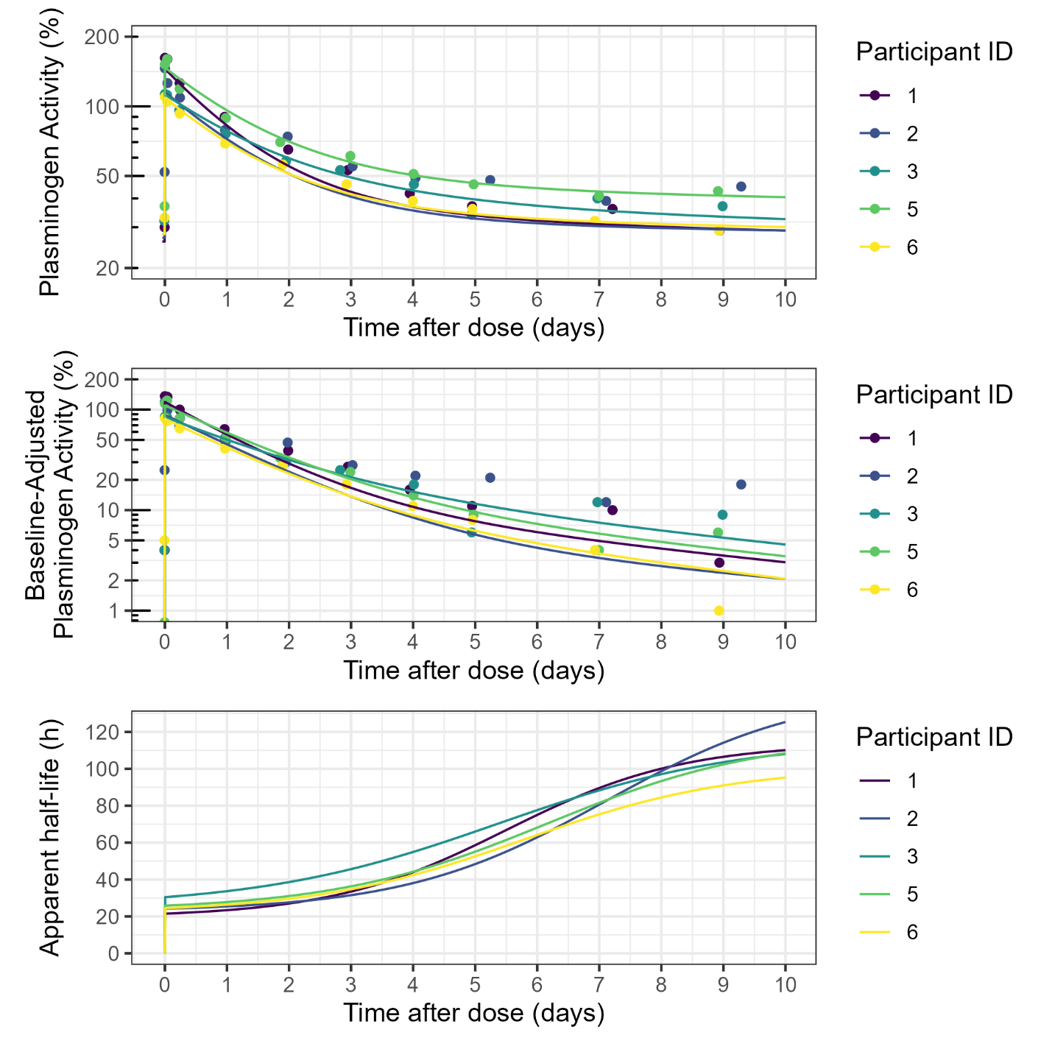
Figure S8: Observed and simulated PK profiles (as total plasminogen activity on top plot and baseline-adjusted plasminogen activity on middle plot) for 5 participants that had 11 measurements sampled within a 10-days interval. Bottom plot displays the apparent half-life of each PK profile.

