Supplementary Information

Tuning silica acidity with ammonium fluoride: Boosting iridium catalyst performance in furfural hydrogenation

Robert Wojcieszak¹, Monika Kot², Arthur Reymond¹, Camila Palombo Ferraz³, Nikolaos Dimitratos⁴, Alberto Villa⁵, Ilaria Barlocco⁵, Silvio Bellomi⁵, Mariusz Pietrowski², Ewa Janiszewska², Michał Zielinski^{2*}, Almudena Marti^{1*}

¹ Université de Lorraine, CNRS, L2CM UMR 7053, F-54000 Nancy, France
² Faculty of Chemistry, Adam Mickiewicz University, Uniwersytetu Poznańskiego 8, 61-614 Poznań, Poland
³ Instituto de Química, Universidade Federal do Rio de Janeiro, Av. Athos da Silveira Ramos, 149, Rio de Janeiro, Brazil
⁴ Dipartimento di Chimica Industriale “Toso Montanari”, Alma Mater Studiorum Università di Bologna, Viale Risorgimento 4, 40126 Bologna, Italy
⁵ Dipartimento di Chimica, Università degli Studi di Milano, via Golgi 19, I-20133, Milano, Italy

* Corresponding authors: Almudena Marti (e-mail: almudena.marti-morant@univ-lorraine.fr), Michał Zielinski (e-mail: michal.zielinski@amu.edu.pl)

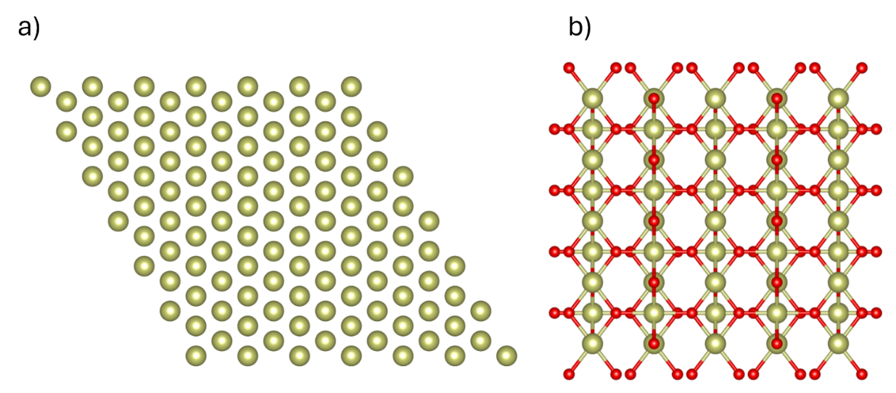
Figure S1. Slab models used for the furfural adsorption studies. a) p(3 × 3) Ir (111) and b) p(2 × 4) IrO₂ (110).

Figure S2. TPD-NH₃ profiles and the Gaussian deconvolution for the unmodified and modified SiO₂ samples (a-d).

Figure S3. FTIR spectra of pyridine adsorbed on SiO-1.0F silica after evacuation at 50, 75, and 100 °C.

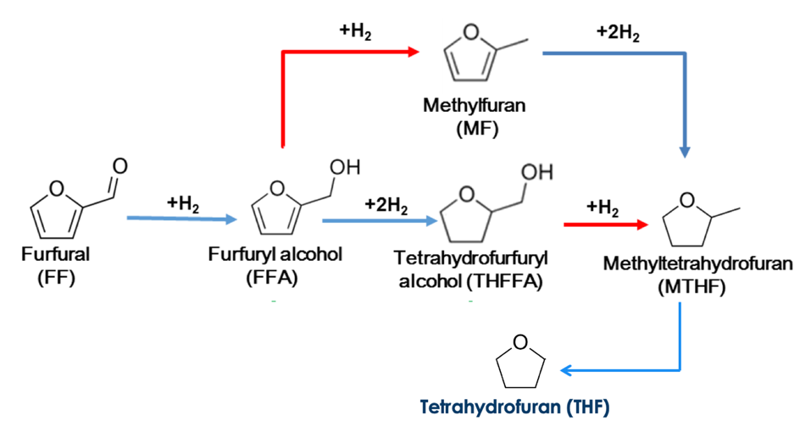
Figure S4. Main reaction pathways in the furfural hydrogenation on metal-based catalysts.

Figure S5. TPR-H₂ proﬁles of the reduced iridium catalysts. Signal intensity was normalized to 100 mg of catalyst.

Table S1. Catalytic activity and selectivity in the selective hydrogenation of furfural.
Catalyst | Temperature  [°C] | Solvent | Furfual conversion  [%] | Furfuryl alcohol selectivity  [%] | Ref
Ir/Nb₂O₅ | 90 | Ethanol | 18 | <95 | [1]
Ir/C | 35 | Isopropanol | 30 | 70 | [2]
Ir/CeO₂ | 150 | Isopropanol | 81 | 73 | [3]
Ir/TiO₂ | 150 | Isopropanol | 45 | 66 | [3]
Ir/NiO | 150 | Isopropanol | 75 | 3.6 | [3]
Ir/TiO₂ (I-473) | 90 | Heptane/ethanol | 30 | 21 | [4]
Pd/Cu/BTC (MOF) | 150 | Water | 100 | 1 | [5]
Pd/Cr-MIL-101 | 150 | Water | 60 | 18 | [5]
Pd/FeCu-DMC | 150 | Water | 38 | 88 | [5]

[1] H. Rojas, et al. Dyna, 2008, 155, 115
[2] R. Kosydar, et al. Int. J. Hydrogen En. 2024, 60, 293
[3] S. Campisi, et al. ChemCatChem, 2022, 14, 1
[4] P. Reyes, et al. Quim. Nova, 2010, 33, 777
[5] Q. Deng et al., Catal. Comm. 2019, 126, 5

Table S2. Adsorption energies and structural parameters of FF adsorbed on Ir(111) surface.
 |  |  | d /Å
Structure |  | ΔE /eV | Ir-O | O=C | C-H | C-C=O | Ir-C | C=C-C=C | C-O=C
flat | cis | -1.827 | 2.11 | 1.30 | 1.10 | 1.43 | 2.19, 2.14, 2.17 | 1.44, 1.44, 1.47 | 1.43, 1.39
flat | trans | -2.029 | 2.20 | 1.35 | 1.10 | 1.43 | 2.20, 2.13 | 1.50, 1.49, 1.42 | 1.40, 1.41
tilted | cis | -1.134 | 2.15 | 1.27 | 1.11 | 1.42 | / | 1.38, 1.41, 1.39 | 1.38, 1.35
tilted | trans | -1.150 | 2.17 | 1.27 | 1.11 | 1.42 | / | 1.39, 1.41, 1.38 | 1.39, 1.35
top | trans | -0.929 | 2.19 | 1.26 | 1.10 | 1.43 | / | 1.39, 1.41, 1.38 | 1.38, 1.36
top | cis | -1.061 | 2.19 | 1.25 | 1.11 | 1.42 | / | 1.39, 1.41, 1.38 | 1.38, 1.36

Table S3. Adsorption energies and structural parameters of FF adsorbed on IrO₂(110) surface.
 |  |  | d /Å
Structure |  | ΔE /eV | Ir-O | O=C | C-H | C-C=O | Ir-C | C=C-C=C | C-O=C
flat | cis | Sterically hindered
flat | trans
tilted | cis | -1.987 | 2.15 | 1.27 | 1.11 | 1.42 | / | 1.38, 1.41, 1.39 | 1.38, 1.35
tilted | trans | -2.091 | 2.17 | 1.27 | 1.11 | 1.42 | / | 1.39, 1.41, 1.38 | 1.39, 1.35
top | trans | -1.710 | 2.19 | 1.26 | 1.10 | 1.43 | / | 1.39, 1.41, 1.38 | 1.38, 1.36
top | cis | -2.476 | 2.19 | 1.25 | 1.11 | 1.42 | / | 1.39, 1.41, 1.38 | 1.38, 1.36

