Table S1 – Sociodemographic and clinical chart: collected data in the Pr-EP program.

Baseline data
Gender, age at entry, ethnic group, migrant status, level of education (in years), civil and living status, occupation, source of referral, family history of psychosis (in first-degree relatives), past specialist contact, baseline hospitalization, baseline compulsory admission, current substance abuse, DUP, previous suicide attempt, psychopharmacological prescription and dosage, and acceptance of psychosocial treatments’ proposal.

Longitudinal data (every 12 months during the 2-year follow-up period)
Service disengagement, new hospitalization, new compulsory admission, new suicide attempt, new self-harm behavior, suicidal ideation, and functional recovery, psychopharmacological prescription ad dosage, and total number of psychosocial treatments’ sessions.

Note – Pr-EP = Parma-Early Psychosis; DUP = Duration of Untreated Psychosis (defined as the time interval [in months] between the onset of overt psychotic symptoms and the first antipsychotic prescription) (Woods et al., 2020). Suicide attempt was defined as a potentially injurious, self-inflicted behavior without a fatal outcome for which there was (explicit or implicit) evidence of intent to die (Silverman et al., 2007). Self-harm behavior was defined was intended as acts of deliberate self-harm or intoxication with alcohol or drugs, but where there was no clear intention to die (Silverman et al., 2007). Current suicidal ideation was defined as “at least occasional suicidal thoughts without intent or specific plan, or the patients feel they would be better off dead” (as indicated by a BPRS item 4 score ≥ 3) (Shafer et al., 2017). Functional recovery = return to work or school.

References
- Silverman MM, Berman AL, Sanddal ND, O'carroll PW, Joiner TE. Rebuilding the tower of Babel: a revised nomenclature for the study of suicide and suicidal behaviors - Part 2: suicide-related ideations, communications, and behaviors. Suicide Life Threat Behav. 2007; 37: 264-77. https://doi.org/10.1521/suli.2007.37.3.264.
- Shafer A, Dazzi F, Ventura J. Factor structure of the Brief Psychiatric Rating Scale - Expanded (BPRS-E) in a large hospitalized sample. J Psychiatr Res. 2017; 93: 79-86. https://doi.org/10.1016/j.jpsychires.2017.05.011.
- Woods SW, Yung AR, McGorry PD, McGlashan TH. Duration of untreated psychosis: getting both the timing and the sample right. Am J Psychiatry 2020; 177: 1183. https://doi.org/10.1176/appi.ajp.2020.20040389.

Figure S1 - Flow chart on service engagement within the Pr-EP program in the FEP total group.

T0
500 FEP participants

T1
Service disengagement
70 FEP participants

430 FEP participants concluded the first year of treatment

Service disengagement
80 FEP participants
T2

350 FEP participants concluded the study

Note – Pr-EP = Parma Early Psychosis; FEP = First Episode Psychosis; T0 = Baseline assessment; T1 = 1-year assessment time; T2 = 2-year assessment time.
As reported in our previous paper, compared to FEP participants who concluded the 2-year Pr-EP treatment, those with service disengagement showed at baseline lower AP prescription and psychosocial acceptance rates, higher prevalence of migrant status and living with parents, and lower severity levels in disorganization and negative symptoms, as well as higher prevalence of diagnosis in DSM-5 longitudinally unstable psychotic disorders (i.e., brief psychotic disorder and schizophreniform disorder). For details, see Pelizza, L., Leuci, E., Quattrone, E., Azzali, S., Pupo, S., Paulillo, G., Pellegrini, P., Menchetti, M., 2024. Rates and predictors of service disengagement in first episode psychosis: results from a 2-year follow-up study in an Italian real-world care setting. Schizophr. Res. 274, 142-149. https://doi.org/10.1016/j.schres.2024.09.015.

Figure S2 – Kaplan-Meier survival functions on 2-year outcome parameters across the 2-year follow-up period in the two FEP subgroups.

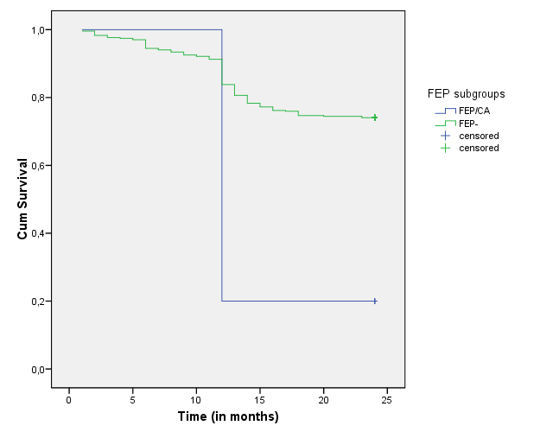

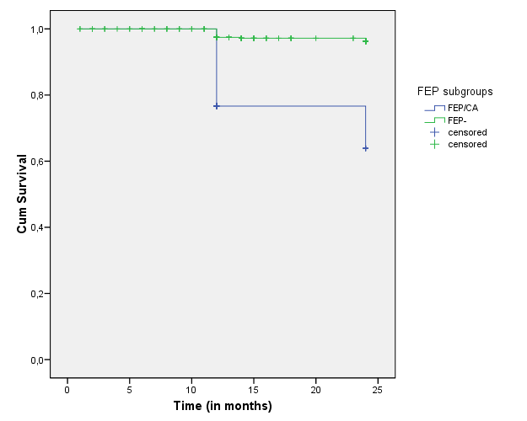

Note - FEP/CA = First Episode Psychosis with new compulsory admission; FEP- = First Episode Psychosis without new compulsory admission.

