Supplementary Material

Recurrence rate and type after hepatocellular carcinoma after curative resection or ablation according to the IMbrave050 risk criteria: a real-life study.

Supplementary Figure 1. Patient selection flowchart (study period: 01 January 2010 – 31 December 2022).
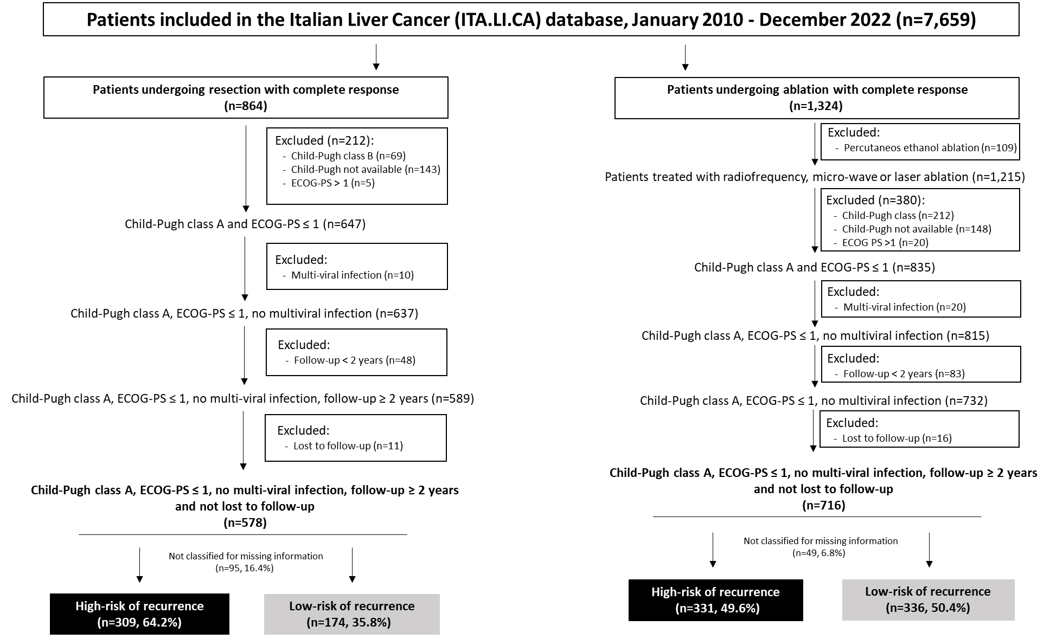
Supplementary Figure 2. Stratification of recurrence risk in patients undergoing liver resection according to multivariate risk function.
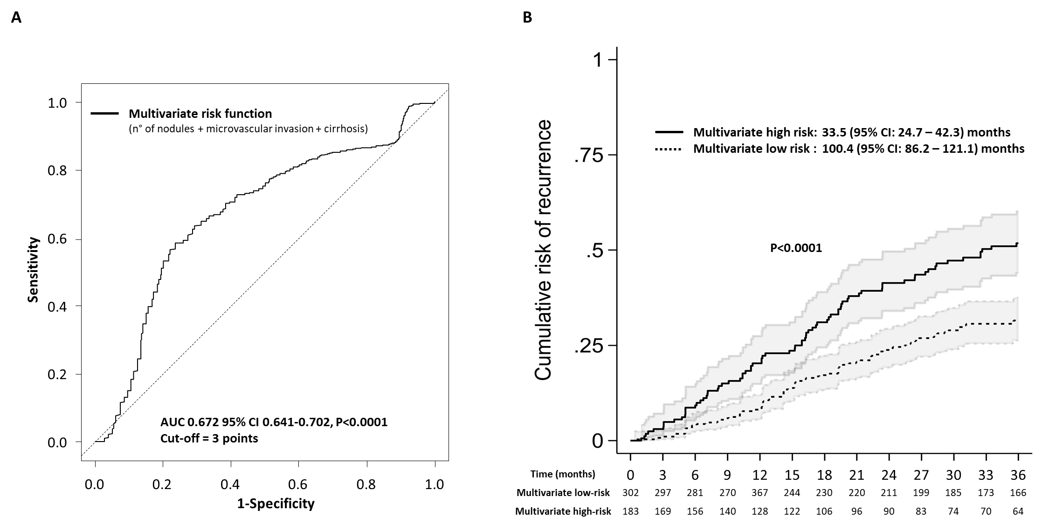
In the multivariate risk function the scoring system for number of nodules is as follows: 0 points for one nodule; +1 point for every additional nodule.

Supplementary Figure 3. Prognostic value of the alpha-fetoprotein levels in predicting HCC recurrence in patients who underwent ablation.
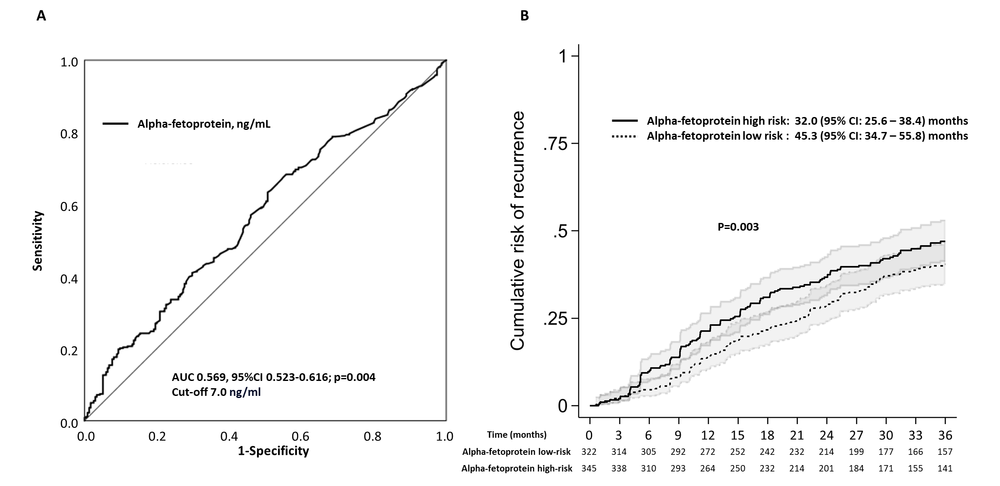
Supplementary Figure 4. Smoothed hazard estimates comparing patients with low and high risk of recurrence after (A) resection and (B) ablation treatments.

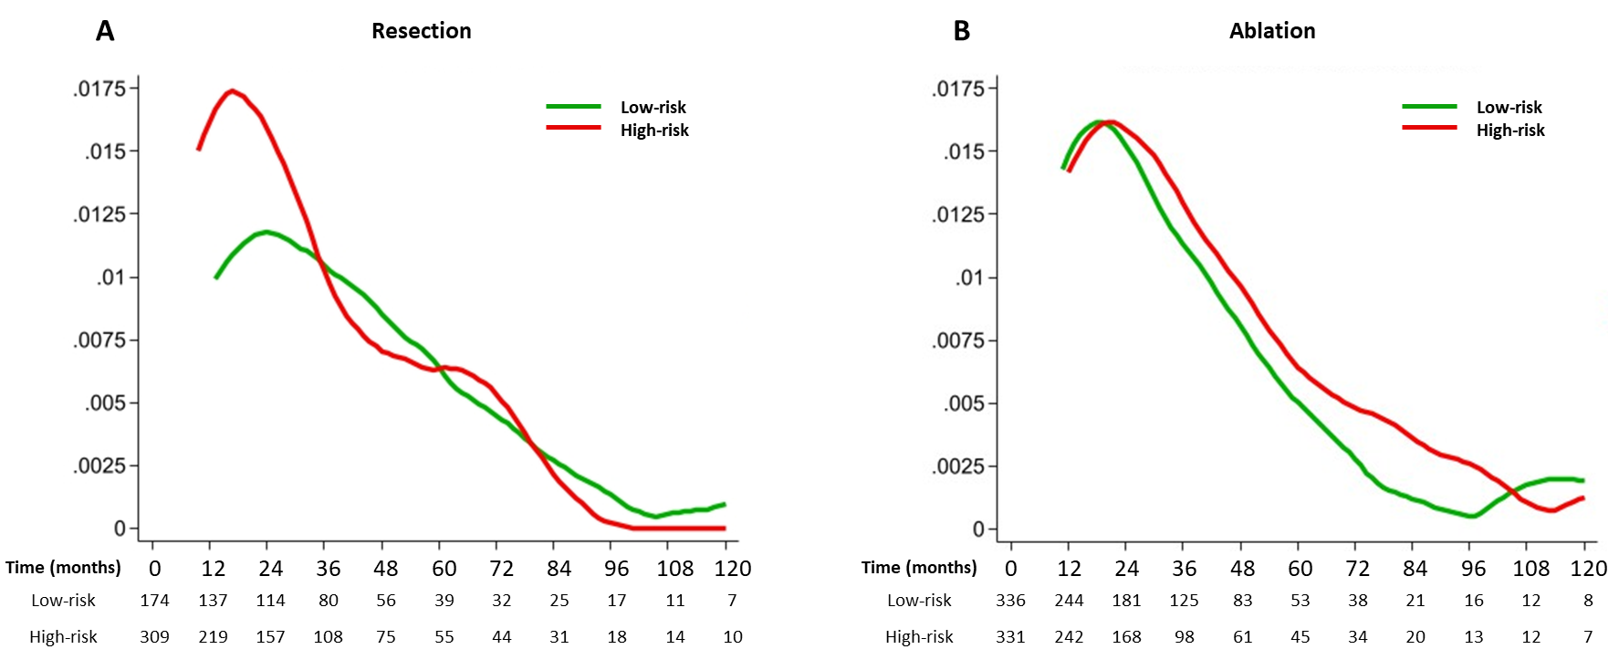

Supplementary Figure 5. Kaplan-Meier recurrence-free survival curves in ablated patients stratified by tumour number and size.
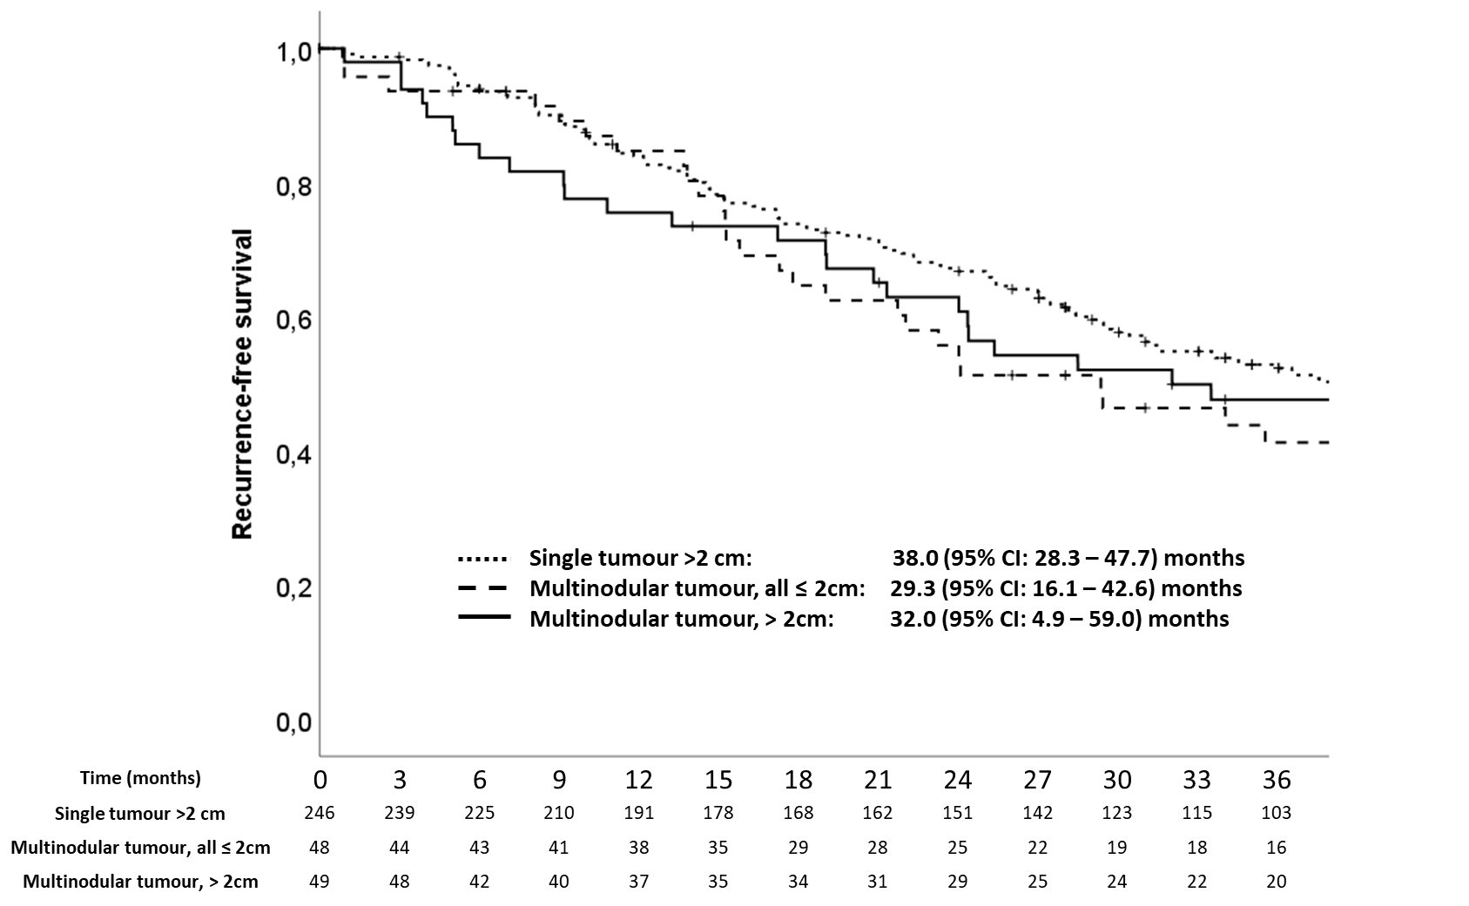

Supplementary Figure 6. Kaplan-Meier survival curves for patients undergoing (A) resection and (B) ablation stratified by occurrence of either early (black line) or late recurrence (grey line).
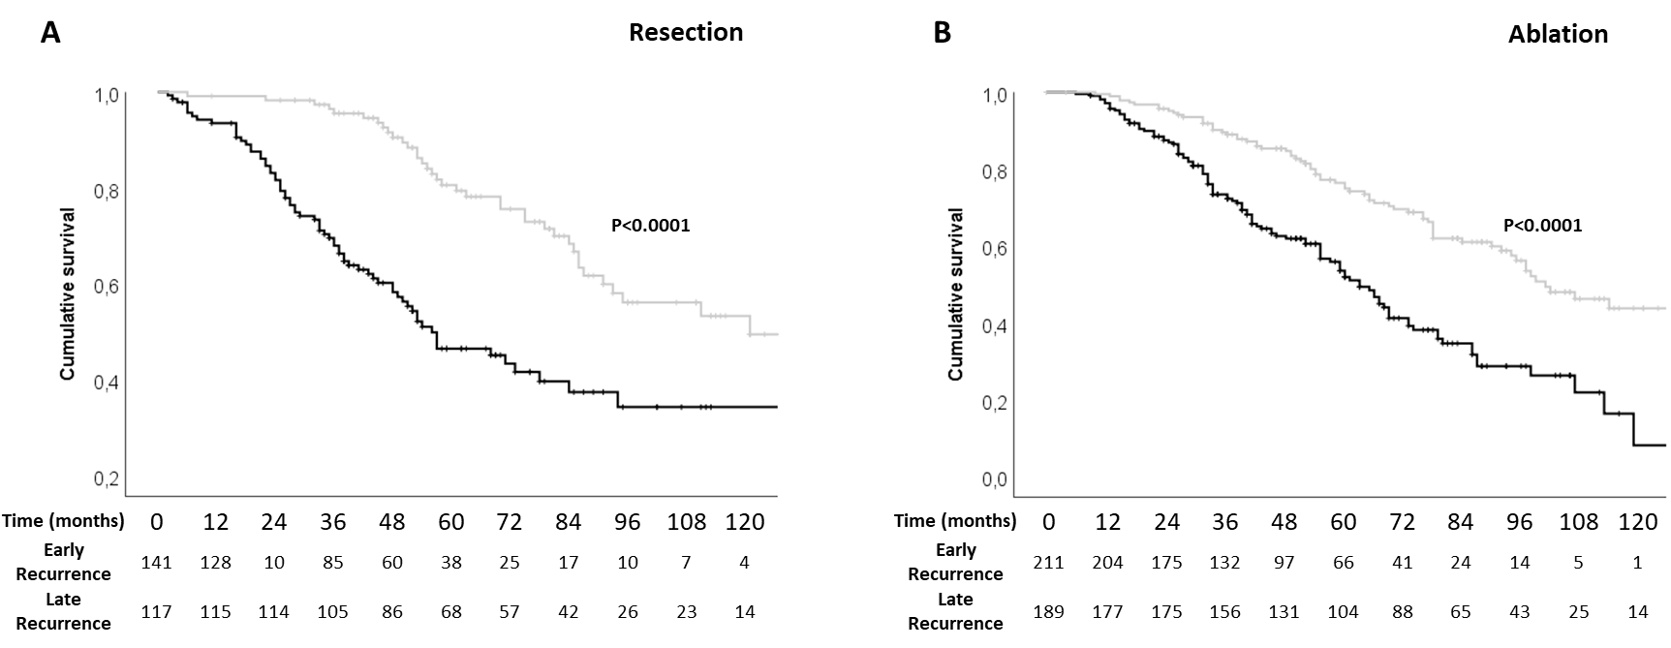

Supplementary Table 1. Definition of patients at high-risk of hepatocellular carcinoma recurrence according to treatment received in the IMbrave050 study.
Curative treatment | High-risk criteria
Resection | - Up to three tumors, with largest tumor >5 cm regardless of vascular invasion (microvascular invasion or macrovascular invasion of Vp1/Vp2) or poor tumor differentiation (Grade 3 or 4)  - Four or more tumors, with largest tumor ≤5 cm regardless of vascular invasion (microvascular invasion or macrovascular invasion of Vp1/Vp2) or poor tumor differentiation (Grade 3 or 4)  - Up to three tumors, with largest tumor ≤5 cm with vascular invasion (microvascular invasion or macrovascular invasion of Vp1/Vp2) and/or poor tumor differentiation (Grade 3 or 4)
Ablation | - Single tumor >2 cm but ≤5 cm  - Multiple tumors (up to four tumors), all ≤5 cm
Vp0, no evidence of tumor thrombus invasion; Vp1, tumor thrombus distal to but not in the second-order branches; Vp2, tumor thrombus in the second-order branches; Vp3, tumor thrombus in the first-order branches; Vp4, tumor thrombus in the main trunk or contralateral or both.

Supplementary Table 2. Univariate and multivariate Cox regression analysis of HCC recurrence for baseline characteristics
Variable | Resection |  |  |  | Ablation
Variable | Univariate analysis |  | Multivariate analysis |  | Univariate analysis |  | Multivariate analysis
Variable | HR (95% CI) | p | HR (95% CI) | p | HR (95% CI) | p | HR (95% CI) | p
Gender (Female=ref) | 0.95 (0.83 – 1.09) | 0.460 |  |  | 1.12 (0.91 – 1.38) | 0.292
Age (+1 year) | 0.99 (0.98 – 1.00) | 0.061 | 0.99 (0.98 – 1.00) | 0.188 | 1.00 (0.99 – 1.01) | 0.619
ECOG PS (+1 point) | 0.93 (0.63 – 1.36) | 0.692 |  |  | 1.00 (0.77 – 1.31) | 0.975
Diagnosis HCC type (surveillance=ref)
Accidental | 0.88 (0.68 – 1.14) | 0.341 |  |  | 0.87 (0.68 – 1.11) | 0.255
Symptomatic | 1.45 (0.89 – 2.35) | 0.137 |  |  | 0.93 (0.44 – 1.98) | 0.859
Presence of cirrhosis (absence=ref) | 1.47 (1.13 – 1.91) | 0.004 | 1.52 (1.13 – 2.05) | 0.006 | 1.02 (0.77 – 1.34) | 0.894
Charlson Comorbidity Index | 0.99 (0.93 – 1.05) | 0.763 |  |  | 1.02 (0.97 – 1.08) | 0.395
Monofocal site (subcapsular) | 0.75 (0.49 – 1.15) | 0.180 |  |  | 0.90 (0.65 – 1.24) | 0.530
N° lesions (+ 1 lesion)† | 1.28 (1.12 – 1.46) | <0.0001 | 1.31 (1.14 – 1.52) | <0.0001 | 1.13 (0.95 – 1.35) | 0.088 | 1.15 (0.96 – 1.38) | 0.125
Median maximum diameter, cm | 1.00 (0.97 – 1.05) | 0.840 |  |  | 1.02 (0.98 – 1.07) | 0.341
Median α-fetoprotein level Ln(ng/mL) | 1.20 (0.851 – 1.35) | 0.686 |  |  | 1.15 (1.07 – 1.23) | <0.0001 | 1.15 (1.07 – 1.23) | <0.0001
MELD score (+1 point) | 0.98 (0.92 – 1.04) | 0.436 |  |  | 1.01 (0.99 – 1.04) | 0.308
Child-Turcotte-Pugh score (+1 point) | 0.93 (0.70 – 1.23) | 0.929 |  |  | 1.13 (0.92 – 1.38) | 0.239
Milan criteria (OUT=ref) | 0.76 (0.60 – 0.96) | 0.021 |  |  | 0.81 (0.60 – 1.11) | 0.187
HCC grading (<3=ref) | 1.15 (0.98 – 1.34) | 0.089 | 1.11 (0.84 –1.46) | 0.483
Microvascular invasion (absence=ref) | 1.44 (1.12 – 1.85) | 0.004 | 1.39 (1.05 – 1.83) | 0.022
†Nodule-count scoring (ordinal continuous): 0 points for one nodule; +1 point for every additional nodule.
Abbreviations: HR, Hazard Ratios; MELD, Model for End-stage Liver Disease; ECOG-PS, Performance Status according to Eastern Cooperative Oncology Group.

Supplementary Table 3. Demographic, clinical and oncological characteristics for each treatment, according to early or late recurrence.
 | Resection  (n=258) |  |  | Ablation  (n=400)
 | Early  recurrence  (n=141, 54.7) | Late  recurrence  (n=117, 45.3) | p | Early  recurrence  (n=211, 52.8) | Late  recurrence  (n=189, 47.2) | p
Age, years | 69 (61-73) | 69 (59-73) | 0.839 | 71 (64-77) | 71 (63-76) | 0.196
Sex, male | 116 (82.3) | 92 (78.6) | 0.462 | 151 (71.6) | 123 (65.1) | 0.163
Aetiology, viral | 90 (65.7) | 74 (66.1) | 0.950 | 142 (69.3) | 134 (72.8) | 0.440
Cirrhosis, presence | 106 (75.2) | 85 (72.6) | 0.645 | 183 (86.7) | 161 (85.2) | 0.657
ALBI, grade
1 | 79 (56.0) | 66 (56.4) | 0.951 | 91 (43.1) | 92 (48.7) | 0.266
2 | 62 (44.0) | 51 (43.6) | 0.951 | 120 (56.9) | 97 (51.3)
MELD, score | 8 (7-9) | 8 (7-9) | 0.128 | 8 (7-9) | 8 (7-9) | 0.287
CCI, score | 4 (3 – 6) | 4 (3 – 5) | 0.242 | 4 (4 – 6) | 4 (4 – 5) | 0.868
Type of diagnosis
Surveillance | 88 (65.2) | 68 (61.3) | 0.830 | 153 (72.5) | 142 (75.1) | 0.801
Incidental | 37 (27.4) | 36 (32.4) | 0.830 | 40 (19.0) | 33 (17.5) | 0.801
Symptomatic | 10 (7.4) | 7 (6.3) | 0.830 | 2 (0.9) | 3 (1.6) | 0.801
Unknown | 6 (4.3) | 6 (5.1) | 0.830 | 16 (7.6) | 11 (5.8) | 0.801
Number of nodules
one | 113 (80.1) | 94 (80.3) |  | 179 (84.8) | 161 (85.2)
2-3 | 24 (17.0) | 22 (18.8) | 0.557 | 28 (13.3) | 25 (13.2) | 1
>3 | 4 (2.8) | 1 (0.9) |  | 4 (1.9) | 3 (1.6)
Maximum diameter, cm | 4 (2.5-5.0) | 3.5 (2.0-4.5) | 0.237 | 2 (1.5-2.8) | 2.1 (1.7-2.8) | 0.383
α-fetoprotein, ng/mL | 8.6 (4.0 – 51.3) | 5.0 (2.9 – 10.8) | 0.005 | 7.9 (3.9 – 28.2) | 7.0 (3.6 – 20.0) | 0.229
MVI, presence | 8 (3.1) | 3 (1.2) | 0.218 | 2 (0.9) | 1 (0.5) | 0.628
Milan criteria, in | 87 (61.7) | 77 (65.8) | 0.495 | 204 (96.7) | 176 (93.1) | 0.103
BCLC
Very early | 19 (13.5) | 14 (12.0) | 0.789 | 41 (19.4) | 45 (23.8) | 0.480
Early | 81 (57.4) | 70 (59.8) | 0.789 | 144 (68.2) | 119 (63.0) | 0.480
Intermediate | 27 (19.1) | 25 (21.4) | 0.789 | 5 (2.4) | 8 (4.2) | 0.480
Advanced | 14 (9.9) | 8 (6.8) | 0.789 | 21 (10.0) | 17 (9.0) | 0.480
End stage | 0 (0.0) | 0 (0.0) | 0.789 | 0 (0.0) | 0 (0.0) | 0.480
Grading, (≥3) | 66 (48.5) | 40 (34.8) | 0.028
Microvascular invasion, presence | 65 (46.1) | 47 (40.2) | 0.152
Data are shown as absolute value and percentage or median and interquartile range.
Abbreviations: ALBI, albumin-bilirubin; MELD, model for end-stage liver disease; CCI, Charlson Comorbidity Index, MVI, macro-vascular invasion; mVI, micro-vascular invasion; BCLC, Barcelona Clinic Liver Cancer; EHS, extra-hepatic spread; MVI, macro-vascular invasion; NA, not applicable

Supplementary Table 4. Univariate and multivariate Cox regression analysis of HCC recurrence or death for baseline characteristics
Variable | Resection |  |  |  | Ablation
Variable | Univariate analysis |  | Multivariate analysis |  | Univariate analysis |  | Multivariate analysis†
Variable | HR (95% CI) | p | HR (95% CI) | p | HR (95% CI) | p | HR (95% CI) | p
Gender (Female=ref) | 1.17 (0.87 – 1.57) | 0.298 |  |  | 1.11 (0.91 – 1.35) | 0.314
Age (+1 year) | 0.99 (0.98 – 1.00) | 0.101 |  |  | 1.01 (0.99 – 1.02) | 0.097 | 1.00 (0.99 – 1.02)  1.01 (0.99 – 1.02) | 0.080  0.082
ECOG PS (+1 point) | 1.72 (1.10 – 2.68) | 0.017 | 1.07 (0.61 – 1.88) | 0.803 | 1.04 (0.75 – 1.45) | 0.799
Diagnosis HCC type (surveillance=ref)
Accidental | 0.99 (0.77 – 1.29) | 0.975 | 0.98 (0.74 – 1.28) | 0.855 | 0.83 (0.66 – 1.06) | 0.132
Symptomatic | 1.78 (1.16 – 2.73) | 0.008 | 1.58 (0.96 – 2.58) | 0.070 | 0.79 (0.37 – 1.66) | 0.530
Presence of cirrhosis (absence=ref) | 1.34 (1.04 – 1.73) | 0.023 | 1.50 (1.12 – 2.00) | 0.006 | 1.23 (0.93 – 1.61) | 0.145
Charlson Comorbidity Index | 1.01 (0.94 – 1.08) | 0.765 |  |  | 1.03 (0.98 – 1.09) | 0.211
Monofocal site (subcapsular) | 0.70 (0.64 – 1.35) | 0.698 |  |  | 0.98 (0.73 – 1.30) | 0.975
N° Lesions (+ 1 lesion) | 1.36 (1.21 – 1.52) | <0.0001 | 1.44 (1.27 – 1.63) | <0.0001 | 1.22 (1.04 – 1.44) | 0.017 | 1.23 (1.03 – 1.45)  1.16 (0.97 – 1.39) | 0.020  0.098
Median maximum diameter, cm | 1.04 (1.00 – 1.07) | 0.032 | 1.04 (0.99 – 1.09) | 0.065 | 1.01 (0.95 – 1.06) | 0.850
Median α-fetoprotein level Ln(ng/mL) | 1.25 (0.74 – 1.57) | 0.553 |  |  | 1.13 (1.06 – 1.20) | <0.0001 | 1.11 (1.04 – 1.18)  1.12 (1.05 – 1.19) | 0.002  0.001
MELD score (+1 point) | 1.03 (0.97 – 1.10) | 0.361 |  |  | 1.03 (1.01 – 1.05) | 0.003 | 1.03 (1.01 – 1.05) | 0.007
Child-Turcotte-Pugh score (+1 point) | 0.93 (0.71 – 1.21) | 0.583 |  |  | 1.30 (1.07 – 1.57) | 0.007 | 1.31 (1.07 – 1.60) | 0.010
Milan criteria (OUT=ref) | 0.68 (0.54 – 0.86) | 0.001 |  |  | 0.93 (0.62 – 1.43) | 0.768
HCC grading (<3=ref) | 1.06 (0.84 – 1.33) | 0.636
Microvascular invasion (absence=ref) | 1.51 (1.19 – 1.90) | 0.001 | 1.48 (1.16 – 1.88) | 0.002
Abbreviations: HR, Hazard Ratios; MELD, Model for End-stage Liver Disease; ECOG-PS, Performance Status according to Eastern Cooperative Oncology Group.
†Multivariate analysis based on two models that include MELD (model 1) and Child-Turcotte-Pugh (model 2) scores, respectively.

