Supplementary Information for direct dating confirms the presence of otter and badger in early Holocene Ireland
Robert C. Power^{1, 2}, Ingelise Stuijts⁴, Finbar McCormick⁵, Sahra Talamo^{2,3},
¹ School of Archaeology, University College Dublin, Dublin, Ireland
² Department of Human Evolution, Max Planck Institute for Evolutionary Anthropology, Deutscher Platz 6, Leipzig, Germany 04103
³ Department of Chemistry G. Ciamician, Alma Mater Studiorum Bologna University, Via Selmi 2, Bologna, Italy 40126
⁴ The Discovery Programme, 6 Mount Street Lower, Dublin 2, Ireland
⁵ School of Geography, Archaeology and Palaeoecology, Queen's University Belfast, University Road, Belfast, Northern Ireland, UK BT9 6AY

Morphometrics
The otter cranium’s postorbital breadth to interorbital constriction is 21:17, suggesting the otter is an older individual (King, 1980; Sleeman, 1987).
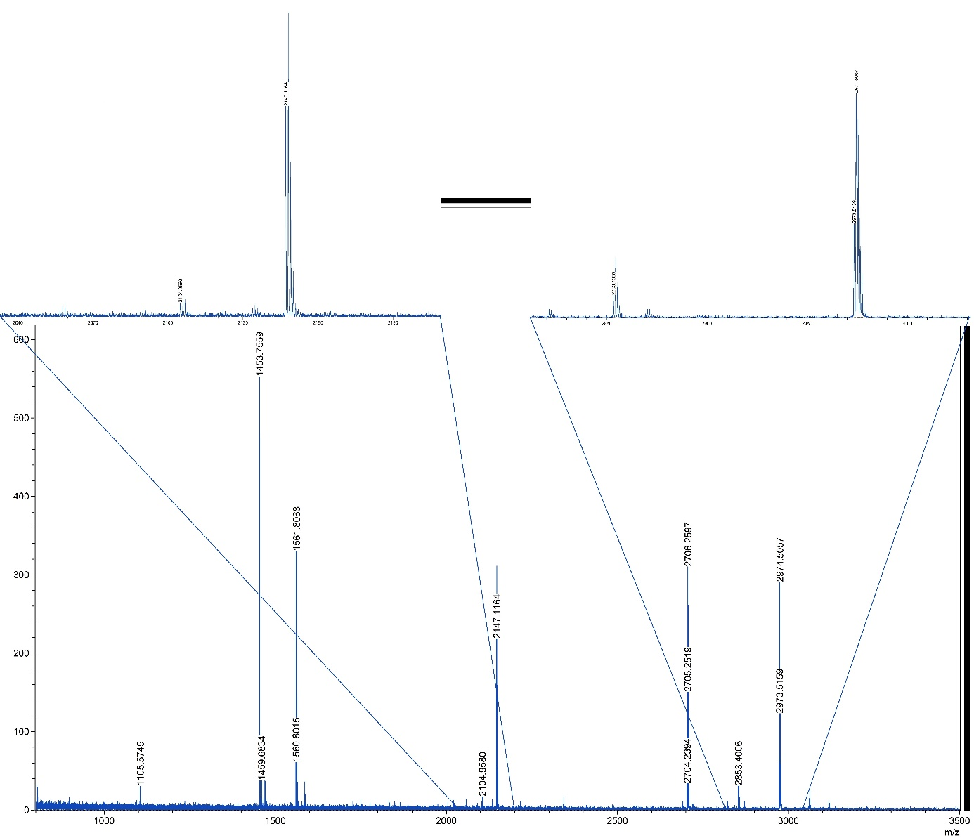
Supplementary figure 1. Badger spectrum. After Spindler 2018.

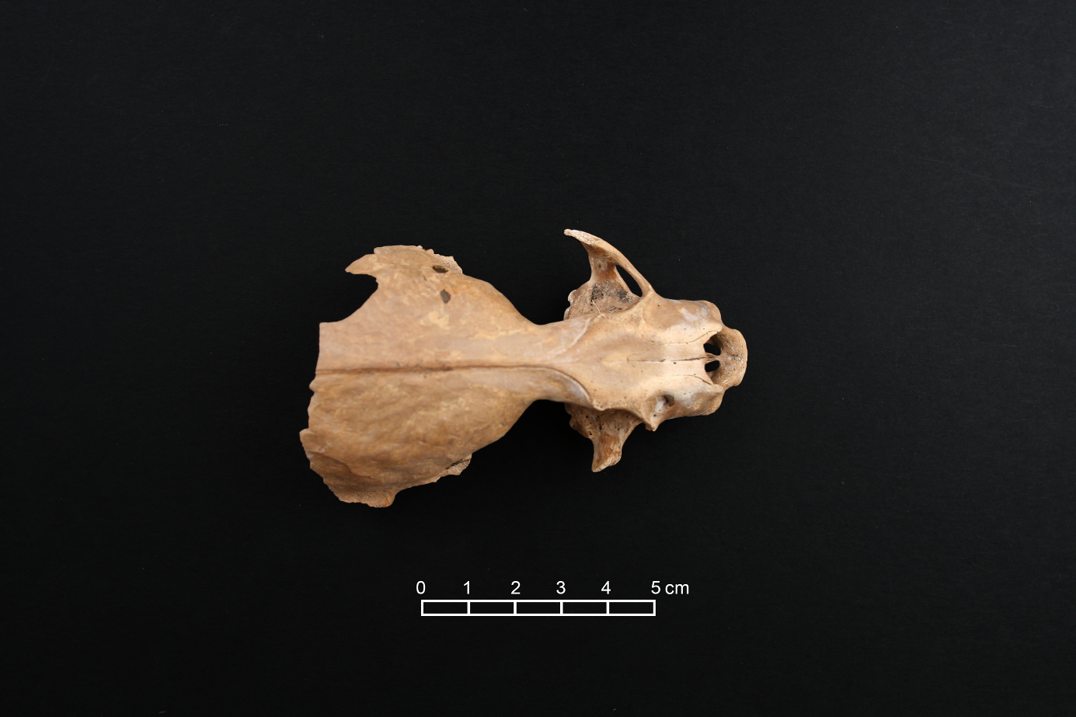
Supplementary figure 2. Otter cranium

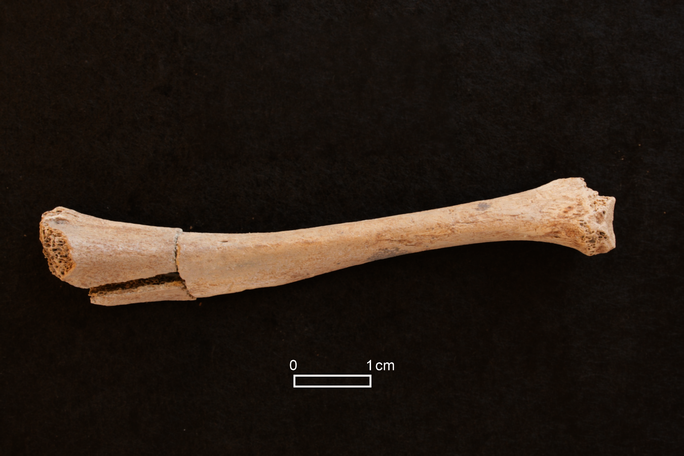
Supplementary figure 3. Archaeological immature badger tibia.

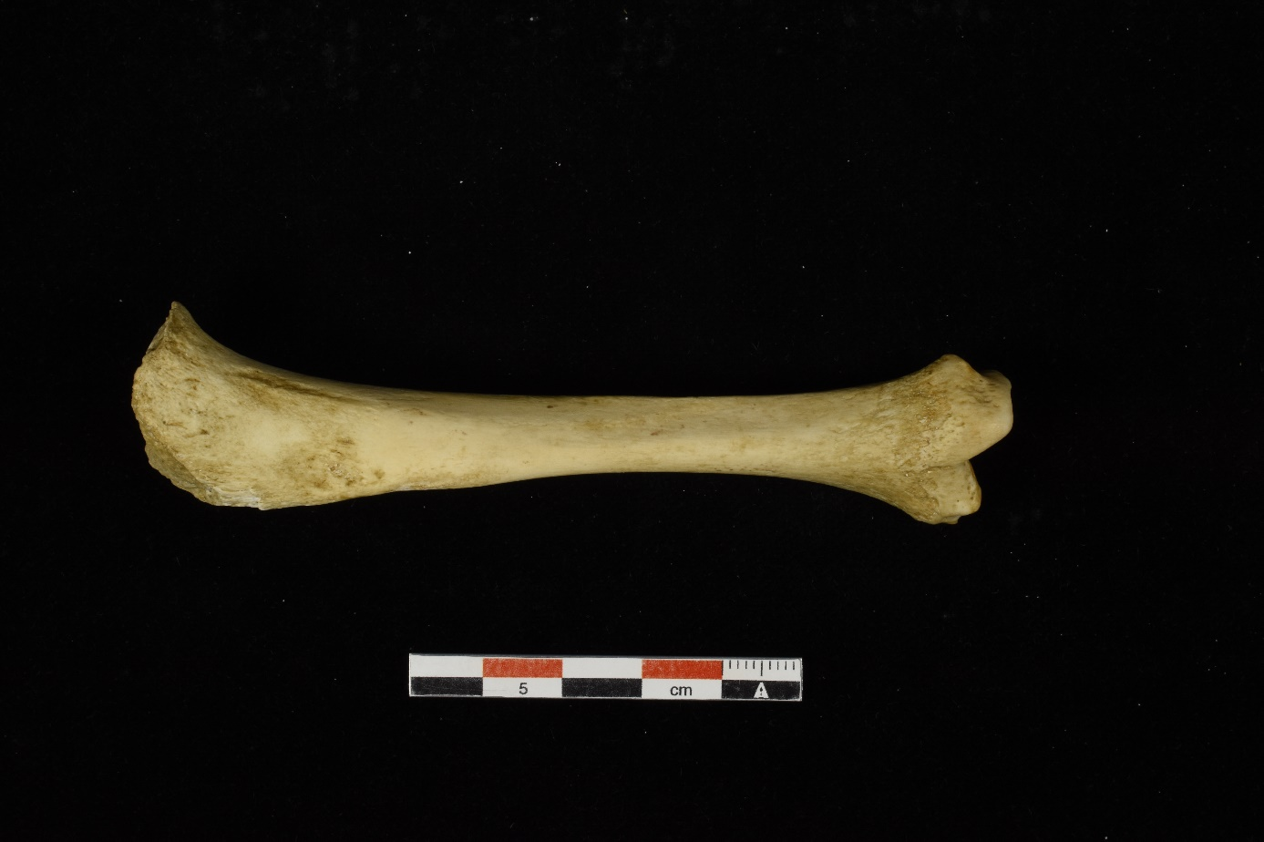
Supplementary figure 4. Reference collection immature badger tibia from the faunal reference collection of the former Department of Human Evolution at the Max Planck for Evolutionary Anthropology, Leipzig.

Supplementary table 1. List of all identified Mesolithic sites on the island of Ireland and identified fauna at each site for accumulation curve analysis. This includes new Derragh finds. All Mesolithic sites are included, with radiometric or cultural dating. Identifications listed as uncertain are included. Multiple individuals are interpreted as one identification for analysis purposes.
Site | pig | hare | canid | bear | otter | badger | stoat | cat | seal | dolphin | wood mouse | lynx
Mount Sandal | 322 | 9 | 1 | 0 | 0 | 0 | 0 | 0 | 0 | 0 | 0 | 0
Lough Boora | 705 | 0 | 4 | 0 | 0 | 0 | 0 | 1 | 0 | 0 | 0 | 0
Ferriters Cove | 86 | 4 | 1 | 0 | 0 | 0 | 0 | 0 | 0 | 0 | 0 | 0
Baylet | 4 | 0 | 0 | 3 | 0 | 0 | 0 | 0 | 0 | 0 | 0 | 0
Port of Larne | 0 | 0 | 0 | 0 | 0 | 0 | 0 | 0 | 0 | 0 | 0 | 0
Dalkey Island | 23 | 0 | 18 | 4 | 0 | 0 | 0 | 0 | 19 | 1 | 0 | 0
Moynagh Lough | 51 | 5 | 0 | 1 | 1 | 0 | 0 | 0 | 0 | 0 | 0 | 0
Sutton | 6 | 0 | 0 | 1 | 0 | 0 | 0 | 0 | 0 | 0 | 0 | 0
Derragh | 171 | 0 | 0 | 1 | 1 | 1 | 0 | 0 | 0 | 0 | 0 | 0
Kilnatierny | 7 | 0 | 0 | 0 | 0 | 0 | 0 | 0 | 0 | 0 | 0 | 0
Kilgreaney | 0 | 0 | 0 | 0 | 0 | 0 | 0 | 0 | 0 | 0 | 0 | 1
Kesh corran | 0 | 0 | 0 | 0 | 0 | 0 | 0 | 0 | 0 | 0 | 0
Belderrig | 0 | 0 | 0 | 0 | 0 | 0 | 0 | 0 | 0 | 0 | 0 | 0
Coffey Cave | 0 | 0 | 0 | 0 | 0 | 0 | 1 | 0 | 0 | 0 | 0 | 0
Newlands Cross | 0 | 0 | 0 | 0 | 0 | 0 | 0 | 0 | 0 | 0 | 1 | 0
North Wall Quay | 0 | 0 | 0 | 0 | 0 | 0 | 0 | 0 | 0 | 0 | 0 | 0
Ballyoran Bog | 0 | 0 | 0 | 0 | 0 | 0 | 0 | 0 | 0 | 0 | 0 | 0
Curraghprevin | 0 | 0 | 0 | 0 | 0 | 0 | 0 | 0 | 0 | 0 | 0 | 0
Muckrifge | 0 | 0 | 0 | 0 | 0 | 0 | 0 | 0 | 0 | 0 | 0 | 0
Ballintra West | 0 | 0 | 0 | 0 | 0 | 0 | 0 | 0 | 0 | 0 | 0 | 0
Ballinatraspig More | 0 | 0 | 0 | 0 | 0 | 0 | 0 | 0 | 0 | 0 | 0 | 0
Ballynacarriga | 0 | 0 | 0 | 0 | 0 | 0 | 0 | 0 | 0 | 0 | 0 | 0
Gortore | 0 | 0 | 0 | 0 | 0 | 0 | 0 | 0 | 0 | 0 | 0 | 0
Curragh Upper | 0 | 0 | 0 | 0 | 0 | 0 | 0 | 0 | 0 | 0 | 0 | 0
Fanore More Site 1. | 0 | 0 | 0 | 0 | 0 | 0 | 0 | 0 | 0 | 0 | 0 | 0
Corralanna | 0 | 0 | 0 | 0 | 0 | 0 | 0 | 0 | 0 | 0 | 0 | 0
Ringneill Quay | 0 | 0 | 0 | 0 | 0 | 0 | 0 | 0 | 0 | 0 | 0 | 0
Hermitage | 0 | 0 | 0 | 0 | 0 | 0 | 0 | 0 | 0 | 0 | 0 | 0
Newferry | 0 | 0 | 0 | 0 | 0 | 0 | 0 | 0 | 0 | 0 | 0 | 0
Creadan Head | 0 | 0 | 0 | 0 | 0 | 0 | 0 | 0 | 0 | 0 | 0 | 0
Toome Bridge | 0 | 0 | 0 | 0 | 0 | 0 | 0 | 0 | 0 | 0 | 0 | 0
Bay Farm | 0 | 0 | 0 | 0 | 0 | 0 | 0 | 0 | 0 | 0 | 0 | 0
Clowanstown | 0 | 0 | 0 | 0 | 0 | 0 | 0 | 0 | 0 | 0 | 0 | 0
Site 34, Newrath | 0 | 0 | 0 | 0 | 0 | 0 | 0 | 0 | 0 | 0 | 0 | 0
Killybegs | 0 | 0 | 0 | 0 | 0 | 0 | 0 | 0 | 0 | 0 | 0 | 0
Ballydawmore | 0 | 0 | 0 | 0 | 0 | 0 | 0 | 0 | 0 | 0 | 0 | 0
Edercloon | 0 | 0 | 0 | 0 | 0 | 0 | 0 | 0 | 0 | 0 | 0 | 0
Cushendun-deposit E | 1 | 0 | 0 | 0 | 0 | 0 | 0 | 0 | 0 | 0 | 0 | 0
Castleroe | 0 | 0 | 0 | 0 | 0 | 0 | 0 | 0 | 0 | 0 | 0 | 0
Kilnatierney | 1 | 0 | 0 | 0 | 0 | 0 | 0 | 0 | 0 | 0 | 0 | 0
Glendhu | 0 | 0 | 0 | 0 | 0 | 0 | 0 | 0 | 0 | 0 | 0 | 0
Rathjordan | 0 | 0 | 0 | 0 | 0 | 0 | 0 | 0 | 0 | 0 | 0 | 0
Blackwater | 0 | 0 | 0 | 0 | 0 | 0 | 0 | 0 | 0 | 0 | 0 | 0
Leixlip | 0 | 0 | 0 | 0 | 0 | 0 | 0 | 0 | 0 | 0 | 0 | 0
Greencastle | 0 | 0 | 0 | 0 | 0 | 0 | 0 | 0 | 0 | 0 | 0 | 0
Mitchelstowndown East | 0 | 0 | 0 | 0 | 0 | 0 | 0 | 0 | 0 | 0 | 0 | 0
Valencia Island | 0 | 0 | 0 | 0 | 0 | 0 | 0 | 0 | 0 | 0 | 0 | 0
Lullymore Bog | 0 | 0 | 0 | 0 | 0 | 0 | 0 | 0 | 0 | 0 | 0 | 0
Tully | 0 | 0 | 0 | 0 | 0 | 0 | 0 | 0 | 0 | 0 | 0 | 0
Lehinch | 0 | 0 | 0 | 0 | 0 | 0 | 0 | 0 | 0 | 0 | 0 | 0
Inishmore | 0 | 0 | 0 | 0 | 0 | 0 | 0 | 0 | 0 | 0 | 0 | 0
O’Briensbridge | 0 | 0 | 0 | 0 | 0 | 0 | 0 | 0 | 0 | 0 | 0 | 0
Ballycurrin Demesne | 0 | 0 | 0 | 0 | 0 | 0 | 0 | 0 | 0 | 0 | 0 | 0
Streamstown | 0 | 0 | 0 | 0 | 0 | 0 | 0 | 0 | 0 | 0 | 0 | 0
Lough Allen | 0 | 0 | 0 | 0 | 0 | 0 | 0 | 0 | 0 | 0 | 0 | 0
River Corrib | 0 | 0 | 0 | 0 | 0 | 0 | 0 | 0 | 0 | 0 | 0 | 0
Mullinabro 4 | 0 | 0 | 0 | 0 | 0 | 0 | 0 | 0 | 0 | 0 | 0 | 0
Clonava | 0 | 0 | 0 | 0 | 0 | 0 | 0 | 0 | 0 | 0 | 0 | 0
Tinryland | 0 | 0 | 0 | 0 | 0 | 0 | 0 | 0 | 0 | 0 | 0 | 0
Glynn | 0 | 0 | 0 | 0 | 0 | 0 | 0 | 0 | 0 | 0 | 0 | 0
Castletown Tara 3 | 0 | 0 | 0 | 0 | 0 | 0 | 0 | 0 | 0 | 0 | 0 | 0
Carrickmines | 0 | 0 | 0 | 0 | 0 | 0 | 0 | 0 | 0 | 0 | 0 | 0
Richhill | 0 | 0 | 0 | 0 | 0 | 0 | 0 | 0 | 0 | 0 | 0 | 0
The Cutts Site 1 | 0 | 0 | 0 | 0 | 0 | 0 | 0 | 0 | 0 | 0 | 0 | 0
Flynn site | 0 | 0 | 0 | 0 | 0 | 0 | 0 | 0 | 0 | 0 | 0 | 0
Ballyhoe Lough | 0 | 0 | 0 | 0 | 0 | 0 | 0 | 0 | 0 | 0 | 0 | 0
Ross Island | 0 | 0 | 0 | 0 | 0 | 0 | 0 | 0 | 0 | 0 | 0 | 0
Eleven Ballyboes, | 0 | 0 | 0 | 0 | 0 | 0 | 0 | 0 | 0 | 0 | 0 | 0
Rough Island | 0 | 0 | 0 | 0 | 0 | 0 | 0 | 0 | 0 | 0 | 0 | 0
Glencurran cave | 0 | 0 | 0 | 0 | 0 | 0 | 0 | 0 | 0 | 0 | 0 | 0
Castle Carra | 0 | 0 | 0 | 0 | 0 | 0 | 0 | 0 | 0 | 0 | 0 | 0
Dundalk Racecourse | 0 | 0 | 0 | 0 | 0 | 0 | 0 | 0 | 0 | 0 | 0 | 0
Rathpatrick | 0 | 0 | 0 | 0 | 0 | 0 | 0 | 0 | 0 | 0 | 0 | 0
Newrath | 0 | 0 | 0 | 0 | 0 | 0 | 0 | 0 | 0 | 0 | 0 | 0
Bay Road | 0 | 0 | 0 | 0 | 0 | 0 | 0 | 0 | 0 | 0 | 0 | 0
Ballyboley | 0 | 0 | 0 | 0 | 0 | 0 | 0 | 0 | 0 | 0 | 0 | 0
Bennetsbridge | 0 | 0 | 0 | 0 | 0 | 0 | 0 | 0 | 0 | 0 | 0 | 0
Blundelstown 1 | 0 | 0 | 0 | 0 | 0 | 0 | 0 | 0 | 0 | 0 | 0 | 0
Ferrystown | 0 | 0 | 0 | 0 | 0 | 0 | 0 | 0 | 0 | 0 | 0 | 0
Colp Cross | 0 | 0 | 0 | 0 | 0 | 0 | 0 | 0 | 0 | 0 | 0 | 0
Soldier’s Hill | 0 | 0 | 0 | 0 | 0 | 0 | 0 | 0 | 0 | 0 | 0 | 0
Kilcummer Lower | 0 | 0 | 0 | 0 | 0 | 0 | 0 | 0 | 0 | 0 | 0 | 0
Methodist Church | 0 | 0 | 0 | 0 | 0 | 0 | 0 | 0 | 0 | 0 | 0 | 0
Coldwinter | 0 | 0 | 0 | 0 | 0 | 0 | 0 | 0 | 0 | 0 | 0 | 0
Guileen | 0 | 0 | 0 | 0 | 0 | 0 | 0 | 0 | 0 | 0 | 0 | 0
Kilsharvan 10 | 0 | 0 | 0 | 0 | 0 | 0 | 0 | 0 | 0 | 0 | 0 | 0
River Nore | 0 | 0 | 0 | 0 | 0 | 0 | 0 | 0 | 0 | 0 | 0 | 0
Drumaheglis Marina | 0 | 0 | 0 | 0 | 0 | 0 | 0 | 0 | 0 | 0 | 0 | 0
Site XXXI, Oranmore | 0 | 0 | 0 | 0 | 0 | 0 | 0 | 0 | 0 | 0 | 0 | 0
Nendrum | 0 | 0 | 0 | 0 | 0 | 0 | 0 | 0 | 0 | 0 | 0 | 0
Ballylumford | 0 | 0 | 0 | 0 | 0 | 0 | 0 | 0 | 0 | 0 | 0 | 0
Clonmore | 0 | 0 | 0 | 0 | 0 | 0 | 0 | 0 | 0 | 0 | 0 | 0
Ballaghaline | 0 | 0 | 0 | 0 | 0 | 0 | 0 | 0 | 0 | 0 | 0 | 0
Templepatrick Road | 0 | 0 | 0 | 0 | 0 | 0 | 0 | 0 | 0 | 0 | 0 | 0
Proposed Marks and Spencers, 75 Belfast Road | 0 | 0 | 0 | 0 | 0 | 0 | 0 | 0 | 0 | 0 | 0 | 0
Staleen and Roughgrange | 0 | 0 | 0 | 0 | 0 | 0 | 0 | 0 | 0 | 0 | 0 | 0
Baldonnell (Site 7), Brownsbarn | 0 | 0 | 0 | 0 | 0 | 0 | 0 | 0 | 0 | 0 | 0 | 0
Lisnasoo Site 1 A26 | 0 | 0 | 0 | 0 | 0 | 0 | 0 | 0 | 0 | 0 | 0 | 0
Curran & Drumaliss (Curran Point) | 0 | 0 | 0 | 0 | 0 | 0 | 0 | 0 | 0 | 0 | 0 | 0
Oranmore Sewerage Scheme | 0 | 0 | 0 | 0 | 0 | 0 | 0 | 0 | 0 | 0 | 0 | 0
Oughterard | 0 | 0 | 0 | 0 | 0 | 0 | 0 | 0 | 0 | 0 | 0 | 0
Drumnaglea (A26 Road Scheme) | 0 | 0 | 0 | 0 | 0 | 0 | 0 | 0 | 0 | 0 | 0 | 0
Greenore Port | 0 | 0 | 0 | 0 | 0 | 0 | 0 | 0 | 0 | 0 | 0 | 0
Carrickfergus Castle | 0 | 0 | 0 | 0 | 0 | 0 | 0 | 0 | 0 | 0 | 0 | 0
Drumakeely (A26 Road Scheme) | 0 | 0 | 0 | 0 | 0 | 0 | 0 | 0 | 0 | 0 | 0 | 0
Kill Hill Site 18 | 0 | 0 | 0 | 0 | 0 | 0 | 0 | 0 | 0 | 0 | 0 | 0
Inishtrahull | 0 | 0 | 0 | 0 | 0 | 0 | 0 | 0 | 0 | 0 | 0 | 0
Burnchurch | 0 | 0 | 0 | 0 | 0 | 0 | 0 | 0 | 0 | 0 | 0 | 0
Jenkinstown | 0 | 0 | 0 | 0 | 0 | 0 | 0 | 0 | 0 | 0 | 0 | 0
Rathgall Hillfort | 0 | 0 | 0 | 0 | 0 | 0 | 0 | 0 | 0 | 0 | 0 | 0
Donacarney Great | 0 | 0 | 0 | 0 | 0 | 0 | 0 | 0 | 0 | 0 | 0 | 0
The Manse | 0 | 0 | 0 | 0 | 0 | 0 | 0 | 0 | 0 | 0 | 0 | 0
Tulsk | 0 | 0 | 0 | 0 | 0 | 0 | 0 | 0 | 0 | 0 | 0 | 0
Inishee Island | 0 | 0 | 0 | 0 | 0 | 0 | 0 | 0 | 0 | 0 | 0 | 0
Ballydown | 0 | 0 | 0 | 0 | 0 | 0 | 0 | 0 | 0 | 0 | 0 | 0
Leshemstown | 0 | 0 | 0 | 0 | 0 | 0 | 0 | 0 | 0 | 0 | 0 | 0
A6 Londonderry to Claudy GI pits | 0 | 0 | 0 | 0 | 0 | 0 | 0 | 0 | 0 | 0 | 0 | 0
Derryharney | 0 | 0 | 0 | 0 | 0 | 0 | 0 | 0 | 0 | 0 | 0 | 0

Bibliography
Spindler, L. (2018). ZooMS analysis of bone fragments from Derragh Lough. In G. McGlynn, I. Stuijts, & B. Stefanini (Eds.), Irish Quaternary Association Field Guide (Vol. 35, pp. 208–214). Irish Quaternary Association.
King, C. M. (1980). Age determination in the weasel (Mustela nivalis) in relation to the development of the skull. Saugetierkunde 45, 50(153–173).
Sleeman, D. P. (1987). The ecology of the Irish stoat. Doctoral thesis. University College Cork.

