Supplemental Methods - Table of Contents

Supplemental Table 1. Selected studies investigating the incidence and risk factors of membranous nephropathy (MN) recurrence in adults
Supplemental Table 2. Missing data in predictors for patients without and with recurrent MN
Supplemental Figure 1. Flow chart of the study selection
Supplemental Figure 2. 10-year incidence rate of MN recurrence per continent
Supplemental Figure 3. Tacrolimus trough levels post-transplant according to remission rates
Supplemental Figure 4. IIF assay images to detect either serum anti-PLA2R or anti-THSD7A antibodies
Supplemental Figure 5. Kidney allograft survival according to treatment response in recurrent MN patients
Supplemental Methods
Supplemental Table 1. Selected studies investigating the incidence and risk factors of MN recurrence in adults (published after 2000 and with more than 10 participants)
Study | Year of publication | Registry data | Design | Total (n) | Incidence of recurrent MN | Risk factors
Briganti et al.¹ | 2002 | Yes | Retrospective, multi-center | 81 | 6% | None identified
Dabade et al.² | 2008 | No | Retrospective, single-center | 19 | 42% | None identified
Chailimpamontree et al.³ | 2009 | Yes | Prospective, multi-center | 20 | 11% | None identified
El-Zoghby et al.⁴ | 2009 | No | Retrospective, multi-center | 29 | 41% | None identified
Moroni et al.⁵ | 2010 | No | Retrospective, single-center | 35 | 34% | Recurrence was significantly more frequent in female sex
Sprangers et al.⁶ | 2010 | No | Prospective, single-center | 34 | 44% | None identified
Seitz-Polski et al.⁷ | 2014 | No | Case series | 15 | 40% | Presence of serum PLA2R antibodies after 6 months post-transplant
Quintana et al.⁸ | 2015 | No | Prospective, two centers | 21 | 33% | Presence of serum PLA2R antibodies prior to biopsy of kidney allograft, or before transplantation  6 of 7 patients with recurrence were carriers of HLA DQA1* 05:01/05 and DQB1* 02:01 alleles
Grupper et al.⁹ | 2016 | No | Retrospective, single-center | 63 | 48% | Recurrence risk was higher in patients with higher proteinuria pretransplant (HR 1.87: 95 CI, 1.16 to 3.00)  Presence of serum PLA2R antibodies before transplantation (HR 3.76: 95 CI, 1.63-8.65)
Gupta et al.¹⁰ | 2016 | No | Retrospective, single-center | 16 | 38% | Shorter times on transplant waiting list  White race compared to Black race  Presence of serum PLA2R antibodies before transplantation
Cosio et al.¹¹ | 2017 | No | Retrospective, single-center | 49 | 55% | None identified
Yang et al.¹² | 2019 | Yes | Retrospective, multi-center | 167 | 11% | None identified
Batal et al.¹³ | 2020 | No | Retrospective, multi-center | 93 | Not specified | Older recipient age (HR per year, 1.04: CI,1.01 – 1.06)  Recipient HLA-A3 antigen (HR 2.89: CI, 1.53 - 5.41)  Steroid-free immunosuppressive regimen (HR 2.66: CI, 1.47 - 4.83)
Chung et al.¹⁴ | 2022 | Yes | Retrospective, multi-center | 199 | 13% | Recipient HLA-A2 and donor HLA-DR12  Donor-recipient HLA-B65 and HLA-DR12 match
MN, membranous nephropathy; PLA2R, phospholipase A2 receptor; HLA, human leukocyte antigen; HR, hazard ratio; CI, confidence interval.

Supplemental Table 2. Missing data in predictors for patients without and with recurrent MN
Variable | No recurrence  (n=151) | Recurrence  (n=43) | P-value
BMI | 10 (7) | 2 (5) | 0.66
Time from diagnosis to ESKD | 21 (14) | 3 (7) | 0.43
HLA-mismatch | 9 (6) | 2 (5) | 0.76
Living Tx | 0 (0) | 0 (0) | N/A
Age donor, per 10 years | 19 (13) | 6 (14) | 0.80
Pre-emptive Tx | 0 (0) | 0 (0) | N/A
Use of induction | 0 (0) | 0 (0) | N/A
History of prior kidney Tx | 0 (0) | 0 (0) | N/A
Immunosuppression with  CNI + MMF + steroids | 1 (1) | 0 (0) | 0.78
Total missing values (% of all data) | 60 (4) | 13 (3) | 0.32
MN, membranous nephropathy; BMI, body mass index; ESKD, end-stage kidney disease; HLA, human leukocyte antigen; Tx, transplant; CNI, calcineurin inhibitors; MMF, mycophenolate mofetil.
T-tests were used for continuous variables, while chi-squared or Fisher's exact tests were used for binary and categorical variables, depending on group size.

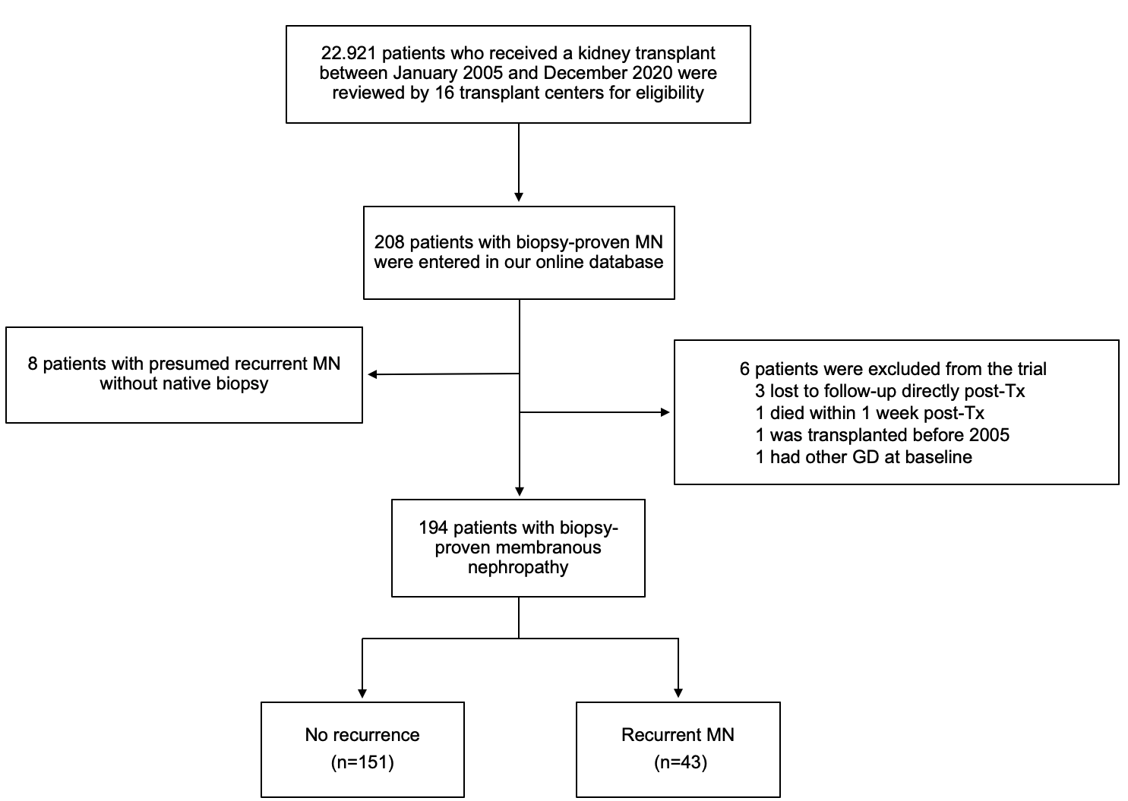
Supplemental Figure 1. Flow chart of the study selection.

MN, membranous nephropathy; Tx, transplant; GD, glomerular disease.
Supplemental Figure 2. 10-year incidence rate of MN recurrence per continent.

Supplemental Figure 3. Tacrolimus trough levels post-transplant in patients with MN recurrence. Comparison of tacrolimus trough levels according to treatment response either (A) directly post-transplant or (B) before and after MN recurrence diagnosis was established. Error bars indicate interquartile range around the median value.

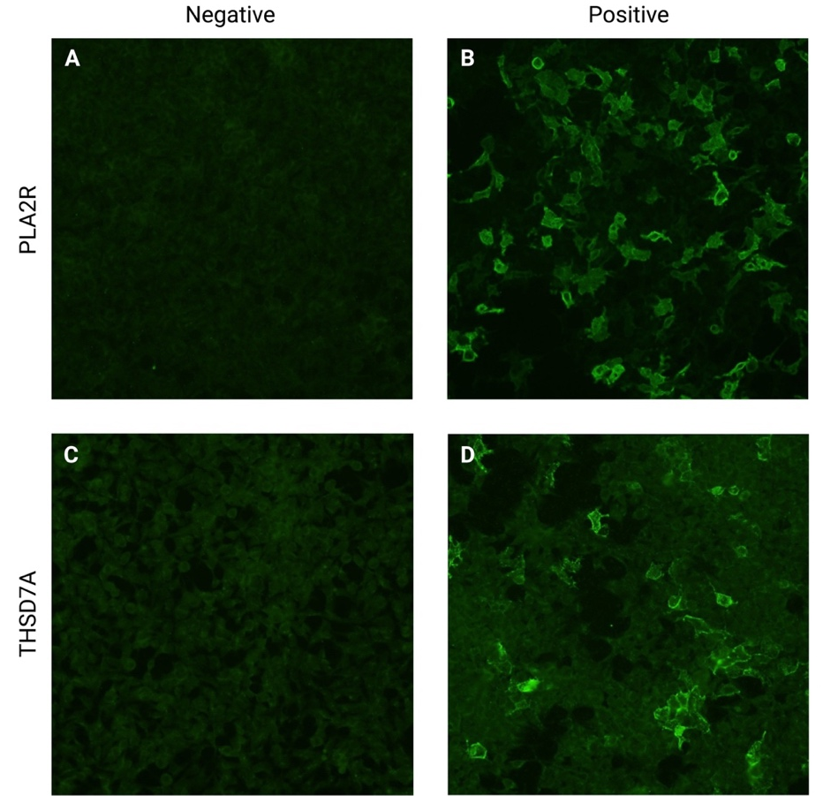
Supplemental Figure 4. IIF images of biochip coated with HEK293 tissue cells transfected with a recombinant construct of either PLA2R or THSD7A protein. Patients were categorized as either negative or positive for PLA2R (A and B) or THSD7A (C and D) antibodies based on reactivity to HEK293 tissue cells.

IIF, Indirect Immunofluorescence; HEK, human embryonic kidney; PLA2R, phospholipase A2 receptor; thrombospondin type 1 domain containing 7A.

Supplemental Figure 5. Kidney allograft survival according to treatment response in patients with recurrent MN.

Supplemental Methods
Definitions
Recurrence of MN was defined as having Immunoglobulin G (IgG) deposits and complement split factors along the subepithelial region of glomerular capillaries, with subsequent thickening of the glomerular basement membrane, and, in some cases segmental sclerosis and tubulointerstitial fibrosis^{15,16}.
Patients with potential MN recurrence because of proteinuria, worsening of kidney function, but without confirmatory kidney biopsy, were not classified as having a recurrence of MN.
Treatment response of recurrent MN was divided into complete, partial, or no remission. Complete remission was defined as a reduction of proteinuria below 0.3 g/24h (or 0.3 g/g of urinary creatinine) with stable estimated glomerular filtration (eGFR). Partial remission was defined as a reduction of proteinuria below 2.0 g/24h (or 2.0 g/g), or a reduction of proteinuria of at least 50% of the highest value to a level below 3.5 g/24h (or 3.5 g/g), both with stable eGFR.
The Modification of Diet in Renal Disease (MDRD) study equation was used to calculate the eGFR.
Patients were only registered for having had an acute antibody- or T cell-mediated rejection if they had a renal biopsy that was confirmed by the pathologist of the respective transplant center. Borderline rejection was not categorized as acute rejection.
Early steroid withdrawal was defined as discontinuation of steroids within three months post-transplantation.
De novo donor-specific antibody (DSA) was recorded when the mean fluorescence intensity (MFI) of anti-human leukocyte antigen (HLA) antibodies exceeded the center's positivity threshold.
Proteinuria was evaluated using a spot urine test, protein to creatinine ratio, or 24-hour urine collection, depending on the clinical practice of the transplant center.
Prior to kidney transplant, donor and recipient cytomegalovirus (CMV) IgG status was documented.
Patient's medical records were screened longitudinally to identify post-transplant complications, such as CMV infection, BK viremia, malignancy, cardiovascular events, and post-transplant diabetes. When a physician identified any of these conditions and recorded them in the medical records, they were documented accordingly.
Malignancy classification also encompassed skin cancers.
The onset of new diabetes was defined as a persistent increase in blood glucose levels after transplantation that required medication to lower glucose levels.

Patient Selection and Screening
Each of the 16 transplant centers conducted screenings for all patients who underwent a kidney transplant between January 2005 and December 2020, covering 16 years, resulting in a total of 22,921 transplant recipients. This screening process ensured the identification of all patients meeting our inclusion criteria. Teams at individual transplant centers, each led by at least one transplant nephrologist, examined individual medical records, including pre-transplant biopsy reports. They then added patients who met the inclusion and exclusion criteria in our online database. A centralized Post-Transplant Glomerular Diseases (TANGO) committee, composed of Leonardo V Riella, Paolo Cravedi, Audrey Uffing, and Frank Hullekes, reviewed each entered patient, taking into account biopsy reports that confirmed MN in the native kidney, and clinical data to rule out a potential secondary cause of MN. If required, the respective transplant center was asked to provide additional information. Six patients initially entered into the online database were subsequently excluded for various reasons. More specifically, three patients were lost to follow-up immediately post-transplant, one patient died within one-week post-transplant, one patient had another glomerular disease at baseline, and one patient had biopsy-proven MN but was transplanted in 2000. For more details, we refer to Supplemental Figure 1.

Identification of serum anti-PLA2R and THSD7A antibodies
Circulating anti-PLA2R antibodies were detected by FDA approved indirect immunofluorescence (IIF) and immunoassay (ELISA) kits (Euroimmun AG, Lubeck, Germany).
For detection of anti-PLA2R antibodies through IIF, diluted patient serum was incubated for 30 minutes at room temperature on Biochip substrates coated with human embryonic kidney (HEK) 293 tissue cells transfected with a recombinant construct of PLA2R1 or HEK293 cells coated with control negative construct. Positive and negative control sera were incubated at the same time. The biochips were then rinsed in PBS. After washing positive anti-PLA2R in the serum binding to the recombinant PLA2R1 construct was detected by incubating Biochip substrate with fluorescein isothiocyanate (FITC) labeled goat anti-human IgG for 30 minutes at room temperature. The biochips were then rinsed in phosphate-buffered saline (PBS), cover slipped in mounting medium, and examined under a fluorescence microscope 460-490 nm. Sera were scored as either negative or positive (Supplemental Figure 4). The indirect immunofluorescence has been shown to be slightly more sensitive than ELISA.
Quantitation of positive anti-PLA2R sera was determined using the Euroimmun ELISA Kit. Patient serum was diluted 1:100. 100 microliters of the diluted serum was incubated in microplate wells coated with a recombinant PLA2R1 (M-type) based on human cDNA in a human cell line for 30 minutes at room temperature. The 5 calibrators for the standard curve and positive and negative controls were incubated at the same time. The plates were drained, washed three times with wash buffer, and then incubated with peroxidase-labeled anti-human IgG for 30 minutes at room temperature. The plates were washed and then incubated with etramethyl benzidine/hydrogen Peroxide (TMB/H₂O₂) a chromogen substrate for peroxidase for 15 minutes at room temperature. To stop the reaction 100 microliters of 0.5 M sulfuric acid was pipetted into each microplate well. The optical density was measured using BioTek Synergy HTX multimode plate reader at a wavelength of 450 nm and a reference wavelength of 630 nm. A standard curve was generated using the 5 calibrators. The curve fit was determined using a 4-parameter linear regression and the quantitation of anti-PLA2R in diluted patient’s serum specimens, positive and negative controls was extrapolated using the standard curve fit, positive ≥ 20 relative units (RU)/mL, borderline ≥ 14 to < 20 RU/mL, and negative < 14 RU/mL. Circulating anti-THSD7A was detected by indirect immunofluorescence kit (EUROIMMUN AG, Lübeck, Germany). Patients’ serum was diluted 1:10 and incubated on Biochips coated with THSD7A-transfected cells and negative control transfected cells at room temperature for 30 minutes. After washing, the slides were incubated with FITC-conjugated secondary antibody to human IgG at room temperature for 30 minutes. The slides were then examined under a fluorescence microscope 450-490 nm (Supplemental Figure 4).
Additionally, 9 patients had been tested clinically at their transplant center prior to transplantation and had results of ELISA PLA2R antibody available. For these 9 patients, results were considered positive if the PLAR2 titer was ≥ 20 RU/mL and negative when the titer was < 14 RU/mL. None of these 9 patients had a borderline titer result (≥ 14 RU/mL to < 20 RU/mL).

Statistical analysis of Imputed data
All predictors and the outcome underwent Little's missing completely at random (MCAR) test to examine the randomness of the missing data. The test resulted in a nonsignificant outcome, indicating that the missing data were random. To impute missing data, STATA's multiple imputation by chained equations (MICE) procedure was used¹⁷. This procedure used logistic regression, ordinal regression, linear regression, and predictive mean matching to impute missing values for categorical, ordinal, normal continuous, and non-normal continuous variables, respectively. All predefined predictors, including recurrence and graft failure, were used to impute each missing value, resulting in 100 imputations per value. Augmentation was performed in cases of perfect prediction to prevent bias in the imputations. The imputations were assessed graphically for outliers and variances, and the coefficients of the imputed cox-models were compared with those of the complete case analysis to ensure agreement. Schoenfeld residuals were used to evaluate the proportional-hazard assumption, and no violation was detected. While investigating a potential correlation between circulating anti-PLA2R antibodies and MN recurrence, we conducted posthoc analyses involving Bonferroni tests for multiple paired comparisons.

Predictor Selection
We selected and collected data on several potential predictors of recurrent MN based on prior literature and clinical practice. These predictors included age at diagnosis, body mass index (BMI), time from diagnosis to end-stage kidney disease (ESKD), HLA-mismatch, living donor status, age of the donor, pre-emptive transplant, use of induction therapy, and immunosuppressive regimen.
Data storage
A specially designed database was used to store all the data, which was entered and accessed through a secure, health insurance portability and accountability act (HIPAA) compliant web-based application called REDCapTM. The application was hosted by the Partners HealthCare Research Computing, Enterprise Research Infrastructure and Services (ERIS) group. Investigators were given access to the secure website to enter and access patient data online, but were only able to view data from their respective centers and not from other centers. To ensure the confidentiality of participants, specific dates were date-shifted upon downloading of the dataset, completing the de-identification process.
Ethical considerations
The overall protocol of the TANGO-Consortium was submitted and approved by the ethical committee of the Partners Human Research Committee (PHRC) at Massachusetts General Hospital in Boston (protocol number: 2015P000993). Other participating centers ensured that they were compliant with their ethical committee policies before transferring data and samples. The protocols used in this study adhere to the Good Clinical Practice Guidelines of the International Conference on Harmonization and the Declaration of Helsinki. The clinical and research activities reported in this study are consistent with the Principles of the Declaration of Istanbul as outlined in the 'Declaration of Istanbul on Organ Trafficking and Transplant Tourism'¹⁸.

Supplemental References

1. Briganti EM, Russ GR, McNeil JJ, Atkins RC, Chadban SJ. Risk of renal allograft loss from recurrent glomerulonephritis. N Engl J Med. Jul 11 2002;347(2):103-9. doi:10.1056/NEJMoa013036
2. Dabade TS, Grande JP, Norby SM, Fervenza FC, Cosio FG. Recurrent idiopathic membranous nephropathy after kidney transplantation: a surveillance biopsy study. Am J Transplant. Jun 2008;8(6):1318-22. doi:10.1111/j.1600-6143.2008.02237.x
3. Chailimpamontree W, Dmitrienko S, Li G, et al. Probability, predictors, and prognosis of posttransplantation glomerulonephritis. J Am Soc Nephrol. Apr 2009;20(4):843-51. doi:10.1681/asn.2008050454
4. El-Zoghby ZM, Grande JP, Fraile MG, Norby SM, Fervenza FC, Cosio FG. Recurrent idiopathic membranous nephropathy: early diagnosis by protocol biopsies and treatment with anti-CD20 monoclonal antibodies. Am J Transplant. Dec 2009;9(12):2800-7. doi:10.1111/j.1600-6143.2009.02851.x
5. Moroni G, Gallelli B, Quaglini S, et al. Long-term outcome of renal transplantation in patients with idiopathic membranous glomerulonephritis (MN). Nephrol Dial Transplant. Oct 2010;25(10):3408-15. doi:10.1093/ndt/gfq223
6. Sprangers B, Lefkowitz GI, Cohen SD, et al. Beneficial effect of rituximab in the treatment of recurrent idiopathic membranous nephropathy after kidney transplantation. Clin J Am Soc Nephrol. May 2010;5(5):790-7. doi:10.2215/cjn.04120609
7. Seitz-Polski B, Payré C, Ambrosetti D, et al. Prediction of membranous nephropathy recurrence after transplantation by monitoring of anti-PLA2R1 (M-type phospholipase A2 receptor) autoantibodies: a case series of 15 patients. Nephrol Dial Transplant. Dec 2014;29(12):2334-42. doi:10.1093/ndt/gfu252
8. Quintana LF, Blasco M, Seras M, et al. Antiphospholipase A2 Receptor Antibody Levels Predict the Risk of Posttransplantation Recurrence of Membranous Nephropathy. Transplantation. Aug 2015;99(8):1709-14. doi:10.1097/tp.0000000000000630
9. Grupper A, Cornell LD, Fervenza FC, Beck LH, Jr., Lorenz E, Cosio FG. Recurrent Membranous Nephropathy After Kidney Transplantation: Treatment and Long-Term Implications. Transplantation. Dec 2016;100(12):2710-2716. doi:10.1097/tp.0000000000001056
10. Gupta G, Fattah H, Ayalon R, et al. Pre-transplant phospholipase A2 receptor autoantibody concentration is associated with clinically significant recurrence of membranous nephropathy post-kidney transplantation. Clin Transplant. Apr 2016;30(4):461-9. doi:10.1111/ctr.12711
11. Cosio FG, Cattran DC. Recent advances in our understanding of recurrent primary glomerulonephritis after kidney transplantation. Kidney Int. Feb 2017;91(2):304-314. doi:10.1016/j.kint.2016.08.030
12. Yang WL, Bose B, Zhang L, et al. Long-term outcomes of patients with end-stage kidney disease due to membranous nephropathy: A cohort study using the Australia and New Zealand Dialysis and Transplant Registry. PLoS One. 2019;14(8):e0221531. doi:10.1371/journal.pone.0221531
13. Batal I, Vasilescu ER, Dadhania DM, et al. Association of HLA Typing and Alloimmunity With Posttransplantation Membranous Nephropathy: A Multicenter Case Series. Am J Kidney Dis. Sep 2020;76(3):374-383. doi:10.1053/j.ajkd.2020.01.009
14. Chung EYM, Blazek K, Teixeira-Pinto A, et al. Predictive Models for Recurrent Membranous Nephropathy After Kidney Transplantation. Transplant Direct. Sep 2022;8(9):e1357. doi:10.1097/txd.0000000000001357
15. KDIGO 2021 Clinical Practice Guideline for the Management of Glomerular Diseases. Kidney Int. Oct 2021;100(4s):S1-s276. doi:10.1016/j.kint.2021.05.021
16. Fogo AB, Lusco MA, Najafian B, Alpers CE. AJKD Atlas of Renal Pathology: Membranous Nephropathy. Am J Kidney Dis. Sep 2015;66(3):e15-7. doi:10.1053/j.ajkd.2015.07.006
17. Blazek K, van Zwieten A, Saglimbene V, Teixeira-Pinto A. A practical guide to multiple imputation of missing data in nephrology. Kidney Int. Jan 2021;99(1):68-74. doi:10.1016/j.kint.2020.07.035
18. Muller E, Dominguez-Gil B, Martin D. The Declaration of Istanbul on Organ Trafficking and Transplant Tourism (2018 Edition) Introduction. Transplantation. Feb 2019;103(2):217. doi:10.1097/tp.0000000000002541

