Annex 1
High-resolution images acquired for monitoring the infestation of the stone pine (Pinus pinea L.) on the Castelporziano Presidential Estate (CPE) are presented.
The annex is organized presenting images per acquisition sensor, clearly highlighting how the health status of the pine forests on the CPE has progressively deteriorated.
To highlight the potential of this data, some images in the panchromatic band are shown, along with the annual images in RGB and false color.
Based on the available bands, the NDVI index and its variation from one year to the previous have also been calculated.
$$NDVI=\frac{(NIR-RED)}{(NIR+RED)},$$
Finally, the photointerpretation work is presented, with the mapping produced for each year.

DigitalGolobe
Spatial resolution 2 m, RGB + IR bands
Zoom in true color (RGB) spatial resolution 2 m (2017)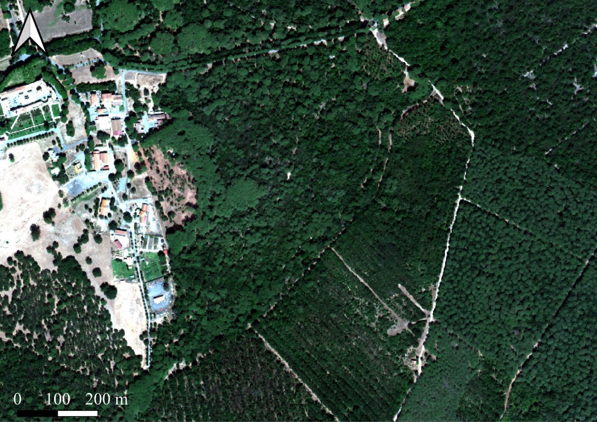
Same zoom area in panchromatic 0.50 m resolution (2017)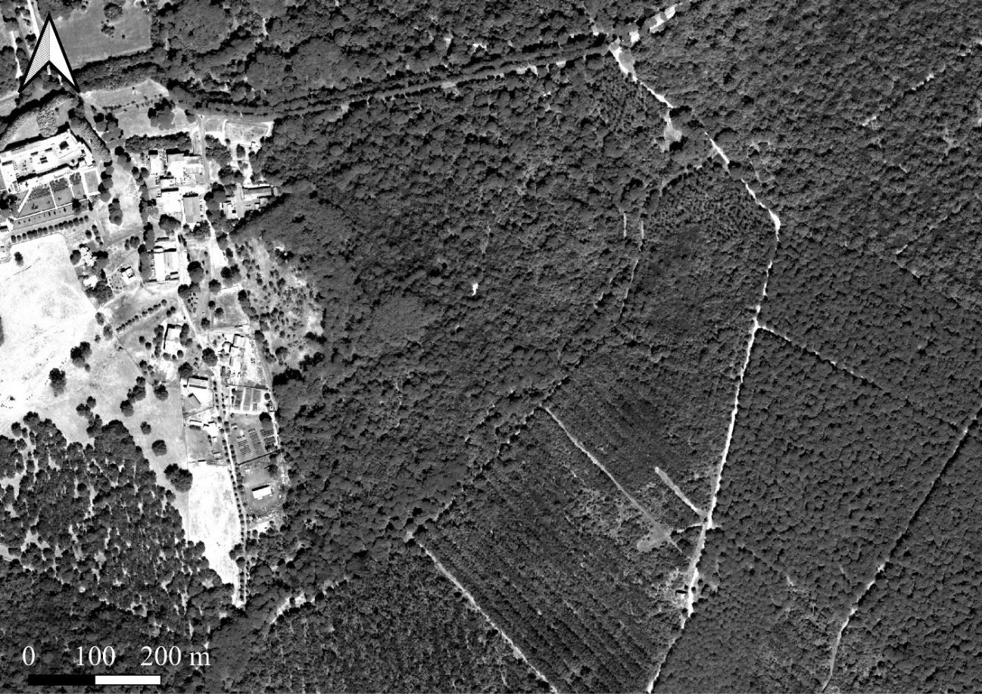

May 31st 2015 August 14th 2017
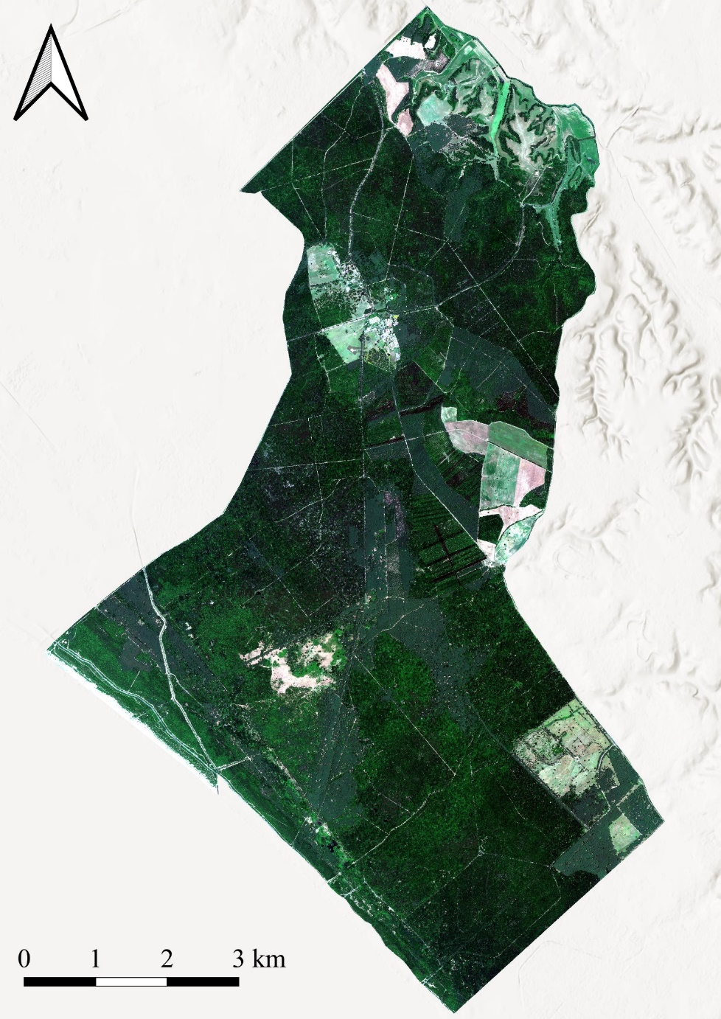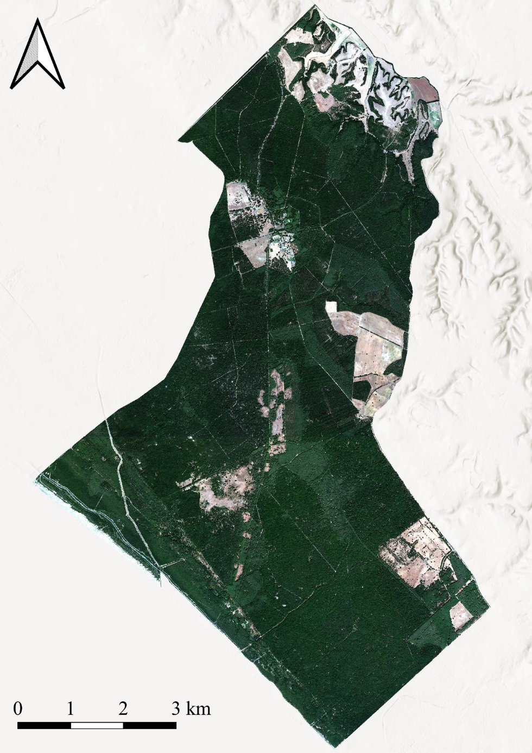

August 11th 2019 August 19th 2020
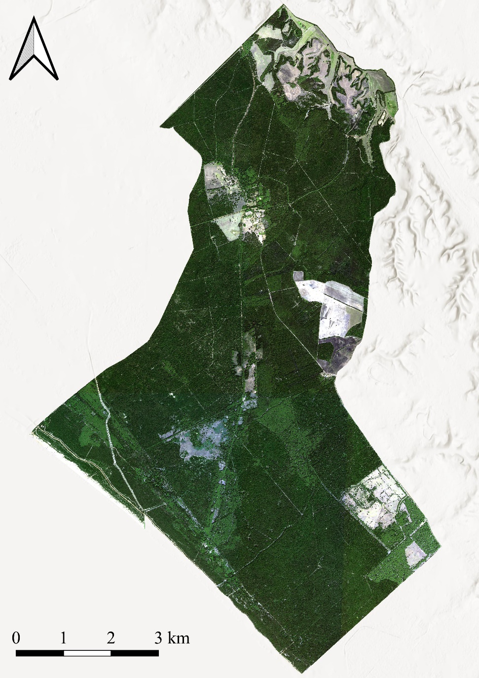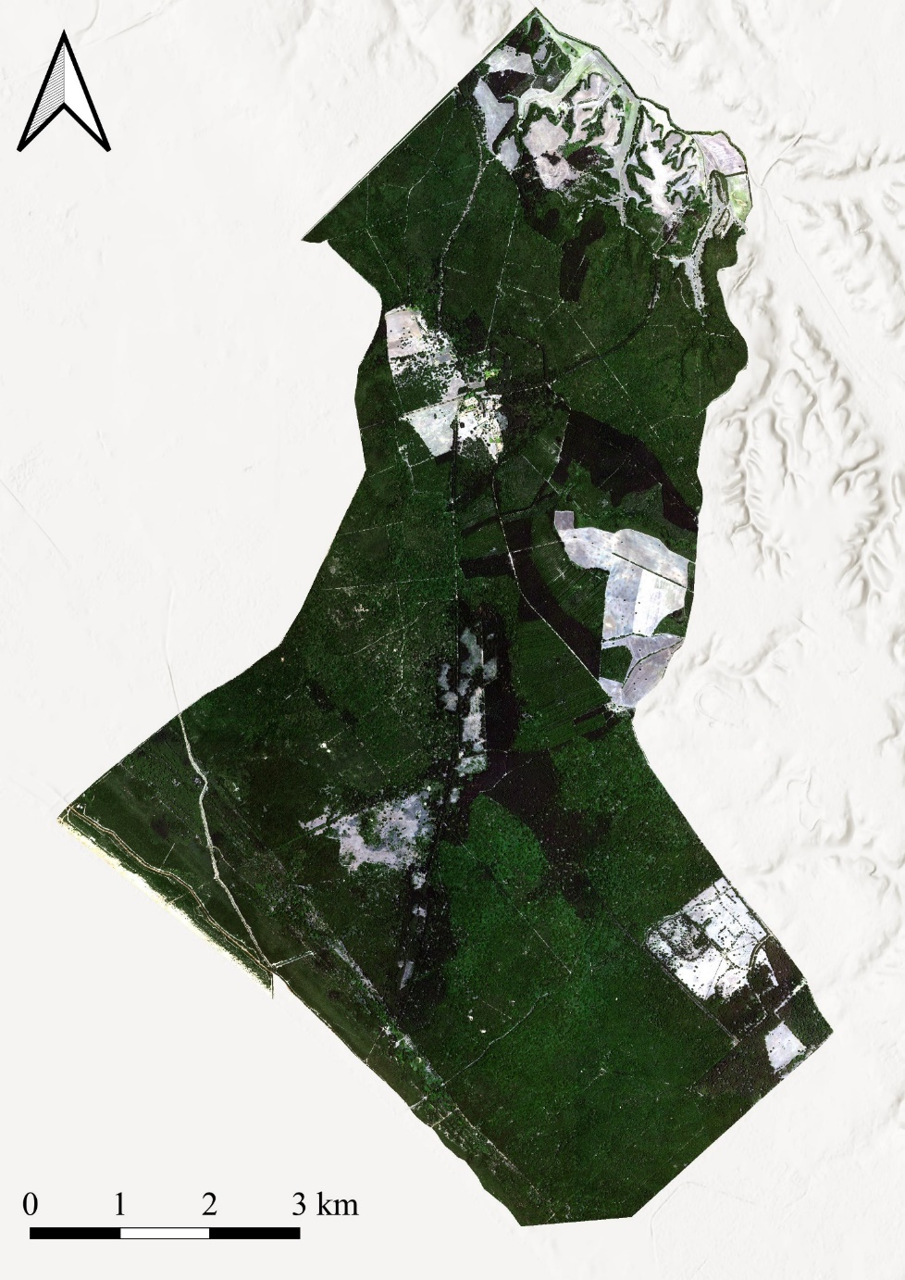

Pleiades
Spatial resolution 2 m, RGB+IR
Zoom in true color (RGB) spatial resolution 2 m (2015)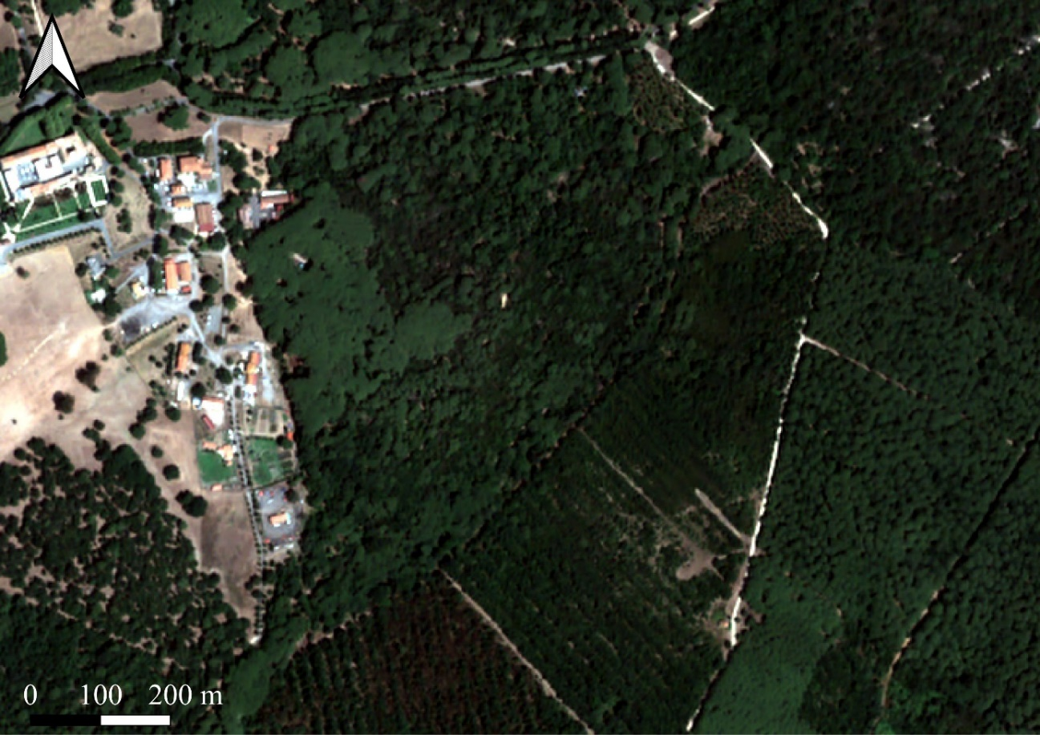
Same zoom area in panchromatic 0.50 m resolution (2015)
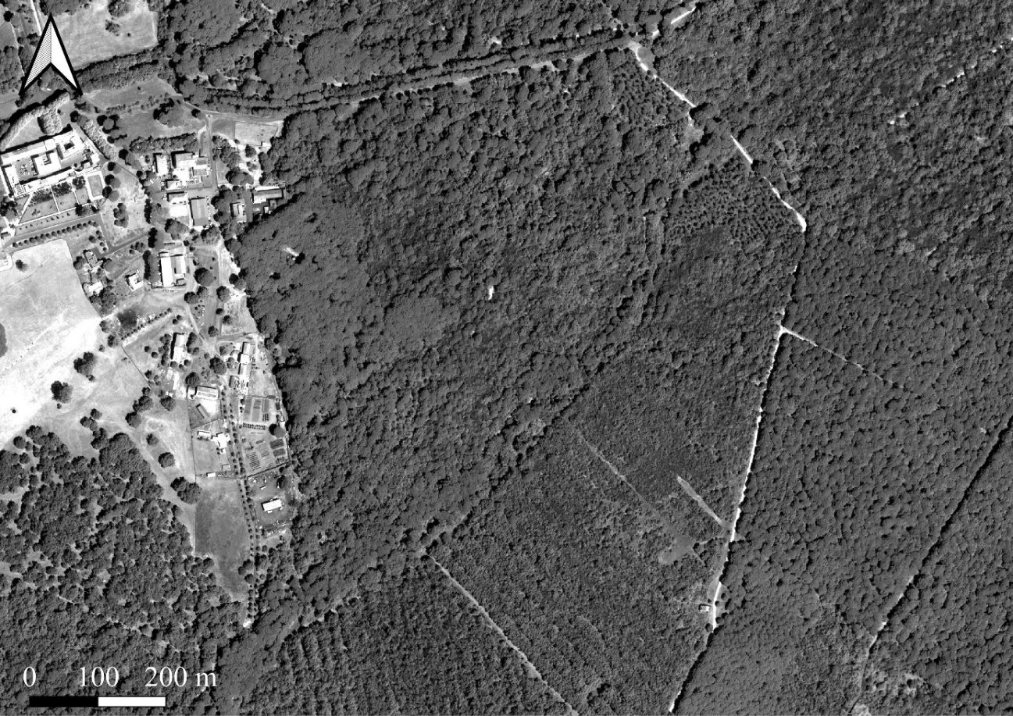

August 6th 2015 August 11th 2018
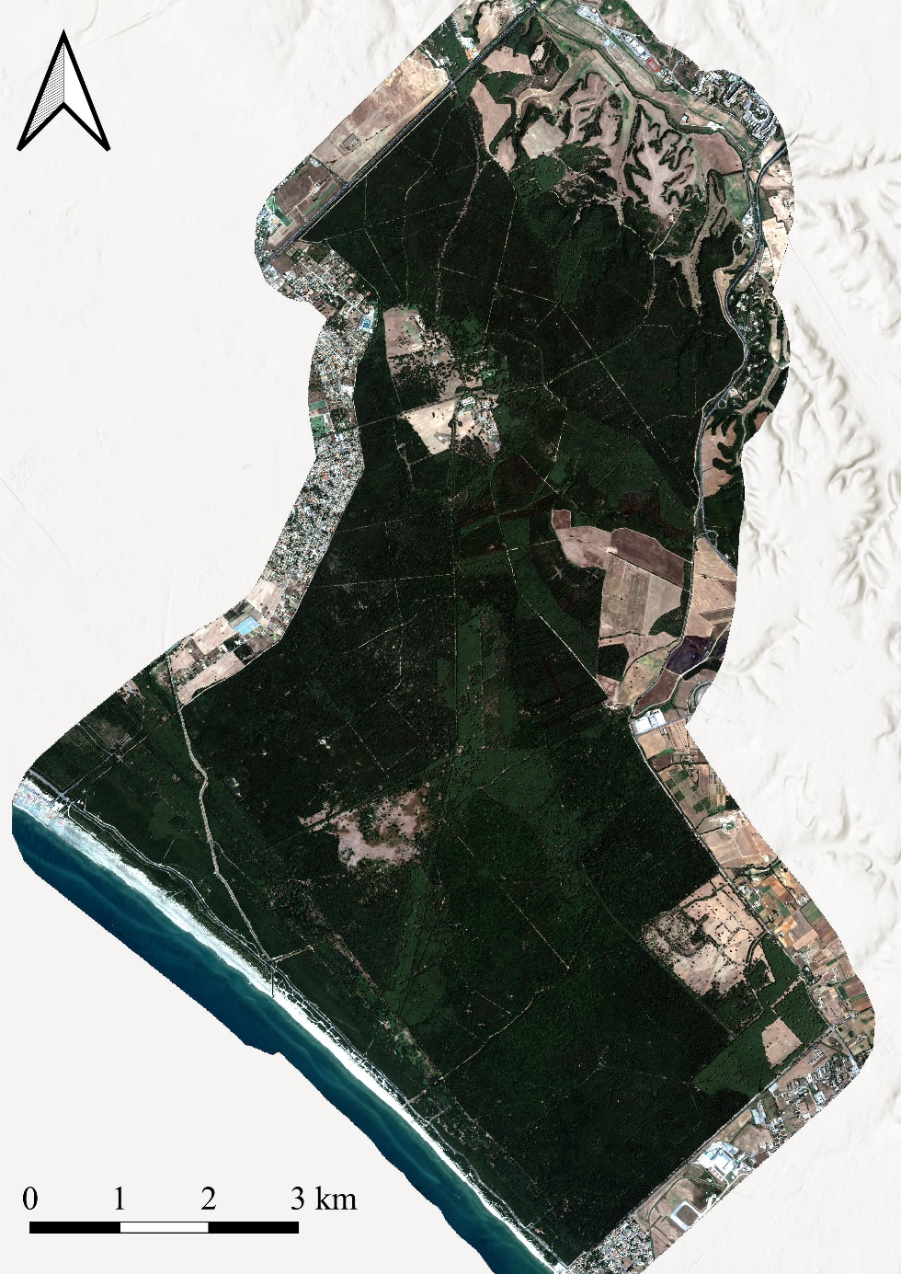
August 16th 2019 August 6th 2020
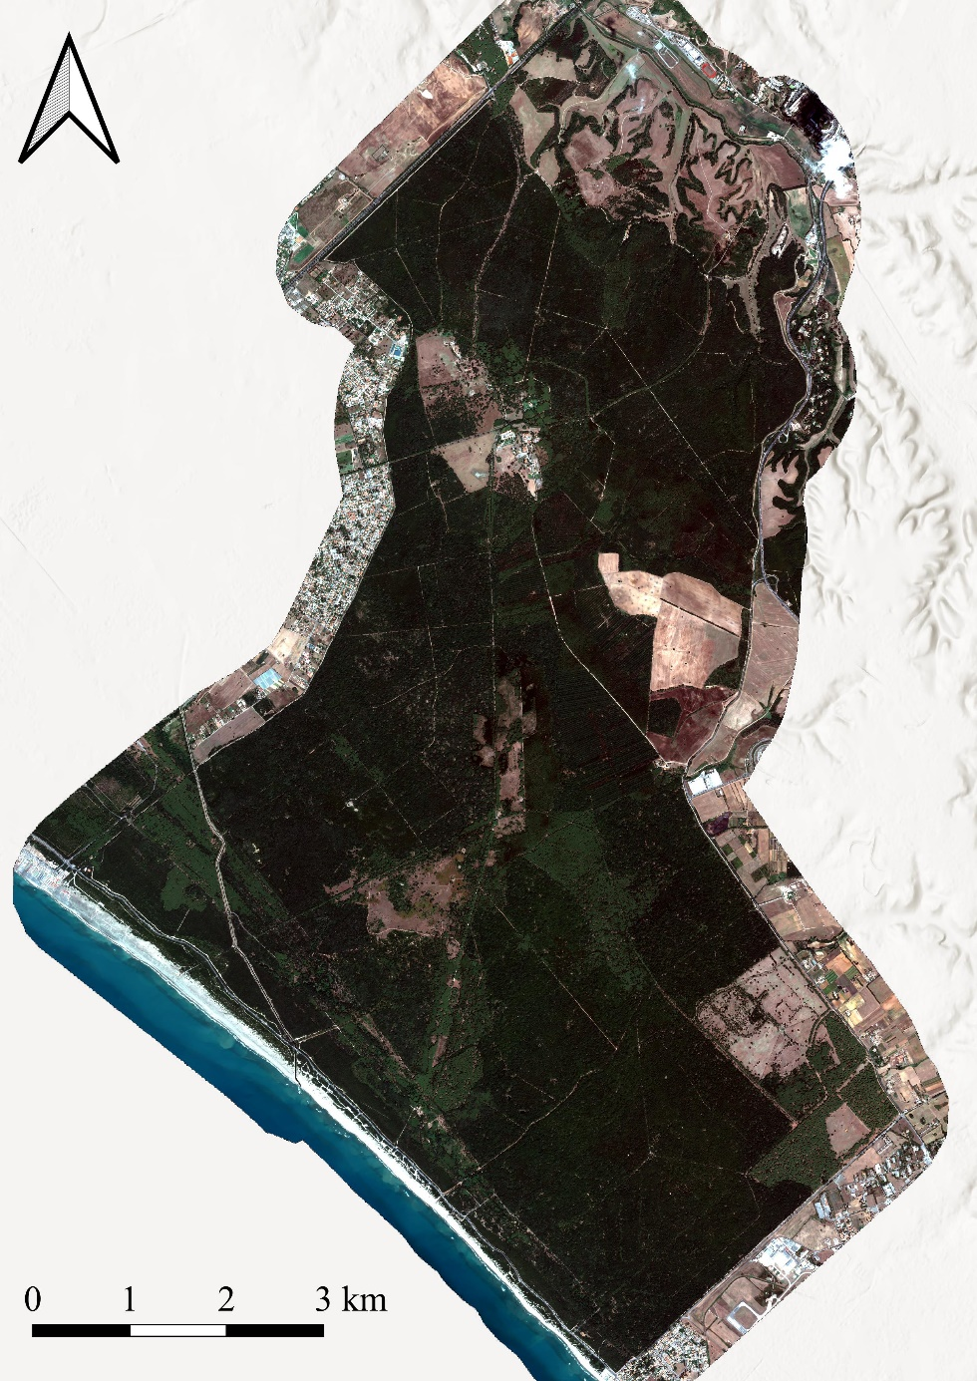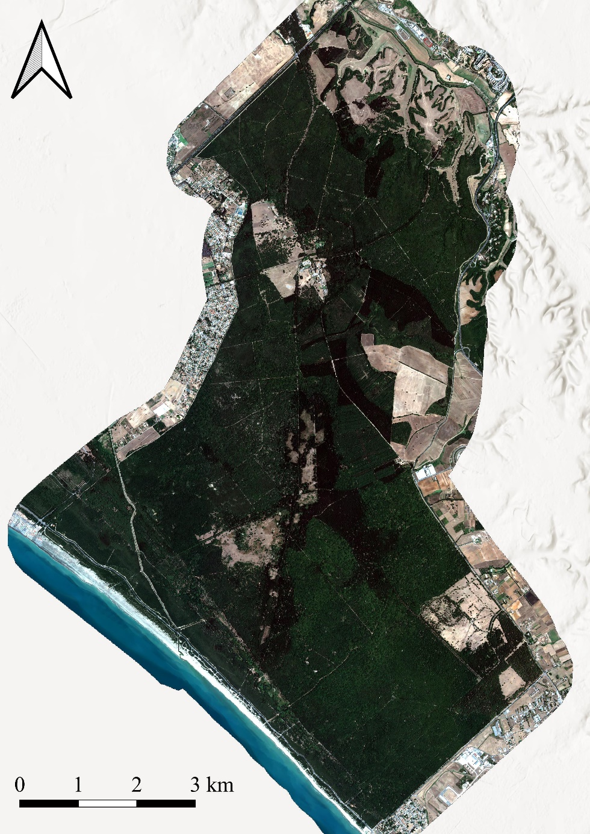

April 4th 2021
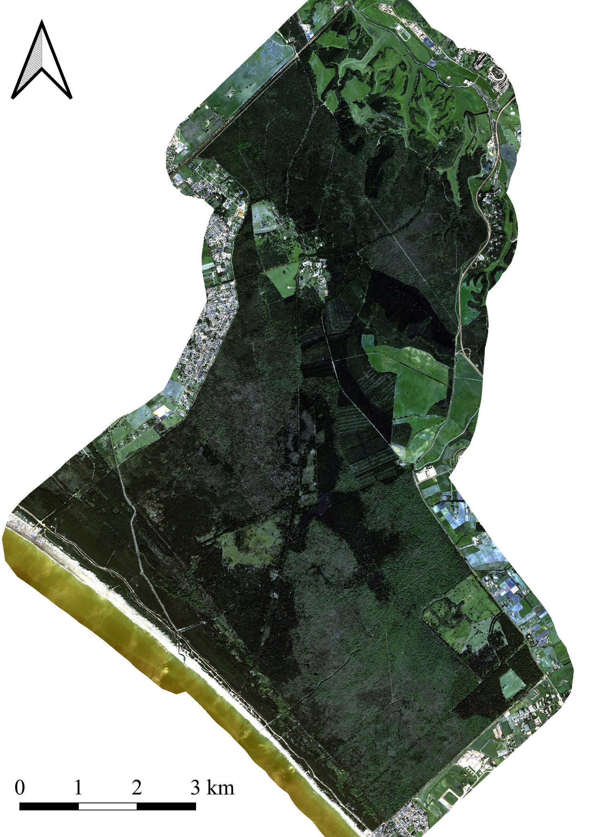

Panchromatic image
Pine forest degradation evolution with multitemporal panchromatic image (0.5 m resolution).
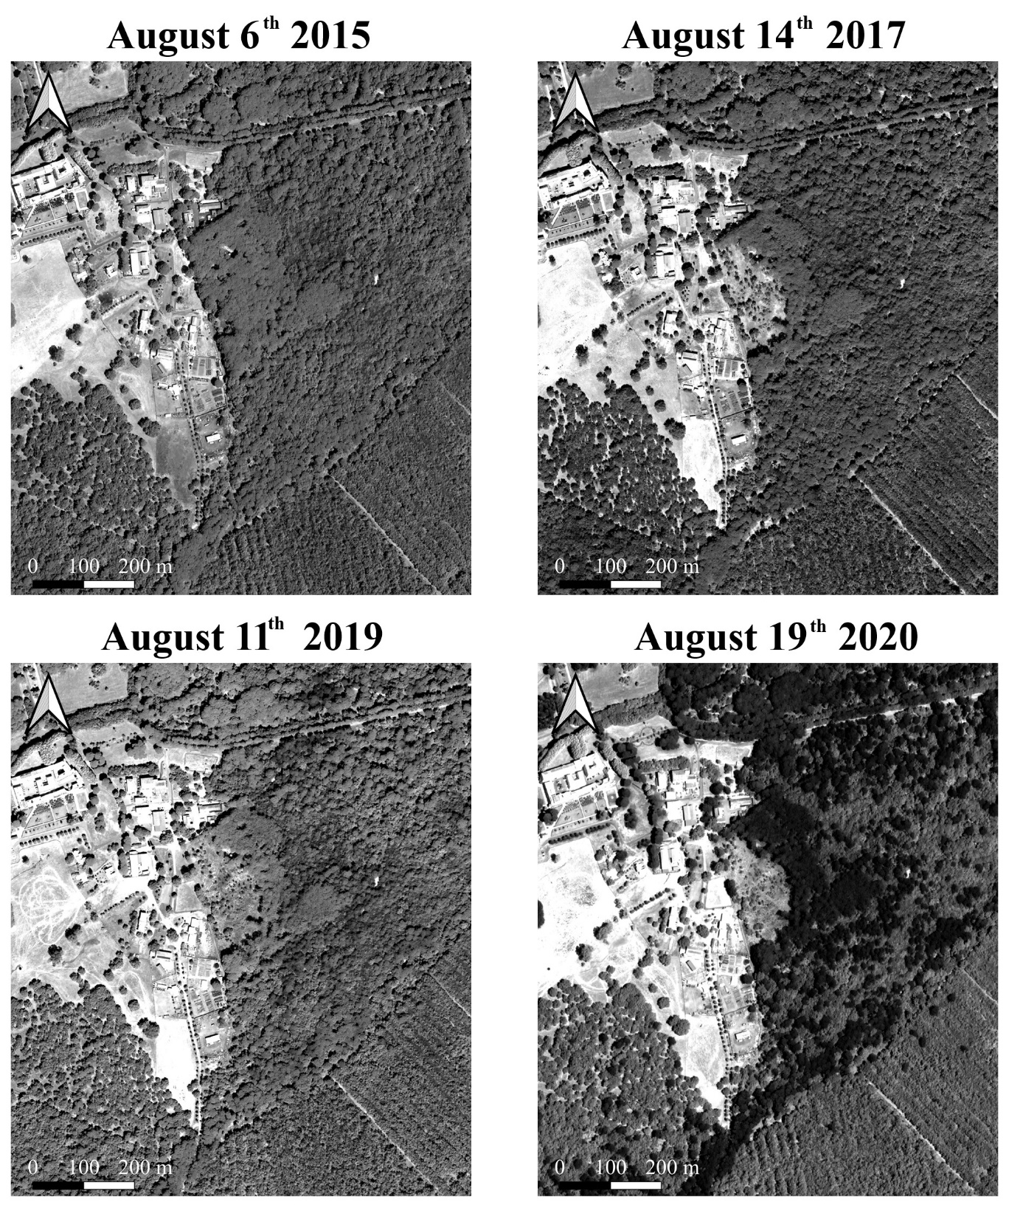

False color image
August 11th 2018 August 11th 2019
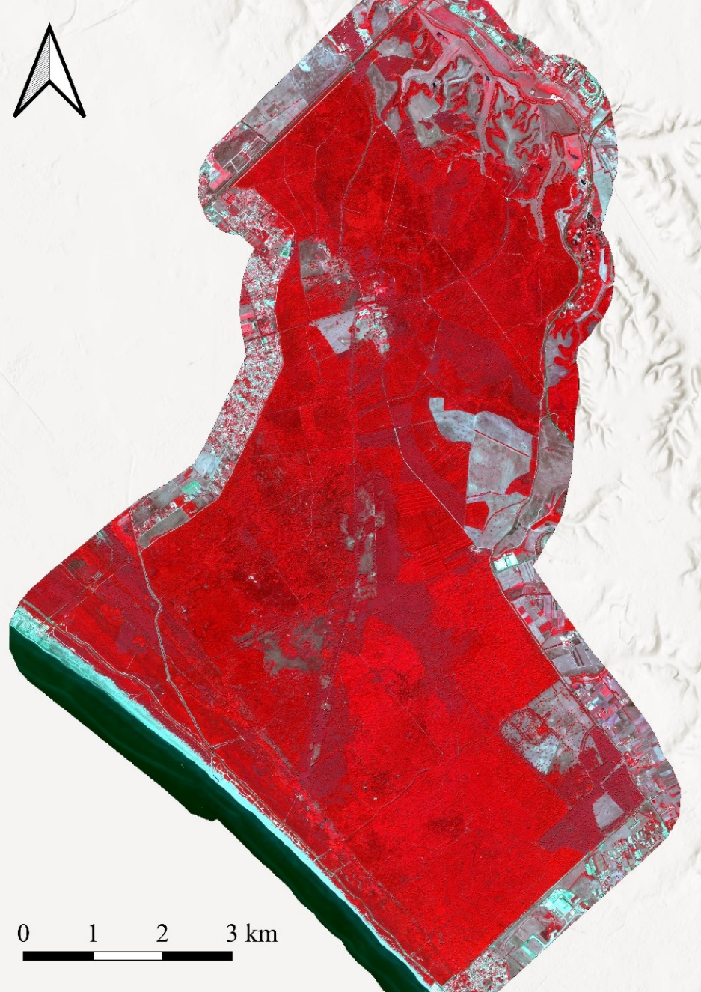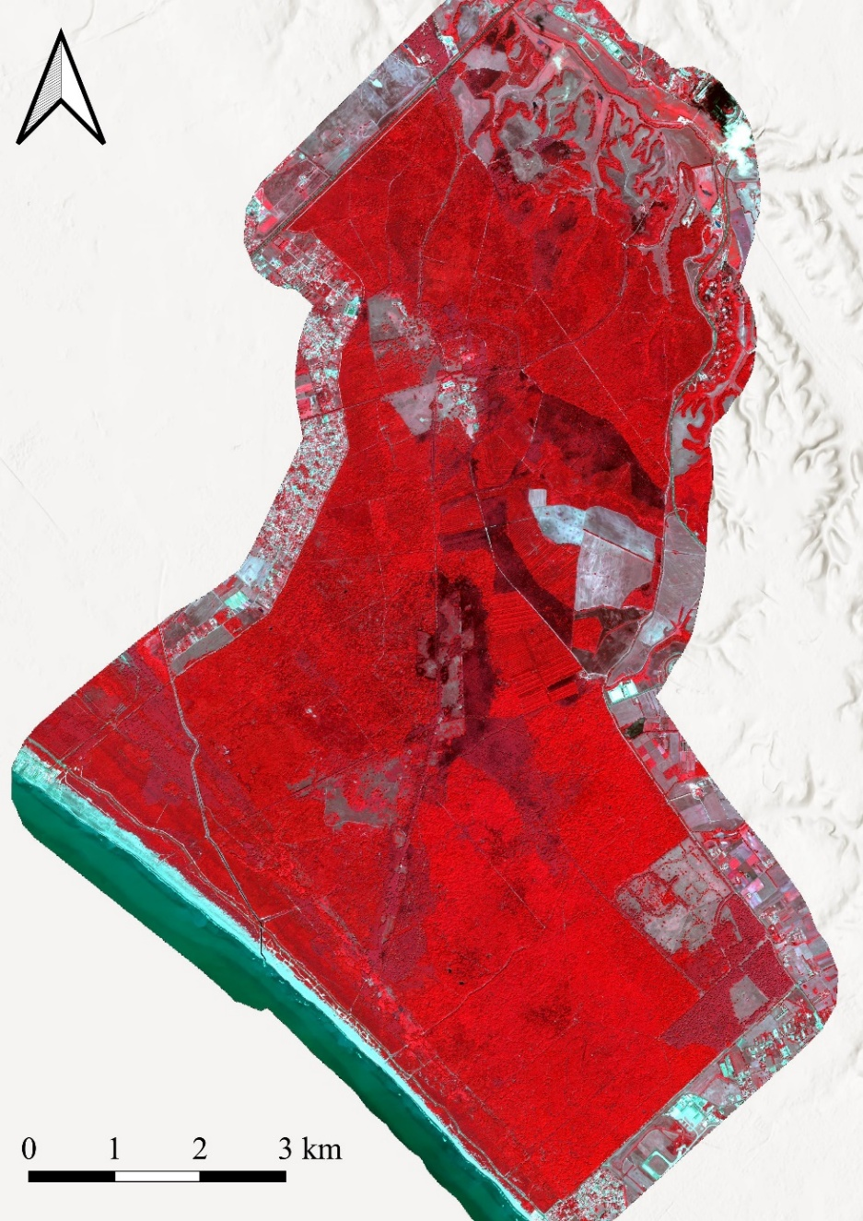

August 6th 2020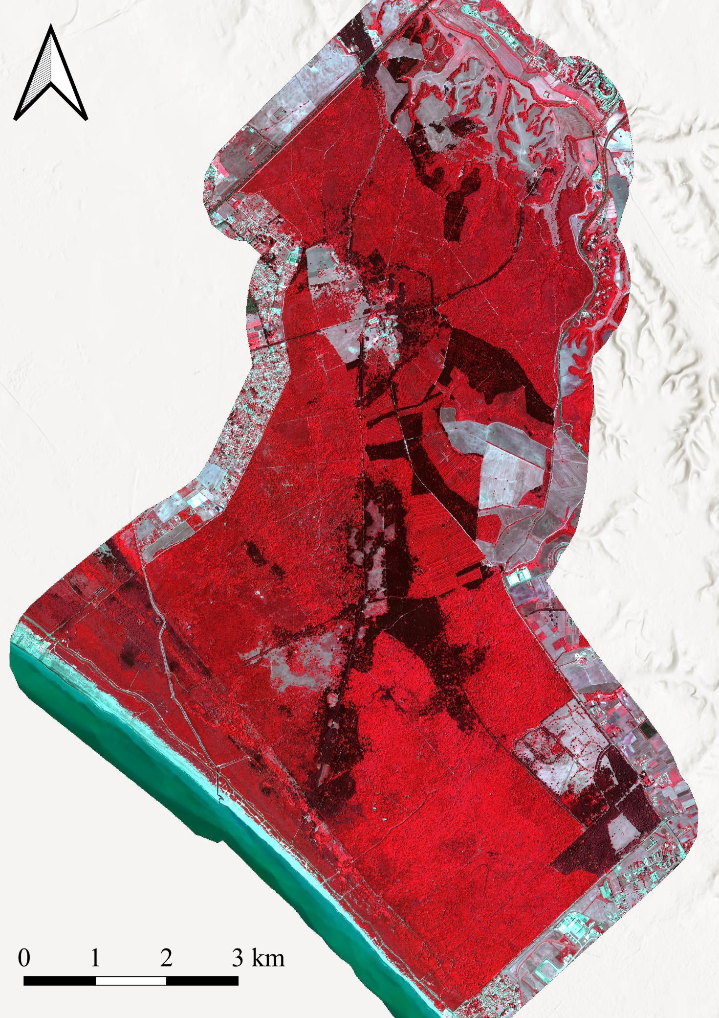
April 4th 2021
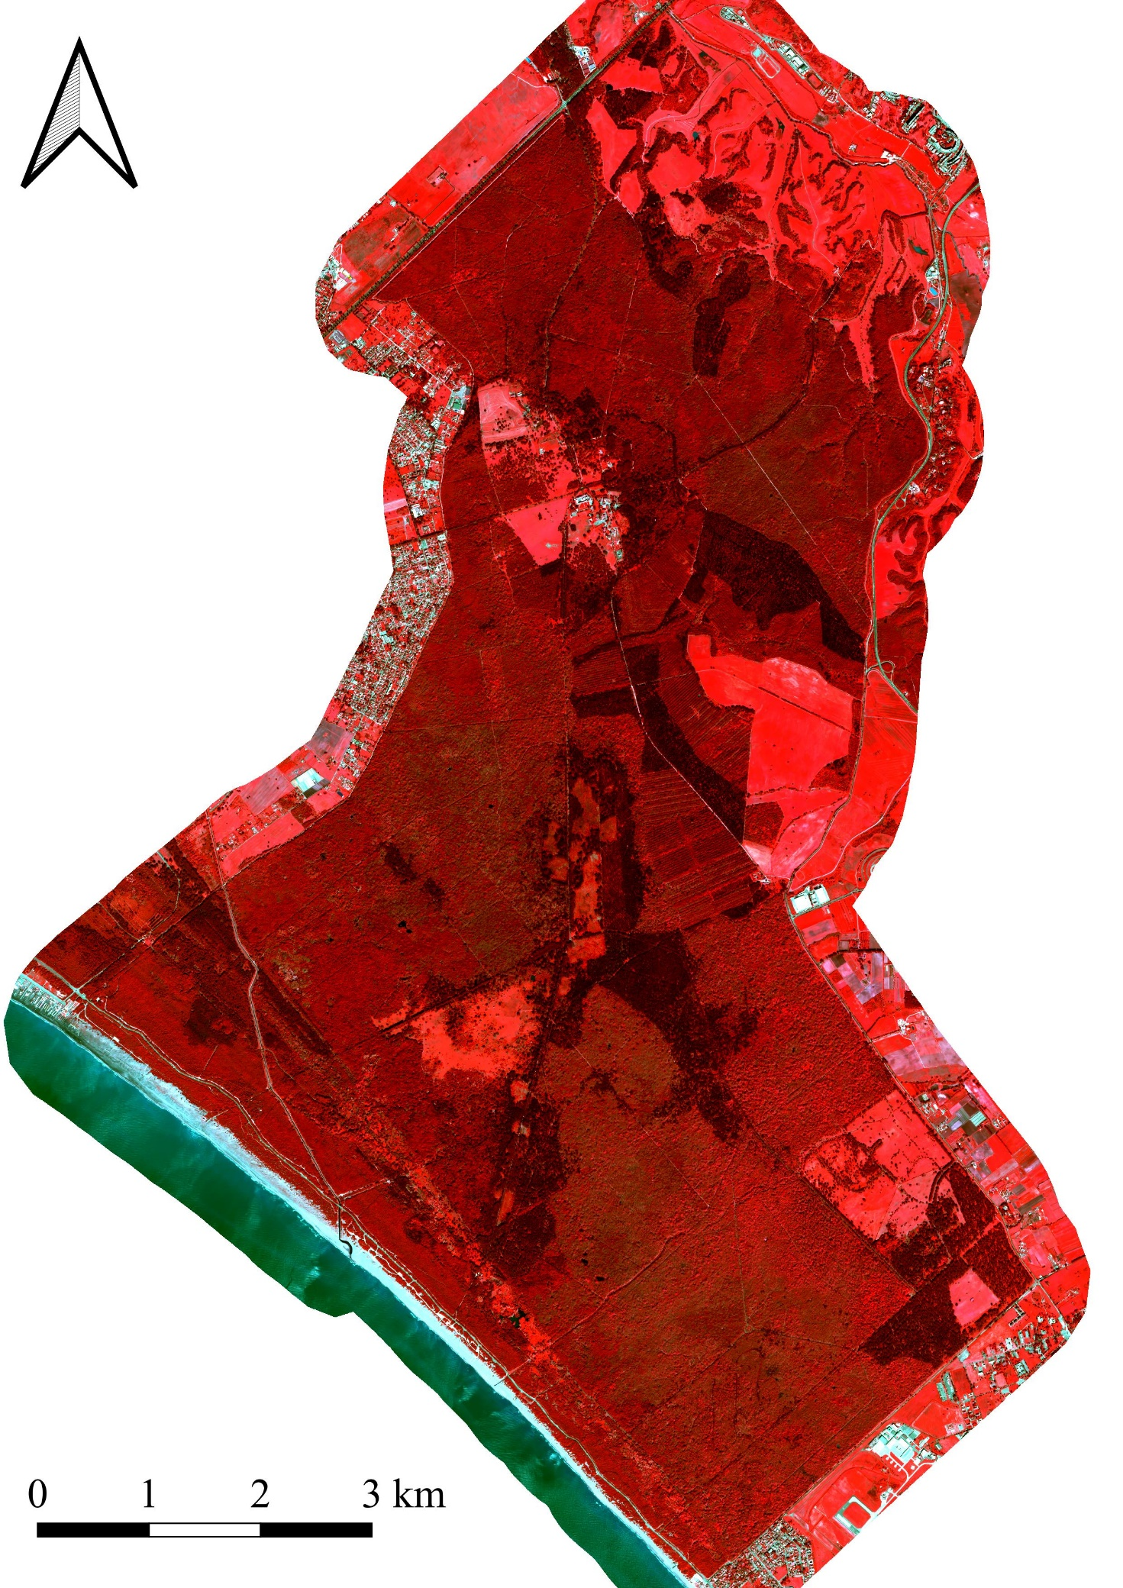

False color zoom
2015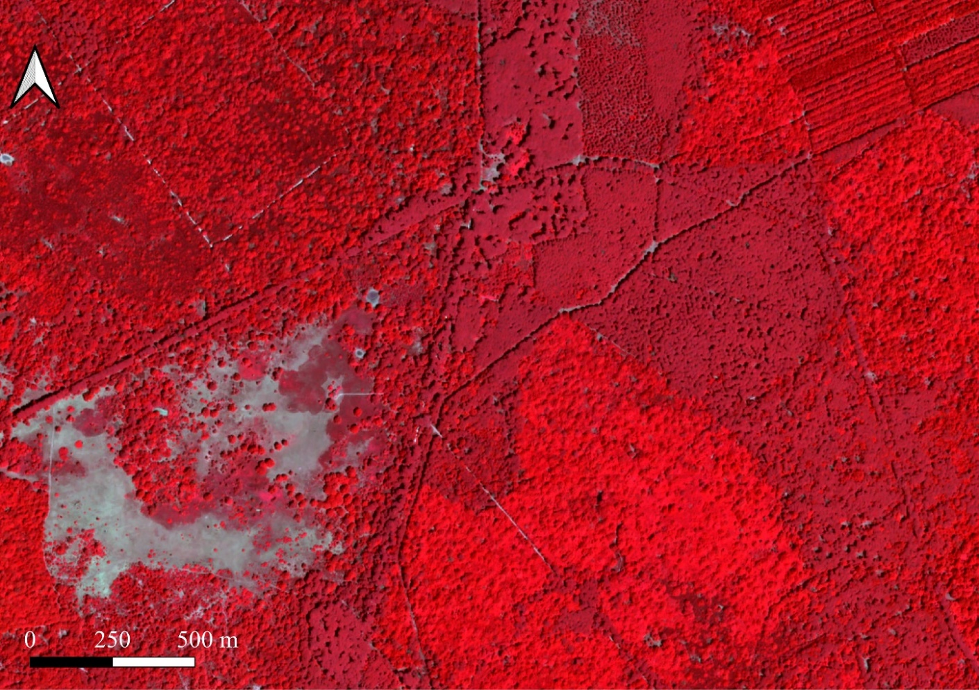
2018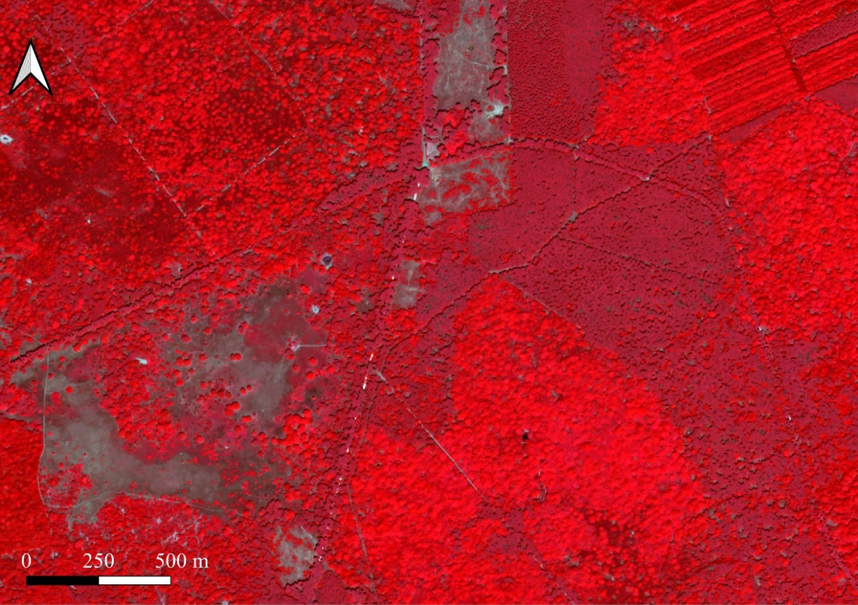
2019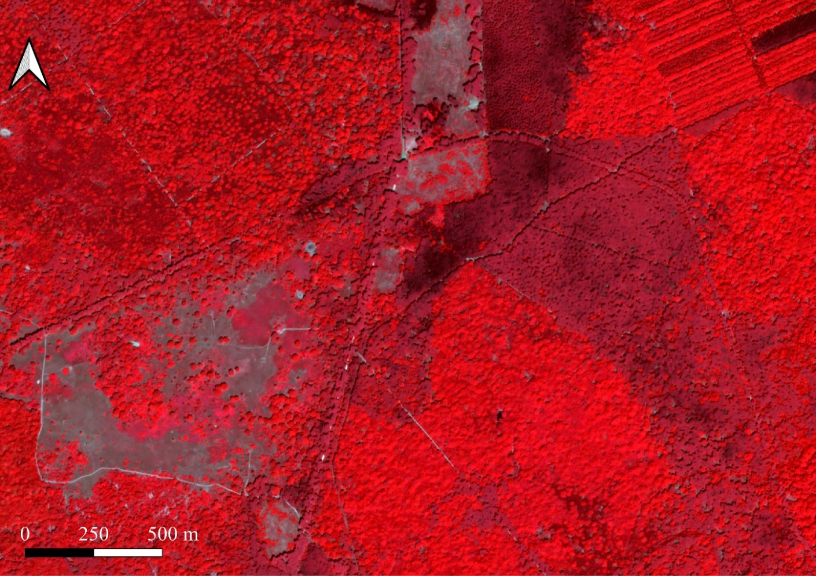
2020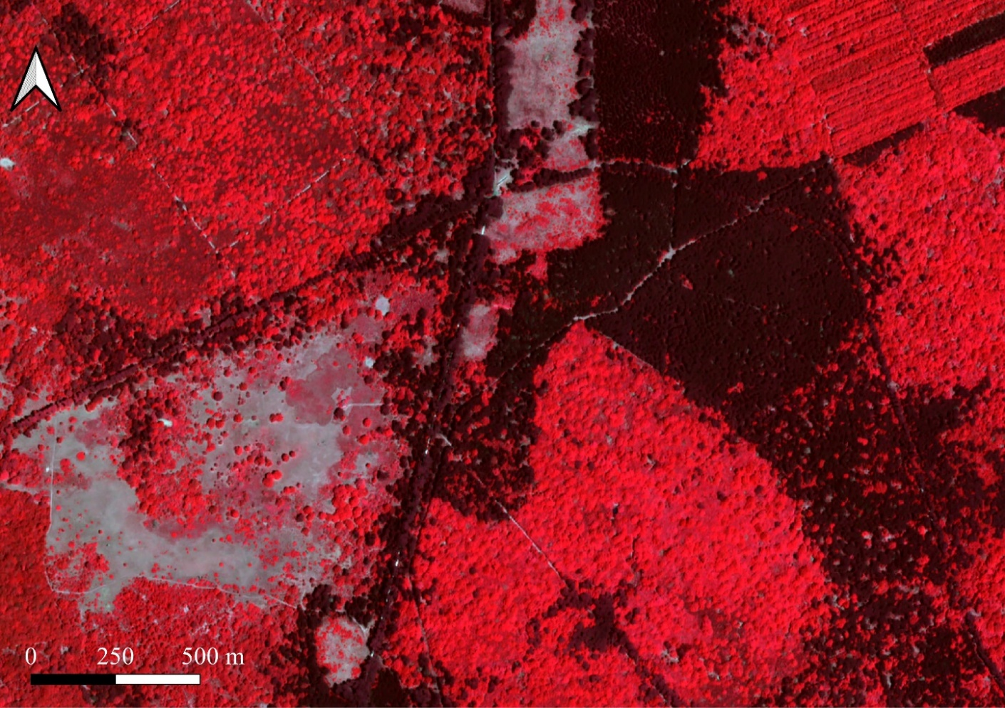

6. NDVI
2015 2018
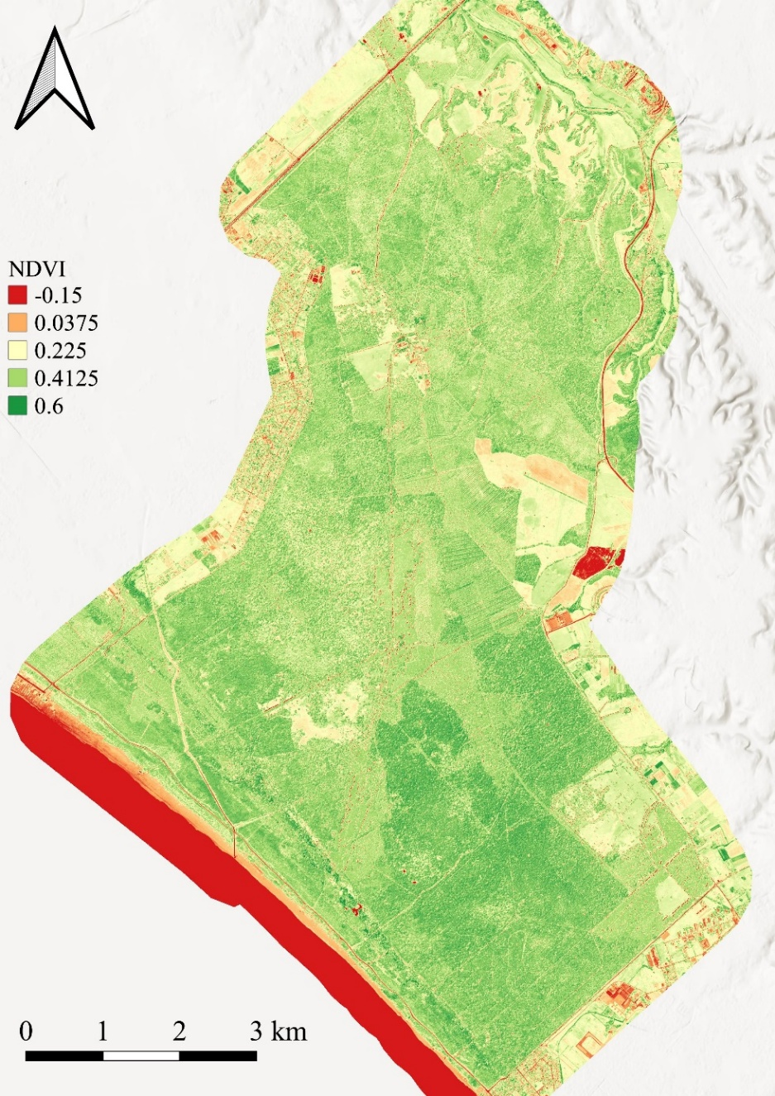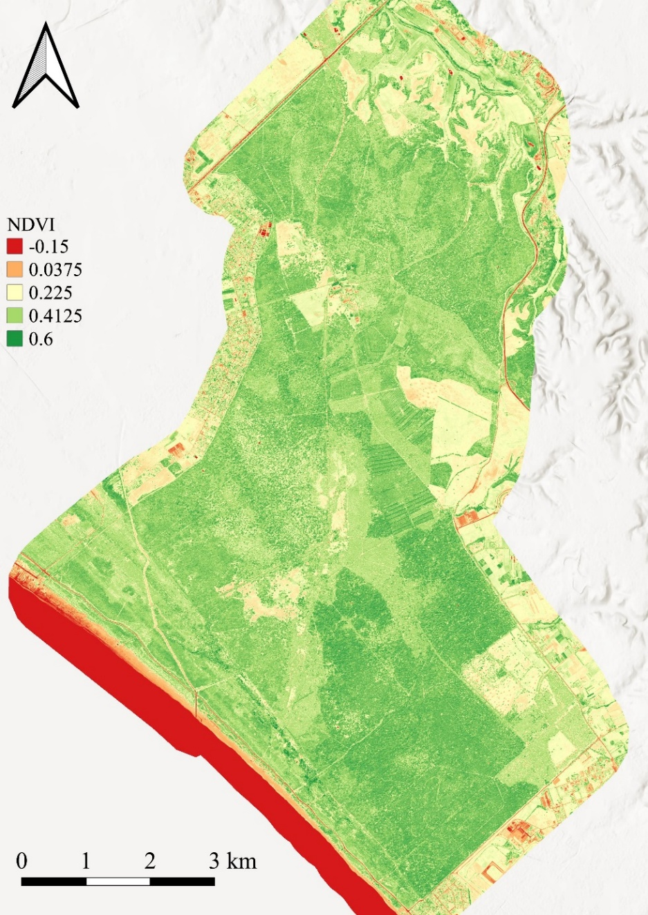

2019 2020
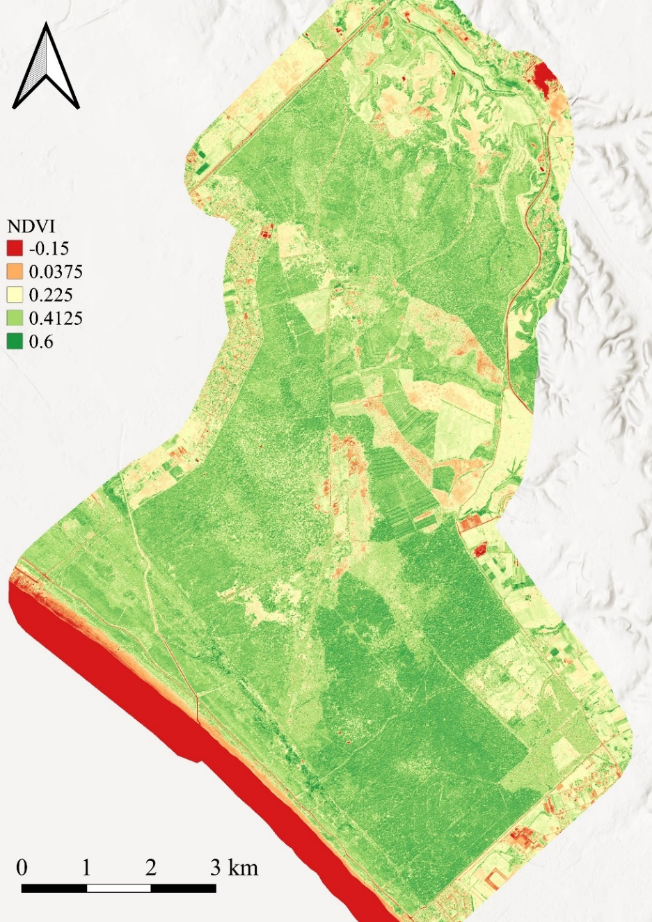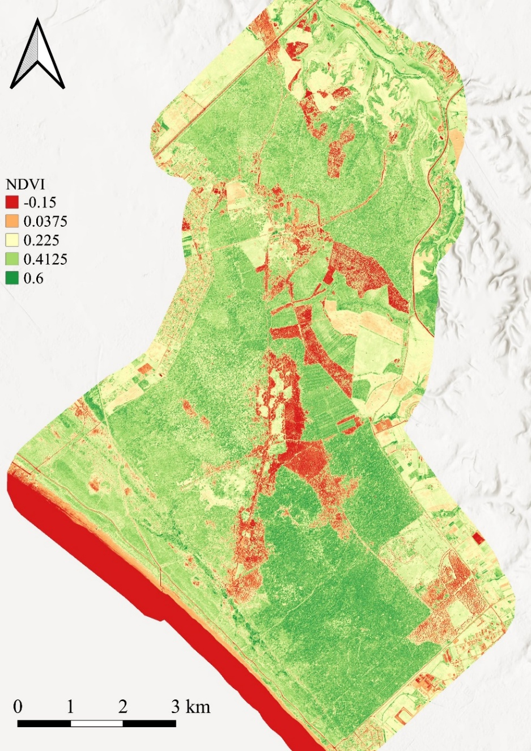

Delta NDVI
2015-2018 Delta NDVI 2018-2019
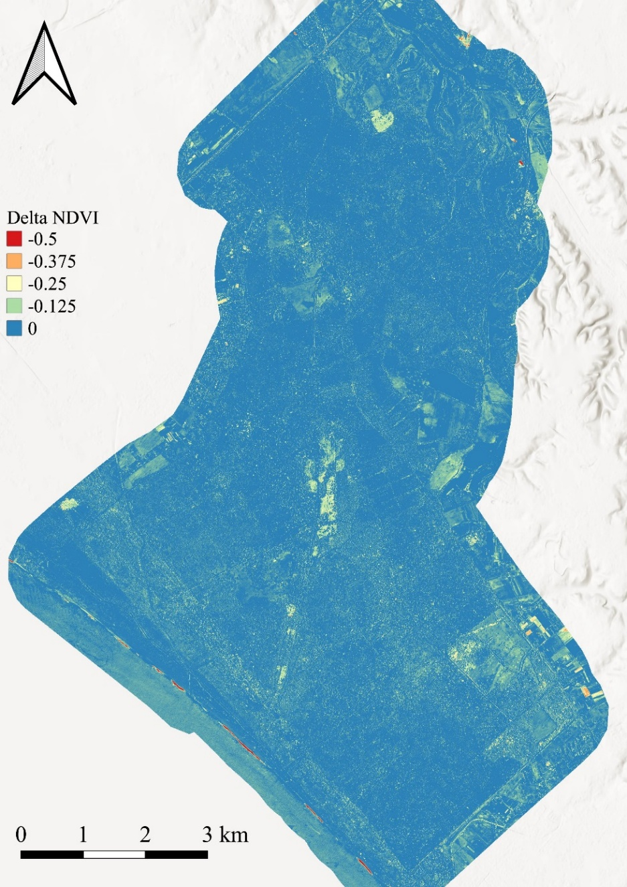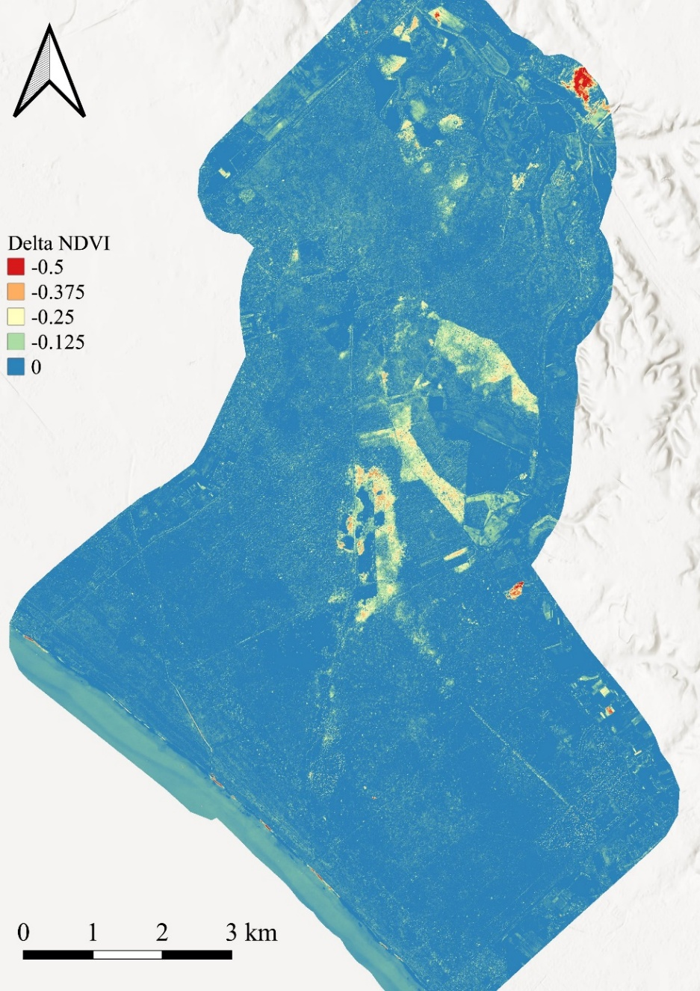

Delta NDVI 2019-2020
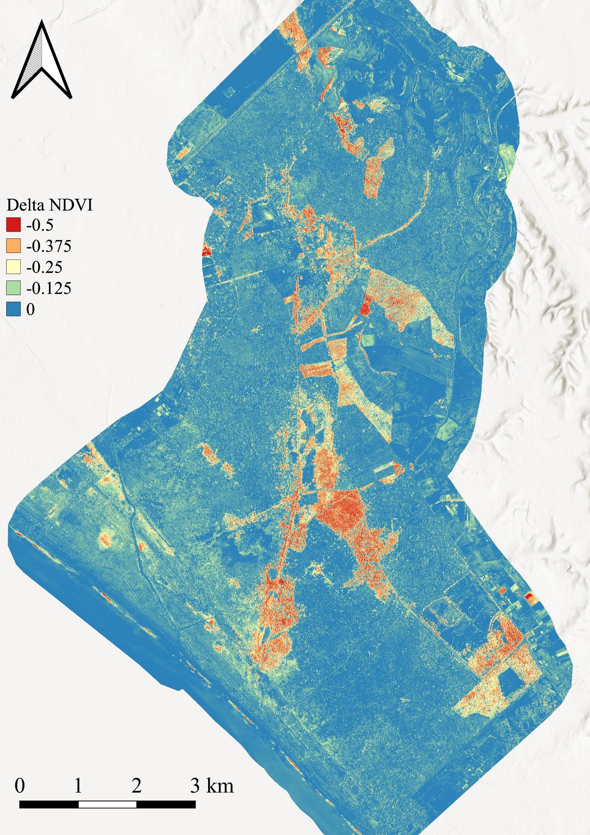

Photointerpretation map
2015
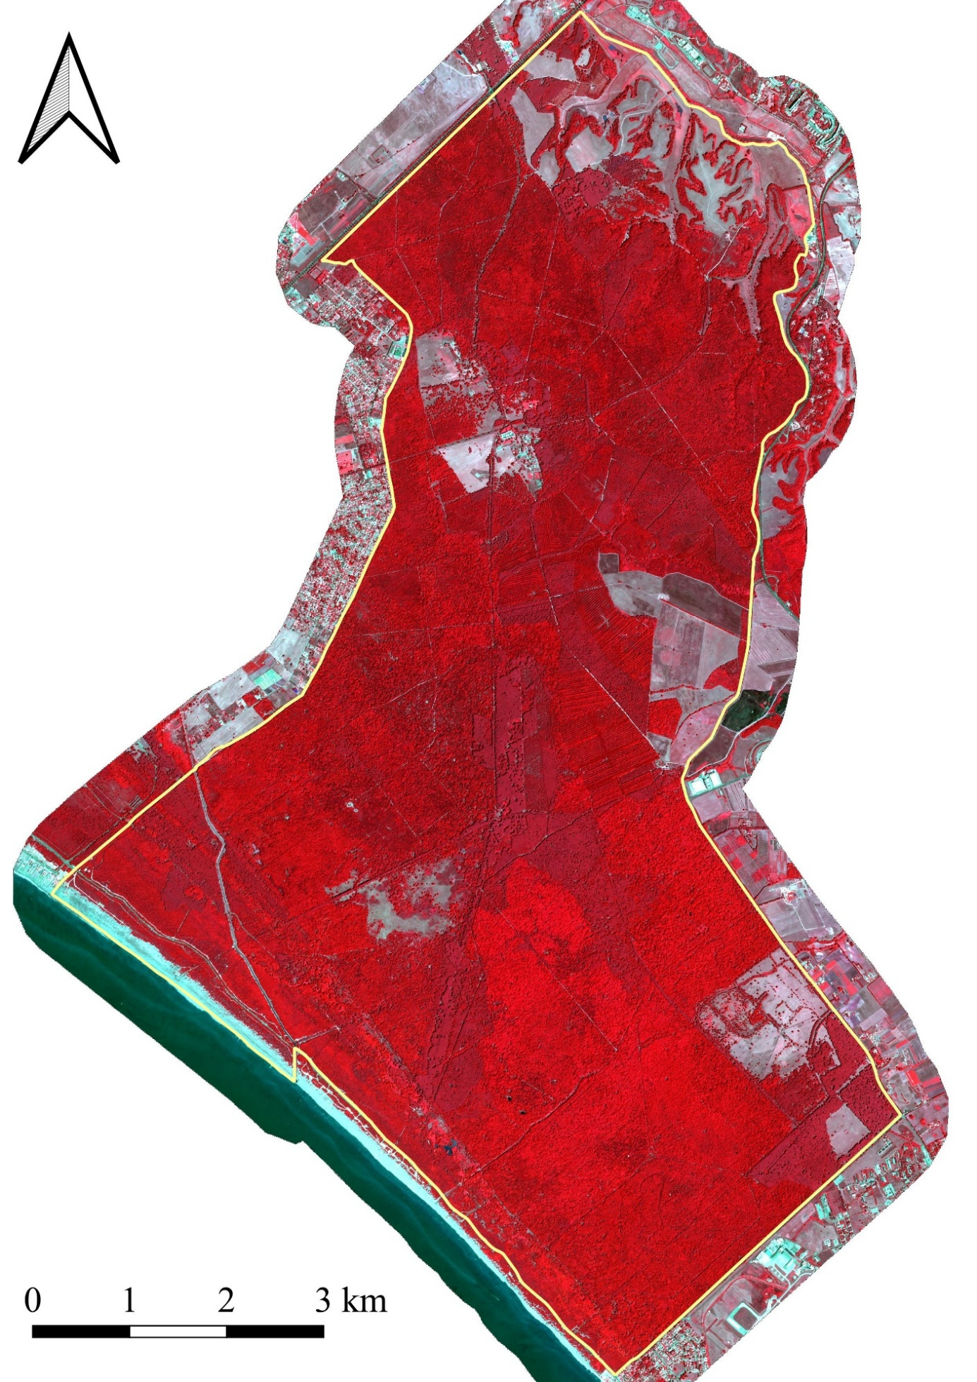
Pre-disturbance conditions in the CPE
2017
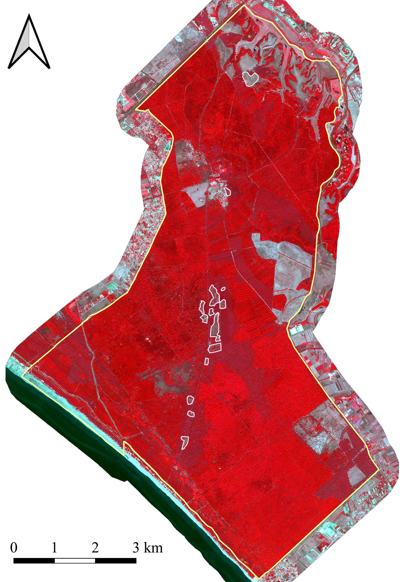
In 2017, the first clear cut in the CPE pine stands were identified. Specifically, 49 hectares of pine forest were cut
2018
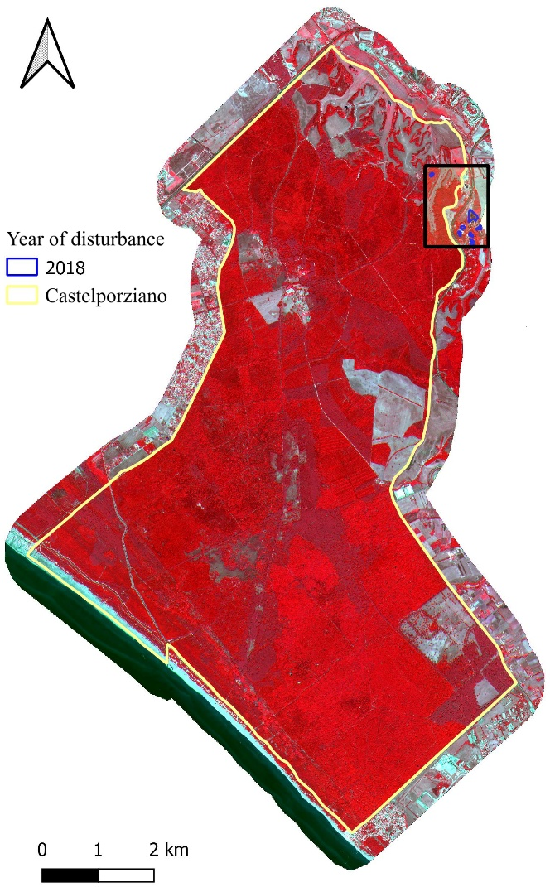

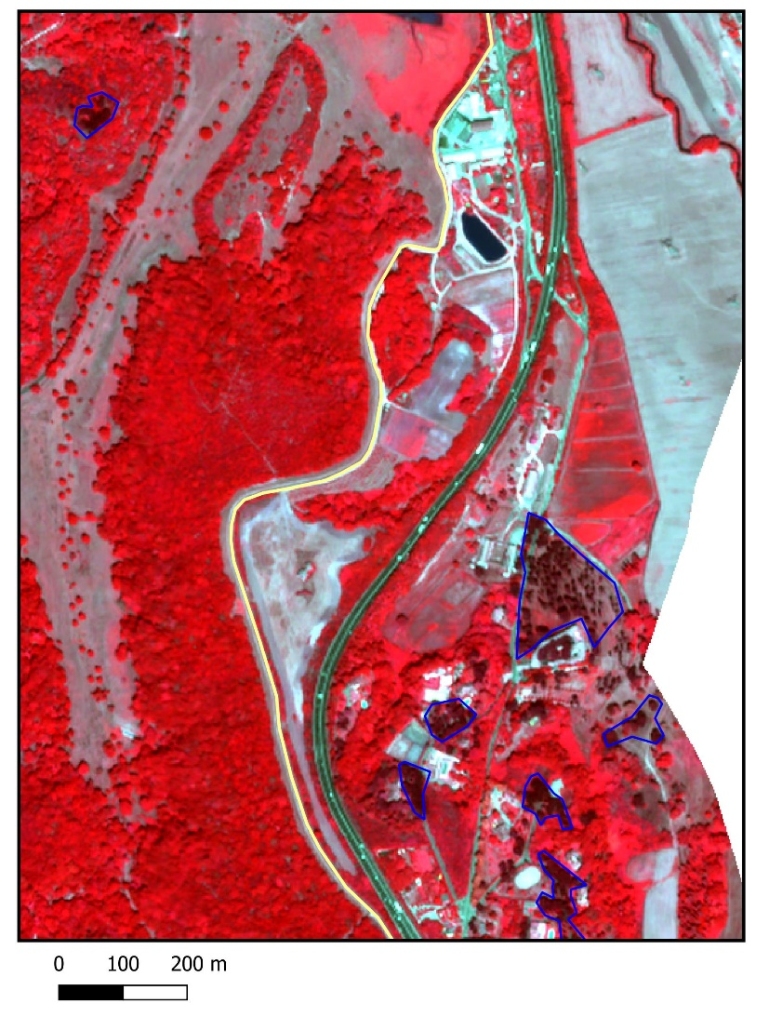

In the northern area of the CPE (plot 250), the first signs of decay emerged. In the same year (2018), further infestations were already present outside the northeast boundary of CPE, in the area close to the ‘Antico Casale’ Restaurant. Within the CPE, 0.2 ha of stone pine forest are degraded.

2019
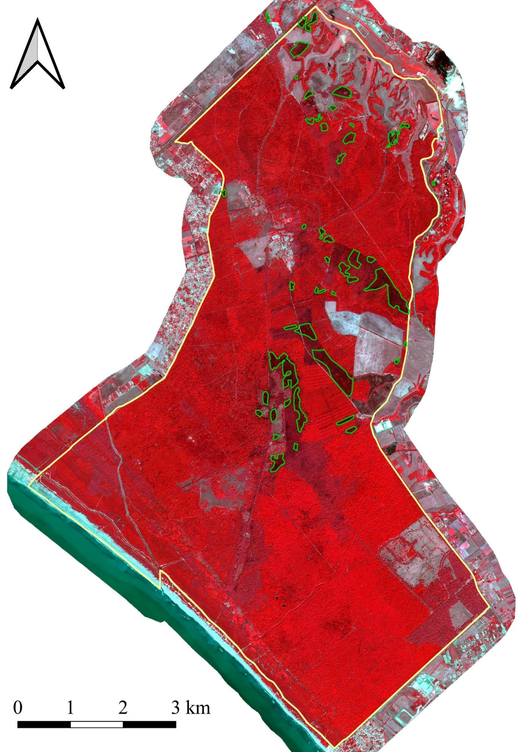
Starting in 2019, the infestation spread significantly. Even in the pine forests adjacent to those mapped in 2019 for severe degradation, signs of browning, corresponding to the initial stages of the deterioration process, can be noted. A total of 139 ha were mapped.
2020
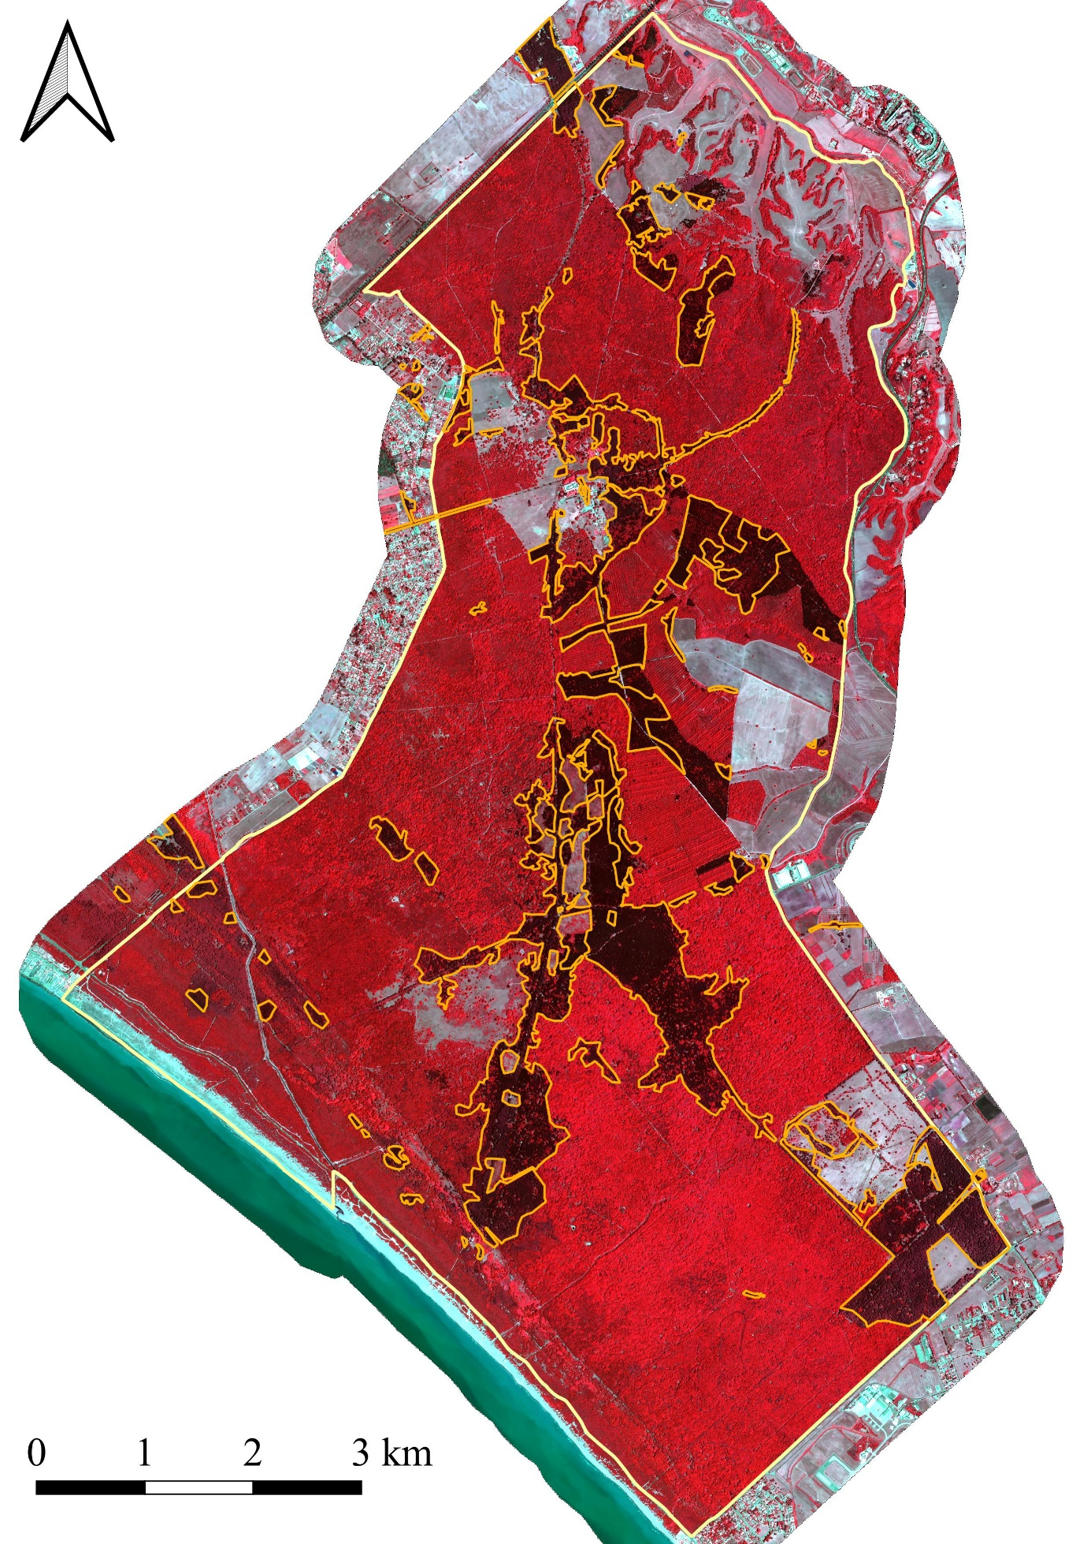
The attack has spread to all the CPE’s pine forests. The black areas in the image indicates the absence of photosynthetic activity and the browning of the canopy, highlighting the extreme severity of the attack. By 2020, a total of 736 hectares had been at least partially damaged.
2020
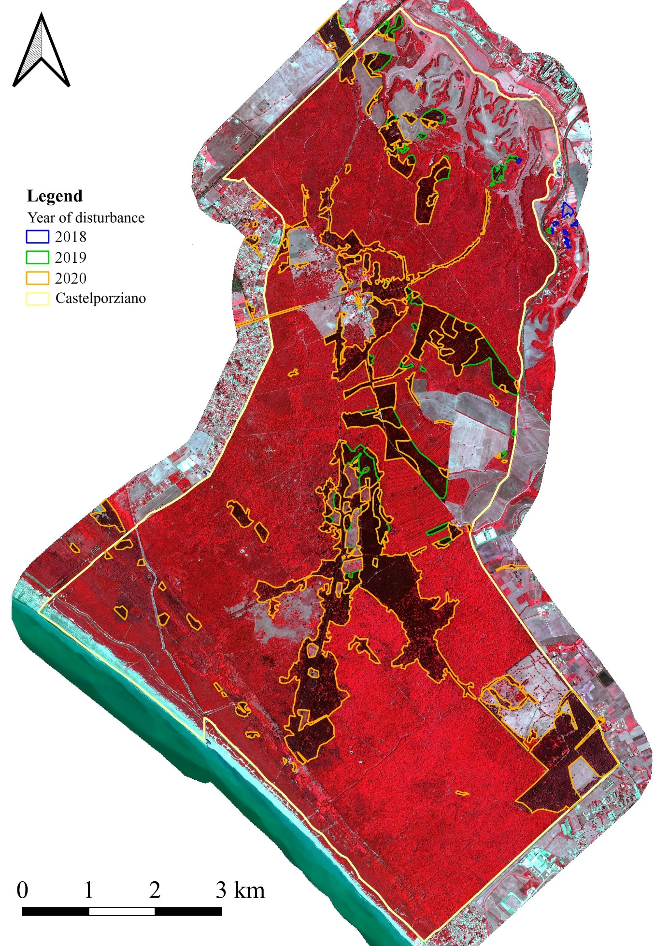
Multi-temporal evolution of the disturbance to 2020.

2021 False-color
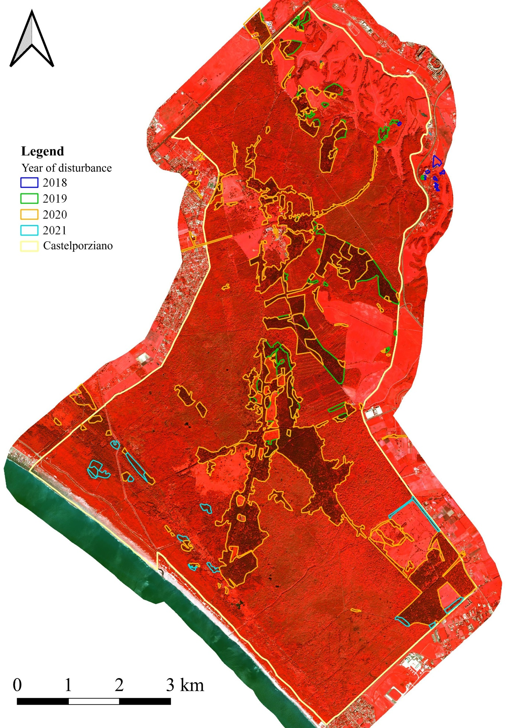
The infestation, which had already spread to a large part of the CPE's pine forests, continued to expand in 2021. Given the widespread diffusion reached in the previous years, between 2020 and 2021 the expansion appears to be limited (about 25 ha) to the areas closest to the coastline.
2021 RGB
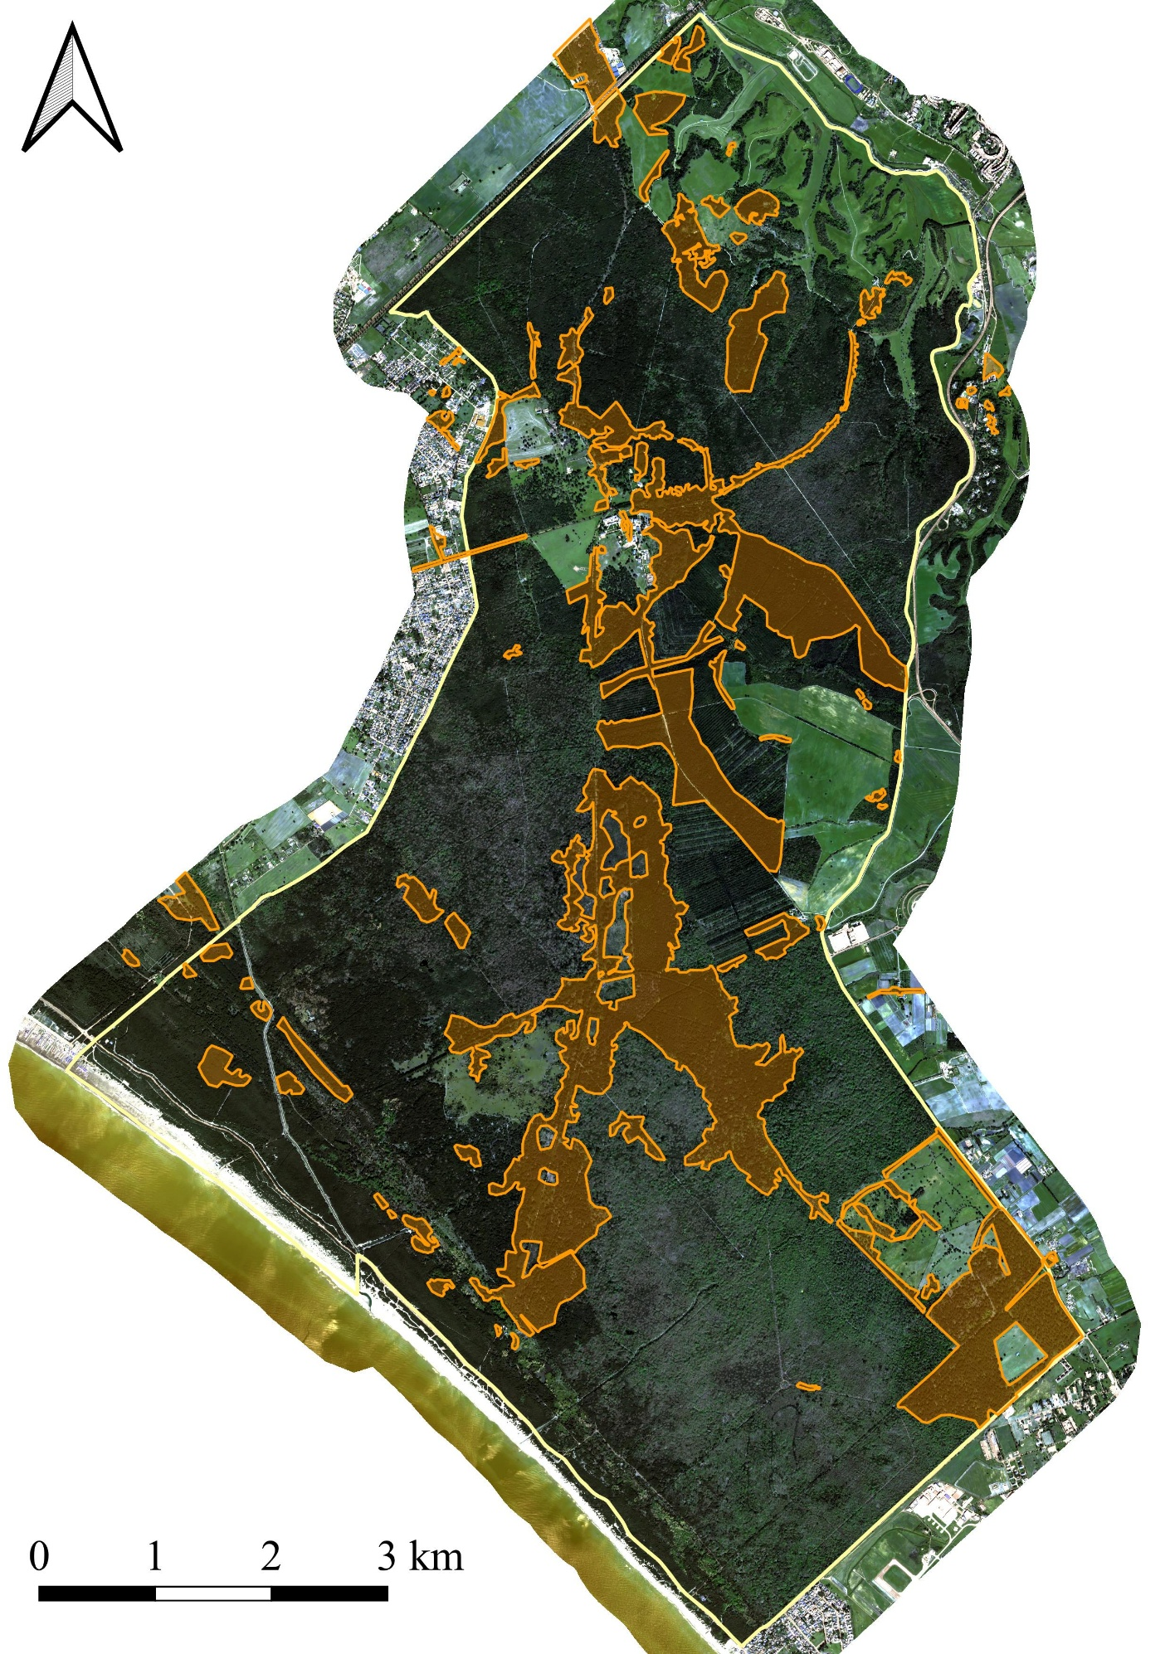

Annex 2
Data of first insect outbreak detection from the NRT Sentinel-2 forest disturbance map (Sentinel-2 images) and by photointerpretation (PlanetScope images).
ID | Data Sentinel-2 | Data PlanetScope | Time Lag
64 | 16/03/2020 | 21/03/2020 | -5
75 | 16/03/2020 | 21/03/2020 | -5
78 | 05/04/2020 | 24/03/2020 | 12
83 | 31/03/2020 | 24/03/2020 | 7
91 | 21/03/2020 | 26/04/2020 | -36
92 | 31/03/2020 | 3/04/2020 | -3
93 | 16/03/2020 | 21/03/2020 | -5
94 | 05/04/2020 | 21/03/2020 | 15
95 | 16/03/2020 | 24/03/2020 | -8
96 | 16/03/2020 | 21/03/2020 | -5
97 | 31/03/2020 | 21/03/2020 | 10
98 | 21/03/2020 | 21/03/2020 | 0
99 | 16/03/2020 | 21/03/2020 | -5
100 | 15/04/2020 | 11/04/2020 | 4
101 | 31/03/2020 | 24/03/2020 | 7
102 | 21/03/2020 | 24/03/2020 | -3
105 | 16/03/2020 | 21/03/2020 | -5
107 | 16/03/2020 | 24/03/2020 | -8
108 | 31/03/2020 | 24/03/2020 | 7
109 | 31/03/2020 | 24/03/2020 | 7
110 | 31/03/2020 | 21/03/2020 | 10
111 | 31/03/2020 | 24/03/2020 | 7
112 | 16/03/2020 | 3/04/2020 | -18
113 | 16/03/2020 | 21/03/2020 | -5
115 | 16/03/2020 | 24/03/2020 | -8
116 | 31/03/2020 | 21/03/2020 | 10
117 | 21/03/2020 | 24/03/2020 | -3
118 | 16/03/2020 | 15/04/2020 | -30
119 | 31/03/2020 | 24/03/2020 | 7
120 | 21/03/2020 | 21/03/2020 | 0

