Supplementary materials
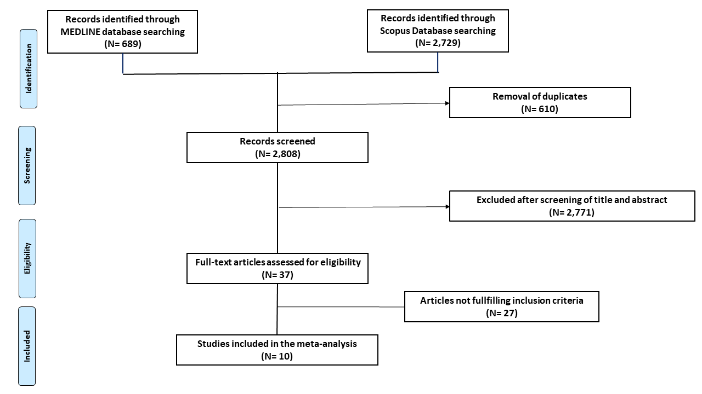
Supplementary Figure 1 – PRISMA flow diagram for study selection.

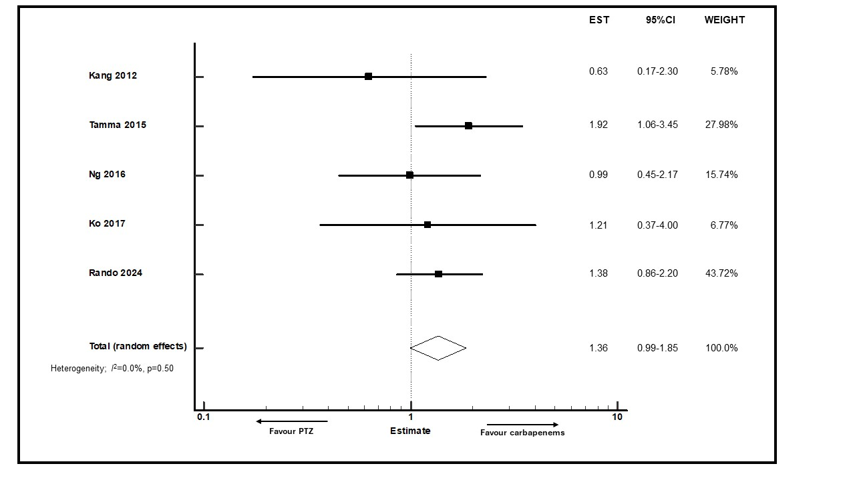
Supplementary Figure 2 – Forest plot of mortality rate in subgroup analysis including studies in which empirical therapy with piperacillin-tazobactam vs. carbapenems was administered.
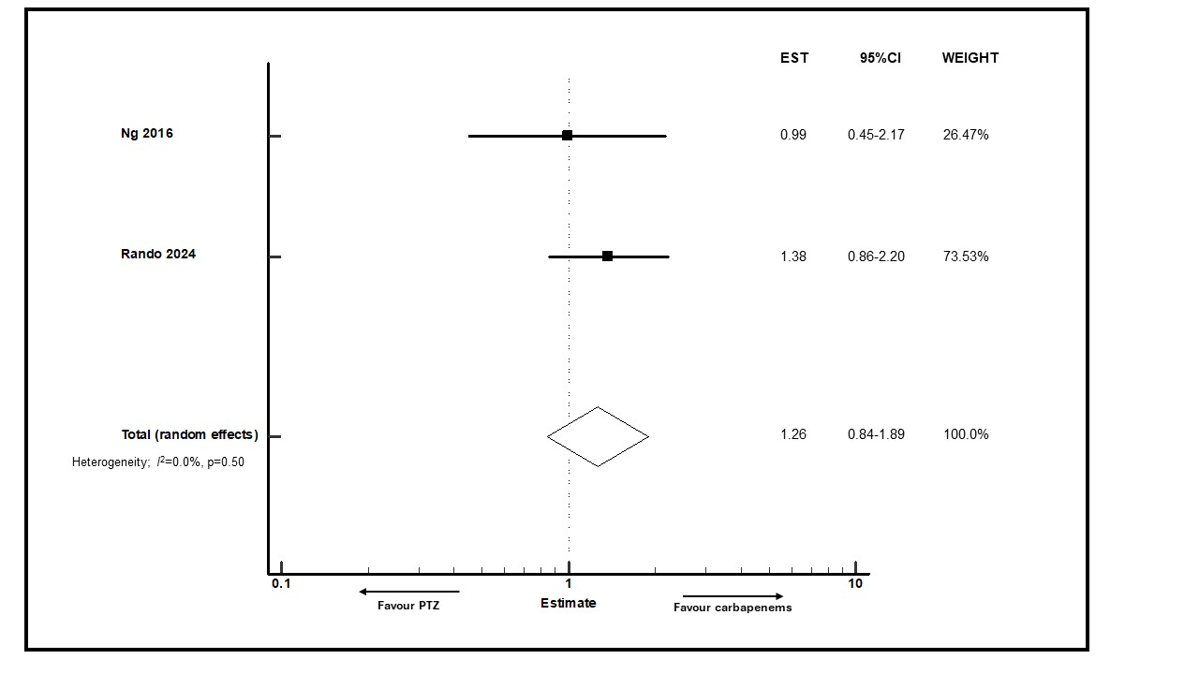
Supplementary Figure 3 – Forest plot of mortality rate in subgroup analysis including studies in which secondary BSIs due to UTI/biliary source accounted for at least 50% of cases.

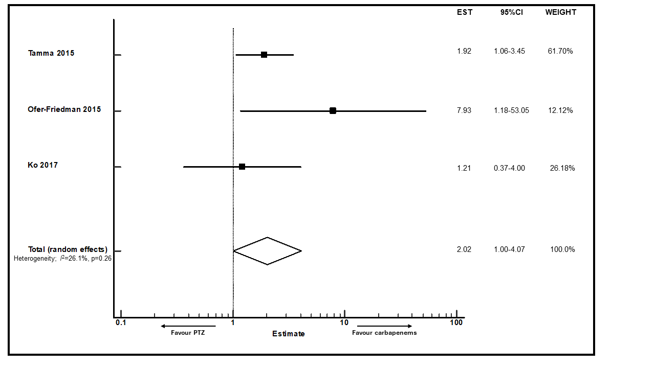
Supplementary Figure 4 – Forest plot of mortality rate in subgroup analysis including studies in which secondary BSIs due to UTI/biliary source accounted for less than 50% of cases.

