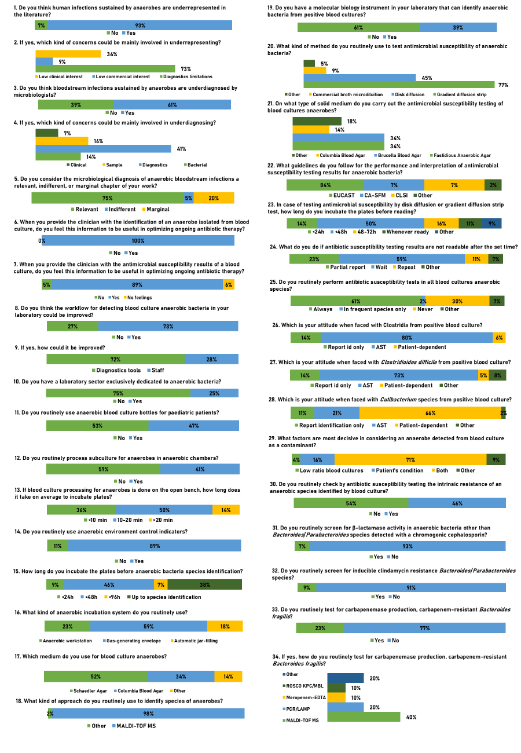
Figure S1. Microbiologists’ attitudes towards anaerobic bacteria diagnostics.

