Supplemental Material – Table of Contents
Supplemental Table S1. Characteristics of interventional pharmacological trials that exclude GD patients
Supplemental Table S2. Characteristics of clinical trials excluding GD patients
Supplemental Figure S1. Flowchart of the trial selection process
Supplemental Methods
Supplemental Table S1. Characteristics of interventional pharmacological trials
 | All trials (n=286) | Trials that exclude GD patients (n=40) | Trials that include GD patients (n=246) | p-value¹
Drug intervention
Immunosuppressants | 125 (44) | 24 (60) | 101 (41) | 0.18
Endocrine | 21 (7) | 1 (3) | 20 (8) | 0.33
Vaccines | 29 (10) | 5 (13) | 24 (10) | 0.58
Antivirals | 43 (15) | 6 (15) | 37 (15) | 1.00
Antihypertensives | 4 (1) | 0 | 4 (2) | 1.00
Antibiotics | 6 (2) | 0 | 6 (2) | 1.00
Other | 58 (18) | 4 (10) | 54 (22) | 0.20
Phase of trial
Phase 1 | 26 (9) | 7(18) | 19 (8) | 0.09
Phase 2 | 55 (19) | 9 (23) | 46 (19) | 0.68
Phase 3 | 50 (17) | 4 (10) | 46 (19) | 0.36
Phase 4 | 104 (36) | 12 (30) | 92 (37) | 0.53
Other | 51 (18) | 8 (20) | 43 (17) | 0.83
Population
Only adults | 262 (92) | 38 (95) | 224 (91) | 0.86
Both kids and adults | 21 (7) | 1 (3) | 20 (8) | 0.33
Only kids | 3 (1) | 1 (3) | 2 (1) | 0.37
Funding type
Industry | 47 (16) | 7 (18) | 40 (16) | 0.82
Government | 16 (6) | 4 (10) | 12 (5) | 0.26
Unspecified | 223 (78) | 29 (73) | 194 (79) | 0.75
Enrollment start year
2000-2008 | 12 (4) | 1 (3) | 11 (5) | 1.00
2009-2017 | 141(49) | 20 (50) | 121 (49) | 0.96
2018-2024 | 133 (47) | 19 (48) | 114 (46) | 0.94
Continent
Asia | 32 (11) | 3 (8) | 29 (12) | 0.59
Africa | 4 (1) | 0 | 4 (2) | 1.00
North America | 142 (49) | 26 (65) | 116 (47) | 0.24
South America | 14 (5) | 3 (8) | 11 (5) | 0.43
Europe | 91(32) | 8 (20) | 83 (34) | 0.28
Australia | 3 (1) | 0 | 3 (1) | 1.00
GD, glomerular disease.
Values represent frequency (percentage).
¹Chi-2 or Fisher’s exact test dependent on sample size.

Supplemental Table S2. Characteristics of clinical trials excluding GD patients
NCT Number | Study Phase | Primary Aim | GD Exclusion Category | Intervention
NCT01349595 | Phase 2 | Impact of proteasome inhibition on anti-donor HLA antibody production | Any GD | Proteasome inhibitor (bortezomib)
NCT00724022 | Phase 4 | Evaluate calcineurin inhibitor reduced, steroid-free immunosuppression | Any GD | Low-dose tacrolimus + mycophenolate
NCT01354301 | Phase 4 | Efficacy/safety of induction strategies with low tacrolimus exposure | Any GD | Everolimus vs sodium mycophenolate + reduced tacrolimus
NCT01446484 | Phase 1/2 | Treatment with CD4+CD25+FoxP3+ T cells to prevent rejection | Any GD | Regulatory T cell infusion
NCT01469884 | Phase 4 | Effect of switching to everolimus in hepatitis C viremia | Any GD | Everolimus (Certican) conversion
NCT01780454 | Phase 1/2 | Renal allograft tolerance through mixed chimerism | Any GD | Combined kidney + hematopoietic stem cell transplant
NCT01909245 | Phase 2 | Islet cell transplant for type 1 diabetes | Any GD | Islet cell transplantation
NCT02096107 | Phase 4 | Everolimus transition study | Any GD | Everolimus transition
NCT02058589 | Phase 3 | Immunogenicity/safety of herpes zoster vaccine | Any GD | GSK herpes zoster subunit vaccine
NCT02314403 | Phase 1 | Renal allograft tolerance through mixed chimerism (belatacept) | Any GD | Belatacept + donor bone marrow
NCT02540395 | NA | Donor-specific T response measurement for immunosuppression minimization | Any GD | Personalized immunosuppression
NCT03781726 | Phase 4 | Multi-center study to transplant hepatitis C infected kidneys | Any GD | HCV+ kidney transplantation with glecaprevir/pibrentasvir
NCT03809533 | Phase 2 | Use of hepatitis C positive kidneys in HCV negative recipients | Any GD | HCV+ to HCV- kidney transplant with sofosbuvir/velpatasvir
NCT04006808 | Phase 1/2 | GSK candidate vaccine for shingles prevention in children | Any GD | GSK1437173A vaccine
NCT04075916 | Phase 2 | Transplanting hepatitis C kidneys into HCV-negative recipients | Any GD | HCV+ to HCV- kidney transplant with sofosbuvir/velpatasvir
NCT04540380 | Phase 1 | Renal allograft tolerance through mixed chimerism | Any GD | Combined kidney + stem cell transplant
NCT05769582 | Phase 2/3 | Safety/efficacy of Anti-BKV for BKV infection treatment | Any GD | Anti-BKV immunotherapy
NCT05525507 | Phase 1 | Retro-active immunological tolerance in HLA-identical transplants | Any GD | Hematopoietic stem cell infusion
NCT06552169 | Phase 2 | Regulatory T cell therapy for immunosuppression reduction | Any GD | Autologous regulatory T cell therapy
NCT05806749 | Phase 1 | Immunological tolerance in mismatched kidney transplants | FSGS | Mixed chimerism protocol
NCT01962922 | Phase 3 | PK crossover study of LCP-Tacro vs generic tacrolimus | FSGS | LCP-Tacro extended-release tacrolimus
NCT02327403 | Phase 2 | Belatacept conversion in proteinuric kidney transplant recipients | FSGS | Belatacept conversion
NCT02743897 | Phase 1/2 | Transplanting hepatitis C kidneys into negative recipients | FSGS | HCV+ kidney transplant + DAAs
NCT03093740 | Phase 4 | DAA therapy to prevent HCV infection (HCV+ donor to HCV- recipient) | FSGS | DAA prophylaxis
NCT01187953 | Phase 3 | LCP-Tacro vs Prograft for rejection prevention in de novo transplant | FSGS | LCP-Tacro vs immediate-release tacrolimus
NCT03623568 | Phase 4 | DAA therapy in donor HCV + to recipient HCV- transplant | FSGS | HCV+ kidney transplantation with glecaprevir/pibrentasvir
NCT01653847 | NA | Impact of two immunosuppressive regimens in renal transplant | FSGS | Comparative immunosuppression study
NCT03289650 | Phase 3 | Extended release tacrolimus vs twice-daily tacrolimus | aHUS | Extended-release vs immediate-release tacrolimus
NCT05030974 | Phase 4 | RECOVAC repeated vaccination study | aHUS | COVID-19 vaccination
NCT06584773 | Phase 4 | Quadruple immunosuppression with mTOR inhibitors in sensitized patients | MPGN | Quadruple immunosuppression with sirolimus
NCT01429038 | Phase 1/2 | Mesenchymal stem cells after renal or liver transplantation | Autoimmune | Mesenchymal stem cell therapy
NCT01870011 | Phase 4 | Comparison of propofol vs desflurane anesthesia for renal protection | Autoimmune | Anesthesia protocol comparison
NCT02586051 | Phase 1 | Obinutuzumab safety/tolerability in hypersensitized ESKD patients | Autoimmune | Obinutuzumab desensitization
NCT03816332 | Phase 1 | Tacrolimus, nivolumab, ipilimumab in transplant recipients with cancer | Autoimmune | Immunotherapy for post-transplant malignancy
NCT04989491 | Phase 4 | Rituximab for EBV prevention in EBV seronegative recipients | Autoimmune | Rituximab prophylaxis
NCT05077254 | Phase 2 | Efficacy of COVID vaccination with and without immunosuppression reduction | Autoimmune | Immunosuppression minimization and COVID vaccination
NCT05285878 | Phase 2 | Fingolimod for interstitial fibrosis/tubular atrophy prevention | Autoimmune | Fingolimod
NCT06056102 | Phase 1 | CAR-T cell therapy for desensitization in kidney transplantation | Autoimmune | CAR-T cell therapy
NCT05702931 | Phase 4 | Semaglutide treatment for post-transplant hyperglycemia | Autoimmune | Semaglutide
NCT05896839 | Phase ½ | Immunotherapy + prednisone + sirolimus for metastatic skin cancer | Autoimmune | Combination immunotherapy
NCT, National Clinical Trial; GD, glomerular disease; HLA, human leukocyte antigen; GSK, GlaxoSmithKline; NA, not applicable; HCV, hepatitis C virus; BKV, BK virus; FSGS, focal segmental glomerulosclerosis; DAA, direct acting antivirals; aHUS, atypical hemolytic uremic syndrome; mTOR, mechanistic target of rapamycin; MPGN, membranoproliferative glomerulonephritis; ESKD, end-stage kidney disease; EBV, Epstein–Barr virus; CAR-T, chimeric antigen receptor T cell.

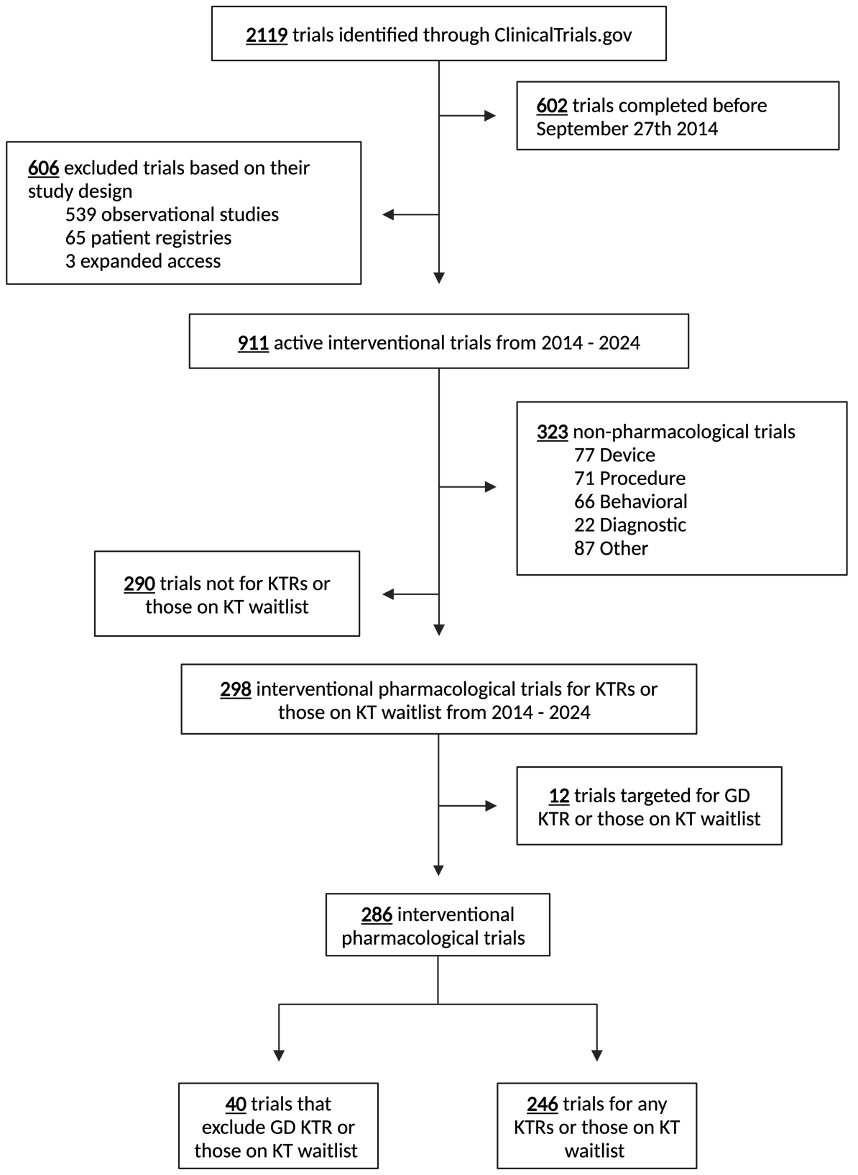
Supplemental Figure S1. Flowchart of the trial selection process.

KTRs, kidney transplant recipients; KT, kidney transplant; GD, glomerular disease.

Supplemental Methods
Detailed Methods
The ClinicalTrials.gov registry was reviewed for interventional drug trials of KTRs and those on the kidney transplant (KT) waitlist, completed between September 27, 2014, and September 27, 2024, or active as of September 27, 2024. Trial demographics and study eligibility criteria were assessed. Two independent investigators reviewed each trial according to the inclusion criteria, and any uncertainties were addressed by the Post-Transplant Glomerular Diseases (TANGO) Consortium Committee (www.tangoxstudy.com)¹. Trials were screened to determine whether they excluded patients with primary GD subtypes. Thrombotic microangiopathy (TMA) was also included due to its high recurrence risk and the potential need for immunosuppressants in case of recurrence. Ethics approval and consent to participate were waived as the institutional review board of Massachusetts General Hospital determined that this study was not considered human subject research. Statistical analysis was performed using R software version 4.4.2. Categorical data are presented as frequencies and percentages. Depending on group size, binary and categorical variables were compared by chi-squared or Fisher’s exact test. Graphics were created using Prism 10.3.1 (GraphPad Software, Inc) and BioRender.com.

Search Terms and Strategy
We searched ClinicalTrials.gov using the terms “kidney transplant” and “kidney disease”, identifying 2,119 trials. Of these, 602 were excluded because they were completed before September 27, 2014. We then restricted the search to interventional studies, excluding 606 trials that were observational (n=539), patient registries (n=65), or expanded access studies (n=3). This yielded 909 active interventional trials from 2014 to 2024. After excluding non-pharmacological interventions, 298 trials remained. Twelve trials specifically targeting GD treatment in KTRs or waitlisted patients were excluded. This resulted in a final cohort of 286 interventional pharmacological trials for analysis. Further details are provided in Supplemental Figure 1.

Limitations of Trial Identification Strategy
Our search was limited to ClinicalTrials.gov, which was selected because it captures the majority of interventional pharmacological trials in kidney transplantation, especially those requiring regulatory oversight in the United States. However, this approach may have excluded relevant trials registered in other international databases such as the WHO International Clinical Trials Registry Platform (ICTRP) or the EU Clinical Trials Register (EudraCT). As such, our dataset may not fully reflect the global landscape of kidney transplant trials. Future studies should consider incorporating multiple trial registries to ensure broader and more comprehensive trial capture.

Risk Classification Model Development
The glomerular disease recurrence risk classification model presented in Table 1 was developed by the TANGO (Post-Transplant Glomerular Diseases) Consortium through systematic review of published literature on post-transplant recurrence rates for specific glomerular disease subtypes. The classification incorporated recent evidence on biomarker-based risk stratification, validated risk assessment tools, and expert consensus from the international TANGO working group members. Risk categories (low, moderate, high) were assigned based on reported recurrence rates, severity of recurrence when it occurs, and availability of predictive biomarkers.

References
1. Uffing A, Pérez-Sáez MJ, La Manna G, et al. A large, international study on post-transplant glomerular diseases: the TANGO project. BMC Nephrol. Sep 12 2018;19(1):229. doi:10.1186/s12882-018-1025-z

