SUPPORTING INFORMATION

FOR
Habitat heterogeneity from lidar and hyperspectral data: Implications for bird guilds and restoration management of coal mines

Lucie Moudrá ¹, Vojtěch Barták ¹, Vítězslav Moudrý ¹, Ruben Remelgado ², Stephanie Roilo ², Duccio Rocchini ^{1,3}, Vladimír Bejček ¹, Karel Šťastný ¹, Ondřej Volf ⁴, Petr Musil ¹, Miroslav Šálek ¹

¹ Faculty of Environmental Sciences, Czech University of Life Sciences Prague, Kamýcká 129, Praha – Suchdol, 165 00, Czech Republic
² Agro-Ecological Modeling Group, Institute of Crop Science and Resource Conservation, University of Bonn, Bonn, Germany
³ BIOME Lab, Department of Biological, Geological and Environmental Sciences, Alma Mater Studiorum University of Bologna, Bologna, Italy
⁴ Spolek Ametyst, Nebílovy 37, 332 04 Nebílovy, Czech Republic

Corresponding author: Vitezslav Moudry; moudry@fzp.czu.cz

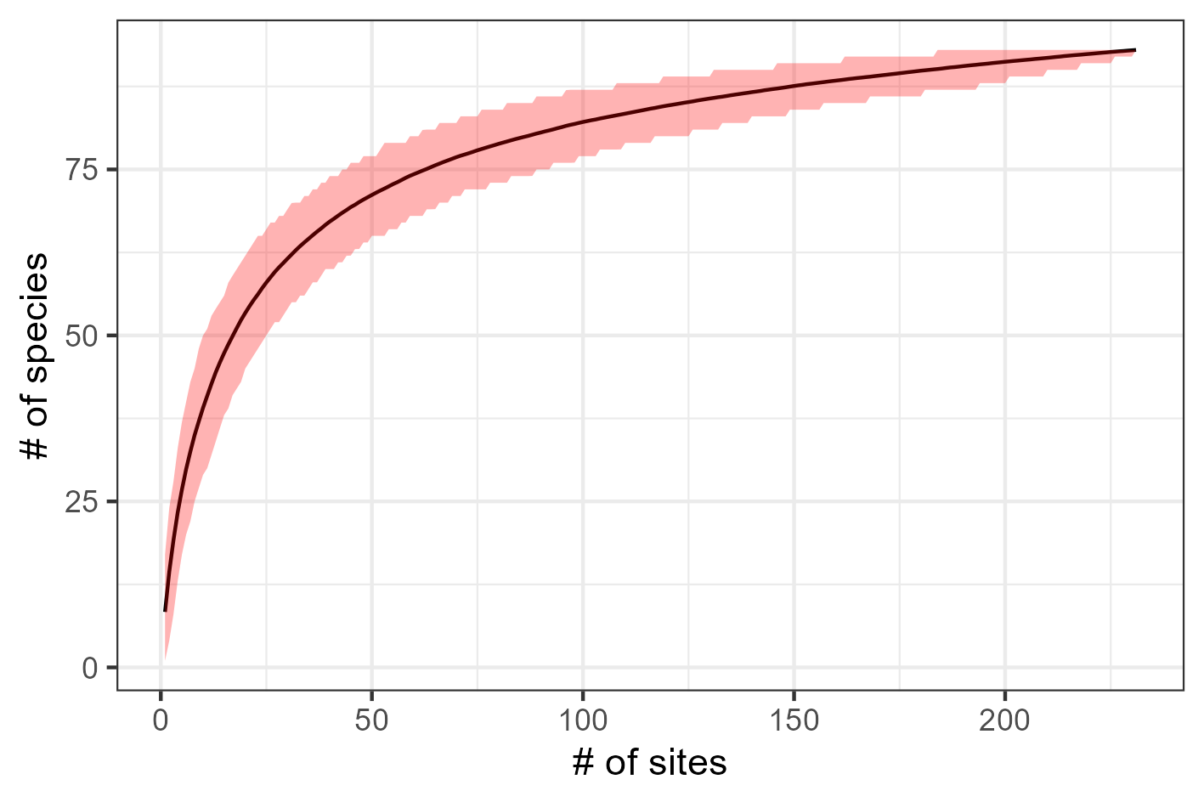
Figure S1. Species accumulation curve based on 1000 randomization of the sites order. For each randomization, the number of detected species were summed up cumulatively, and the mean (black line) and 0.025 and 0.975 percentiles (red region) are plotted.

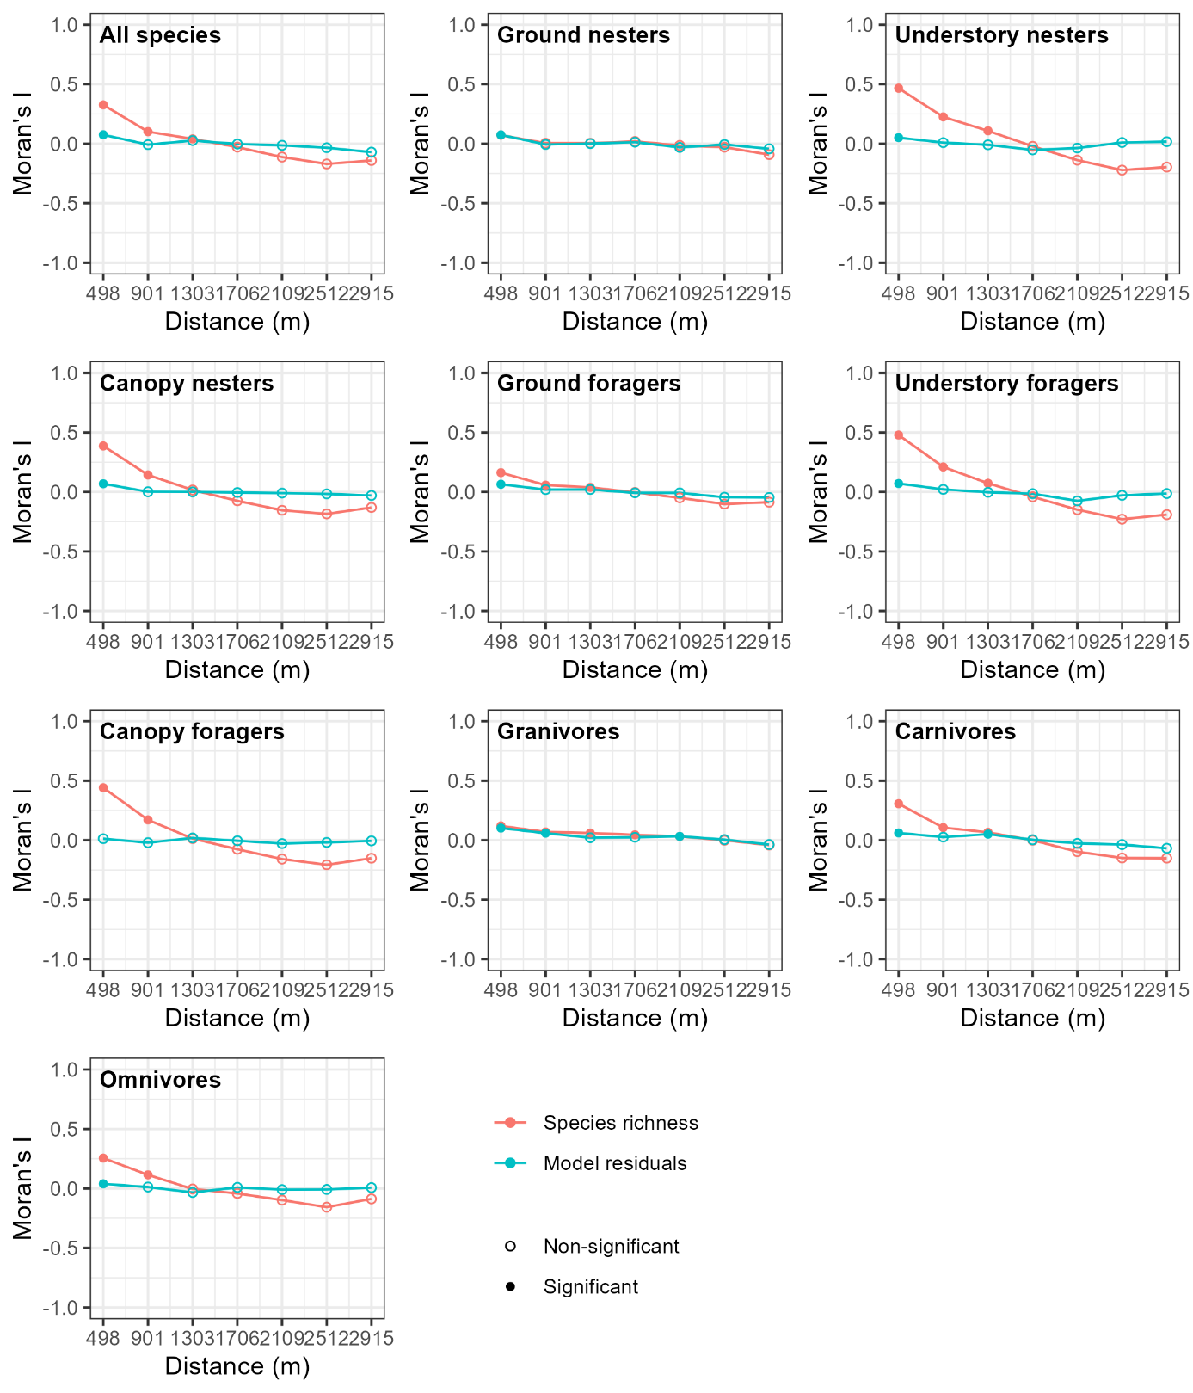
Figure S2. Correlograms for species richness of each species group as well as for residuals from a corresponding generalized additive model.

Tab S1. Table of coefficients of the parametric terms of the GAM models. Individual models are in columns. Parameter estimates ± standard errors are reported, together with the standard identification of significance based on Wald tests.
Termª | All species | Ground nesters | Understory nesters | Canopy nesters | Ground foragers | Understory foragers | Canopy foragers | Granivores | Carnivores | Omnivores
Intercept | 2.326 ± 0.054 *** | 1.019 ± 0.107 *** | 1.464 ± 0.08 *** | 1.274 ± 0.118 *** | 1.644 ± 0.067 *** | 1.372 ± 0.088 *** | 1.212 ± 0.085 *** | -0.33 ± 0.185 | 1.958 ± 0.066 *** | -0.264 ± 0.144
RNR | -0.38 ± 0.086 *** | 0.005 ± 0.102 | -1 ± 0.113 *** | -0.896 ± 0.142 *** | -0.152 ± 0.07 * | -1.167 ± 0.124 *** | -0.934 ± 0.123 *** | -0.423 ± 0.245 | -0.388 ± 0.069 *** | -
PSRI | - | 4.642 ± 1.022 *** | - | - | 1.747 ± 0.894 | - | - | - | 2.031 ± 0.849 * | -
CUR | - | - | - | - | -0.423 ± 0.242 | - | - | - | - | -0.732 ± 0.383
SD | - | - | - | - | - | - | - | - | - | 0.126 ± 0.037 ***
UC | - | - | - | - | - | - | - | - | - | 0.02 ± 0.009 *
ª The predictors are coded as follows: UC – Undestory cover, SD – Canopy cover SD, PSRI – PSRI index, CUR – Terrain curvature, TWI – TWI index, RNR – Restoration, level Restored

Tab S2. Significance of smooth terms of the GAM models. Individual models are in columns. Effective degrees of freedom (a measure of degree of nonlinearity) together with the 𝜒² statistics are reported. The asterisks refer to the approximate significance of the smooth terms (ignoring the uncertainty of the smoothing parameters estimation).
Smooth termª | All species | Ground nesters | Understory nesters | Canopy nesters | Ground foragers | Understory foragers | Canopy foragers | Granivores | Carnivores | Omnivores
SD:RNN | 1 (2.16) | - | 1 (0.02) | 4.66 (8.68) | - | 1 (0.65) | - | 1.3 (1.38) | 1 (0.21) | -
SD:RNR | 1 (10.26) ** | - | 1 (8.41) ** | 3.64 (29.91) *** | - | 1 (30.68) *** | - | 2.47 (4.91) | 1 (6.94) ** | -
UC:RNN | 1 (0.38) | - | - | 1 (2.05) | - | 1 (0.26) | - | - | - | -
UC:RNR | 3.54 (15.47) ** | - | - | 1 (2.08) | - | 2.15 (17.14) *** | - | - | - | -
CUR:RNN | 1 (0.32) | - | 1 (0.29) | 1 (2.15) | - | 1 (0) | - | - | 1 (0) | -
CUR:RNR | 4.54 (10.09) | - | 1 (8.12) ** | 1 (12.18) *** | - | 1.09 (6.45) * | - | - | 1 (4.6) * | -
CC | 3.37 (13.19) * | 2.66 (11.71) * | - | 5.07 (37.68) *** | 4.83 (57.72) *** | 4.31 (21.67) *** | - | 3.07 (7.12) | - | 4 (24.01) ***
PSRI | 3.49 (12.79) * | - | 1.44 (3.01) | - | - | - | - | - | - | -
TWI:RNN | - | 2.13 (7.58) * | - | - | - | 1 (0.03) | - | 1 (4.77) * | - | -
TWI:RNR | - | 1.17 (0.88) | - | - | - | 4.81 (9.3) | - | 2.13 (4.2) | - | -
CUR | - | 6.15 (9.64) | - | - | - | - | - | - | - | -
CC:RNN | - | - | 1.91 (5.12) | - | - | - | 2.02 (8.81) * | - | 2.32 (9.91) * | -
CC:RNR | - | - | 6.59 (48.05) *** | - | - | - | 7.13 (111.98) *** | - | 4.17 (57.21) *** | -
UC | - | - | 1.57 (5.63) * | - | - | - | - | - | - | -
SD | - | - | - | - | - | - | 1.99 (28.25) *** | - | - | -
ª The predictors are coded as follows: UC – Undestory cover, CC – Canpy cover, SD – Canopy cover SD, PSRI – PSRI index, CUR – Terrain curvature, TWI – TWI index, RNR – Restoration, level Restored, RNN – Restoration, level Not restored
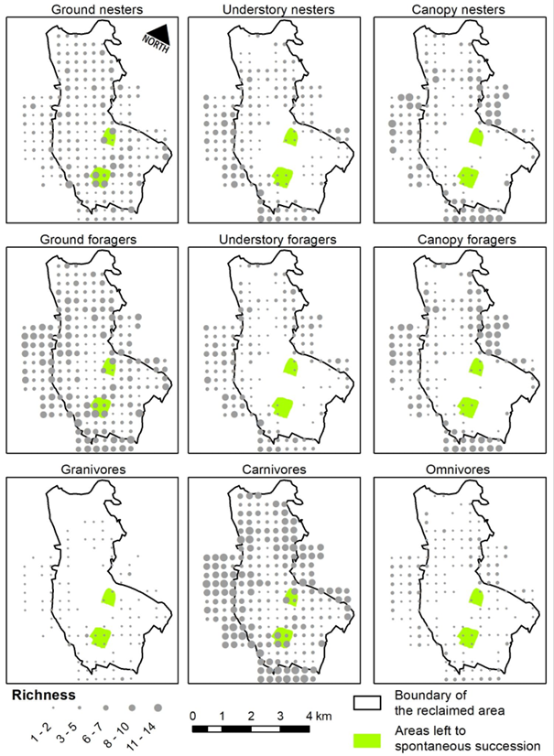
Figure S3. Species richness per guild. Spatial distribution of richness of individual guilds on the restoredclaimed site and the surrounding undisturbed area. Note the two sites left to spontaneous succession without reclamation.

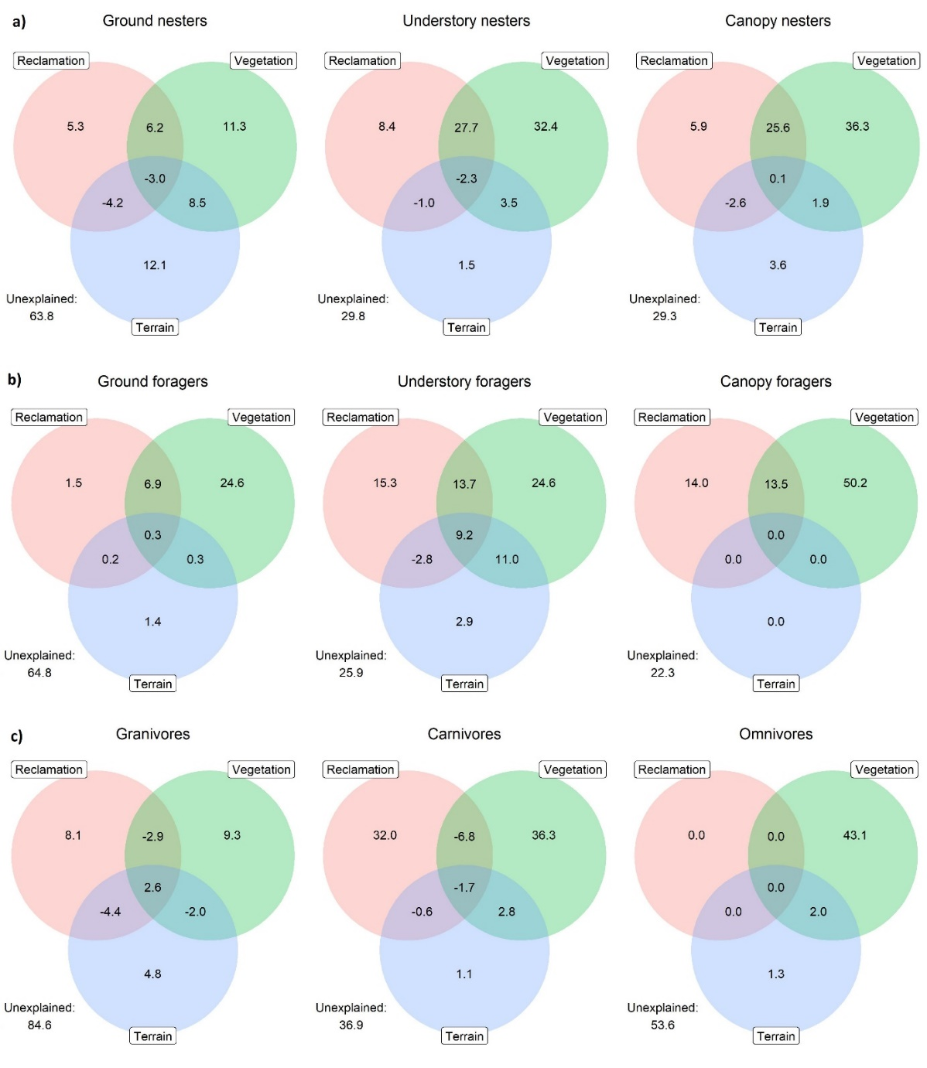
Figure S4. Venn diagrams showing the percentage of explained (and unexplained) deviance in the richness of a) nesting, b) foraging, and c) diet guilds, as explained by the three groups of predictors: vegetation characteristics (understorey cover, canopy cover, standard deviation of vegetation height, PSRI), reclamation status (restored vs. surrounding area), and terrain characteristics (curvature, topographic wetness index). The overlap of the circles indicates fractions of the variation that cannot be unequivocally attributed to one of the overlapping predictors. The richness of canopy and understorey nesters was strongly affected by vegetation characteristics, with restoration status having a moderate effect that shared a large portion of the explained variability with vegetation characteristics. The terrain characteristics had a weak effect. The ground nesting guild was equally affected by vegetation and terrain characteristics. The richness of all foraging guilds was strongly affected by vegetation characteristics, with the restoration status having a moderate effect that shared a considerable portion of the explained variability with vegetation characteristics. The terrain characteristics had a weak effect. The richness of all diet guilds was affected by vegetation characteristics and restoration status, while terrain characteristics had a negligible effect.

