SUPPLEMENTARY MATERIALS
Molecular characterisation
Figure S1: ¹H-NMR spectrum of P(BS-HDG)5 copolymer with signals’ assignment.
Figure S2: ¹³C-NMR spectra of all the materials under study with signals’ assignment

Table S1: Values of integrals of the ¹³C-NMR signals and the probability values used to calculate the degree of randomness and the block length for P(BS-HDG)5, P(BS-HDG)20 and P(BS-HDG)120 copolymers.
 | P(BS-HDG)5 | P(BS-HDG)20 | P(BS-HDG)120
I_{S-B-S} | 1 | 1 | 1
I_{S-B-DG} and I_{DG-B-S} | 0.03 and 0.07 | 0.14 and 0.24 | 0.55 and 0.54
I_{DG-B-DG} | - | - | 0.35
I_{DG-H-DG} | 0.58 | 0.66 | 0.56
I_{DG-H-S} and I_{S-H-DG} | 0.05 and 0.05 | 0.16 and 0.11 | 0.50 and 0.43
I_{S-H-S} | - | - | 0.38
P_{B-S} | 0.043 | 0.160 | 0.353
P_{B-DG} | - | - | 0.609
P_{H-DG} | 0.079 | 0.170 | 0.454
P_{H-S} | - | - | 0.550

Thermal characterisation
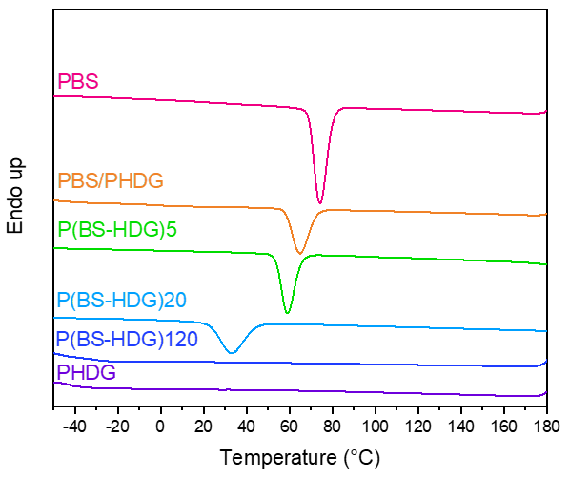
Figure S3: DSC scans of all the polymers under study: crystallization from the melt (10 °C/min).

Table S2: Crystallization temperature (T_{c}) and enthalpy (ΔH_{c}) obtained from cooling DSC scans (10 °C/min) of all the polymers under study
Sample | T_{c} (°C) | ΔH_{c} (J/g)
PBS | 74 | 66
PBS/PHDG | 65 | 39
P(BS-HDG)5 | 59 | 43
P(BS-HDG)20 | 33 | 39
P(BS-HDG)120 | - | -
PHDG | - | -

Mechanical cyclic tests
Table S3: Cyclic test data of PBS/PHDG and P(BS-HDG)5 after 21 cycles. Experiment 1: maximum elongation of 8% and 10% for PBS/PHDG and P(BS-HDG)5; Experiment 2: maximum elongation of 18% and 20% for PBS/PHDG and P(BS-HDG)5.
Polymer | Experiment 1 |  | Experiment 2
 | Shape recovery (%) | Hysteresis (mJ/mm³) |  | Shape recovery (%) | Hysteresis (mJ/mm³)
PBS/PHDG | 63.37 | 3.40 |  | 56.30 | 5.39
P(BS-HDG)5 | 71.20 | 1.70 |  | 62.95 | 5.88

Qualitative memory shape evaluation

Hydrolytic degradation tests

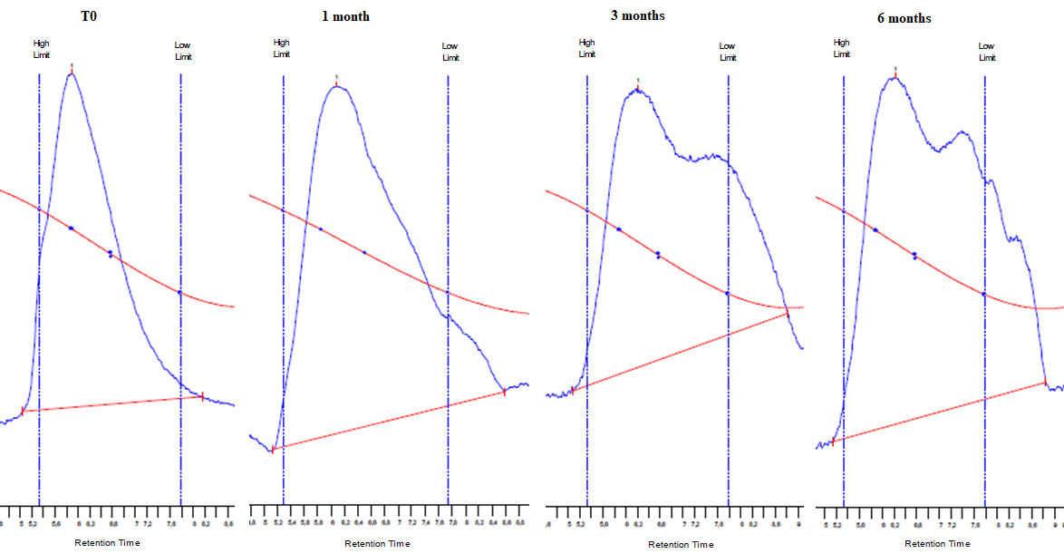
Figure S4: chromatograms of neat PBS/PHDG blend (T0) and partially degraded samples after 2, 4 and 6 months of incubation.

Figure S5: First DSC scan of A) PBS, B) PBS/PHDG and C) P(BS-HDG)5 after 1, 3 and 6 months of incubation in hydrolytic conditions, compared of those of the neat (t₀) and blank samples after 1 and 6 months.
Table S4: Thermal characterisation data of the partially hydrolysed PBS, PBS/PHDG, P(BS-HDG)5 samples compared with those of the neat samples (t0) and the corresponding blanks.
 | T_{g}  (°C) | ΔC_{p} (J/g*°C) | T_{m}  (°C) | ΔH_{m}  (J/g) | T_{g}  (°C) | ΔC_{p} (J/g*°C) | T_{m}  (°C) | ΔH_{m}  (J/g)
 | PBS blank |  |  |  | PBS partially degraded
0m | -32 | 0.135 | 113 | 54 | -32 | 0.135 | 113 | 54
1m | -32 | 0.175 | 115 | 56 | -30 | 0.192 | 114 | 55
2m | -30 | 0.163 | 114 | 55 | -30 | 0.184 | 114 | 58
3m | -32 | 0.230 | 114 | 56 | -32 | 0.241 | 114 | 63
4m | -30 | 0.203 | 114 | 58 | -31 | 0.188 | 115 | 63
5m | -30 | 0.073 | 114 | 58 | -31 | 0.178 | 115 | 63
6m | -30 | 0.163 | 114 | 55 | -32 | 0.157 | 115 | 62
 | PBS/PHDG blank |  |  |  | PBS/PHDG partially degraded
0m | -39 | 0.324 | 38  113 | 3  39 | -39 | 0.324 | 38  113 | 3  39
1m | -39 | 0.318 | 46  112 | 11  39 | -38 | 0.316 | 40  50  113 | 6.7  1.8  47
2m | -42 | 0.288 | 45  111 | 15  38 | -39 | 0.389 | 38  48  111 | 6.5  6.3  42
3m | -43 | 0.174 | 45  111 | 15  42 | -39 | 0.428 | 39  49  112 | 3.6  8.9  48
4m | -44 | 0.305 | 44 110 | 13  43 | -40 | 0.266 | 48  111 | 12  47
5m | -44 | 0.141 | 45  110 | 15  43 | -39 | 0.266 | 39  50  113 | 4.8  7.9  47
6m | -46 | 0.227 | 45  110 | 17  52 | -41 | 0.268 | 50  111 | 11  49
 | P(BS-HDG)5 blank |  |  |  | P(BS-HDG)5 partially degraded
0m | -38 | 0.409 | 42  110 | 3  36 | -38 | 0.409 | 42  110 | 3  36
1m | -39 | 0.426 | 45  110 | 3.3  43 | -39 | 0.368 | 51  111 | 1.6  47
2m | -42 | 0.447 | 43  109 | 3.3  42 | -40 | 0.400 | 50  112 | 5.7  49
3m | -43 | 0.378 | 44  108 | 3.3  46 | -41 | 0.294 | 49  112 | 4.0  51
4m | -44 | 0.393 | 49  108 | 3.0  45 | -41 | 0.347 | 48  110 | 6.2  53
5m | -44 | 0.328 | 50  107 | 4.8  45 | -41 | 0.216 | 50  111 | 7.4  51
6m | -46 | 0.379 | 49  106 | 4.8  49 | -45 | 0.202 | 111 | 72

