Supplementary Material

Supplementary Figures and Tables

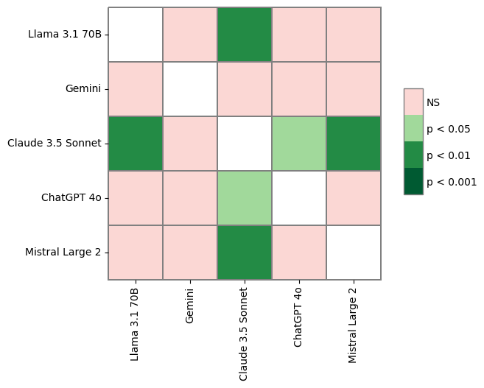
Supplementary Figure 1. Heatmap with comparisons between the statistical significance among the grades obtained by each LLM.

Supplementary Table 1. Expert panel key information.
Evaluator | Country | Institution
Dr. Luis Esteban | Spain | CIEMAT
Dr. Lucas Frungillo | England | University of Edinburgh
Dr. Estefanía Butassi | Argentina | CICONET
Dr. Alessandro Zambon | Italy | Università di Bologna
Dr. María Herranz | Spain | Miguel Hernández University
Dr. Mario Aranda | Chile | Universidad Católica de Chile
Dr. Federica Pollastro | Italy | Piamonte Orientale University
Dr. Anne Sylvie Tixier | France | Avignon University
Dr. Enrique Barrajón | Spain | Miguel Hernández University
Dr. Jose Vicente García | Spain | Polytechnic University of Valencia
Dr. David Arráez | Spain | Granada University
Dr. Andrew Ross | England | Leeds University
Dr. Pedro Mena | Italy | Parma University
Dr. Ru Angelie Edrada-Ebel | Scotland | University of Strarthclyde
Dr. James Lyng | Ireland | University College Dublin
Dr. Vicente Micol | Spain | Miguel Hernández University

