Appendix
In this Appendix we report a set of additional analyses that do not find place in the main text. The first analysis is devoted to check the validity of the RDD assumptions (i.e., the homogeneity of students in the neighborhood of the threshold). Figure A1 shows the results of the McCrary test for the three different observation windows used in the analyses and for all these windows no discontinuities are observed in the neighborhood of the threshold. In Table A1 a set of additional checks are reported. We use a set of relevant covariates as outcomes in an RDD logic and the results of the non-parametric estimation are not statistically significant, pointing out that there are no discontinuities on the threshold.
Figure A1. McCrary test for the manipulation of the running variable according to the three different windows of observation used in the analyses.
ISEE less than 2,000€ | ISEE less than 3,000€
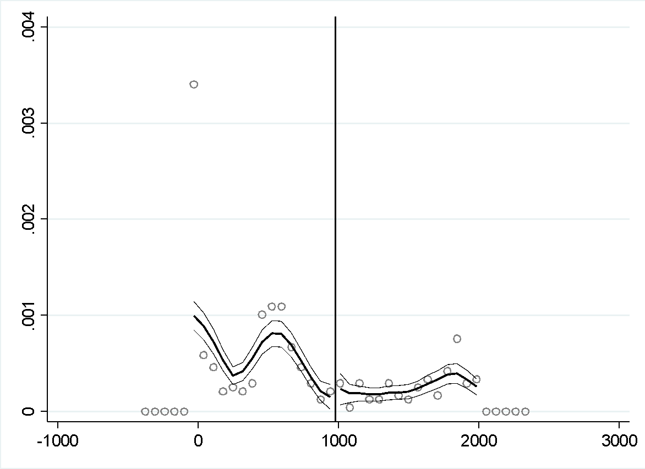 | 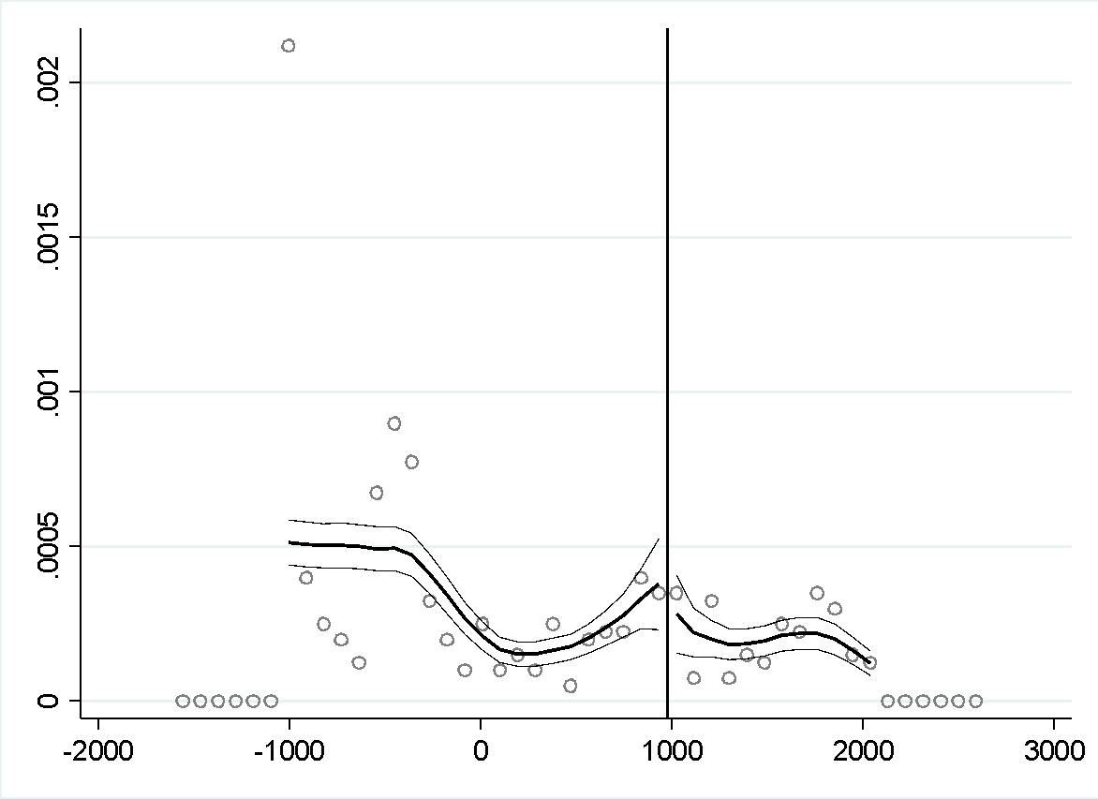
ISEE less than 4,000€
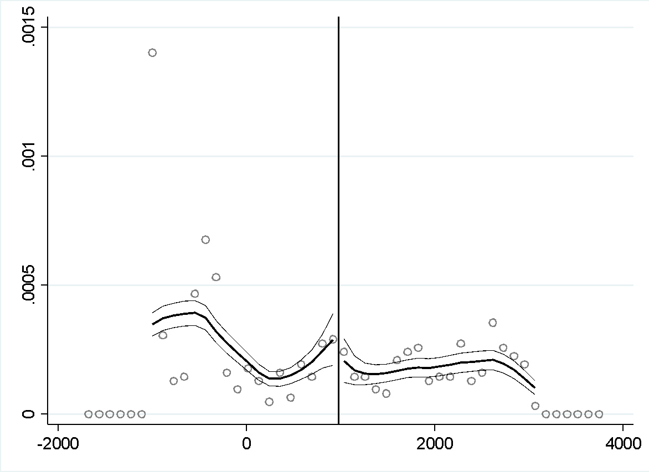

Table A1. Test for the continuity of the relevant covariates on the threshold point, non-parametric estimates.
 | Estimate | Std. err.
Sex (1=males) | -0.356 | 0.254
Family size | 0.587 | 0.942
Final mark at the high school | -11.588 | 9.450
High school track (1=academic) | 0.101 | 0.102
Note: all the covariates are coded as dummy variables with the exceptions of the final mark and the family size that are treated as a continuous variables.

The second set of analysis regards a more detailed discussione regarding the financial aid system (Diritto allo studio) in Italy and in the other Italian regions (not only in Piedmont). A common point is that every university implements a progressive system based on family income, which is assessed using the ISEE (Index of Equivalent Economic Condition). With the help of support measures and additional subsidies, such as the recent introduction of the 'no-tax area' policy, families with very low income are exempted from paying tuition fees. Students with an ISEE up to €20,000 only need to pay a regional tax of €140 or less, depending on the region. Students who do not qualify for a full exemption pay tuition fees based on their ISEE, and the amount varies according to the university. The specific thresholds that determine the ISEE classes and the corresponding tuition fees depend on each university's policies. The primary support measure for students from low-income families is the Diritto allo Studio program. Eligible students can receive various forms and levels of assistance based on their family income as determined by the ISEE. This assistance may include tuition waivers, subsidies for food and housing, or scholarships. Unfortunately, one major issue with the program is that not all eligible students receive scholarships due to insufficient funding at the regional level. Although Diritto allo Studio is a nationwide program ruled by the central government, the provision of individual aid is managed locally and relies on funding from local governments. Consequently, the distribution of funding and the chances of receiving support are not equal among regions (Table A2). Specifically, regions in the North, which have more available resources, allocate more funds to the Diritto allo Studio program to cover the costs of scholarships for eligible students compared to other regions.
Table A2. Percentage of grant recipient students in the total population of eligible students.
 |  | 2007/08 |  | 2008/09 | 2009/10 |  |  | 2010/11 |  | 2011/12 | 2012/13 |  |  | 2013/14 | 2014/15 |  | 2015/16 |  | 2016/17
Abruzzo |  | 87,8 | 59,8 |  |  | 55,7 | 60,8 |  | 43,4 |  |  | 67,0 | 70,4 |  |  | 100,0 |  | 100,0 |  | 100,0
Basilicata |  | 31,9 | 100,0 |  |  | 100,0 | 100,0 |  | 100,0 |  |  | 100,0 | 100,0 |  |  | 100,0 |  | 100,0 |  | 100,0
Calabria |  | 57,7 | 55,7 |  |  | 58,8 | 44,7 |  | 40,7 |  |  | 57,2 | 42,1 |  |  | 38,2 |  | 61,1 |  | 67,1
Campania |  | 62,0 | 60,3 |  |  | 56,1 | 50,8 |  | 34,4 |  |  | 27,4 | 52,8 |  |  | 48,6 |  | 80,6 |  | 87,6
Emilia-Romagna |  | 100,0 | 100,0 |  |  | 100,0 | 100,0 |  | 99,6 |  |  | 100,0 | 100,0 |  |  | 100,0 |  | 100,0 |  | 100,0
Friuli V.G. |  | 88,4 | 100,0 |  |  | 100,0 | 100,0 |  | 98,0 |  |  | 98,2 | 99,4 |  |  | 100,0 |  | 100,0 |  | 100,0
Lazio |  | 100,0 | 100,0 |  |  | 99,2 | 82,5 |  | 80,5 |  |  | 77,1 | 77,0 |  |  | 75,5 |  | 100,0 |  | 100,0
Liguria |  | 100,0 | 100,0 |  |  | 100,0 | 68,7 |  | 49,9 |  |  | 100,0 | 100,0 |  |  | 100,0 |  | 100,0 |  | 100,0
Lombardia |  | 100,0 | 100,0 |  |  | 100,0 | 77,8 |  | 67,4 |  |  | 87,0 | 91,2 |  |  | 96,4 |  | 99,0 |  | 99,7
Marche |  | 86,9 | 84,4 |  |  | 96,6 | 97,4 |  | 98,0 |  |  | 96,5 | 98,1 |  |  | 100,0 |  | 100,0 |  | 100,0
Molise |  | 37,0 | 43,5 |  |  | 63,6 | 54,2 |  | 58,7 |  |  | 84,1 | 64,4 |  |  | 72,7 |  | 64,9 |  | 93,9
Piemonte |  | 100,0 | 100,0 |  |  | 100,0 | 100,0 |  | 30,8 |  |  | 60,9 | 55,1 |  |  | 85,0 |  | 100,0 |  | 100,0
Alto Adige |  | 100,0 | 100,0 |  |  | 100,0 | 100,0 |  | 100,0 |  |  | 100,0 | 100,0 |  |  | 100,0 |  | 100,0 |  | 100,0
Trentino |  | 100,0 | 100,0 |  |  | 100,0 | 100,0 |  | 100,0 |  |  | 100,0 | 100,0 |  |  | 100,0 |  | 100,0 |  | 100,0
Puglia |  | 50,1 | 53,4 |  |  | 60,3 | 52,7 |  | 52,8 |  |  | 94,5 | 73,3 |  |  | 75,7 |  | 99,9 |  | 100,0
Sardegna |  | 86,4 | 85,7 |  |  | 86,1 | 93,3 |  | 81,1 |  |  | 64,2 | 56,0 |  |  | 64,9 |  | 100,0 |  | 100,0
Sicilia |  | 67,2 | 69,5 |  |  | 70,2 | 58,2 |  | 55,6 |  |  | 76,9 | 32,3 |  |  | 43,5 |  | 70,1 |  | 81,3
Toscana |  | 99,7 | 99,2 |  |  | 100,0 | 98,8 |  | 100,0 |  |  | 100,0 | 100,0 |  |  | 100,0 |  | 100,0 |  | 100,0
Umbria |  | 100,0 | 100,0 |  |  | 100,0 | 42,3 |  | 46,0 |  |  | 100,0 | 100,0 |  |  | 100,0 |  | 100,0 |  | 100,0
Valle d’Aosta |  | 100,0 | 100,0 |  |  | 100,0 | 100,0 |  | 96,8 |  |  | 100,0 | 100,0 |  |  | 100,0 |  | 100,0 |  | 100,0
Veneto |  | 90,0 | 86,6 |  |  | 86,7 | 65,5 |  | 82,6 |  |  | 100,0 | 100,0 |  |  | 90,4 |  | 98,8 |  | 99,1
ITALIA |  | 83,0 | 82,5 |  |  | 84,1 | 75,1 |  | 67,7 |  |  | 80,3 | 74,9 |  |  | 78,9 |  | 93,6 |  | 95,7
Source: Osservatorio Regionale per l’Università e per il Diritto allo studio universitario.

Table A3. Effects of grants on academic performance according to three different windows of observation. Parametric estimates obtained through a 2SLS estimator.
 | ISEE less than 2,000€ |  | ISEE less than 3,000€ |  | ISEE less than 5,000€
 | LATE | S.E. | LATE | S.E. | LATE | S.E.
Average GPA | 1.606 | 1.690 | -0.455 | 1.826 | -0.458 | 1.610
Credits | 9.284 | 6.904 | -3.097 | 7.335 | -8.106 | 6.931
Drop-out | -0.370* | 0.195 | -0.288** | 0.144 | -0.183* | 0.099
F-test first stage | 51.76 |  | 52.02 |  | 52.30

