Title: Widespread pollination deficits in pear (Pyrus communis L.) orchards: the role of pollinators, landscape context and pesticide risk

Index of Supplementary materials
Table S1. Description of the studied orchards………………………………………………………………………………………………2
Table S2. Summary of the analysis performed………………..………………………………………………………………...…………3
Table S3. Summary of model comparisons and results……………………………………………………………………………...3-4
Table S4. Correlation table of landscape categories at the 3 radii………………………….………………………………………………………………………………………………………………………………....4
Figure S1. Legend of Corine Land Cover categories……………………………………………………………………………………….5
Figure S2. Pollinator abundance across orchards...………………………………………………………………………………………..6
Table S5. List of the 39 active ingredients detected in pear flowers: pesticide type, LD50 (µg/bee) and residues (mg/kg) and their frequency of detection………………………………………………………………………………………………….6-7
Figure S3a, b. Relationship between seed set, final fruit set and pollination deficit……………………………………………………………………………………………………….………………………………………………….8
Figure S4. Relationship between initial fruit set open and final fruit set exclusion…………………………………………………………………………………………………..………………………………………………….9
Figure S5. Relationship between bumblebees’ visitation rate and seed set…………………………………………………..9

ORCHARD | Polliniser distribution | Hormones application | Managed pollinators | Mean visitation rate | Initial fruit set | Final fruit set | Seed set | PDef initial fruit set | PDef final fruit set
FE1 | Alternate blocks | No | Yes, BB | 0.00017 | 0.0078 | 0.0046 | 0.95 | 0.60 | 0.56
FE2 | Adjacent block | Yes | No | 0.00011 | 0.0798 | 0.0393 | 2.91 | 0.28 | 0.30
FE3 | Adjacent block | Yes | No | 0.00014 | 0.0097 | 0.0052 | 2.00 | 0.00 | 0.00
FE4 | Adjacent block | No | No | 0.00010 | 0.0000 | 0.0024 | 1.88 | 0.23 | 0.23
FE5 | Adjacent block | Yes | No | 0.00011 | 0.0081 | 0.0081 | 1.41 | 0.74 | 0.74
FE6 | Adjacent block | Yes | No | 0.00024 | 0.0000 | 0.0000 | 1.10 | 0.20 | 0.40
MO1 | Adjacent block | Yes | No | 0.00017 | 0.0057 | 0.0029 | 1.47 | 0.30 | 0.30
MO2 | Alternate blocks | No | No | 0.00016 | 0.0143 | 0.0100 | 2.00 | 0.11 | 0.11
MO3 | Adjacent block | No | No | 0.00003 | 0.0036 | 0.0036 | 2.55 | 0.63 | 0.56
MO4 | Adjacent block | No | No | 0.00007 | 0.0040 | 0.0011 | 2.05 | 0.17 | 0.17
MO5 | Adjacent block | No | No | 0.00005 | 0.0016 | 0.0000 | 2.65 | 0.00 | 0.00
MO6 | Adjacent block | Yes | No | 0.00025 | 0.0061 | 0.0102 | 2.14 | 0.30 | 0.20
RA1 | Adjacent block | Yes | No | 0.00003 | 0.0210 | 0.0210 | 1.70 | 0.46 | 0.56
RA2 | Alternate blocks | No | Yes, HB | NA | 0.0360 | 0.0626 | 3.14 | 0.40 | 0.28
RA3 | Alternate blocks | No | No | 0.00011 | 0.0076 | 0.0048 | 1.70 | 0.18 | 0.30
RA4 | Along the rows | Yes | Yes, HB and BB | 0.00010 | 0.0000 | 0.0071 | 0.85 | 0.50 | 0.50
Table S1. General description of the 16 studied orchards with information on orchard management, mean visitation rate of all pollinators, productive metrics (mean Initial fruit set, mean final fruit set and mean seed set under open pollination) and pollination deficits.
Table S2. Summary of the analysis performed. First block represents the effect of environmental variables (landscape and pesticide risk) on pollinators visitation rate; second block represents the combined effect of local variables (pesticide risk and orchard management practices, identified by output under pollinator exclusion) and pollinators visitation rate on pear reproductive success. PF0.5/1.0/1.5 km= Pollinator friendly landscape at 0.5, 1.0 and 1.5 km radii, each tested separately; HB=Honeybees, BB= Bumblebees, Wild pollinators= Wild bees + Syrphids + Muscoid flies.
 |  | RESPONSE VARIABLES | EXPLANATORY VARIABLES
Environment | Pollinators visitation rate | Honeybees | Risk + PF0.5/1.0/1.5 km
Environment | Pollinators visitation rate | Bumblebees | Risk + PF0.5/1.0/1.5 km
Environment | Pollinators visitation rate | Wild bees | Risk + PF0.5/1.0/1.5 km
Environment | Pollinators visitation rate | Syrphids | Risk + PF0.5/1.0/1.5 km
Environment | Pollinators visitation rate | Muscoid flies | Risk + PF0.5/1.0/1.5 km
Reproductive success | Production | Initial Fruit set | HB + BB + Wild pollinators + Pollinator Exclusion initial fruit set + Risk
Reproductive success | Production | Final Fruit set | HB + BB + Wild pollinators + Pollinator Exclusion final fruit set+ Risk
Reproductive success | Production | Seed set | HB + BB + Wild pollinators + Pollinator Exclusion initial fruit set + Risk
Reproductive success | Pollination service and deficit | Pollination Service (initial Fruit set) | HB + BB + Wild_pollinators + Risk + Pollinator Exclusion initial fruit set
Reproductive success | Pollination service and deficit | Pollination Service (final Fruit set) | HB + BB + Wild_pollinators + Risk + Pollinator Exclusion final fruit set
Reproductive success | Pollination service and deficit | Pollination Deficit initial Fruit set | HB + BB + Wild_pollinators + Pollinator Exclusion initial fruit set
Reproductive success | Pollination service and deficit | Pollination Deficit final Fruit set | HB + BB + Wild_pollinators + Pollinator Exclusion final fruit set

Table S3. Best-supported models (ΔAICc<2) analyzing i) the effect of environment (landscape and pesticide risk) on pollinators visitation rate; ii) effect of pollinators visitation rate, pesticide risk and orchard management (pollinator exclusion) on pear production, pollination service and pollination deficit. PF0.5, PF1, PF1.5= Pollinator friendly landscape at 0.5, 1.0 and 1.5 km, respectively; Risk= pesticide risk index; PS= Pollination service; PD_FLS= pollination deficit initial fruit set; PD_FS= pollination deficit final fruit set; FLS_ex= Initial Fruit set exclusion; FS_ex= Final Fruit set exclusion; HB= Honeybees, BB= Bumblebees, WB= Wild bees, SYR= Syrphids, MSC= Muscoid flies; Wild_mix= Wild pollinators. Blank spaces refer to null model; variables in bold were also significant.
Model | Rank | Variables selected | df | AICc | ΔAICc | Weight | adjR²
HB_log ~ Risk + PF0.5 km | 1  2 | PF0.5 km | 2  3 | -284.7  -283.1 | 0.00  1.57 | 0.579  0.264 | 0  0
HB_log ~ Risk + PF1.0 km | 1 |  | 2 | -284.7 | 0.00 | 0.685 | 0
HB_log ~ Risk + PF1.5 km | 1 |  | 2 | -284.7 | 0.00 | 0.685 | 0
BB_log ~ Risk + PF0.5 km | 1 |  | 2 | -338.7 | 0.00 | 0.675 | 0
BB_log ~ Risk + PF1.0 km | 1 |  | 2 | -338.7 | 0.00 | 0.609 | 0
BB_log ~ Risk + PF1.5 km | 1 |  | 2 | -338.7 | 0.00 | 0.674 | 0
WB_log ~ Risk + PF0.5 km | 1  2  3 | PF0.5  Risk | 2  3  3 | -356.1  -355.0  -354.3 | 0.00  1.12  1.82 | 0.455  0.260  0.183 | 0  0  0
WB_log ~ Risk + PF1.0 km | 2  1 | PF1.0 | 3  2 | -357.4  -356.1 | 0.00  1.33 | 0.507  0.260 | 0  0
WB_log ~ Risk + PF1.5 km | 2 | PF 1.5 | 3 | -358.4 | 0.00 | 0.577 | 0
SYR ~ Risk + PF0.5 km | 1  2 | PF0.5 | 2  3 | -314.1  -313.5 | 0.00  0.67 | 0.494  0.353 | 0  0
SYR ~ Risk + PF1.0 km | 1  2 | PF1.0 | 2  3 | -314.1 -312.7 | 0.00 1.47 | 0.569  0.273 | 0  0
SYR ~ Risk + PF1.5 km | 1  2 | PF1.5 | 2  3 | -314.1  -313.4 | 0.00  0.70 | 0.495  0.350 | 0  0
Muscoid ~ Risk + PF0.5 km | 1 |  | 2 | -285.5 | 0.00 | 0.634 | 0
Muscoid ~ Risk + PF1.0 km | 1 |  | 2 | -285.5 | 0.00 | 0.630 | 0
Muscoid ~ Risk + PF1.5 km | 1 |  | 2 | -285.5 | 0.00 | 0.616 | 0
FLS_Open_log ~ FLS_ex + HB + BB + Wild_mix + Risk | 11 | FLS_ex + Risk | 4 | -121.0 | 0.00 | 0.671 | -9.493e-04
FS_Open_log ~ FS_ex + HB + BB + Wild_mix + Risk | 3  1 | FS_ex | 3  2 | -118.7  -116.8 | 0.00  1.97 | 0.375  0.140 | -8.680e-05  0
Seed ~ HB + BB + Wild_mix+ FLS_ex + Risk | 2  4  6 | BB  BB+ FLS_ex  BB + HB | 2  4  4 | 41.1  41.2  41.9 | 0.00  1.44  1.62 | 0.244  0.119  0.109 | 0.38750  0.50720  0.49900
PS_FLS ~ HB + BB + Wild_mix+ FLS_ex + Risk | 11  3  1 | FLS_ex + Risk  FLS_ex | 4  3  2 | -40.0  -39.0  -38.7 | 0.00  0.95  1.30 | 0.259  0.171  0.136 | -2.440e-02  -1.203e-02  0
PS_FS ~ HB + BB + Wild_mix+ FS_ex + Risk | 1  5  9 | FS_ex  HB | 2  3  3 | -42.9  -42.1  -41.2 | 0.00  0.75  1.64 | 0.248  0.169  0.180 | 0  -6.418e-03  -4.189e-03
PD_FLS ~ HB + BB + Wild_mix+ FLS_ex + Risk | 2  1  18 | BB  BB + Wild_mix | 3  2  4 | 1.8  1.9  3.6 | 0.00  0.16  1.88 | 0.222  0.205  0.087 | -0.8757  0  -1.3020
PD_FS ~ HB + BB + Wild_mix+ FS_ex + Risk | 1  2  9 | BB  Risk | 2  3  3 | 1.1  2.1  2.4 | 0.00  1.01  1.36 | 0.247  0.149  0.125 | 0  -0.44860  -0.38100

Table S4. Correlation between pollinator-friendly landscape (arcsin-transformed) at 0.5, 1.0 and 1.5 km radii
Variable 1 | Variable 2 | r | p-value
Friendly_0.5 | Friendly_1.0 | 0.731 | 0.001
Friendly_0.5 | Friendly_1.5 | 0.460 | 0.073
Friendly_1.0 | Friendly_1.5 | 0.754 | <0.001

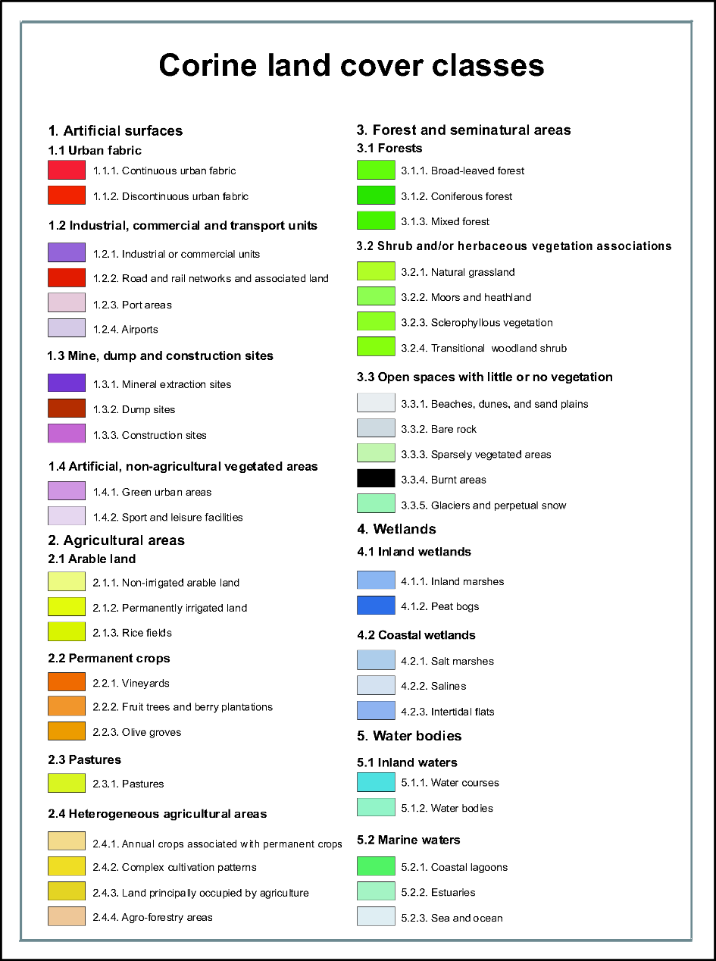
Figure S1. Legend of Corine Land Cover categories grouped in the 3 main categories “Agricultural” (2.1 and 2.2), “Urban” (1.1, 1.2 and 1.3) and “Pollinator friendly” (1.4, 2.3, 2.4, 3.1, 3.2 and 4).
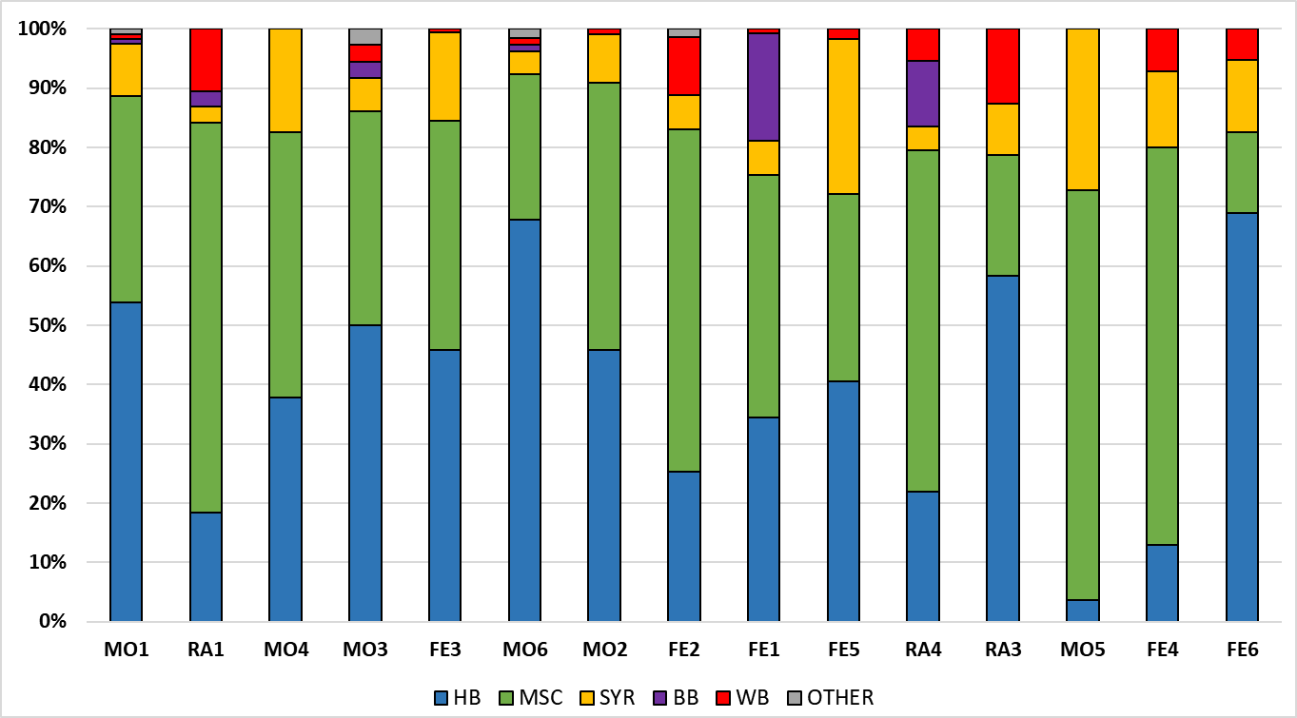

Figure S2. Abundances (%) of pollinators across the studied orchards, ordered by increasing proportion of pollinator-friendly landscape at 1.5 km. HB= Honeybees; MSC= Muscoid flies; SYR= Syrphids; BB= Bumblebees; WB= Wild bees.

Table S5. List of the 39 active ingredients detected in pear flowers; pesticide type, LD50 (µg/bee) and residues (mg/kg) and their frequency of detection across the 16 orchards are reported. LD50 in bold refer to oral toxicity.
# | Compound | Pesticide type | LD50 (μg/bee) | Residues (mg/Kg) |  |  |  | Frequency of detection (% orchards)
 |  |  |  | Mean | Median | Min | Max | Frequency of detection (% orchards)
1 | 1-Naftil acetamide | Planth Growth Regulator | 100 | 0.086 | 0.086 | 0.086 | 0.086 | 6.3%
2 | 1-naftilacetammide and acid  1-naftilacetic (sum of 1-  naftilacetammide and 1-  naftilacetic and its salts,  expressed as acid 1-  naftilacetic) | Planth Growth Regulator | 78.6 | 0.086 | 0.086 | 0.086 | 0.086 | 6.3%
3 | 6-Benziladenine | Planth Growth Regulator | 58.73 | 0.024 | 0.023 | 0.012 | 0.039 | 56.3%
4 | Acetamiprid | Insecticide | 8.09 | 2.677 | 1.875 | 0.038 | 6.92 | 25%
5 | Acibenzolar acid | Fungicide | 100 | 0.338 | 0.338 | 0.338 | 0.338 | 6.3%
6 | Acibenzolar-s-methyl | Fungicide | 100 | 0.013 | 0.013 | 0.013 | 0.013 | 6.3%
7 | Acibenzolar-S-methyl  (sum of acibenzolar-Smethyl  and acibenzolar acid) | Fungicide | 100 | 0.375 | 0.375 | 0.375 | 0.375 | 6.3%
8 | Gibberellic Acid | Planth Growth Regulator | 25 | 0.237 | 0.237 | 0.237 | 0.237 | 6.3%
9 | Boscalid | Fungicide | 166 | 0.015 | 0.015 | 0.013 | 0.017 | 12.5%
10 | Captan | Fungicide | 100 | 32.55 | 67.335 | 0.018 | 162 | 37.5%
11 | Captan (Sum of captan and THPI) | Fungicide | 100 | 41.80 | 0.377 | 0.074 | 264 | 50%
12 | Carbendazim (Sum of  benomyl and carbendazim) | Fungicide | 50 | 0.034 | 0.034 | 0.034 | 0.034 | 6.3%
13 | Chlorpyrifos | Insecticide | 0.068 | 0.029 | 0.033 | 0.018 | 0.037 | 18.8%
14 | Chlorpyrifos Methyl | Insecticide | 0.148 | 0.027 | 0.027 | 0.027 | 0.027 | 6.3%
15 | Cyprodinil | Fungicide | 75 | 13.71 | 3.46 | 0.014 | 59 | 56.3%
16 | Difenoconazole | Fungicide | 100 | 2.08 | 1.98 | 0.014 | 4.84 | 56.3%
17 | Diflufenican | Herbicide | 100 | 0.015 | 0.015 | 0.015 | 0.015 | 6.3%
18 | Dithianon | Fungicide | 25.4 | 1.896 | 0.64 | 0.022 | 10.5 | 68.8%
19 | Dodine | Fungicide | 145 | 0.022 | 0.022 | 0.014 | 0.03 | 12.5%
20 | Flonicamid | Insecticide | 60.5 | 0.012 | 0.012 | 0.012 | 0.012 | 6.3%
21 | Flonicamid (sum of  Flonicamid, TFNG e TFNA) | Insecticide | 60.5 | 0.012 | 0.012 | 0.012 | 0.012 | 6.3%
22 | Fluazinam | Fungicide | 100 | 22.98 | 20.6 | 0.011 | 41.8 | 31.3%
23 | Fludioxonil | Fungicide | 100 | 9.052 | 3.85 | 2.64 | 19.3 | 31.3%
24 | Fluopyram | Fungicide | 100 | 1.542 | 1.542 | 0.024 | 3.06 | 12.5%
25 | Flupyradifurone | Insecticide | 1.2 | 4.645 | 4.645 | 2.48 | 6.81 | 12.5%
26 | Fluxapyroxad | Fungicide | 100 | 6.257 | 2.13 | 1.34 | 15.3 | 18.8%
27 | Glyphosate | Herbicide | 100 | 0.023 | 0.016 | 0.011 | 0.063 | 75%
28 | Iprodione | Fungicide | 100 | 0.024 | 0.025 | 0.019 | 0.029 | 18.8%
29 | Mefentrifluconazole | Fungicide | 100 | 7.635 | 0.1135 | 0.013 | 30.3 | 25%
30 | Metazaclor | Herbicide | 72.2 | 0.061 | 0.084 | 0.013 | 0.087 | 18.8%
31 | Pendimetalin | Herbicide | 100 | 0.026 | 0.026 | 0.026 | 0.026 | 6.3%
32 | Pyriproxifen | Insecticide | 74 | 0.227 | 0.094 | 0.013 | 0.799 | 93.8%
33 | Pyrimethanil | Fungicide | 100 | 7.51 | 8.145 | 0.033 | 14.5 | 75%
34 | Spirodiclofen | Acaricide | 196 | 0.153 | 0.153 | 0.153 | 0.153 | 6.3%
35 | Spirotetramat - BYI08330-  chetoidrossi | Insecticide | 100 | 0.033 | 0.033 | 0.033 | 0.033 | 6.3%
36 | Tau Fluvalinate | Insecticide | 12 | 0.028 | 0.012 | 0.01 | 0.061 | 18.8%
37 | Tebuconazole | Fungicide | 83.05 | 4.733 | 0.098 | 0.031 | 14.4 | 31.3%
38 | Tetraidroftalimmide (THPI) | Fungicide | 100 | 7.903 | 0.211 | 0.037 | 51.2 | 56.3%
39 | Triflumuron | Insecticide | 200 | 0.101 | 0.101 | 0.101 | 0.101 | 6.3%

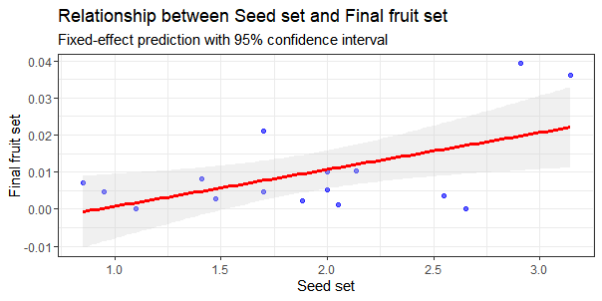
Figure S3a. Positive relationship between seed set and final fruit set open branches (p=0.025); each dot represents an orchard, the red line represents the fitted regression line and the grey shaded area represent the 95% confidence intervals. Final fruit set= final fruit set derived from open pollination.
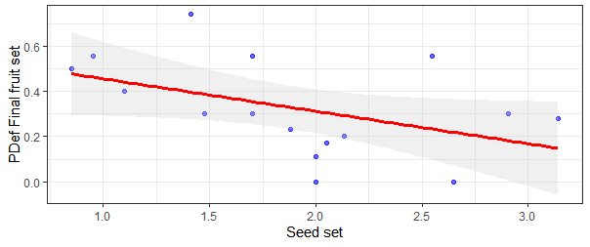

Figure S3b. Negtive trend between seed set and pollination deficit of final fruit set (p=0.077); each dot represents an orchard, the red line represents the fitted regression line and the grey shaded area represent the 95% confidence intervals. PDef fruit set= pollination deficit of final fruit set.

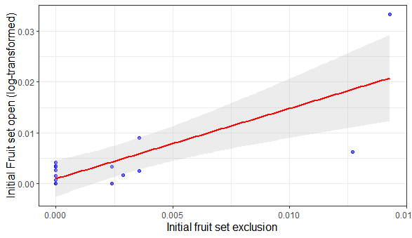
Figure S4. Positive relationship between initial fruit set open branches and initial fruit set exclusion branches (p< 0.001); each dot represents an orchard, the red line represents the fitted regression line and the grey shaded area represent the 95% confidence intervals.
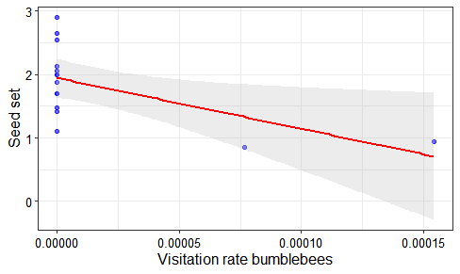

Figure S5. Negative relationship between bumblebees’ visitation rate (n° of bumblebees per n° of flowers in the transect) and seed set (p=0.028); blue dots represent the orchards, the red line represents the fitted regression line and the grey shaded area represent the 95% confidence intervals

