Supplementary Table 1. Spectrum of mutations identified in the HoFH cohort.

LDLR gene
Gene | Protein | Variant type | Allele frequency  % | Homozygotes | Heterozygotes
LDLR c.-188C>T | p.? | Promoter site mutation | 0,44248 | 0 | 1
LDLR c.(67+1_68-1)_(1845+1_1846-1)del | p.? | Large deletion | 1,76991 | 2 | 0
LDLR c.81C>G | p.(Cys27*) | Nonsense | 0,44248 | 0 | 1
LDLR c.103C>T | p.(Gln35*) | Nonsense | 0,44248 | 0 | 1
LDLR c.187C>T | p.(Cys63Arg) | Missense | 0,44248 | 0 | 1
LDLR c.265T>C | p.(Cys89Arg) | Missense | 0,44248 | 0 | 1
LDLR c.274C>T | p.(Gln92*) | Nonsense | 0,44248 | 0 | 1
LDLR c.304C>T | p.(Gln102*) | Nonsense | 1,32743 | 0 | 3
LDLR c.352G>T | p.(Asp118Tyr) | Missense | 2,65487 | 0 | 6
LDLR c.363C>A | p.(Cys248*) | Nonsense | 0,88496 | 0 | 2
LDLR c.367T>C | p.(Ser123Pro) | Missense | 0,44248 | 0 | 1
LDLR c.373 C>T | p.(Gln125*) | Nonsense | 0,88496 | 1 | 0
LDLR c.418G>T | p.(Glu140*) | Nonsense | 0,44248 | 0 | 1
LDLR c.542C>G | p.(Pro181Arg) | Missense | 0,44248 | 0 | 1

LDLR c.589T>C | p.(Cys197Arg) | Missense | 0,44248 | 0 | 1
LDLR c.621C>T | p.(Gly207_Cys231del) | Small deletion in frame | 0,88496 | 1 | 0
LDLR c.641G>A | p.(Trp214*) | Nonsense | 0,44248 | 0 | 1
LDLR c.661G>A | p.(Asp221Asn) | Missense | 0,44248 | 0 | 1
LDLR c.662A>G | p.(Asp221Gly) | Missense | 3,09735 | 2 | 4
LDLR c.665G>A | p.(Cys222Tyr) | Missense | 0,44248 | 0 | 1
LDLR c.681C>G | p.(Asp227Glu) | Missense | 0,88496 | 1 | 0
LDLR c.682G>A | p.(Glu228Lys) | Missense | 0,44248 | 0 | 1
LDLR c.718G>A | p.(Glu240Lys) | Missense | 1,32743 | 0 | 3
LDLR c.727T>C | p.(Cys243Arg) | Missense | 0,44248 | 0 | 1
LDLR c.761A>C | p.(Gln254Pro) | Missense | 1,32743 | 1 | 1
LDLR c.796G>A | p.(Asp266Asn) | Missense | 0,44248 | 0 | 1
LDLR c.798T>A | p.(Asp266Glu) | Missense | 0,88496 | 1 | 0
LDLR c.817+5G>C | p.? | Intronic splicing affecting | 0,44248 | 0 | 1
LDLR c.828C>G | p.(Cys276*) | Nonsense | 0,44248 | 0 | 1
LDLR c.858C>A | p.(Ser286Arg) | Missense | 0,88496 | 0 | 2
LDLR c.898A>G | p.(Arg300Gly) | Missense | 0,88496 | 0 | 2
LDLR c.907C>T | p.(Arg303Trp) | Missense | 0,44248 | 0 | 1

LDLR c.929T>A | p.(Ile310Asn) | Missense | 0,44248 | 0 | 1
LDLR c.940_940+14 | p.? | Deletion | 0,88496 | 1 | 0
LDLR c.974G>A | p.(Cys325Tyr) | Missense | 0,44248 | 0 | 1
LDLR c.1003G>A | p.(Gly335Ser) | Missense | 1,76991 | 0 | 4
LDLR c.1027G>A | p.(Gly343Ser) | Missense | 0,44248 | 0 | 1
LDLR c.1056C>G | p.(Cys352Trp) | Missense | 0,44248 | 0 | 1
LDLR c.1066G>A | p.(Asp356Asn) | Missense | 0,44248 | 0 | 1
LDLR c.1069_1086dup | p.(Glu357_Asp362dup) | Small duplication in frame | 0,88496 | 0 | 2
LDLR c.1090T>C | p.(Cys364Arg) | Missense | 0,44248 | 0 | 1
LDLR c.1109A>C | p.(Asn370Thr) | Missense | 0,88496 | 1 | 0
LDLR c.1118G>A | p.(Gly373Asp) | Missense | 1,32743 | 1 | 1
LDLR c.1130G>T | p.(Cys377Tyr) | Missense | 0,44248 | 0 | 1
LDLR c.1135T>C | p.(Cys379Arg) | Missense | 2,65487 | 1 | 4
LDLR c.1175_1186del | p.(Glu380_Gly396del) | Small deletion in frame | 1,76991 | 0 | 4
LDLR c.1186+5T>C | p.(Gly396fs*26) | Intronic Splicing affecting | 0,44248 | 0 | 1
LDLR c.1187-10G>A | p.? | Intronic Splicing affecting | 0,44248 | 0 | 1
LDLR c.1195G>A | p.(Ala399Thr) | Missense | 0,88496 | 0 | 2
LDLR c.1211C>T | p.(Thr404Ile) | Missense | 0,88496 | 0 | 2

LDLR c.1230 G>C | p.(Arg410Ser) | Missense | 0,44248 | 0 | 1
LDLR c.1257C>G | p.(Tyr419*) | Nonsense | 1,76991 | 0 | 4
LDLR c.126C>A | p.(Tyr42*) | Missense | 0,88496 | 0 | 2
LDLR c.1285G>A | p.(Val429Met) | Missense | 0,44248 | 0 | 1
LDLR c.1291G>A | p.(Ala431Thr) | Missense | 0,88496 | 1 | 0
LDLR c.1414 G>T | p.(Asp472Tyr) | Missense | 0,44248 | 0 | 1
LDLR c.1454A>G | p.(His485Arg) | Missense | 0,44248 | 0 | 1
LDLR c.1478_1479del | p.(Ser493Cysfs*42) | Small deletion frame shift | 0,88496 | 0 | 2
LDLR c.1567G>A | p.(Val523Met) | Missense | 7,9646 | 5 | 8
LDLR c.-156C>T | p./ | Regulatory or promoter | 0,88496 | 1 | 0
LDLR c.1585G>C | p.Gly529Arg | Missense | 0,44248 | 0 | 1
LDLR c.1586+1_1587-1_(*450_?)del | p.? | Large deletion | 0,44248 | 0 | 1
LDLR c.1586+5G>A | p.= | Intronic splicing affecting | 0,44248 | 0 | 1
LDLR c.1618G>A | p.(Ala540Thr) | Missense | 1,76991 | 1 | 2
LDLR c.1646G>A | p.(Gly549Asp) | Missense | 7,07965 | 3 | 10
LDLR c.1646G>A | p.(Gly549Asp) | Missense | 0,88496 | 0 | 2
LDLR c.1691A>G | p.(Asn564Ser) | Missense | 0,44248 | 0 | 1
LDLR c.1720C>T | p.(Arg574Cys) | Missense | 0,44248 | 0 | 1

LDLR c.1735G>A | p.(Asp579Asn) | Missense | 0,44248 | 0 | 1
LDLR c.1739C>T | p.(Ser580Phe) | Missense | 1,76991 | 1 | 2
LDLR c.1775G>A | p.(Gly592Glu) | Missense | 10,6195 | 8 | 8
LDLR c.1845+1_1846-1_2311+1_2312-1del | p.(Asp616Leufs*17) | Large deletion | 0,44248 | 0 | 1
LDLR c.1846-1894_2140+1498del | p.? | Large deletion | 2,21239 | 0 | 5
LDLR c.1891_2311+1062del | p.? | Large deletion | 0,44248 | 0 | 1
LDLR c.1898G>A | p.(Arg633His) | Missense | 0,88496 | 1 | 0
LDLR c.1982C>T | p.(Pro661Leu) | Missense | 0,44248 | 0 | 1
LDLR c.2041T>A | p.(Cys681Ser) | Missense | 0,44248 | 0 | 1
LDLR c.2054C>T | p.(Pro685Leu) | Missense | 2,21239 | 0 | 5
LDLR c.2079_2083del | p.? | Small deletion frame shift | 0,44248 | 0 | 1
LDLR c.2140+1G>T | p.? | Intronic splicing affecting | 0,44248 | 0 | 1
LDLR c.2311+1G>A | p.[(Gln770_Ala771ins30;Val7  31Leufs*17;Glu 714_Gln770del) | Intronic splicing affecting | 0,88496 | 1 | 0
LDLR c.2312-3C>A | p.(Ala750_Ile775del) | Intronic – Skipping exon  16 | 1,32743 | 0 | 3
LDLR c.2389G>A | p.(Val797Met) | Missense | 0,88496 | 1 | 0

LDLR c.2390-1G>A | p.(Val797Glyfs*153) | Intronic splicing affecting | 0,88496 | 1 | 0
LDLR c.2476C>A | p.(Pro826Thr) | Missense | 0,44248 | 0 | 1
LDLR exon 13-14del | p.? | Large deletion | 0,44248 | 0 | 1
LDLR exon 7_15dup | p.? | Large duplication | 0,44248 | 0 | 1
APOB gene
APOB c.1618-15C>T | p.? | Unknown | 0,44248 | 0 | 1
APOB c.2068-4T>A | p.? | Intronic splicing affecting | 0,44248 | 0 | 1
APOB c.6001A>G | p.(Thr2001Ala) | Missense | 0,44248 | 0 | 1
APOB c.7763C>A | p.(Pro2588His) | Missense | 0,44248 | 0 | 1
APOB c.8405A>T | p.(Glu2802Val) | Missense | 0,44248 | 0 | 1
APOB c.9349A>G | p.(Ile3111Val) | Missense | 0,44248 | 0 | 1
APOB c.10580G>A | p.(Arg3527Gln) | Missense | 0,44248 | 0 | 1
APOB c.10672C>T | p.(Arg3558Cys) | Missense | 1,76991 | 0 | 4
PCSK9 gene
PCSK9 c.-28G>A | p.(=) | Regulatory or promoter | 0,44248 | 0 | 1
PCSK9 c.60_65dup | p.(Leu22_Leu23dup) | Small duplication in frame | 0,44248 | 0 | 1
PCSK9 c.331 C>A | p.(=) | Synonim | 0,88496 | 0 | 2
PCSK9 c.1906A>C | p.(Ser636Arg) | Missense | 0,44248 | 0 | 1

LDLRAP1 gene
LDLRAP1 c.65 G>A | p.(Trp22Ter) | Missense | 1,32743 | 1 | 1
LDLRAP1 c.89-1 G>C | p.? | Intronic splicing affecting | 1,32743 | 1 | 1
LDLRAP1 c.432_433insA | p.(Ala145fs) | Small insertion frame-shift | 7,9646 | 9 | 0
LDLRAP1 c.605C>A | p.(Ser202Tyr) | Missense | 0,44248 | 0 | 1
LDLRAP1 c.711G>A | p.(Pro237=) | Synonim | 0,44248 | 0 | 1
LDLRAP1 c.1068 C>A | p.(Ile355Asp) | Missense | 0,44248 | 0 | 1
LDLRAP1 c.1745G>A | p.(Leu582Pro) | Missense | 0,44248 | 0 | 1
LIPA gene
LIPA c.-23C>T | p.? | Regulatory or Promoter | 0,44248 | 0 | 1
Legend: Allele distribution among cohort. 4 patients had unavailable genetics at date of database lock. Allele frequency was calculated as number of variants found in HoFH cohort/total alles in HoFH cohort. HGVS nomenclature is relative to the LDLR NM_000527.5, APOB NM_000384.3, PCSK9 NM_174936.4, LDLRAP1 NM_015627.3 amd LIPA NM_000235.4 transcripts. Variant position numbers are reported in the context of the reference human genome build, hg19.

Supplementary Table 2. Baseline clinical characteristics of HoFH patients according to genotypes

 | mHoFH |  | ARH |  | BiHoFH |  | PhHoFH |  | p-  value
Number, n (%) | 37 | (26.62) | 11 | (7.91) | 63 | (45.32) | 28 | (20.14)
Males, n % | 24 | (64.9) | 6 | (64.5) | 31 | (49.2) | 10 | (35.7) | NS
Age at clinical diagnosis, mean ± SD (min-  max) | 25.6 ± 22.4 | (0 - 75) | 25.6 ± 23.0 | (0 - 65) | 23.6 ± 17.6 | (1 - 63) | 33.5 ± 17.4 | (9 - 63) | NS
Age at first visit, mean ± SD (min-max) | 34.2 ± 7.1 | (0 - 75) | 32.3 ± 15.2 | (1 - 69) | 32.8 ± 5.5 | (3 - 70) | 41.9 ± 7.0 | (4 - 62) | NS
Xantomathas, n % Planus  Tuberosus  Tendineus | 21  17  31 | (56.8)  (45.9)  (83.8) | 4  3  5 | (36.4)  (27.3)  (45.5) | 17  7  40 | (27.0)  (11.1)  (63.5) | 5  2  2 | (17.9)  (7.1)  (7.1) | 0.066  <0.01  0.014
Total cholesterol untreated, mean ± SD (min-  max) | 633.1 ± 162.9 | (512.5-754.5) | 574.1 ± 110.3 | (461.0-667.0) | 584.3 ± 139.1 | (468.0-616.0) | 534.1 ± 128.4 | (480.5-551.5) | 0.044
LDL-C untreated, mean ± SD (min-max) | 572.4 ± 177.6 | (338-1029) | 511.0 ± 112.9 | (305 - 641) | 464.5 ± 135.1 | (197 - 841) | 416.8 ± 77.9 | (216 - 556) | <0.01
Total cholesterol baseline, mean ± SD (min-  max) | 393.1 ± 175.9 | (271.0-448.0) | 433.4 ± 120. 2 | (335.0-530.7) | 387.7 ± 113.8 | (279.7-481.0) | 454.1 ± 143.4 | (330.0-545.0) | NS
LDL-C baseline, mean ± SD (min-max) | 316.2± 169.5 | (44-887) | 349.5 ± 114.8 | (218-608) | 323.4 ± 118.7 | (132-645) | 366.8 ± 141.3 | (48-744) | NS
Age at statin start, mean ± SD (min-max) | 24.6 ± 18.9 | (1 - 68) | 30.5 ± 21.2 | (1 - 68) | 26.9 ± 17.9 | (3 - 66) | 39.4 ± 16.5 | (4 - 60) | 0.052

MACE-plus, n % | 19 | (51.4) | 3 | (27.3) | 17 | (27.0) | 7 | (25.0) | 0.05
Age at first MACE-plus event, mean ± SD (min-max) | 38.1 ± 11.2 | (21 - 62) | 50.0 ± 21.2 | (35 - 65) | 42.3 ± 12.5 | (20 - 64) | 36.3 ± 5.7 | (31 - 44) | NS

Legend: The table represents the clinical data of HoFH patients according to genotypes at first visit at the lipid centre. Data are expressed as mean ± SD, median (IQR) and number (percentage) as appropriate. P has been provided for differences in trend among the four groups. For age at the clinical diagnosis data is not available for 6 patients (2 ARH, 2 CHE/DHE and 2 Clinical FH). 27 patients have unavailable data for age of molecular diagnosis (8 monogenic HoFH, 1 ARH, 14 billelic HoFH and 4 Phenotipic HoFH). Data for age at first visit is missing for 9 patients (9 ARH, 5 CHE/DHE and 3 clinical HoFH). BMI is not available for 24 patients (5 monogenic HoFH, 2 ARH, 7 Biallelic HoFH, 10 Phenotipic HoFH). The untreated value of LDL is not available for 26 patients (5 monogenic HoFH, 1 ARH, 12 Biallelic HoFH and 8 Phenotipic HoFH). mHoFH, monogenic homozygous familiar hypercholesterolemia; biHoFH, biallelic HoFH, phHoFH, phenotipic HoFH; ARH, autosomal recessive hypercholesterolemia; MACE-plus, major atherosclerotic cardiovascular event plus carotid artery revascularization, peripheral arteries revascularization or aortic aneurism reparation; SD, standard deviation; NS, not significant.

Supplementary Table 3. Detailed lipid-lowering therapy at follow-up

Lipid-lowering therapy | BASELINE (N) | % | LAST VISIT (N) | %
No therapies | 24 | 17.3 | 1 |  | 0.7
Statins | 71 | 51.1 | 6 |  | 4.2
Statins + Ezetimibe | 22 | 15.8 | 17 |  | 12.3
Apheresis + Statins ± Ezetimibe | 9 | 6.5 | 7 |  | 5.1
PCSK9i | 0 | 0 | 1 |  | 0.7
PCSK9i + Statins | 2 | 0.7 | 11 |  | 7.9
PCSK9i + Ezetimibe | 3 | 2.1 | 8 |  | 5.7
PCSK9i + Statins + Ezetimibe | 8 | 5.7 | 46 |  | 33.0
PCSK9i + Statins + Ezetimibe + Apheresis | 0 | 0 | 3 |  | 2.2
Lomitapide | 0 | 0 | 2 |  | 1.4
Lomitapide + Statins | 0 | 0 | 1 |  | 0.7
Lomitapide + Apheresis | 0 | 0 | 2 |  | 1.4
Lomitapide + Statins + Ezetimibe | 0 | 0 | 18 |  | 12.9
Lomitapide + Statins + Apheresis ± Ezetimibe | 0 | 0 | 4 |  | 2.9
Lomitapide + PCSK9i ± Ezetimibe | 0 | 0 | 5 |  | 3.6
Evinacumab + Statins + Ezetimibe | 0 | 0 | 2 |  | 1.4
Evinacumab + Lomitapide +Statins + Ezetimibe | 0 | 0 | 1 |  | 0.7
Evinacumab + Lomitapide + PCSK9i +Statins + Ezetimibe | 0 | 0 | 4 |  | 2.9

Legend: The table represents the detailed lipid-lowering therapy of HoFH patients at the baseline and last visit. Number of patients is reported on the left and relative percentages on the total population are reported on the right. PCSK9i, protease proprotein convertase subtilisin/kexin type 9 inhibitor.

Supplementary Table 4. Total number and types of incident MACE-Plus occurred during follow-up according to genotypes.

 | Total MACE-Plus | Coronary events | Extracoronary events | Cerebrovascular Events | Severe aortic Valve Stenosis | Cardiovascular death
 | 58 | 37 | 3 | 8 | 6 | 4
mHoFH n (%) | 23 (39.7) | 14 (37.8) | 0 (0) | 3 (37.5) | 4 (66.6) | 2 (50.0)
ARH n (%) | 12 (20.6) | 6 (16.2) | 1 (33.3) | 3 (37.5) | 1 (16.6) | 1 (25.0)
biHoFH n (%) | 17 (29.3) | 13 (35.1) | 1 (33.3) | 1 (12.5) | 1 (16.6) | 1 (25.0)
phHoFH n (%) | 6 (10.3) | 4 (10.8) | 1 (33.3) | 1 (12.5) | 0 | 0

Legend: the table represents total number of incident MACE-plus events occurred during follow-up. Definition of events are reported in the Material and Method section. Data are reported as number and percentages.mHoFH, monogenic HoFH, biHoFH, biallelic HoFH; phHoFH; phenotypic HoFH; ARH, autosomal recessive hypercholesterolemia. For the type of events see Material and Methods. MACE-plus, major atherosclerotic cardiovascular event plus carotid artery revascularization, peripheral arteries revascularization or aortic aneurism reparation.

Supplementary Figure 1. Distribution of lipid lowering therapies at last visit according to genotypes

A B
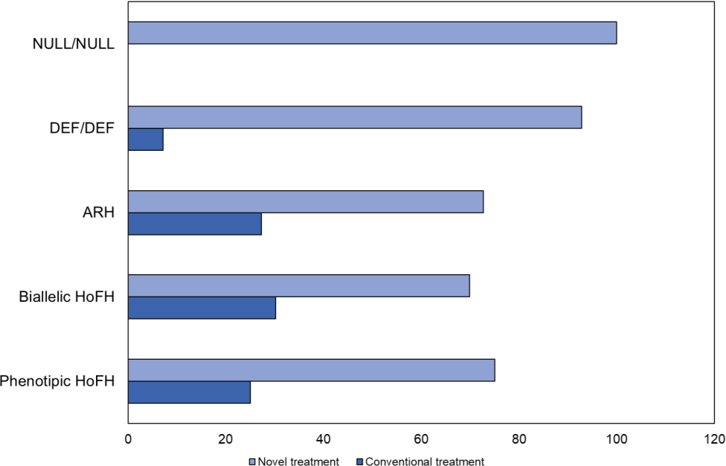
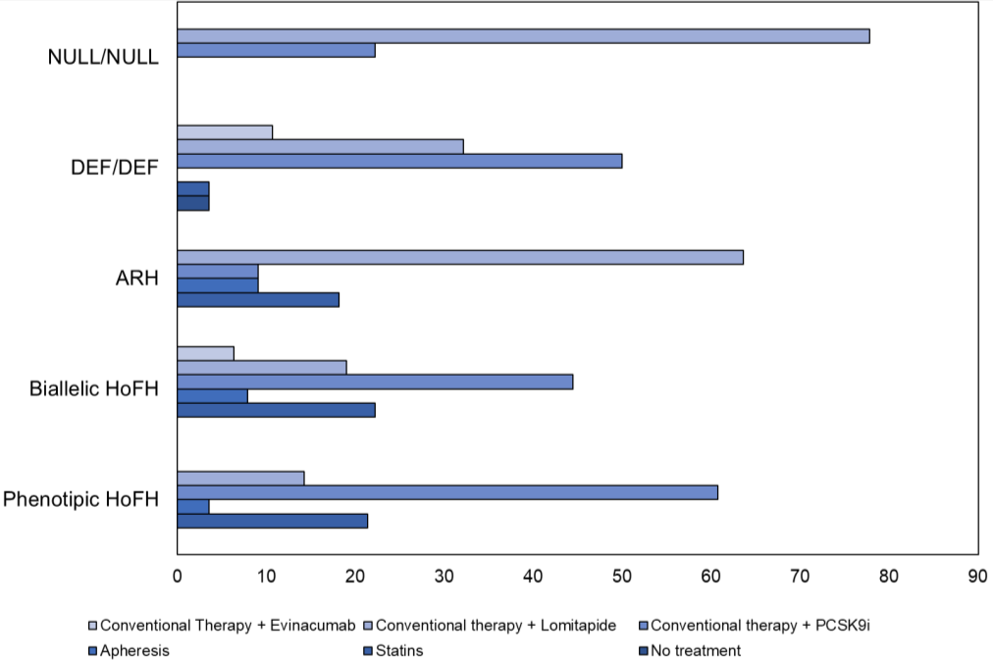

Legend. Distribution of lipid lowering therapies at last visit according to genotypes. Data are shown as percentage. Panel A describe the distribution of conventional and novel lipid lowering therapies. Novel therapies included PCSK9i, lomitapide and evinacumab whereas conventional statins, ezetimibe, and Lipoprotein Apheresis (see Material and Methods. Panel B reports the distribution of combinations of novel lipid lowering therapies (see Material and Methods). Data are shown as percentage. NULL/NUL and DEF/DEF indicate mHoFH patients; ARH, autosomal recessive hypercholesterolemia; HoFH, homozygous familial hypercholesterolemia; PCSK9i, protease proprotein convertase subtilisin/kexin type 9 inhibitor.

Supplementary Figure 2. Kaplan-Meier analysis of historical LIPIGEN cohort vs contemporary LIPIGEN cohort.

Legend. Kaplan-Meier analysis of historical LIPIGEN cohort vs contemporary LIPIGEN cohort. Historical LIPIGEN cohort is shown in red, Contemporary LIPIGEN cohort is shown in blue. Vertical lines are for follow-up termination in uncensored cases.

