Supporting Information for:
MXene-Substrate Adhesion - Towards more efficient and durable coatings

Edoardo Marquis¹, Daniela Lizama^{2, 3}, Rodrigo Espinoza-Gonzalez^{2, 3}, Andreas Rosenkranz^{2, 3*}, Maria Clelia Righi^{1*}
- Department of Physics and Astronomy “Augusto Righi”, University of Bologna, Bologna 40127, Italy
- Department of Chemical Engineering, Biotechnology and Materials, FCFM, University of Chile, Santiago 8370415, Chile
- ANID – Millennium Science Initiative Program, Millennium Nuclei of Advanced MXenes for Sustainable Applications (AMXSA), Santiago, Chile

*Corresponding Authors
Email: Prof. Dr. Andreas Rosenkranz, arosenkranz@ing.uchile.cl
Email: Prof. Dr. Maria Clelia Righi, clelia.righi@unibo.it

Table S1: Details about the supercells employed and k-points grids used to sample the Brillouin zone. The terminations on the MXene surface are selected to have almost one third of each type (e.g., F, O and OH).

Substrate | Cell type | MXene Supercell | Terminations | K-points grid (x, y, z)
Si (100) dimer | Ortho | 5x6 | 10O, 10F, 10OH | 2 x 2 x 1
Si (100) P-doped | Ortho | 5x6 | 10O, 10F, 10OH | 2 x 2 x 1
Si (100) B-doped | Ortho | 5x6 | 10O, 10F, 10OH | 2 x 2 x 1
Si-H₂O | Ortho | 3x4 | 4O, 4F, 4OH | 4 x 4 x 1
Fe (110) | Ortho | 4x2 | 2O, 3F, 3OH | 3 x 6 x 1
α-Fe₂O₃ (0001) | Hex | 3x3 | 3O, 3F, 3OH | 2 x 2 x 1

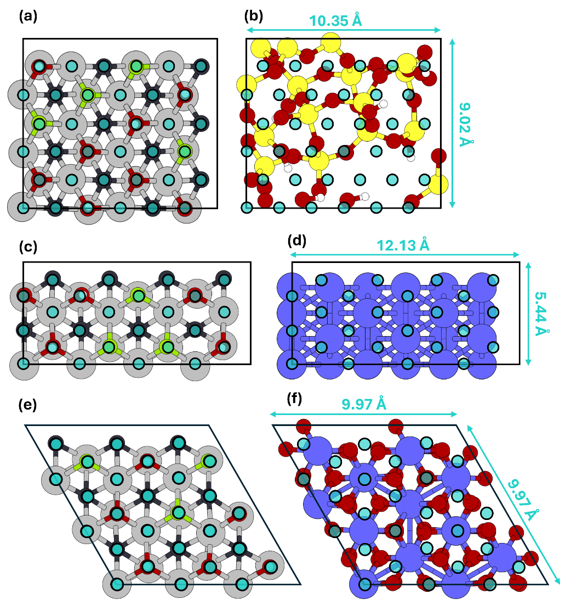
Figure S1. Supercells employed to model our interfaces: (a,b) MX@Si-H₂O, (c,d) MX@Fe and (e,f) MX@Fe₂O₃. The lateral positions used to construct the potential energy surface experienced by the MXene layer on each substrate are highlighted by blue circles. The size of the lattice parameters is also reported.
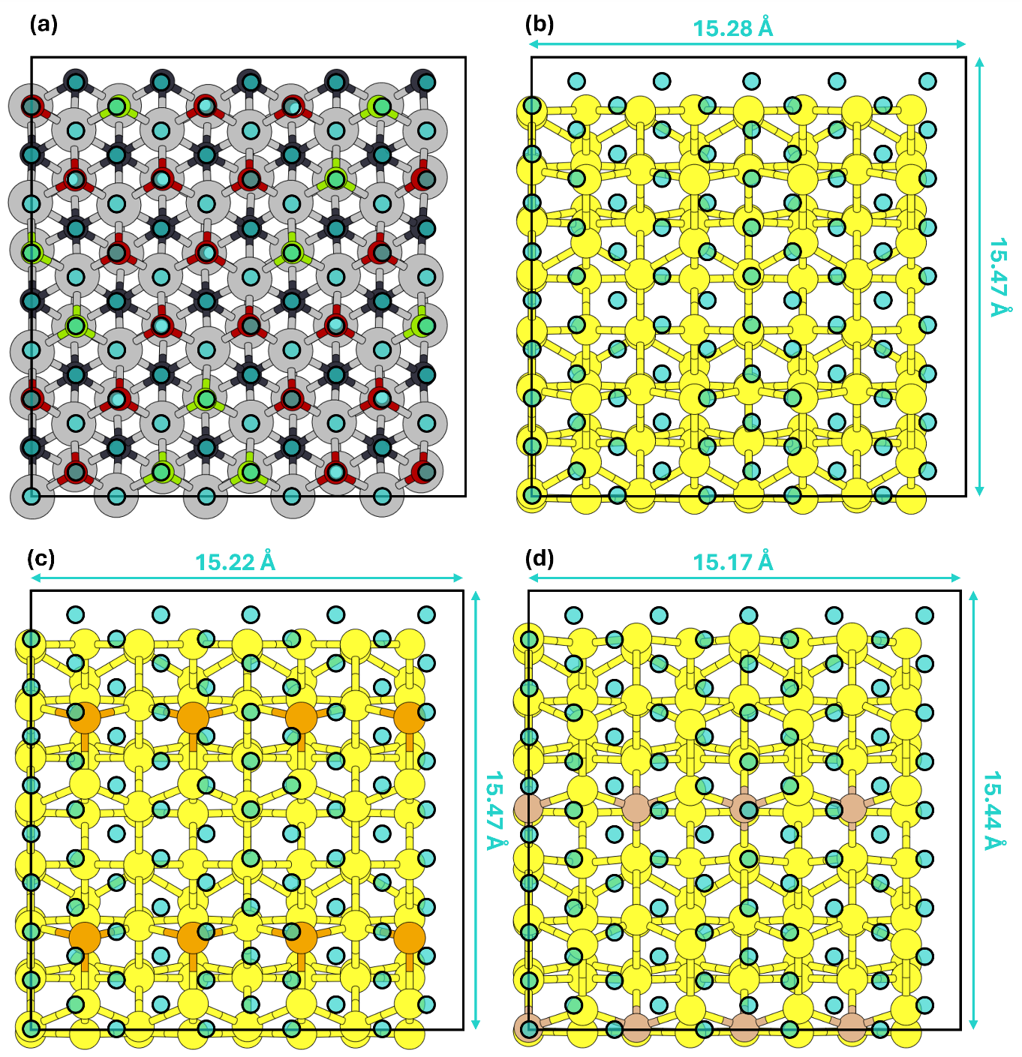
Figure S2. Supercells employed to model our interfaces: (a,b) MX@Si, (a,c) MX@Si-P_doped and (a,d) MX@Si-B_doped. The lateral positions explored to construct the PES experienced by the MXene layer on each substrate are highlighted by blue circles. The size of the lattice parameters is also reported.

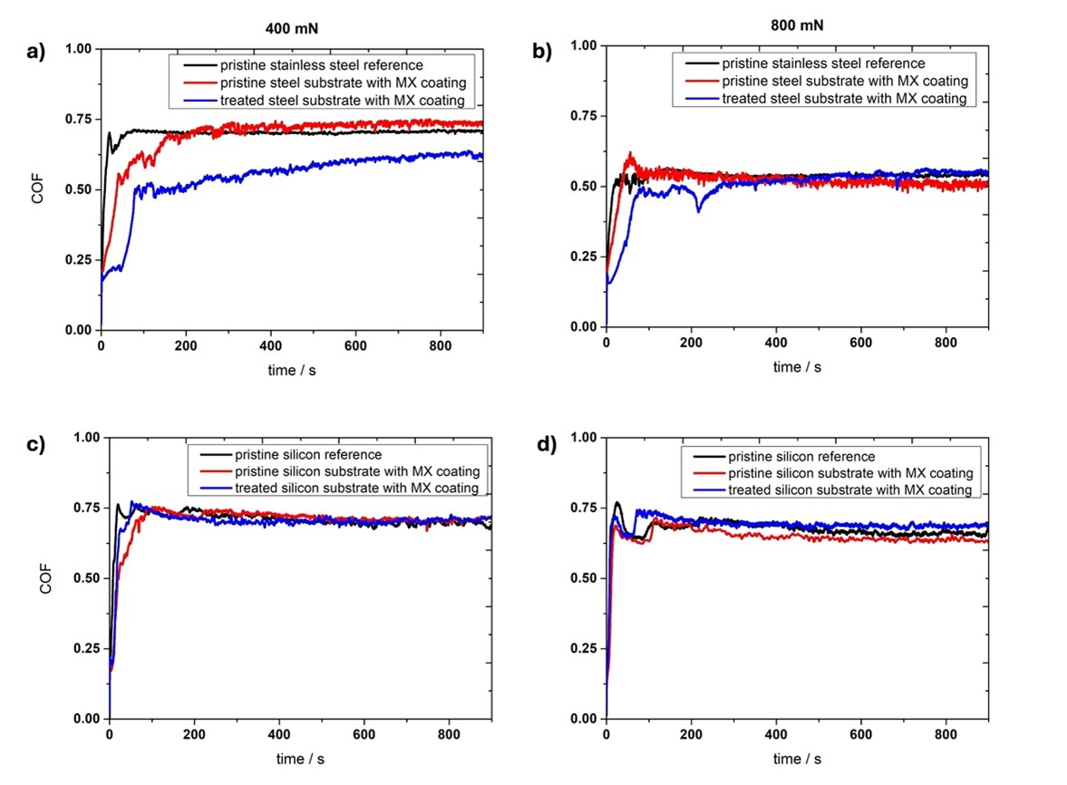
Figure S3. Temporal evolution of the coefficient of friction (COF) for normal loads of (a and c) 0.4 and (b and d) 0.8 N, respectively, for Ti3C2Tx coating deposited (a and b) on steel substrate (red line) and steel substrate treated with Nital solution to remove the oxide layer (blue line) as well as (c and d) silicon wafers (red line) and silicon wafers treated with HF to remove the oxidized layer (blue line).

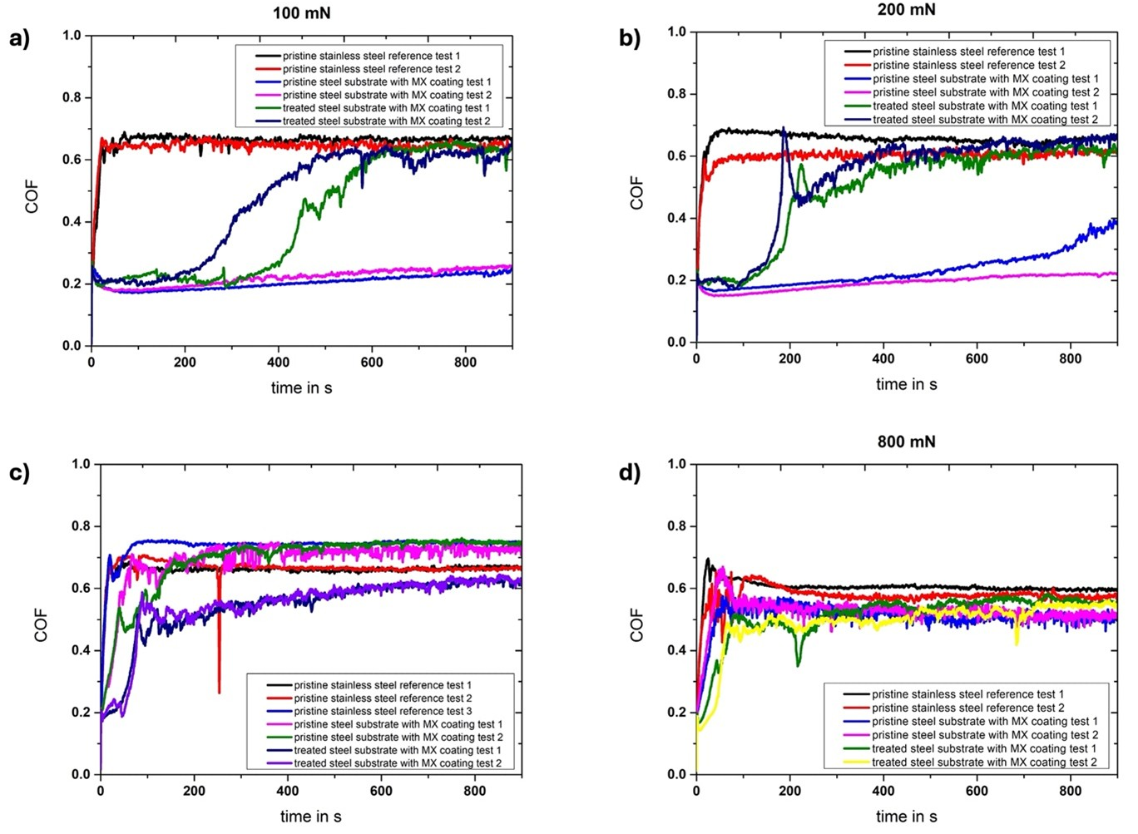
Figure S4. Temporal evolution of the coefficient of friction (COF) for normal loads of (a) 0.1, (b) 0.2, (c) 0.4 and (d) 0.8 N, respectively, for the uncoated steel substrate as well as the Ti₃C₂T_{x} coating deposited on the pristine and treated substrate.

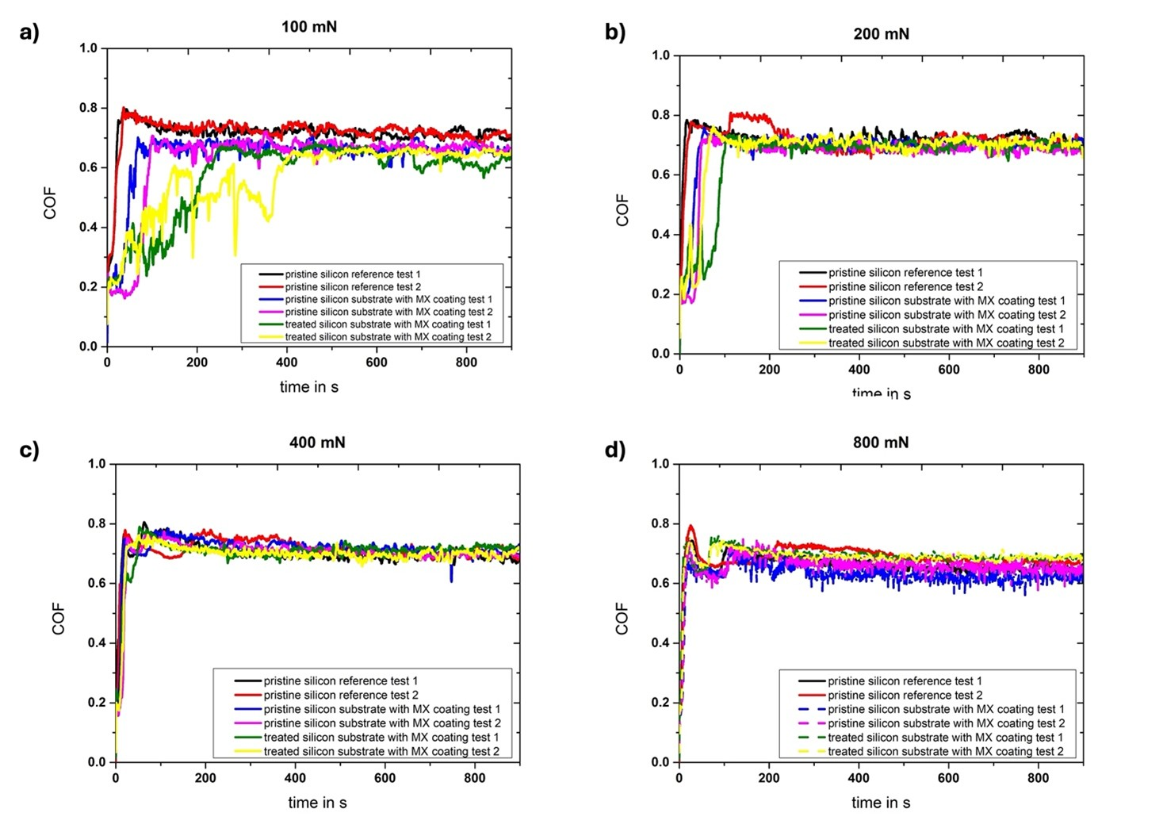
Figure S5. Temporal evolution of the coefficient of friction (COF) for normal loads of (a) 0.1, (b) 0.2, (c) 0.4 and (d) 0.8 N, respectively, for the uncoated silicon substrate as well as the Ti₃C₂T_{x} coating deposited on the pristine and treated silicon substrate.

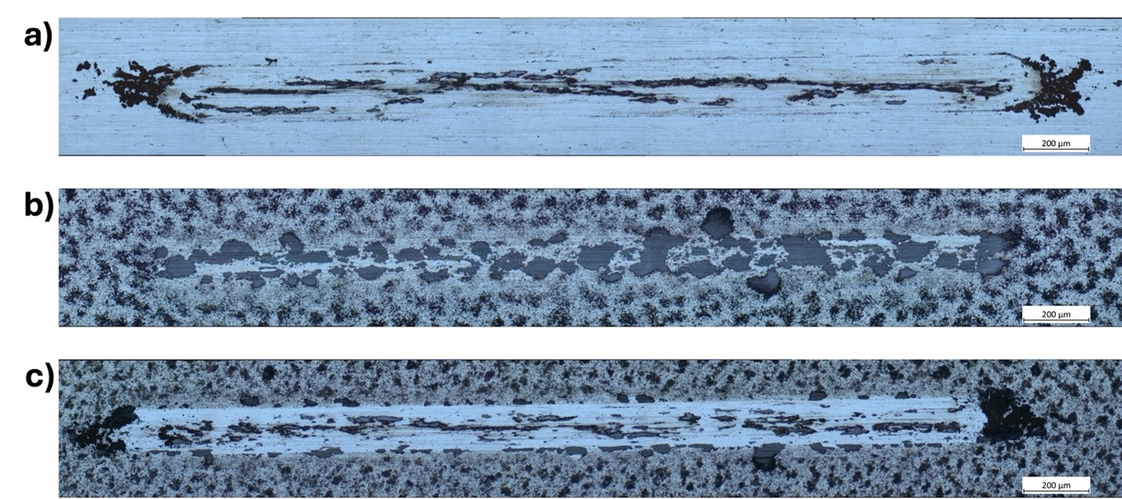
Figure S6. Panoramic light microscopic images of the resulting wear tracks of (a) the uncoated steel substrate and the MXene coatings deposited onto the (b) pristine and (c) Nital-treated substrate, respectively, after tribo-testing using an applied normal load of 100 mN.

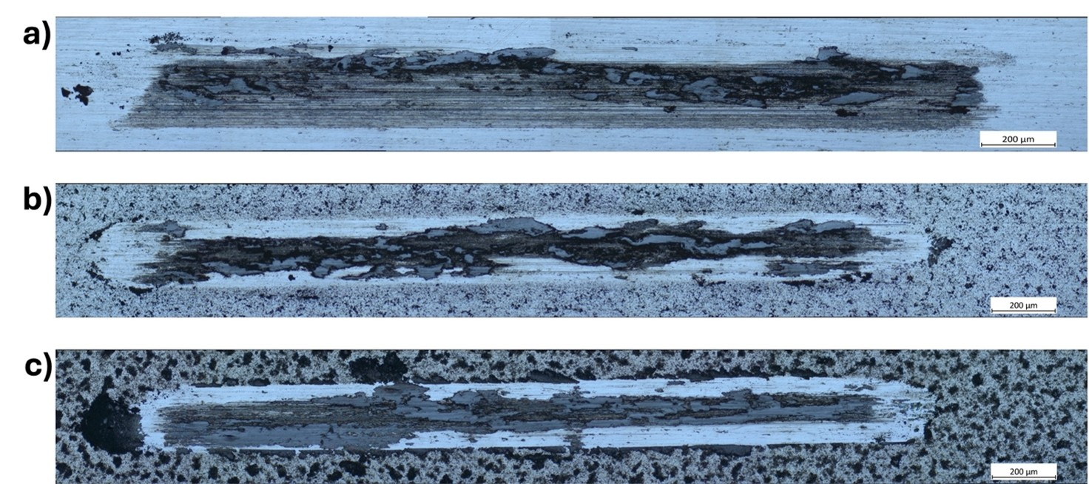
Figure S7. Panoramic light microscopic images of the resulting wear tracks of (a) the uncoated steel substrate and the MXene coatings deposited onto the (b) pristine and (c) Nital-treated substrate, respectively, after tribo-testing using an applied normal load of 800 mN. It can be seen that the wear track of the uncoated substrate demonstrated clear signs of abrasive wear and tribo-oxidation. The wear track of both MXene coatings reveal that most of the initial MXene coating has been removed and pronounced signs of tribo-oxidation can be observed. These features can be connected with the increased normal load/contact pressure.

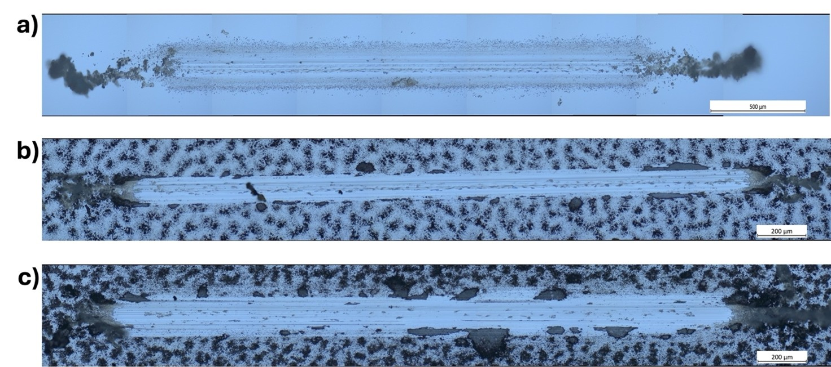
Figure S8. Panoramic light microscopic images of the resulting wear tracks of (a) the uncoated silicon substrate and the MXene coatings deposited onto the (b) pristine and (c) Nital-treated silicon substrate, respectively, after tribo-testing using an applied normal load of 100 mN.

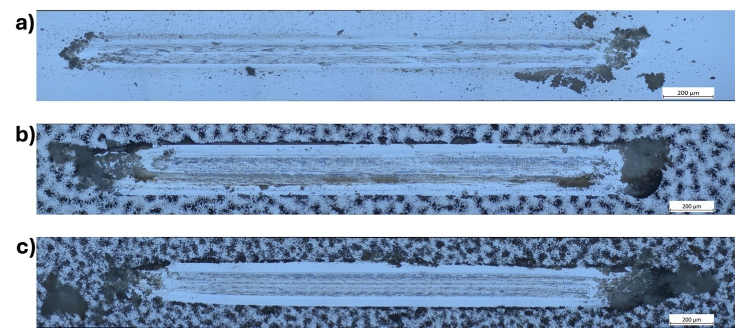
Figure S9. Panoramic light microscopic images of the resulting wear tracks of (a) the uncoated silicon substrate and the MXene coatings deposited onto the (b) pristine and (c) Nital-treated silicon substrate, respectively, after tribo-testing using an applied normal load of 800 mN.

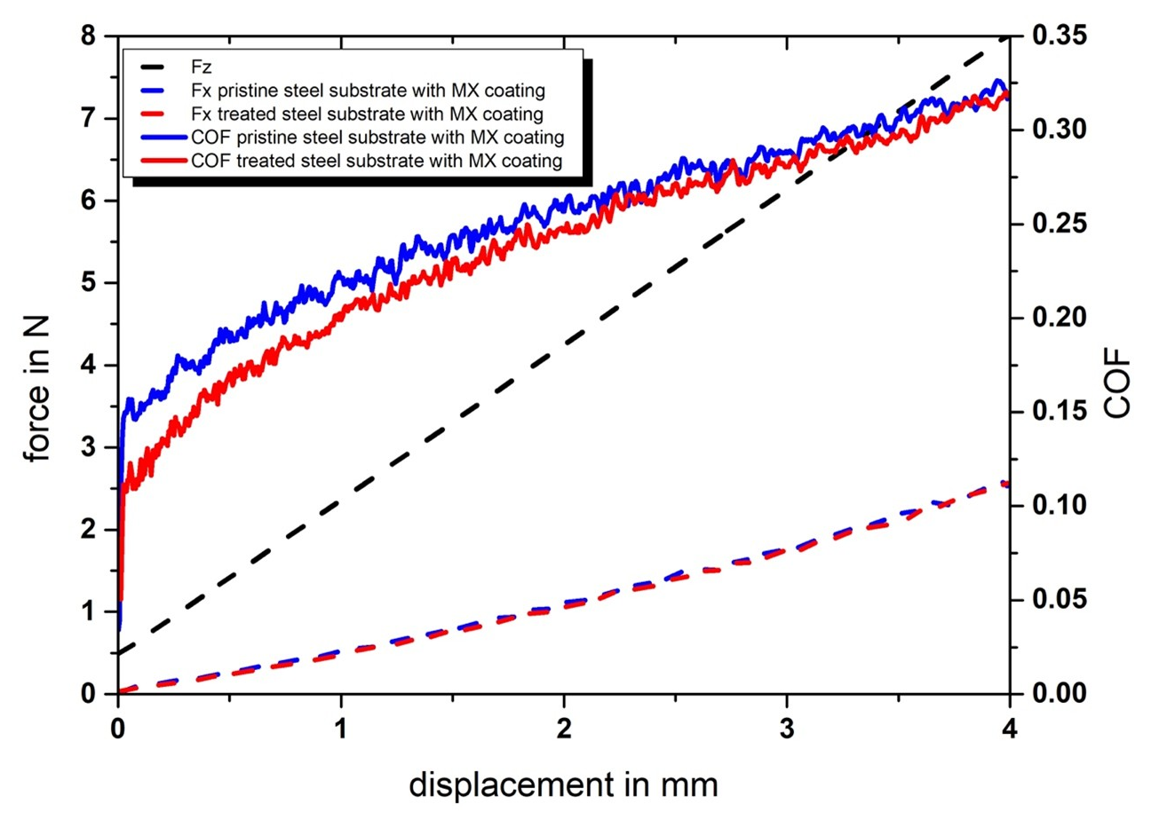
Figure S10. Micro-scratch tests performed on spray-coated MXene films (8 mL deposited) using a linearly increasing load from 0.5 to 4 N. Measured normal (Fz) and tangential forces (Fx) versus lateral displacement for MXene coatings deposited using 8 ml over a pristine and treated stainless-steel substrate. Moreover, the resulting COF (Fx divided by Fz) is depicted. Coatings on pristine stainless steel exhibited higher tangential force and COF than those on treated substrates, indicating stronger adhesion.

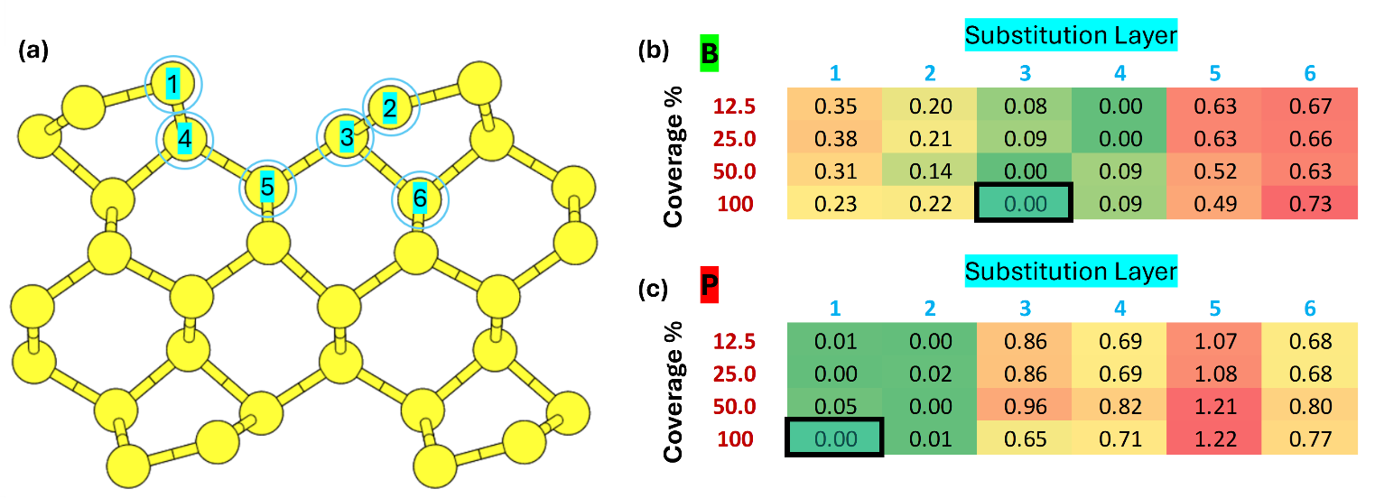

Figure S11. Several doped surfaces were modeled, 24 for each dopant element (B and P). Specifically, we considered six different substitution layers (labeled 1 to 6 in panel a) and four different dopant coverages. The values shown in panels (b) and (c) correspond to ∆E (in eV), calculated with respect to the most favorable substitution layer. Thus, for each coverage percentage, there is one energetically preferred layer. To evaluate adhesion to the MXene layer, we considered the most favorable substitution layer at maximum coverage (i.e., 100%). For boron (b), the third layer is the most stable, while for phosphorus, the first layer is preferred.

