Supporting Information

Stability of PEA₂PbBr₄ Thin-Film Photodetectors under Thermal and Moisture Stress

Sara Cepić, Andrea Ciavatti*, Enrico Gianfranco Campari, Beatrice Fraboni

Table S1. Comparative analysis of environmental stability strategies for optoelectronic devices
Strategy | Material | Application | Conditions | Key results | Limitations | Ref.
Physical encapsulation | Polyisobutylene (PIB)  PMMA  epoxy polymer  ALD Al₂O₃  glass–glass | Solar cells | 85% RH at 85°C | Blocks moisture and oxygen  Retains >95.17% initial PCE after 1500 h | Adds mass/bulk; increases fabrication complexity/cost; delamination during cycling, epoxies can crack. | [1–4]
Physical encapsulation | UV-curable resin shell with AB epoxy sealant and a desiccant sheet | Photodetector | 85% RH at 25°C | Retains ~90% of initial photoresponsivity after 24 h and ~73% after 168 h | Outgassing from the AB epoxy can damage the device | [5]
Halogen Bonding | IPFB, fluorinated XB donors, bifunctional perfluoroarenes | Solar cells | Continuous light illumination, high humidity, at 85°C | Retains 80% of efficiency after 500 h of illumination, and 95% of efficiency after 4 months of storage in r.t. | Excessive concentration can induce local lattice strain or phase segregation at grain boundaries  and reduce of photocurrent. | [6–9]
Halogen Bonding | 1,4-TFIB | Photodetectors | Up to 98%RH and 120°C through 12 days | Reduction in deviation of responsivity and roughness in wide range of temperature and humidity values (98%RH, 120°C) | Limits the absolute photocurrent signal | This work
Compositional engineering | FA, MA, Cs, or Rb cation mixing | Solar cells | 85% RH, up to 140°C | Enhanced moisture, thermal and photochemical stability | Alters the intrinsic bandgap; high-temperature processing; potential phase segregation. | [10–12]
Doping | (Mo(tfd-COCF₃)₃) | Solar cells | 85°C | Improving thermal stability while yielding ~21% efficiency. | High dopant concentrations make the surface too strongly p-type, increasing recombination; dopant solubility limits in solvents. | [13]

[1] W. Kim, B. Koo, and M. J. Ko, Nanomicro Lett. 18, 329 (2026).
[2] Y. Shi and F. Zhang, Solar RRL 7, (2023).
[3] Q.-Q. Chu, Z. Sun, D. Wang, B. Cheng, H. Wang, C.-P. Wong, and B. Fang, Matter 6, 3838 (2023).
[4] Y. Han, S. Meyer, Y. Dkhissi, K. Weber, J. M. Pringle, U. Bach, L. Spiccia, and Y.-B. Cheng, J. Mater. Chem. A Mater. 3, 8139 (2015).
[5] F. Zhao, X. Luo, C. Gu, J. Chen, Z. Hu, and Y. Peng, Adv. Mater. Technol. 7, (2022).
[6] G. Cavallo, P. Metrangolo, R. Milani, T. Pilati, A. Priimagi, G. Resnati, and G. Terraneo, Chem. Rev. 116, 2478 (2016).
[7] P. Metrangolo, L. Canil, A. Abate, G. Terraneo, and G. Cavallo, Angew. Chem. Int. Ed. 61, (2022).
[8] A. Abate, M. Saliba, D. J. Hollman, S. D. Stranks, K. Wojciechowski, R. Avolio, G. Grancini, A. Petrozza, and H. J. Snaith, Nano Lett. 14, 3247 (2014).
[9] S. Bi, H. Wang, J. Zhou, S. You, Y. Zhang, X. Shi, Z. Tang, and H. Zhou, J. Mater. Chem. A Mater. 7, 6840 (2019).
[10] M. Saliba, T. Matsui, J.-Y. Seo, K. Domanski, J.-P. Correa-Baena, M. K. Nazeeruddin, S. M. Zakeeruddin, W. Tress, A. Abate, A. Hagfeldt, and M. Grätzel, Energy Environ. Sci. 9, 1989 (2016).
[11] R. J. Sutton, G. E. Eperon, L. Miranda, E. S. Parrott, B. A. Kamino, J. B. Patel, M. T. Hörantner, M. B. Johnston, A. A. Haghighirad, D. T. Moore, and H. J. Snaith, Adv. Energy Mater. 6, (2016).
[12] K. Poorkazem and T. L. Kelly, ACS Appl. Energy Mater. 1, 181 (2018).
[13] N. K. Noel, S. N. Habisreutinger, A. Pellaroque, F. Pulvirenti, B. Wenger, F. Zhang, Y.-H. Lin, O. G. Reid, J. Leisen, Y. Zhang, S. Barlow, S. R. Marder, A. Kahn, H. J. Snaith, C. B. Arnold, and B. P. Rand, Energy Environ. Sci. 12, 3063 (2019).

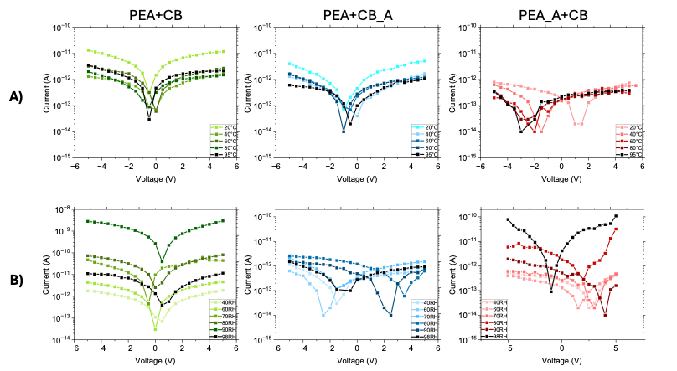

Figure S1. Current dependence on voltage behavior for the three different samples deposited with three different recipes through temperature (A) and humidity (B) changes

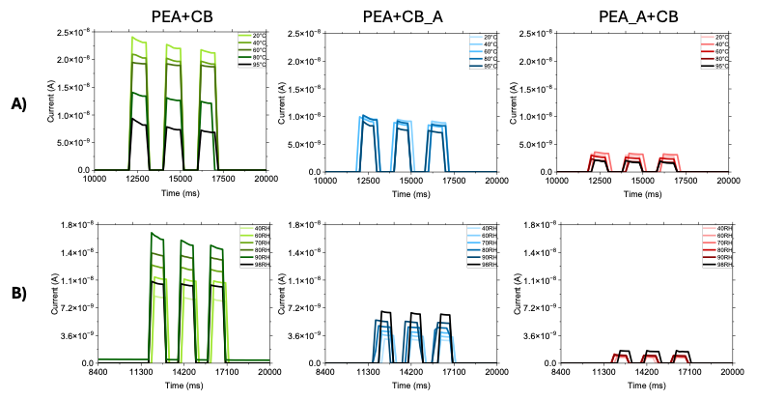

Figure S2. Changes in response under the UV LED for the three different samples deposited with three different recipes through temperature (A) and humidity (B)

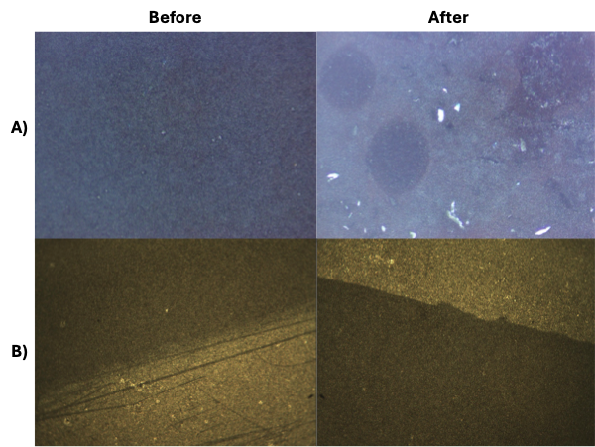

Figure S3. Morphological analysis done with optical microscope showing two samples of PEA+CB, one kept at 60°C for two days (A), and other kept on 60°C for annealing in duration of half an hour (B)

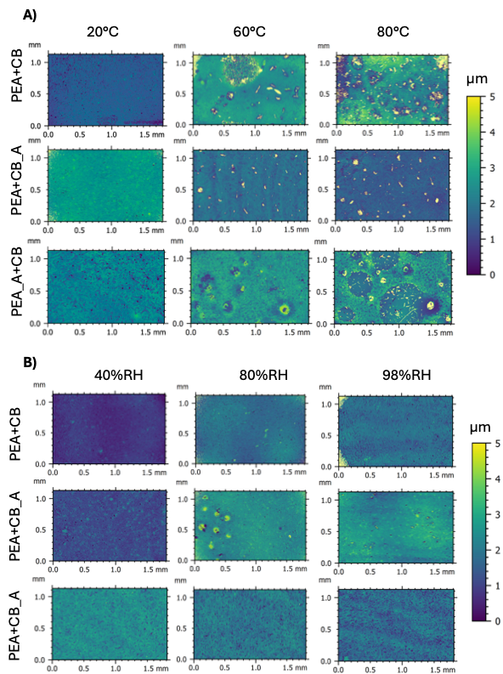

Figure S4. Morphological analysis done with white light interferometry showing samples for three recipes and their changes induced by increase of temperature (A), and humidity (B).
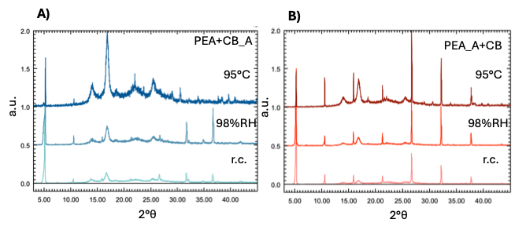
Figure S5. Powder X-ray diffraction (XRD) patterns for PEA+CB_A (A), and PEA_A+CB (B) sample in the room condition (r.c.), after humidity treatment, and after temperature treatment.

