Altered gastrointestinal motility as a risk-factor for colic associated with transportation of horses

Pre-transportation information
Owner / agent details [de-identified prior to analysis]
Name of horse _______________________________ Name: ________________________________
Breed Thoroughbred Other _____________ Contact details: _________________________
Age ____________ years (DOB: ________)
Gender Male / Male castrate / Female Brand:

Use / activity: racing / breeding / performance / other (specify: _________________________________________ )
Training / level of activity: nil / minimum / moderate / competing
Frequency: nil / monthly or less / weekly / daily
Intensity / duration: low / moderate / high (details: _________________________________________ )
Racing / competing: yes / no Last race: __________________________________________________
Current form / health: poor / recovering / good (no problems)
If poor / recovering, provide details:
Current medication (specify):
MM’s
Prior travel history
Transported previously: yes / no
Number of times: few / moderate / many / unknown
(1 or 2 trips) (>10 trips)
Previous history of adverse events (illness / injury) associated with transportation: yes / no / unknown
Details: __________________________________________________________________________________________
________________________________________________________________________________________________
________________________________________________________________________________________________

Feed management prior to transportation
Diet: Grain (type/s: _________________________________________________________ )
Pellets / commercial (specify: _____________________________________________ )
Hay (type/s: ___________________________________________________________ )
Pasture access: yes / no (type/s and frequency / duration: ________________________________ )
Supplements (type/s: ___________________________________________________ )
Other:
Management at depot (routine feeding and management practices in note book – only record variations)
Location prior to transportation:
Arrival at depot:
Transport time to depot (approx.):
Feed management at the depot: standard (Ultimate / Goldners / other) changed: _____________
Last fed:
Pre-departure veterinary examination (T-1) Time: _______________ Initials: ___________
HR __________ bpm MM colour and CRT: _____________________________
RR __________ bpm Peripheral perfusion, jugular refill: ___________________
Rectal Cardiac auscultation: _____________________________
Temperature _________ ºC Pulmonary auscultation: ___________________________
Abdominal auscultation:
0 absent
+ decreased
++ normal
+++ increased
Demeanour: ICS ____ / 2 minutes
LD RD
LV RV
Dull QAR BAR Excited
Other (specify)

Injuries or other abnormalities:

Body condition score:
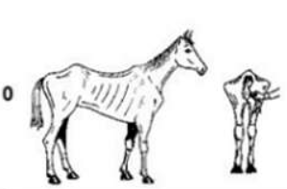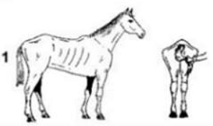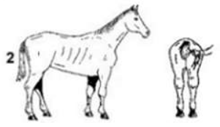

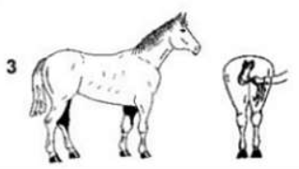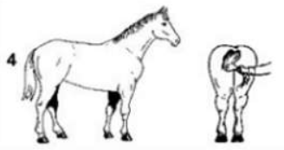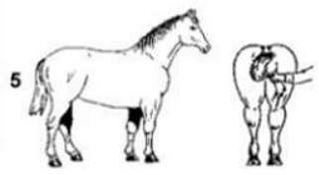
(adapted from Carroll C.L. and Huntington P.J., Body Condition Scoring and Weight Estimation of Horses)

Size and weight: height: _________ cm; girth: _________ cm; body weight (tape): _________ kg; shoulder: _________ cm

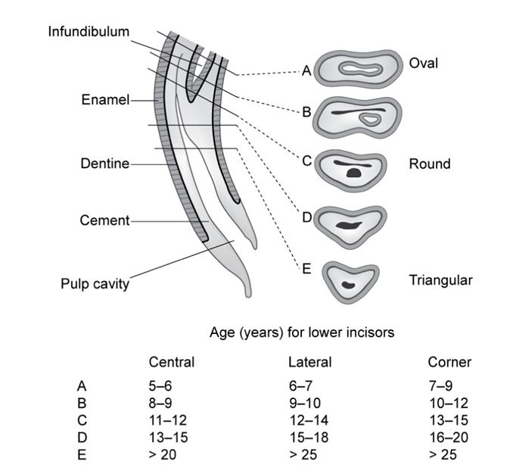
Age (dentition): ________________________________________________________________________________
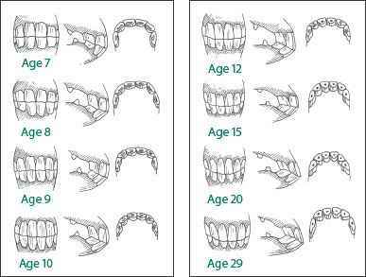
Pre-departure abdominal ultrasound examination (T-1)

Date: _________________ Time: ______________________ Performed by: _______________________

Duodenal motility | Caecal motility | Jejunal motility | Ventral colon motility
Visualized adjacent to R kidney | R lateral taenial band of caecum, ventral to costochondral junction | Image R or L inguinal region, or ventral abdomen | Image ventral abdomen, to right of midline
Count number of circular contractions during 60s cineloop: | Grade movement:  0 = there is no movement  1 = there is infrequent (<2) mixing mvt evident  2 = there are 1 or 2 contractions (mvt away from probe / abdo wall) &/or frequent mixing contractions  3 = there are frequent contractions (>2) or continuous mixing movements | Grade visualization:  0 = no jejunal loops viz  + = 1 or 2 loops intermittently visible  ++ = 1 or 2 loops visible for most or all of video (60s)  +++ = multiple loops visualized  Grade movement:  0 = there is no movement  1 = mvt of ingesta <50% of recording  2 = mvt of ingesta >50% of recording  3 = near continuous motility  Sediment (yes/no) | Grade movement:  0 = there is no movement  1 = mvt of ingesta <50% of recording  2 = mvt of ingesta >50% of recording  3 = near continuous motility
File saved as*  DUOD _ _ _ _ _ | CAEC _ _ _ _ _ | JEJM _ _ _ _ _ | COLN _ _ _ _ _
* allocate random number from list provided

Saliva sample T-1: Time:

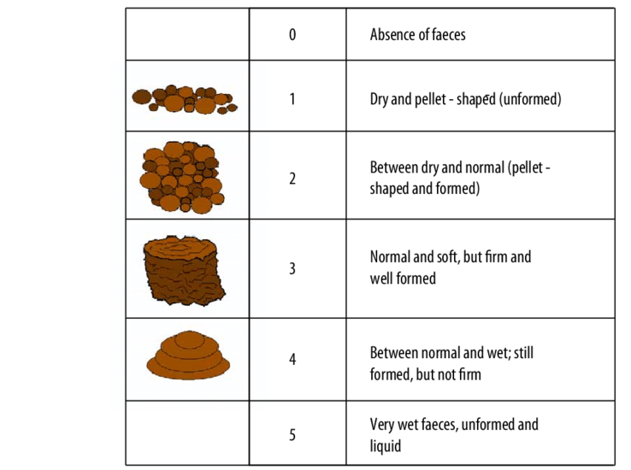
Faecal score T-1: Number of faecal piles in box:
Faecal sample collected
Sample number: _________________

Pre-departure veterinary examination (T0) Time: _______________ Initials: ___________
(if possible)

HR __________ bpm MM colour and CRT: _____________________________
RR __________ bpm Peripheral perfusion, jugular refill: ___________________
Abdominal auscultation:
0 absent
+ decreased
++ normal
+++ increased
Demeanour: ICS ____ / 2 minutes
LD RD
LV RV
Dull QAR BAR Excited
Other (specify)

Feed consumed overnight (circle): All >1/2 <1/2 Little / none
Water consumed overnight (circle): >1/2 bucket ¼ to ½ bucket Almost none Spilled Unable to assess
Feed prior to loading (circle): All >1/2 <1/2 Little / none

Pre-departure (T0) US examination (if possible)
Date: _________________ Time: ________________________ Performed by: ___________________

Stomach US: not distended moderate distension marked distension

Duodenal motility | Caecal motility | Jejunal motility | Ventral colon motility
Visualized adjacent to R kidney | R lateral taenial band of caecum, ventral to costochondral junction | Image R or L inguinal region, or ventral abdomen | Image ventral abdomen, to right of midline
Count number of circular contractions during 60s cineloop: | Grade movement:  0 = there is no movement  1 = there is infrequent (<2) mixing mvt evident  2 = there is 1 or 2 contractions (mvt away from probe / abdo wall) &/or frequent mixing contractions  3 = there are frequent contractions (>2) or continuous mixing movements | Grade visualization:  0 = no jejunal loops viz  + = 1 or 2 loops intermittently visible  ++ = 1 or 2 loops visible for most or all of video (60s)  +++ = multiple loops visualized  Grade movement:  0 = there is no movement  1 = mvt of ingesta <50% of recording  2 = mvt of ingesta >50% of recording  3 = near continuous motility  Sediment (yes/no) | Grade movement:  0 = there is no movement  1 = mvt of ingesta <50% of recording  2 = mvt of ingesta >50% of recording  3 = near continuous motility
File saved as*  DUOD _ _ _ _ _ | CAEC _ _ _ _ _ | JEJM _ _ _ _ _ | COLN _ _ _ _ _

Saliva sample T0: Time:

Faeces in box (o/nte): __________ piles Score: _____________ Sampled? (T0)
Transportation details
Loaded: | Well  (minimal or no resistance) |  | With moderate encouragement |  | Poorly  (multiple attempts – record time taken)
On truck prior to departure (or enroute): |  | Standing quietly |  | Somewhat agitated |  | Marked agitation  (vocalising, pawing, other)

Departure point: ____________________ Destination: _____________________________
Departure time: ____________________ Arrival time: _____________________________

Travelled: | Well  (quiet & calm during entire trip) | Mostly well  (agitated at beginning of trip or occasional mild agitation, but mostly calm) | Agitated  (agitated or distressed at beginning of & during trip; abn behaviour more intense or prolonged) | Poor  (pawing, scrambling, vocalising during much of the trip; abn behaviour intense or prolonged)
Observation / events en route:

Demeanour on arrival: | somnolent / obtunded | normal | agitated / excited
Other or comment: __________________________________________________________________________

Feed available during transit: yes / no details: ______________________________ amount consumed:
Water available during transit: yes / no details: ______________________________ amount consumed:
(include amounts offered and consumed, if applicable)

Sweat score on arrival (adapted from Zeyner et al 2014, J An Phys Nut 98: 246-250):
0 | No visible sweat
1 | Focal areas sticky / moist, sticky throat area, flanks darker than normal
2 | Focal areas obviously moist or small white areas of foam, friction surfaces related to tack
3 | Tack leaves clear wet impression on the head, typically with foam or obvious focal wet areas on body / flanks
4 | Throat and flanks completely wet, moist dark wrinkles above eyes, sweat / foam between hindlimbs
5 | Horses additionally dripping fluid above the eyes and/or under the belly

Faecal passage in transit: yes / no Faecal consistency (score):
Amount: nil / scant / ~one pile / multiple piles
T1 faeces collected? (sample #)

Urination: yes / no / uncertain

Meteorological information (source from BOM post travel):
 | Departure | Way point #1 | Way point #2 | Way point #3 | Arrival
Location
Time
Temperature (ºC)
Humidity
Rain / other
(detail)
Arrival abdominal ultrasound examination (T1)

Date: _________________ Time: ________________________ Performed by: ___________________

Stomach US: not distended moderate distension marked distension

Duodenal motility | Caecal motility | Jejunal motility | Ventral colon motility
Visualized adjacent to R kidney | R lateral taenial band of caecum, ventral to costochondral junction | Image R or L inguinal region, or ventral abdomen | Image ventral abdomen, to right of midline
Count number of circular contractions during 60s cineloop: | Grade movement:  0 = there is no movement  1 = there is infrequent (<2) mixing mvt evident  2 = there is 1 or 2 contractions (mvt away from probe / abdo wall) &/or frequent mixing contractions  3 = there are frequent contractions (>2) or continuous mixing movements | Grade visualization:  0 = no jejunal loops viz  + = 1 or 2 loops intermittently visible  ++ = 1 or 2 loops visible for most or all of video (60s)  +++ = multiple loops visualized  Grade movement:  0 = there is no movement  1 = mvt of ingesta <50% of recording  2 = mvt of ingesta >50% of recording  3 = near continuous motility  Sediment (yes/no) | Grade movement:  0 = there is no movement  1 = mvt of ingesta <50% of recording  2 = mvt of ingesta >50% of recording  3 = near continuous motility
File saved as*  DUOD _ _ _ _ _ | CAEC _ _ _ _ _ | JEJM _ _ _ _ _ | COLN _ _ _ _ _

Post arrival cortisol swab sample:
Time collected: _______________________

Post-transportation veterinary examination (T1) Time: _______________ Initials: ___________

HR __________ bpm MM colour and CRT: _____________________________
RR __________ bpm Peripheral perfusion, jugular refill: ___________________
Rectal Cardiac auscultation: _____________________________
Temperature _________ ºC Pulmonary auscultation: ___________________________
Abdominal auscultation (four quadrants):
0 absent
+ decreased
++ normal
+++ increased
Demeanour: ICS ___ / 2 min
LD RD
LV RV
Dull QAR BAR Excited
Other (specify)

Obvious injuries (describe) / other comments:

Recovery ultrasound examination (T2)

Date: _________________ Time: ________________________ Performed by: ___________________

Stomach US: not distended moderate distension marked distension

Duodenal motility | Caecal motility | Jejunal motility | Ventral colon motility
Visualized adjacent to R kidney | R lateral taenial band of caecum, ventral to costochondral junction | Image R or L inguinal region, or ventral abdomen | Image ventral abdomen, to right of midline
Count number of circular contractions during 60s cineloop: | Grade movement:  0 = there is no movement  1 = there is infrequent (<2) mixing mvt evident  2 = there is 1 or 2 contractions (mvt away from probe / abdo wall) &/or frequent mixing contractions  3 = there are frequent contractions (>2) or continuous mixing movements | Grade visualization:  0 = no jejunal loops viz  + = 1 or 2 loops intermittently visible  ++ = 1 or 2 loops visible for most or all of video (60s)  +++ = multiple loops visualized  Grade movement:  0 = there is no movement  1 = mvt of ingesta <50% of recording  2 = mvt of ingesta >50% of recording  3 = near continuous motility  Sediment (yes/no) | Grade movement:  0 = there is no movement  1 = mvt of ingesta <50% of recording  2 = mvt of ingesta >50% of recording  3 = near continuous motility
File saved as*  DUOD _ _ _ _ _ | CAEC _ _ _ _ _ | JEJM _ _ _ _ _ | COLN _ _ _ _ _

Recovery veterinary examination (T2) Time: _______________ Initials: ___________

HR __________ bpm MM colour and CRT: _____________________________
RR __________ bpm Peripheral perfusion, jugular refill: ___________________
Rectal Cardiac auscultation: _____________________________
Temperature _________ ºC Pulmonary auscultation: ___________________________
Abdominal auscultation (four quadrants):
0 absent
+ decreased
++ normal
+++ increased
Demeanour: ICS ___ / 2 min
LD RD
LV RV
Dull QAR BAR Excited
Other (specify)

Obvious injuries (describe) / other comments:

After transportation
Location subsequent to transportation:
Arrival at destination:
Transport time from depot (approx.):

Appetite: nil (inappetant) reduced as expected increased
Provide details if abnormal:

Water consumption: not assessed reduced as expected increased

Demeanour: dull as expected agitated other (please describe)

Faecal output: not assessed reduced as expected increased
abnormal (describe):

Clinical abnormalities: colic diarrhoea febrile muscle soreness, tied up respiratory disease injury
(circle any that apply, provide details below)

Required veterinary attention: yes / no
(provide details)

