Supplementary Material

Supplementary Figure 1. Map of countries participating in the ARON-2EV Study

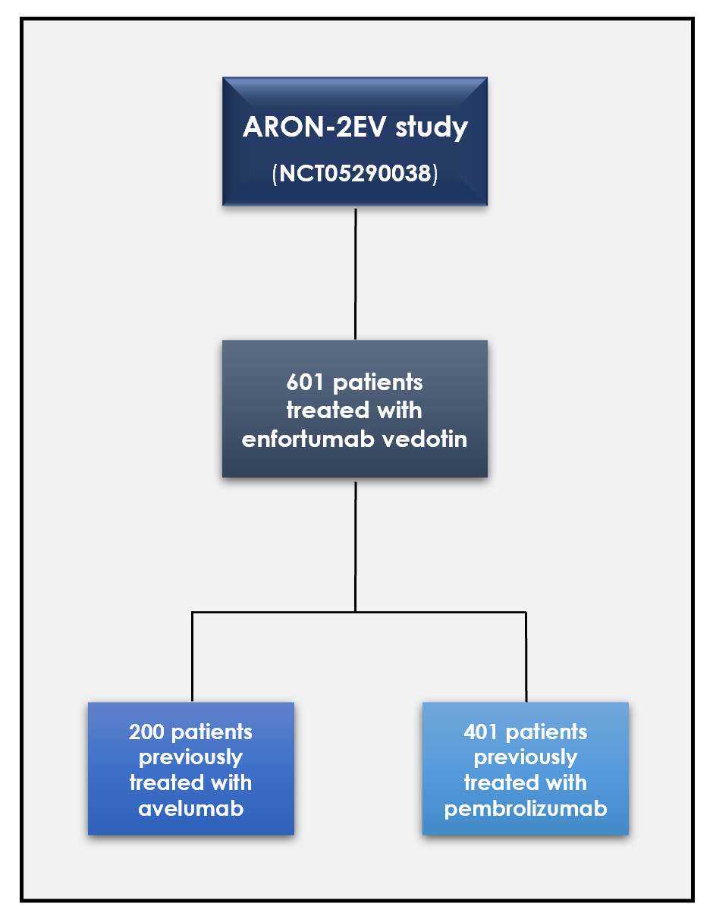
Supplementary Figure 2. Selection process from the ARON-2EV dataset

Supplementary Figure 3. Subgroup analyses of Overall Survival in patients receiving Enfortumab Vedotin (EV)

Supplementary Figure 4. Correlogram of Pearson’s correlation coefficients showing factors associated with objective response to enfortumab vedotin (EV)

Supplementary Figure 5. Overall Survival (OS) and Time on Treatment (ToT) from the start of enfortumab vedotin (EV) therapy in patients stratified by the ToT with prior pembrolizumab (ToT_{PEM})

