Little-known heritage and digital storytelling. School as protagonist in the rediscovery of the locality
Authors
Camilla Casonato, Department of Architecture and Urban Studies (DASTU), Politecnico di Milano.
Nicoletta Di Blas, Department of Electronic, Information and Bioengineering, Politecnico di Milano.
Manuela Fabbri, Department of Education Studies "G.M. Bertin", University of Bologna
Università degli Studi di Bologna.
Luca Ferrari, Department of Education Studies "G.M. Bertin", University of Bologna
Università degli Studi di Bologna.

Abstract This paper introduces the project “School Activates Resources” (ScAR), coordinated by Politecnico di Milano, the largest technical university in Italy. ScAR is focused on empowering students to discover and communicate their local heritage by means of digital storytelling (among other technology-based actitivies). Through the critical reading of a number of reports by the teachers who took part in the experience, the contribution focuses on the perceived impact, from the teachers’ point of view, of storytelling activities carried out during the ScAR initiative. These reports show that an active approach, mediated by digital technologies, encourages students to take an interest in cultural heritage, especially to the less-known aspects to which less attention is usually given.
KEY-WORDS Heritage Education; Digital Storytelling; Active learning; Schools; Student agency.

- INTRODUCTION
The school as the driving force behind an action of rediscovery, enhancement and communication of cultural heritage: this is the "heart" of the ScAR project ("School Activates Resources”) by Politecnico di Milano, the largest technical university in Italy.
ScAR is one of the winning projects of PoliSocial 2017, a social responsibility program by Politecnico di Milano, which in that year had as theme “the suburbs”. ScAR puts some schools (levels 1 to 12) at the center of knowledge-building processes aimed at understanding and conveying, through technologies, the value of their everyday landscape: less “glaring” with respect to “official” cultural heritage, but not less interesting.
The students, in their own words, have turned “from seeing to looking”, realizing “that there is no need for planes and exotic destinations” since also “your neighborhood, after all, can be the starting point of a journey [...] if there is the spirit of discovery”.
ScAR has put in place a wide range of activities, both tech-based and not, to prompt this discovery attitude. One of these, on which the article is focused, is digital storytelling: a creative way of presenting a topic using an interactive, multimedia language.
In the light of the project data, elaborated through the analysis of the educational reports teachers were required to prepare, this study aims to investigate whether and how digital storytelling can prompt pupils, of different ages, to care for their territory and its cultural assets.
The study focuses on the Italian context, where the (well-known) abundance of cultural heritage of all kinds and ages somehow inevitably leads to neglecting scattered, little known heritage. Italy therefore proved to be the ideal test-bed for the project.
- HERITAGE EDUCATION AND TECHNOLOGIES
The centrality of “heritage education” as a tool for citizenship training has long been established in Europe. In the document produced in 2006 for the Council of Europe entitled “European democratic citizenship, heritage education and identity”, Copeland jointly explores the concepts of citizenship and heritage, examining their mutual relationships and examining their possible applications in the pedagogical field, in order to fight “the mistaken belief that heritage and heritage education are marginal in the development of the European citizen” (Copeland, 2006, p. 7). Moreover, European policies identify heritage education as a means of guaranteeing the right of every citizen to participate freely in cultural life (Faro Convention, 2005).
Since 2015, the Italian government, in harmony with the reflection that was developing in Europe, established the long-term objective of creating a heritage education system capable of involving a plurality of subjects and devising substantial forms of involvement in the management and safeguarding of cultural heritage and the acquisition of new and qualified knowledge, with mutual benefit for society and the heritage itself. Indeed, the training linked to cultural heritage offers the possibility of contributing to improve the life of each individual from a cultural point of view, developing a sense of belonging to one or more cultures and to the territory. However current deficiencies in training actions and promotion of research favoring synergy between universities and schools are still significant.
An important contribution that universities can offer to schools in the field of heritage education consists, on the one hand, in the development of participatory methodologies of knowledge construction and communication and, on the other, in the introduction of advanced (but accessible) technologies within the processes. The usefulness of introducing forms of participatory culture related to communication technologies in schools has long been established. «A growing body of scholarship suggests potential benefits of these forms of participatory culture, including opportunities for peer-to-peer learning, a changed attitude toward intellectual property, the diversification of cultural expression, the development of skills valued in the modern workplace, and a more empowered conception of citizenship» (Jenkins 2009, 3). The new media literacies, under this respect, should be seen as ways of interacting within a larger community, i.e. as social skills.
The use of new technologies may facilitate the approach to cultural heritage, due to the potential of the instruments and the strength of their attraction on new generations. Students are immersed in a society that is technologically rich and pervaded by the media and digital technologies and cannot be left alone. It is important to encourage students to go from being mere consumers to being “critical consumers” and “producers” of digital content.
The ScAR project aims to face these questions putting into place an experimental set of actions in a context rich in critical issues and dealing with a fragile and neglected heritage such as that of the urban peripheries.
- PROJECT DESCRIPTION
ScAR is a participatory project that involves diverse actors and interacts with multiple interlocutors such as municipal institutions (Municipalities 4 and 5 of the City of Milan), cultural institutions (the Prada Foundation, by the famous Italian brand, and the Urban Ecomuseum of South Milan), school districts, as well as local associations. The project involved five schools, located in southern Milan, with 16 classes ranging from primary to upper secondary schools. Students and teachers from other regions were also involved, thanks to the partnership with a larger digital storytelling project, called PoliCultura, which involved more than 700 students in 2018-2019.
The fieldwork activities were preceded by a phase in which the teachers were trained on the main principals of cultural heritage education and communication and on the potential of new technologies in relation to the representation and enhancement of landscape and cultural heritage. The projects that were conducted in these classes varied and were the results of the participatory nature of the project and its many facets. The activities that were carried out without any technological support (e.g. neighborhood visits, mental mapping, model making, interviewing witnesses, landscape drawing, and participatory planning), are combined with other tech-based activities (e.g. digital storytelling, gamification, social media communication, multimedia guided tours, virtual reality tours in the neighborhoods).
Various topics were tackled and conveyed a sense of exploring territory and reading a value system that is undergoing constant transformation. It is not a matter of opening a guide and visiting the official cultural places that are recommended, but rather constructing narrations and representations within an interpretative process that identifies landscape in a broad sense and in relation with those who live in it, as «a determined part of the territory, as perceived by the populations, whose character stems from the action of natural and/or human factors and from their interrelations» (European Landscape Convention, 2000). In this sense, the most significant tasks investigate the landscape along paths that are connected to personal experience, like the roads from home to school, or a treasure hunt in the neighborhoods through the most significant places of collective memories. Journeys into intangible heritage, for instance along a pathway traced by primary school students connecting the artisan businesses located along their way to school, traditional and historical or newly established ones, are also significant. They have also become an opportunity to entwine the cultures in the neighborhood and reflect the multicultural composition of the class.
Through these processes, a territory that is generally considered “peripherical” turns into a repository of values, a resource for exchanges among generations and cultures.
- DIGITAL storytelling AT SCHOOL
Digital storytelling was proposed to all the schools participating in the project. The opportunity arose from the partnership between ScAR and PoliCultura, a competition by HOC-LAB (Politecnico di Milano) active since 2006 and open to schools all over Italy, from K to 12.
Digital storytelling has a twenty-year history: it is a form of expression mediated by technologies that has found different applications in different field. Among these, cultural heritage and education are particularly relevant (Di Blas, Ferrari, 2014). ScAR has the merit of crossing these two strands, which normally run on parallel tracks, prompting schools to use digital storytelling to communicate their local heritage.
In October 2018, a special track dedicated to ScAR was launched within the PoliCultura initiative, in which the project's mission was explained and all Italian schools were invited to participate. A total of 13 classes participated, from 5 different regions. The result is flattering because it represents about 10% of the total number of participants, a figure never reached by any other special track within PoliCultura. Normally, the “stories” proposed in PoliCultura touch on various topics, from curricular disciplines (mathematics, Italian) to social themes (bullying, condition of women ...). The high percentage of response to the special ScAR track dedicated to the rediscovery of the suburbs shows that the theme meets the interest of schools in a special way.
The teachers enrolled attended a "Massive" Online Course (MOOC) offered on the PoliCultura platform. The course focuses on the use of storytelling in education, on how to organize the students’ work, the various activities required to create a multimedia story and how to use the authoring-tool made available for the activity: "1001stories" by HOC-LAB. The tool has a very low entry threshold (Resnick, 2019): it does not require sophisticated skills to use it. This allows any teachers and students to participate. The course, therefore, is not focused so much on the technical as on the organizational and pedagogical aspects.
Work at school spanned a 3-months period, from January to March 2019. Each group was organized differently, but all dedicated from 20-25 hours on average to the activity. Beyond the differences related to the scholastic level, a common trait to all participants is that the activity is run collaboratively, thus making the result everyone's responsibility. In most cases, moments in which the group is involved as a whole (like when the overall topic of the story is chosen) alternate with small groups work on a specific task (e.g. to create a chapter in the story).
Working with 1001stories to create a digital story entails a lot of "traditional", non-digital activities: first of all, search for content, which in the case of the ScAR stories meant exploration of the territory, interviews with experts but also ordinary people from the neighborhood. Then, re-elaboration of the content: to write texts, to decide on the use of videos or images (drawings, photos…). Along with the non-digital activities, there run the technology-based activities: recording of the audios, sometimes including musical tracks, editing of images and videos and, finally, inserting the various contents in the 1001stories tool, to create an interactive multimedia product.
The topics covered by the ScAR participants were the most varied, from “street art” (Figure 1), to a family-run puppet theater (Figure 2).
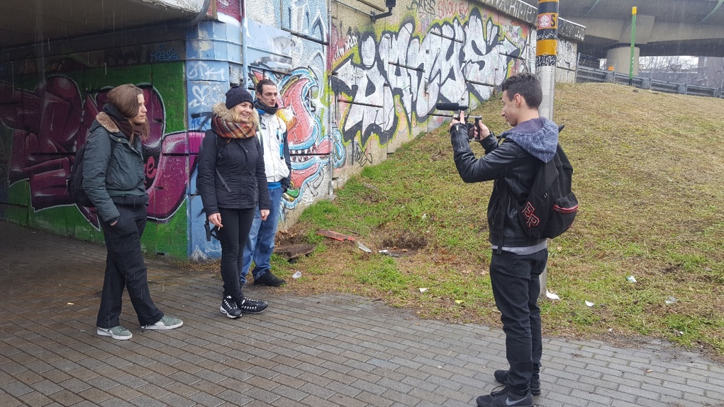
Figure 1. Students taking pictures for their storytelling about “Street art”. Credits: ScAR project.
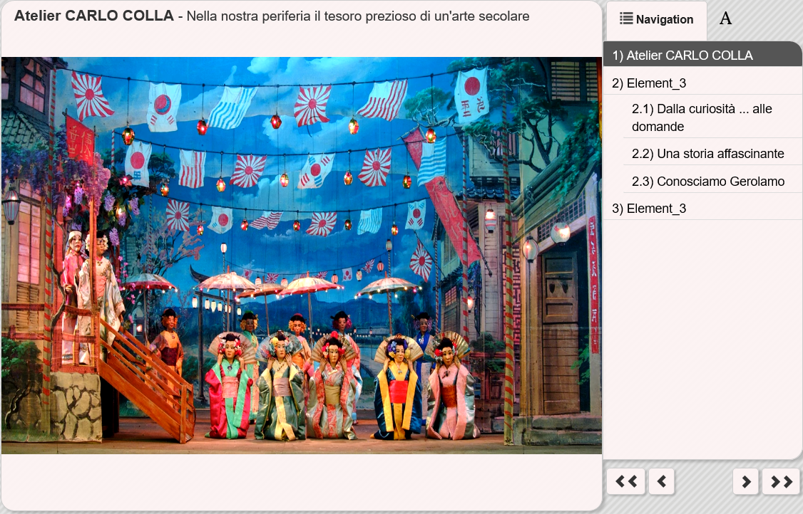
Figure 2. The “puppet theater” storytelling (on the right, the organization into chapters/sub-chapters of the story). Credits: ScAR project.
In the next section, we examine the impact by the activity and we try to give an answer to the question of whether digital storytelling can generate in the students a “bond” with the territory. The discussion is based on the analysis of the reports each teacher delivered, which was organized along these lines: activity description, objectives, tasks and roles of the students, organization of the work (spaces and tools) and overall evaluation of the experience.
- DATA ANALYSIS AND RESULTS
  - General features
In the following paragraphs we present through the teacher’s voice, the recurring elements which have guided the design and implementation of Digital Storytelling (DST) experiences.
In most cases, DST were designed not only to face learning and socialisation needs of pupils, but also to improve teacher’s collaboration: “the Class Council [...] decided to take part in the activity to strengthen the students’ motivation to learn, to research and to be more productive. Furthermore, it was important to highlight the qualities of our students, and to consolidate relations between classmates increasing the sense of co-responsibility [...]”. (S.13); “[this] project has been an opportunity for teachers and students to get to know each other” (S.3).
The connection between the cultural heritage and the enhancement of local historical areas was a feature found in all the educational reports by the teachers. In most cases, schools have promoted the cultural heritage underestimated in their territory: “I learned that the Sanctuary does not even have any informative brochure. The idea came from the desire to create a virtual tour of the Sanctuary, where citizens may actively use the DST to know this place [...]”. (S.7). In this direction, the “digital” has been seen as a mediator through which promote/support the following process: an “active” use of digital technologies by students; the active participation of students in decision-making processes (student agency); the transformation of learning environments; the knowledge of the local territory.
  - Aims, disciplines and relation with the school curriculum
The reports outline direct and indirect benefits that have had a “positive” impact on the teachers’ professional development. On one hand, the ScAR project has contributed to consolidate moments of collaboration and exchange among colleagues, enhancing a “collegial decision-making” perspective. On the other hand, the participating schools have facilitated the promotion of interdisciplinary (different disciplines address, in parallel but independently, a common topic) and multidisciplinary (the same “cultural object” is co-constructed by integrating the different disciplinary contributions) didactic approaches. Considering the perceptions of the teachers, apart from one of them, most of the projects with DST have been declared as curricular. However, an initial qualitative analysis of all the reports has pointed out that there are minimal references to formal schools’ curricula. For example, only one school has clearly explained the connection between the DST activities and the official curriculum published in the school’s web-site.
Considering the curriculum subjects involved, there was a slight prevalence of humanities over scientific disciplines. This factor could be influenced by the specific field (cultural heritage) of the ScAR project.
Analysing the dimension of the didactic objectives declared by the teachers in the design of the DST activity, it is possible to identify two types of “prevailing goals” which have guided the implementation of these experiences. The first typology refers to the definition of generic objectives (which can be considered, in reality, as transversal ones) that the different projects intended to pursue. For example: “to become aware of the opportunities offered by a suburban environment”; “[to approach] the dynamics of the organization of life in the suburbs”; [to be] aware of the meaning of “being part” of a community (S.5). Or: “to give life to a different and effective learning based on the general knowledge of the territory, on the search for identity values typical of the peripheral reality that our children live daily”. (S.9). The second type of objectives analysed, refers to more precise taxonomic criteria (even if not always formulated correctly) and they were related to the acquisition of specific skills, such as: “write correctly texts using different multimedia tools; recognize [...] basic and specialist words; select and organize information comparing local history in relation to Italian, European and world history” (S.4).
Increased knowledge of the territory, “digital awareness” to promote active and inclusive teaching, have been the main “keywords” declared by teachers in the “project goals” section of the reports. Evidently, the DST activities promoted during the ScAR initiative have made it possible, in some cases, to promote positive experiences of inclusion and didactic innovation.
The cultural heritage topic was addressed, on one hand, by enhancing multi-perspective approaches on the “cultural objects” dealt with; on the other hand, by providing students with cultural tools to interpret the work they were doing. Digital storytelling, in this sense, was intended as a technological mediator, a transversal element to all school’s subject, a way to accompany the implementation of different activities.
The DST experiences highlight the inclusive values (in terms of individuals and groups) promoted within these projects. To give just a few examples, one teacher states that “a student with relational and cognitive difficulties has been given the opportunity to interact with the class group, contributing to the knowledge of the territory and the suburbs in which she finds herself living” (S.7); another teacher points out, instead, that “by dividing the work among the pupils, cooperative learning has been privileged. [Tasks] are assigned to each pupil, including tutoring, to strengthen the sense of responsibility and co-responsibility. The aim was to enhance and strengthen the expressive, technological and organisational skills of each student” (S.8). “The project [...] has strengthened the class group” (S.1).
As can be seen from the above-mentioned examples, the analysis of the project description has brought out, therefore, the adoption by teachers of didactic strategies capable to stimulate (also) the active participation and inclusion of students with more difficulties. Although these aspects undoubtedly deserve an in-depth research, some statements on the subject have been reported as examples, which will be examined in more detail in subsequent qualitative and quantitative surveys.
  - Tasks and roles within the groups.
All the teaching projects alternated “plenary” sessions with work in small groups. In the vast majority of cases, the teachers set the goals for the various groups, the roles of their member pupils and their tasks, while the pupils were free to choose the specific educational topic to be elaborated. There was also alternation with regard to the constitution of the working groups: in some cases, groups were chosen by the teachers to guarantee a heterogeneous mix of abilities and gender and the inclusion of pupils with special educational needs, alternating both the composition of the group over the course of the project and the roles played by the pupils; at other times, the pupils themselves chose the groups they wished to work with, depending on their interests and skills: “the groups [...] were created mainly by the children themselves, under clear instructions always to choose different companions and to form groups with a mixture of boys and girls” (S.5). In some school contexts, groups formed by the pupils and others formed under the teachers’ guidance alternated, depending on the various activities under way, while in three cases one leader/tutor per group “responsible for control of and compliance with the planned activities” was appointed (S.7).
In many schools, the pupils’ skills and aptitudes were considered when allocating tasks, playing to their strengths in order to increase their motivation. Some were tasked with coordinating activities, revising the outputs and leading teams, while other pupils, with a higher level of IT and language skills than their classmates, were assigned a specific role in constructing the DST: “all the pupils were allocated a role as appropriate to their talents […] they were all involved, but the pupils best at drawing expressed their ideas in graphic form by designing the film sets […]. Finally, the working groups were organised considering each member's strengths and weaknesses and the need to encourage cooperative learning” (S.3). Apart from the differences within the individual schools and areas, one common feature was the focus on the collaborative aspect of the project, which led the teachers to develop inclusive teaching strategies: “I aimed to increase the degree of cooperative learning, especially with regard to the class […] with the most obvious gap between highly motivated and less motivated pupils. For this class, I created ‘mixed’, uneven groups, and I tried to get them to focus on a precise common aim and on meeting delivery deadlines […]. By mixing them up like this, I increased the level of responsibility allocated to the least motivated pupils by making their step the central one in the specific output, [explaining that without their contribution the work of the whole group would be held up]. On the basis of the results achieved, I am very happy with the group dynamics, since [the project] developed a sense of responsibility in some pupils who previously did not have one or in whom it was very weak” (S.13).
  - Organisation of working phases
The educational project was conducted mainly in classrooms and multimedia laboratories in normal lesson time. The various project phases took place in these environments, led and supervised by the teachers but always with input from the participants, through brainstorming activities and discussions involving the whole class or small groups. These phases were: a) the choice of topic, in some cases suggested by the teacher and in others by the pupils, intended to encourage the rediscovery and appreciation of the “forgotten” local heritage; b) the construction of the editorial plan and the choice of contents; c) the planning of the activities by the teachers, in terms of both contents and time scales; and d) the sharing of tasks and roles amongst the pupils.
In most schools, the intermediate phases were carried out independently by the children themselves, both at school and – even more so – at home, working “individually and in small groups, meeting after school hours and at the weekends to gather additional useful material” (S.1). Following the guidelines provided in the storyboard designed in the classroom, pupils looked for sources, chose multimedia materials and produced the documentation (writing of written texts, photographs, video films ...), all of which were subsequently viewed and approved by the teachers and their classmates.
The local area was also fundamental in the creation of the multimedia storytelling: site visits, guided tours and interviews with key witnesses were organised, photographic and audiovisual documentation was acquired and paper materials only available from specific archives in municipal public libraries were consulted.
In the final phases, in which the various multimedia materials selected and/or constructed by the pupils were assembled, the DST was edited using specific software, and the digital product was uploaded onto the PoliCultura platform. This phase took place mainly back in the IT laboratories, under the supervision of teachers; they were occasionally carried out by pupils working independently.
Besides the paper documents in the school library, depending on the school's material and technological resources, desktop PCs and tablets and, in some cases only, digital cameras and video cameras, were also used in the production of the DST. One middle school used a drone for aerial filming, while the primary school used an interactive whiteboard and an Ozobot robot. The pupils also used their own digital devices for both individual and small group activities.
As the teachers’ feedback reveals, the purposes for which the various technologies were used during the course of the project were: the production of multimedia material (acquisition of images and videos using various devices, first and foremost the pupils’ own smartphones); finding and downloading materials from the Internet (websites, repositories and specific platforms, social media networks such as YouTube, etc.); storing and sharing the multimedia documentation in cloud environments; and assembly and editing of the storytelling.
  - Distribution and dynamics of “knowledge”
Due to its specific didactic potentials, the DST activity created new knowledge and reciprocal collaborations amongst pupils and teachers, generating positive and, to a certain extent, new dynamics and exchanges in terms of contents, relationships and digital and general skills (Di Blas et el, 2014): “it enabled both us teachers and the pupils to acquire new skills: the reciprocal exchange of ideas, the teamwork, the criticalities to be resolved and the demands to be met combined to offer us a particularly enriching experience” (S.2); “the storytelling was a reciprocal learning opportunity […], since you learn as you go and learn from one another, in all four directions: teacher-pupil, pupil-teacher, teacher-teacher and pupil-pupil” (S.8). Collaborative learning encouraged inclusive learning dynamics amongst children: “the peer-to-peer learning activities […] taught pupils to include all members of the group” (S.12); “pupils filmed videos and took photographs to produce a short film with a script they wrote themselves, even including the least able, least confident children” (S.10).
In the production of the DST, each teacher contributed to the educational project depending on their own disciplinary, organisational and technological skills, participating, individually or in a team, in the revision of the texts, in the deepening of knowledge - at school or during site visits - of specific topics, in the supervision of the editing, etc. This played an essential role in enabling the children to acquire knowledge of contents relating to the local historical, cultural and environmental heritage: “pupils learnt a great deal about the area's local traditions, not only from the multimedia sources but also from the input provided by the teacher” (S. 2); “this definitely helped to deepen their knowledge of the historical period concerned and about aspects of which they knew nothing, even though for many of them they concerned the history of their own town” (S. 9). The collaboration of other subject and support teachers within the school, not directly involved in the project, was also definitely very valuable: in most schools, this collaboration began in the planning phase, and in many schools it continued through to the end of the didactic project, providing considerable enrichment both with regard to the educational contents offered to the children and in terms of organisation and technology, an aspect in which some teachers’ specific digital skills were fundamental.
As we have already underlined, it was particularly important for the children to get out and about in the local area, visiting, photographing and filming areas of interest for their landscape, archaeology or history. In almost all projects, the pupils also entered into a constructive dialogue with the local population, interviewing the inhabitants of the district on the streets, at association meetings or in school, in order to recover personal opinions and knowledge about current or past events and topics: “books and the Internet still have their role to play, but in this specific case we also learnt new things from direct contact with the people of Caramagna themselves” (S. 11); “the interviews with the people living in the places enabled the pupils to gather information that helped them to learn about, appreciate and respect the cultural heritage they were exploring” (S. 7); “every outing expanded our network of encounters, and we walked the streets without a script, but with a story just waiting to be written” (S.3).
Not only external experts such as architects, restorers, energy resource experts and the forestry service, but also street-art artists and retired teachers provided knowledge of the cultural, historical, landscape and architectural heritage, by giving interviews, supervising the children's work and providing first-hand accounts, guiding them in their discovery of the area: “the first help we received from outside was a lesson from a retired teacher […] he was our oral source, a real 'open book', and the children lapped up what he had to say. He told us about our town's forgotten beauty, its unappreciated cultural heritage and the potential of the Racale area, as well as its historical origins” (S. 5). “Adding the inputs of experts to the familiar school learning process further expanded the knowledge circuit” (S.12). Municipal and provincial local authorities, represented by mayors, councillors and tourist offices, also helped when requested by making their knowledge of the specific topic of the DST available to the school and supplying materials and documents it would otherwise have been difficult to obtain.
The pupils proved to be a fundamental resource, both for their classmates and for their teachers, providing technological knowledge, educating their classmates and teachers, and exploiting their language skills by translating the texts into English. In one high school, in particular, pupils wishing to obtain information about places and events of importance to their area turned to the schoolmates involved in the travel agency operating inside the school, while the pupils of a middle school studying the important local figure of Father Pino Puglisi made use of photographs produced in the previous academic year by another class in their school.
In some schools, families played a significant part in certain aspects of the DST project, often helping by organising and managing the extracurricular activities (especially in view of the age of the primary and middle school children), and by, for example, giving advice on which experts to be contacted.
In conclusion, in the opinion of the teachers their skills in teaching and in collaboration with colleagues, as well as their knowledge of the local cultural heritage and their understanding of the pupils' characteristics and potential were all enriched and consolidated through participation in the project and the constructive collaboration with both colleagues and pupils: “it was an opportunity for teamwork, for drawing up assessment score-sheets and observation protocols, and for deciding procedures for monitoring activities” (S.13); “some features of the municipal area were unfamiliar even to teachers who live only a few kilometres from Caramagna, or have taught here for almost 30 years” (S.11); “as a teacher, I discovered talents, skills and interests which tend not to emerge during normal teaching activities […] pupils are only prepared to reveal and use their talents when topics are presented in a form designed to interest them” (S.6).

  - Evaluation
The last aspect considered in the project description concerns the overall evaluation of the DST didactic experience. The analysis of the project’s reports led us to identify a number of strengths and weaknesses which are summarized in Table 1.

Strengths | Weaknesses
- relationship between teachers and students;  - relationship among students;  - motivation and transversal skills;  - language and expression skills;  - critical use of digital technologies;  - inclusion of student with difficulties;  - knowledge of the territory. | - organisational aspects;  - collaboration with colleagues;  - dissemination of experiences;  - several technical aspects related to the usability of “1001storia” authoring tool.
Table 1. Strenghts and weeknesses of DST experiences
The majority of teachers stated that they have improved the level of the educational relationship with their pupils. The introduction of digital technologies, together with the adoption of active teaching methods, has allowed the strengthening of both the relationship between teachers, and the cohesion of the class group, ensuring the inclusion of pupils with more difficulties. As one teacher underlines: “[this activity has] undoubtedly consolidated our relationship and made us a good team and this is, perhaps, the best result for me [...]; I’m glad when I see my students growing in such a positive way, and when we work together” (S.1.); or: “The project has been particularly meaningful for its educational value, because it has improved the relationships between the pupils, especially encouraging [...] the inclusion of students with learning disorder” (S.10).
In addition to these important aspects, to be considered as fundamental dimensions for establishing a good educational relationship, the motivational dimension and the acquisition of transversal skills (even more than those purely disciplinary) seem to have been an ally of the DST experiences. Definitely, the following statement can be considered as representative: “[the] final balance of the activity highlights the benefits obtained in terms of increased motivation of students, the acquisition of transversal skills such as: responsibility, respect for deadlines and delivery of work, the development of critical sense, the critical use of digital media [...]”. (S.4).
Other teachers identify an improvement in expressive and linguistic skills of their students. The latter concerned the ability to decode specific languages that qualify the basic alphabets of the different disciplines, and digital technologies involved in the implementation of DST experiences.
Considering the aspects “to be improved”, teachers pointing out some technical problems related to the “1001stories” authoring tool. For example, they have highlighted some usability problems. Other critical elements were related to a difficult collaboration among colleagues, and the fact that the minority of didactic experiences were adequately disseminated in the territory. In this sense, in addition to widening the gap between the pedagogical and technological knowledge of teachers, problems are related to the know-how transfer and project sustainability (Ferrari, 2017). Teachers stated that: “Sometimes it has not been possible to count on the complete collaboration of all colleagues; some of them were (erroneously) convinced that such activities - that go beyond the “curricular programs” - are not an effective teaching tool. (S.6). Finally, other teachers underline that “the involvement of a greater number of colleagues has not worked, and it was the challenge that we had proposed to ourselves at the beginning of the year! Certainly not for lack of availability, but for objective difficulties to find available teaching staff” (S.13).
- CONCLUSIONS AND RECOMMENDATIONS
In conclusion, after an initial analysis of the main points that have characterized the teaching plans of the teachers, it is possible to argue that the experiences conducted within the framework of ScAR have allowed us to work in the school, at all levels, in an innovative way on the theme of cultural heritage. Considering both the strengths and the weaknesses that emerged in the teachers’ reports, the educational directions undertaken allow us to outline a “positive” scenario in which the theme promoted by ScAR has certainly represented a fertile territory, capable of triggering active learning processes and educational inclusion for a democratic school in which all students have the right-duty to receive quality education.
Regarding the specific theme of the ScAR project, the digital storytelling activity shows that an active approach is able to encourage the children to take an interest in the cultural heritage, in particular the less known one, on which “the eye could slip”. The best stories (even in the past editions of PoliCultura) are in fact those in which the classes describe their own territory and tell stories about apparently minor topics (traditions, village festivals, characters, museums ...) that their words make irresistibly interesting. We believe this is a result not only didactically but also socially relevant, particularly in a nation, Italy, which brings together the largest number of sites included in the UNESCO World Heritage list. Relevant because to be able to communicate something one must first have discovered it, known it and made it one’s own. And it is good that this process is lived by the “citizens of tomorrow”, those in whose hands we entrust this good, hoping that they will be able to take care of it.

Acknowledgement
This contribution, fully shared by the four authors, was drawn up as follows: paragraphs 1, 4 and 6 by Nicoletta di Blas; paragraphs 2 and 3 by Camilla Casonato; paragraphs 5.1, 5.2 and 5.6 by Luca Ferrari, paragraphs 5.3, 5.4, 5.5 by Manuela Fabbri.
- REFERENCES

Alterio, M., & J. McDrury, (2003). Learning through storytelling in higher education: Using reflection and experience to improve learning. London: Kogan Page.

Blair, D. J. (2016). Experiential learning for teacher professional development at historic sites. Journal of Experiential Education, 39(2), 130-144.

Calcagno Maniglio, A. ( Landscape and education. In Council of Europe (ed.), Landscape dimensions. Reflections and proposals for the implementation of the European Landscape Convention. Strasbourg: Council of Europe Publishing, 55-120.
Conole, G. (2013). Designing for Learning in an Open World. New York: Springer.

Cook-Sather, A., Bovill, C., & Felten, P. (2014). Engaging students as partners in learning and teaching. San Francisco, CA: Jossey-Bass.

Copeland, T. (1998). Whose monuments, are they? Whose past is it? The multicultural use of monuments. In
Copeland, T. (2006). European democratic citizenship, heritage education and identity. Strasbourg, France: Council of Europe Publishing.
Council of Europe (eds.) (1998). Cultural Heritage and its educational implications: a factor for tolerance, good citizenship and social integration: Proceedings. Brussels Seminar 1995. Strasbourg: Council of Europe Publishing.
De Troyer, V. (ed.) (2005). Hereduc. Heritage Education in the classroom. A Practical Manual for Teachers. Antwerpen-Apeldoom: Garant.
Di Blas, N., & Ferrari, L. (2014). Digital storytelling at school: what kind of educational benefits? International Journal of Arts and Technology, 7(1), 38-54.
Di Blas, N., Paolini, P., Sawaya, S. & Mishra, P. (2014). Distributed TPACK: Going Beyond Knowledge in the Head. In M. Searson & M. Ochoa (Eds.), Proceedings of Society for Information Technology & Teacher Education International Conference 2014. Jacksonville, Florida, USA: Association for the Advancement of Computing in Education (AACE), 2464-2472.

Falcione, S., Campbell, E., McCollum, B., Chamberlain, J., Macias, M., Morsch, L., & Pinder, C. (2019). Emergence of different perspectives of success in collaborative learning. The Canadian Journal for the Scholarship of Teaching and Learning, 10(2).

Gillies, Robyn (2016). Cooperative Learning: Review of Research and Practice. Australian Journal of Teacher Education. 41 (3), 39–51.

Healey, M., Flint, A., & Harrington, K. (2014). Engagement through partnership: Students as partners in learning and teaching in higher education. Heslington, UK: The Higher Education Academy.

Jenkins, H. (2009). Confronting the Challenges of Participatory Culture Media Education for the 21st Century, Cambridge, MA, USA: MIT Press.

Kolb, D.A. (1984) Experiential Learning: Experience as the Source of Learning and Development. Englewood Cliffs, N.J.: Prentice-Hall.

Kolb, A.Y., & Kolb, D.A. (2009). Experiential Learning Theory: A Dynamic, Holistic Approach to Management Learning, Education and Development. In Armstrong, S.J., Fukami, C.V. (eds.). Handbook of Management Learning, Education and Development, London: SAGE Publications Ltd, 42–68.

Lambert, J. (2013). Digital Storytelling: Capturing Lives, Creating Community (4th ed.). Berkeley, CA, USA: Digital Diner Press.

Lu, F., Tian, F., Jiang, Y., Cao, X., Luo, W., Li, G., Zhang, X., Dai, G., Wang, H. (2011). ShadowStory: creative and collaborative digital storytelling inspired by cultural heritage. In Proceedings of the 2011 annual conference on Human factors in computing systems. New York, NY, USA: ACM, 1919-1928.

Luigini, A. Ed. (2019), Proceedings of the 1st International and Interdisciplinary Conference on Digital Environments for Education, Arts and Heritage, EARTH 2018. Cham, Switzerland: Springer.

Moon, J.A., (2004). Handbook of Reflective and Experiential Learning. New York: Routledge Falmer.

Ott, M., Pozzi, F. (2011), Towards a new era for Cultural Heritage Education. Discussing the role of ICT, Computers in Human Behavior, 27 (4), 1365-1371.

Prince, M. (2004). Does Active Learning Work? A Review of the Research. Journal of Engineering Education, 93. 223-231.

Quay, J., & Seaman, J. (2013). John Dewey and education outdoors: Making sense of the 'educational situation' through more than a century of progressive reforms. Rotterdam: Sense Publishers.

Resnick, M. (2019). Lifelong Kindergarten: Cultivating Creativity through Projects, Passion, Peers, and Play. Cambridge, MA, USA: MIT Press.
Scardamalia, M., Bereiter C. (2006). Knowledge building: Theory, pedagogy, and technology. In K. Sawyer (ed.). Cambridge Handbook of the Learning Sciences. New York: Cambridge University Press.

Schul, J.E. (2012). Revisiting and old friend: The practice and promise of cooperative learning for the twenty-first century. The Social Studies, 102, 88-93.

Van Lakerveld, J., Gussen, I. (2011). Aqueduct. Acquiring Key Competences through Heritage Education. Bilzen (Belgium): Lies Kerkhofs, Landcommanderij Alden Biesen.

Vuopala, E., Hyvönen, P., & Järvelä, S. (2015). Interaction forms in successful collaborative learning in virtual learning environments. Active Learning in Higher Education, 17, 25-38.

Waterton, E., Watson, S. (2010), Culture, Heritage and representation. Perspectives on Visuality and the past, Farnham, England: Ashgate.

Documents
European Landscape Convention, Florence 2000. https://rm.coe.int/CoERMPublicCommonSearchServices/DisplayDCTMContent?documentId=09000016802f80c6 (accessed October 2019)
Faro Convention. Council of Europe Framework Convention on the Value of Cultural Heritage for Society, Faro 2005. https://www.coe.int/en/web/conventions/full-list/-/conventions/rms/0900001680083746 (accessed October 2019).
Florence Declaration on Heritage and Landscape as Human Values, Florence 2014.
https://www.icomos.org/images/DOCUMENTS/Secretariat/2015/GA_2014_results/GA2014_Symposium_FlorenceDeclaration_EN_final_20150318.pdf (accessed October 2019).

Pocket-sized robot used for coding and educational robotics, with the aim of introducing children to the programming language.
The travel agency was founded inside the school as a Simulated Training Enterprise to provide work experience and it now organises tourism events in the local area in partnership with Provincial associations in the Lazio region.

