Table S1 Sampling details date for HSW samples collected

Sample | Date
HSW1 | 22-23/01/21
HSW2 | 31/01/21
HSW3 | 10/02/21
HSW4 | 05/03/21

Pyrolysis gas chromatograph-mass spectrometer
Py-GC/MS is a method of chemical analysis that first thermally degrades the sample to produce smaller and more analytically useful fragments that can be separated on a GC column and detected in an MS instrument. In this work, a filament pyrolizer was used. Samples were inserted in a sample holder, consisting of a pre-muffled (400°C, 4 h) quartz tube (1,9 mm in diameter, from CDS Analytical), between two pre-muffled quartz disks (C), punched out from a pre-muffled quartz fiber filter using a 1,9 mm puncher, provided by CDS Analytical.
The sample holder was located in the pyroprobe, between the filament wires and the pyroprobe was introduced in the interface (or accessory).
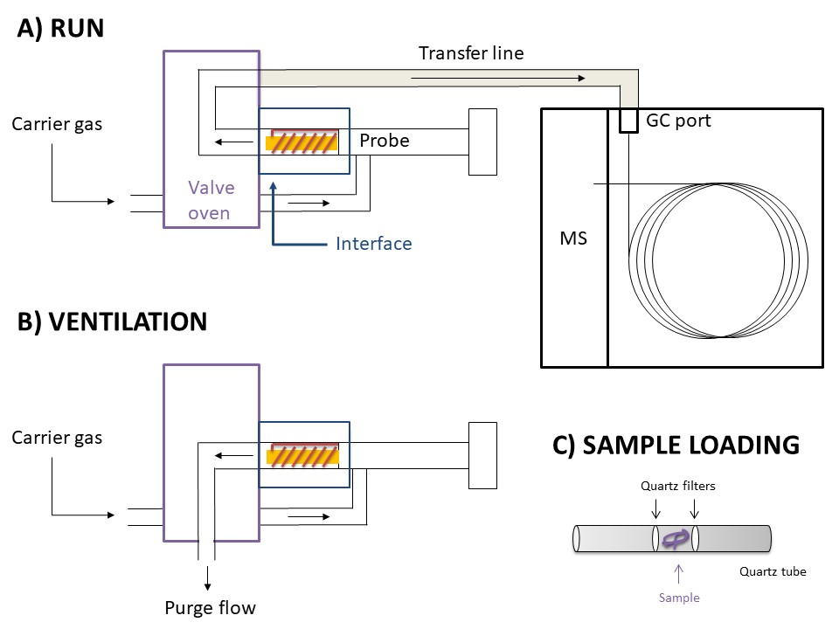
When pyrolysis occurs (A), the pyrolizer is online with the GC: the carrier gas (He) transfers the vaporized sample to the GC port passing through a heated transfer line. During the run, the interface (or accessory), the valve oven, and the transfer line are set at a temperature high enough to maintain the pyrolysis products in the gaseous phase during the whole path till the GC port.
Before the pyrolysis, a ventilation step was applied (B). During the ventilation step, the pyrolizer is offline with the GC, the filament is not heated, and the interface is maintained at 200°C for 3 minutes so that the He flux can remove volatile and semi-volatile compounds.

Table S2 Identification of rubbers in tire wear particles and stormwater samples HSW1 and HSW2 by Py-GC/MS. Pyrolysis markers are in bold, according to Unice et al. 2013.
Retention time | Pyrolysis products | Polymer | m/z values | Match HSW1 | Match HSW2 | Match Homemade reference material
2.41 min | 1,3-butadiene | BR, SBR | 54, 39 | 78% | 56% | 74%
2.67 min | Isoprene / 2-methyl-1,3-butadiene | NR, IR | 67 ,53 | 91% | 91% | 94%
6.06 min | 4-vinyl-cyclohexene /  4-ethenyl-cyclohexene (VCH) | BR, SBR | 54 , 79 | 76 % | 90% | 95%
6.99 min | styrene | SBR | 104 ,78 | 97% | 97% | 97%
8.86 min | limonene / dipentene | NR, IR | 68 , 93 | 91% | 95% | 96%

Organic solvent-free and cold-pressed sunflower seeds oil (SSO) details information:
Organic cold-pressed SSO was chosen according to Corami et al., 2020. It was certified solvent-free; besides, it had a minor content of pigments (e.g., chlorophyll, carotenoids, etc.) compared to other oils (e.g., canola oil, castor oil, extra virgin olive oil, rapeseed oil, etc; Mani et al., 2019; Scopetani et al., 2020).

List of the reference libraries employed with Omnic Picta Software (Thermo Fisher)
- Synthetic fibers by Microscope
- Plastic Fibers
- Polymer additives and plasticizers
- HR Polymer additives and plasticizers
- HR Hummel Polymer and plasticizers
- HR Nicolet Sampler Library
- HR Sprouse Polymer additives
- HR rubber compounding material

Aspect ratio and volume of TWPs
Aspect ratio (AR; Corami et al. 2020) is the ratio between the maximum length (L) and the maximum width (W) of the smallest rectangle (bounding box) enclosing the shape:
AR =$\frac{{L }_{max}}{W_{max}}$ (1)
L_{max} and W_{max} were retrieved using the imaging function of Omnic™ Picta™ software. The shape of the particles can resemble regular geometric solids. When AR ≤1, particles are considered spherical, while when AR ≤2, particles are elongated/ellipsoidal and they are considered elliptical. When AR isc≥ 3, particles are considered cylindrical. Volumes of SMPs are then calculated according to their geometrical shape (i.e., sphere, ellipse, and cylinder).

Table S3 Comparison of other studies on TWPs analysis with the matrix analyzed, abundance (or weight), and the technique employed.

Matrix | Abundance or weight | Technique | References
stormwater floating treatment wetland in Australia | 4.0 ± 2.4 microplastic particles/L | FTIR | Ziajahromi et al., 2020
Sediment from floating treatment wetland in Australia | 595 ± 120 microplastic particles/kg dry | FTIR | Ziajahromi et al., 2020
river water in China | from 0.8 mg L-1 of TWPs | GC | Ni et al., 2008
stormwater rain | to 2.5 mg L−1 | pyrolysis GC-MS | Parker-Jurd et al., 2021
River water from the USA | from 1.6 mg L-1 | GC-MSD | Wik and Dave, 2009
Sediments from rivers receiving highway runoff from Japan | 179 mg L-1 | GC-FPD | Kumata et al., 2000
highway runoff sediments Germany | 480 mg g−1 | TED-GC/MS | Klöckner et al. (2020)

Figures in Supplementary
Fig. S1 Additional spectra identified as cadmium, zinc, and barium sulfide blend from HSW samples (a-b) and homemade reference material (c ).

Fig. S2 AR (Aspect Ratio) showed that ellipsoid (e) was the most common shape among TWPs in the four HSW samples.

Fig. S3 Example of TWPs size distribution in length (µm) from sample HSW 1

Fig. S4 Chemical characterization of tire wear used as a reference by Py-GC/MS

Fig. S5 Example of pyrogram with the presence of SBR and NR in the HSW sample confirmed by the identification of VCH and limonene

Fig. S6 TWPs in HSW samples and homemade reference material were analyzed via SEM/EDSEDX to compare the aspect, morphological evaluation, and size measurement. Fig. S6 a b show the TWPs “rolled up” shape may result from the shear and friction forces; Fig. S6 c d show that 40% of the total high amount of particles analyzed were less than 30-25 µm in length; Fig. S6 e f show the complex heterogenous mixture and the encrustation of other compounds in most of the TWPs.
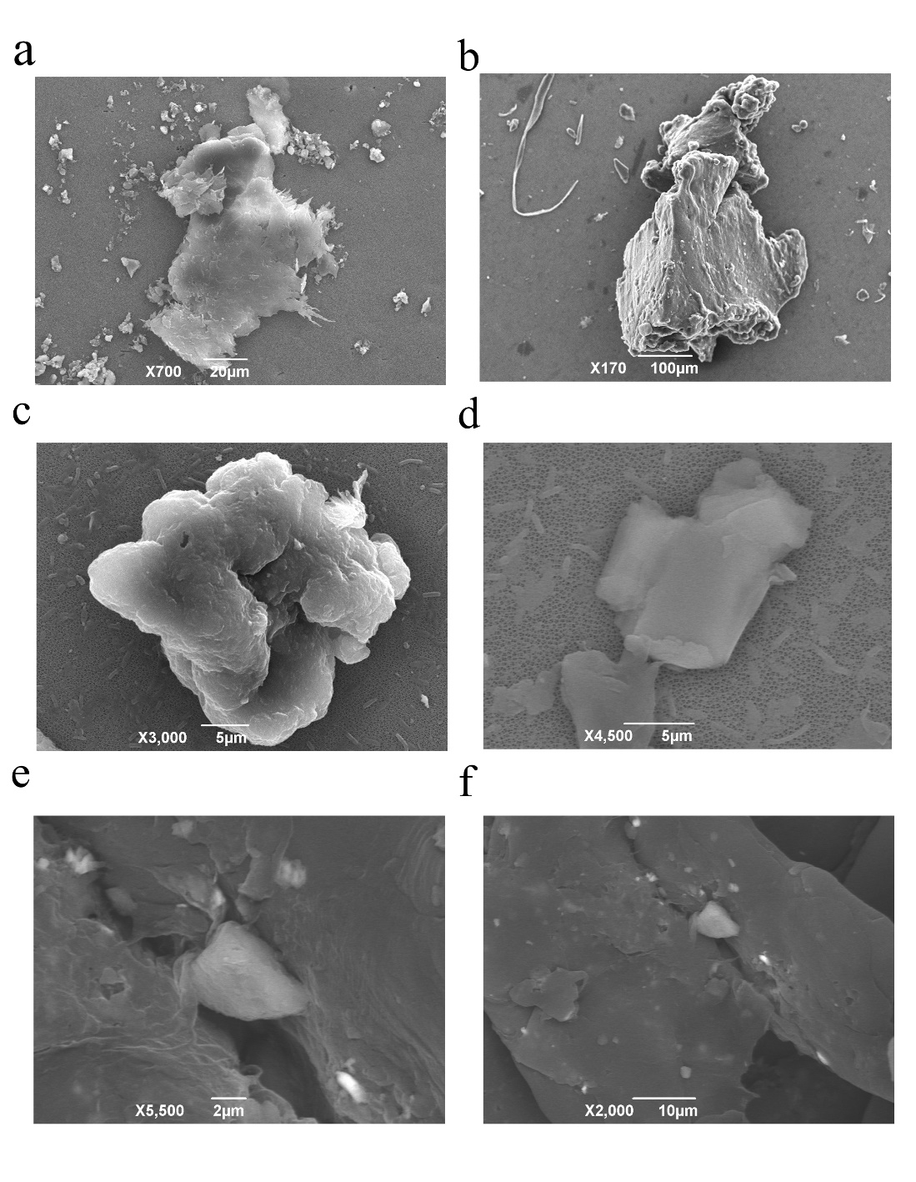

Fig. S7, a b c TWPs surface element analysis of SEM/EDSEDX, show elements such as Si, Ca, and Mg, respectively, present in crystals, compounds phase (e.g., silica filler) or aggregates derived probably from silicates, calcite, clay, albite, or mixtures. These compounds could derive from brake wear, road wear, pavement, dust, asphalts, and construction roadwork

Fig. S8 TWPs surface element analysis of SEM/EDSEDX shows other particles mainly contain metals (e.g., Fe and Ni, respectively) probably derived from brake wear and disc deposited on the road surface and/or bitumen wear.

