Supplementary Appendix

This appendix has been provided by the authors to give readers additional information about their work.

Supplement to: Angeletti A, Bin S, Magnasco A, Bruschi M, Cravedi P and Ghiggeri GM.

Supplementary Appendix 1

Table of contents
- List of investigators ………………………………………………..…………………... 3
- Supplementary Methods …………………………………..………………………..… 4
- Supplementary Tables .….………………………………………..…………………….7
- Supplementary Figures ..….…….……………………………………..………………11
- References ………………………………………………………….………….….……13

1. List of investigators
Andrea Angeletti¹, Sofia Bin², Alberto Magnasco¹, Maurizio Bruschi¹, Paolo Cravedi² and Gian Marco Ghiggeri¹

¹Department of Medical Paediatric Sciences, Division of Nephrology, Dialysis and Transplantation, IRCCS Istituto Giannina Gaslini, Genoa, 16147, Italy;
²Department of Medicine, Division of Nephrology and Translational Transplant Research Center, Icahn School of Medicine at Mount Sinai, New York, NY, 10029, USA.

2. Supplementary Methods

2.1 Rituximab Infusion
Patients received a premedication with intravenous methyl-prednisolone (2 mg/kg diluted in 100 ml of normal saline in 30 minutes), oral cetirizine (0.2 mg/kg), and oral paracetamol (15 mg/kg), to reduce the risk of infusion reactions. Rituximab was administered as a single dose of 375 mg/m² diluted in saline. For doses lower than 500 mg, rituximab was diluted in 250 ml of normal saline and administered at 6 ml/h for the first 30minutes; 9 ml/h for the second 30minutes; 18 ml/h for the third 30minutes; 36 ml/h until the end of the infusion. For doses between 500 and 1000 mg, rituximab was diluted in 500 ml of normal saline and administered at 9 ml/h for the first 30 minutes; thereafter, the infusion rate was doubled every 30 minutes up to a maximum of 72 ml/h.

2.2 Daratumumab Infusion
Daratumumab was infused 15 days after rituximab. Patients received a premedication with methyl-prednisolone (2 mg/kg infused in 30’ intravenous diluted in 100 ml of normal saline), oral cetirizine (0.2 mg/kg), and oral paracetamol (15 mg/kg). After 2h of infusion, patients received a pre-medication with methyl-prednisolone (20mg infused in 15’ intravenous diluted in 50 ml of normal saline) and oral cetirizine (0.2 mg/kg).
Daratumumab was administered as a single dose of 16mg/kg diluted in 1000ml of saline. Daratumimab was administered at 9 ml/h for the first 30minutes; thereafter, the infusion rate was doubled every 30 minutes up to a maximum of 100 ml/h.
No prophylaxis against any type of viral or bacterial infections was administered before infusions. As per protocol, immunosuppressive treatment based on steroids, mycophenolate mofetil and calineurin inhibitors, was not modified after diagnosis of FSGS recurrence

2.3 Flow Cytometry
PBMC were isolated from peripheral blood by Ficoll gradient and frozen for batched analysis. We designed six multicolor flow cytometry panels to quantify T cell subsets and B cell subsets. The following fluorochrome conjugated anti-human antibodies were used from BD Biosciences (San Jose, CA): CD3-FITC, CD3-PerCP-Cy5.5, CD8-BV510, CD45RO-FITC, CD45RA-APC, CD45RA-APC-Cy7, CCR4-PE, CD27-PE, CD28-BV421, CD138-BV421, CCR6-BV421, CXCR3-PE, CD71-PE, IgD- PerCP-Cy5.5, CD25-APC-Cy7; from Biolegend (San Diego, CA): CD56-FITC, CD127-FITC, CD27-APC, CD57-PerCp-Cy5.5, CD19-BV510, PD-1-APC-Cy7, CXCR5-FITC;IgM- Alexa Fluor 700; from eBioscience (San Diego, CA): CD4-PE-Cy7, CD21-PE, CD24-APC-Cy7; from Miltenyi Biotec (San Diego, CA): CD25-APC and KLRG1-PE; from Beckman Coulter (Brea, CA): CD38-PE-Cy7. Data were acquired on a three-laser Canto II flow cytometer (BD Biosciences) and analyzed using FlowJo (https://www.flowjo.com) software.

2.4 Genetic Tests
As per our center practice, all children or young adults affected by FSGS were tested for monogenic causes of NS with Next Generation sequencing (NGS), including 50 genes associated with MRNS. Genes were selected according to a deep review of the current literature and the OMIM database (http://www.omim.org).^{1,2} DNA was isolated from peripheral blood samples and extracted by using QIAamp DNA Blood Midi kit (Qiagen). Informed consent for genetic tests was obtained from patients and parents (CBUF-IGG2022).

2.5. ELISA for anti-CD40 antibodies
Autoantibodies against CD40 were quantified using a direct ELISA assay. Briefly, Nunc™MaxiSorp™ ELISA plate (Thermo Fisher) was coated with 100ng of CD40 in carbonate buffer and incubated at 4°C overnight. Uncoated wells were used to quantify background. Wells were washed three times with PBS and blocked with 3% BSA in PBS at 4°C overnight. Thereafter, wells were incubated 2h at RT with serum diluted 1:100 in PBS containing 0.05% v/v of Tween 20 (PBS-T). Then, wells were washed three times in PBS-T and incubated with 100µl of anti-Human IgG HRP-conjugated diluted 1:2000 in PBS-T, containing 1% w/v BSA for 30 minutes at RT. Wells were washed again three times with PBS-T and developed with TMB substrate (Bio-Rad). The reaction was stopped by adding H₂SO₄ and the absorbance was measured at 450 nm using iMark plate reader (Bio-Rad). The reference standards were run in triplicate. The detection limit was determined as the highest protein dilution that was differentiated from blank.

3. Supplementary Tables

Table S1. Changes in the percentages of circulating plasma cells
 |  |  | Patient 1 |  | Patient 3
 |  |  | Months after Kidney Transplant
Subset name | Markers | Parent Population | 1 | 4 | 35 | 39
Total Lymphocytes |  | Acquired cells | 49,40% | 56,00% | 66,70% | 71,50%
Plasma cell | CD3-CD56-CD19+CD38highCD27highCD138+ | CD3-CD56-CD19+CD38highCD27high | 10,50% | 0,00% | 8,33% | 7,14%
Plasma cell | CD3-CD56-CD19+CD38highCD27highCD138+ | CD3-CD56-CD19+ | 0,72% | 0,00% | 0,12% | 0,07%
Plasma cell | CD138-CD38high | Singlets | 5,40% | 0,00% | 3,71% | 3,06%
Plasma cell | CD3-CD56-CD19+CD38highCD27high | CD3-CD56-CD19+ | 0,26% | 0,00% | 0,05% | 0,04%

Table S2. Changes in the percentages of circulating lymphocytes.
 |  |  | Patient 1 |  | Patient 3
 |  |  | Months after Kidney Transplant
Subset name | Markers | Parent Population | 1 | 4 | 35 | 39
Total Lymphocytes |  | Acquired cells | 49,40% | 56,00% | 66,70% | 71,50%
Total B cells | CD3-CD56-CD19+ | Singlets | 6,86% | 0,07% | 1,50% | 1,03%
Naïve/transitional B cells | CD3-CD56-CD19+IgD+CD27- | Singlets | 6,00% | 0,00% | 1,39% | 0,94%
Unswitched memory B cells | CD3-CD56-CD19+IgD+CD27+ | Singlets | 0,11% | 0,00% | 0,02% | 0,02%
Switched memory B cells | CD3-CD56-CD19+ IgD-CD27+ | Singlets | 0,43% | 0,00% | 0,04% | 0,03%
Double negative memory B cells | CD3-CD56-CD19+IgD-CD27- | Singlets | 0,31% | 0,07% | 0,04% | 0,04%
T3 B cells | CD3-CD56-CD19+IgD+CD27-CD24lowCD38low | Singlets | 0,77% | 0,00% | 0,27% | 0,14%
T1 B cells | CD3-CD56-CD19+IgD+CD27-CD24highCD38high | Singlets | 0,00% | 0,00% | 0,10% | 0,31%
T2 B cells | CD3-CD56-CD19+IgD+CD27-CD24intCD38int | Singlets | 2,59% | 0,00% | 2,14% | 2,83%
T1+T2 B cells | CD3-CD56-CD19+IgD+CD27-CD24int/highCD38int/high | Singlets | 2,82% | 0,00% | 2,39% | 3,46%
B_{REG} | CD3-CD56-CD19+CD25highCD71high | Singlets | 0,01% | 0,00% | 0,00% | 0,00%
Ab secreting B cells | CD3-CD56-CD19+CD38+CD27+ | CD3-CD56-CD19+ | 3,80% | 0,00% | 3,21% | 3,78%
Ab secreting B cells | CD3-CD56-CD19+CD38highCD27high | CD3-CD56-CD19+ | 0,26% | 0,00% | 0,58% | 1,23%
Activated lymphocytes | CD38high | Singlets | 7,31% | 0,01% | 5,53% | 4,51%
Memory B cells | CD3-CD56-CD19+CD21- | Singlets | 0,07% | 0,00% | 0,01% | 0,01%
Naïve CD4 T cells | CD8-CD4+CD45RA+CD45RO-CD28+CD27+ | Singlets | 33,66% | 53,88% | 59,71% | 56,98%
Effector CD4 T cells | CD8-CD4+CD45RA-CD45RO+CD28+CD27- | Singlets | 14,26% | 21,05% | 13,44% | 12,51%
Memory CD4 T cells | CD8-CD4+CD45RA-CD45RO+CD28+CD27+ | Singlets | 24,50% | 35,52% | 39,16% | 34,40%
Plasmablast | CD3-CD56-CD19+CD38highCD27highCD138- | CD3-CD56-CD19+CD38highCD27high | 89,50% | 0,00% | 91,70% | 92,90%
Plasmablast | CD3-CD56-CD19+CD38highCD27highCD138- | CD3-CD56-CD19+ | 6,14% | 0,00% | 1,38% | 0,96%
Plasmablast | CD138+CD38high | Singlets | 0,08% | 0,01% | 0,07% | 0,05%
Naïve CD8 T cells | CD4-CD8+CD45RA+CD45RO-CD28+CD27+ | CD4-CD8+ | 15,19% | 22,01% | 19,58% | 21,42%
Effector CD8 T cells | CD4-CD8+CD45RA-CD45RO+CD28+CD27+ | Singlets | 17,14% | 24,24% | 20,43% | 18,51%
Memory CD8 T cells | CD4-CD8+CD45RA-CD45RO+CD28+CD27- | Singlets | 1,94% | 3,16% | 2,86% | 4,22%
T_{REG} | CD3+CD8-CD4+CD25+CD127low | CD3+CD8-CD4+ | 2,84% | 2,79% | 6,47% | 7,03%
Active T_{REG} | CD3+CD8-CD4+CD25+CD127lowCCR4+CD45RA- | CD3+CD8-CD4+ | 43,90% | 34,73% | 9,92% | 3,61%
Active T_{REG} | CD3+CD8-CD4+CCR4+CD45RA-CD25+CD127low | CD3+CD8-CD4+CCR4+CD45RA- | 3,74% | 2,44% | 5,43% | 4,59%
Total T cells | CD3+ | Acquired cells | 27,80% | 6,16% | 61,00% | 79,70%
CD4 T cells | CD3+CD8-CD4+ | CD3+ | 66,30% | 71,20% | 66,30% | 60,50%
Exhausted CD4 T cells | CD3+CD8-CD4+PD1+CD57-KLRG+ | CD3+CD8-CD4+ | 8,78% | 9,56% | 17,62% | 12,11%
Exhausted CD4 T cells | CD3+CD8-CD4+PD1+CD57- | CD3+CD8-CD4+ | 11,70% | 4,49% | 2,37% | 1,96%
Exhausted CD4 T cells | CD3+CD8-CD4+PD1+CD57-KLRG1+ | CD3+CD8-CD4+PD1+CD57- | 11,00% | 11,10% | 25,00% | 17,60%
Anergic CD4 T cells | CD3+CD8-CD4+PD1+CD57-KLRG1- | CD3+CD8-CD4+ | 59,54% | 47,29% | 48,94% | 49,23%
Anergic CD4 T cells | CD3+CD8-CD4+PD1+CD57-KLRG1- | CD3+CD8-CD4+PD1+CD57- | 88,20% | 88,90% | 73,50% | 80,60%
Senescent CD4 T cells | CD3+CD8-CD4+PD1-CD57+KLRG1+ | CD3+CD8-CD4+ | 63,32% | 49,71% | 64,26% | 57,91%
Senescent CD4 T cells | CD3+CD8-CD4+PD1-CD57+KLRG1+ | CD3+CD8-CD4+PD1-CD57+ | 92,50% | 100,00% | 95,30% | 92,80%
Senescent CD4 T cells | CD3+CD8-CD4+CD28- | CD3+CD8-CD4+ | 2,90% | 3,28% | 5,70% | 7,83%
Total PD1 CD4 | CD3+CD8-CD4+PD1+ | CD3+CD8-CD4+ | 9,76% | 4,98% | 1,05% | 1,21%
CD8 T cells | CD3+CD4-CD8+ | CD3+ | 27,10% | 20,70% | 27,70% | 34,40%
Exhausted CD8 T cells | CD3+CD4-CD8+PD1+CD57-KLRG1+ | CD3+CD4-CD8+ | 11,94% | 20,55% | 17,21% | 23,12%
Exhausted CD8 T cells | CD3+CD4-CD8+PD1+CD57- | CD3+CD4-CD8+ | 7,61% | 6,26% | 1,51% | 1,55%
Exhausted CD8 T cells | CD3+CD4-CD8+PD1+CD57-KLRG1+ | CD3+CD4-CD8+PD1+CD57- | 47,20% | 54,50% | 64,70% | 70,70%
Anergic CD8 T cells | CD3+CD4-CD8+PD1+CD57-KLRG1- | CD3+CD4-CD8+ | 11,92% | 18,02% | 7,98% | 7,16%
Anergic CD8 T cells | CD3+CD4-CD8+PD1+CD57-KLRG1- | CD3+CD4-CD8+PD1+CD57- | 51,90% | 45,50% | 34,80% | 27,80%
Senescent CD8 T cells | CD3+CD4-CD8+PD1-CD57+KLRG1+ | CD3+CD4-CD8+ | 23,40% | 32,84% | 24,26% | 29,95%
Senescent CD8 T cells | CD3+CD4-CD8+PD1-CD57+ | CD3+CD4-CD8+ | 4,40% | 0,57% | 11,20% | 17,40%
Senescent CD8 T cells | CD3+CD4-CD8+CD28- | CD3+CD4-CD8+ | 16,80% | 17,90% | 25,50% | 31,90%
Total PD1 CD8 | CD3+CD4-CD8+PD1+ | CD3+CD4-CD8+ | 12,70% | 12,00% | 3,37% | 4,77%
Total TFH cells | CD8-CD4+CXCR5+PD1+ | CD8-CD4+ | 0,23% | 0,33% | 0.050 % | 0.051 %
TFH17 | CD8-CD4+CXCR5+PD1+CCR6+CXCR3- | CD8-CD4+ | 4,48% | 1,54% | 0,00% | 1,49%
TFH1 | CD8-CD4+CXCR5+PD1+CCR6-CXCR3+ | CD8-CD4+ | 1,12% | 0,00% | 0,00% | 4,47%
TFH2 | CD8-CD4+CXCR5+ PD1+CCR6-CXCR3- | CD8-CD4+ | 57,12% | 60,35% | 68,50% | 55,11%

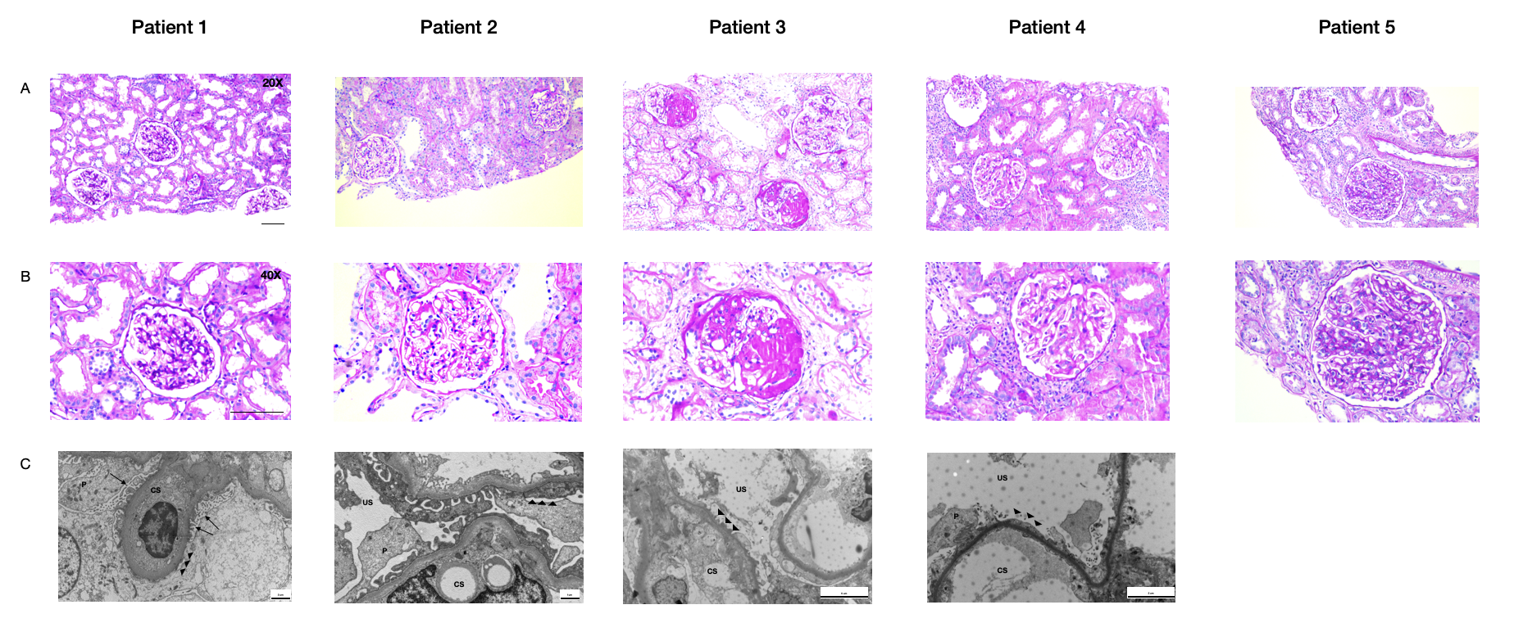
4. Supplementary Figures
Figure S1. Optical and Trasmission Electric Microscopy
Kidney graft biopsies at enrolment, before administrating combined therapy. PAS staining at A) 20X and B) 40X magnification, scale bar 50um and In patient 1 and patient 2, we observed no major abnormalities, as expected due to the really prompt FSGS recurrence after kidney transplant. In patient 3, hystological findings were characterized by not-otherwise-specified (NOS) focal segmental lesions in two glomeruli and interstitial fibrosis resulted less than 10%. Patient 4 showed focal adhesion between glomerulus stuff and Bowman’s capsule, with no signs of sclerosis. There was also a moderate (less than 25%) interstitial infiltrate, mostly consisted with T-lymphocytes (not shown). In Patient 5 we observed focal and segmental mesangial expansion and proliferation. C) Trasmission electric microscopy of patient 1 and patient 3 shows complete foot process effacement (triangles), podocytes (P) are hypertrophic and present some intracytoplasmic vacuoles . More in general, capillary spaces (CS) are patent, glomerular basement membranes present regular size, without deposits. In patient 2 and 4 podocytes are hypertrophic with intracytoplasmic vacuoles, but foot process effacement (triangles) is alternated with some areas where appear regularly interdigitated. Urinary Space (US). Immunoflorescence for IgG, IgA, IgM, C3, C4d, C1q was negative in all patients. BANFF score was performed and resulted negative for any type of allograft rejection.

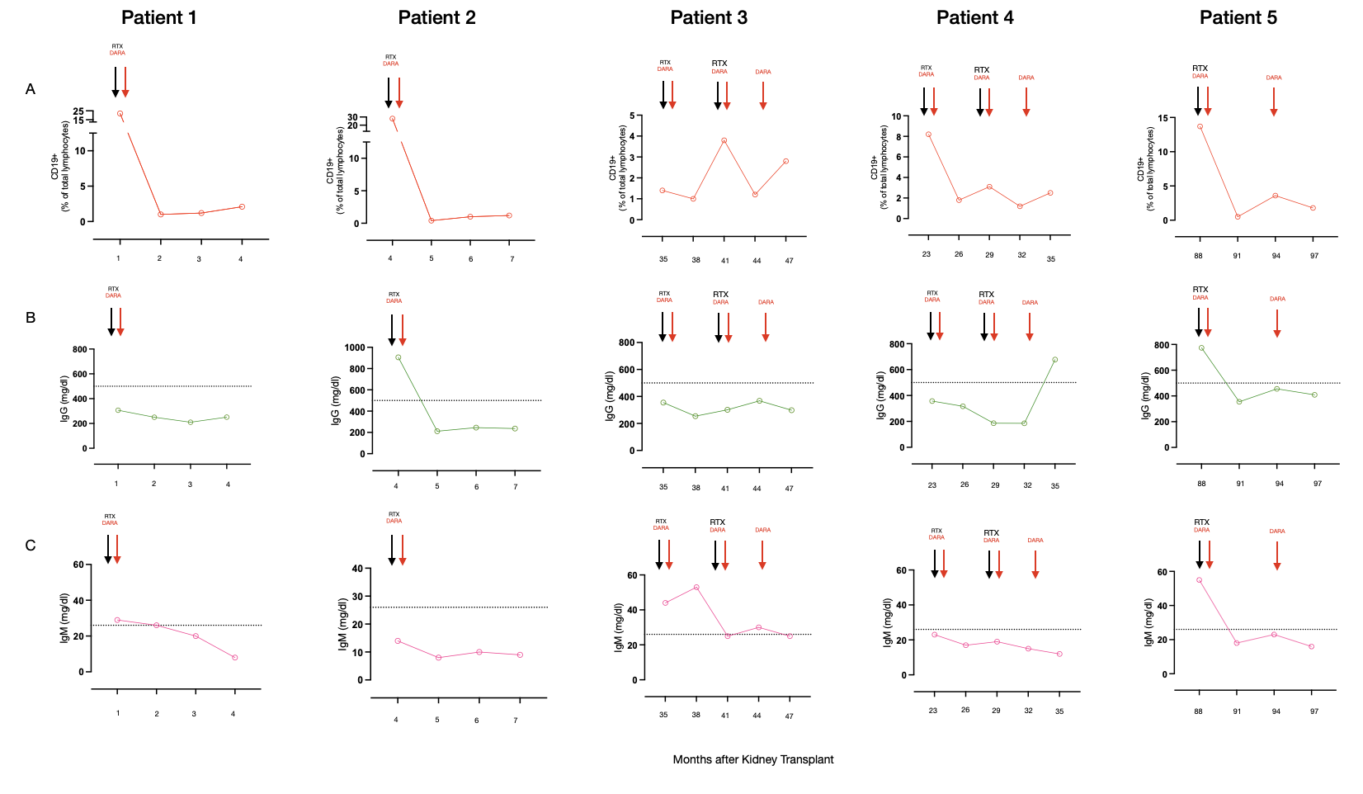

Figure S2. Circulating B cells, IgG and IgM changes.
Serial measurements of A) the percentages of circulating CD19+ B cells, B) serum IgG, and C) IgM levels before and after combined rituximab and daratumumab treatment. Dashed lines indicate normal low values.
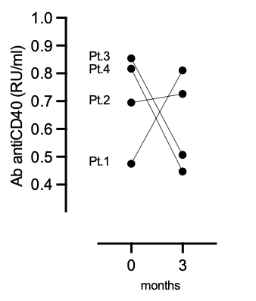

Figure S3. Circulating anti-CD40 antibodies changes.
Antibodies were detected at enrolment and 3 months after combined treatment.

References

1. Watanabe A, Feltran LS, Sampson MG. Genetics of Nephrotic Syndrome Presenting in Childhood: Core Curriculum 2019. Am J Kidney Dis 2019;74:549-57.
2. Richards S, Aziz N, Bale S, et al. Standards and guidelines for the interpretation of sequence variants: a joint consensus recommendation of the American College of Medical Genetics and Genomics and the Association for Molecular Pathology. Genet Med 2015;17:405-24.

