Supporting Information
Tomography Electrogenerated Chemiluminescence Imaging from Magnetic Microbeads
Yanlong Feng,ª Chengkai Wang,ª Wenshuai Zhou,ª Xiaolin Yang,ª Francesco Paolucci,^{b} Giovanni Valenti,^{b*} Honglan Qi ^{a*}
a, Key Laboratory of Analytical Chemistry for Life Science of Shaanxi Province, School of Chemistry and Chemical Engineering, Shaanxi Normal University, Xi’an, 710062, P.R. China
b, Department of Chemistry “Giacomo Ciamician”, University of Bologna, Bologna 40126, Italy

*Corresponding author. E-mail: g.valenti@unibo.it; honglanqi@snnu.edu.cn.

Table of Contents
1. Experimental section S2
1.1 Materials and apparatus S2
1.2 Preparation of Ru1-Mag@MB S2
1.3 Fabrication of side window glassy carbon electrode S3
1.4 Fabrication of Ru1-Mag@MB modified electrode S3
1.5 FL and ECL imaging of Ru1-Mag@MB S4
2. Results S5
2.1 Characterization of Ru1-Mag@MB S5
2.2 Sidelong ECL imaging of Ru1-Mag@MB S9
2.3 Finite element simulation and monitoring optical parameters of microbeads via sidelong ECL imaging S11
2.4 Monitoring radical lifetime of coreactant S17
2.5 Effect of Electrolytes on the ECL Behavior of Ru1-Mag@MB S19
Reference S21

1. Experimental section

1.1 Materials and apparatus
Streptavidin-coated magnetic microbeads (MB, diameters: 2.8 μm, 10 mg/mL) was obtained from Thermo Scientific (USA). Streptavidin-coated magnetic micro-beads (MB, 5.0 mg/mL, diameters: 2~3 μm, 3~4 μm, 5 μm, 10 μm) was purchased from Tianjin BaseLine ChromTech Research Centre (China). Bis(2,2'-bipyridine)-4'-methyl-4-carboxybipyridine-ruthenium N-succinimidyl ester-bis (hexafluorophosphate) (abbreviated as Ru1)-labeled biotinylated peptide (biotin-GSK-Ru1) was obtain from Apeptide Co., Ltd. (China). Tri-n-propylamine (TPrA), triethanolamine (TEOA), 2-(dibutylamino)ethanol (DBAE), 2,2'-(butylimino)diethanol (BIDE), acetonitrile (MeCN) and Tween 20 were purchased from Sigma-Aldrich (USA). 2,2-Bis(hydroxymethyl)-2,2',2''-nitrilotriethanol (BIS-TRIS) and Tetran-butyl ammonium hexafluorophosphate (TBAPF₆) were purchased from TCI (Shanghai) Development Co., Ltd. (China). Buffer of Roche Diagnostic (containing 180 mM TPrA), Buffer of Accucise Diagnostic (containing 180 mM TPrA) and Buffer of Lifotronic Diagnostic (containing 162 mM TPrA) were obtained from Roche Diagnostics (Shanghai) Co., Ltd. (China), Accucise Diagnostic Technology Co., Ltd. (China) and Lifotronic Technology Co., Ltd. (China). All aqueous solutions were prepared using Milli-Q water (18 MΩ·cm).
A MPI-E ECL detector (Xi’an Remax Analysis Instruments Co. Ltd., China), CHI 660E electrochemical workstation (Shanghai Chenhua Instrument Co., Ltd. China), field emission scanning electron microscope (FE-SEM, SU8220, HITACHI, Japan), Inductively coupled plasma mass spectrometer (Bruker, M90, USA), Olympus IX 73 inverted microscopy and 60X microscope objective (Olympus, Japan) coupled with Prime 95B complementary metal-oxide-semiconductor (CMOS, Resolution: 1200×1200, 11 μm/pixel, Photometrics, USA) and Olympus IX 81 inverted microscope with confocal system (FV1200, Olympus, Japan) were used in this work.

1.2 Preparation of Ru1-Mag@MB
The magnetic microbeads ECL probes were prepared on basis of binding between streptavidin on MB with biotin in the biotin-GSK-Ru1.^{[1]} Briefly, 25 µL of biotin-GSK-Ru1 (0.11 mg/mL) solution was added into a tube containing 25 µL of newly washed MB (2.5 mg/mL), lowed to be incubated for 60 min at room temperature on a temperature-controlled vortex mixer using gentle rotation. The tube was replaced on a magnetic shelf for one minute and then the supernatant was discarded. Magnetic separation was repeated for 2-3 times using 250 µL of 1× PBS (pH 7.40) washing buffer to remove the adsorbed biotin-GSK-Ru1 on the magnetic beads. The resulted MB/biotin-GSK-Ru1 (Ru1-Mag@MB) was suspended in 250 µL of 0.10 M PBS (0.081 M NaH₂PO₄, 0.019 M Na₂HPO₄ and 0.10 M KCl, pH 7.40) and stored at 4℃ in a refrigerator before use.

1.3 Fabrication of side window glassy carbon electrode
A side window glassy carbon electrode (S-GCE) was prepared for sidelong ECL imaging (as shown in supporting information, Scheme S1a). A piece of glass carbon sheet (10*10*2 mm) and copper wire (d = 2 mm, L = 80 mm) are contacted together and embedded in the polytetrafluoroethylene (PTFE) insulating shell. After fixing with UV glue, a S-GCE was obtained for sidelong imaging.

Scheme S1. Schematic fabrication of S-GCE and Ru1-Mag@MB modified S-GCE

1.4 Fabrication of Ru1-Mag@MB modified electrode
In this work, two types of were fabricated by using different working electrode, including the fabricated S-GCE and conventional magnetic GCE. For sideling imaging, S-GCE was prepared for sidelong ECL imaging (Scheme S1b). Before modification, Ru1-Mag@MB suspensions were magnetically separated for 2-3 times using water. 5 µL of 0.025 mg/mL Ru1-Mag@MB suspensions in water were dropped on the S-GCE, and a rectangular rubidium magnet is placed at a distance below the S-GCE. After drying, Ru1-Mag@MB modified S-GCE was obtained.
For top-view imaging, conventional magnetic GCE was employed. Ru1-Mag@MB modified GCE was obtained by dropping different amount of Ru1-Mag@MB onto the magnetic GCE and drying, smiliar with that above mentioned.

1.5 FL and ECL imaging of Ru1-Mag@MB
Confocal laser scanning microscope (CLSM) images of Ru1-Mag@MB on culture dish on Olympus IX 81 inverted microscope with confocal system were obtained over the collection windows of 550 nm-650 nm with the excitation at 488 nm. ECL images and FL images of Ru1-Mag@MB on GCE were recorded on Olympus IX 73 inverted microscopy coupled with Prime 95B CMOS. A home-made microscope device was employed by placing the electrochemical system on the microscope operating platform (Scheme 1b). ECL and FL imaging were performed in 0.1 M PBS (0.082 M Na₂HPO₄, 0.018 M NaH₂PO₄, 0.1 M KCl, pH 6.9) containing 180 mM TPrA, otherwise stated. Three-electrode system (Ru1-Mag@MB modified electrode as working electrode, an Ag/AgCl (saturated KCl) as reference electrode and a platinum sheet as counter electrode) were employed in this work. For ECL imaging, multi-potential steps technique (initial potential, 0 V (pulse time, 0.01 s), high potential, + 1.3 V (pulse time, 0.5 s), exposure time, 10 s) was employed. FL images of Ru1-Mag@MB on electrode using Olympus IX 73 inverted microscopy coupled with Prime 95B CMOS were obtained over the collection windows of green excitation (530 nm-580 nm) with the excitation by mercury lamp light source (20 W cm⁻²) and exposure time of 0.2 s. The parameter "Binning" of CMOS is set to 2×2 for recording ECL and FL images under 60 X objective lens (NA: 1.35; FN: 26.5). The obtained CLSM, FL images and ECL images were analyzed using ImageJ software.

2. Results

2.1 Characterization of Ru1-Mag@MB
Figure S1. Size distribution of (a) 2.8 µm MB, (b) 5 µm MB and (c) 10 µm MB.

Table S1. Loading amount of Ru on single Ru1-Mag@MB with different diameters
Ru1-Mag@MB  (μm) | Area_{MB}/μm² | Particles/  (×10⁵) | Total_{Ru}/(10⁻¹⁰ mol) | ᴦ_{Ru}  (10⁻¹¹ mol/cm²)
2.8 | 25 | 60.2 | 2.12 | 14.1
5 | 79 | 74.4 | 4.68 | 7.9
10 | 314 | 16.1 | 1.95 | 3.8
The loading amount of Ru per Ru1-Mag@MB was quantified by using inductively coupled plasma optical emission spectrometry (ICP-MS) for determining the amount of Ru and an automated cell counter for counting the number of Ru1-Mag@MB.

Figure S2. (a) Schematic diagram of CLSM imaging of Ru1-Mag@MB deposited on the cover glass. (b) CLSM images of single 2.8 µm Ru1-Mag@MB deposited on the bottom of cover glass at different focal slices from Z = 0 to Z = 2.8 μm. (c) 3D-reconstructed CLSM image of one single Ru1-Mag@MB.

Table S2. The theoretical diameter of 2.8 μm microbead and the experimental diameter of Ru1-Mag@MB obtained from CLSM images at different Z height.
Z height (μm) | 0 | 0.4 | 0.8 | 1.2 | 1.6 | 2.0 | 2.4 | 2.8
Theoretical diameter (μm) | 0.00 | 1.96 | 2.53 | 2.77 | 2.77 | 2.53 | 1.96 | 0.00
Experimental diameter (μm) | 2.2 | 2.4 | 2.6 | 2.8 | 2.8 | 2.7 | 2.4 | 2.0

Figure S3. (a) CLSM images of single 5 µm Ru1-Mag@MB deposited on the bottom of cover glass at different focal slices from Z = 0 to Z = 5 μm. (b) 3D-reconstructed CLSM image of one single 5 µm Ru1-Mag@MB.

Figure S4. (a) CLSM images of single 10 µm Ru1-Mag@MB deposited on the bottom of cover glass at different focal slices from Z = 0 to Z = 10 μm. (b) 3D-reconstructed CLSM image of one single 10 µm Ru1-Mag@MB.

Figure S5. Representative pseudo-color ECL images of single 2.8 (a), 5 (b) and 10 µm (c) Ru1-Mag@MB modified on GCE in 0.1 M PBS (pH 6.9) containing 180 mM TPrA via top-view imaging.

Figure S6. Representative pseudo-color FL images (a) and ECL images (b) of single 2.8 µm Ru1-Mag@MB modified on GCE in 0.1 M PBS (pH 6.9) containing 180 mM TPrA at different Z via top-view imaging.

Figure S7. Representative pseudo-color FL images (a) and ECL images (b) of single 5 µm Ru1-Mag@MB modified on GCE in 0.1 M PBS (pH 6.9) containing 180 mM TPrA at different Z via top-view imaging.

Figure S8. Representative pseudo-color FL images (a) and ECL images (b) of single 10 µm Ru1-Mag@MB modified on GCE in 0.1 M PBS (pH 6.9) containing 180 mM TPrA at different Z via top-view imaging.

Figure S9. Representative pseudo-color ECL images of 2.8 (a: Z = 3 µm), 5 (b: Z = 4 µm) and 10 µm (c: Z = 5 µm) Ru1-Mag@MB modified on GCE in 0.1 M PBS (pH 6.9) containing 180 mM TPrA via top-view imaging. (d) Normalized representative plots of the gray value across one indicated Ru1-Mag@MB with the line in images a, b and c.

2.2 Sidelong ECL imaging of Ru1-Mag@MB
Figure S10. Experimental BF images (a), FL images (b) and RF images (c) of 2.8 µm Ru1-Mag@MB modified on S-GCE in 0.1 M PBS (pH 6.9) containing 180 mM TPrA via sidelong imaging.

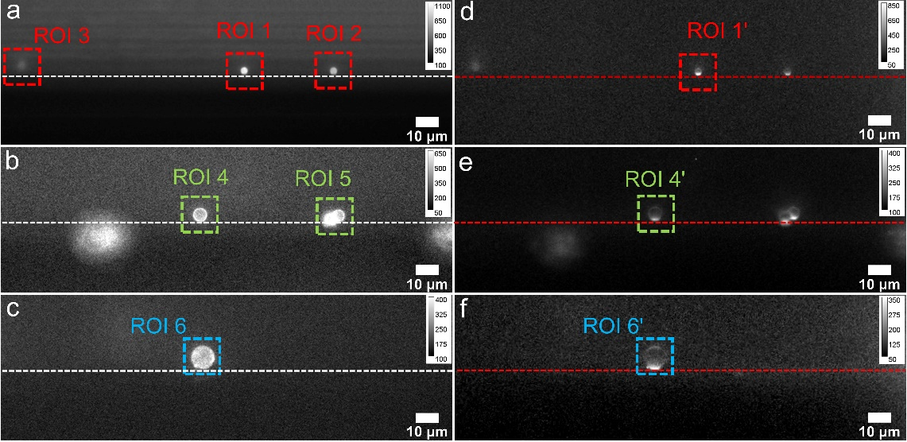
Figure S11. Experimental RF images (a-c) and ECL images (d-f) of 2.8 (a, d), 5 (b, e) and 10 µm (c, f) Ru1-Mag@MB modified on S-GCE in 0.1 M PBS (pH 6.9) containing 180 mM TPrA via sidelong imaging.

Figure S12. Representative plots of the experimental ECL intensity across one indicated Ru1-Mag@MB with the arc line in images Figure 2 a2–c2.

Figure S13. In the sidelong configuration (a) and the top-view configuration (b), ratios of three Ru1-Mag@MBs in terms of Ru1 coverage (ᴦ_{Ru1}, mol/cm²), FL intensity per unit area (I_{S-FL}/cm²) and ECL intensity per unit area (I_{S-ECL}/cm²), in which they are normalized with that of 2.8 μm Ru1-Mag@MB.

2.3 Finite element simulation and monitoring optical parameters of microbeads via sidelong ECL imaging
Table S3. Reactions involving ECL process of Ru1-TPrA in this work according to reference¹.
Reactions | Rate constant | Equation No.
TPrAH⁺ ⇋ TPrA + H⁺ | k1/k_1 | eq.1
TPrA – e⁻ → TPrA^{•+} | ks2 | eq.2
TPrA^{•+}⇋ TPrA• + H⁺ | k_{f}/k_{b} | eq.3
TPrA• → e⁻ + P1 | ks4 | eq.4
Ru1²⁺ + TPrA•→Ru1⁺ + P1 | k5 | eq.5
Ru1⁺ + TPrA^{•+}→Ru1^{2+*} + TPrA | k6 | eq.6
Ru1^{2+*} →Ru1²⁺ + hv | k_{ECL} | eq.7
where P1 is the iminium product

Figure S14. Geometry modeling (a) and enlarger geometry modeling (b) of 2.8 μm Ru1-Mag@MB in COMSL software. Red number is different domain. Domain 1 (the semicircle) is the prepared Ru1-Mag@MB and domain 2 (the rectangle) is the reaction electrolyte. The semicircle represented the Ru1-Mag@MB, whose surface was covered by Ru1 molecules. Black number is boundary, in which boundary 2 is the electrode surface; Boundaries 1, 3 and 4 are the axis of symmetry; boundaries 7 and 8 are the surface of Ru1-Mag@MB; boundary 5 represents the optical window.

Table S4. Simulation parameters used in this work
Name | Expression | Value | Description
^{[a]}L | 100 [μm] | 1E-4 m | Length of geometric model
^{[a]}H | 30 [μm] | 3E-5 m | Height of geometric model
^{[a]}cTPrA0 | 0.2 [mmol/L] | 0.2 mol/m³ | Initial concentration of TPrA
^{[a]}cTPrAH0 | 179.8 [mmol/L] | 179.8 mol/m³ | Initial concentration of TPrA⁺
^{[a]}c0_Ru1²⁺ | 1.4E-10 [mol/cm^2] | 1.4E-6 mol/m² | The coverage rate of Ru1²⁺
^{[a]}cH | 10^ - 6.9 [mol/L] | 1.2589E-4 mol/m³ | Initial concentration of H⁺
^{[b]}D_{TPrA} | 5E-6 [cm^2/s] | 5E-10 m²/s | Diffusion coefficient of TPrA, TPrA^{•+} and TPrA•
^{[b]}D_{Ru} | 5E-6 [cm^2/s] | 5E-10 m²/s | Diffusion coefficient of Ru1 and its derivatives
^{[c]}k₁ | 4E6 [1/s] | 4E6 1/s | Forward rate constant for TPrA generation
^{[c]}k_{_1} | 1E17 [L/mol/s] | 1E14 m³/(s·mol) | Backward rate constant for TPrA generation
^{[b]}k_{s2} | 10 [cm/s] | 0.1 m/s | Standard rate constant for TPrA^{•+} generation on electrode surface
^{[b]}k_{f} | 3500 [1/s] | 3500 1/s | Forward rate constant for TPrA• generation
^{[c]}k_{b} | 1E6 [L/mol/s] | 1E3 m³/(s·mol) | Backward rate constant for TPrA• generation
^{[b]}k_{s4} | 10 [cm/s] | 0.1 m/s | Standard rate constant for P1 generation on electrode surface
^{[b]}k₅ | 3E5 [L/mol/s] | 300 m³/(s·mol) | Rate constant for Ru⁺ generation on microbead surface
^{[b]}k₆ | 3E5 [L/mol/s] | 300 m³/(s·mol) | Rate constant for Ru1^{2+*} generation on microbead surface
^{[d]}k_{ECL} | 1E8 [1/s] | 1E8 1/s | Rate constant for ECL generation on microbead surface
^{[e]}S_{igma} | 0.2 [1/μm] | 2E5 1/m | Scattering coefficient on the microbead
^{[e]}k_{appa} | 0.2 [1/μm] | 2E5 1/m | Absorption coefficient on the microbead
^{[a]}d_bead | 2.8, 5, 10 [µm] | 2.8E-6 m  5E-6 m  1E-5 m | The diameter of three Ru1-Mag@MB
^{[a]}r_bead | d_bead/2 | 1.4E-6 m  2.5E-6 m  5E-6 m | The radius of three Ru1-Mag@MB
[a], by experimental data; [b], from Milica Sentic’s work;^{[19]} [c], by Kenta Imai’s work;^{[2]} [d], by Enrico Daviddi’s work.^{[3]} [e] by our previous work.^{[22]}
Table S5. The reaction rates of TPrA, TPrA^{•+}, TPrA• and P1 for simulation parameters on the electrode surface (boundary 2)
Variables | Expression | Unit | Description
R_TPrA•_e | -k_{s4}*cTPrA• | mol/(m²·s) | The generating rate of TPrA• on the electrode surface
R_P1_e | k_{s4}*cTPrA• | mol/(m²·s) | The generating rate of P1 on the electrode surface
R_TPrA^{•+}_e | k_{s2}*cTPrA | mol/(m²·s) | The generating rate of TPrA^{•+} on the electrode surface
R_TPrA_e | -k_{s2}*cTPrA | mol/(m²·s) | The generating rate of TPrA on the electrode surface

Table S6. The reaction rates of TPrAH⁺, TPrA, TPrA^{•+} and TPrA• for simulation parameters in the electrolyte (domain 2)
Variables | Expression | Unit | Description
R_cTPrA^{•+} | - k_{f} *cTPrA^{•+} + k_{b} *cTPrA•*cH | mol/(m³·s) | The generating rate of TPrA^{•+} in the electrolyte
R_cTPrA• | k_{f} *cTPrA^{•+} – k_{b} *cTPrA•*cH | mol/(m³·s) | The generating rate of TPrA• in the electrolyte
R_TPrA | k₁*cTPrAH⁺ – k_{_1}*cTPrA*cH | mol/(m³·s) | The generating rate of TPrA in the electrolyte
R_TPrAH⁺ | -k₁*cTPrAH⁺ + k_{_1}*cTPrA*cH | mol/(m³·s) | The generating rate of TPrAH in the electrolyte

Table S7. The reaction rates of Ru1²⁺, Ru1⁺, Ru1^{2+*}, ECL_hv, TPrA, TPrA^{•+}, TPrA• and P1 via electrode-electrolyte interface coupling in the microbead surface (boundary 7, 8)
Variables | Expression | Unit | Description
R_P1_b | k₅*(cRu1²⁺)*cTPrA• | mol/(m²·s) | The generating rate of Ru²⁺ on the microbead surface
R_ TPrA•_b | - k₅*(cRu1²⁺)*cTPrA• | mol/(m²·s) | The generating rate of TPrA• on the microbead surface
R_ TPrA^{•+}_b | - k₆*(cRu1⁺)*cTPrA^{•+} | mol/(m²·s) | The generating rate of TPrA^{•+} on the microbead surface
R_TPrA_b | k₆*(cRu1⁺)*cTPrA^{•+} | mol/(m²·s) | The generating rate of TPrA on the microbead surface
R_Ru1^{2+*}_b | k₆*(cRu1⁺)*cTPrA^{•+} – k_{ECL}*(cRu1^{2+*}) | mol/(m²·s) | The generating rate of Ru^{2+*} on the microbead surface
R_Ru1⁺_b | k₅*(cRu1²⁺)*cTPrA• – k6*(cRu1⁺) * cTPrA^{•+} | mol/(m²·s) | The generating rate of Ru⁺ on the microbead surface
R-Ru1²⁺_b | - k₅*(cRu1²⁺)*cTPrA• + k_{ECL}*(cRu1^{2+*}) | mol/(m²·s) | The generating rate of Ru²⁺ on the microbead surface
R_ECL_hv | k_{ECL}*(cRu1^{2+*}) | mol/(m²·s) | The generating rate of light on the microbead surface

Figure S15. Simulated 3D surface concentration distribution of Ru1^{2+*} for 2.8 (a), 5 (b) and 10 μm (c) Ru1-Mag@MB. Normalized plots of the experimental (black line) and simulated (red line) concentration distribution of Ru1^{2+*} across one indicated 2.8 (d), 5 (e), and 10 μm (f) Ru1-Mag@MB with the arc line in images Figure 2 a2–c2 and Figure S15 a–c.

Figure S16 Experimental RF images (a0–b0), pseudo-color FL images (a1–b1) and ECL images (a2–b2) of Ru1-Mag@MB modified on S-GCE in 0.1 M PBS (pH 6.9) containing 180 mM TPrA via sidelong imaging. (a3-b3) Normalized plots of the experimental (black line) and simulated (red line) I_{ECL} across one indicated Ru1-Mag@MB edge with the arc line in images a2–b2. 2 μm (a) and 3.5 μm (b) Ru1-Mag@MB. Scale bar: 5 μm.

Table S8. Estimated S_{igma} and k_{appa} from different Ru1-Mag@MB.
Ru1-Mag@MB | k_{f} (s⁻¹) | S_{igma} (μm⁻¹) | k_{appa} (μm⁻¹) | k₅, k₆ (M⁻¹s⁻¹) | Z_{Max}(μm)
2.8 μm ^{[a]} | 3500 | 0.2 | 0.2 | 3×10⁵ | 1.8
2 μm ^{[b]} | 3500 | 0.15 | 0.1 | 3×10⁵ | 2.0 ^{[c]}
3.5 μm ^{[b]} | 3500 | 0.15 | 0.1 | 3×10⁵ | 2.4
5 μm ^{[b]} | 3500 | 0.15 | 0.1 | 3×10⁵ | 2.1
10 μm ^{[b]} | 3500 | 0.15 | 0.1 | 3×10⁵ | 2.0
[a], from Thermo Scientific (USA). [b] from Tianjin BaseLine ChromTech Research Centre (China). [c], The ECL intensity did not decrease to 30% of the maximum ECL intensity across the microbead diameter.

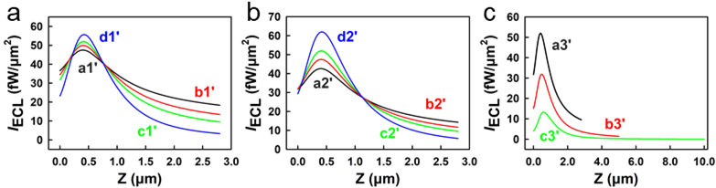
Figure S17. Dependence of I_{ECL} distributions on absorption coefficient (k_{appa}, a) and scattering coefficient (S_{igma}, b) of 2.8 μm Ru1-Mag@MB. Dependence of I_{ECL} distributions on 2.8, 5 and 10 μm (c) Ru1-Mag@MB at same k_{appa} and S_{igma}. The S_{igma} and k_{appa} parameters of each line are detailed in Table S9.

Table S9. Different S_{igma} and k_{appa} corresponding to the maximum distance of ECL emission and ECL intensity of Ru1-Mag@MB.
Ru1-Mag@MB | Line  (Figure S16) | S_{igma}  (μm⁻¹) | k_{appa}  (μm⁻¹) | Z_{Max}  (μm) | I_{S}-_{ECL}  (fW) | I_{S-ECL/}μm²  (fW/μm²)
2.8 μm | a1' | 0.2 | 0.01 | ^{[a]}2.8 | 778.6 | 31.61
2.8 μm | b1' | 0.2 | 0.1 | 2.5 | 720.4 | 29.25
2.8 μm | c1' | 0.2 | 0.2 | 1.8 | 662.5 | 26.90
2.8 μm | d1' | 0.2 | 0.5 | 1.3 | 528.3 | 21.45
2.8 μm | a2' | 0.01 | 0.2 | ^{[a]}2.8 | 667.5 | 27.10
2.8 μm | b2' | 0.1 | 0.2 | 2.2 | 665.8 | 27.03
2.8 μm | c2' | 0.2 | 0.2 | 1.8 | 662.5 | 26.90
2.8 μm | d2' | 0.5 | 0.2 | 1.4 | 645.3 | 26.20
2.8 μm | a3' | 0.2 | 0.2 | 1.8 | 662.5 | 26.90
5 μm | b3' | 0.2 | 0.2 | 1.8 | 834.9 | 10.63
10 μm | c3' | 0.2 | 0.2 | 1.7 | 857.7 | 2.73
[a], The ECL intensity did not decrease to 30% of the maximum ECL intensity across the microbead diameter.

2.4 Monitoring radical lifetime of coreactant
Figure S18. Representative plots of the ECL intensity across single 2.8 µm Ru1-Mag@MB with the arc line in images Figure 3 a0–d0.

Figure S19 Experimental RF images (a0–b0), pseudo-color FL images (a1–b1) and ECL images (a2–b2) of Ru1-Mag@MB modified on S-GCE in 0.1 M PBS (pH 6.9) containing 180 mM BIS-TRIS via sidelong imaging. (a3-b3) Normalized plots of the experimental (black line) and simulated (red line) I_{ECL} across one indicated Ru1-Mag@MB edge with the arc line in images a2–b2. 5 μm (a) and 10 μm (b) Ru1-Mag@MB. Scale bar: 5 μm.

Table S10. Simulated parameters used in the estimation of cationic radical lifetime.
Ru1-Mag@MB | Tertiary amine | k_{f} (s⁻¹) | τ_{1/2}(μs) | S_{igma} (μm⁻¹) | k_{appa} (μm⁻¹) | k₅, k₆ (M⁻¹s⁻¹)
2.8 μm ^{[a]} | TPrA | 3500 | 200 | 0.2 | 0.2 | 3×10⁵
2.8 μm ^{[a]} | BIS-TRIS | 2000 | 347 | 0.2 | 0.2 | 3×10⁵
2.8 μm ^{[a]} | TEOA | 6000 | 116 | 0.2 | 0.2 | 3×10⁵
2.8 μm ^{[a]} | DBAE | 25000 | 28 | 0.2 | 0.2 | 3×10⁵
2.8 μm ^{[a]} | BIDE | 35000 | 20 | 0.2 | 0.2 | 3×10⁵
5 μm ^{[b]} | TPrA | 3500 | 200 | 0.15 | 0.1 | 3×10⁵
5 μm ^{[b]} | BIS-TRIS | 2000 | 347 | 0.15 | 0.1 | 3×10⁵
10 μm ^{[b]} | TPrA | 3500 | 200 | 0.15 | 0.1 | 3×10⁵
10 μm ^{[b]} | BIS-TRIS | 2000 | 347 | 0.15 | 0.1 | 3×10⁵
[a], from Thermo Scientific (USA). [b] from Tianjin BaseLine ChromTech Research Centre (China).

Table S11. Results of cationic radical lifetime of different tertiary amine in different ECL systems.
ECL system | Electrolyte solution | Lifetime (^{[a]}R^{•+}; τ_{1/2}, μs) |  |  |  |  | Ref
ECL system | Electrolyte solution | TPrA | BIS-TRIS | TEOA | DBAE | BIDE | Ref
Ru(bpy)₃²⁺-TPrA | 0.10 M Tris/0.10 M LiClO₄ | 200 | - | - | - | - | [1]
Ru(bpy)₃²⁺-PS beads-TPrA | PBS | 240 | - | - | - | - | [19]
Ru@beads-TPrA | 0.2 M PB | d > 1 μm: 700  d < 1 μm: 5 | - | - | - | - | [21]
Ru(bpy)₃²⁺-^{[a]}R | 0.2 M PB | ^{[b]}200 | 328 | 5 | 58 | 18 | [13]
Ru1-Mag@MB-^{[a]}R | 0.1 M PBS | ^{[b]}200 | 347 | 116 | 28 | 20 | This work
[a], R = TPrA; BIS-TRIS; TEOA; DBAE; BIDE. [b], as a standard reference value

2.5 Effect of Electrolytes on the ECL Behavior of Ru1-Mag@MB

Figure S20. Representative plots of the experimental (black line) and simulated (red line) normalized ECL intensity (I_{ECL}) across one single 2.8 μm Ru1-Mag@MB in different solution. Experimental conditions, (a) Buffer of Roche Diagnostic, (b) Buffer of Accucise Diagnostic, (c) Buffer of Lifotronic Diagnostic.

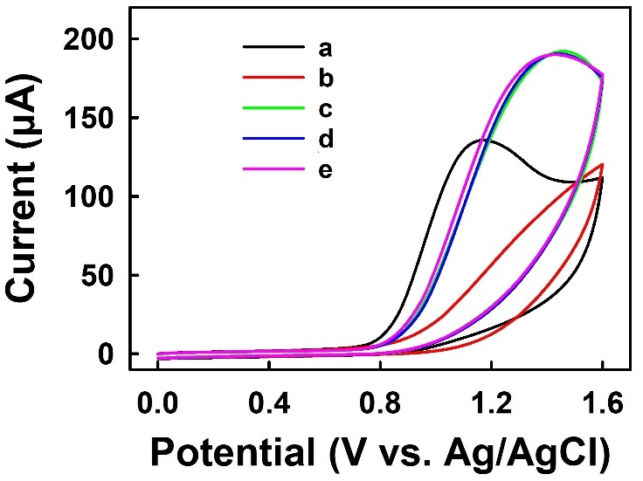
Figure S21. Cyclic voltammograms (CV) of TPrA at GCE in different solutions. (d = 2 mm). Experimental conditions, (a) 0.1 M PBS (pH 6.9) containing 180 mM TPrA, (b) 0.1 M PBS (pH 6.9) containing 180 mM TPrA and 0.1% Tween 20, (c) Buffer of Roche Diagnostic, (d) Buffer of Accucise Diagnostic, (e) Buffer of Lifotronic Diagnostic. Scan rate: 0.1 V/s.

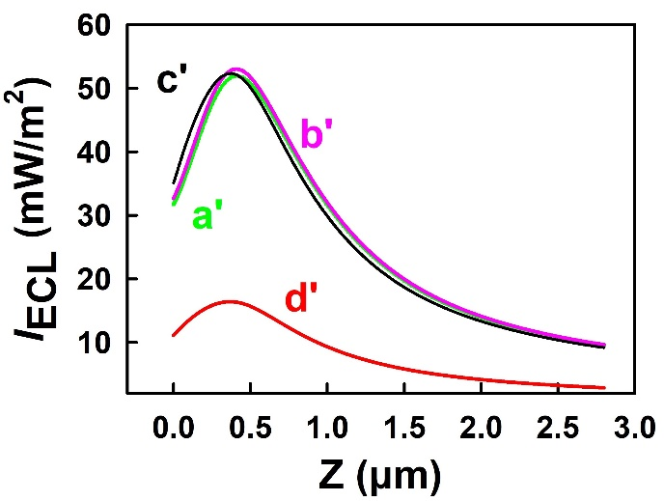
Figure S22. Dependence of I_{ECL} distributions on standard rate constant of eq. R2 (k_{s2}, a'-d': 10, 1, 0.01, 0.001 cm/s) on 2.8 μm Ru1-Mag@MB surface.

Table S12. Estimated cationic radical lifetime and reaction rate constant from different buffer.
Ru1-Mag@MB | Buffer | k_{f} (s⁻¹) | τ_{1/2}(μs) | S_{igma}  (μm⁻¹) | k_{appa}  (μm⁻¹) | k₅, k₆ (M⁻¹s⁻¹)
2.8 μm | 0.1 M PBS | 3500 | 200 | 0.2 | 0.2 | 3×10⁵
2.8 μm | 1% Tween |  |  |  |  | 4.2×10⁵
2.8 μm | Roche |  |  |  |  | 6×10⁶
2.8 μm | Accucise |  |  |  |  | 3×10⁶
2.8 μm | Lifotronic |  |  |  |  | 4.5×10⁶
2.8 μm | MeCN | 9000 | 77 | 0.2 | 0.2 | 9.2×10⁴

Reference
[1] X. Yang, Y. Wei, Y. Du, H. Qi, Q. Gao, C. Zhang, Anal. Chem. 2020, 92, 15837-15844.
[2] K. Imai, G. Valenti, E. Villani, S. Rapino, E. Rampazzo, M. Marcaccio, L. Prodi, F. Paolucci, J. Phys. Chem. C 2015, 119, 26111-26118.
[3] E. Daviddi, A. Oleinick, I. Svir, G. Valenti, F. Paolucci, C. Amatore, ChemElectroChem 2017, 4, 1719-1730.

