- Supplementary Materials

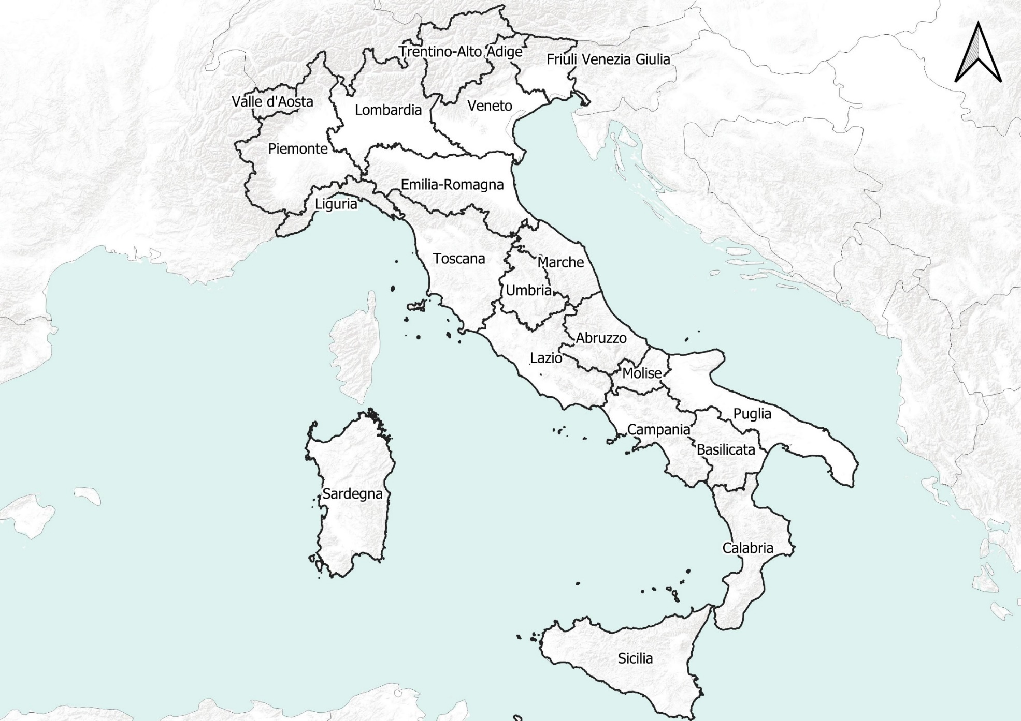
Figure S1. Italian Administrative Region (NUT2 level). The names of the Regions are the same as reported in the main text and in Figures S2, S3, S9, and S10.
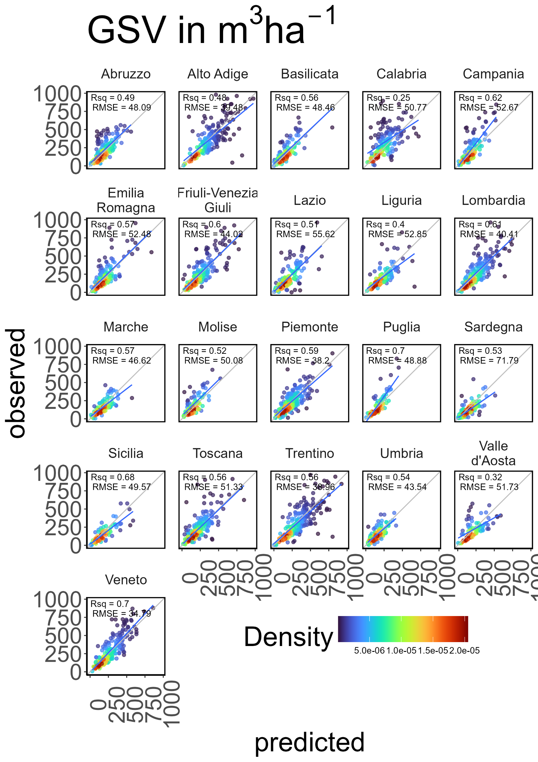
Figure S2. Validation at the plot-level of the 3D-CMCC-FEM simulation against the field-measured values of the third Italian NFI grouped by Administrative Region (NUT2). GSV is the growing stock volume. The gray line is the y=x line, and the blue one is the regression line between predicted and observed values. Colour represents point density.
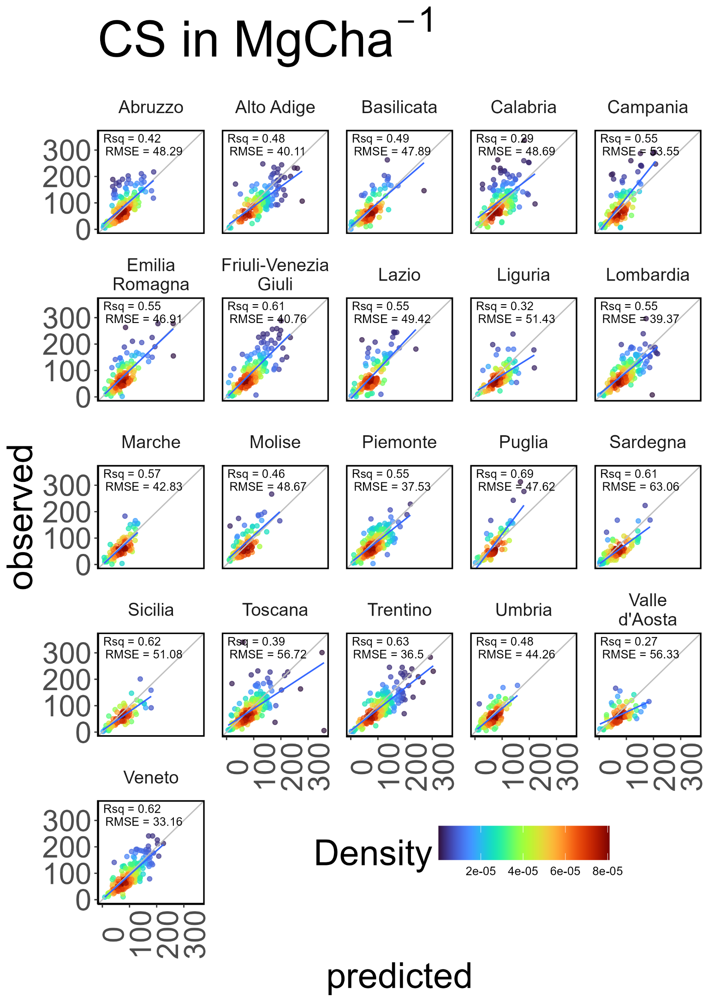
Figure S3. Validation at the plot-level of the 3D-CMCC-FEM simulation against the field-measured values o
Figure S3. Validation at the plot-level of the 3D-CMCC-FEM simulation against the field-measured values of the third Italian NFI grouped by Administrative Region (NUT2). CS is the carbon stock. The gray line is the y=x line, and the blue one is the regression line between predicted and observed values. Colour represents point density.

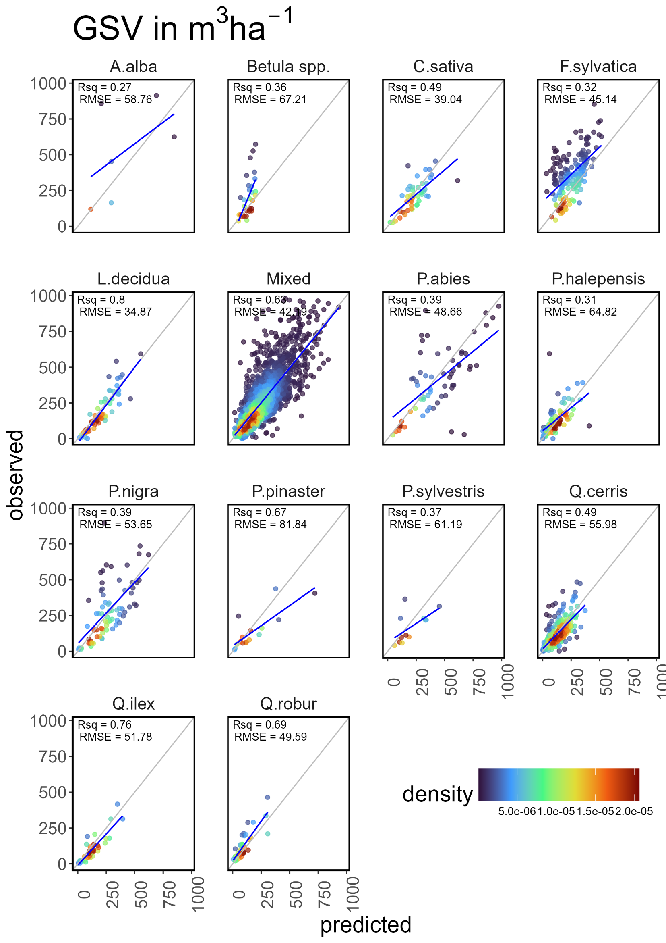
the third Italian NFI grouped by Administrative Region (NUT2). CS is carbon stock. The gray line is the y=x
Figure S4. Validation at the plot-level of the 3D-CMCC-FEM simulation against the field-measured values of the third Italian NFI grouped by species. GSV is the growing stock volume. The gray line represents the y=x line, and the blue line represents the regression line between the predicted and observed values. Colour represents point density.
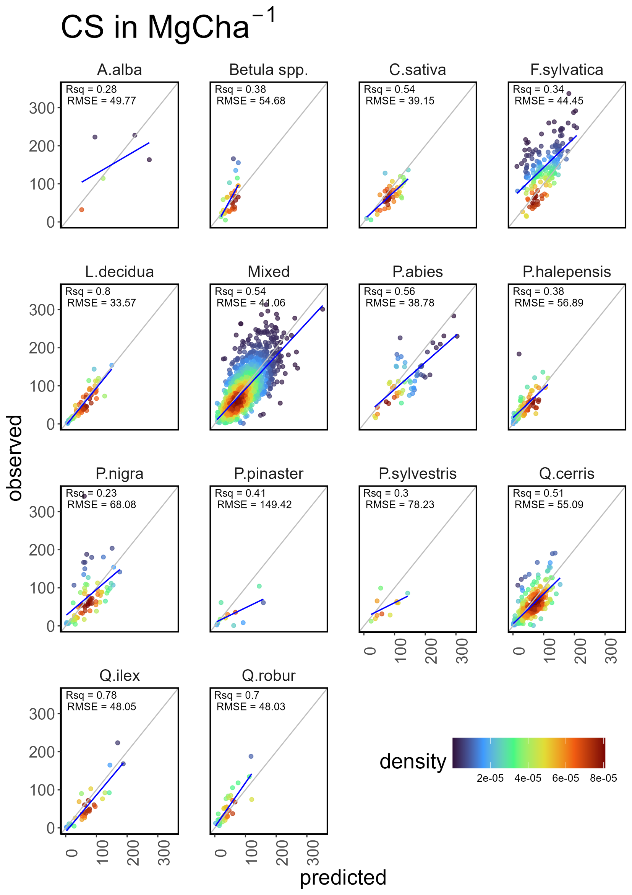
Figure S5. Validation at the plot-level of the 3D-CMCC-FEM simulation against the field-measured values of the third Italian NFI grouped by species. CS is the carbon stock. The gray line represents the y=x line, and the blue line represents the regression line between the predicted and observed values. Colour represents point density.

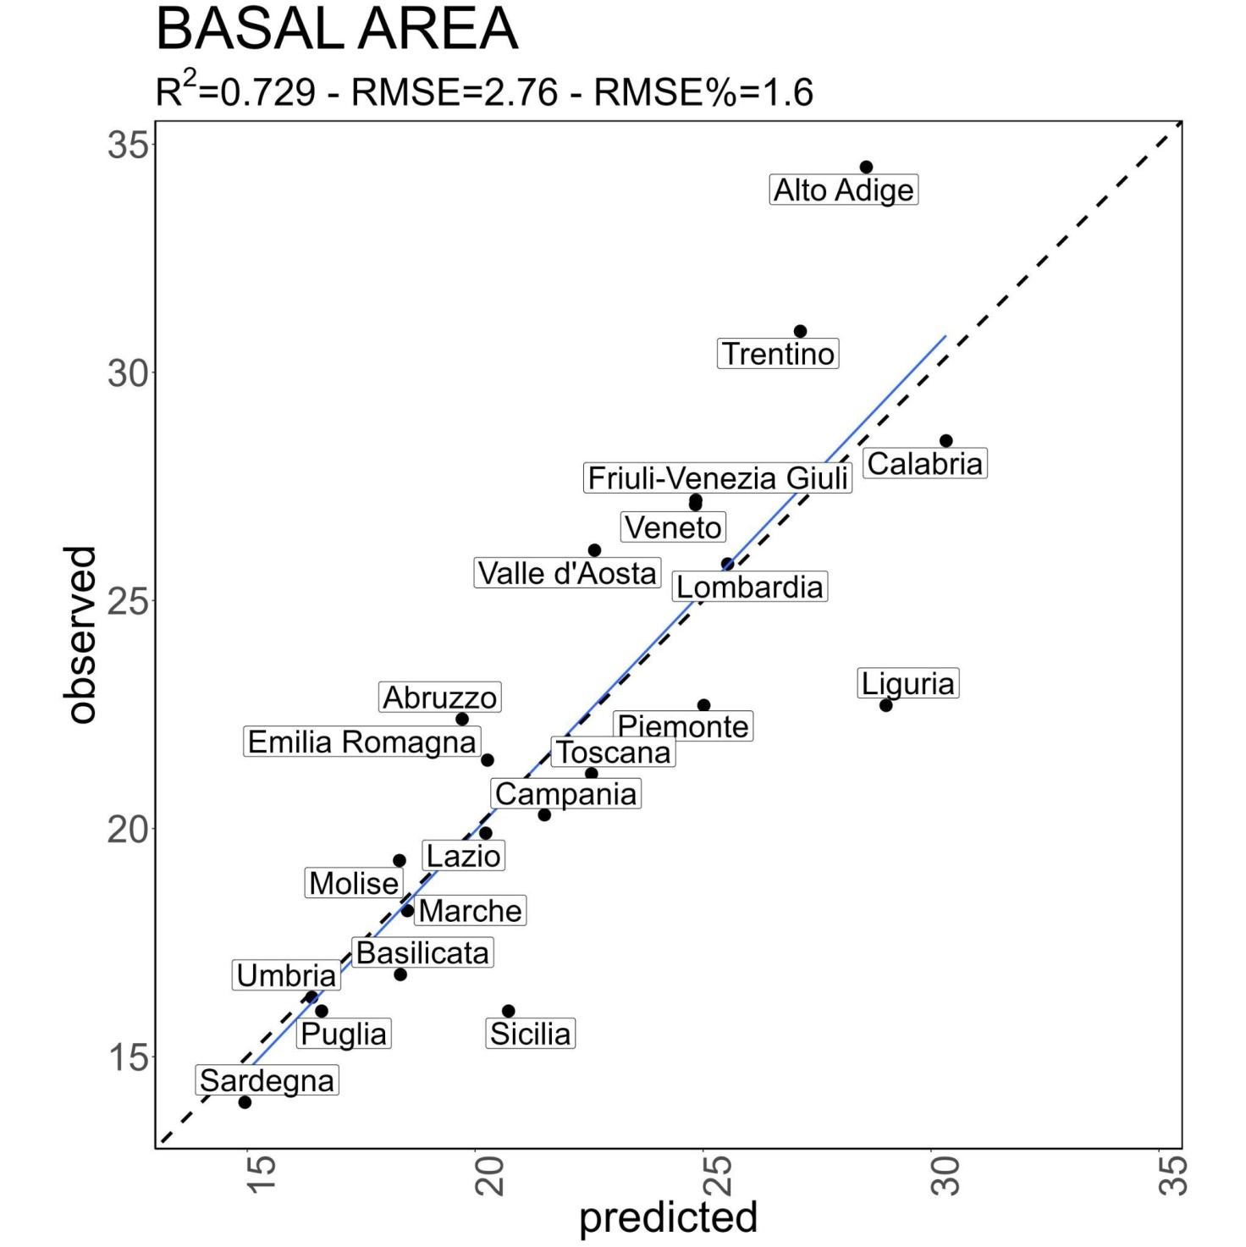
Figure S6. NUT2 INFC 2015 basal area (m² ha⁻¹) against the modeled one. The dotted line is the y = x line, and the blue is the regression line.
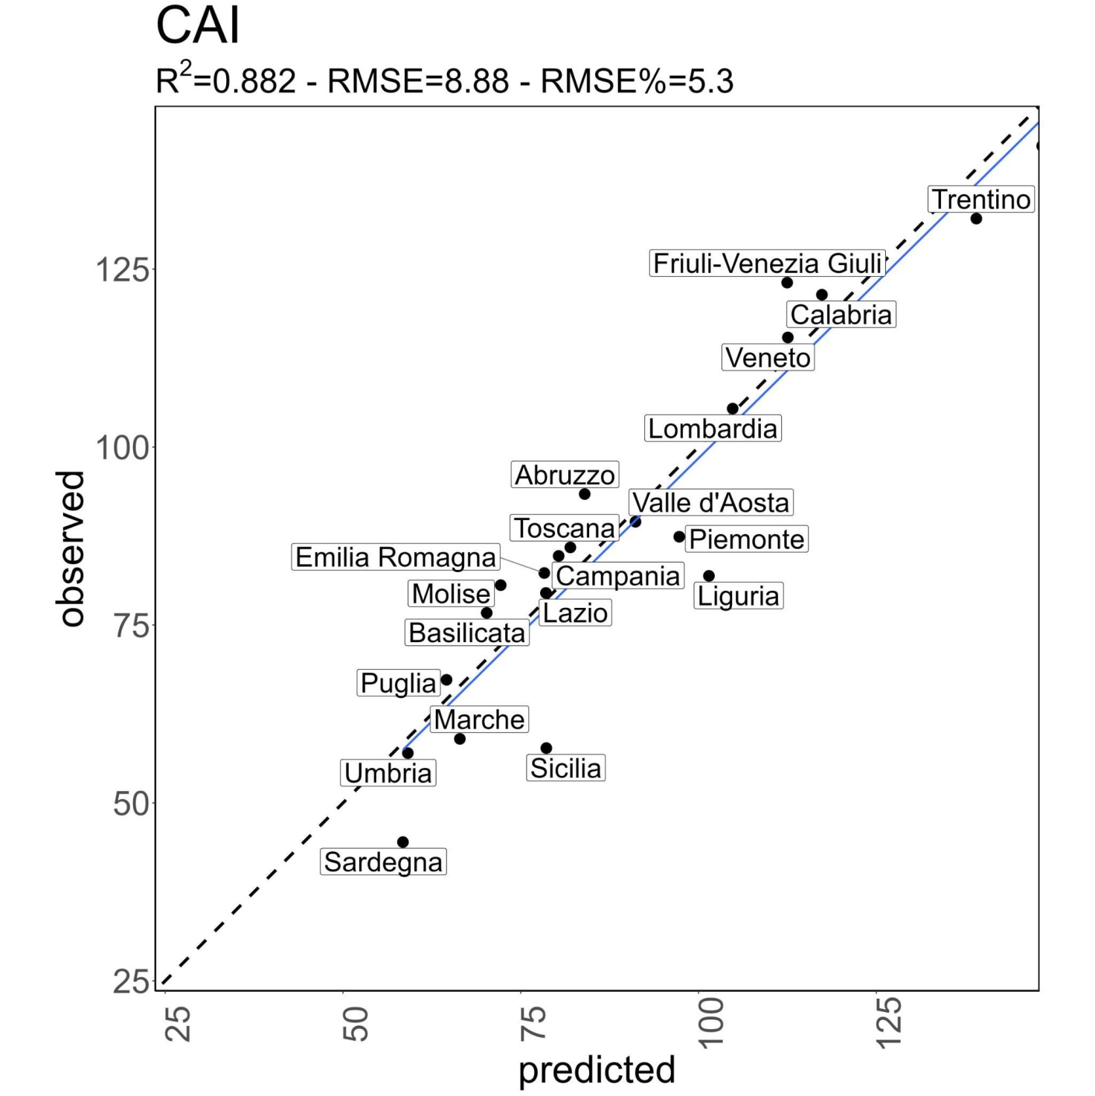
Figure S7.. NUT2 INFC 2015 current annual increment (m³ ha⁻¹y⁻¹) against the modeled one. The dotted line is the y = x line, and the blue is the regression line.
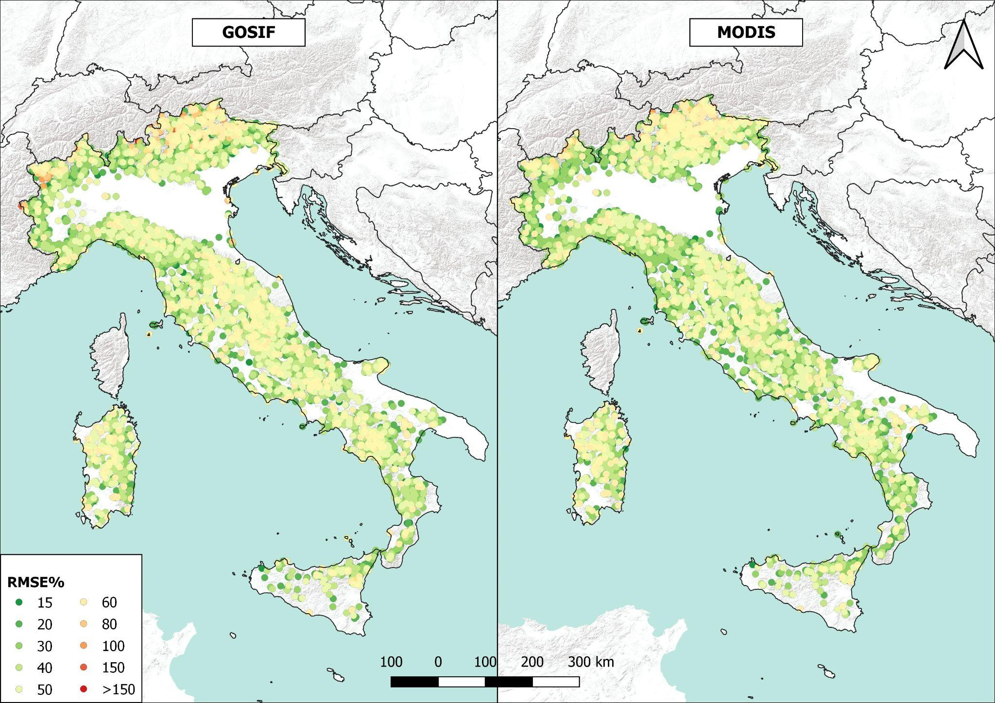
Figure S8. RMSE% values against GOSIF (on the right) and MODIS (on the left) datasets. For this figure RMSE% was computed over the years of simulation (2005-2020).

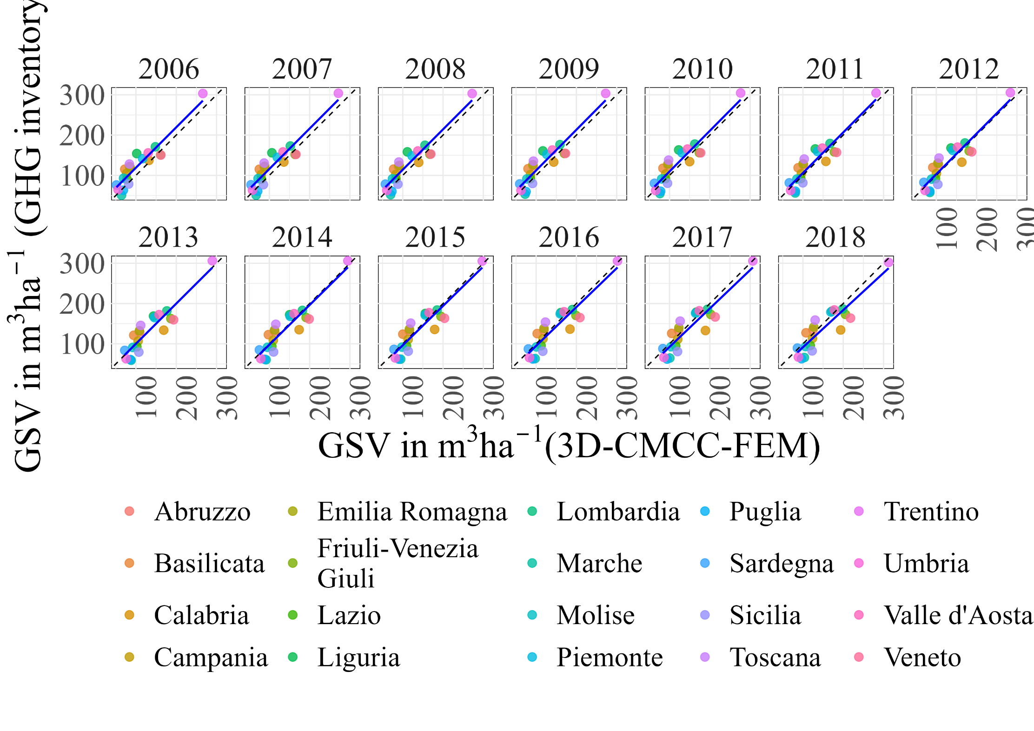
Figure S9. Comparison of mean GSV at the regional level against the Italian GHGI LULUCF sector, forest land, and remaining forest land category.

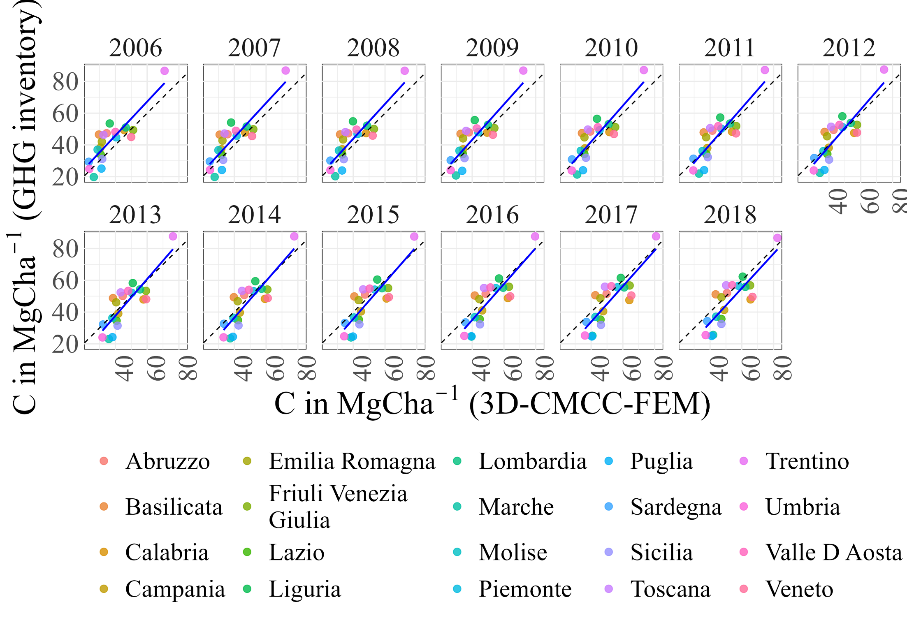
Figure S10. Comparison of mean CS at the regional level against the Italian GHGI LULUCF sector, forest land, and remaining forest land category.

