A direct, real-time, size-resolved analytical strategy to follow drug loading and release from biocompatible gold nanoparticles
Valentina Marassi^{1,2,3§}, Junjie Wang^{1§}, Stefano Giordani^{1,2,3}, Anna Placci^{1,2,3}, Barbara Roda^{1,2,3}, Pierluigi Reschiglian^{1,2,3}, Andrea Zattoni^{1,2,3}*

¹Department of Chemistry G. Ciamician, University of Bologna, 40126 Bologna, Italy
²byFlow srl, 40129 Bologna, Italy
³INBB – Biostructures and Biosystems National Institute, 00136 Rome, Italy
§Contributed equally
*Author to whom correspondence should be addressed.
Email: andrea.zattoni@unibo.it

Table S1
AF2000 operating conditions
FFF channel dimension | 30 cm long, 350 µm thick
Membrane | 10 kDa RC
Carrier liquid | Phosphate buffer 10 mM PH 7.4
Detector flow (mL/min) | 0.5
Cross flow (mL/min) | 3.0 (0-10 min)  3.0-0.4 (10-20 min, exp. 0.25)  0.4-0.0 (20-35 min, linear)  0.0 (35-40 min)
Injection flow (mL/min) | 0.2
Injection time (min) | 3.0

The main structural forms of curcumin and its degradation products (drawn using Chemdraw 19.0).[1]
Figure S1. Pictures of the Au-BSA-CUR mixture samples after centrifugation under different synthesis conditions, pH 6 (left) and pH 7.4 (right)

Figure S2. The workflow for preparing samples in different ways and the UV-Vis spectra of Au-BSA-CUR-cen and Au-BSA-cen-CUR-cen and their respective supernatants. (cen: centrifuge)

Figure S3. DLS data of samples purified with different instruments (centrifuge and AF4).

Figure S4. The UV spectra of freshly prepared pure curcumin samples and samples after 24 hours under light-proof and exposure conditions.

Figure S5. The absorbance intensity (270 nm) of samples extracted from the reservoir (10 mM PB, pH 7.4) at different time points and different temperatures.
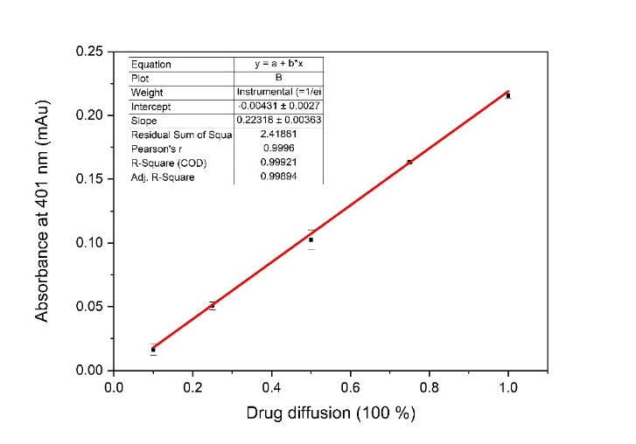
Figure S6. The standard curve was established by dispersing different concentrations of standard curcumin samples into a reservoir containing 50 ml fresh PB buffer (10 mM, pH 7.4) and recording the corresponding absorbance intensity at 401 nm. The maximum drug dispersion of 0.1 mg was defined as 100% release.

Reference
[1] Shen L., Ji H.-F., The pharmacology of curcumin: is it the degradation products?, Trends in Molecular Medicine, 18 (2012) 138-144. https://doi.org/https://doi.org/10.1016/j.molmed.2012.01.004

