Table S1: Participants numbers and body weight change across the study groups.
 | Whole Cohort | Hypertension | Systolic BP >130 | Systolic BP >140 | Resistant Hypertension
n= | 3136 | 2050 | 996 | 397 | 111
Semaglutide | 2109 | 1376 | 656 | 257 | 78
Placebo | 1027 | 674 | 340 | 140 | 33
% of STEP 1,3,4 Cohort | 100% | 65% | 32% | 13% | 4%
Body Weight Change
Semaglutide | -13.9% | -13.6% | -13.7% | -14.2% | -12.8%
Placebo | -1.1% | 1.3% | -1.8% | -2.5% | -1.7%

Table S2: Comparison of demographics and parameters for primary analysis and the sensitivity analysis cohorts.
 | STEP 1, 3, 4 | STEP 1, 3
n= | 3136 | 2365
Age | 47 | 47
Female | 76% | 76%
SBP | 124.8 | 126.1
SBP >130mmHg | 32% | 35%
SBP>140mmHg | 13% | 15%
Resistant | 4% | 4%
On Anti-hypertensives | 32% | 32%
Body Weight Change
Semaglutide | -13.9% | -15.8%
Placebo | -1.1% | -3.5%

Table S3: Study outcomes for groups stratified by body mass index (BMI) including patients from STEP 1 and 3 (STEP 4 omitted due to the active run-in period).
 | Semaglutide | Placebo
Class I (BMI 30-35 kg/m2) | 527 | 246
SBP Change | -6.16 | -1.36
SD SBP Change | 13.03 | 12.49
DBP Change | -2.94 | 0.49
SD DBP Change | 9.14 | 8.64
BW Change | -16.6% | -3.3%
BMI Change | -5.40 | -1.09
Stopped/Decreased | 7.0% | 4.1%
Started/Increased | 3.0% | 5.3%
Class II (BMI 35-40 kg/m2) | 505 | 253
SBP Change | -6.81 | -0.26
SD SBP Change | 14.41 | 12.76
DBP Change | -3.08 | -0.30
SD DBP Change | 9.27 | 9.21
BW Change | -16.2% | -3.9%
BMI Change | -6.04 | -1.44
Stopped/Decreased | 6.5% | 2.8%
Started/Increased | 4.4% | 4.3%
Class III (BMI >40 kg/m2) | 458 | 228
SBP Change | -6.34 | -3.08
SD SBP Change | 13.90 | 14.52
DBP Change | -3.44 | -2.12
SD DBP Change | 9.70 | 9.95
BW Change | -14.4% | -3.3%
BMI Change | -6.57 | -1.55
Stopped/Decreased | 6.8% | 2.2%
Started/Increased | 4.6% | 7.5%

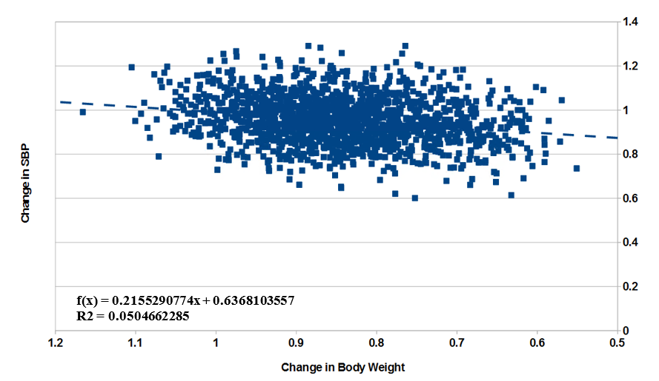
Figure S1: Change in SBP plotted against change in body weight as proportions of the baseline values for participants treated with semaglutide. Pearson correlation co-efficient 0.197 (p<0.001).

Table S4: Anti-hypertensive medications at baseline as a percentage of each group and by treatment allocation.
 | Non Responders | 0% to 10% | 11% to 20% | 20% to 30% | Super Responders
n | 85 | 388 | 600 | 363 | 154
% | 5.3% | 24.4% | 37.7% | 22.8% | 9.7%
Age | 42.6 | 46.9 | 47.0 | 47.2 | 43.7
SBP Change | 0.6 +/- 11.4 | -3.99 +/- 13.58 | -6.67 +/- 13.6 | -7.88 +/- 13.9 | -12.55 +/- 13.75
DBP Change | 1.21 +/- 7.8 | -1.1 +/- 9.0 | -3.42 +/- 9.4 | -4.39 +/- 9.6 | -6.62 +/- 9.55

Table S5: Anti-hypertensive medications at baseline as a percentage of each group and by treatment allocation. CCB = calcium channel blocker, ACEI = angiotensin-converting enzyme inhibitor, ARB = angiotensin receptor blocker, BB = beta-adrenergic receptor blocker.
 | Cohort |  | HTN |  | HTN130 |  | HTN140 |  | RH
Treatment | Semaglutide | Placebo | Semaglutide | Placebo | Semaglutide | Placebo | Semaglutide | Placebo | Semaglutide | Placebo
CCB | 8.6 | 7.9 | 13.2 | 12.0 | 12.8 | 13.2 | 16.0 | 11.4 | 57.7 | 51.5
ACEI | 10.2 | 8.9 | 15.7 | 13.5 | 14.5 | 12.9 | 15.6 | 17.9 | 25.6 | 24.2
ARB | 12.2 | 11.5 | 18.7 | 17.4 | 19.4 | 19.4 | 19.8 | 20.0 | 65.4 | 57.6
BB | 7.4 | 8.0 | 11.4 | 12.2 | 11.7 | 9.7 | 9.7 | 10.0 | 44.9 | 39.4
Thiazide | 12.2 | 10.0 | 18.7 | 15.1 | 17.5 | 14.6 | 22.8 | 15.0 | 87.2 | 66.7

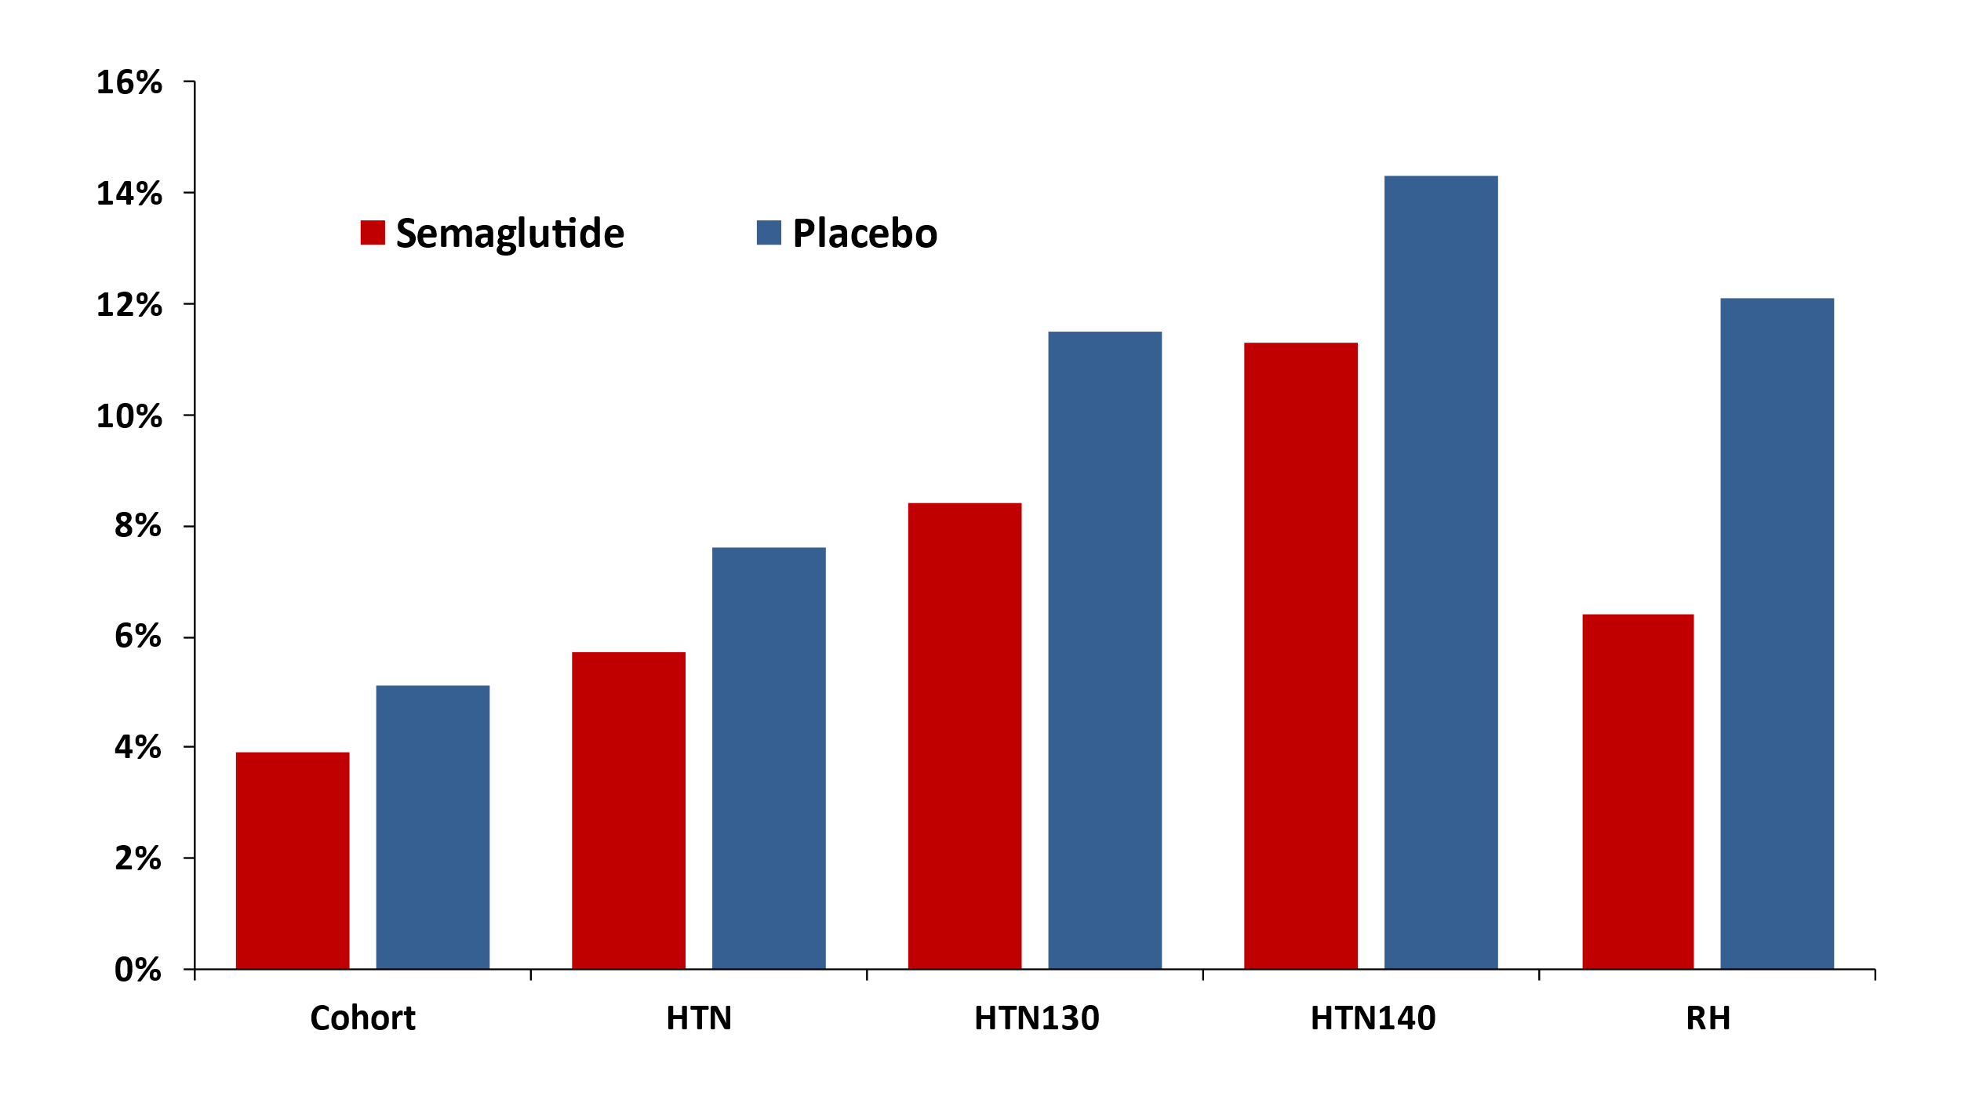
Figure S2: Percentages of patients with anti-hypertensives escalated (yes/no) comparing the semaglutide and placebo treated groups in STEP 1, 3 and 4 trials. HTN = group with a diagnosis of hypertension, BP>130mmHg or on an antihypertensive treatment, HTN130 = group with systolic BP >130mmHg, HTN140 = group with systolic BP >140mmHg, RH = group with resistant hypertension.
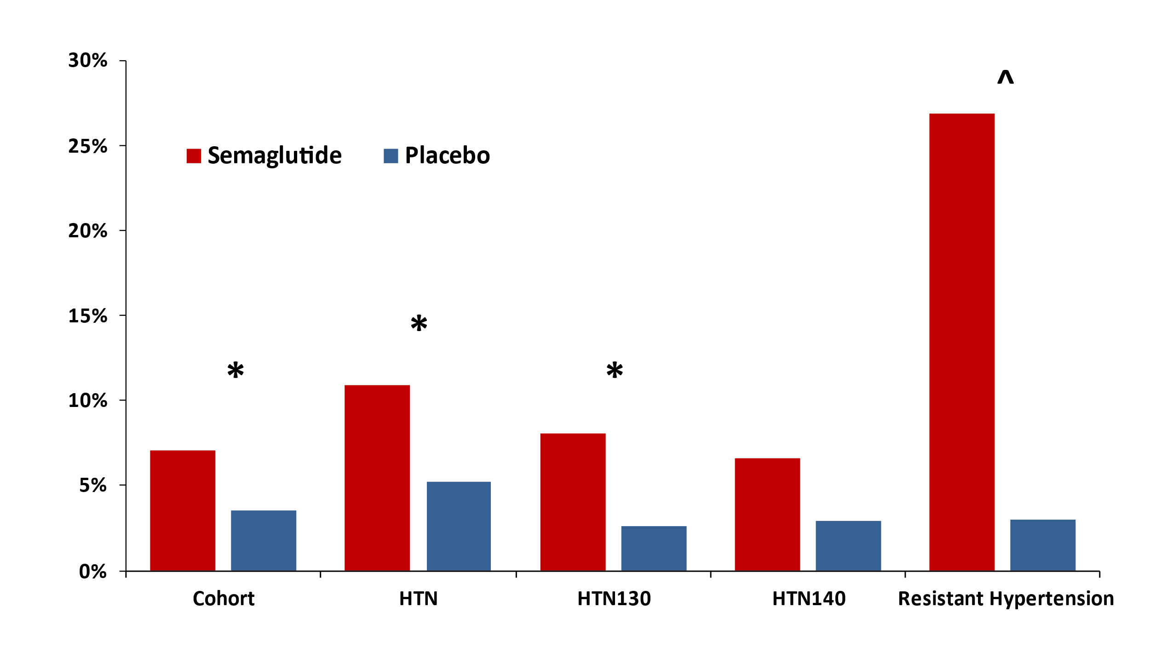
Figure S3: Percentages of patients with anti-hypertensives de-escalated (yes/no) comparing the semaglutide and placebo treated groups in STEP 1, 3 and 4 trials. * p<0.001, ^ p<0.05. HTN = group with a diagnosis of hypertension, BP>130mmHg or on an antihypertensive treatment, HTN130 = group with systolic BP >130mmHg, HTN140 = group with systolic BP >140mmHg, RH = group with resistant hypertension.

