Bridging the Ideological Divide:

Advertising Strategies for Promoting Stigmatized Products

Table of Contents
Appendix A: Literature Review 2
Appendix B: Study 1 4
Appendix C: Study 2 8
Appendix D: Supplemental Study S1 16
Appendix E: Study 3 18
Appendix F: Study 4 20
References 22

Appendix A: Literature Review
Table A1. Selected Literature on Stigma in Consumer Research
Author(s) | Focus | Antecedents | Mechanism | Moderators | Key Findings
Shao & Hill (1994) | General stigmatized products | Product type, country development | \ | \ | Health- and sex-related products face higher social restrictions; developed countries impose fewer social but similar legal restrictions.
Fahy et al. (1995) | General stigmatized products | Age, income, religion, race | \ | \ | Demographics significantly affect the acceptance of ads for sensitive products.
Waller (1999) | General stigmatized products | Product type, gender | \ | \ | Ads for racially extremist groups are perceived as the most offensive; women are more easily offended by ads with nudity, sexism, and racism.
Dahl et al. (2001) | Single stigmatized product (condoms) | Social presence | \ | Familiarity | Social presence increases embarrassment during stigmatized product purchase; familiarity with product purchase reduces embarrassment.
Prendergast & Hwa (2003) | General stigmatized products | Demographics, media type | \ | \ | Women and older adults are more easily offended; web ads are more offensive than other media.
Fam et al. (2004) | General stigmatized products | Religion, religious intensity, cultural values, product type | \ | \ | Higher religious intensity increases perceived offensiveness; Muslim respondents perceive ads for social/political groups as the most offensive.
Jones et al. (2018) | General stigmatized products | Packaging | Embarrassment | Placement, discount | Anonymous packaging reduces embarrassment and increases purchase intention; this effect is stronger when products are placed in an aisle rather than on an endcap; price promotions can mitigate this effect.
Chaney et al. (2019) | Stigmatized identity | \ | \ | \ | Consumers with stigmatized identities attend to stigmatized identity cues to assess devaluation threats and infer a company’s ideology.
Eisend & Hermann (2019) | Stigma-based ad strategy | Homosexual imagery in ads | \ | Congruence | Persuasive impact is similar for homosexual and heterosexual imagery. Incongruence with consumer characteristics, cultural values, or product type leads to negative responses.
Harmeling et al. (2021) | Stigmatized identity | Consumers’ potentially stigmatizing attributes | Anticipated audience intention, anticipated empowerment | Audience cues | Audience cues shape perceived social devaluation; anticipated empowerment encourages beneficial consumption among consumers with stigmatized identities.
Homburg & Ukrainets (2021) | Stigmatized identity | Social stigmatization of the low-income group | Social identity threat | Power distance | Social stigmatization of low-income shoppers has a positive direct and a negative indirect relationship with high-income consumer loyalty; the relationship is stronger among consumers with high power distance.
Ndichu & Rittenburg (2021) | Single stigmatized product (menstrual cups) | \ | \ | \ | Stigma-related risks reduce menstrual cup adoption; stigma-concealing design and peer sharing reduce perceived risk.
Tsai et al. (2021) | Single stigmatized product (HPV vaccination) | Chatbot vs. human agent | \ | Emotional elicitation | Chatbots and humans perform similarly in promoting compliance; anger reduces interaction satisfaction more strongly with chatbots than with humans.
Srivastava et al. (2024) | Stigma-based ad strategy | Stigma-based message framing | Devaluation threat, self-brand connection | Fear of embarrassment | Stigma-leveraging messages (vs. stigma-disrupting/stigma-neutral messages) are less persuasive due to devaluation threat, which weakens self-brand connection; this effect holds when fear of embarrassment is salient.
Our research | Socially beneficial yet stigmatized products | Political ideology | Individualizing moral foundation, perceived social acceptability | Ad Cues: AI vs. human and government vs. corporate | Conservatives (vs. liberals) respond more negatively to stigmatized products. This pattern is driven by conservatives’ lower endorsement of the individualizing moral foundation and lower perceptions of social acceptability. The relationship is weakened when the ad features AI (vs. human or control) and strengthened when the ad discloses government (vs. corporate or collaborative) sponsorship.

Appendix B: Study 1
Table B1. Summary of Variables, Measures, and Sources
Variable | Measure | Source
HPV vaccine uptake | Yearly percentage of teenagers aged 13-17 who received at least 1 dose of the HPV vaccine | CDC TeenVaxView
Conservative ideology | Yearly proportion of Republican Senate and House seats out of total seats in the state | NCSL State Partisan Composition
Female | 1 if the HPV vaccine recipients are female, 0 otherwise | CDC TeenVaxView
Education | State-level proportion of population 25 years and over who holds a bachelor’s degree or higher qualification (measured in 2022) | U.S. Census Bureau
Income | State-level median income (in USD) of households in the past 12 months (measured in 2022) | U.S. Census Bureau
Familiarity | 1 if there are statutes or regulations requiring the development and distribution of materials regarding the HPV vaccine to parents, 0 otherwise (measured in 2018) | Hoss et al. (2019); Westlaw Next
Religious belief intensity | State-level proportion of adults who are “highly religious” (measured in 2014) | Pew Research Centre
Foreign-born | State-level proportion of residents who were not U.S. citizens at birth (measured in 2021) | U.S. Census Bureau
Urbanization | State-level proportion of urban population (measured in 2020) | U.S. Census Bureau
Race (four distinct variables) | State-level proportions of (1) Asian, (2) Black, (3) Hispanic, and (4) White residents (measured in 2020) | U.S. Census Bureau

Table B2. Descriptive Statistics and Correlations
 | Mean | SD | 1 | 2 | 3 | 4 | 5 | 6 | 7 | 8 | 9 | 10 | 11 | 12 | 13
1. HPV vaccine uptake | 61.19 | 18.08 | 1
2.Conservative ideology | .52 | .19 | -.22 | 1
3. Female | .51 | .50 | .31 | .02 | 1
4. Education | .35 | .05 | .19 | -.51 | -.01 | 1
5. Income | 74,721 | 12,234 | .20 | -.59 | -.01 | .89 | 1
6. Familiarity | .27 | .44 | -.07 | .13 | .00 | .01 | -.06 | 1
7. Religious belief intensity | .56 | .10 | -.24 | .54 | .01 | -.65 | -.70 | .19 | 1
8. Foreign-born | .11 | .06 | .12 | -.66 | -.01 | .54 | .67 | .00 | -.48 | 1
9. Urbanization | .77 | .12 | .15 | -.58 | -.01 | .59 | .69 | .01 | -.53 | .84 | 1
10. Asian Population | .05 | .06 | .10 | -.61 | -.01 | .27 | .53 | -.03 | -.34 | .60 | .44 | 1.
11. Black Population | .12 | .09 | -.13 | .12 | .00 | -.25 | -.35 | .24 | .63 | -.18 | -.30 | -.21 | 1
12. Hispanic Population | .14 | .10 | .03 | -.32 | -.01 | .13 | .20 | -.05 | -.19 | .63 | .59 | .16 | -.31 | 1
13. White Population | .62 | .14 | .00 | .51 | .01 | -.03 | -.18 | -.05 | -.08 | -.64 | -.46 | -.62 | -.21 | -.62 | 1
N = 958; correlations in bold are significant at p < .05.

Robustness Checks 1 and 2
In robustness check 1 (Column 2), we used a binary variable for state control as the measure of state-level political ideology. Specifically, we assigned a value of 1 if Republicans (conservatives) control the state and 0 otherwise. The NCSL database provides information on state partisan composition: when a single party (Republican or Democrat) controls both the legislature and the governorship, that party is considered to have state control; otherwise, the state is classified as having divided control.
Although previous research on political ideology largely adopted state-level presidential election data as the proxy for political ideology (Fernandes et al., 2022; Goenka & Thomas, 2022; Han et al., 2019; Ordabayeva & Fernandes, 2018), we used state partisan composition data out of the reason that, unlike presidential election data, state partisan composition is tracked on a yearly basis. Nonetheless, we measured political ideology using state-level presidential election data in a robustness check reported in the manuscript (Column 3).

Post-hoc Test
Stimulus
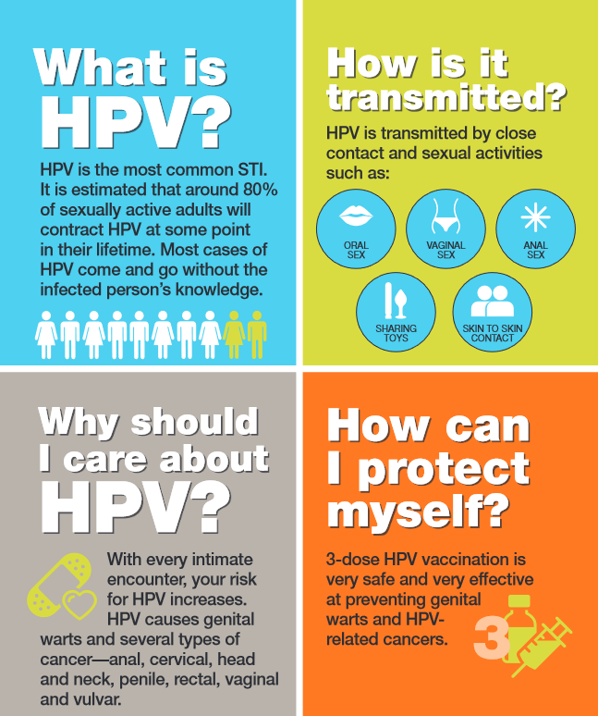

Measures
Perceived stigma (1 = strongly disagree, 7 = strongly agree; α = .73)
- The HPV vaccine may carry some social stigma.
- Discussing or purchasing the HPV vaccine could evoke feelings of awkwardness or embarrassment.
Political Ideology (adopted from Jost, 2006)
- Please locate yourself on the following scale of political ideology (1 = extremely liberal, 7 = extremely conservative).
Results
A one-sample proportion test indicated that 64.36% of participants rated perceived stigma at or above the midpoint of the 7-point scale, which was significantly greater than 50%, z = 2.89, p = .002. A simple linear regression showed that political ideology did not significantly predict perceptions of stigma, b = 0.13, p = .268.

Appendix C: Study 2

Stimuli
Product | Image | Description
Condoms |  | Condoms are a "barrier" method of contraception used during sexual intercourse to reduce the probability of pregnancy or a sexually transmitted infection (STI)
STI self-test kits |  | A STI self-test kit will test you for HIV, Syphilis, Chlamydia and Gonorrhoea. It's a way to check on your sexual health.
HPV vaccines | 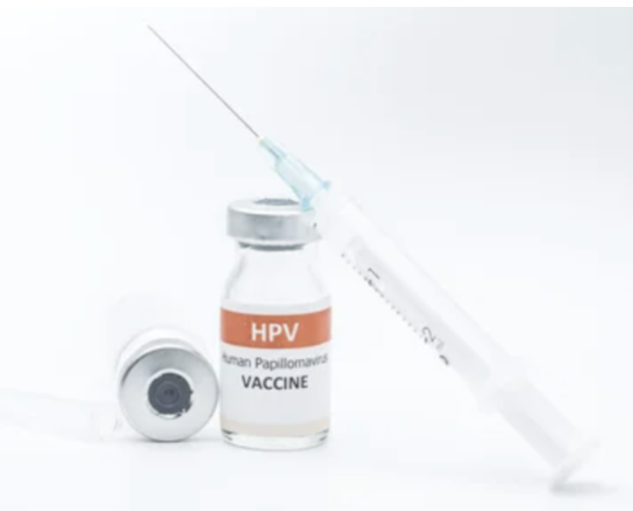 | The HPV vaccine helps protect against cancers caused by HPV and genital warts.
Contraceptive pills | 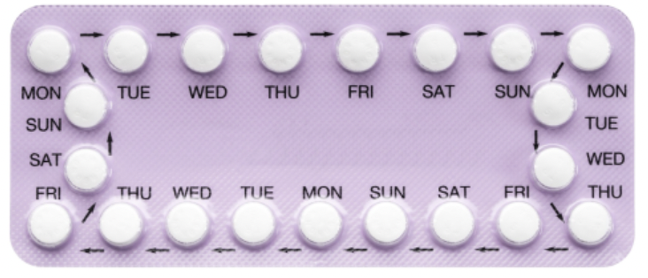 | Contraceptive pill is a daily pill that contains hormones to change the way the body works and prevent pregnancy.
Menstrual cups |  | A menstrual cup is a flexible cup designed for use inside the vagina during the period to collect blood.

Measures
Political Ideology (adopted from Jost, 2006)
- Please locate yourself on the following scale of political ideology (1 = extremely liberal, 7 = extremely conservative).
Attitude (adapted from Batra & Stayman, 1990)
- Please indicate how you perceive condoms/ STI self-test kits/ HPV vaccines/ contraceptive pills/menstrual cups. (1 = bad, 7 = good; 1 = unfavorable, 7 = favorable; 1 = unlikeable, 7 = likeable; 1 = disagreeable, 7 = agreeable).
Purchase Intention (adapted from Goenka & Thomas, 2022)
- How likely are you to purchase condoms/ STI self-test kits/ HPV vaccines/ contraceptive pills/menstrual cups? (1 = very unlikely; 7 = very likely).
Moral Foundation (adopted from Graham et al., 2011)
When you decide whether something is right or wrong, to what extent are the following considerations relevant to your thinking? Please rate each statement using this scale:
- Whether or not someone suffered emotionally (1 = not at all relevant, 7 = extremely relevant)
- Whether or not someone cared for someone weak or vulnerable (1 = not at all relevant, 7 = extremely relevant)
- Whether or not some people were treated differently from others (1 = not at all relevant, 7 = extremely relevant)
- Whether or not someone acted unfairly (1 = not at all relevant, 7 = extremely relevant)
- Whether or not someone action showed love for his or her country (1 = not at all relevant, 7 = extremely relevant)
- Whether or not someone did something to betray his or her group (1 = not at all relevant, 7 = extremely relevant)
- Whether or not someone showed a lack of respect for authority (1 = not at all relevant, 7 = extremely relevant)
- Whether or not someone conformed to the traditions of society (1 = not at all relevant, 7 = extremely relevant)
- Whether or not someone violated standards of purity and decency (1 = not at all relevant, 7 = extremely relevant)
- Whether or not someone did something disgusting (1 = not at all relevant, 7 = extremely relevant)
Please read the following sentences and indicate your agreement or disagreement:
- Compassion for those who are suffering is the most crucial virtue (1 = strongly disagree, 7 = strongly agree)
- One of the worst things a person could do is hurt a defenseless animal (1 = strongly disagree, 7 = strongly agree)
- When the government makes laws, the number one principle should be ensuring that everyone is treated fairly (1 = strongly disagree, 7 = strongly agree)
- Justice is the most important requirement for a society (1 = strongly disagree, 7 = strongly agree)
- I am proud of my country’s history (1 = strongly disagree, 7 = strongly agree)
- People should be loyal to their family members even when they have done something wrong (1 = strongly disagree, 7 = strongly agree)
- Respect for authority is something all children need to learn (1 = strongly disagree, 7 = strongly agree)
- Men and women each have different roles to play in society (1 = strongly disagree, 7 = strongly agree)
- People should not do things that are disgusting, even if no one is harmed (1 = strongly disagree, 7 = strongly agree)
- I would call some acts wrong on the grounds that they are unnatural (1 = strongly disagree, 7 = strongly agree)
Perceived Social Acceptability (adapted from Wang & Yu, 2023)
- Please indicate to what extent do you find condoms/ STI self-test kits/ HPV vaccines/ contraceptive pills/menstrual cups socially acceptable/appropriate? (1 = very socially unacceptable, 7 = very socially acceptable; 1 = very socially inappropriate, 7 = very socially appropriate)
Familiarity (adapted from Milberg et al., 1997)
- Please indicate how familiar are you with purchasing condoms/ STI self-test kits/ HPV vaccines/ contraceptive pills/menstrual cups? (1 = extremely unfamiliar, 7 = extremely familiar)

Robustness Check
To check the robustness of the relationship between political ideology and consumer responses to stigmatized products, we conducted five separate multivariate regression analyses for the five products (i.e., condoms, STI self-test kits, HPV vaccines, contraceptive pills, and menstrual cups). We regressed attitude and purchase intention indexes for each product on conservative ideology, while controlling for the covariates. The results show that conservative ideology significantly reduces attitude toward (see Columns 2-6 in Table C1) and purchase intention of (see Columns 2-6 in Table C2) most stigmatized products (ps < .05). Next, we conducted two linear regressions with participants’ conservative ideology as independent variable and their average attitude toward and purchase intention of the five products as dependent variables, while controlling for the covariates. Again, we found consistent evidence that conservative ideology reduces consumer attitude toward (b = –.21, SE = .04, p < .001) and purchase intention of (b = –.11, SE = .05, p = .036) stigmatized products (see Column 7 in Tables C1 and C2). Finally, when we do not account for the covariates, the relationships between political ideology and attitude and purchase intention remain unchanged (see Column 8 in Tables C1 and C2).
Table C1. Political Ideology and Attitude toward Stigmatized Products
 | 1  mixed-effect | 2  condom | 3  STI self-test kits | 4  HPV vaccination | 5  contraceptive | 6  menstrual cup | 7  average | 8  no controls
Conservative Ideology | -.21***  (.04) | -.08  (.05) | -.21*** (.05) | -.31*** (.06) | -.22***  (.06) | -.22***  (.06) | -.21***  (.04) | -.23*** (.03)
Female | .39 (.86) | .13 (.17) | .22 (.18) | -.61** (.23) | -.76*** (.24) | -.19 (.24) | -.19 (.14) | -
Age | .08 (.05) | .01 (.07) | .12 (.07) | .08 (.09) | .20* (.09) | -.03 (.09) | .08 (.05) | -
Education | -.06 (.05) | .02 (.06) | -.11 (.07) | -.03 (.08) | -.07 (08) | -.11 (.08) | -.06 (.03) | -
Income | .11* (.05) | .07 (.06) | .07 (.06) | .11 (.08) | .13 (.06) | .15 (.08) | .11* (.05) | -
Religious belief Intensity | -.06 (.03) | -.12**(.04) | -.03 (.05) | -.05 (.06) | -.13* (.06) | .02 (.06) | -.06 (.03) | -
Familiarity | .09*** (.02) | .07 (.04) | .06 (.06) | .06 (.05) | .15*** (.05) | .20*** (.06) | .11* (.05) | -
Race indicators | Yes | Yes | Yes | Yes | Yes | Yes | Yes | No
Product indicators | Yes | No | No | No | No | No | No | No
Adjusted R² | .42ª | .13 | .14 | .19 | .24 | .14 | .28 | .25
*p < .05. **p < .01. ***p < .001; numbers in parentheses are standard errors; the models include a constant.
ª Pseudo conditional R²; random intercepts for individual participants included.

Table C2. Political Ideology and Purchase Intention for Stigmatized Products
 | 1  mixed-effect | 2  condom | 3  STI self-test kits | 4  HPV vaccination |  |  | 5  contraceptive |  |  | 6  menstrual cup |  | 7  average |  |  | 8  no controls
Conservative Ideology | -.11*  (.05) | -.07 (.09) | -.21** (.08) |  | -.17* (.08) |  |  | -.06 (.08) |  |  | -.06 (.07) |  |  | -.11* (.05) |  |  | -.20*** (.05)
Female | .49 (1.19) | -1.02***(.34) | .38 (.26) |  |  | .02 (.29) |  |  | .25 (.33) |  | .59 *(.26) |  | .07 (.19) |  |  | -
Age | -.52***  (.07) | -.70*** (.34) | -.34*** (.11) |  |  | -.59*** (.12) |  |  | -.64***  (.12) |  | -.31*** (.10) |  | -.52***  (.07) |  |  | -
Education | .04 (.07) | .14 (.12) | .04 (.10) |  |  | .03 (.11) |  |  | .03 (.11) |  | -.01 (.09) |  | .05 (.07) |  |  | -
Income | -.07 (.07) | -.08 (.12) | -.10 (.10) |  |  | -.07 (.11) |  |  | -.04 (.11) |  | -.03 (.09) |  | -.07 (.07) |  |  | -
Religious belief Intensity | .04 (.05) | .04 (.08) | .07 (.07) |  |  | .04 (.08) |  |  | -.02 (.08) |  | .06 (.06) |  | .04 (.05) |  |  | -
Familiarity | .39*** (.03) | .25***  (.09) | .56***  (.09) |  |  | .29***  (.07) |  |  | .36***  (.07) |  | .45*** (.06) |  | .37***  (.07) |  |  | -
Race Indicators | Yes | Yes | Yes |  |  | Yes |  |  | Yes |  | Yes |  | Yes |  |  | No
Product indicators | Yes | No | No |  |  | No |  |  | No |  | No |  | No |  |  | No
Adjusted R² | .52ª | .27 | .31 |  |  | .30 |  |  | .31 |  | .39 |  | .42 |  |  | .07
*p < .05. **p < .01. ***p < .001; numbers in parentheses are standard errors; the models include a constant.
ª Pseudo conditional R²; random intercepts for individual participants included.

Figure C1. Mediation Effect

Section 1. Attitude
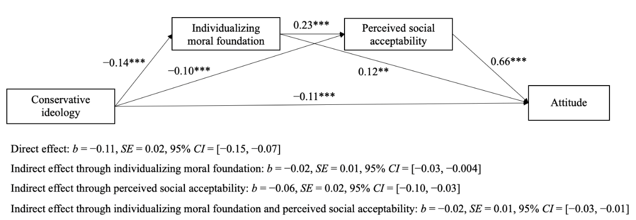

Section 2. Purchase Intention
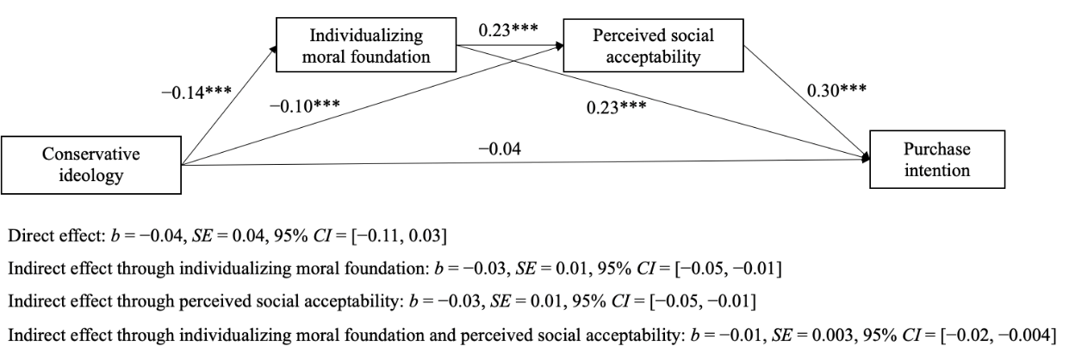

Additional Analysis
We also tested whether the relationship between political ideology and responses to stigmatized products was moderated by gender, race, religious belief intensity, or age. The interaction between political ideology and age was significant for attitude (b = 0.06, SE = 0.02, p = .029). None of the other interactions were significant (more details are available upon reasonable request). Importantly, even when age was included as an interaction, the negative relationship between conservative ideology and attitude remained significant (b = –0.39, SE = 0.08, p < .001).

Appendix D: Supplemental Study S1
In Supplemental Study S1, we conducted a survey to replicate the findings of Study 2 in a different setting, the U.K. Importantly, this study aims to rule out additional alternative mechanisms, namely reactance, disgust, and trust in the government.

Method
A total of 208 U.K. adults were recruited on Prolific in exchange for a small monetary compensation (35.9% females; M_{age} = 44.53, SD = 13.40).
We showed participants the same stimuli as in Study 2, namely a brief introduction and an image of five stigmatized products, i.e., condoms, STI self-test kits, HPV vaccines, contraceptive pills, and menstrual cups, in randomized order. For each product, participants indicated their purchase intention and perceived social acceptability, with the same measures of Study 2. Next, participants reported their political ideology and individualizing moral foundation with the same measures of Study 2.
Participants then indicated their psychological reactance with a 3-item, 7-point scale (“I resist the attempts of others”, “I consider advice from others to be an intrusion”, “Advice and recommendations cause me to do just the opposite”; 1= strongly disagree, 7 = strongly agree; Zhang & Ruan, 2024; α = .66), disgust with a 2-item, 7-point scale (“Please indicate the extent to which you felt disgusted after viewing these products” and “Please indicate the extent to which you felt revolted after viewing these products”, 1 = not at all, 7 = extremely; Paramita et al., 2022; α = .97), and trust in the government with a 3-item, 7-point scale (“I trust the government”, “The government is reliable”, and “The government is dependable”; 1 = strongly disagree, 7 = strongly agree; Thompson & Siamagka, 2022; α = .97).
Finally, participants were debriefed and provided demographic information, including age, gender, education, income, race, familiarity with the product, and religious belief intensity.

Results
We conducted a serial mediation analysis (Model 6 in PROCESS, 5,000 bootstraps) with conservative ideology as independent variable, individualizing moral foundation and perceived social acceptability as mediators (in this order), and purchase intention as dependent variable, while controlling for the same covariates as Study 2. The results indicate a significant serial indirect relationship between conservative ideology and purchase intention (b = –.005, SE = .002, 95% CI = [–.01, –.002]) through individualizing moral foundation and perceived social acceptability, supporting H2.
Alternative Mechanisms
As for the roles of reactance, disgust, and trust in the government, mediation analysis (Model 4 in PROCESS, 5,000 bootstraps) controlling for the same covariates showed that the indirect effect was not significant for reactance (b = –.01, 95% CI = [–.02, .002]), disgust (b = .01, 95% CI = [–.0001, .03]), nor trust in the government (b = –.01, 95% CI = [–.03, .01]), thus ruling out these alternative explanations.

Discussion
Using a U.K. sample, our findings reveal that conservative ideology exerts a negative indirect effect on consumer responses to stigmatized products through individualizing moral foundation and perceived social acceptability, thereby increasing the generalizability of our results. Further, in this study, we ruled out alternative explanations, including the possibility that the observed relationship was driven by conservatives’ higher reactance, greater disgust, or lower trust in the government.

Appendix E: Study 3

Stimuli
 | HPV vaccines | Male Contraceptives
AI | 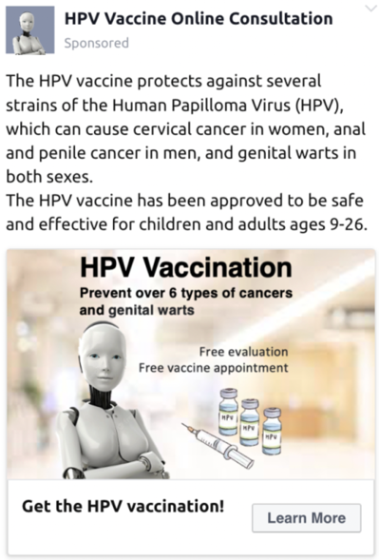 | 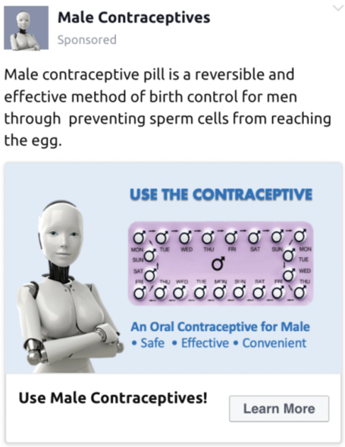
Human | 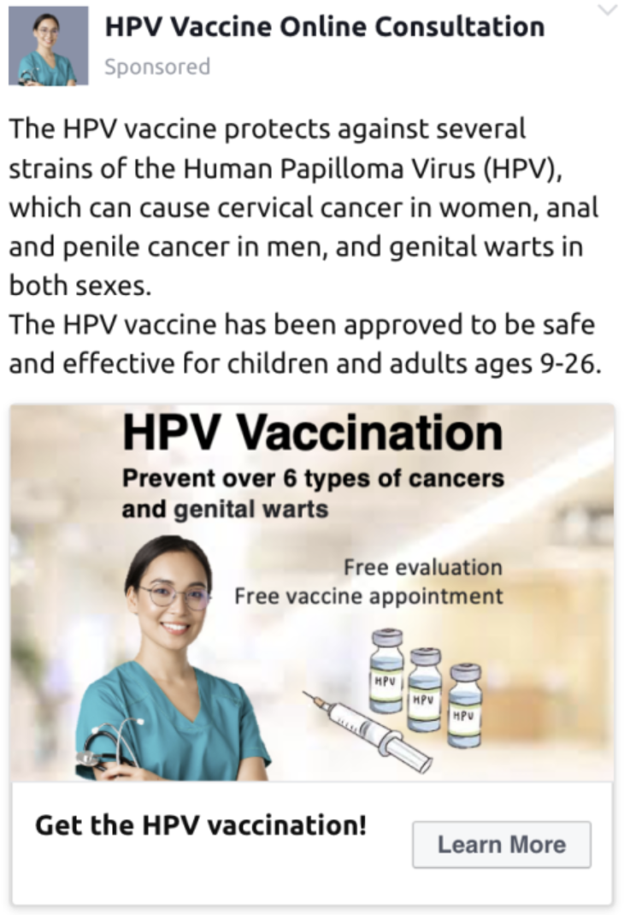 | 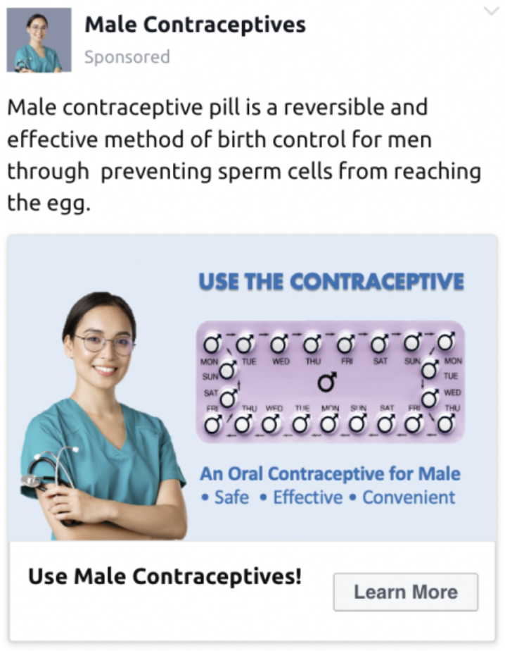
Control | 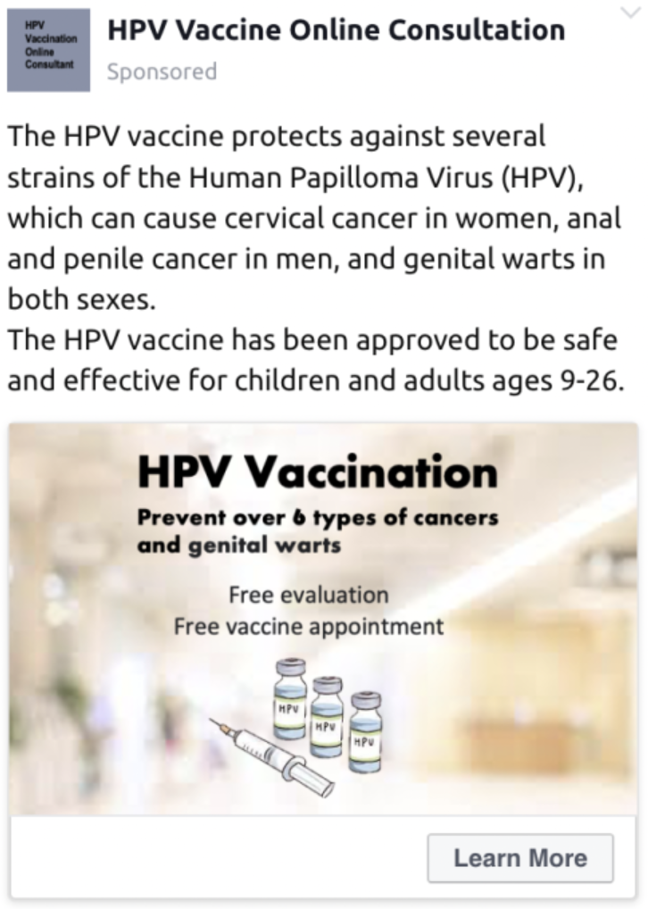 | 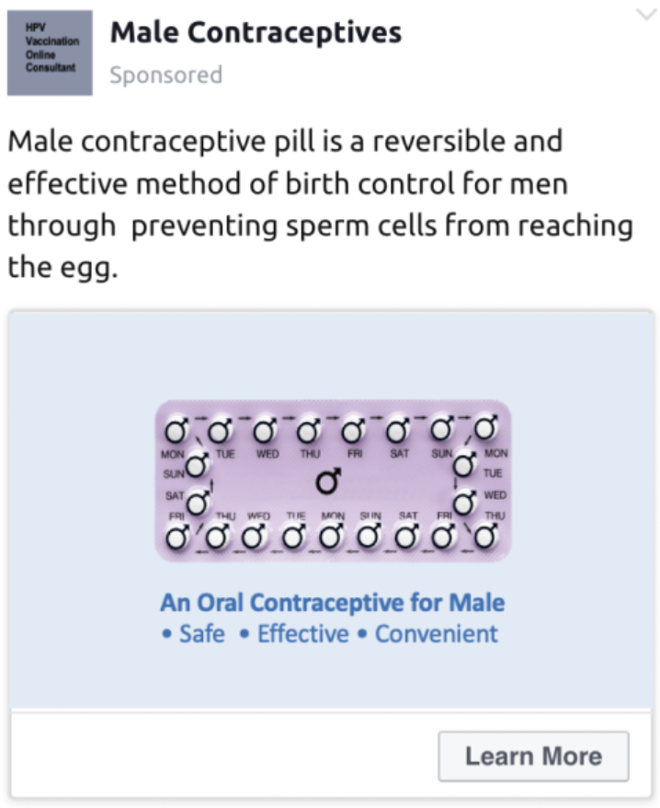

Measures
Political Ideology
The same scale as used in Study 2.
Attitude
The same scale as used in Study 2.
Interest (adapted from Wang & Yu, 2023)
- Are you interested in getting more information on HPV vaccines/male contraceptive pills? (1 = not at all interested, 7 = very interested)
- Are you thinking about getting the HPV vaccines/ having some male contraceptive pills? (1 = absolutely no, 7 = absolutely yes)
- Would you like to request a free online consultation about the HPV vaccine/a free sample of male contraceptive pills? (1 = absolutely no, 7 = absolutely yes)
Purchase Intention
The same scale as used in Study 2.

Post-hoc Manipulation Check for Study 3
Stimuli
Same HPV vaccines stimuli of Study 3.
Measures
- Who do you think was featured as the doctor in the advertisement? (1 = An artificial intelligence (AI) doctor, 2 = A human doctor, 3 = No doctor was shown, 4 = I’m not sure)
Results
A cross-tabulation analysis revealed the success of our manipulation (χ² = 240.69, p < .001). Specifically, 92.5% of participants in the AI condition selected the “an artificial intelligence (AI) doctor,” 65.7% of participants in the human condition selected “a human doctor,” and 83.6% of participants in the control condition selected “No doctor was shown”.

Appendix F: Study 4

Stimuli
 | Scenarios | Images
Company message source | This raffle is sponsored by Durex and Oral-B.  Durex is a brand owned by a private sector company, Reckitt, making condoms, lubes and sex toys.  Oral-B is a brand owned by a private sector company, Procter & Gamble, making oral hygiene products. | 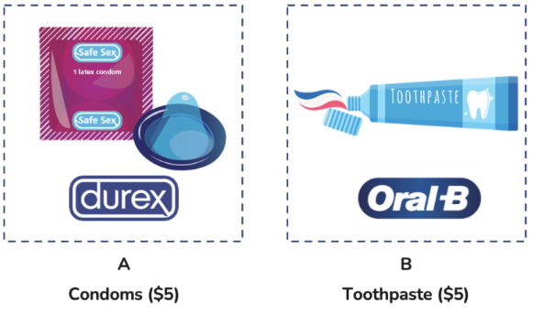
Government message source | This raffle is sponsored by Centers for Disease Control and Prevention (CDC).  CDC is a United States federal agency under the Department of Health and Human Services. | 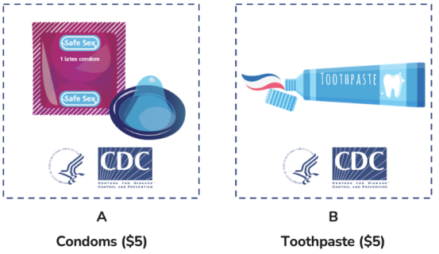
Collaboration message source | This raffle is sponsored by the cooperation between Centers for Disease Control and Prevention (CDC) and two companies: Durex and Oral-B.  CDC is a United States federal agency under the Department of Health and Human Services.  Durex is a brand owned by a private sector company, Reckitt, making condoms, lubes and sex toys.  Oral-B is a brand owned by a private sector company, Procter & Gamble, making oral hygiene products. | 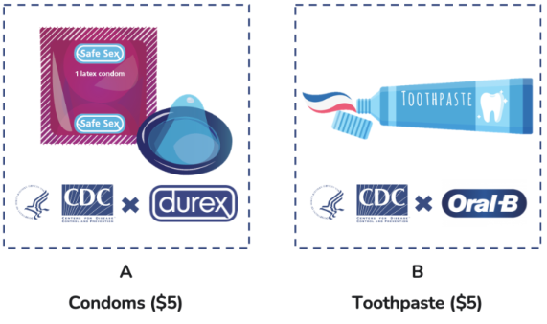

Measures
Political Ideology
The same scale as used in Study 2.
Consumer Choice
Which product would you like to enter a draw to win? (1 = Product A: Condoms; 0 = Product B: Toothpaste)

Post-hoc Manipulation Check for Study 4
Stimuli
Same stimuli of Study 4.

Measures
- To what extent do you perceive the campaign to be sponsored by a government agency or a private company? (1 = definitely government agency; 4 = both equally, 7 = definitely private company).
Results
A one-way ANOVA revealed that the manipulation was successful (F(2,197) = 79.70, p < .001). Participants in the government condition (M_{government} = 2.64, SD = 1.92) perceived the campaign as significantly more likely to have been sponsored by a government agency than those in the company (M_{corporate} = 6.12, SD = 1.78; p < .001) or control (M_{control} = 4.06, SD = 1.64; p < .001) conditions.

References
Brauer, M., & Curtin, J. J. (2018). Linear mixed-effects models and the analysis of nonindependent data: A unified framework to analyze categorical and continuous independent variables that vary within-subjects and/or within-items. Psychological Methods, 23(3), 389-411.
Ellen, P. S., & Bone, P. F. 2008. Stained by the label? Stigma and the case of genetically modified foods. Journal of Public Policy & Marketing, 27(1), 69-82.
Fam, K. S., & Waller, D. S. 2003. Advertising controversial products in the Asia Pacific: what makes them offensive?. Journal of Business Ethics, 48(3), pp.237-250.
Han, K., Jung, J., Mittal, V., Zyung, J. D., & Adam, H. 2019. Political identity and financial risk taking: Insights from social dominance orientation. Journal of Marketing Research, 56(4), 581-601.
Hoss, A., Meyerson, B. E., & Zimet, G. D. 2019. State statutes and regulations related to human papillomavirus vaccination. Human Vaccines & Immunotherapeutics, 15(7-8), 1519-1526.
Jones, C. L. E., Barney, C., & Farmer, A. (2018). Appreciating anonymity: An exploration of embarrassing products and the power of blending in. Journal of Retailing, 94(2), 186-202.
Mattison Thompson, F., & Siamagka, N. T. (2022). Counteracting consumer subversion: Organizational privacy ethical care as driver of online information sharing. Psychology & Marketing, 39(3), 579-597.
Paramita, W., Septianto, F., & Nasution, R. A. (2022). The interactive effects of moral identity and humor on advertising evaluations: The mediating role of disgust. International Journal of Advertising, 41(7), 1263-1281.
Sohn, S., Labrecque, L., Siemon, D., & Morana, S. (2025). Artificial intelligence versus human service agents: How their presence shapes consumer information privacy concerns. Journal of Retailing.
Stewart, E. A. (2023). How Britain loves the NHS: Practices of care and contestation (p. 171). Policy Press.
Zhang, N., & Ruan, C. (2024). Danmaku consistency reduces consumer purchases during live streaming: A dual‐process model. Psychology & Marketing, 41(11), 2591-2607.

https://data.cdc.gov/Teen-Vaccinations/Vaccination-Coverage-among-Adolescents-13-17-Years/ee48-w5t6
https://www.ncsl.org/about-state-legislatures/state-partisan-composition
https://data.census.gov/table/ACSST1Y2022.S1501?g=010XX00US$0400000&moe=false&tp=true
https://data.census.gov/table/ACSST1Y2022.S1901?q=Income%20(Households,%20Families,%20Individuals)&g=010XX00US$0400000&tp=true
https://www.pewresearch.org/fact-tank/2016/02/29/how-religious-is-your-state/?state=alaska
https://www.census.gov/topics/population/foreign-born/data/tables.html
https://www.census.gov/programs-surveys/geography/guidance/geo-areas/urban-rural.html
https://data.census.gov/table/ACSDT1Y2021.B02001?q=Race%20and%20Ethnicity&g=010XX00US$0400000_040XX00US01&y=2021
To enhance external validity, we used a leaflet introducing HPV vaccines from the Indiana Immunization Coalition (a community health center) as the stimulus: https://vaccinateindiana.org/product-category/hpv/
In additional analyses, not reported here in the interest of brevity, we found no significant difference in familiarity between CDC and Durex (p = .15), but significant differences between CDC and Oral-B (p < .001), and between Durex and Oral-B (p < .001), with Oral-B being more familiar than both Durex and CDC. The random assignment of participants to sponsor conditions in Study 4 addresses concerns about familiarity.

