SUPPLEMENTARY MATERIALS

Deterioration of bioplastics in the soil environment: a thermoanalytical insight into the composition and degradation of commercial biodegradable polymers

Alessandro G. Rombolà^{a*}, Irene Coralli^{b}, Chiara Samorìª, Cristian Torriª, Nicolas Greggio^{c}, Daniele Fabbri^{b}

ª Department of Chemistry “Giacomo Ciamician”, Alma Mater Studiorum-University of Bologna, Campus of Ravenna, Via Sant’Alberto 163, 48123, Ravenna, Italy
^{b} Department of Chemistry “Giacomo Ciamician” and C.I.R.I. FRAME Tecnopolo di Rimini, Alma Mater Studiorum-University of Bologna, Via Dario Campana 71, 47192, Rimini, Italy
^{c} Department of Biological, Geological, and Environmental Sciences, Alma Mater Studiorum-University of Bologna, Campus of Ravenna, Interdepartmental Centre for Research in Environmental Sciences (CIRSA), Via Sant’ Alberto 163, 48123, Ravenna, Italy

*Corresponding author.
E-mail address: alessandro.rombola@unibo.it (A.G. Rombolà).

Number of pages: 15 (including this page)
Number of figures: 11
Number of tables: 6

Parameters | Units | Soil GA
TC | % | 3.20±0.09
TOC | % | 2.0±0.2
TIC | % | 1.2±0.2
N | % | 0.19±0.03
H | % | 0.99±0.10
H/C | atomic | 3.3
pH |  | 8.14±0.01

Table SM1. Elemental analysis and pH of soil from "Ganazzoli Filippo Mezzani" farm. Mean values ± s.d. (n = 3).

The bioplastic samples investigated in this study were purchased as commercially available items from local retailers. To maintain scientific neutrality, the products were anonymized and are referred to throughout the manuscript and Supplementary Material as PLA (commercial PLA plates) and SB (commercial starch-based shopper bags).
b)
a)
d)
c)
Relative abundance (%)
m/z 56
m/z 129
0
50
100
m/z 149
SB
0
50
100
Relative abundance (%)
SB
SB-aged-30
SB-aged-100
m/z 56
0
50
100
Relative abundance (%)
m/z 129
200
300
400
500
600
0
50
100
Relative abundance (%)
m/z 149
Temperature (°C)
Figure SM1. EGA-MS spectra obtained from unaged and aged SB bioplastics. a) Extracted ion thermograms (EITs) of ions at m/z 56 (meso-lactide and D,L-lactide, black), 129 (⁺O≡C-CH₂-CH₂-CH₂-COOH, blue), and 149 (⁺O≡C-Ph-COOH, red) of unaged SB bioplastics; b) EITs at m/z 56 (meso-lactide and D,L-lactide) of unaged and aged SB bioplastics; c) EITs of ions at m/z 129 (⁺O≡C-CH₂-CH₂-CH₂-COOH, blue) of unaged and aged SB bioplastics; d) EITs of ions at m/z 149 (⁺O≡C-Ph-COOH) of unaged and aged SB bioplastics.

d)
a)
b)
c)
0
50
100
Relative abundance (%)
m/z 155
200
300
400
500
600
0
50
100
Relative abundance (%)
m/z 173
0
50
100
Relative abundance (%)
PLA
PLA-aged-30
PLA-aged-100
m/z 55
0
50
100
Relative abundance (%)
m/z 56

Figure SM2. EGA-MS spectra obtained from unaged and aged PLA bioplastics. a) EITs at m/z 55 (butylene, blu), b) at m/z 56 (meso-lactide and D,L-lactide, black), c) at m/z 155 (succinic acid, di(3-butenyl) ester, red), d) at m/z 173 (butylene succinate, green) of unaged and aged PLA bioplastics.

As reported by Coralli et al. (2024), the mass spectra of pyrolysis products derived from the adipate and terephthalate sequences are characterized by distinctive fragment ions.
- Adipate sequence: the fragment at m/z 129, assigned to (+O≡C–CH₂–CH₂–CH₂–COOH), was detected in several pyrolysis products, including:
  - but-3-en-1-yl hydrogen adipate,
  - 1,6-dioxacyclododecane-7,12-dione,
  - di(but-3-en-1-yl) adipate,
  - but-3-en-1-yl (4-hydroxybut-1-yl) adipate,
  - but-3-en-1-yl (4-(pentanoyloxy)butyl) adipate,
  - 6-(4-((6-(but-3-en-1-yloxy)-6-oxohexanoyl)oxy)butoxy)-6-oxohexanoic acid,
  - but-3-en-1-yl (4-((6-(but-3-en-1-yloxy)-6-oxohexanoyl)oxy)butyl) terephthalate.
- Terephthalate sequence: the fragment at m/z 149, assigned to (+O≡C–Ph–COOH), was distinctive of the following products:
  - but-3-en-1-yl hydrogen terephthalate,
  - but-3-en-1-yl terephthalate,
  - but-3-en-1-yl (4-hydroxybut-1-yl) terephthalate,
  - 4-(benzoyloxy)butyl but-3-en-1-yl terephthalate,
  - cyclic dibutylene adipate terephthalate,
  - but-3-en-1-yl (4-((6-(but-3-en-1-yloxy)-6-oxohexanoyl)oxy)butyl) terephthalate,
  - cyclic dibutylene terephthalate,
  - dibut-3-enyl butane-1,4-diyl diterephthalate
    - (alternative assignment: 4-((4-(4-((but-3-nyloxy)carbonyl)benzoyloxy)butoxy))).
In summary, the ion at m/z 129 serves as a diagnostic marker of adipate-derived products, whereas the ion at m/z 149 is distinctive of terephthalate-derived species.

 | SB
Aging days | TIT | m/z 56 | m/z 129 | m/z 149
 | A_{p}
0 | 560000±29000 | 9000±2200 | 13000±1800 | 68000±4000
30 | 430000±19000 | 7300±2100 | 8000±1600 | 44000±10000
100 | 360000±28000 | 5900±1800 | 7800±2200 | 37000±10000

Table SM2. Peak area (A_{p}) from total ion thermogram (TIT) at 404 °C and extracted ion thermograms (EITs) of ions at m/z 56 (meso-lactide and D,L-lactide), 129 (⁺O≡C-CH₂-CH₂-CH₂-COOH), and 149 (⁺O≡C-Ph-COOH) of unaged and aged SB bioplastics. The AP was calculated by dividing the area integrated from the total and extracted ion thermogram by the sample weight (ng). Mean values ± s.d. (n = 3).

 | SB
Aging days | TIT | m/z 56 | m/z 129 | m/z 149
 | C_{p} %
0 | - | - | - | -
30 | 23±8 | 27±7 | 34±17 | 34±17
100 | 35±5 | 41±7 | 41±19 | 44±15

Table SM3. Aging-induced percent change (C_{p}) from total ion thermogram (TIT) at 404 °C and extracted ion thermograms (EITs) of ions at m/z 56 (meso-lactide and D,L-lactide), 129 (⁺O≡C-CH₂-CH₂-CH₂-COOH), and 149 (⁺O≡C-Ph-COOH) of unaged and aged SB bioplastics. Mean values ± s.d. (n = 3).

 | PLA
Aging days | TIT | m/z 56 | m/z 55 | m/z 155 | m/z 173
 | A_{p}
0 | 460000±110000 | 75000±23000 | 50000±18000 | 7600±1800 | 7900±1900
30 | 360000±97000 | 69000±21000 | 39000±11000 | 5600±900 | 5800±700
100 | 340000±90000 | 62000±18000 | 36000±10000 | 5600±500 | 5700±500

Table SM4. Peak area (A_{p}) from total ion thermogram (TIT) at 390 °C and extracted ion thermograms (EITs) of ions at m/z 55 (butylene), 56 (meso-lactide and D,L-lactide, black), 155 (succinic acid, di(3-butenyl) ester), and 173 (succinic acid, di(3- butenyl) ester) of unaged and aged PLA bioplastics. Mean values ± s.d. (n = 3).

 | PLA
Aging days | TIT | m/z 56 | m/z 55 | m/z 155 | m/z 173
 | C_{p} %
0 | - | - | - | - | -
30 | 20±1 | 8±6 | 20±10 | 24±10 | 25±12
100 | 25±1 | 17±4 | 25±9 | 24±13 | 35±11

Table SM5. Aging-induced percent change (C_{p}) from total ion thermogram (TIT) at 390 °C and extracted ion thermograms (EITs) of ions at m/z 55 (butylene), 56 (meso-lactide and D,L-lactide, black), 155 (succinic acid, di(3-butenyl) ester), and 173 (succinic acid, di(3- butenyl) ester) of unaged and aged PLA bioplastics. Mean values ± s.d. (n = 3).

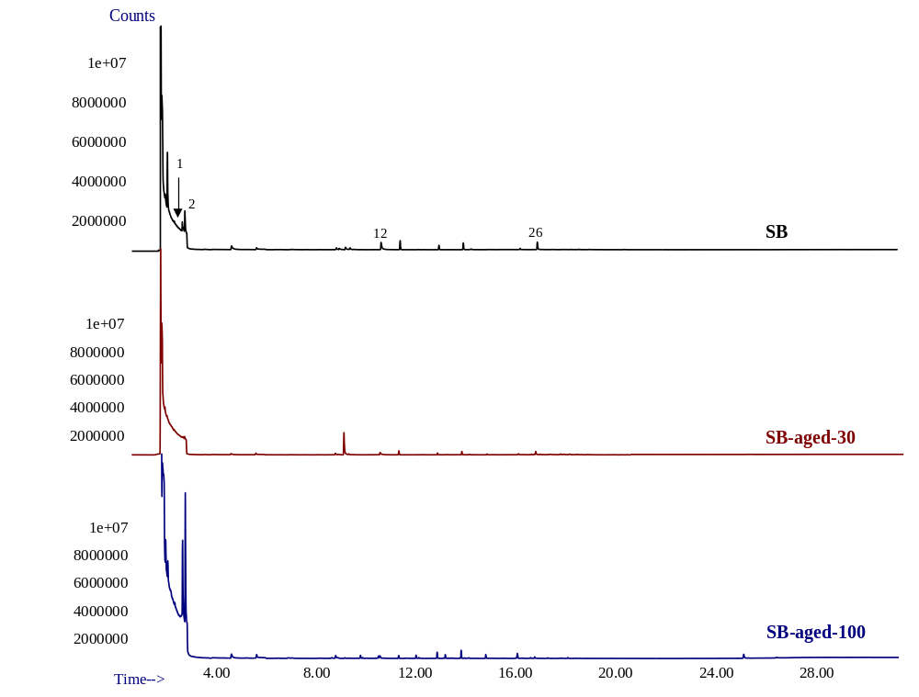
Figure SM3. Total ion chromatograms of volatile organic compounds from unaged and aged starch-based (SB) bioplastics by HS-SPME/GC-MS performed at 50 °C. Identification table is reported in Table 1.
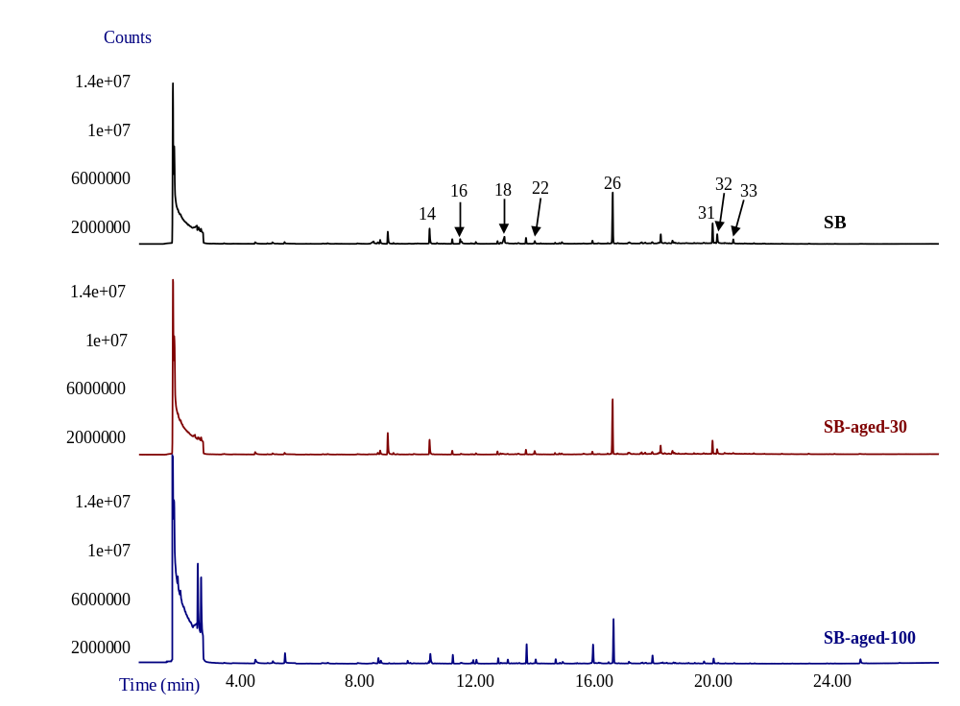
Figure SM4. Total ion chromatograms of volatile organic compounds from unaged and aged starch-based (SB) bioplastics by HS-SPME/GC-MS performed at 100 °C. Identification table is reported in Table 1.
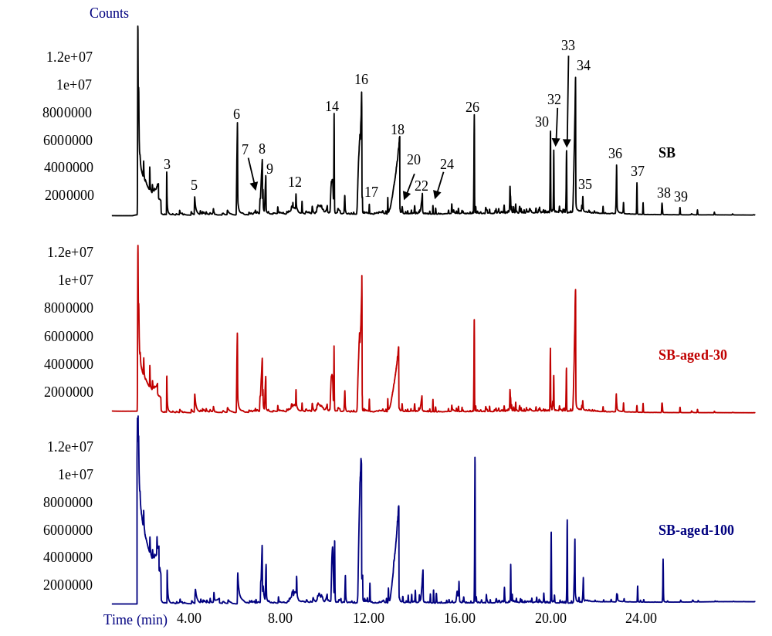
Figure SM5. Total ion chromatograms of volatile organic compounds from unaged and aged starch-based (SB) bioplastics by HS-SPME/GC-MS performed at 150 °C. Identification table is reported in Table 1.
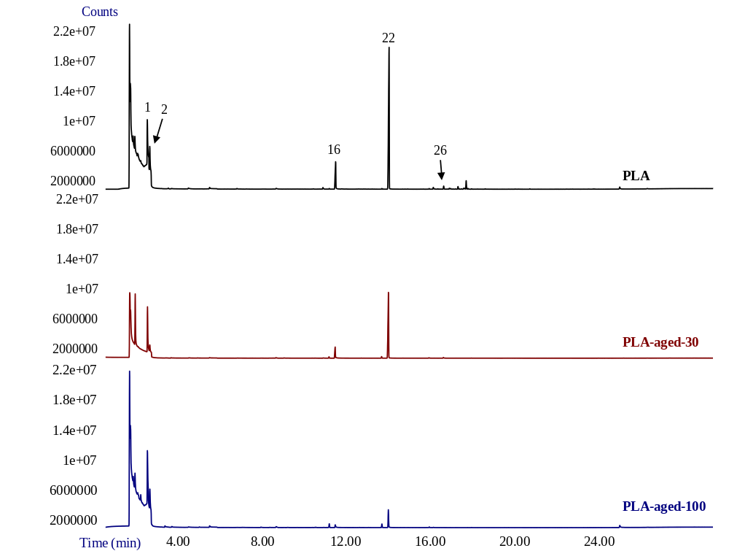
Figure SM6. Total ion chromatograms of volatile organic compounds from unaged and aged PLA bioplastics by HS-SPME/GC-MS performed at 50 °C. Identification table is reported in Table 1.
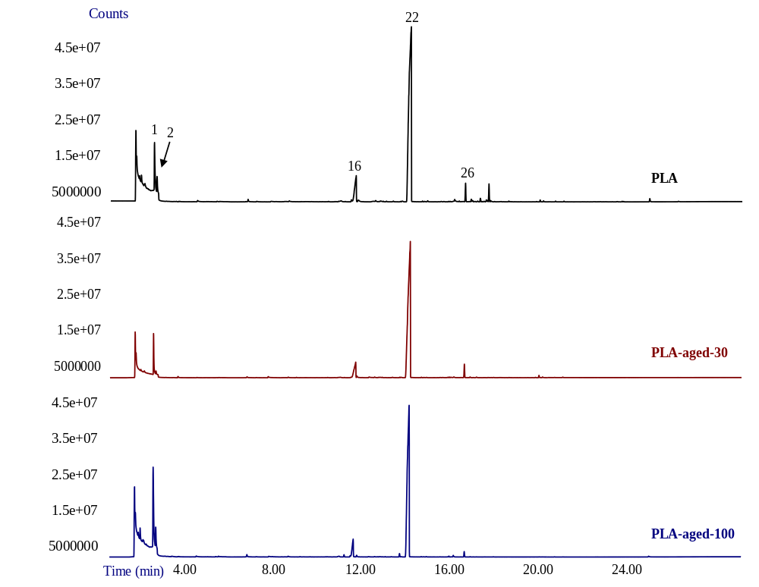
Figure SM7. Total ion chromatograms of volatile organic compounds from unaged and aged PLA bioplastics by HS-SPME/GC-MS performed at 100 °C. Identification table is reported in Table 1.
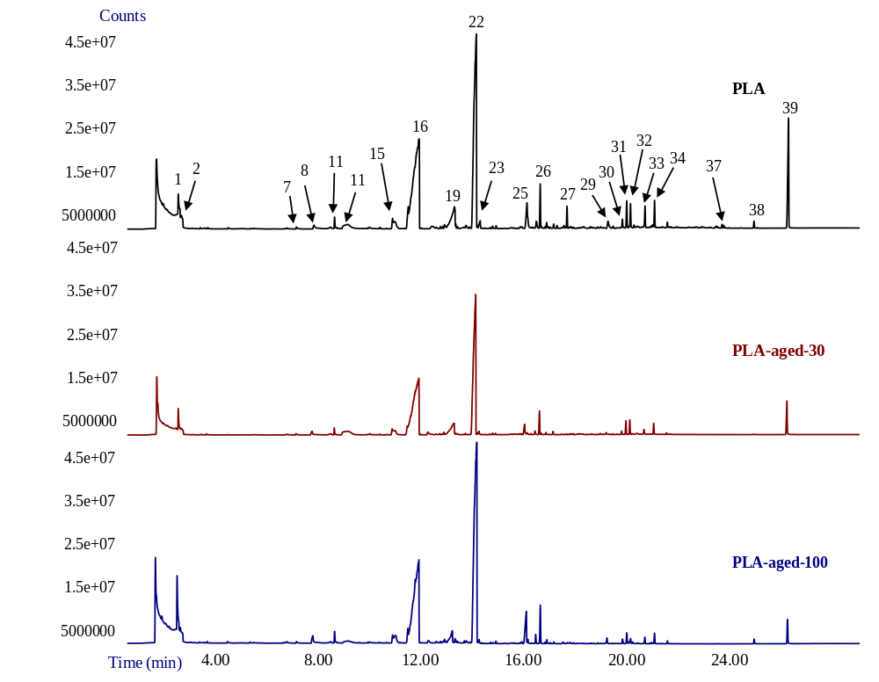
Figure SM8. Total ion chromatograms of volatile organic compounds from unaged and aged PLA bioplastics by HS-SPME/GC-MS performed at 150 °C. Identification table is reported in Table 1.

 | SB |  |  | PLA
Aging days | T_{onset} | T_{endset} | T_{peak} | T_{onset} | T_{endset} | T_{peak}
 | (°C)
0 | 232 | 440 | 355 | 200 | 403 | 308
30 | 280 | 445 | 380 | 195 | 406 | 306
100 | 305 | 445 | 380 | 198 | 410 | 306

Table SM6. Characteristic temperatures of unaged and aged bioplastics from TGA analysis: T₀, T_{inf} and T_{peak} (°C) which correspond to the initial, final and maximum degradation temperatures respectively.

Fig. SM9. Thermogravimetric (TG) curves obtained from unaged and aged bioplastics applied in the laboratory experiment.

Fig. SM10. Differential thermogravimetry (DTG) curves obtained from unaged and aged starch-based (SB) samples applied in the laboratory experiment.
Fig. SM11. Differential thermogravimetry (DTG) curves obtained from unaged and aged PLA samples applied in the laboratory experiment.

