Synthesis and biological evaluation of mixed aryl-alkyl succinates as modulators of autophagy and apoptosis in gastric carcinoma
Diego Olivieriª, Michele Mariª, Michela Battistelliª*, Sabrina Burattiniª, Carla Carfagna^{b}, Federico Gianfantiª**, Francesco Onesimoª, Giovanni Bottegoniª, Riham Osmanª, Nour Annousª, Sara Salucci^{c}, Ilaria Versari^{c}, Irene Faenza^{c}, Matteo Micucci^{a†} and Michele Retini^{a†}

ªDepartment of Biomolecular Sciences, University of Urbino “Carlo Bo”, Campus Scientifico E. Mattei, via Ca’ Le Suore 2, 61029 Urbino (PU), Italy.
^{b}Department of Industrial Chemistry “Toso Montanari”, University of Bologna, Via Piero Gobetti 85, 40129 Bologna (BO), Italy.
^{c}Department of Biomedical and NeuroMotor Sciences, University of Bologna, 40126 Bologna (BO), Italy.

*Corresponding author: Michela Battistelli: michela.battistelli@uniurb.it
**Co-Corresponding author: Federico Gianfanti: federico.gianfanti@uniurb.it
†These authors contributed equally to this work

Supporting Information

Contents:

- Experimental data for succinic compounds 2 |  | S2
- Copies of ¹H NMR for known compounds 2a-2g, 2l |  | S5
- Copies of ¹H and ¹³C NMR for the new compound 2h |  | S9
- HPLC/UV and HMRS analyses |  | S10
- MTT assay values |  | S19
- Proposed Molecular Mechanism |  | S21
- References |  | S22

- Experimental data for succinic compounds 2

1-(4-hydroxyphenyl) 4-isopropyl 2-phenylsuccinate (2a):
Compound 2a has been obtained following a literature procedure.^{[1]}
White solid; yield: 90%.
R_{f} = 0.27 (CH₂Cl₂/Et₂O = 95:5).
¹H NMR (400 MHz, CDCl₃) δ 7.41 – 7.28 (m, 5H), 6.87 – 6.81 (m, 2H), 6.77 – 6.70 (m, 2H), 5.03 (hept, J = 6.3 Hz, 1H), 4.28 (dd, J = 10.4, 5.2 Hz, 1H), 3.24 (dd, J = 16.9, 10.4 Hz, 1H), 2.73 (dd, J = 16.9, 5.2 Hz, 1H), 1.23 (d, J = 6.3 Hz, 3H), 1.20 (d, J = 6.3 Hz, 3H).
¹³C NMR (101 MHz, CDCl₃) δ 172.4, 171.3, 153.6, 144.2, 137.3, 129.2, 128.00, 127.97, 122.3, 116.0, 68.7, 47.5, 38.4, 21.93, 21.90.
ESI-MS: m/z = 327 [M-H]⁻.
mp = 115-117 °C
HPLC/UV retention time 5.86 min; Purity: 95.3%
HRMS (m/z): [M+H]⁺ calcd for C₁₉H₂₁O₅ 329.1384; found 329.1398.
Spectral data were in agreement with previously reported literature data.^{[1]}

1-(4-hydroxyphenyl) 4-isopropyl 2-benzylsuccinate (2b):
Compound 2b has been obtained following a literature procedure.^{[1]}
Off-white solid; yield: 42%.
R_{f} = 0.36 (CH₂Cl₂/Et₂O 92:8).
¹H NMR (400 MHz, CDCl₃) δ 7.36 – 7.30 (m, 2H), 7.29 – 7.21 (m, 3H), 6.82 – 6.78 (m, 2H), 6.78 – 6.73 (m, 2H), 5.02 (hept, J = 6.3 Hz, 1H), 3.39 – 3.25 (m, 1H), 3.13 (dd, J = 13.6, 7.1 Hz, 1H), 2.91 (dd, J = 13.6, 8.0 Hz, 1H), 2.77 (dd, J = 16.8, 9.5 Hz, 1H), 2.52 (dd, J = 16.8, 4.9 Hz, 1H), 1.22 (d, J = 6.3 Hz, 3H), 1.22 (d, J = 6.3 Hz, 3H).
¹³C NMR (101 MHz, CDCl₃) δ 173.5, 171.3, 153.4, 144.4, 138.1, 129.3, 128.8, 127.0, 122.5, 116.0, 68.5, 43.4, 38.0, 36.09, 22.0 (2C).
ESI-MS: m/z = 341 [M-H]⁻.
mp = 79-81 °C
HPLC/UV retention time 6.31 min; Purity: 100%
HRMS (m/z): [M+H]⁺ calcd for C₂₀H₂₃O₅ 343.1540; found 343.1556.
Spectral data were in agreement with previously reported literature data.^{[1]}

1-(4-hydroxyphenyl) 4-isopropyl 2-phenethylsuccinate (2c):
Compound 2c has been obtained following a literature procedure.^{[1]}
Off-white solid; yield: 65%.
R_{f} = 0.20 (petroleum ether/EtOAc = 80:20).
¹H NMR (400 MHz, CDCl₃) δ 7.35 – 7.27 (m, 2H), 7.25 – 7.18 (m, 3H), 6.96 – 6.89 (m, 2H), 6.80 – 6.73 (m, 2H), 5.04 (hept, J = 6.3 Hz, 1H), 3.13 – 3.04 (m, 1H), 2.84 (dd, J = 16.5, 9.4 Hz, 1H), 2.80 – 2.72 (m, 2H), 2.59 (dd, J = 16.5, 5.1 Hz, 1H), 2.19 – 2.08 (m, 1H), 2.00 – 1.90 (m, 1H), 1.24 (d, J = 6.3 Hz, 3H), 1.24 (d, J = 6.3 Hz, 3H).
¹³C NMR (101 MHz, CDCl₃) δ 174.2, 171.5, 153.7, 144.2, 141.1, 128.7, 128.6, 126.4, 122.5, 116.2, 68.6, 41.2, 36.7, 33.8, 33.4, 22.0 (2C).
ESI-MS: m/z = 355 [M-H]⁻.
mp = 70-71 °C
HPLC/UV retention time 6.64 min; Purity: 96.6 %
HRMS (m/z): [M+H]⁺ calcd for C₂₁H₂₅O₅ 357.1697; found 357.1708
Spectral data were in agreement with previously reported literature data.^{[1]}

1-(4-hydroxyphenyl) 4-isopropyl 2-pentylsuccinate (2d):
Compound 2d has been obtained following a literature procedure.^{[1]}
White solid; yield: 60%.
R_{f} = 0.35 (petroleum ether/EtOAc = 80:20).
¹H NMR (400 MHz, CDCl₃) δ 6.92 – 6.86 (m, 2H), 6.77 – 6.71 (m, 2H), 5.03 (hept, J = 6.3 Hz, 1H), 3.08 – 2.98 (m, 1H), 2.79 (dd, J = 16.6, 9.8 Hz, 1H), 2.53 (dd, J = 16.6, 4.8 Hz, 1H), 1.83 – 1.72 (m, 1H), 1.68 – 1.57 (m, 1H), 1.48 – 1.37 (m, 2H), 1.37 – 1.28 (m, 4H), 1.24 (d, J = 6.3 Hz, 3H), 1.23 (d, J = 6.3 Hz, 3H), 0.90 (t, J = 6.8 Hz, 3H).
¹³C NMR (101 MHz, CDCl₃) δ 174.6, 171.8, 153.6, 144.2, 122.5, 116.1, 68.5, 41.6, 36.7, 32.1, 31.7, 26.8, 22.6, 22.0 (2C), 14.1.
ESI-MS: m/z = 321 [M-H]⁻.
mp = 42-44 °C.
HPLC/UV retention time 7.36 min; Purity: 97.5 %.
HRMS (m/z): [M+H]⁺ calcd for C₁₈H₂₇O₅ 323.1853; found 323.1870.
Spectral data were in agreement with previously reported literature data.^{[1]}

1-(4-hydroxyphenyl) 4-isopropyl 2-(acetoxymethyl)succinate (2e):
Compound 2e has been obtained following a literature procedure.^{[1]}
Colorless oil; yield: 36%.
R_{f} = 0.39 (CH₂Cl₂/Et₂O 95:5).
¹H NMR (400 MHz, CDCl₃) δ 6.97 – 6.89 (m, 2H), 6.82 – 6.75 (m, 2H), 5.05 (hept, J = 6.2 Hz, 1H), 4.48 (dd, J = 11.2, 5.5 Hz, 1H), 4.40 (dd, J = 11.2, 5.7 Hz, 1H), 3.39 (app dq, J = 8.6, 5.6 Hz, 1H), 2.88 (dd, J = 16.9, 8.6 Hz, 1H), 2.62 (dd, J = 16.9, 5.5 Hz, 1H), 2.09 (s, 3H), 1.25 (d, J = 6.2 Hz, 3H), 1.25 (d, J = 6.2 Hz, 3H).
¹³C NMR (101 MHz, CDCl₃) δ 171.2, 170.9 (2C), 153.7, 144.1, 122.4, 116.1, 68.8, 63.8, 41.3, 33.5, 21.9 (2C), 20.9.
ESI-MS: m/z = 323 [M-H]⁻.
HPLC/UV retention time 3.28 min; Purity: 89.1 %
HRMS (m/z): [M+H]⁺ calcd for C₁₆H₂₁O₇ 325.1282; found 325.1290
Spectral data were in agreement with previously reported literature data.^{[1]}

1-(4-hydroxyphenyl) 4-isopropyl 2-(phenoxymethyl)succinate (2f):
Compound 2f has been obtained following a literature procedure.^{[1]}
Pale yellow oil; yield: 74%.
R_{f} = 0.21 (petroleum ether/EtOAc = 80:20).
¹H NMR (400 MHz, CDCl₃) δ 7.33 – 7.27 (m, 2H), 7.01 – 6.96 (m, 1H), 6.96 – 6.92 (m, 2H), 6.92 – 6.87 (m, 2H), 6.78 – 6.73 (m, 2H), 5.06 (hept, J = 6.3 Hz, 1H), 4.37 (dd, J = 9.3, 6.0 Hz, 1H), 4.31 (dd, J = 9.3, 5.0 Hz, 1H), 3.59 – 3.48 (m, 1H), 3.03 (dd, J = 17.0, 8.2 Hz, 1H), 2.79 (dd, J = 17.0, 5.5 Hz, 1H), 1.25 (d, J = 6.3 Hz, 6H).
¹³C NMR (101 MHz, CDCl₃) δ 171.7, 171.4, 158.5, 153.7, 144.1, 129.7, 122.5, 121.5, 116.1, 114.8, 68.8, 67.7, 42.0, 33.5, 22.0 (2C).
ESI-MS: m/z = 357 [M-H]⁻.
HPLC/UV retention time 6.14 min; Purity: 96.3 %
HRMS (m/z): [M+H]⁺ calcd for C₂₀H₂₃O₆ 359.1489; found 359.1501
Spectral data were in agreement with previously reported literature data.^{[1]}

dimethyl 2-pentylsuccinate (2g):
Compound 2g has been obtained following a literature procedure.^{[2]}
Pale yellow oil; yield: 92%.
R_{f} = 0.42 (EtOAc/Cyclohexane = 10:90).
¹H NMR (400 MHz, CDCl₃) δ 3.70 (s, 3H), 3.67 (s, 3H), 2.88 – 2.80 (m, 1H), 2.72 (dd, J = 16.4, 9.3 Hz, 1H), 2.43 (dd, J = 16.4, 5.1 Hz, 1H), 1.69 – 1.59 (m, 1H), 1.55 – 1.44 (m, 1H), 1.35 – 1.21 (m, 6H), 0.87 (t, J = 6.8 Hz, 3H).
¹³C NMR (101 MHz, CDCl₃) δ 175.7, 172,6, 51.74, 51.69, 41.1, 35.7, 31.8, 31.4, 26.5, 22.3, 13.8.
ESI-MS: m/z = 239 [M+Na]⁺:
HRMS (m/z): [M+Na]⁺ calcd for C₁₁H₂₀O₄Na 239.1254; found 239.1258
Spectral data were in agreement with previously reported literature data.^{[2]}
diisopropyl 2-pentylsuccinate (2h):
Compound 2h has been obtained following a literature procedure.^{[3]}
Pale yellow oil; yield: 50%.
R_{f} = 0.60 (EtOAc/Cyclohexane = 10:90).
¹H NMR (400 MHz, CDCl3) δ 5.01 (hept, J = 6.3 Hz, 1H), 4.99 (hept, J = 6.3 Hz, 1H), 2.81 – 2.71 (m, 1H), 2.64 (dd, J = 16.2, 9.3 Hz, 1H), 2.36 (dd, J = 16.2, 5.2 Hz, 1H), 1.68 – 1.54 (m, 1H), 1.53 – 1.42 (m, 1H), 1.34 – 1.25 (m, 6H), 1.23 (d, J = 6.3 Hz, 3H), 1.22 (d, J = 6.3 Hz, 3H), 1.21 (d, J = 6.3 Hz, 3H), 1.21 (d, J = 6.3 Hz, 3H), 0.86 (t, J = 6.8 Hz, 3H).
¹³C NMR (101 MHz, CDCl₃) δ 174.7, 171.7, 68.00, 67.8, 41.6, 36.6, 32.1, 31.7, 26.6, 22.6, 21.94, 21.93, 14.1.
ESI-MS: m/z = 273 [M+H]⁺:.
HRMS (m/z): [M+H]⁺ calcd for C₁₅H₂₉O₄ 273.2060; found 273.2066

2-pentylsuccinic acid (2i):
Compound 2i has been obtained following a literature procedure.^{[4]}
White solid; yield: 57%.
¹H NMR (400 MHz, CDCl₃) δ 2.89 – 2.80 (m, 1H), 2.73 (dd, J = 17.1, 10.9 Hz, 1H), 2.51 (dd, J = 17.1, 3.7 Hz, 1H), 1.75 – 1.65 (m, 1H), 1.59 – 1.48 (m, 1H), 1.41 – 1.21 (m, 6H), 0.88 (t, J = 6.8 Hz, 3H).
¹³C NMR (101 MHz, CDCl₃) δ 181.8, 178.9, 41.2, 35.7, 31.8, 31.6, 26.7, 22.5, 14.1.
ESI-MS: m/z = 187 [M-H]⁻.
mp = 78-80 °C
HRMS (m/z): [M+H]⁺ calcd for C₉H₁₇O₄ 189.1121; found 189.1118.
Spectral data were in agreement with previously reported literature data.^{[4]}
- Copies of ¹H NMR for known compounds 2a-2g, 2l
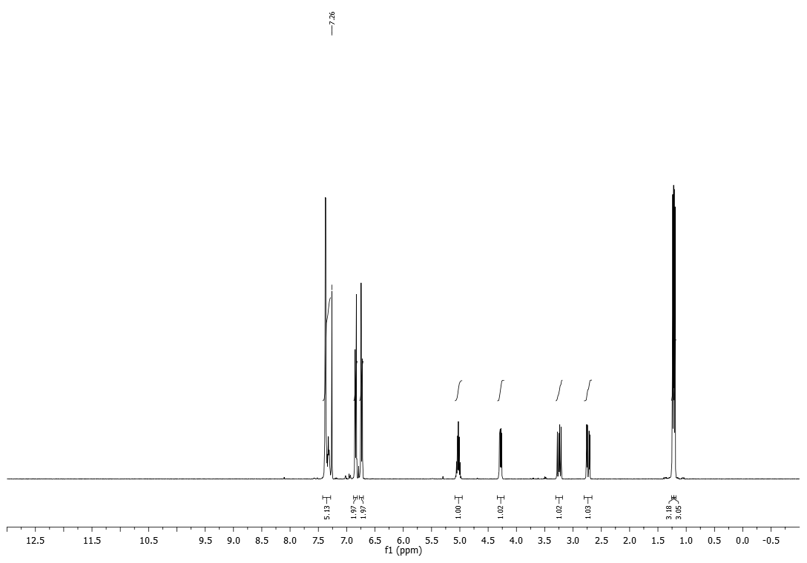
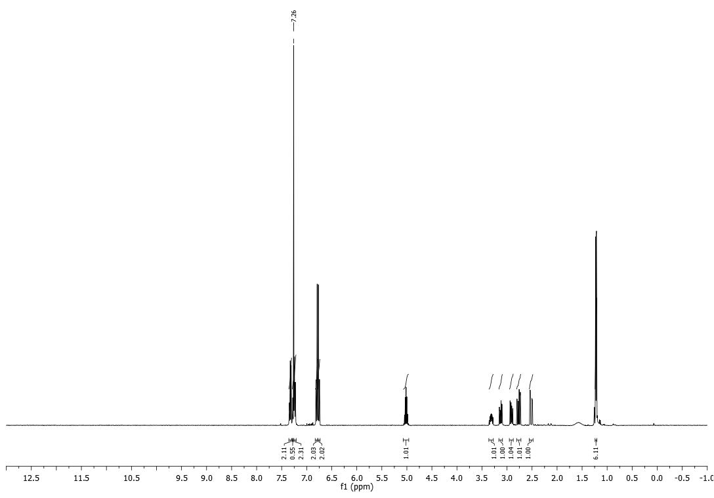
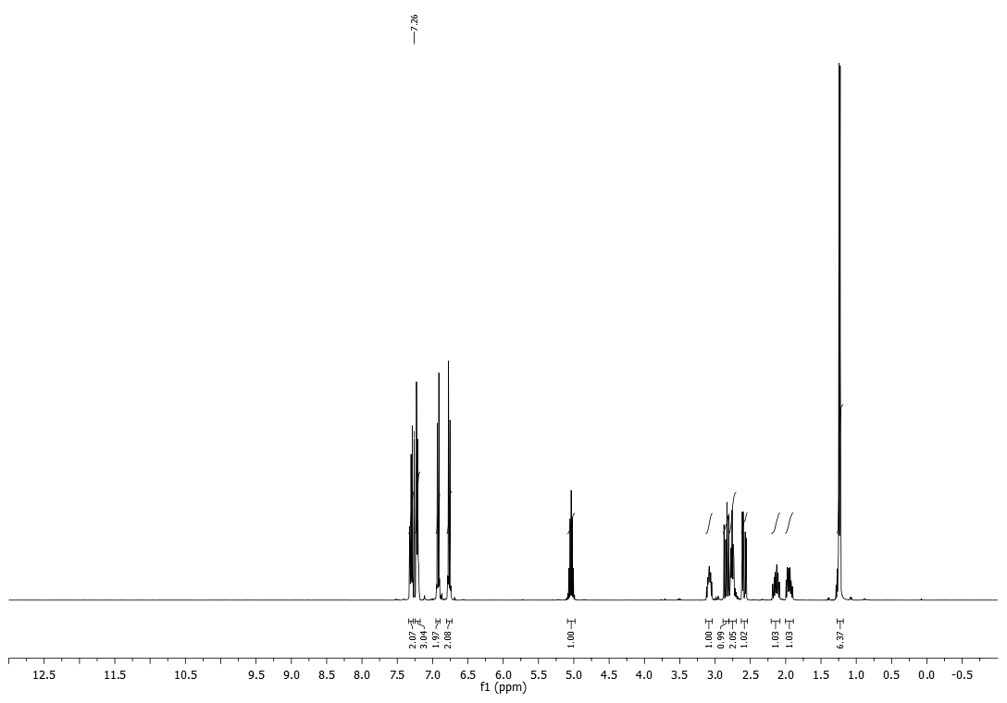
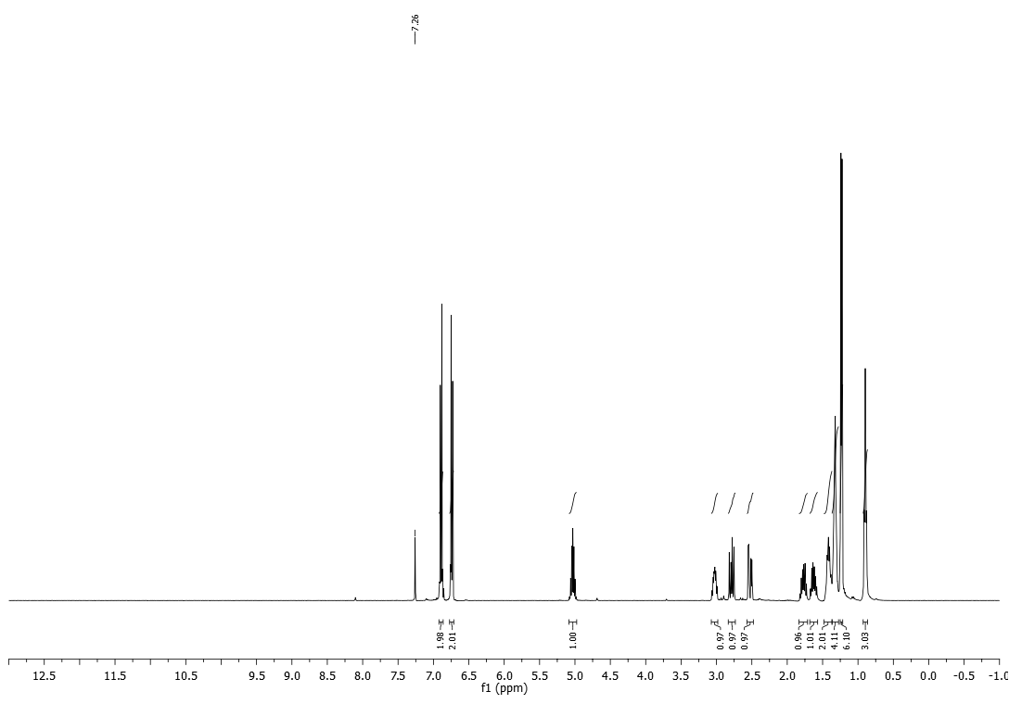
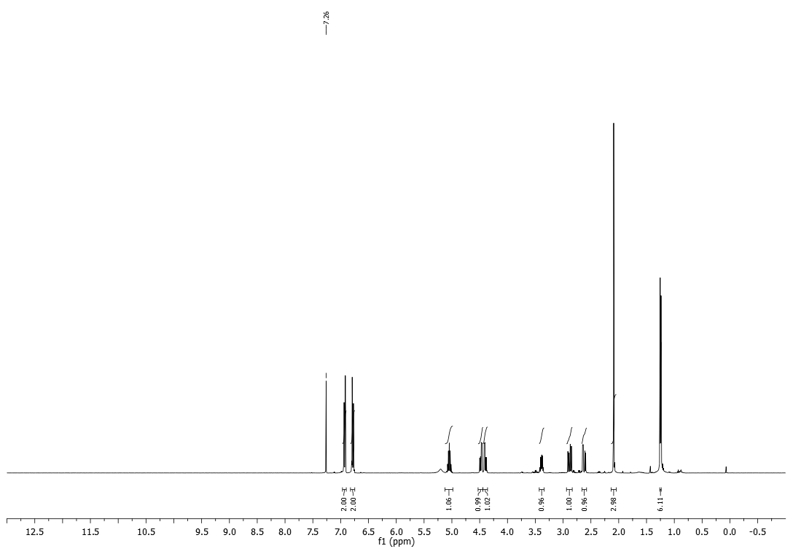
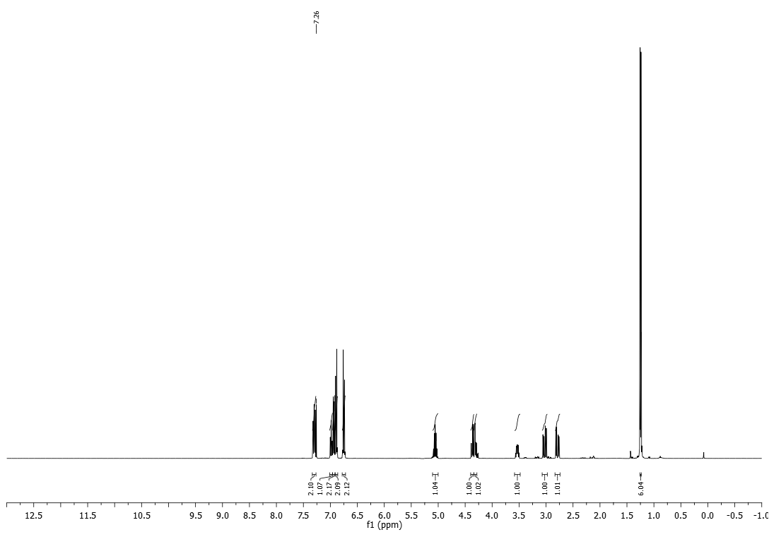
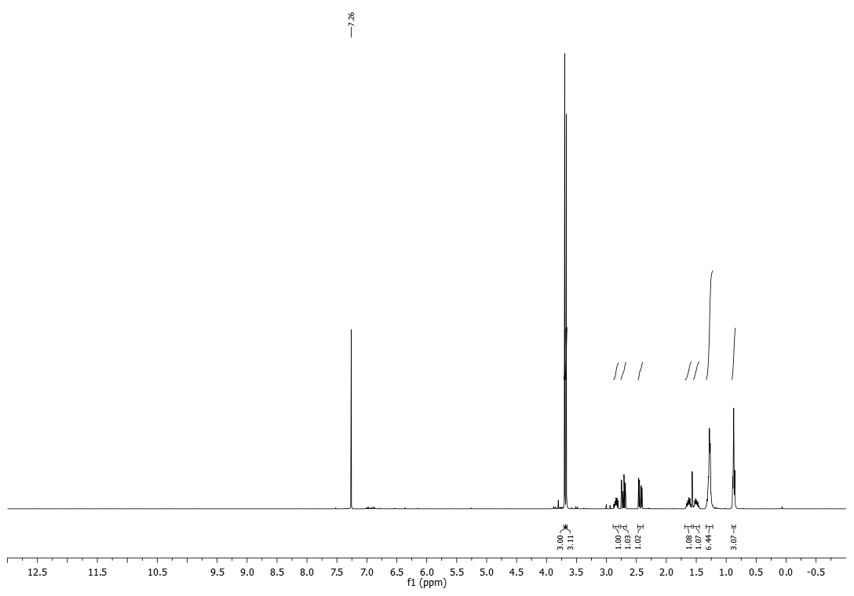
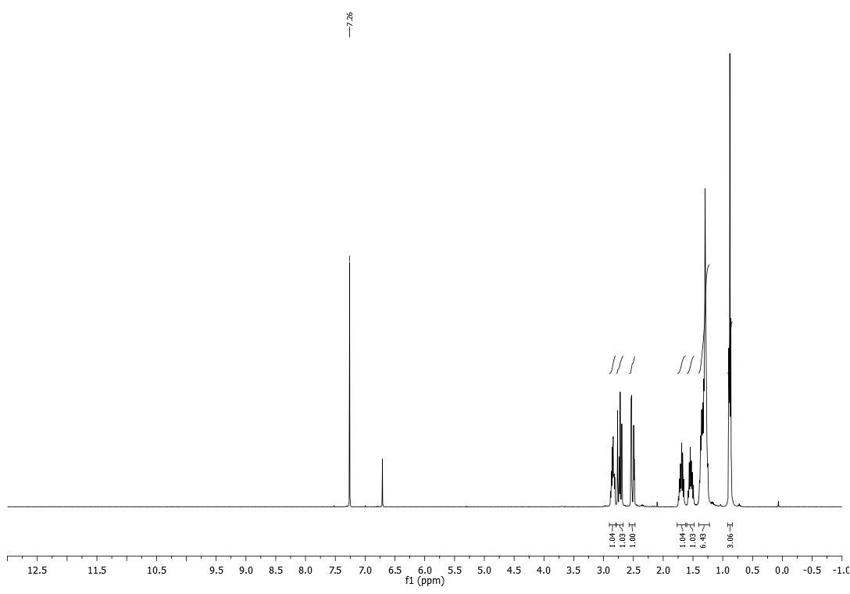

- Copies of ¹H and ¹³C NMR for the new compound 2h
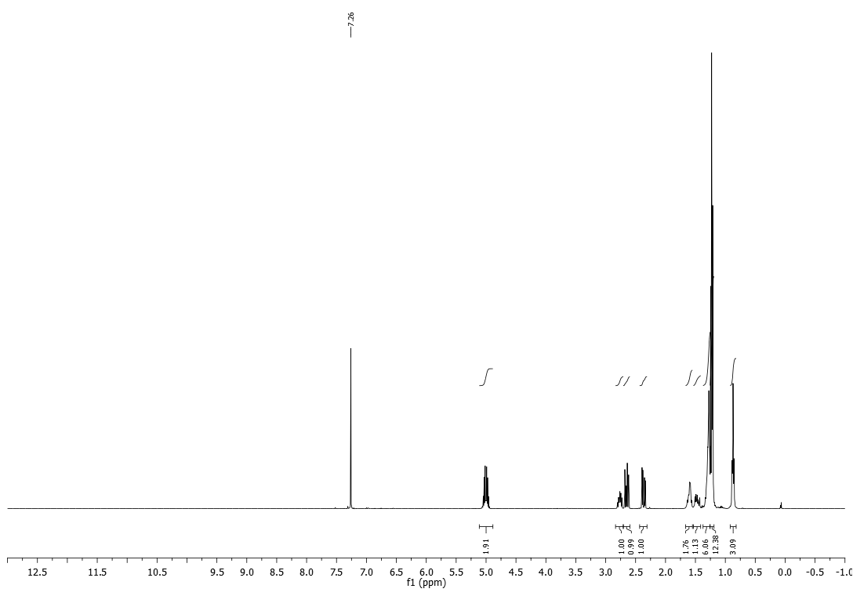
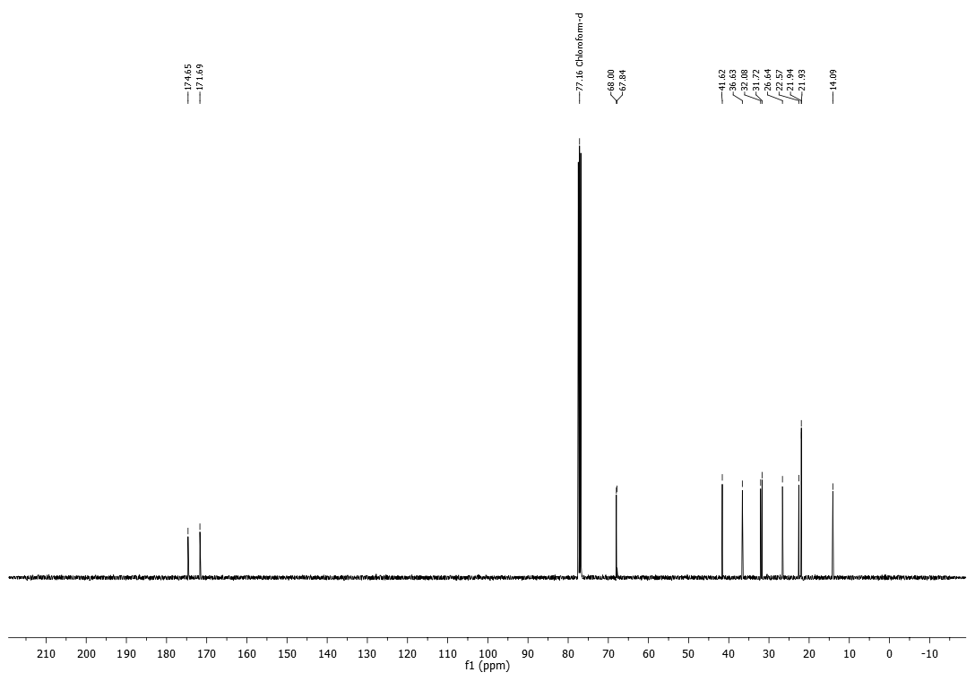

- HPLC/UV and HMRS analyses

1-(4-hydroxyphenyl) 4-isopropyl 2-phenylsuccinate (2a)

HPLC/UV Analysis:
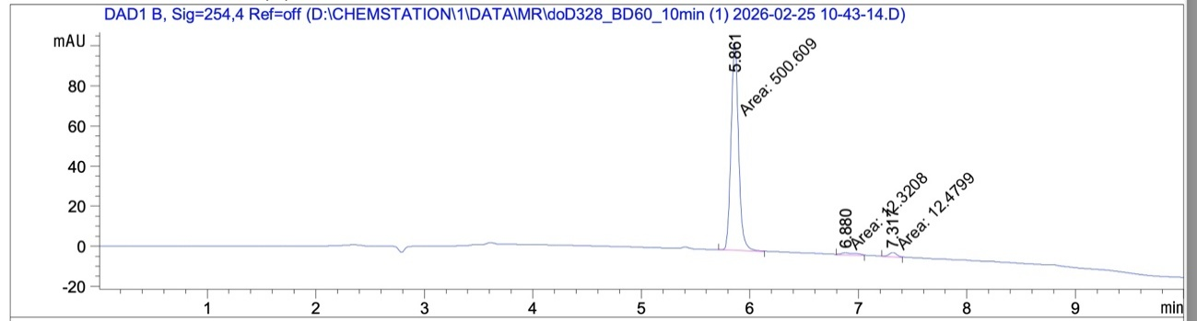
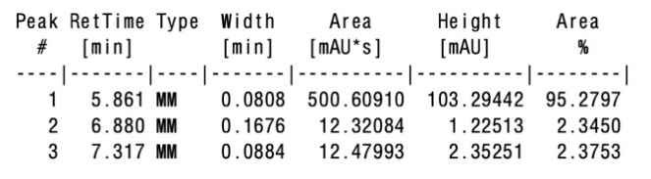

HRMS:
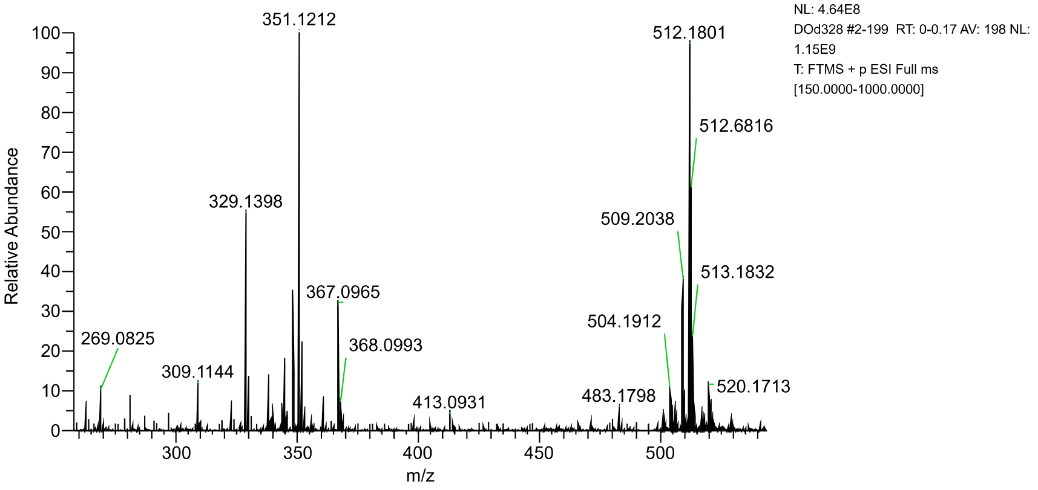

1-(4-hydroxyphenyl) 4-isopropyl 2-benzylsuccinate (2b)

HPLC/UV Analysis:
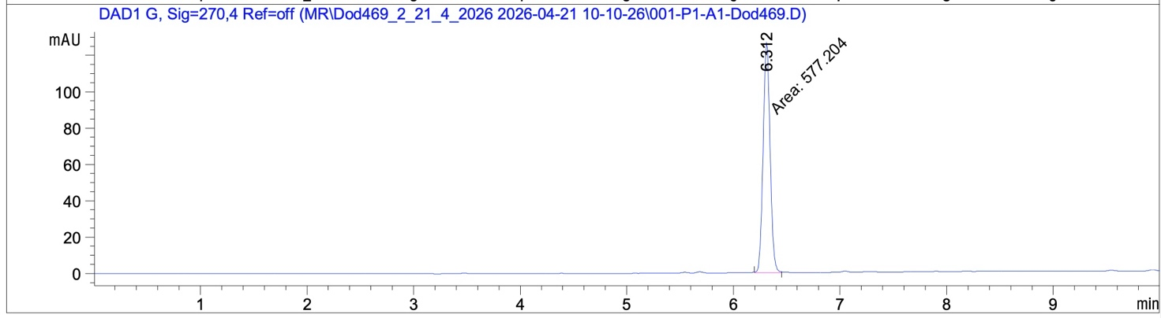
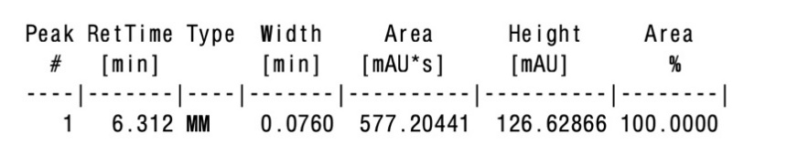
HRMS:
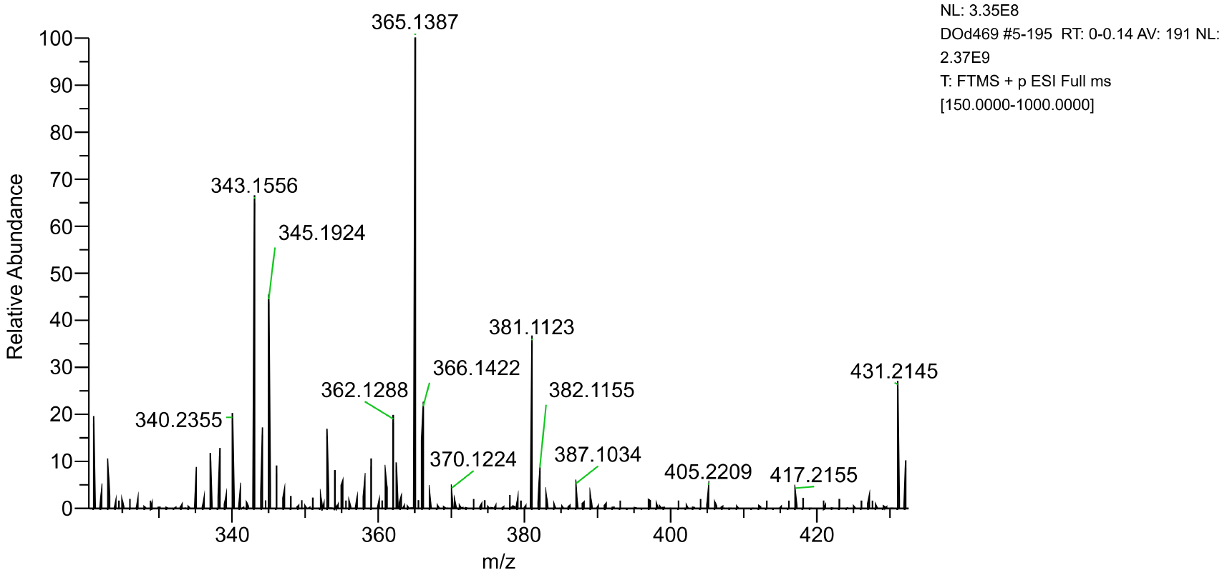

1-(4-hydroxyphenyl) 4-isopropyl 2-phenethylsuccinate (2c)

HPLC/UV Analysis:
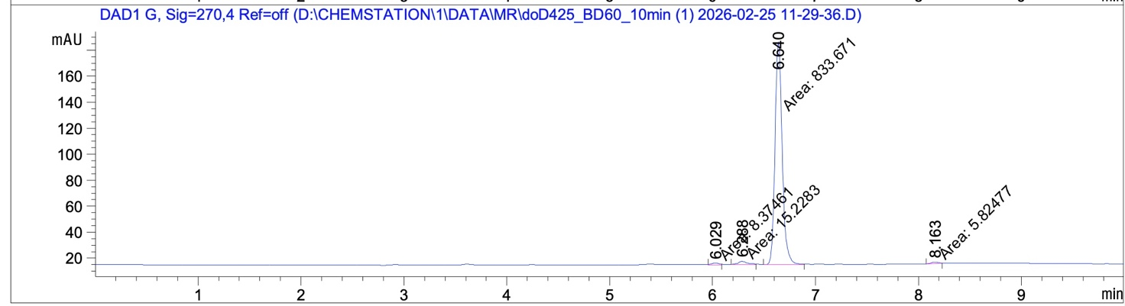
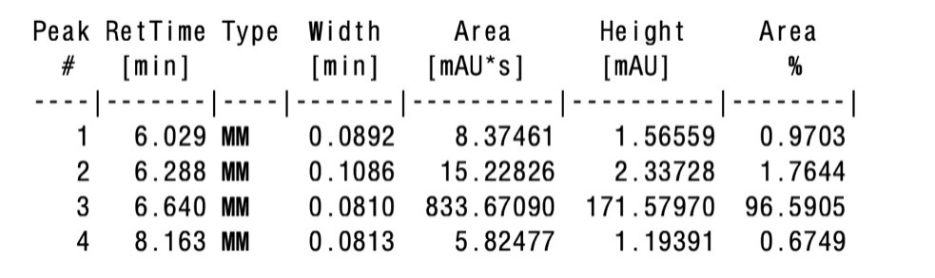

HRMS:

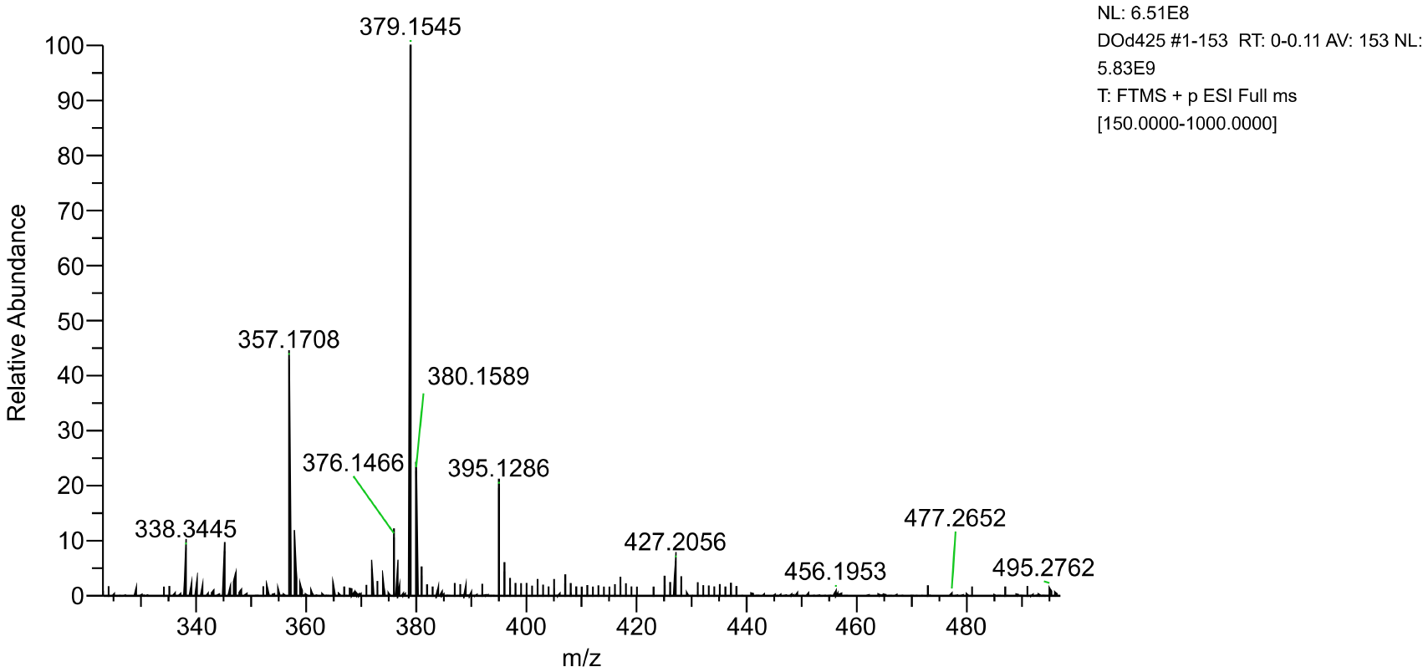

1-(4-hydroxyphenyl) 4-isopropyl 2-pentylsuccinate (2d)

HPLC/UV Analysis:
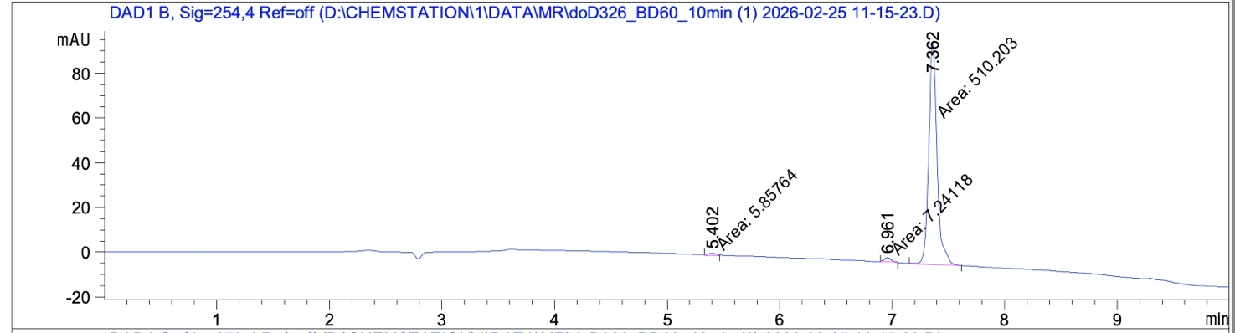
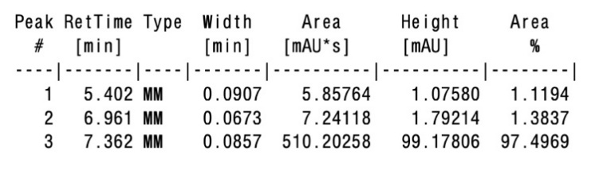

HRMS:
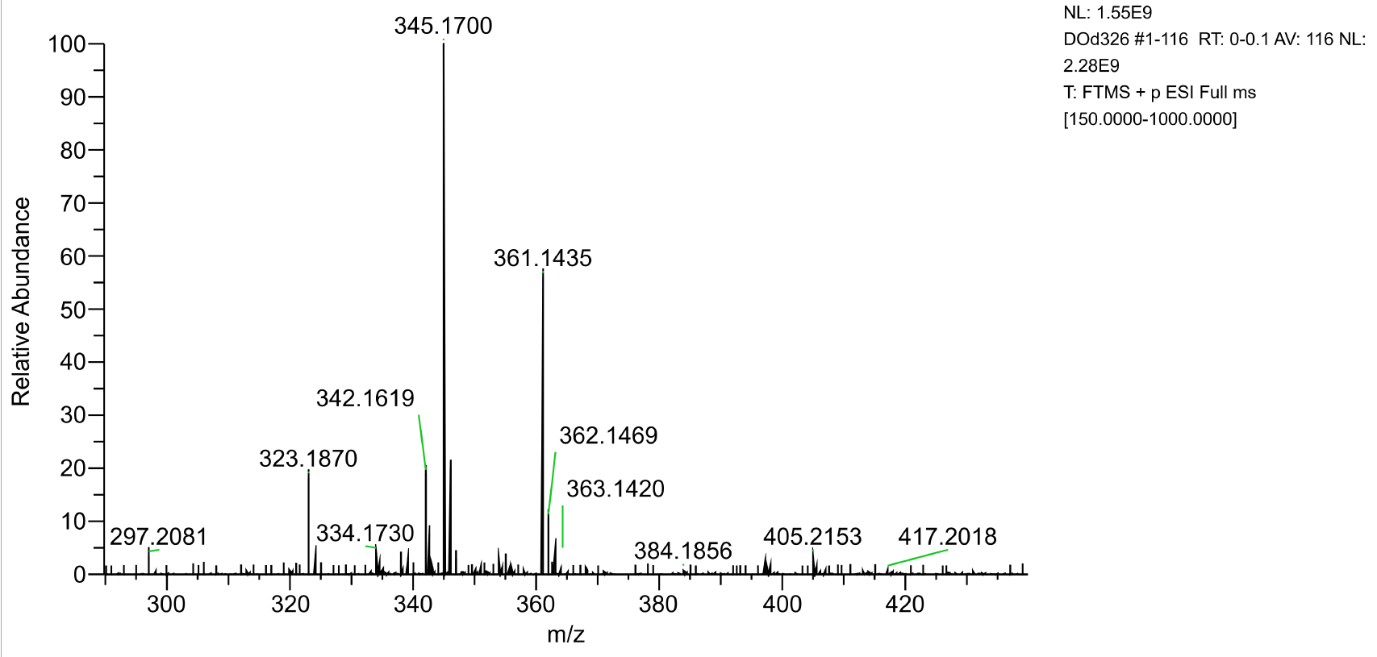

1-(4-hydroxyphenyl) 4-isopropyl 2-(acetoxymethyl)succinate (2e)

HPLC/UV Analysis:
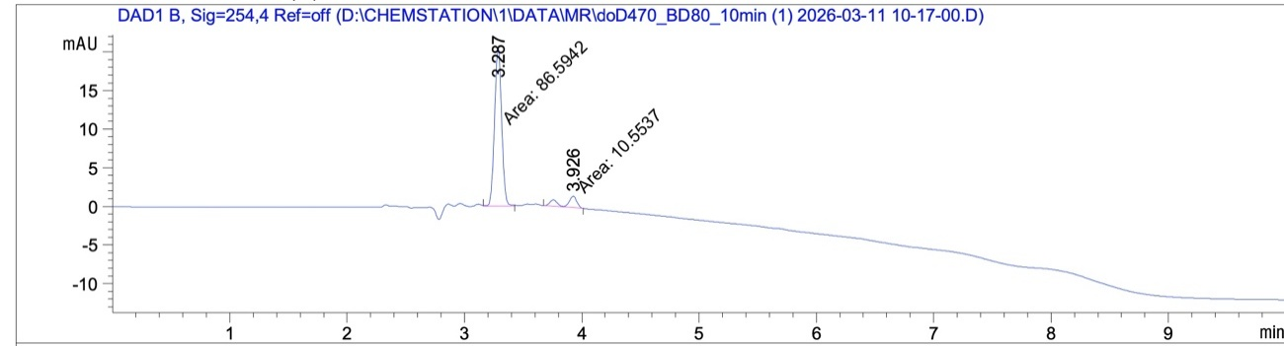
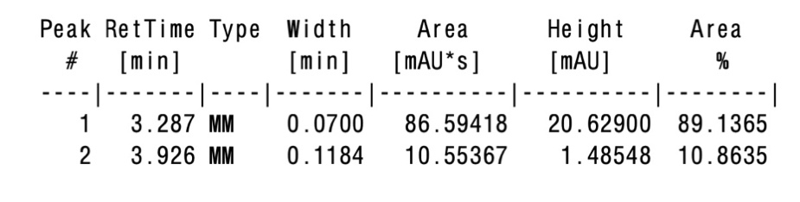

HRMS:
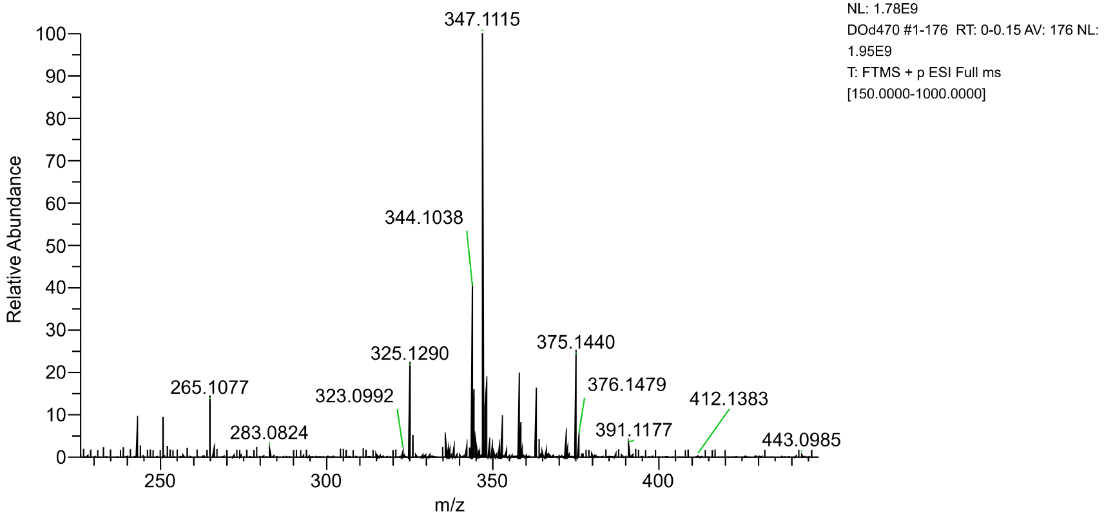

1-(4-hydroxyphenyl) 4-isopropyl 2-(phenoxymethyl)succinate (2f)

HPLC/UV Analysis:
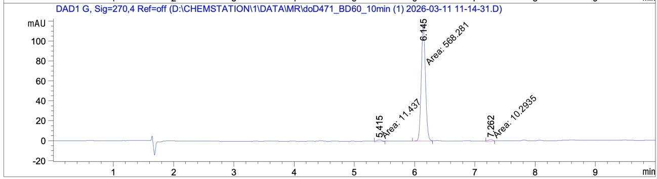
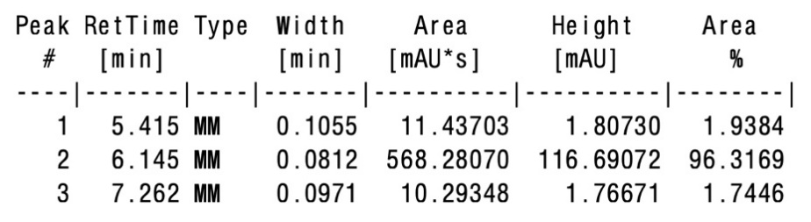

HRMS:
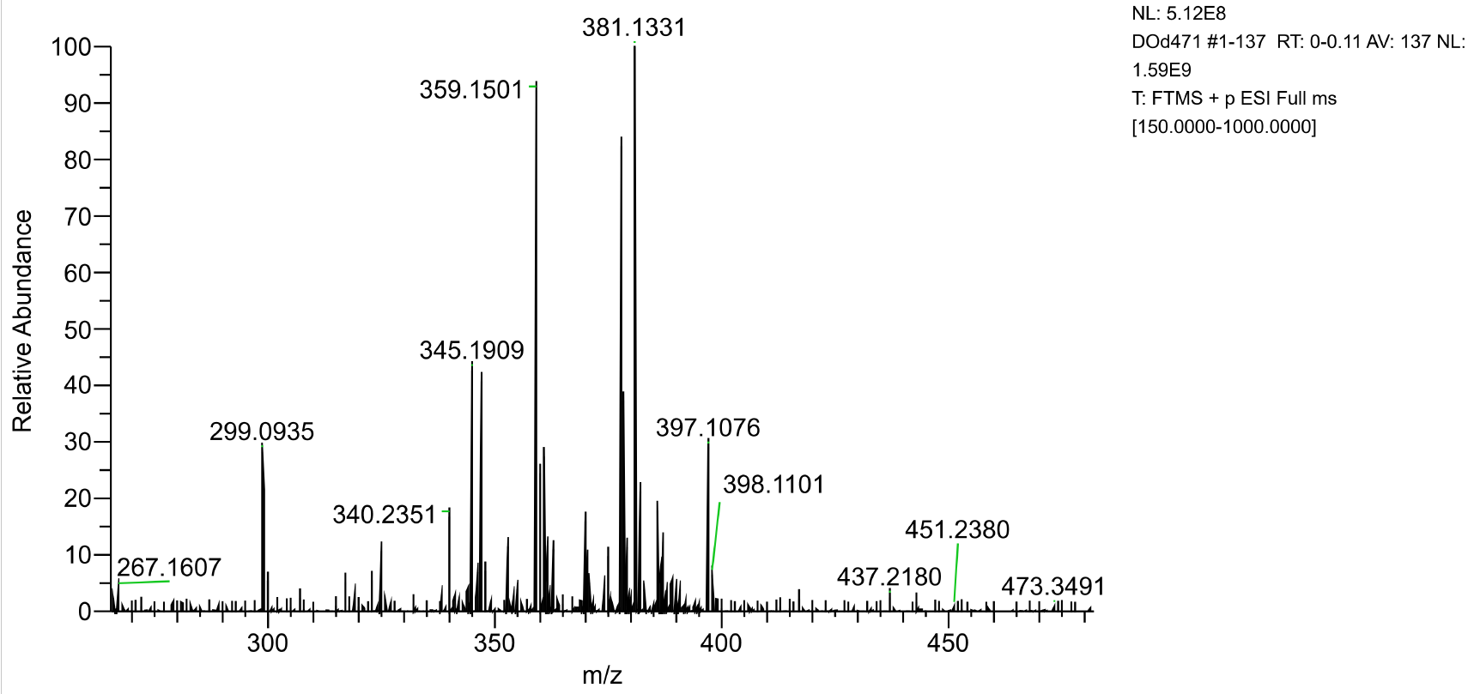

dimethyl 2-pentylsuccinate (2g)

HRMS:
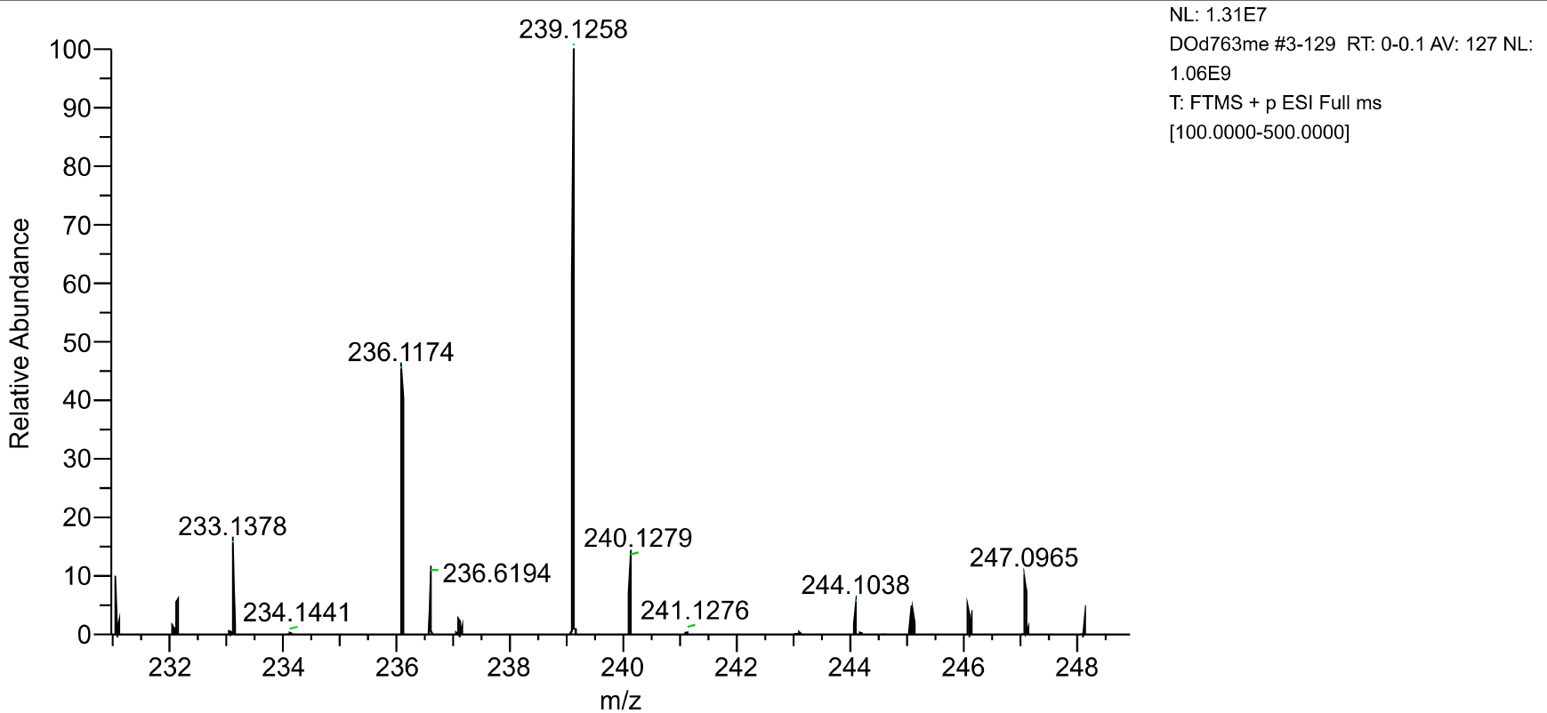

diisopropyl 2-pentylsuccinate (2h)

HRMS:
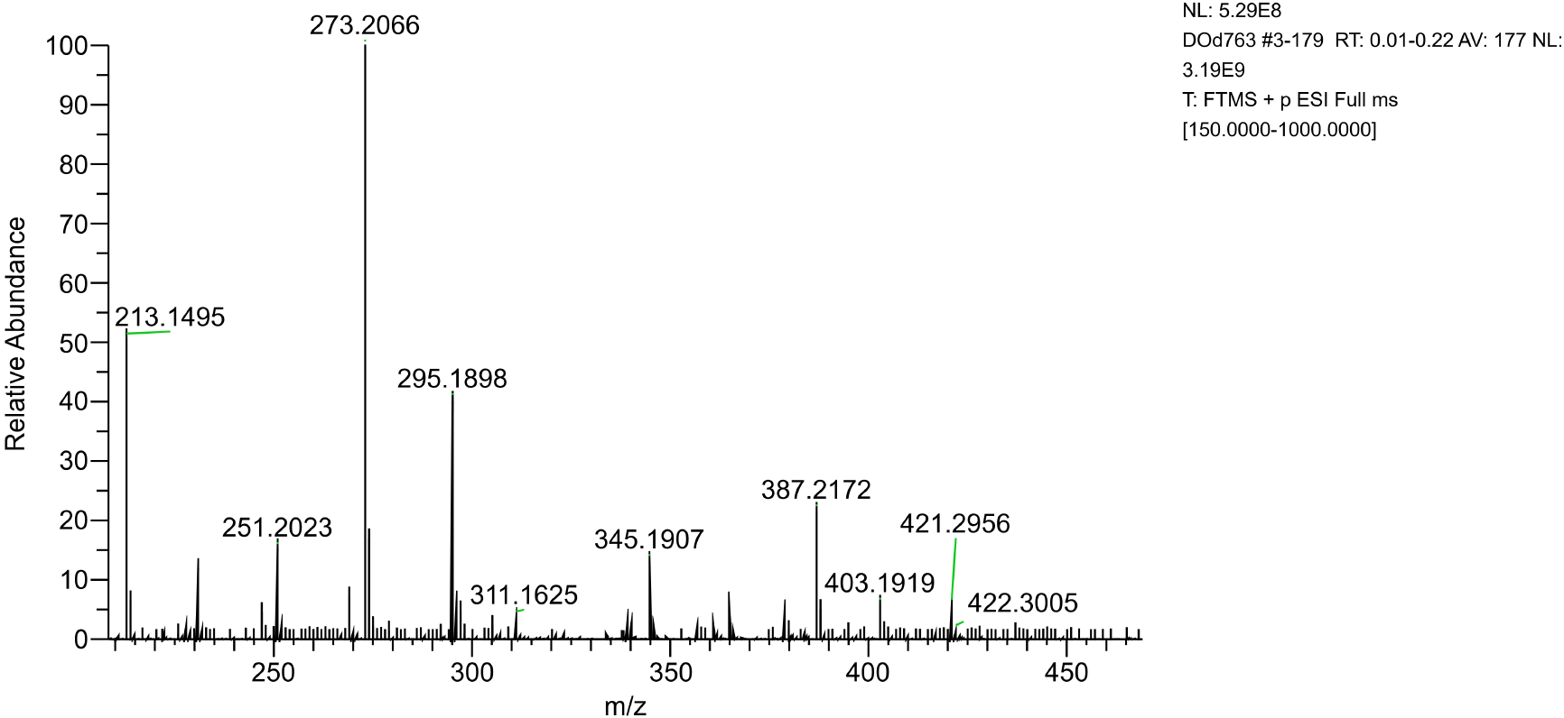

2-pentylsuccinic acid (2i)

HRMS:
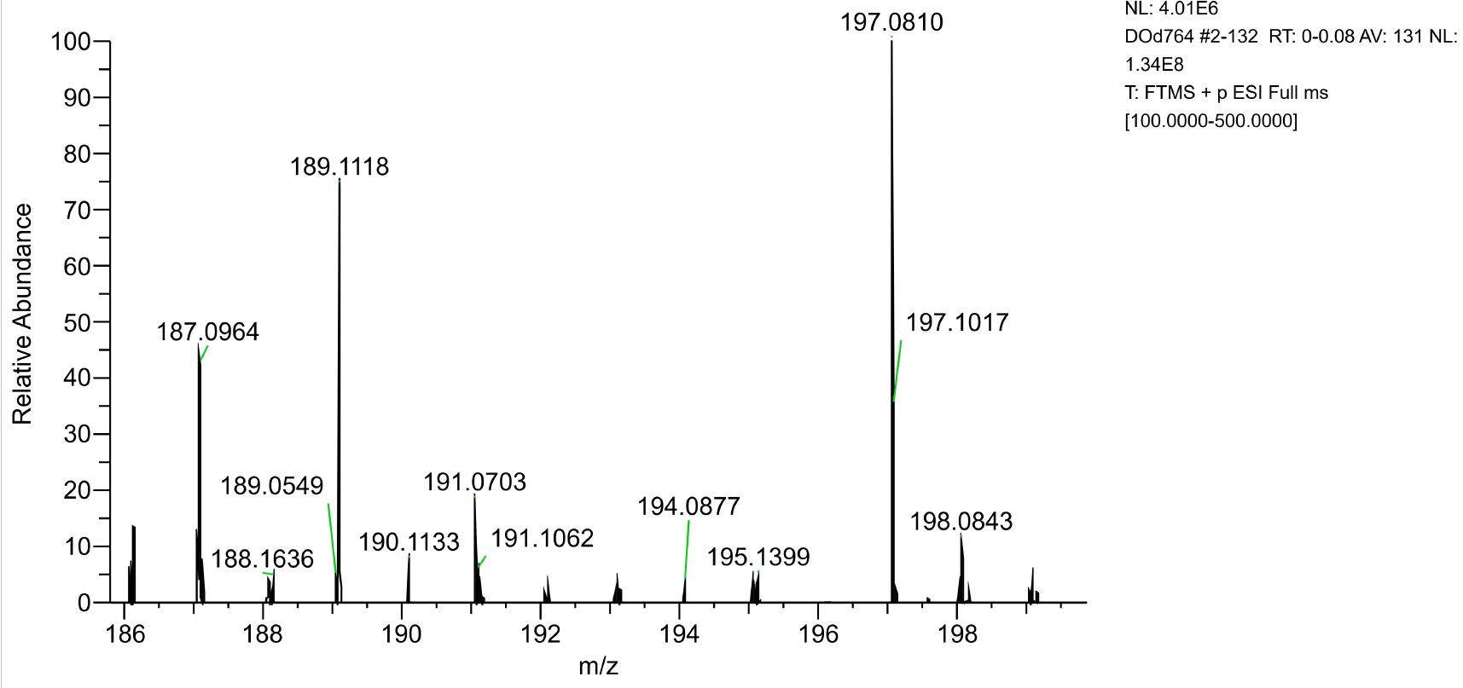

- MTT assay values.

Table S1 – MTT assay values
 | KATO III |  |  |  | AGS
 | C (μM) | Mean | SD | N | C (μM) | Mean | SD | N
2e | 300 | 29.07 | 0.91 | 3 | 120 | 89.47 | 7.92 | 3
2e | 150 | 80.70 | 0.36 | 3 | 60 | 130.20 | 5.76 | 3
2e | 75 | 89.50 | 1.87 | 3 | 30 | 118.80 | 3.56 | 3
2e | 37.5 | 103.40 | 5.46 | 3 | 15 | 121.80 | 2.49 | 3
2e | 18.8 | 109.10 | 3.43 | 3 | 7.5 | 112.40 | 3.21 | 3
2e | 9.4 | 102.70 | 6.96 | 3 | 3.8 | 99.30 | 3.03 | 3
2e | 4.7 | 107.00 | 1.42 | 3 | 1.9 | 93.53 | 12.64 | 3
2e | Ctrl | 100.00 | 1.65 | 3 | Ctrl | 100.00 | 3.22 | 3
2a | 350 | 31.33 | 2.25 | 3 | 450 | 41.33 | 5.37 | 3
2a | 175 | 29.40 | 7.30 | 3 | 225 | 29.17 | 2.84 | 3
2a | 87.5 | 68.30 | 4.33 | 3 | 112.5 | 80.33 | 6.85 | 3
2a | 43.8 | 100.00 | 1.32 | 3 | 56.3 | 111.50 | 7.05 | 3
2a | 21.9 | 109.60 | 6.82 | 3 | 28.1 | 122.70 | 5.66 | 3
2a | 10.9 | 107.10 | 1.89 | 3 | 14.1 | 120.10 | 7.91 | 3
2a | 5.5 | 112.80 | 6.85 | 3 | 7.0 | 120.70 | 10.53 | 3
2a | Ctrl | 100.00 | 4.39 | 3 | Ctrl | 100.00 | 1.13 | 3
2c | 120 | 8.37 | 0.61 | 3 | 120 | 13.93 | 10.89 | 3
2c | 60 | 48.17 | 6.70 | 3 | 60 | 62.00 | 12.37 | 3
2c | 30 | 103.50 | 3.35 | 3 | 30 | 108.00 | 1.05 | 3
2c | 15 | 112.40 | 7.57 | 3 | 15 | 119.00 | 1.08 | 3
2c | 7.5 | 103.10 | 4.05 | 3 | 7.5 | 109.80 | 3.70 | 3
2c | 3.8 | 96.07 | 7.04 | 3 | 3.8 | 99.73 | 6.28 | 3
2c | 1.9 | 94.20 | 8.26 | 3 | 1.9 | 90.60 | 5.47 | 3
2c | Ctrl | 100.00 | 1.65 | 3 | Ctrl | 100.00 | 3.91 | 3
2d | 60 | 6.07 | 1.10 | 3 | 120 | 6.37 | 0.21 | 3
2d | 30 | 49.17 | 0.29 | 3 | 60 | 5.10 | 0.46 | 3
2d | 15 | 71.13 | 5.22 | 3 | 30 | 68.00 | 0.78 | 3
2d | 7.5 | 75.33 | 6.96 | 3 | 15 | 86.83 | 0.83 | 3
2d | 3.8 | 81.60 | 14.90 | 3 | 7.5 | 94.33 | 2.58 | 3
2d | 1.9 | 91.43 | 2.27 | 3 | 3.8 | 95.30 | 2.17 | 3
2d | 0.9 | 83.53 | 14.58 | 3 | 1.9 | 94.73 | 3.58 | 3
2d | Ctrl | 100.00 | 7.30 | 3 | Ctrl | 100.00 | 2.10 | 3
2b | 100 | 83.80 | 26.23 | 3 | 80 | 116.90 | 6.10 | 3
2b | 50 | 88.50 | 6.41 | 3 | 40 | 121.10 | 16.29 | 3
2b | 25 | 93.67 | 6.35 | 3 | 20 | 137.90 | 21.71 | 3
2b | 12.5 | 92.40 | 4.15 | 3 | 10 | 125.30 | 3.89 | 3
2b | 6.3 | 96.97 | 8.32 | 3 | 5 | 125.10 | 10.76 | 3
2b | 3.1 | 99.60 | 10.39 | 3 | 2.5 | 106.30 | 4.12 | 3
2b | 1.6 | 96.73 | 7.63 | 3 | 1.3 | 110.50 | 3.66 | 3
2b | Ctrl | 100.00 | 31.28 | 3 | Ctrl | 100.00 | 12.42 | 3
2f | 60 | 92.63 | 20.67 | 3 | 60 | 106.50 | 3.09 | 3
2f | 30 | 105.70 | 11.12 | 3 | 30 | 136.30 | 6.49 | 3
2f | 15 | 96.97 | 2.94 | 3 | 15 | 145.40 | 3.20 | 3
2f | 7.5 | 97.60 | 7.96 | 3 | 7.5 | 143.70 | 4.96 | 3
2f | 3.8 | 94.27 | 2.42 | 3 | 3.8 | 129.70 | 0.17 | 3
2f | 1.9 | 96.57 | 0.78 | 3 | 1.9 | 125.40 | 3.59 | 3
2f | 0.9 | 89.50 | 3.76 | 3 | 0.9 | 124.70 | 10.10 | 3
2f | Ctrl | 100.00 | 15.20 | 3 | Ctrl | 100.00 | 4.33 | 3
2h | 240 | 94.20 | 8.31 | 3 | 240 | 72.23 | 2.55 | 3
2h | 120 | 96.70 | 23.31 | 3 | 120 | 123.10 | 12.83 | 3
2h | 60 | 113.30 | 8.73 | 3 | 60 | 131.80 | 23.46 | 3
2h | 30 | 116.50 | 7.40 | 3 | 30 | 140.00 | 15.21 | 3
2h | 15 | 111.70 | 6.07 | 3 | 15 | 125.50 | 4.99 | 3
2h | 7.5 | 109.40 | 8.17 | 3 | 7.5 | 121.90 | 4.01 | 3
2h | 3.8 | 94.63 | 15.16 | 3 | 3.8 | 111.90 | 11.81 | 3
2h | Ctrl | 100.00 | 1.30 | 3 | Ctrl | 100.00 | 2.54 | 3
2i | 240 | 114.00 | 7.85 | 3 | 240 | 119.10 | 4.40 | 3
2i | 120 | 111.60 | 2.01 | 3 | 120 | 121.70 | 3.89 | 3
2i | 60 | 112.20 | 5.42 | 3 | 60 | 116.00 | 3.92 | 3
2i | 30 | 113.70 | 3.72 | 3 | 30 | 126.30 | 2.07 | 3
2i | 15 | 114.20 | 2.65 | 3 | 15 | 119.80 | 4.84 | 3
2i | 7.5 | 106.90 | 6.41 | 3 | 7.5 | 111.30 | 3.65 | 3
2i | 3.8 | 104.90 | 0.85 | 3 | 3.8 | 111.20 | 4.97 | 3
2i | Ctrl | 100.00 | 4.45 | 3 | Ctrl | 100.00 | 7.80 | 3
2G | 240 | 101.90 | 0.29 | 3 | 240 | 93.87 | 1.75 | 3
2G | 120 | 108.00 | 3.75 | 3 | 120 | 123.90 | 0.81 | 3
2G | 60 | 106.00 | 2.44 | 3 | 60 | 121.80 | 10.55 | 3
2G | 30 | 106.60 | 4.09 | 3 | 30 | 127.90 | 6.26 | 3
2G | 15 | 105.20 | 5.83 | 3 | 15 | 127.90 | 8.46 | 3
2G | 7.5 | 103.80 | 4.75 | 3 | 7.5 | 109.00 | 4.52 | 3
2G | 3.8 | 104.80 | 3.44 | 3 | 3.8 | 118.00 | 11.15 | 3
2G | Ctrl | 100.00 | 7.14 | 3 | Ctrl | 100.00 | 1.36 | 3
MTT assay values of cell viability expressed as percentage relative to untreated controls. Values for each tested concentration represent the mean of three replicates (N) ± SD.

- Proposed Molecular Mechanism

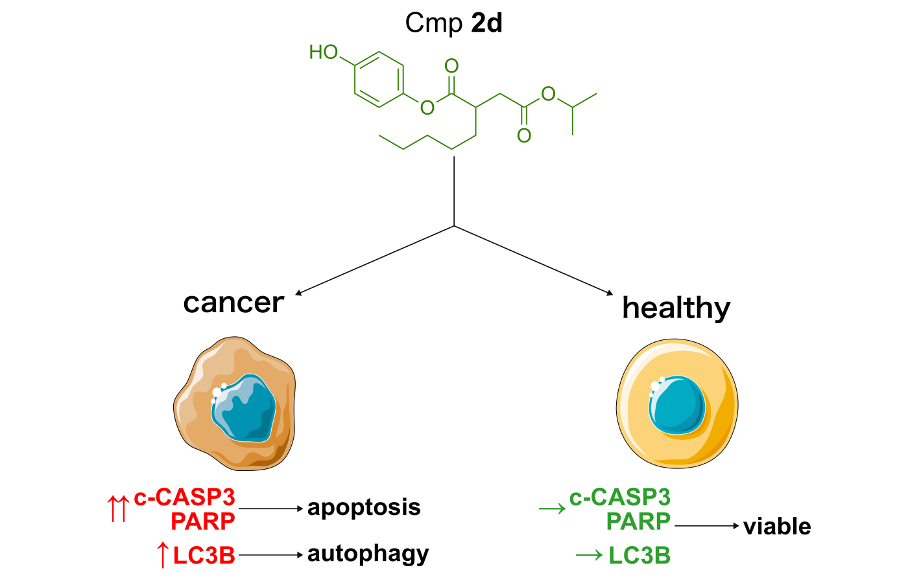
Figure S1 - Mechanistic pathway diagram summarizing the proposed molecular events

- References

- D. Olivieri, R. Tarroni, S. Zacchini, et al., Regioselective one-step alkoxy-aryloxycarbonylation of alkenes, J Catal 421 (2023) 431-440, https://doi.org/10.1016/j.jcat.2023.03.008

- F. Fini, M. Beltrani, R. Mancuso, et al., Selective Aryl α-Diimine/Palladium-Catalyzed Bis-Alkoxy- carbonylation of Olefins for the Synthesis of Substituted Succinic Diesters Adv Synth Catal 357 (2015) 177-184, https://doi.org/10.1002/adsc.201400501

- D. Olivieri, F. Fini, R. Mazzoni, et al., Diastereospecific Bis-alkoxycarbonylation of 1,2- Disubstituted Olefins Catalyzed by Aryl α-Diimine Palladium(II) Catalysts, Adv Synth Catal 360 (2018) 3507-3517, https://doi.org/10.1002/adsc.201701597

- R. Ballini, G. Bosica, D. Fiorini, P. Righi, Nitroalkanes and Dimethyl Maleate as Source of 3-Alkyl Succinic Anhydrides and (E)-3-Alkylidene Succinic Anhydrides, Synthesis 5 (2002) 0681-0685, https://doi.org/10.1055/s-2002-23548

