Supporting Information

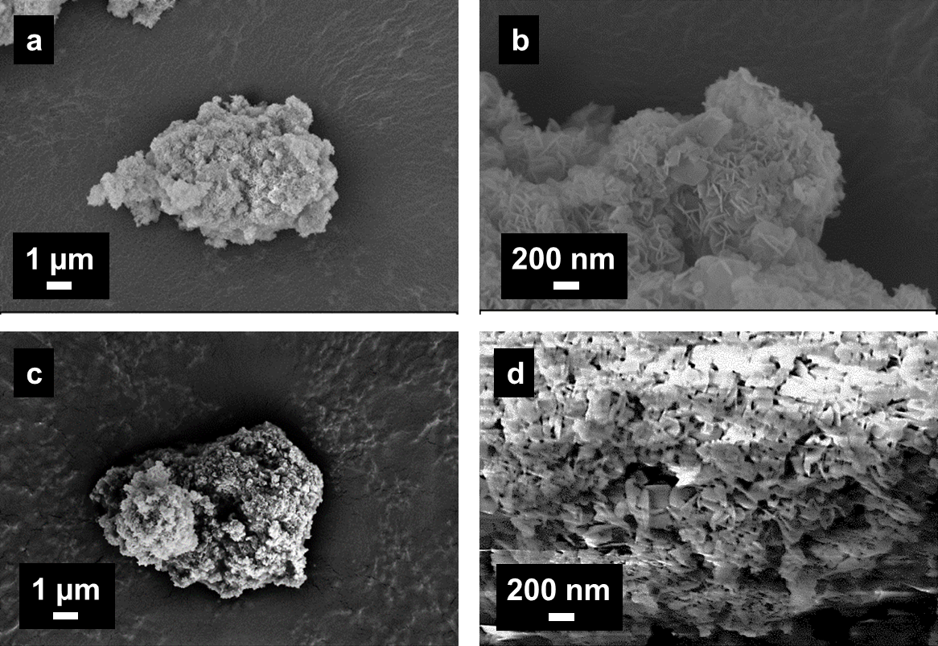
Figure S1 - FE-SEM images of powder particles of CuMgAl-LDH (a, b) and CuMgFe-LDH (c, d).
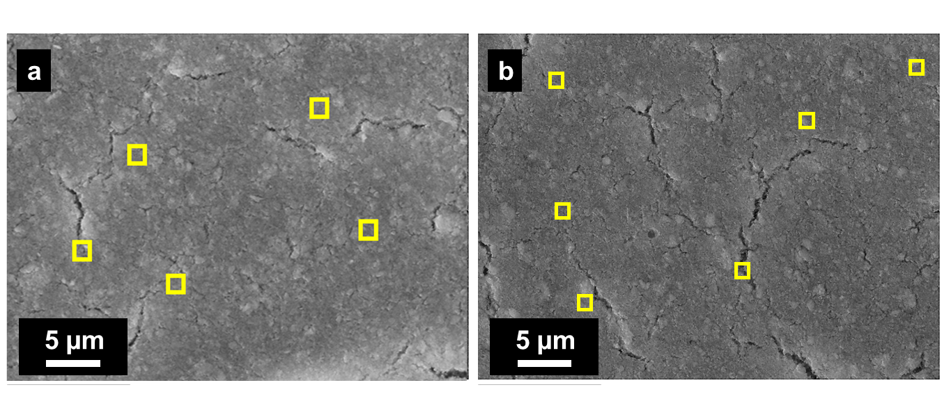

Figure S2 - Punctual EDX analysis on pristine photocathodes: a) CuMgAl-LDH; b) CuMgFe-LDH

Table S1 - Element atomic percentage calculated by EDX analyses on pristine photocathodes
- CuMgAl LDH |  | - CuMgFe LDH
Element | Atomic % | Element | Atomic %
Cu | 13.8 ± 0.3 | Cu | 14.7 ± 0.2
Mg | 7.1 ± 0.2 | Mg | 6.9 ± 0.2
Al | 6.8 ± 0.2 | Fe | 6.8 ± 0.5
O | 56.6 ± 0.4 | O | 50.4 ± 0.8
C | 15.4 ± 0.6 | C | 21.1 ± 0.7

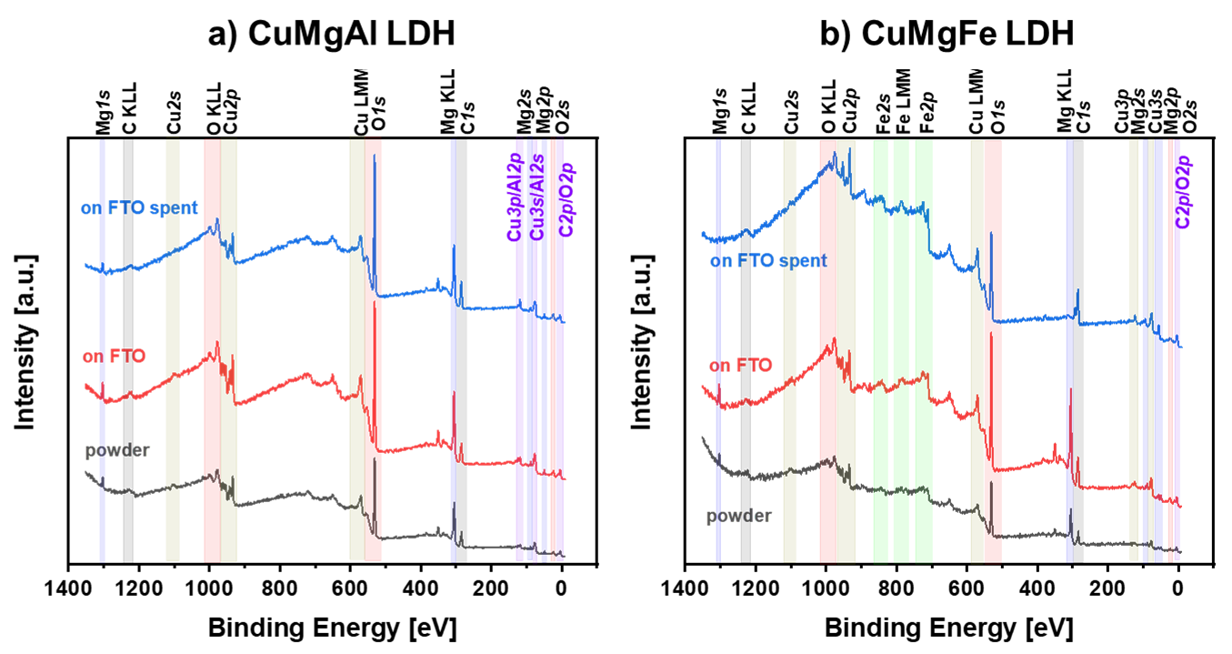

Figure S3 - XPS Survey spectra: a) CuMgAl-LDH; b) CuMgFe-LDH.

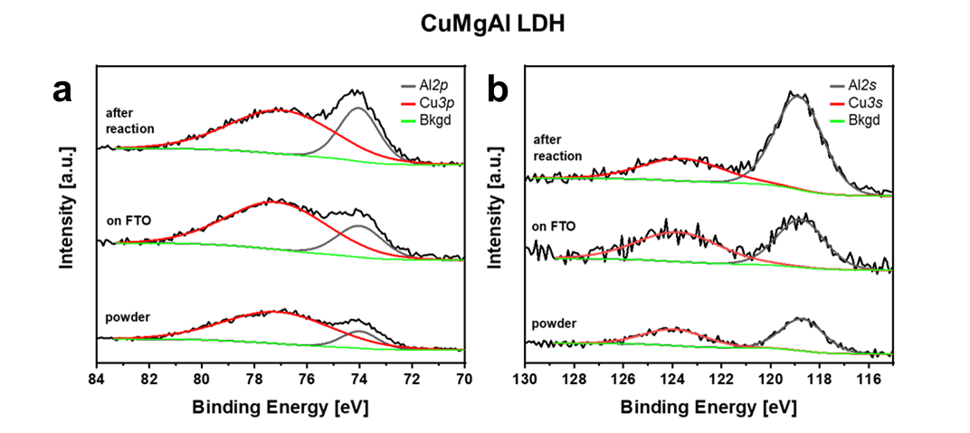

Figure S4 - XPS High-resolution spectra of CuMgAl-LDH showing the overlapping between Al and Cu core levels: a) Al 2p and Cu3p and b) Al 2s and Cu 3s.

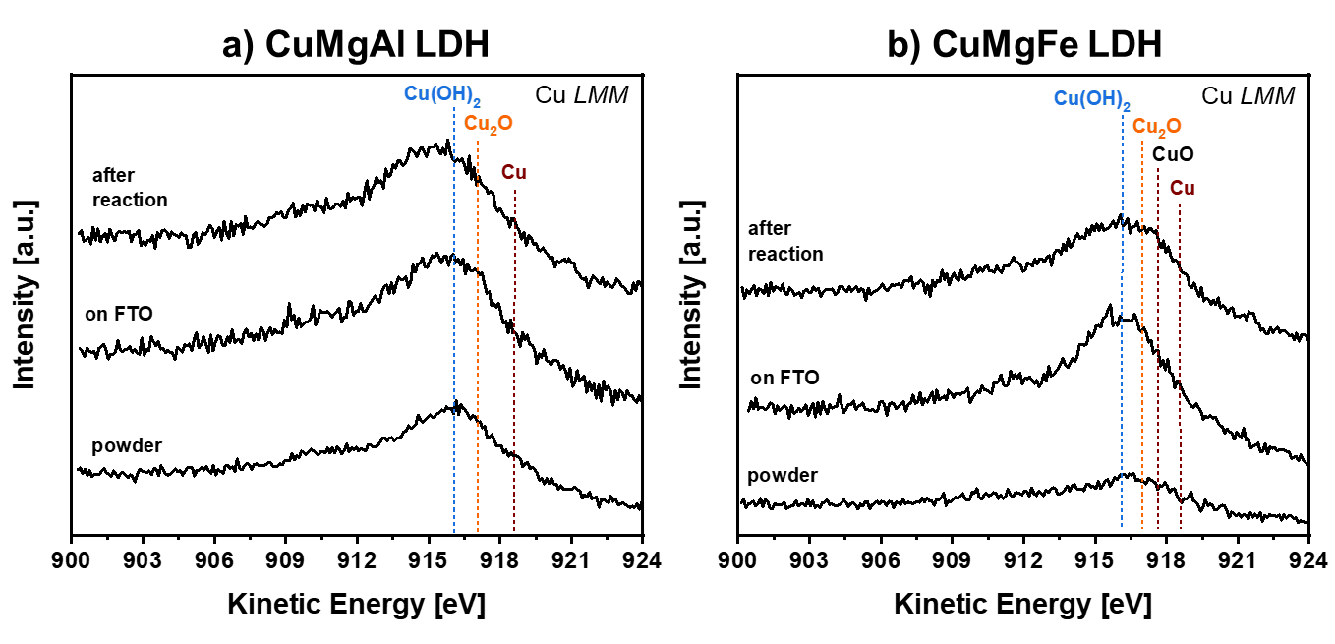

Figure S5 - High-resolution spectra in the Cu LMM electronic transition region for: a) CuMgAl-LDH and b) CuMgFe-LDH.
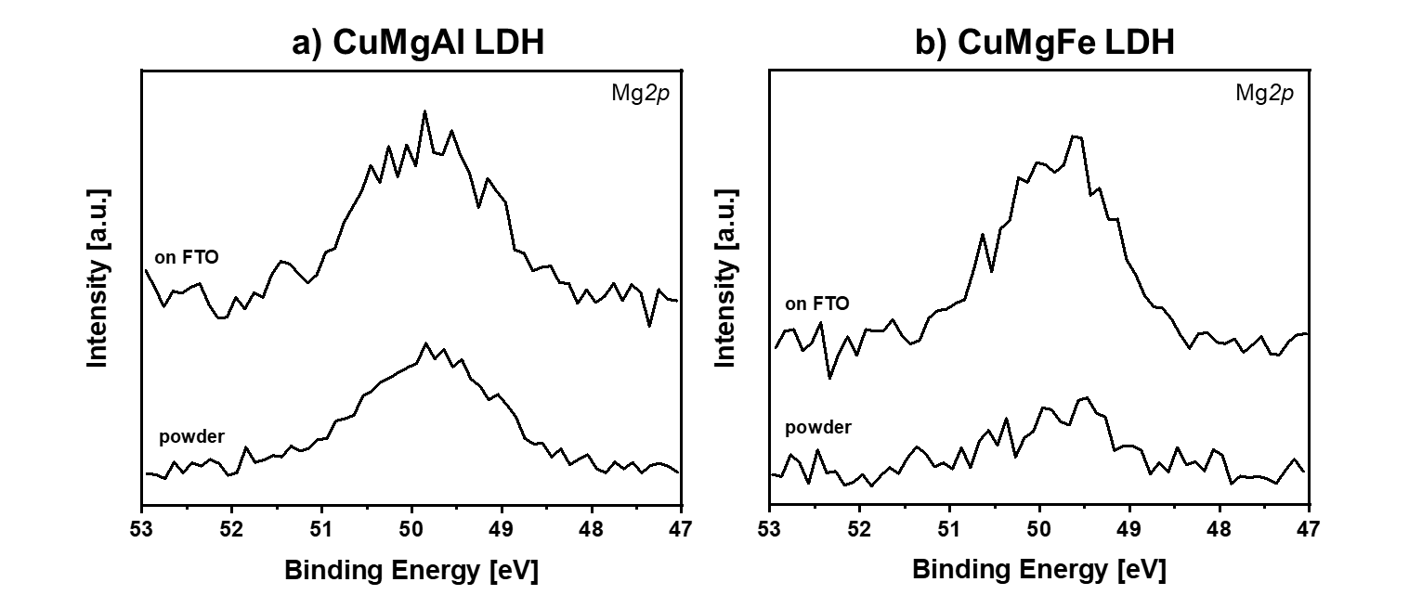

Figure S6 - High-resolution XPS spectra of the core levels Mg 2p for a) CuMgAl-LDH and b) CuMgFe-LDH.
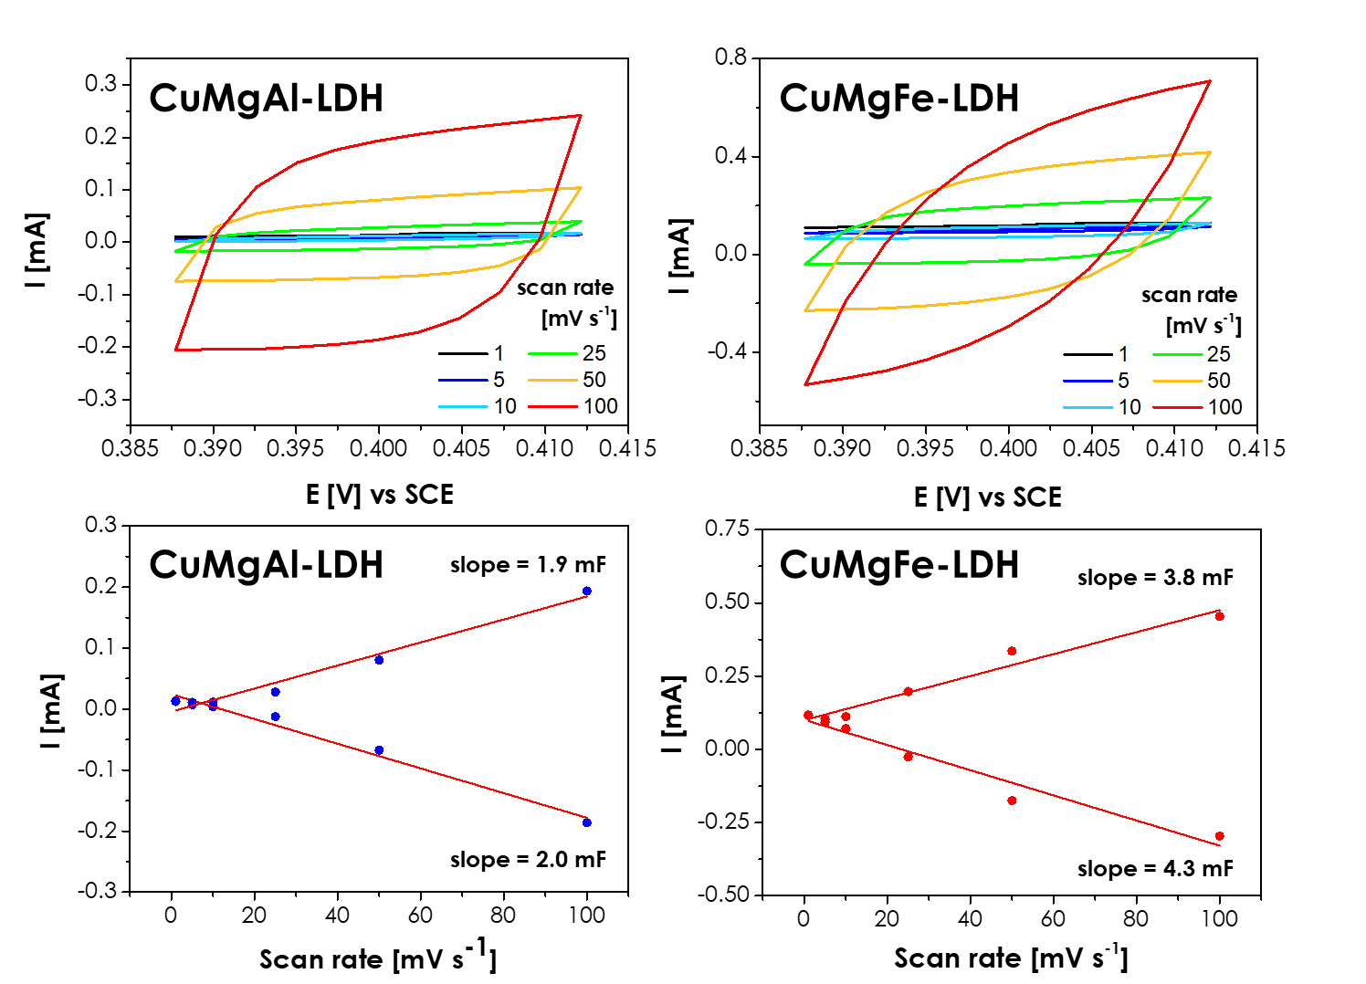
Figure S7 - CV curves for prepared photoelectrodes in 1 M NaOH aqueous solution at different scan rates, and their corresponding plots for electrochemical double layer capacitance. The double-layer capacitance of the system is taken as the average of the absolute value of the slope of the linear fits to the data.

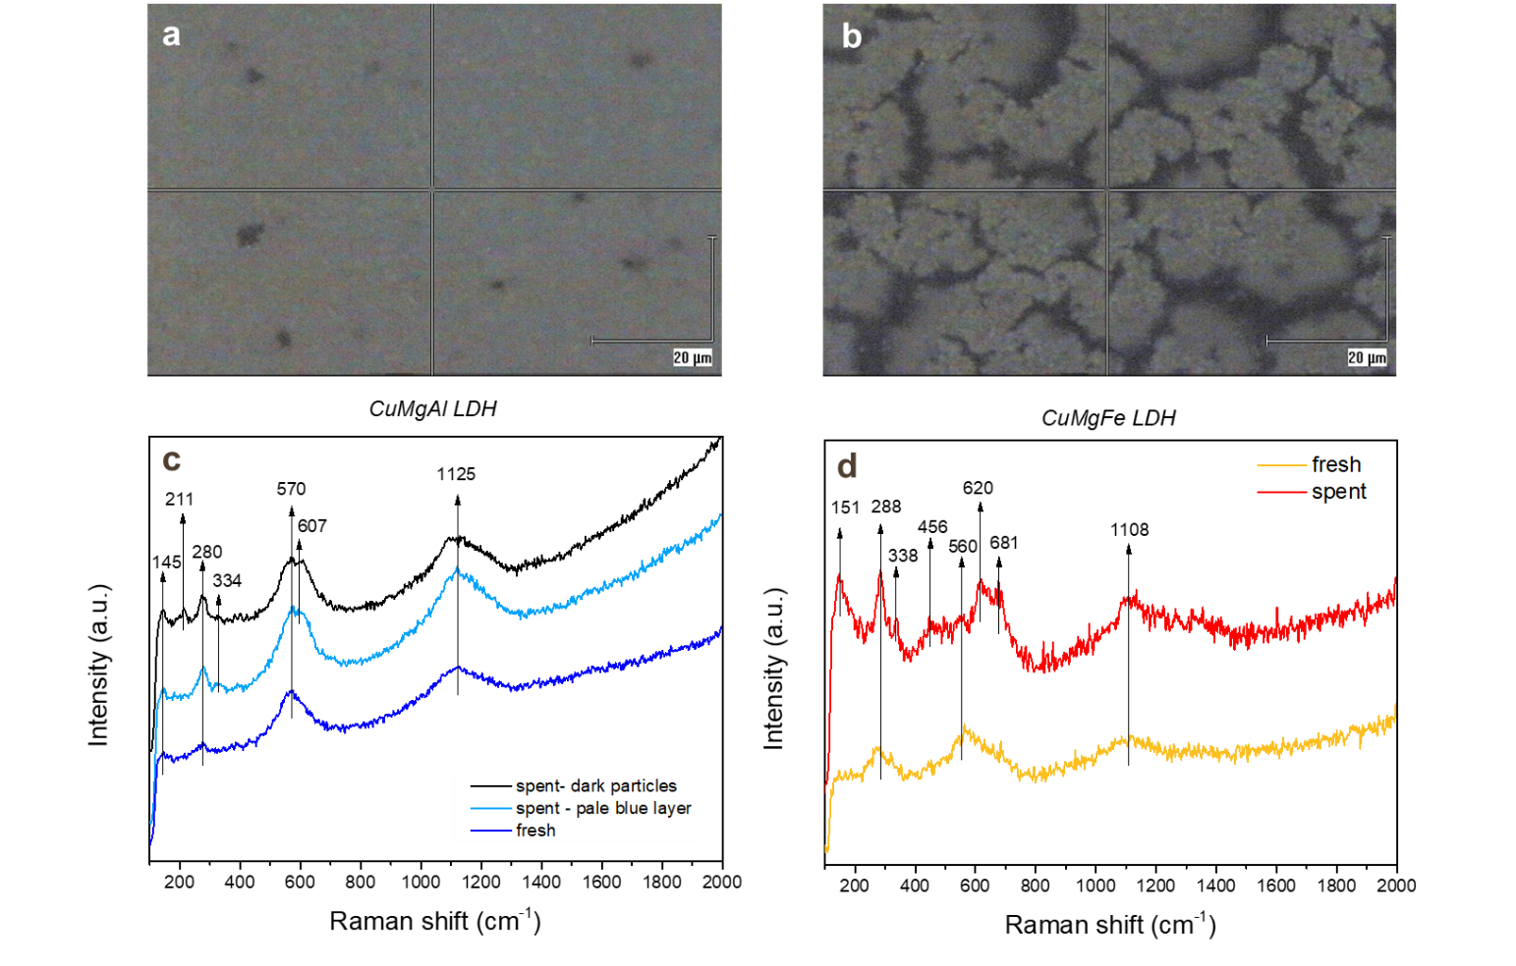
Figure S8 - Optical microscope images of spent CuMgAl-LDH (a) and CuMgFe-LDH (b) and related Raman spectra (c, d).
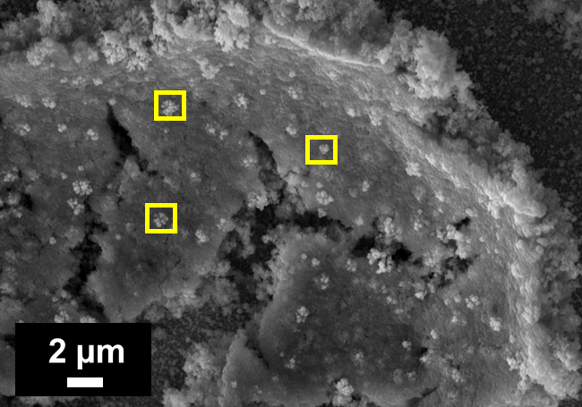
Element | Atomic % (yellow spots)
Cu | 23 ± 2
Mg | 0.20 ± 0.03
Fe | 7 ± 2
O | 42 ± 2
C | 27 ± 3

Figure S9 - Punctual EDX analysis on cubic particles of spent CuMgFe-LDH photocathode.

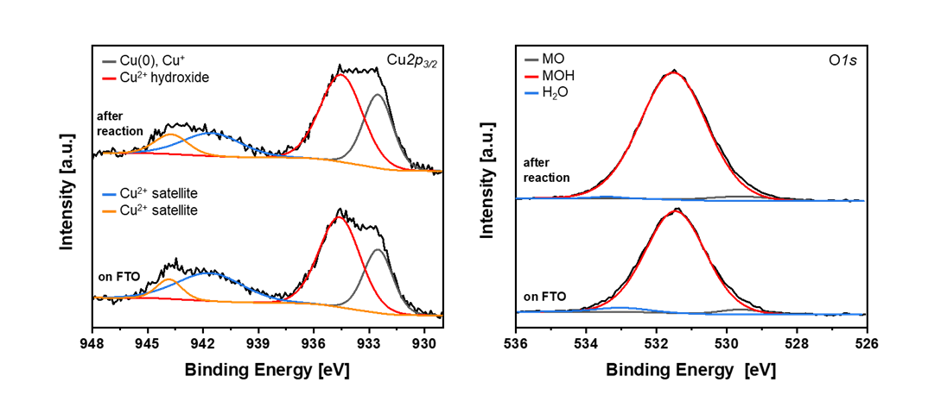
Figure S10 - High-resolution XPS spectra of fresh and spent CuMgAl-LDH/FTO for the core levels Cu 2p_{3/2} (left) and O 1s (right).
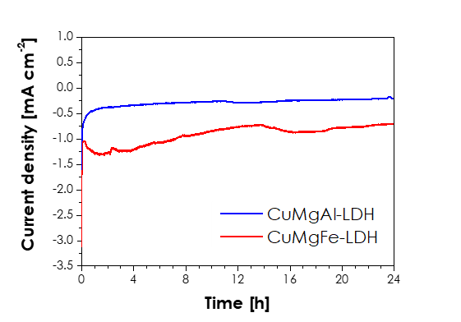
Figure S11 – 24 h tests carried out at –0.4 V vs RHE in 0.3M KHCO₃ saturated with CO₂ for the CuMgAl-LDH and CuMgFe-LDH photocathodes.
Table S2 - Reported studies on CO₂ photoelectrocatalytic reduction to C₂₊ over Cu-based catalysts.
Photocathode | Conditions | Current density | Performance | Stability | Ref.
CuFeO₂/CuO on FTO | 0.1 M NaHCO₃, - 0.4 V vs. Ag/ AgCl, white light LED  (100 mW cm⁻²) | 0.1 mA cm⁻² | Acetic acid  0.19 µmol h⁻¹ cm⁻²  FE: 80% | 10 min | [1]
Cu₂O/Ag on Cu foil | 0.1 M KHCO3,  - 0.7 V vs RHE, CO₂-sat., Xe arc lamp  (100 mW cm⁻²) | 3 mA cm⁻² | Acetic acid  212.7 µmol h⁻¹ cm⁻²  FE: 47.7% | 12 h | [2]
Cu/Cu2O/CuO/Pd NRs on Cu foam | 0.1 M KHCO_{3,} - 1.4 V vs RHE, CO₂-sat., Xe arc lamp (100 mW cm⁻²) | 26 mA cm⁻² | Acetic acid  FE: 21.4%  Ethanol  FE: 3% | 5 h | [3]
Cu2O/CuFeO2 on FTO | 0.5 M KHCO₃, + 0.35 V vs RHE, CO₂-sat., Xe arc lamp (100 mW cm⁻²) | 1.1 mA cm⁻² | Acetic acid  FE: 68.6% | 10 sweep | [4]
Ag-supported dendritic Cu on n⁺/n⁻Si | 0.1 M CsHCO₃, -1 vs RHE, CO₂ flux, Xe arc lamp (100 mW cm⁻²) | 27.7 mA cm⁻² | Ethanol  10.8 µmol h⁻¹ cm⁻²  FE: 12.5 %  1-Propanol  4.88 µmol h⁻¹ cm⁻²  FE: 8.5 % | 48 h | [5]
CuN_{x-M}/CuO on FTO | 0.1 M KHCO3,  0.2 V vs RHE, CO₂-sat., Xe arc lamp  (100 mW cm⁻²) | 1.0 mA cm⁻² | Ethanol  13.7 µmol L⁻¹ h⁻¹ cm⁻²  FE: 15.2% | 5 h | [6]
CuMgAl LDH on FTO | 0.3 M KHCO₃, 0 vs RHE, CO₂-sat., Xe arc lamp (100 mW cm⁻²) | 0.34 mA cm⁻² | Acetic acid  0.44 µmol h⁻¹ cm⁻²  FE: 27.9 %  Ethanol  0.10 µmol h⁻¹ cm⁻²  FE: 9.3 % | 24 h | This work
CuMgFe LDH on FTO | 0.3 M KHCO₃, -0.4 V vs RHE, CO₂-sat., Xe arc lamp (100 mW cm⁻²) | 1.0 mA cm⁻² | Acetic acid  0.30 µmol h⁻¹ cm⁻²  FE: 9.2 %  Ethanol  0.14 µmol h⁻¹ cm⁻²  FE: 6.6 %  1-Propanol  0.12 µmol h⁻¹ cm⁻²  FE: 8.7 % | 24 h | This work

References

[1] X. Yang, E.A. Fugate, Y. Mueanngern, L.R. Baker, Photoelectrochemical CO2 Reduction to Acetate on Iron–Copper Oxide Catalysts, ACS Catal. 7 (2017) 177–180. https://doi.org/10.1021/acscatal.6b02984.
[2] Y. Zhang, Q. Wang, K. Wang, Y. Liu, L. Zou, Y. Zhou, M. Liu, X. Qiu, W. Li, J. Li, Plasmonic Ag-decorated Cu2O nanowires for boosting photoelectrochemical CO2 reduction to multi-carbon products, Chem. Commun. 58 (2022) 9421–9424. https://doi.org/10.1039/D2CC03167A.
[3] P. Uthirakumar, Y. Lee, H. Son, V. Dao, C.Y. Kim, I.-H. Lee, Binder-free Cu/Cu2O/CuO/Pd nanorods photoelectrode for regulating the faradaic efficiency for acetaldehyde and acetate production during photoelectrochemical CO2RR by stabilizing the Cu2O phase, Journal of Environmental Chemical Engineering 11 (2023) 111253. https://doi.org/10.1016/j.jece.2023.111253.
[4] S.-H. Oh, H.-Y. Kang, W.-H. Joo, Y.-C. Joo, Photoelectrochemical CO2 Reduction via Cu2O/CuFeO2 Hierarchical nanorods photocatalyst, ChemCatChem 12 (2020) 5185–5191. https://doi.org/10.1002/cctc.202000775.
[5] G. Gurudayal, J.W. Beeman, J. Bullock, H. Wang, J. Eichhorn, C. Towle, A. Javey, F.M. Toma, N. Mathews, J.W. Ager, Si photocathode with Ag-supported dendritic Cu catalyst for CO₂ reduction, Energy Environ. Sci. 12 (2019) 1068–1077. https://doi.org/10.1039/C8EE03547D.
[6] K. Wang, Y. Liu, Q. Wang, Y. Zhang, X. Yang, L. Chen, M. Liu, X. Qiu, J. Li, W. Li, Asymmetric Cu-N sites on copper oxide photocathode for photoelectrochemical CO2 reduction towards C2 products, Applied Catalysis B: Environmental 316 (2022) 121616. https://doi.org/10.1016/j.apcatb.2022.121616.

