SUPPLEMENTARY INFORMATION
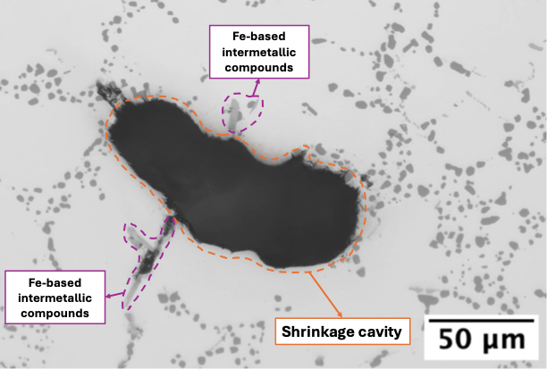 | 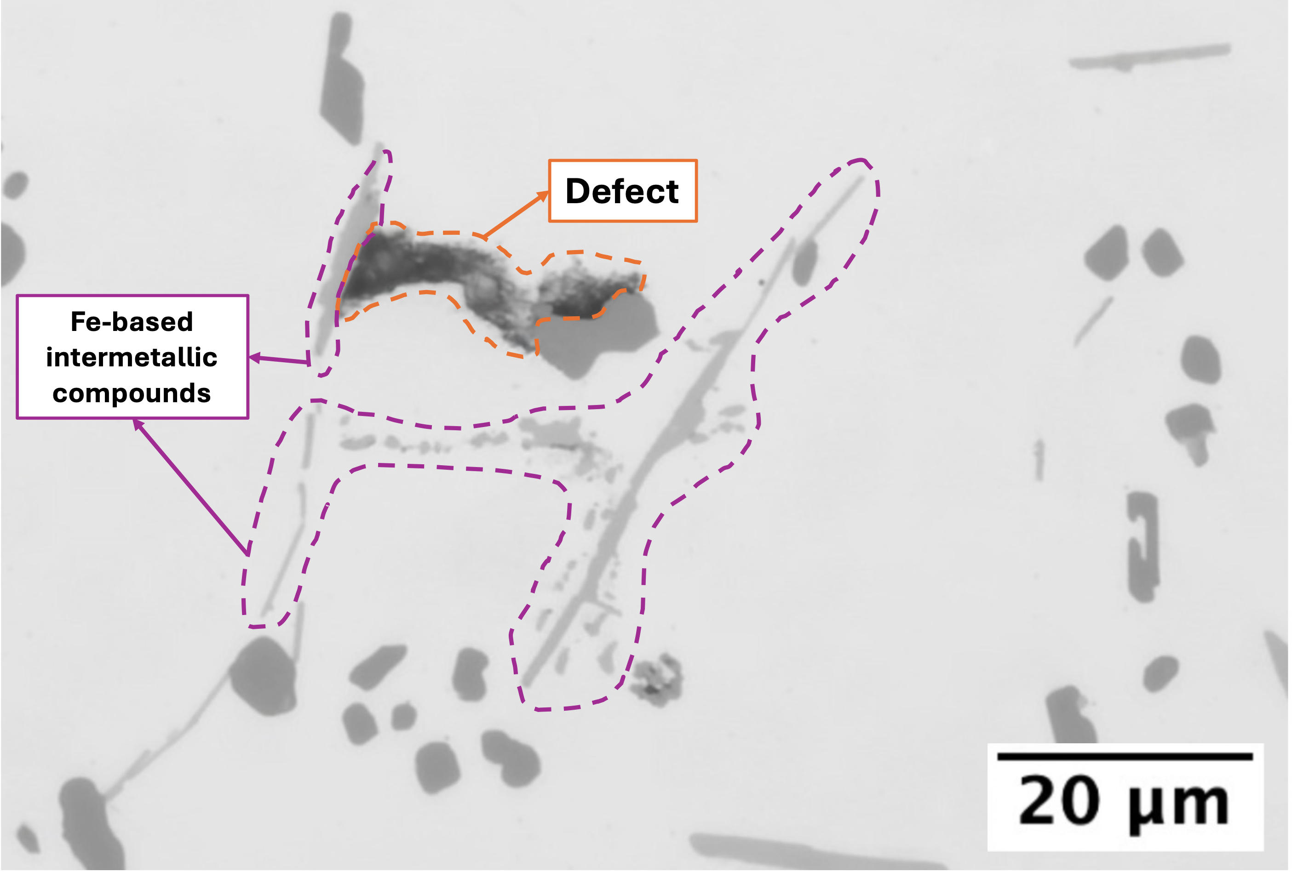
a) | b)
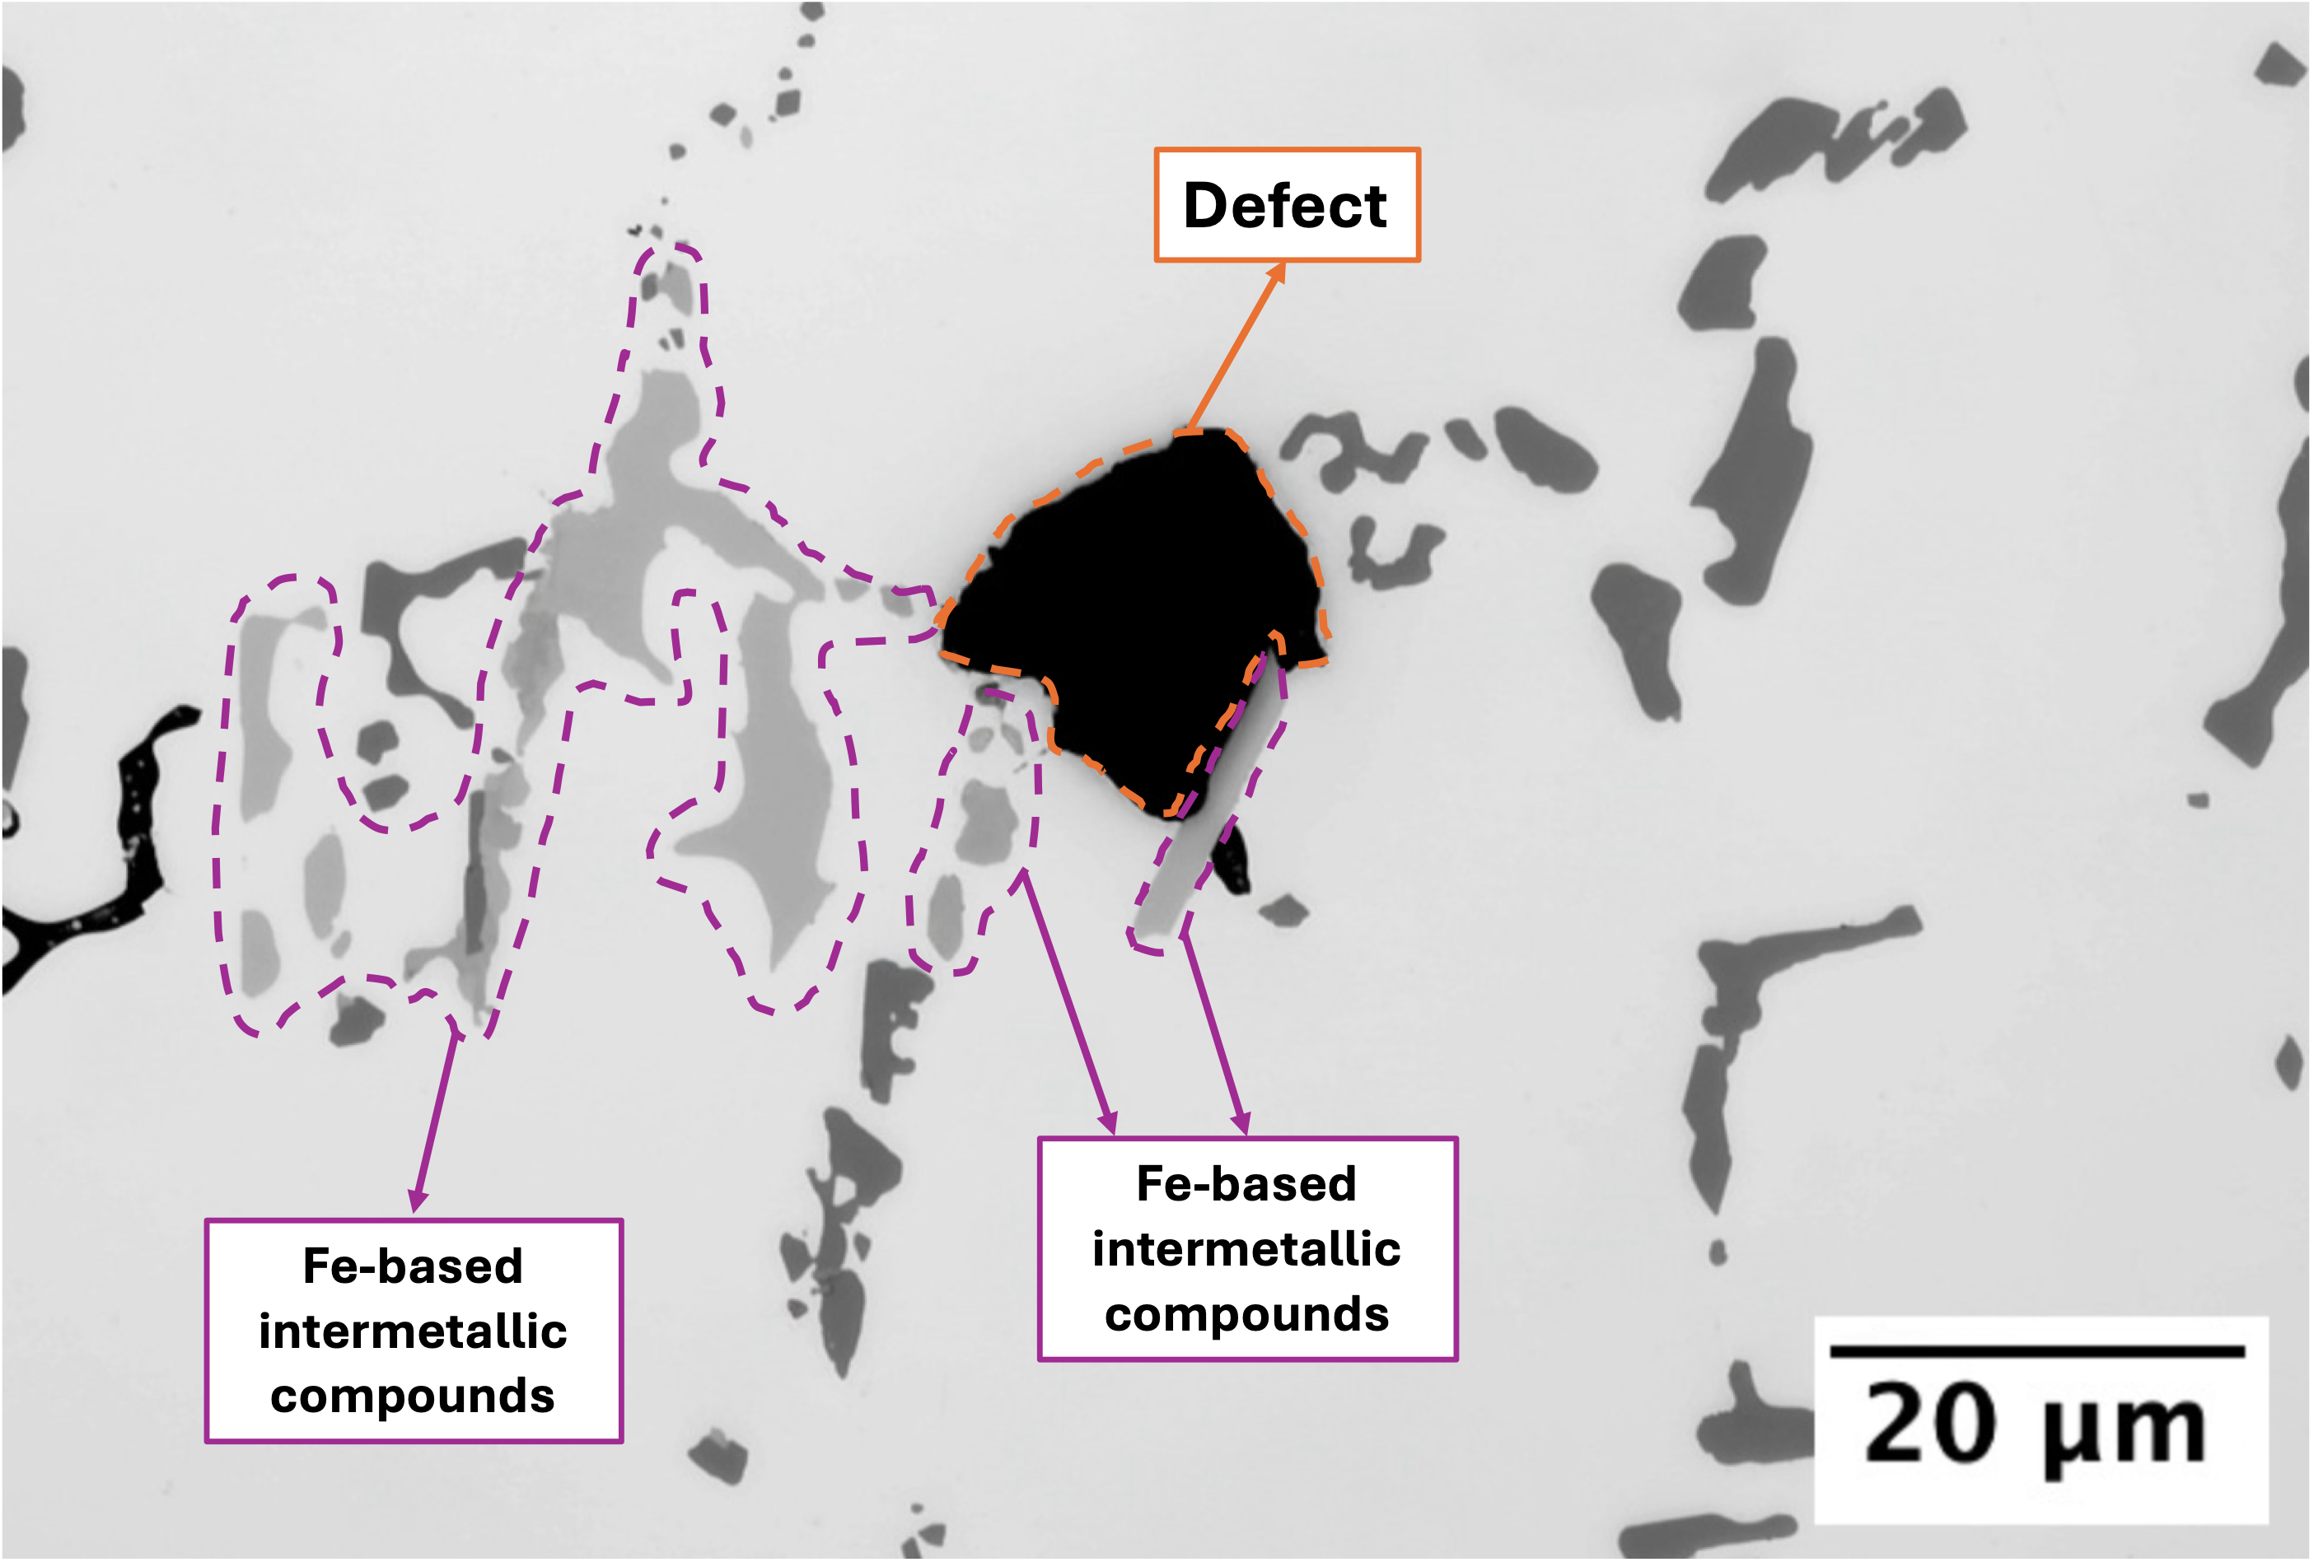 | 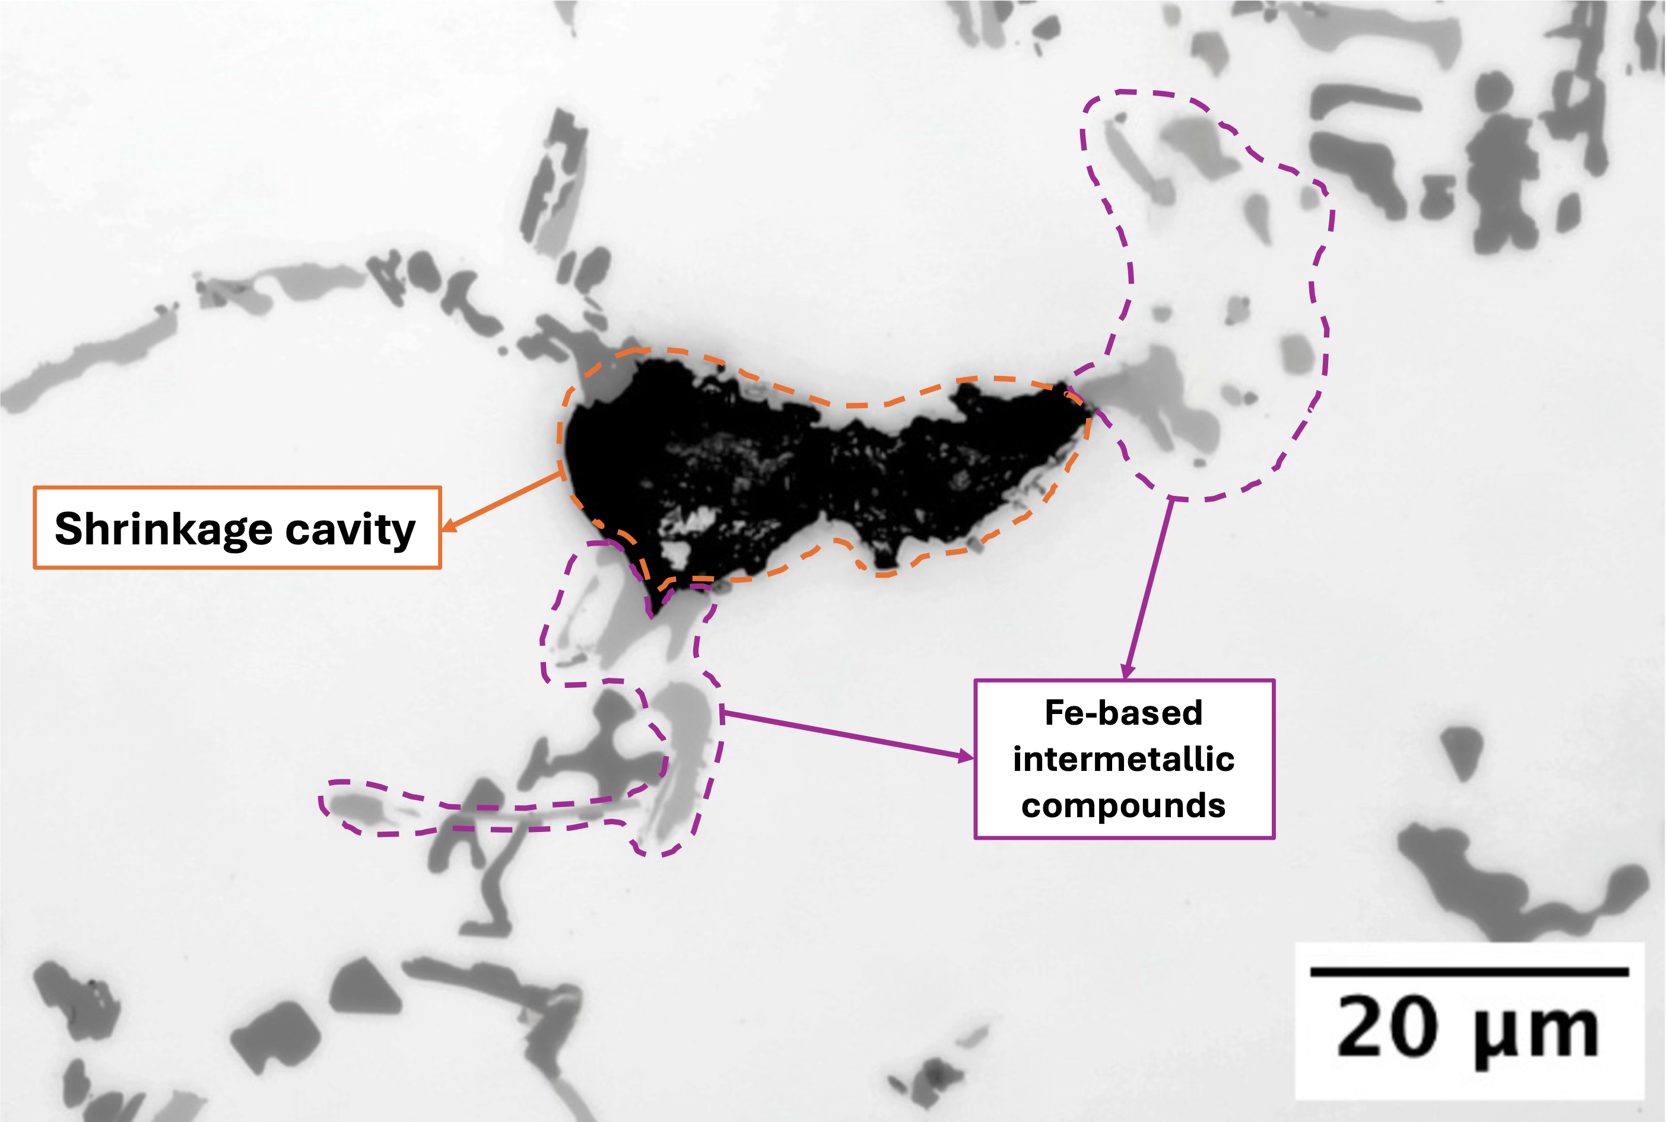
c) | d)
Supplementary Figure 1 Representative optical micrographs of shrinkage defects in the recycled EN 45500 alloy in T6 condition showing the association between solidification defects and Fe-rich intermetallic compounds. Fe-based intermetallic phases are frequently observed near shrinkage cavities, supporting their role in locally hindering interdendritic feeding during solidification. (a) A shrinkage cavity surrounded by Fe-rich intermetallics; (b, c, d) higher-magnification detail illustrating the morphology and distribution of Fe-based intermetallic compounds at defects boundaries.

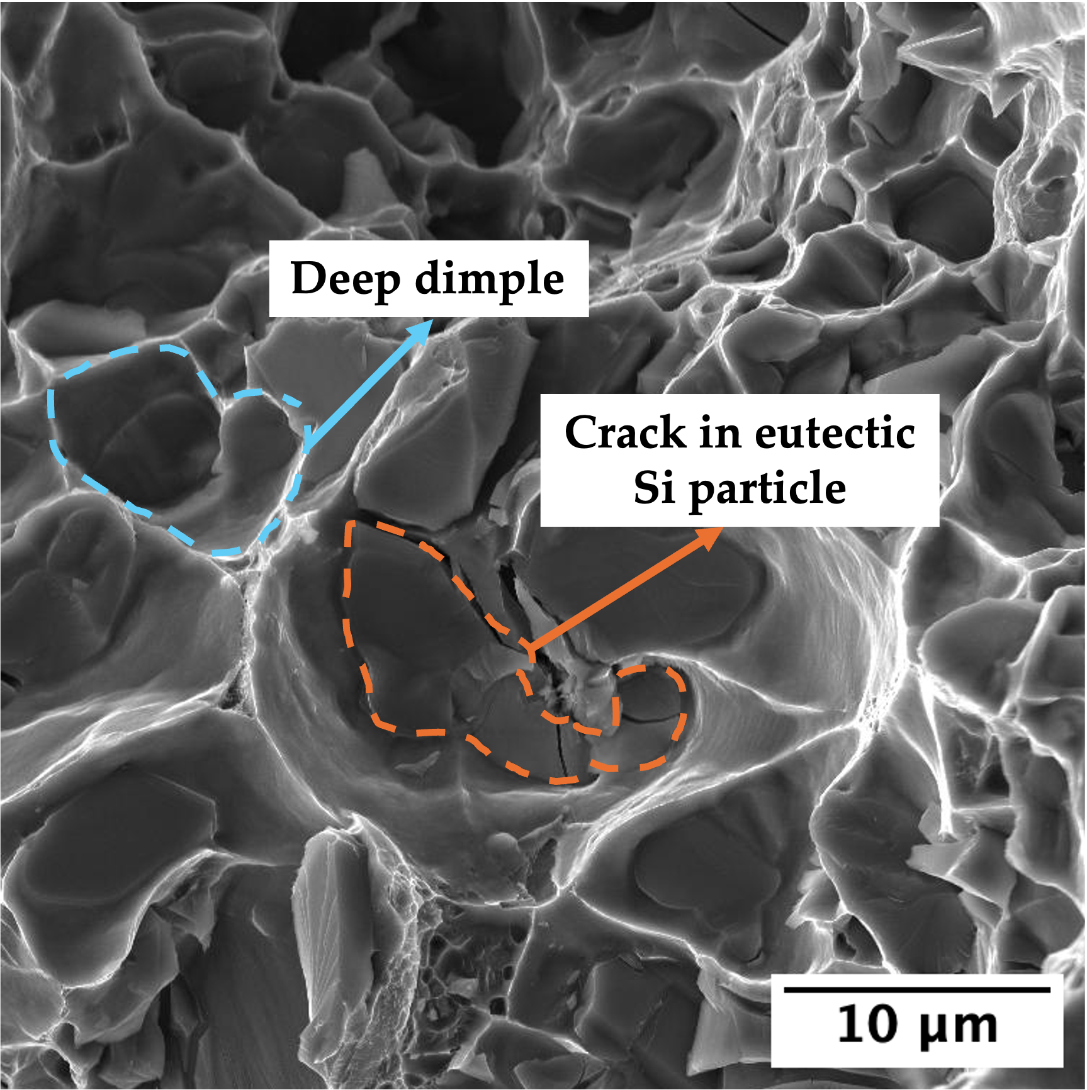 | 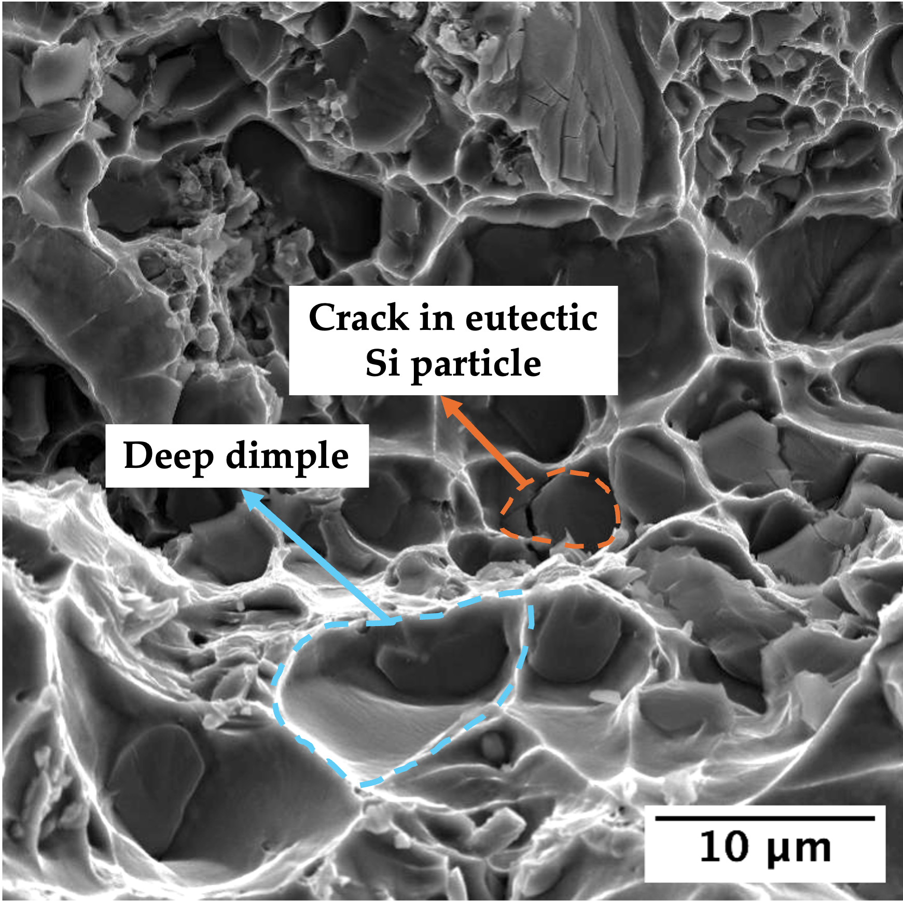
a) | b)
Supplementary Figure 2 FEG-SEM fracture surfaces of primary (a) and recycled (b) EN 45500 alloy in the overaged condition. Both alloys exhibit a predominantly ductile fracture characterized by large dimples, with evidence of cracked intermetallic particles at the bottom of the cavities.
DATA AVAILABILITY
Data will be made available on request.

