Supplemental Materials

Figure S1 Correlation between the IgG measurements from the Meso Scale U-plex assay and ELISA
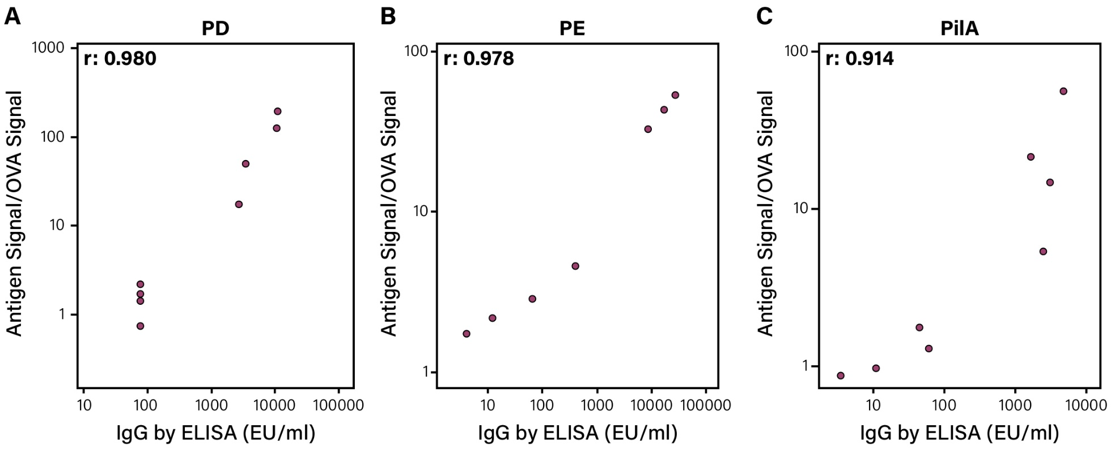
Correlation analysis of the specific IgG measured in sera with the Meso Scale U-plex assay (on the vertical axis) and ELISA (on the horizontal axis) against the three NTHi antigens PD (left panel), PE (middle panel), and PilA (right panel). r, correlation coefficient.

Figure S2 IgG levels measured with the U-plex assay in three different sputum dilutions

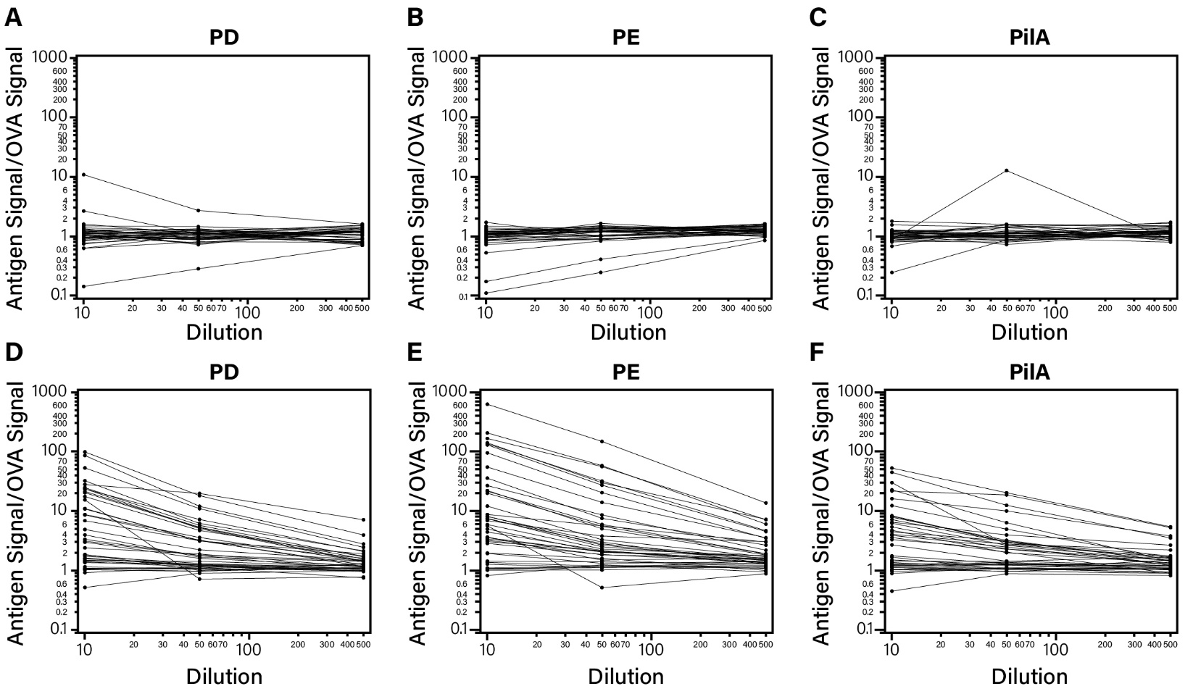
IgG measurements in sputum samples from all patients with the U-plex assay at three different dilutions (1:10, 1:50, 1:500). A-C. Before the first dose (PRE). D-E. At 30 days (DAY90) after the second dose.

Figure S3 Serum IgG on DAY90 by disease severity
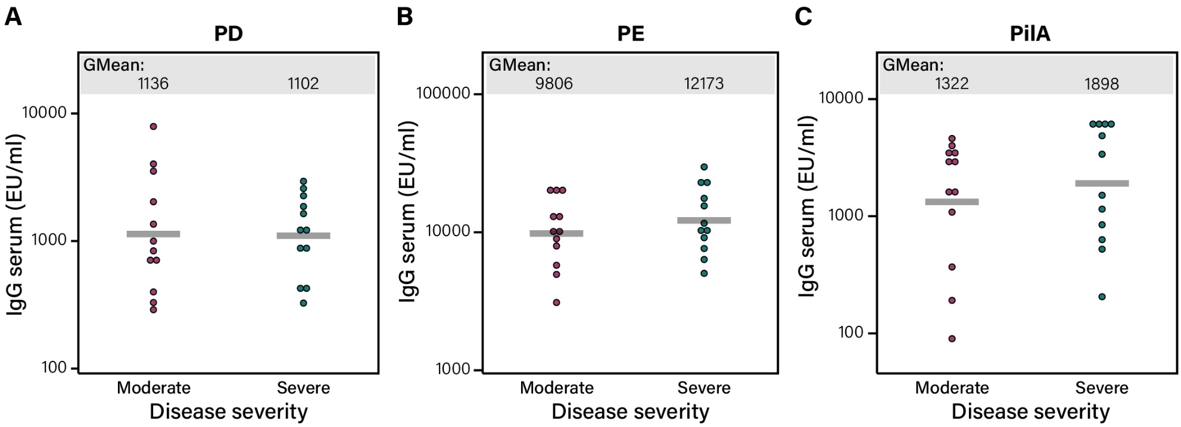
Signals (presented in log10) from serum IgG antibodies specific for A) PD, B) PE, and C) PilA. Signals are from serum samples of 12 moderate and 12 severe COPD patients collected 30 days after the second vaccination (DAY90) with the NTHi vaccine. Each circle represents one sample measured by ELISA. Signals between the moderate and severe are not significantly different (P-value: PD 0.9354; PE 0.3662; PilA 0.4813).

