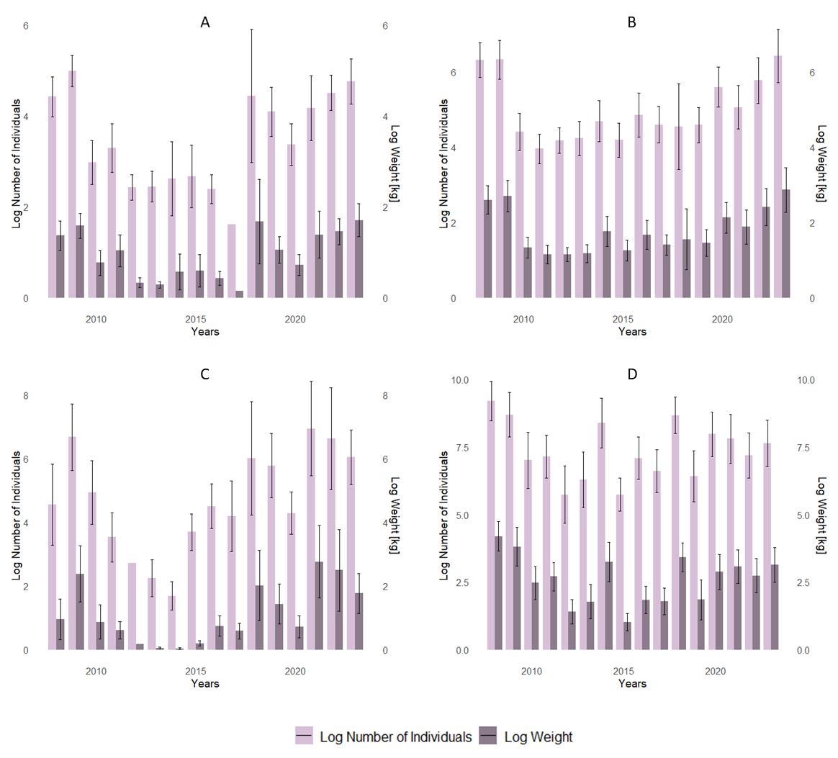
Supplementary Figure 1. Average of the logarithm of the number of individuals and the logarithm of weight per year with standard errors across all stations, for the southern and northern stocks of A. kagoshimensis (A and B) and A. transversa (C and D). A constant of 1 was added to the values before applying the logarithm to prevent negative logarithms.

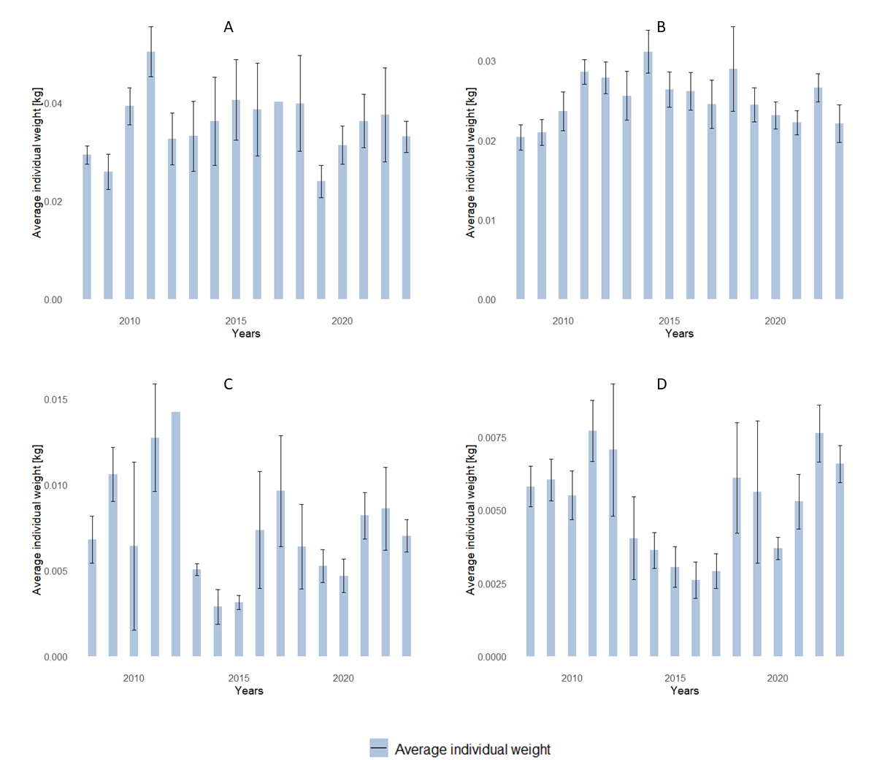
Supplementary Figure 2. Average individual weight per year across all stations with standard errors for the southern and northern stocks of A. kagoshimensis (A and B) and A. transversa (C and D).

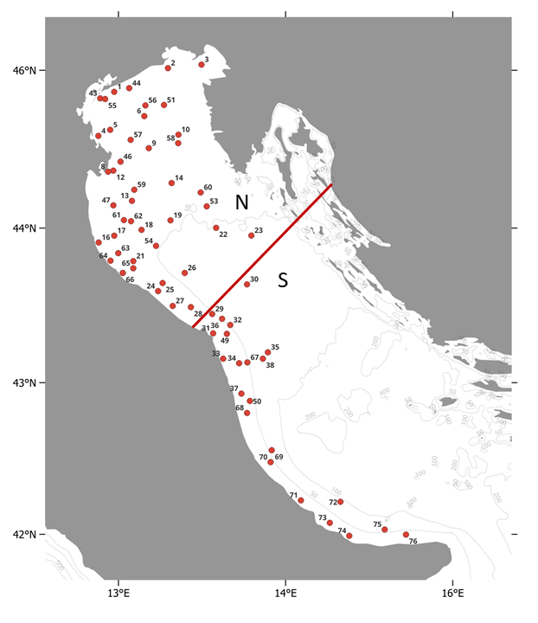
Supplementary Figure 3. Stations belonging to the northern sampling area (above the red line) and to the southern sampling area (below the red line).
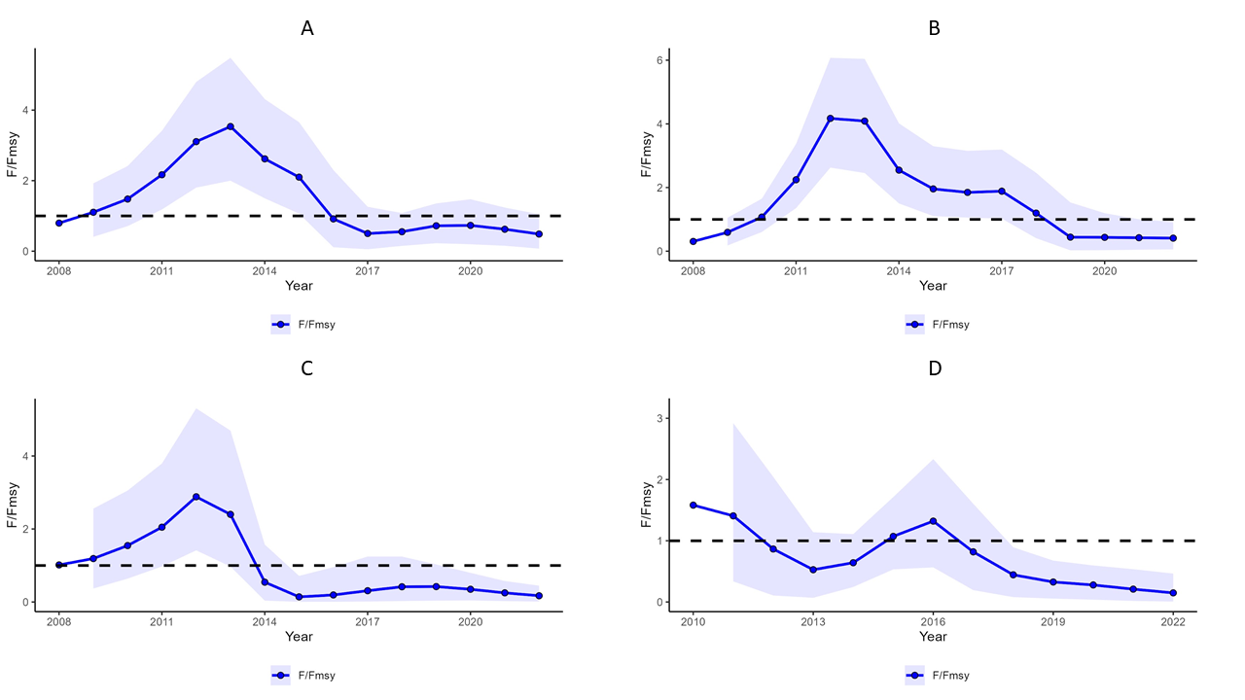
Supplementary Figure 4. The exploitation ratio (F/FMSY) of the southern and northern stocks of A. kagoshimensis (A and B) and A. transversa (C and D). Each panel displays a blue line representing the estimated F/FMSY ratio over time, with shaded areas indicating confidence intervals. The horizontal dashed line at F/FMSY = 1 denotes the threshold for sustainable exploitation. Values above this line suggest overfishing, while values below indicate fishing pressure within sustainable limits.

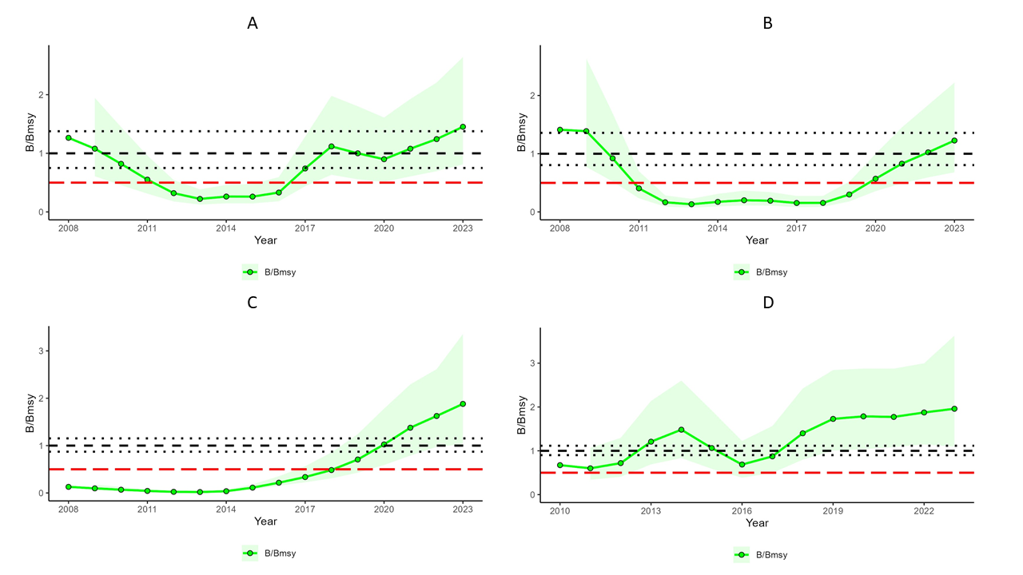
Supplementary Figure 5. Trends in the biomass of the southern and northern stocks of A. kagoshimensis (A and B) and A. transversa (C and D). Each panel shows a green line with data points representing annual biomass values, surrounded by a shaded green area indicating the confidence intervals. The horizontal black dashed line represents the sustainable biomass level (B/BMSY equal 1), with its confidence interval also shown as dashed lines. A horizontal red line marks the biomass limit (50% of B/BMSY).

