Supplementary materials

1. TEM measurement of PtNPs distribution
The morphology and size distribution of the nanoparticles were characterized through bright-field transmission electron microscopy (BF-TEM). A minimum of 300 nanoparticles was analyzed using a JEOL JEM-1011 microscope equipped with a thermionic W filament and operated at 100 kV. High-angle annular dark-field scanning TEM (HAADF-STEM) was carried out using an image-Cs-corrected JEOL JEM-2200FS microscope with a Schottky emitter and operated at 200 kV.

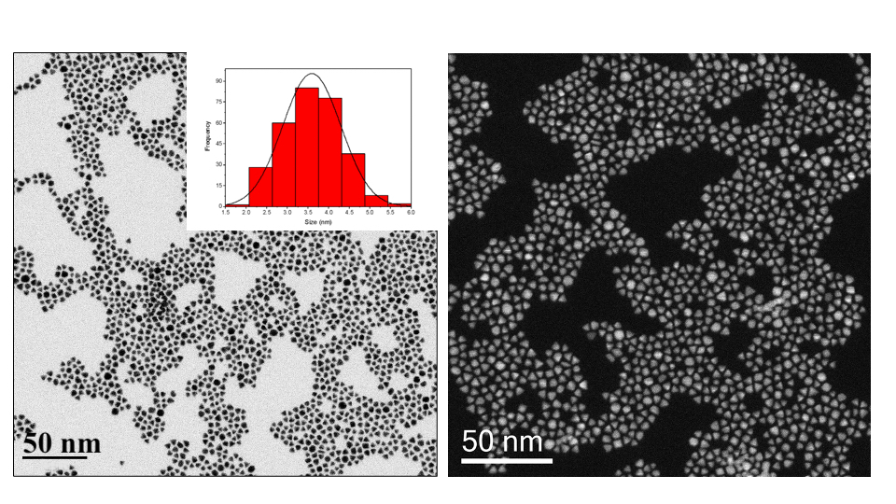

Figure S1. Representative transmission electron microscopy (TEM) images of pyramidal platinum nanoparticles. The left panel depicts bright-field TEM images illustrating the pronounced monodispersity of the pyramidal platinum nanoparticles. The right panel presents a high-angle annular dark-field scanning transmission electron microscopy (HAADF-STEM) image that confirms the uniform geometric morphology of the nanocrystals.

2. Calibration curve for solution of Mix D
Solution of conjugated-PtNPs isolated for Mix D in the concentration range of 0.04–4 μg/mLwere prepared and used to determine the calibration curve. The calibration curve demonstrated a strong linear correlation (R² > 0.99) between the CL signal-to-blank ratio and the amount of conjugated-PtNPs across the entire range. Each data point represents the average of triplicate measurements.

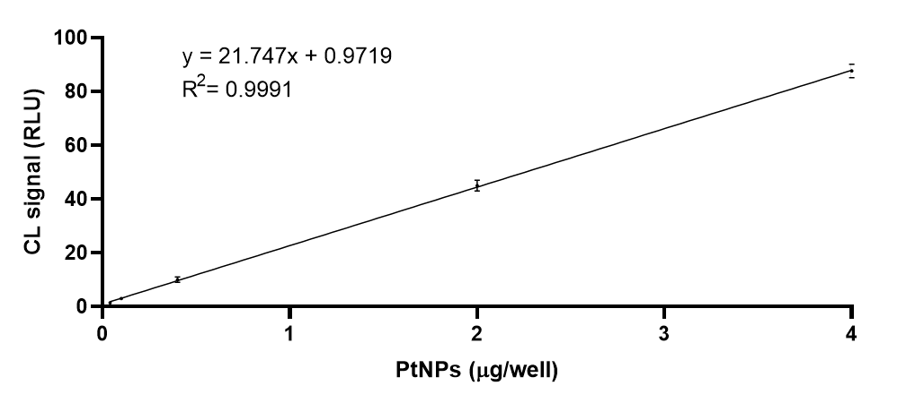

Figure S2. Calibration curve: CL signal-to-blank ratio vs PtNPs concentration.

3. CL dot-immunobinding assay: calibratuion curve
Solutions of Rabbit-IgG in the concentration ranging from 0,08 to 0,5 ng/mL were prepared and used to determine the calibration curve. Each curve was repeated three times.

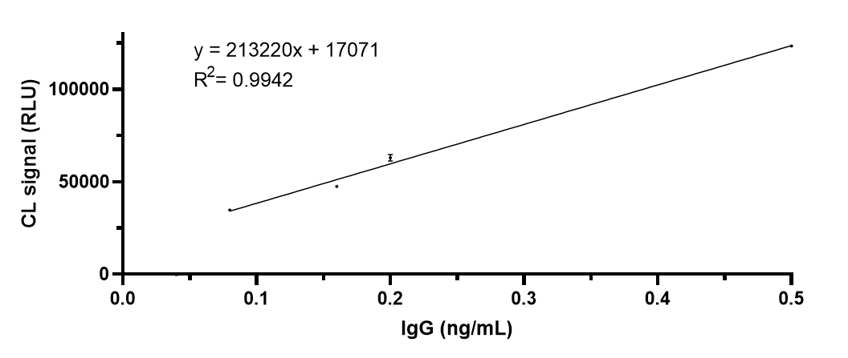

Figure S3. Calibration curve: CL signal vs IgG concentration.

