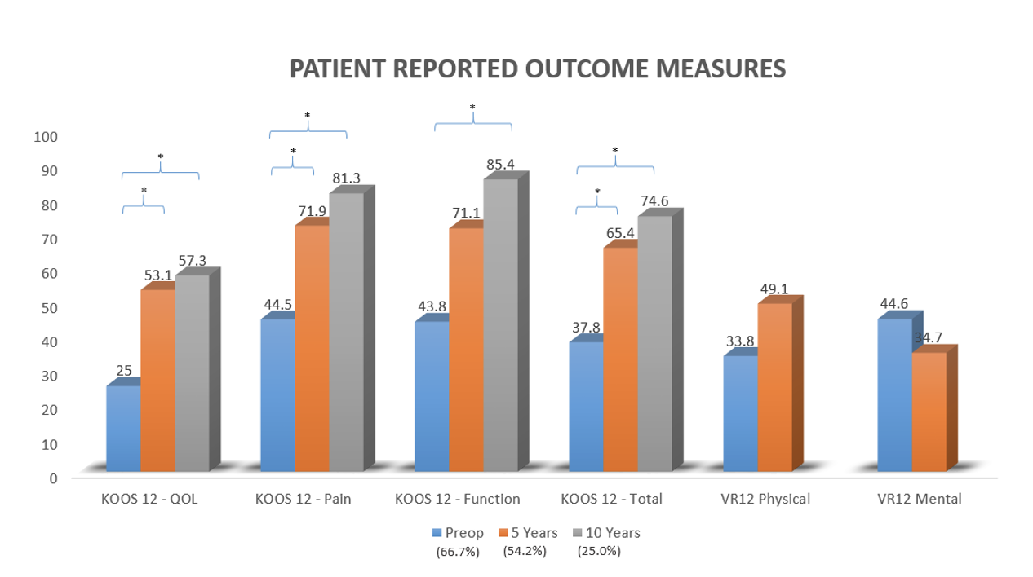
* Paired Samples T-Test (significant), KOOS Knee Injury And Osteoarthritis Outcome Score, VR-12 Veterans RAND-12, % available patients with completed clinical follow up

Supplementary Material 1. Preoperative, 5-years, and 10-years patient reported outcomes
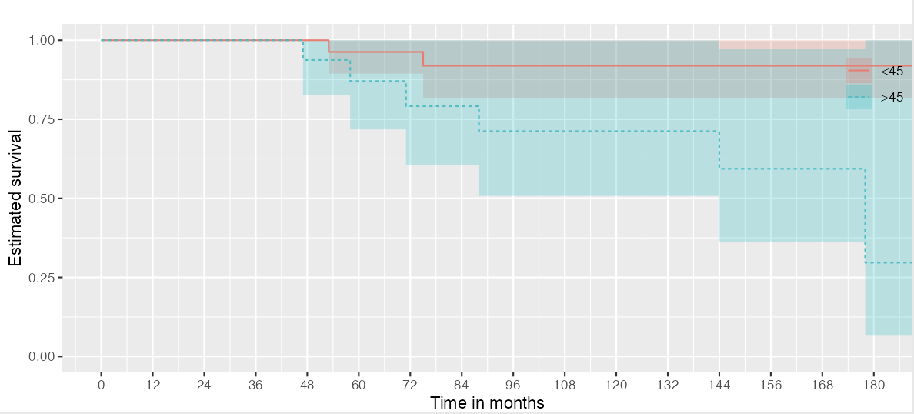

Supplementary Material 2. Survivorship based on Kaplan-Meier estimates for patients above, and below 45 years of age

