Supplementary Materials

Time to Metastasis as a Prognostic Factor in Metastatic Urothelial Carcinoma: Results from the ARON-2 Study

Renate Pichler¹, Gerald Klinglmair¹, Kirstin Binz², Enrique Grande³, Alina Pirshtuk⁴, Hideki Takeshita⁵, Yüksel Ürün⁶, Javier Molina-Cerrillo⁷, Zin W. Myint⁸, Alfonso Gómez de Liaño⁹, Augusto Mota¹⁰, Alessia Salfi¹¹, Wataru Fukuokaya¹², Enrico Sammarco¹³, Martin Angel¹⁴, Jakub Kucharz¹⁵, Deniz Tural¹⁶, Ondřej Fiala^{17,18*}, Alejo Rodriguez-Vida¹⁹, Franco Morelli²⁰, Alexandr Poprach²¹, Mobin Safi²², Alvaro Pinto²³, Francesco Massari^{24,25}, Sebastiano Buti^{26,27}, Shilpa Gupta²⁸, Fernando Sabino Marques Monteiro^{29,30}, Andrey Soares^{30,31}, Nicola Battelli³², Ravindran Kanesvaran³³, Matteo Santoni³²

¹Department of Urology, Comprehensive Cancer Center Innsbruck, Medical University of Innsbruck, Innsbruck, Austria; ²Division of Medical Oncology, Department of Internal Medicine, University of Kansas Cancer Center, US; ³Department of Medical Oncology, MD Anderson Cancer Center Madrid, Madrid, Spain; ⁴Department of Oncology, Second Faculty of Medicine, Charles University and University Hospital Motol, V Uvalu 84, 150 06, Prague, Czech Republic; ⁵Department of Urology, Saitama Medical Center, Saitama Medical University, Kawagoe, Saitama, Japan; ⁶Department of Medical Oncology, Ankara University Faculty of Medicine, 06620 Ankara, Türkiye; ⁷Department of Medical Oncology, Hospital Ramón y Cajal, Madrid, Spain; ⁸Division of Medical Oncology, Department of Internal Medicine, Markey Cancer Center, University of Kentucky, Lexington, Kentucky, USA; ⁹Medical Oncology Department, CHU Insular-Materno Infantil, Las Palmas de Gran Canaria, Spain; ¹⁰Clínica AMO - Assistência Multidisciplinar em Oncologia, Salvador, Brazil; ¹¹Oncology Unit 2, University Hospital of Pisa, Pisa 56126, Italy; ¹²Department of Urology, Jikei University School of Medicine, Tokyo, Japan; ¹³Medical Oncology Unit, Livorno Hospital, Azienda Toscana Nord Ovest, 57124 Livorno, Italy; ¹⁴Clinical Oncology, Genitourinary Oncology Unit, Alexander Fleming Institute, Buenos Aires, Argentina; ¹⁵Department of Uro-Oncology, Maria Sklodowska-Curie National Research Institute of Oncology Warsaw, Warsaw, Poland; ¹⁶Department of Medical Oncology, Koc University Medical Faculty, Istanbul, Türkiye; ¹⁷Department of Oncology and Radiotherapeutics, Faculty of Medicine and University Hospital in Pilsen, Charles University, Pilsen, Czech Republic; ¹⁸Biomedical Center, Faculty of Medicine in Pilsen, Charles University, Pilsen, Czech Republic; ¹⁹Hospital del Mar, Barcelona, Spain; ²⁰Medical Oncology Unit, IRCCS Casa Sollievo della Sofferenza, Foggia, Italy; ²¹Masaryk Memorial Cancer Institute, Brno, Czech Republic - Faculty of Medicine, Masaryk University, Brno, Czech Republic; ²²U.O. Oncologia, Ospedale C. Urbani, Jesi, Italy; ²³Servicio de Oncología, Hospital Universitario La Paz, Madrid, Spain; ²⁴Medical Oncology, IRCCS Azienda Ospedaliero-Universitaria di Bologna, Bologna, Italy; ²⁵Department of Medical and Surgical Sciences (DIMEC), University of Bologna, Bologna, Italy; ²⁶Medical Oncology Unit, University Hospital of Parma, Parma, Italy; ²⁷Department of Medicine and Surgery, University of Parma, Parma, Italy; ²⁸Taussig Cancer Institute, Cleveland Clinic, Cleveland, OH, USA; ²⁹Oncology and Hematology Department, Hospital Sírio Libanês, Brasília, Brazil; ³⁰Latin American Cooperative Oncology Group - LACOG, Porto Alegre, Brazil; ³¹Oncology Unit, Hospital Israelita Albert Einstein, São Paulo, SP, Brazil; ³²Medical Oncology Unit, Macerata Hospital, Macerata, Italy; ³³Division of Medical Oncology, National Cancer Centre Singapore, Singapore, Singapore

*§Correspondence to: Ondrej Fiala, M.D., Ph.D., Department of Oncology and Radiotherapy, Faculty of Medicine and University Hospital Pilsen, Charles University Prague, alej Svobody 80, CZ-304 60 Pilsen, Czech Republic. Tel.: +42 0728655488, e-mail: fialao@fnplzen.cz

First-line platinum-based chemotherapy (Cohort 1)
Subgroup | Synchronous | TTM <6 months | TTM ≥6 months | p-value
Males | 20.4 (95% CI 18.3–23.5) | 22.9 (95% CI 19.9–116.5) | 27.5 (95% CI 22.0–32.6) | 0.049
Age ≥70y | 18.9 (95% CI 14.6–82.0) | 21.0 (95% CI 17.0–116.5) | 26.9 (95% CI 21.2–32.2) | 0.010
ECOG-PS 0–1 | 20.6 (95% CI 18.7–23.5) | 22.3 (95% CI 20.0–116.5) | 28.4 (95% CI 23.3–34.3) | 0.011
UTUC | 17.6 (95% CI 13.4–77.5) | 21.4 (95% CI 13.8–31.8) | 31.3 (95% CI 22.4–49.0) | 0.020
Mixed histology | 14.6 (95% CI 12.2–82.0) | 18.4 (95% CI 14.0–31.8) | 36.3 (95% CI 19.9–52.2) | 0.005
Lung metastases | 19.1 (95% CI 15.0–21.0) | 22.0 (95% CI 15.3–116.5) | 27.2 (95% CI 21.6–30.4) | 0.006

Second-line pembrolizumab (Cohort 2)
Subgroup | Synchronous | TTM <6 months | TTM ≥6 months | p-value
Females | 10.7 (95% CI 6.6–60.0) | 12.4 (95% CI 7.8–16.1) | 23.0 (95% CI 15.3–39.2) | 0.013
ECOG-PS 0–1 | 15.6 (95% CI 13.0–111.2) | 16.7 (95% CI 13.8–86.9) | 23.0 (95% CI 18.4–91.0) | 0.044
UTUC | 13.2 (95% CI 8.5–72.4) | 13.0 (95% CI 7.7–23.4) | 23.0 (95% CI 18.4–34.6) | 0.015
Pure UC histology | 15.4 (95% CI 11.7–83.6) | 15.8 (95% CI 13.0–86.9) | 21.2 (95% CI 16.3–91.0) | 0.029
Lung metastases | 12.9 (95% CI 10.0–83.6) | 15.0 (95% CI 8.8–22.4) | 22.2 (95% CI 17.4–25.8) | 0.002
Liver metastases | 7.0 (95% CI 4.3–72.4) | 9.8 (95% CI 5.8–23.1) | 14.6 (95% CI 8.0–16.4) | 0.031

Third-line enfortumab vedotin (Cohort 3)
Subgroup | Synchronous | TTM <6 months | TTM ≥6 months | p-value
Lung metastases | 6.4 (95% CI 5.0–9.7) | 10.7 (95% CI 8.5–13.7) | 13.6 (95% CI 9.2–18.7) | 0.021
ECOG-PS = Eastern Cooperative Oncology Group-Performance Status; UC = urothelial carcinoma; UTUC = upper tract urothelial carcinoma; TTM = Time to Metastasis
Table S1. Median overall survival (OS) by subgroups according to time to metastasis (TTM)
Figure S1. Selection process from the ARON-2 dataset.

Figure S2. Map of Countries participating to the ARON-2 Study.

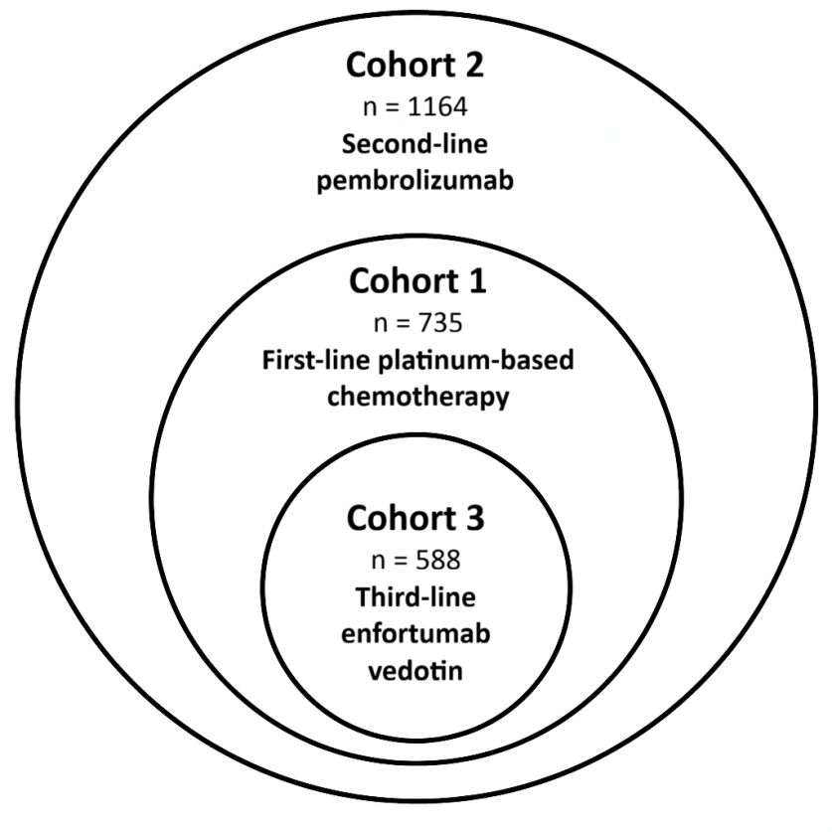

Figure S3. Hierarchical structure of the study cohorts.

