Content of Appendix
Avelumab plus axitinib in patients with advanced gastrointestinal stromal tumor
Piotr Lukasz Rutkowski, Anna Klimczak, Pawel Teterycz, Maria Abbondanza Pantaleo, Tomasz Switaj, Pawel Rogala, Jan Poleszczuk, Margherita Nannini, Maria Concetta Nigro, Katarzyna Kozak

Inclusion and exclusion criteria 2
Summary table 5
Supplemenary table 1 5
Progression-free survival by primary tumor site, number of prior lines and mutation status 6
Supplementary figure 1 6
Supplementary table 2 6
Supplementary figure 2 7
Supplementary table 3 7
Supplementary figure 3 8
Spider plot illustrating changes in tumour burden from the baseline 9
Supplementary figure 4 9

Inclusion and exclusion criteria

Inclusion criteria
All of the following criteria have to be met for including the patient in the study:
1. Signed written informed consent.
2. Male or female subjects aged ≥ 18 years.
3. Histologically proven locally advanced or metastatic GIST. C-Kit (CD117) positive tumors detected by immunohistochemistry
4. Known mutational status KIT or PDGFRA.
5. Documented disease progression (as per RECIST 1.1) within 3 months before study entry
6. No more than 3 previous lines of treatment, which must include imatinib and sunitinib .
7. Performance status ≤ 2 at trial entry and an estimated life expectancy of at least 3 months.
8. Disease must be measurable with at least 1 unidimensional measurable lesion by RECIST 1.1. Clinically
and/or radiographically documented measurable disease within 21 days prior to registration
• CT-scan, physical exam ≥10 mm
• Chest X-ray ≥20 mm
• Lymph node short axis ≥15 mm
All radiology studies must be performed within 21 days prior to registration.
9. Adequate hematological function defined by the following laboratory tests results, obtained within 14
days prior to initiation of study treatment
- white blood cell (WBC) count ≥ 3 × 109/L with absolute neutrophil count (ANC) ≥ 1.5 × 109/L,
- lymphocyte count ≥ 0.5 × 109/L,
- platelet count ≥ 100 × 109/L,
- hemoglobin ≥ 9 g/dL (patients may be transfused).
10. Adequate hepatic function defined by
- total bilirubin level ≤ 1.5 × the upper limit of normal range (ULN),
- an AST level ≤ 2.5 × ULN, and an ALT level ≤ 2.5 × ULN or, for subjects with documented
metastatic disease to the liver, AST and ALT levels ≤ 5 × ULN.
11. Serum creatinine ≤ 1.5 x ULN or creatinine clearance ≥ 50 ml/min on the basis of the Cockroft- Gault
glomerular filtration rate estimation:
(140-age) x (weight in kg) x (0,85 if female)/72x(serum creatinine in mg/dl)
12. No clinically significant (i.e., active) cardiovascular disease: cerebral vascular accident/stroke (< 6 months prior to enrollment), myocardial infarction (< 6 months prior to enrollment), Uncontrolled hypertension (systolic blood pressure >150 mmHg and/or diastolic blood pressure >100 mmHg , unstable angina, congestive heart failure (≥2 New York Heart Association Classification medication) serious cardiac arrhythmia. All other significant diseases (e.g., inflammatory bowel disease), which, in the opinion of the investigator, might impair the subject’s tolerance of trial treatment;
13. Absence of any psychological, familial, sociological or geographical condition potentially hampering compliance with the study protocol and follow-up schedule; those conditions should be discussed with the patient before registration in the trial
14. Patients not receiving anticoagulant medication who have an International Normalized Ratio (INR) >1.5 or an activated partial thromboplastin time (aPTT) >1.5 x ULN within 7 days prior to first study treatment. Note: Patients receiving full dose oral or parenteral anticoagulants may be included in the study as long as anticoagulant dosing has been stable for at least 2 weeks prior to study entry and the appropriate coagulation monitoring tests are within local therapeutic limits;
15. Effective contraception for both male and female subjects if the risk of conception exists. (Note: The effects of the study drugs on the developing human fetus are unknown. Thus, women of childbearing potential and men must agree to use effective contraception, defined as 2 barrier methods e.g. implants, injectables, combined oral contraceptives in combination with a barrier method, some intrauterine contraceptive devices, sexual abstinence, or a vasectomized partner;)
16. Availability of representative formalin-fixed paraffin-embedded (FFPE) tumor specimens in paraffin blocks.

3.2 Exclusion criteria

1. Concurrent anticancer treatment within 14 days before the start of trial treatment (e.g., cytoreductive therapy, radiotherapy [with the exception of palliative bone directed radiotherapy], immune therapy, or cytokine therapy except for erythropoietin); major surgery within 28 days before the start of trial treatment (excluding prior diagnostic biopsy); use of hormonal agents within 7 days before the start of trial treatment; or use of any investigational drug within 28 days before the start of trial treatment.
2. Patients with PDGFRA D842V mutations are not eligible for this study.
3. Previous treatment with anti-PD-1 or anti-PD-L1 antibodies, previous therapy with axitinib.
4. Persisting toxicity related to prior therapy Grade > 1 CTCAE v 4.0,
5. Major surgical procedure within 28 days prior to the first study treatment, or anticipation of the need for major surgery during the course of the study treatment; or minor surgical procedures, within 24 hours prior to the first study treatment;
6. Subjects with active, known or suspected autoimmune disease. Subjects with vitiligo, type I diabetes mellitus, residual hypothyroidism due to autoimmune condition only requiring hormone replacement, psoriasis not requiring systemic treatment, or conditions not expected to recur in the absence of an external trigger are permitted to enroll.
7. Subjects with a condition requiring systemic treatment with either corticosteroids (> 10 mg daily prednisone equivalents) or other immunosuppressive medications within 14 days of study drug administration except for adrenal replacement steroid. The use of inhaled corticosteroids for chronic obstructive pulmonary disease is allowed.
8. History of abdominal fistula, grade 4 bowel obstruction or gastrointestinal perforation, intra-abdominal abscess within 6 months of enrollment;
9. History of idiopathic pulmonary fibrosis (including pneumonitis), drug-induced pneumonitis, organizing pneumonia (i.e., bronchiolitis obliterans, cryptogenic organizing pneumonia), or evidence of active pneumonitis on screening chest CT scan
10. Significant acute or chronic infections including, among others: positive testing for human immunodeficiency virus (HIV) or known acquired immunodeficiency syndrome (AIDS);
11. Active hepatitis B virus (HBV) infection (chronic or acute), defined as having a positive hepatitis B surface antigen (HBsAg) test at screening. Patients with past or resolved HBV infection, defined as having a negative HBsAg test and a positive total hepatitis B core antibody (HBcAb) test at screening, are eligible for the study.
12. Active hepatitis C virus (HCV) infection, defined as having a positive HCV antibody test and positive HCV RNA test at screening
13. Active tuberculosis
14. Severe infection within 2 weeks prior initiation of study treatment, including, but not limited to, hospitalization for complications of infection, bacteriemia or severe pneumonia
15. Brain or leptomeningeal metastases, history of intracranial hemorrhage
16. Treatment with a live, attenuated vaccine within 4 weeks prior to initiation of study treatment, or anticipation of need for such a vaccine during the course of the study
17. Known alcohol or drug abuse.
18. Inability or unwillingness to swallow pills
19. Pregnant or breastfeeding, or intending to become pregnant during the study. Woman of childbearing potential must have a negative serum pregnancy test result within 14 days prior to initiation of study treatment.
20. Symptomatic brain metastases, history of intracranial hemorrhage
21. Previous enrollment in this study

SUMMARY TABLE
Supplementary Table 1. Summary table
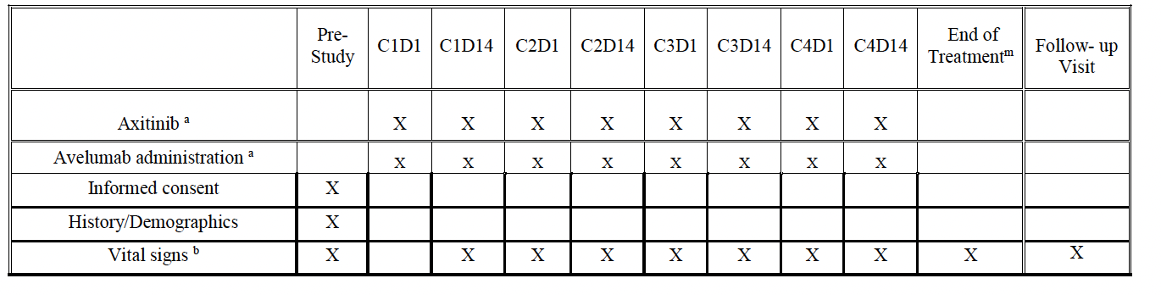
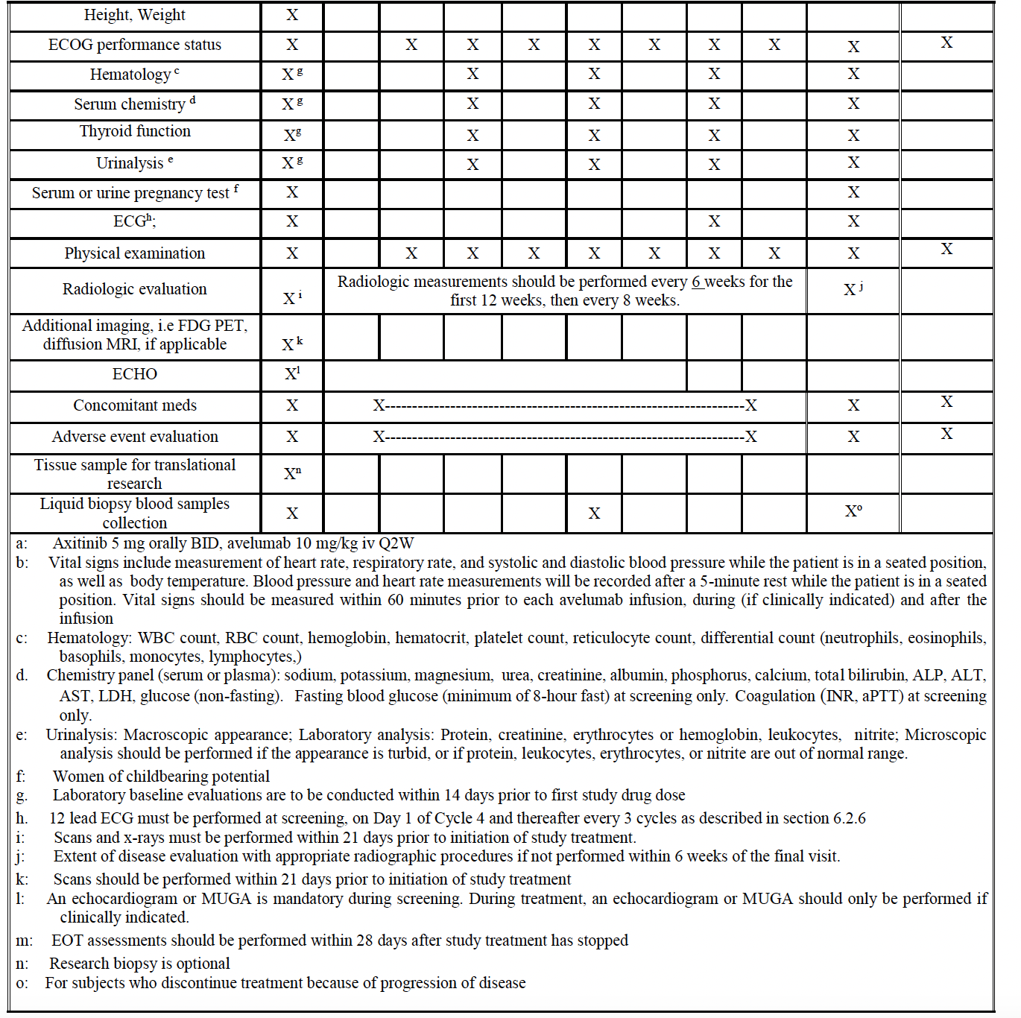
Progression free survival according to primary tumor site, number of prior lines and mutation status
Supplementary Figure 1. Progression free survival by primary tumor site
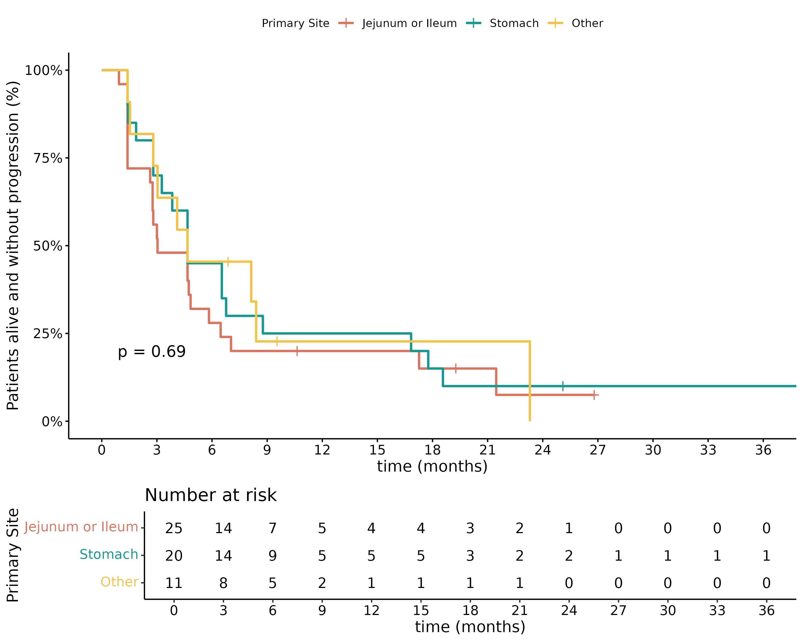

Supplementary Table 2. Median progression-free survival according to primary tumor site
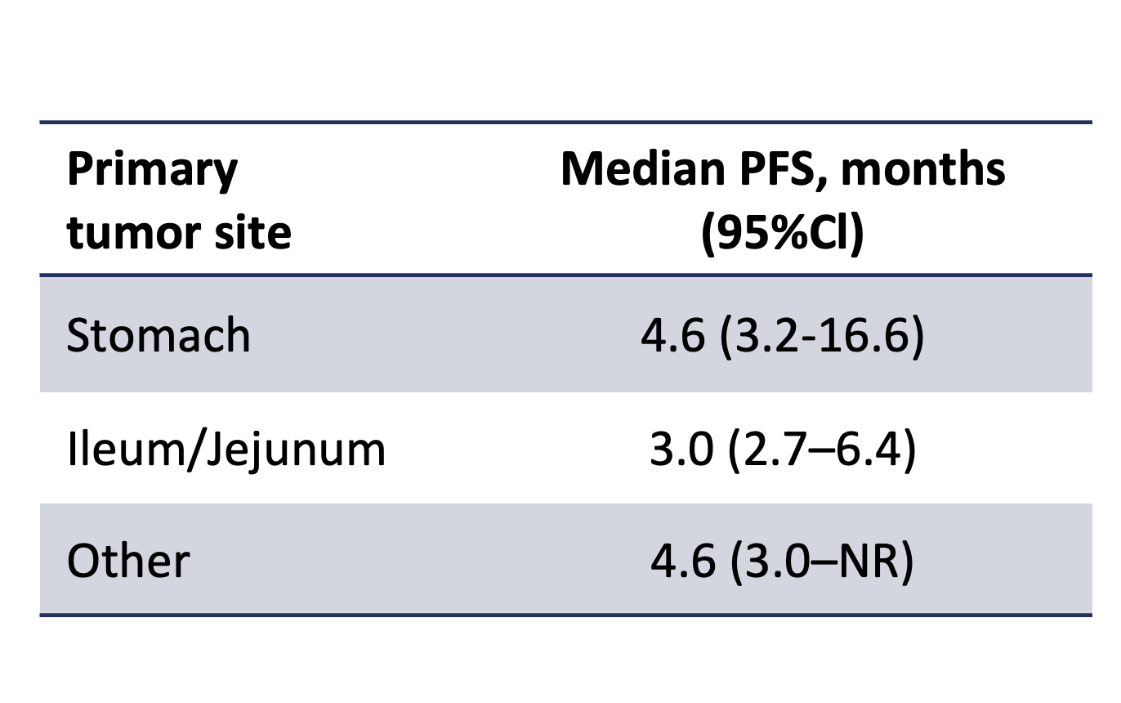

Supplementary Figure 2. Progression-free survival according to mutation status

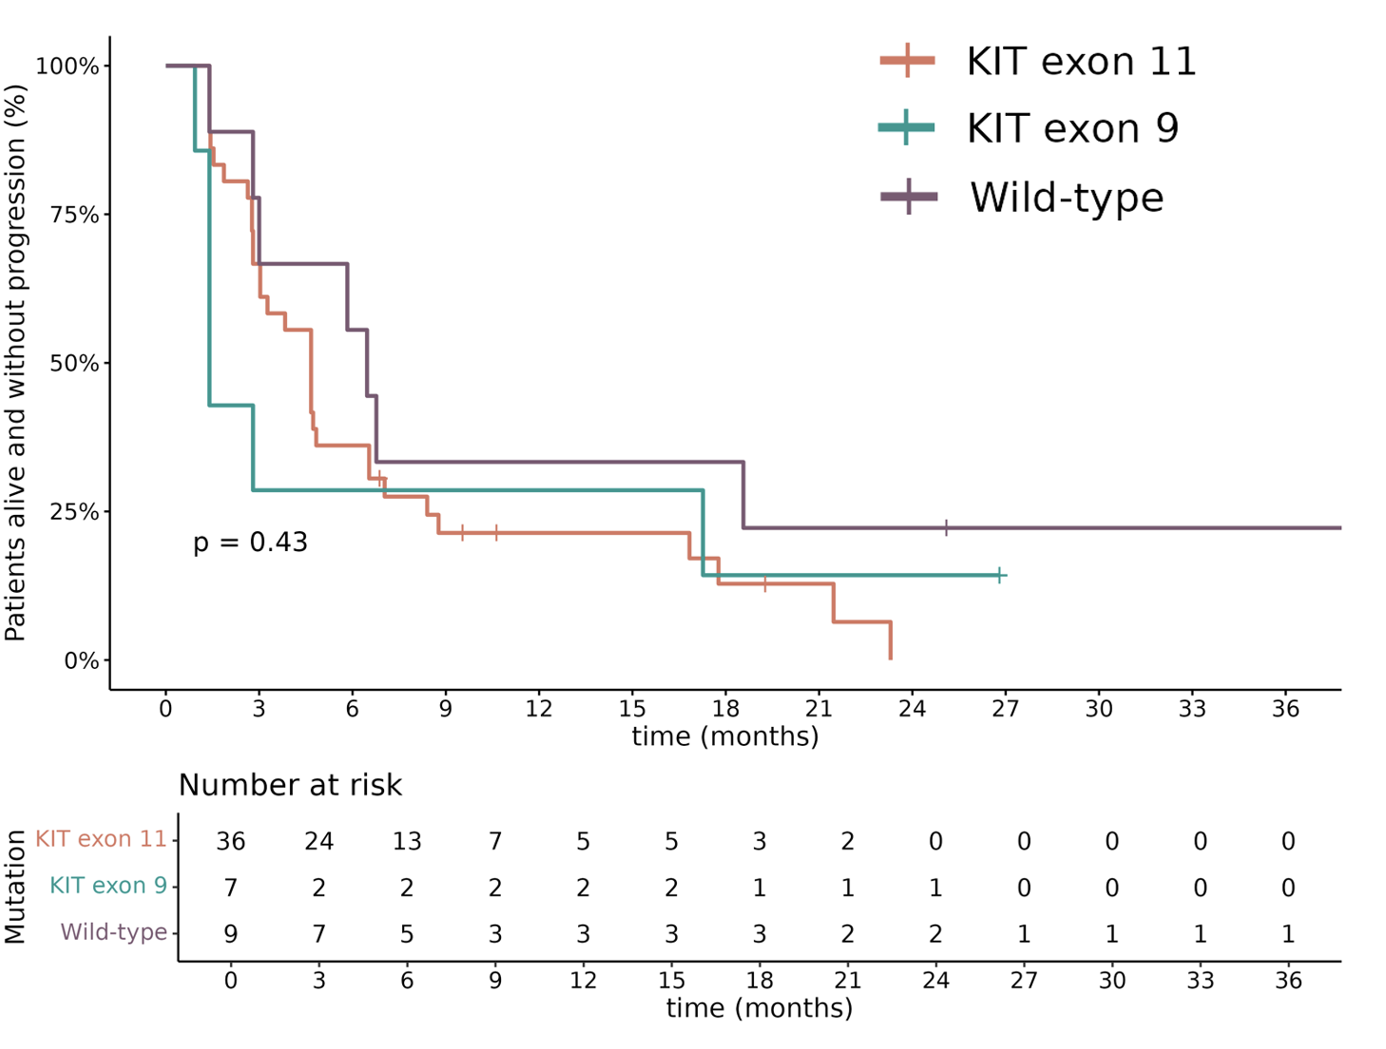

Supplementary Table 3. Median progression-free survival according to mutation status
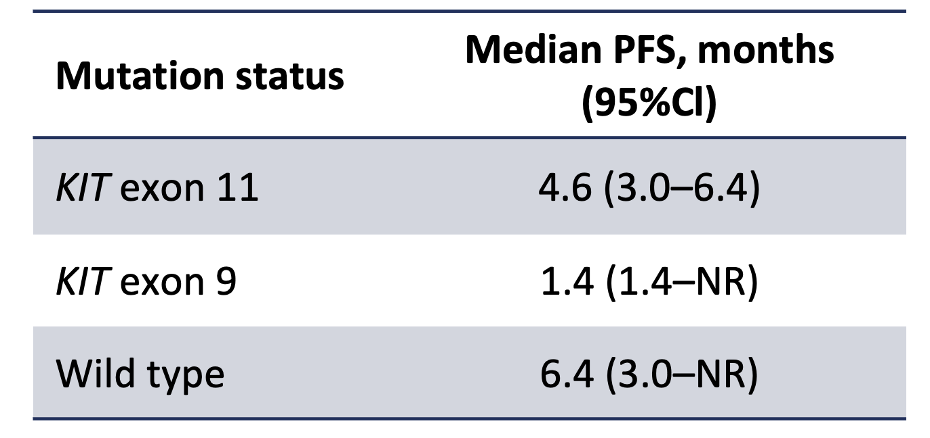

Supplementary Figure 3. Progression free survival by number of prior lines of treatment

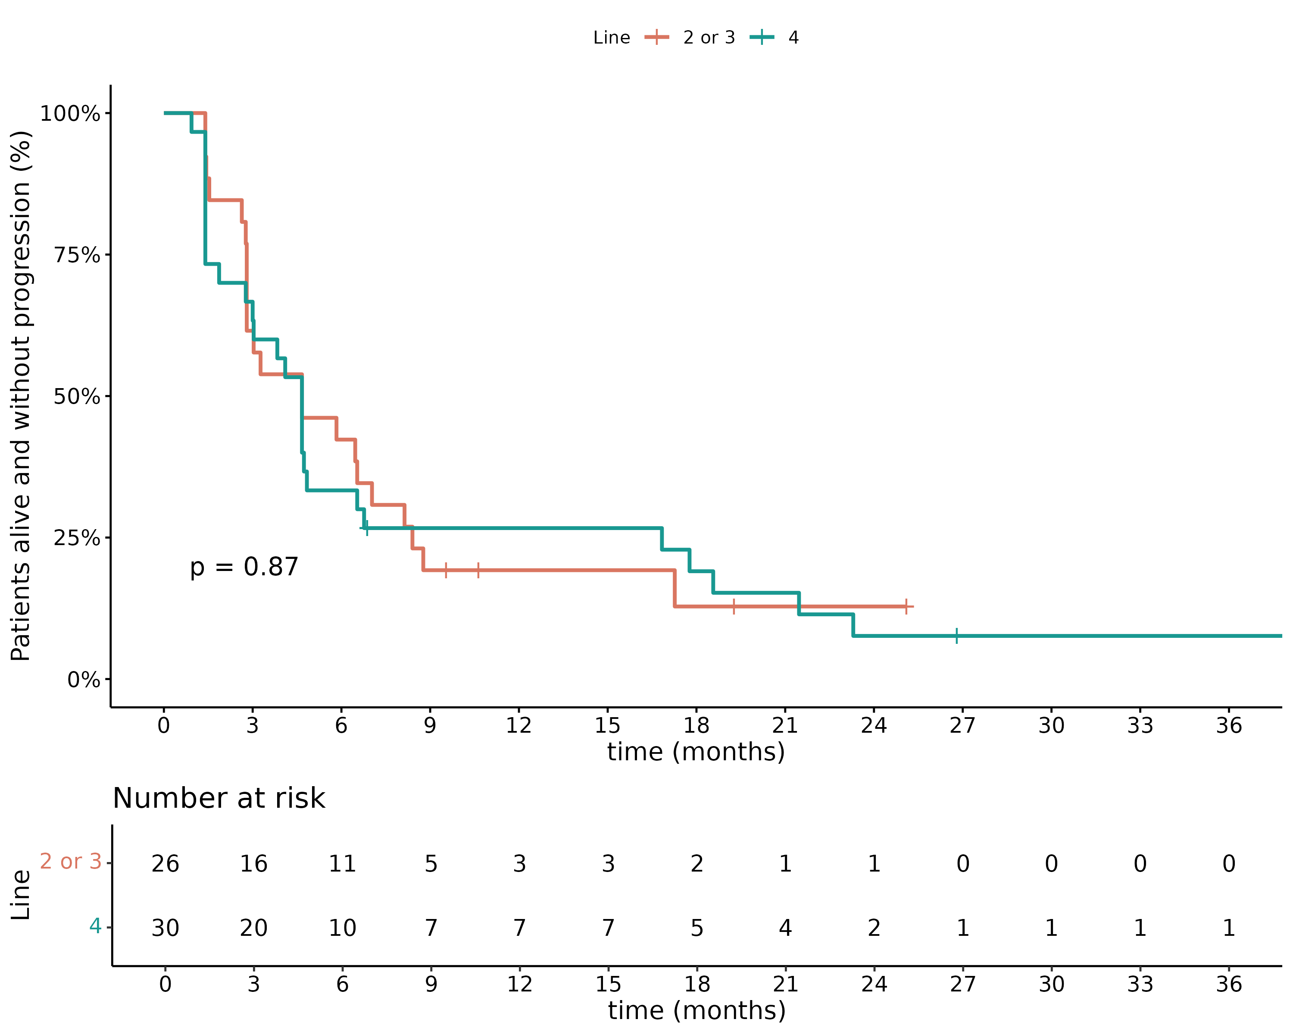

Supplemntary Figure 4. Spider plot illustrating changes in tumour burden from the baseline

