SUPPLEMENTARY MATERIAL

Manuscript title: Dietary vitamin D and gastric cancer risk within the Stomach Cancer Pooling (StoP) Project

Table of contents
Supplementary Figure 1. Funnel plot of studies on the odds ratios of gastric cancer risk for the highest versus the lowest tertile of vitamin D intake. (p Egger’s test for funnel plot asymmetry=0.3728) 2
Supplementary Figure 2. Forest plot for study-specific and pooled odds ratios (OR)ª with 95% confidence intervals (CI) of gastric cancer for the highest versus the lowest tertile of vitamin D intake, according to sex. 3
Supplementary Figure 3. Forest plot for study-specific and pooled odds ratios (OR)ª with 95% confidence intervals (CI) of gastric cancer for the highest versus the lowest tertile of vitamin D intake, according to age classes. 4
Supplementary Figure 4. Forest plot for study-specific and pooled odds ratios (OR)ª with 95% confidence intervals (CI) of gastric cancer for the highest versus the lowest tertile of vitamin D intake, according to socioeconomic status. 5
Supplementary Figure 5. Forest plot for study-specific and pooled odds ratios (OR)ª with 95% confidence intervals (CI) of gastric cancer for the highest versus the lowest tertile of vitamin D intake, according to smoking status. 6
Supplementary Figure 6. Forest plot for study-specific and pooled odds ratios (OR)ª with 95% confidence intervals (CI) of gastric cancer for the highest versus the lowest tertile of vitamin D intake, according to alcohol consumption. 7
Supplementary Figure 7. Forest plot for study-specific and pooled odds ratios (OR)ª with 95% confidence intervals (CI) of gastric cancer for the highest versus the lowest tertile of vitamin D intake, according to vegetables and fruits intake consumption. 8

Supplementary Figure 1. Funnel plot of studies on the odds ratios of gastric cancer risk for the highest versus the lowest tertile of vitamin D intake. (p Egger’s test for funnel plot asymmetry=0.3728)

Supplementary Figure 2. Forest plot for study-specific and pooled odds ratios (OR)ª with 95% confidence intervals (CI) of gastric cancer for the highest versus the lowest tertile of vitamin D intake, according to sex.

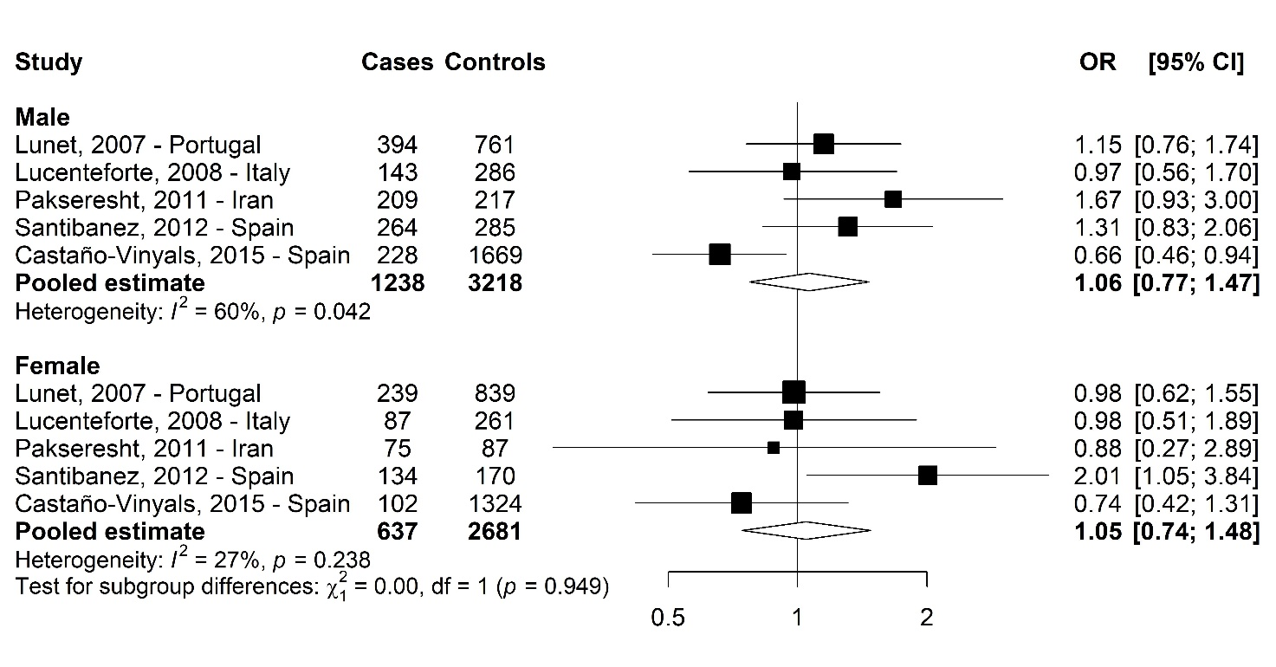
ª Estimated by two-stage meta-analysis using logistic regression models adjusted for sex, age, socioeconomic status, smoking status, family history of gastric cancer, Hp infection (when available), and total energy intake.

Supplementary Figure 3. Forest plot for study-specific and pooled odds ratios (OR)ª with 95% confidence intervals (CI) of gastric cancer for the highest versus the lowest tertile of vitamin D intake, according to age classes.
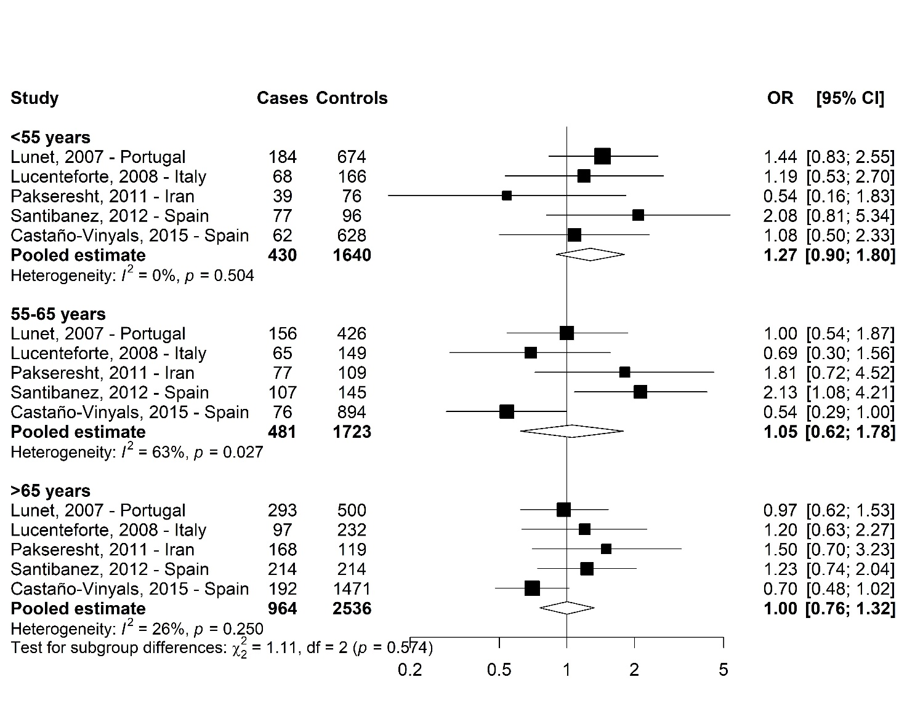
ª Estimated by two-stage meta-analysis using logistic regression models adjusted for sex, age, socioeconomic status, smoking status, family history of gastric cancer, Hp infection (when available), and total energy intake.

Supplementary Figure 4. Forest plot for study-specific and pooled odds ratios (OR)ª with 95% confidence intervals (CI) of gastric cancer for the highest versus the lowest tertile of vitamin D intake, according to socioeconomic status.

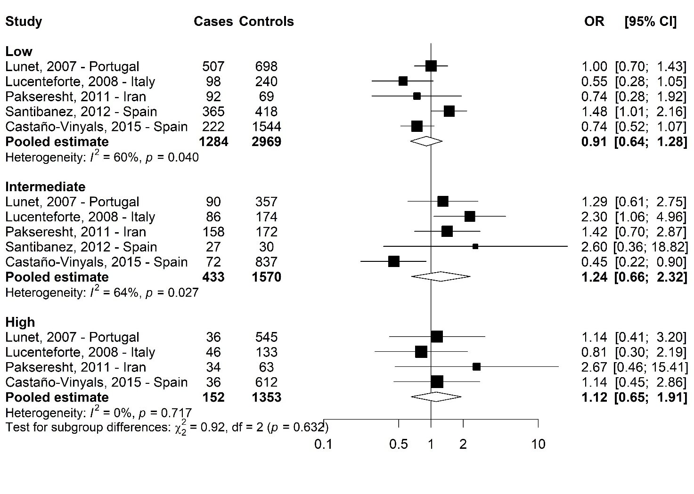
ª Estimated by two-stage meta-analysis using logistic regression models adjusted for sex, age, socioeconomic status, smoking status, family history of gastric cancer, Hp infection (when available), and total energy intake.

Supplementary Figure 5. Forest plot for study-specific and pooled odds ratios (OR)ª with 95% confidence intervals (CI) of gastric cancer for the highest versus the lowest tertile of vitamin D intake, according to smoking status.
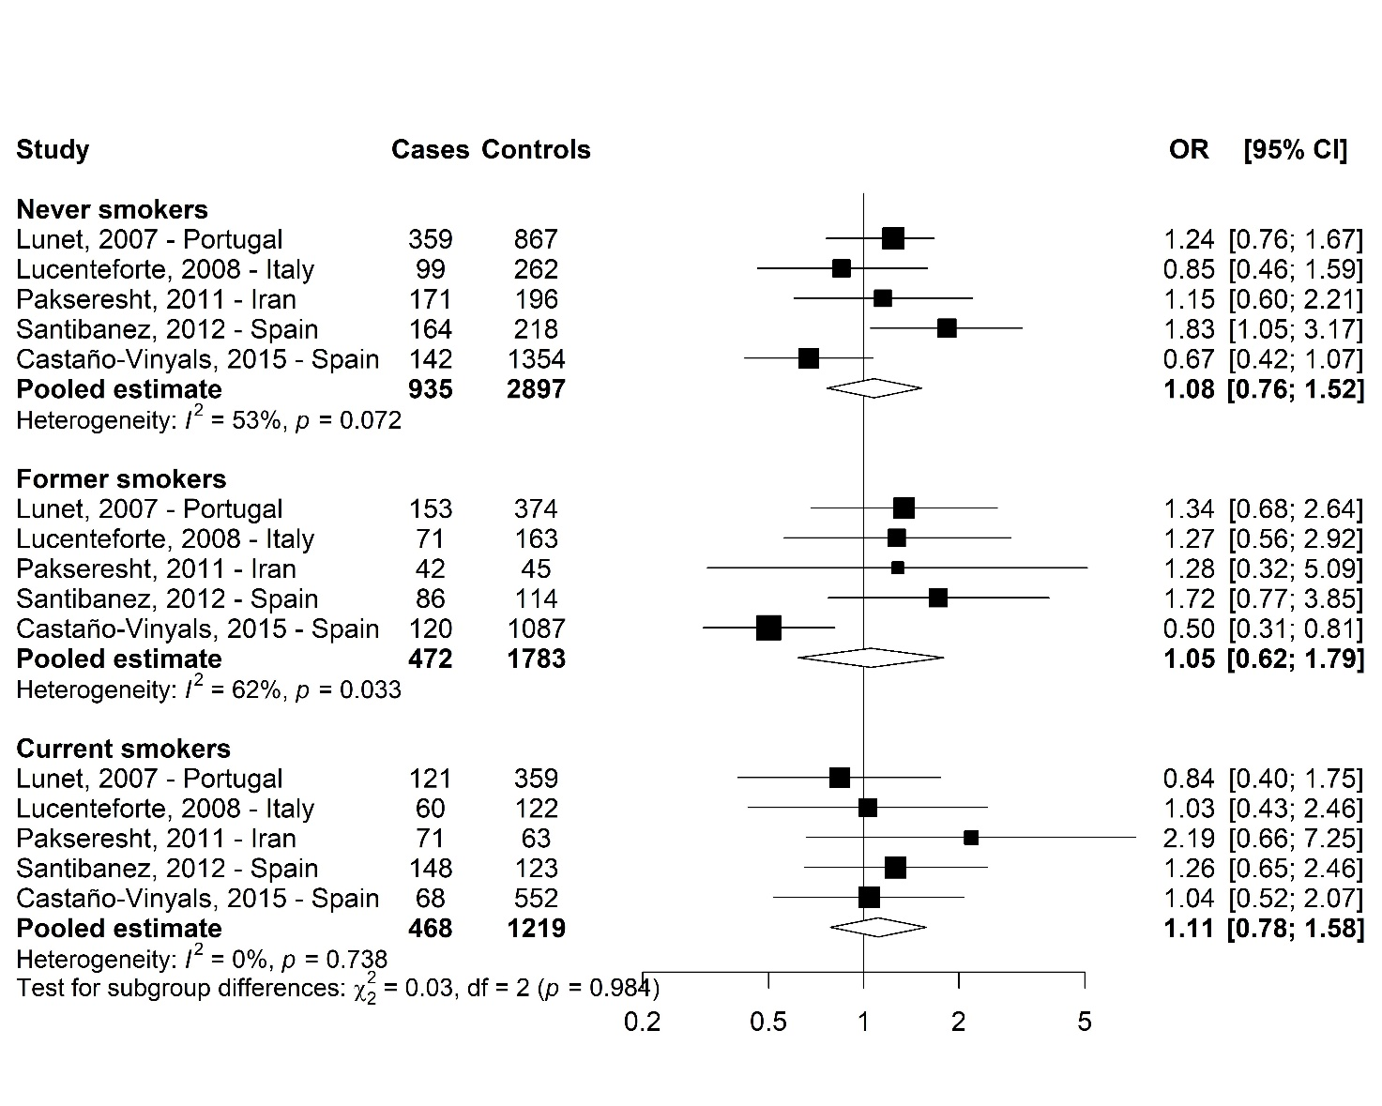
ª Estimated by two-stage meta-analysis using logistic regression models adjusted for sex, age, socioeconomic status, smoking status, family history of gastric cancer, Hp infection (when available), and total energy intake.

Supplementary Figure 6. Forest plot for study-specific and pooled odds ratios (OR)ª with 95% confidence intervals (CI) of gastric cancer for the highest versus the lowest tertile of vitamin D intake, according to alcohol consumption.
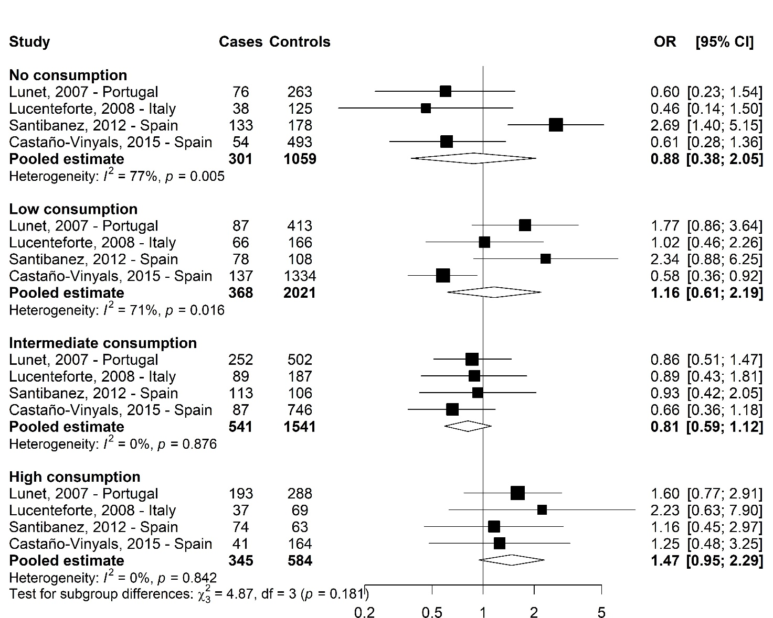
ª Estimated by two-stage meta-analysis using logistic regression models adjusted for sex, age, socioeconomic status, smoking status, family history of gastric cancer, Hp infection (when available), and total energy intake.

Supplementary Figure 7. Forest plot for study-specific and pooled odds ratios (OR)ª with 95% confidence intervals (CI) of gastric cancer for the highest versus the lowest tertile of vitamin D intake, according to vegetables and fruits intake consumption.
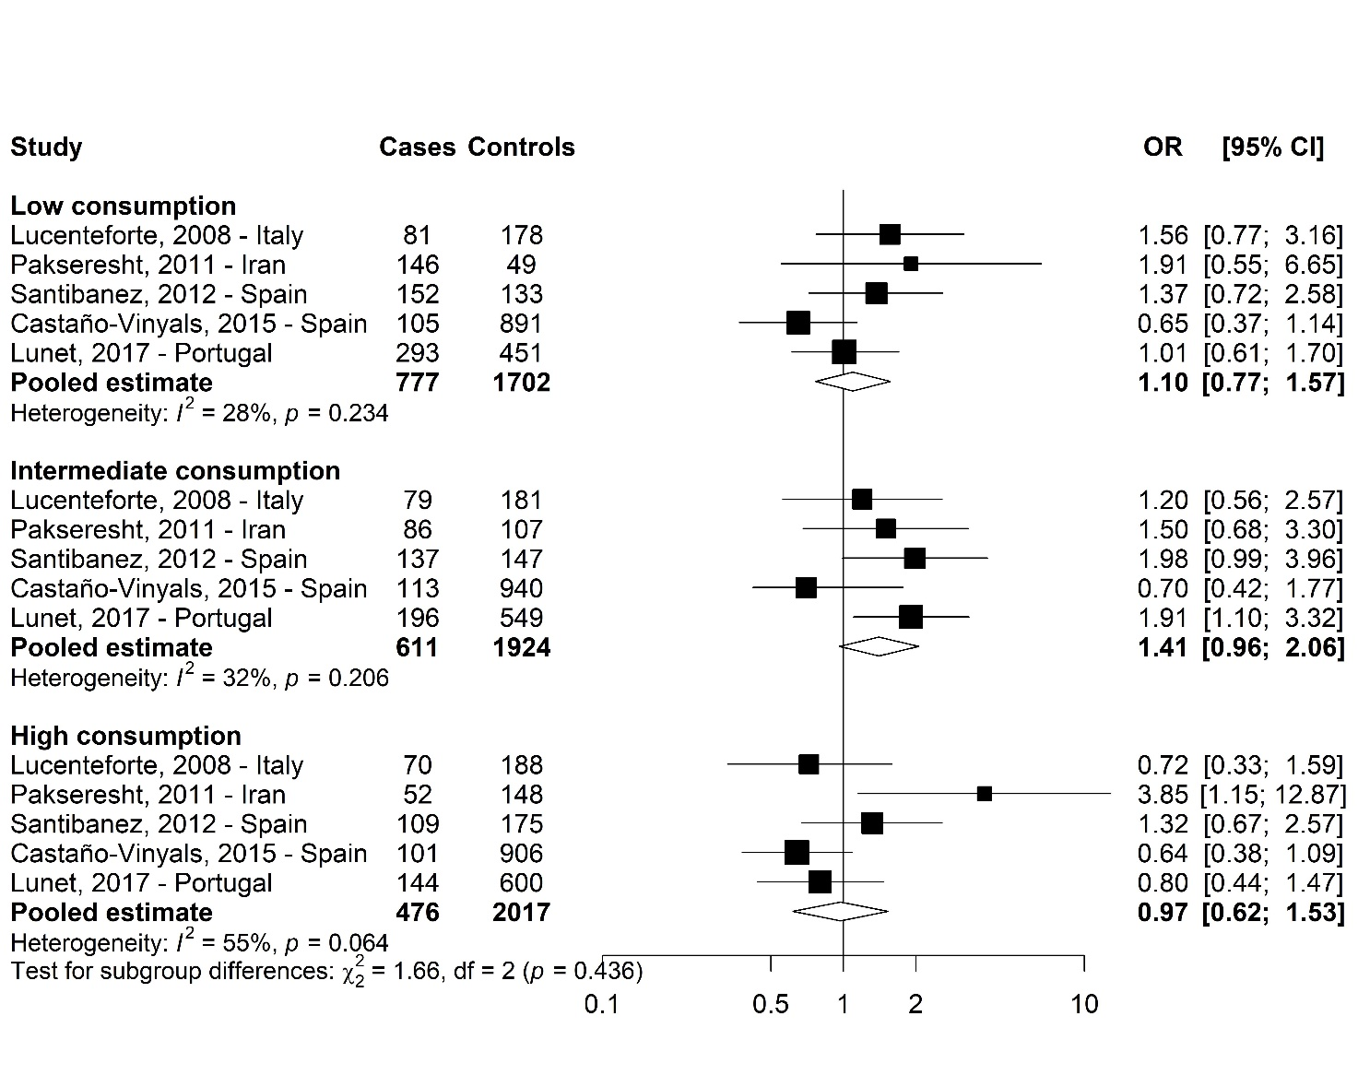 ª Estimated by two-stage meta-analysis using logistic regression models adjusted for sex, age, socioeconomic status, smoking status, family history of gastric cancer, Hp infection (when available), and total energy intake.

