Outcome of interest | No. | Hazard Ratio (95%CI) | P-value | I² (%) | Egger^ | Begg^
OS | 20 | 0.80 (0.73; 0.88) | <0.001 | 98.0 | 0.891 | 0.770
DFS | 12 | 0.84 (0.74; 0.96) | 0.012 | 96.0 | 0.927 | 0.534

Table 1. Meta-analysis results.
Legend: CI = Confidence Interval; ^Egger and Begg’s test for publication bias; OS = Overall Survival; DFS = Disease Free Survival.

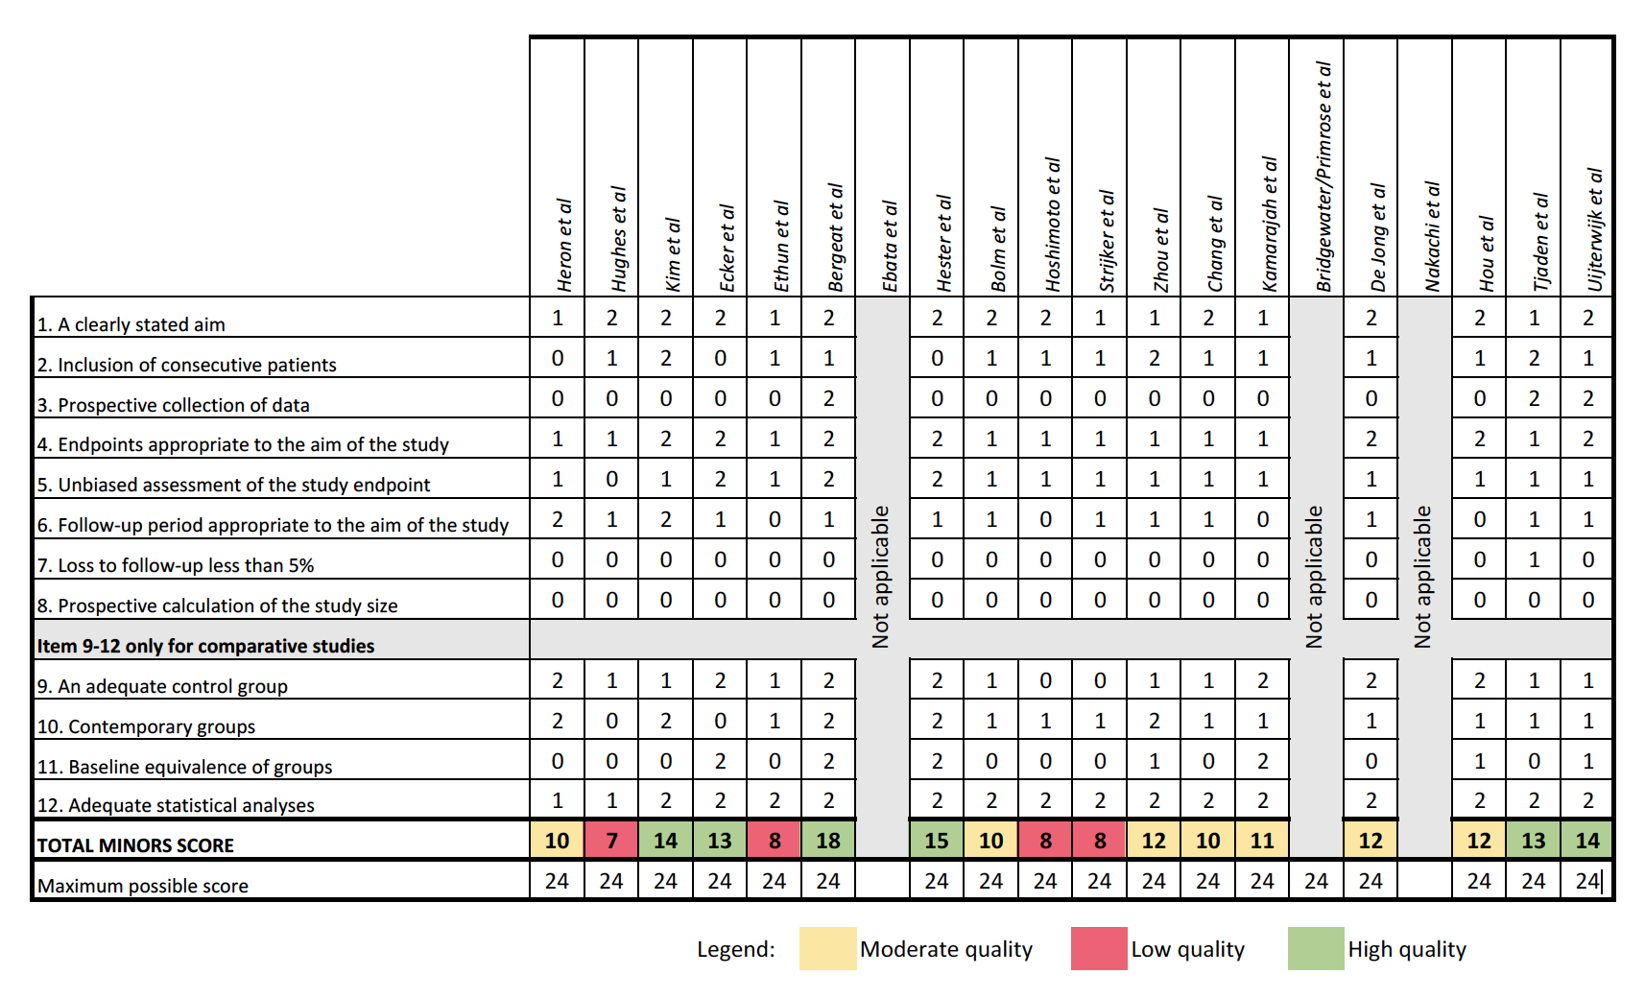

Figure 1. MINORs score for retrospective studies

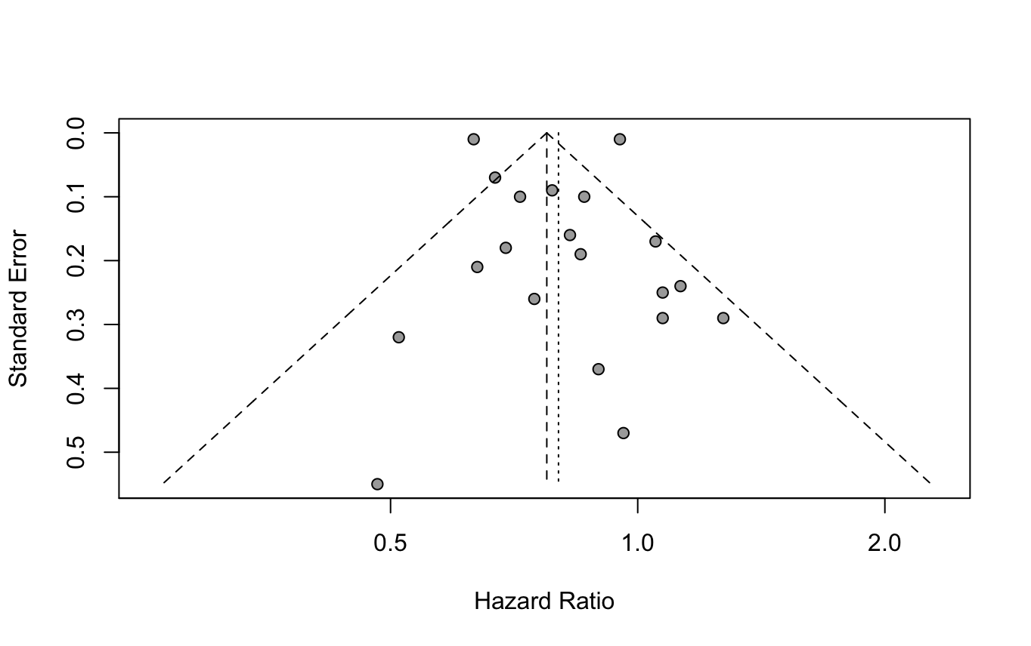
Figure 2. Funnel Plot of Overall Survival.
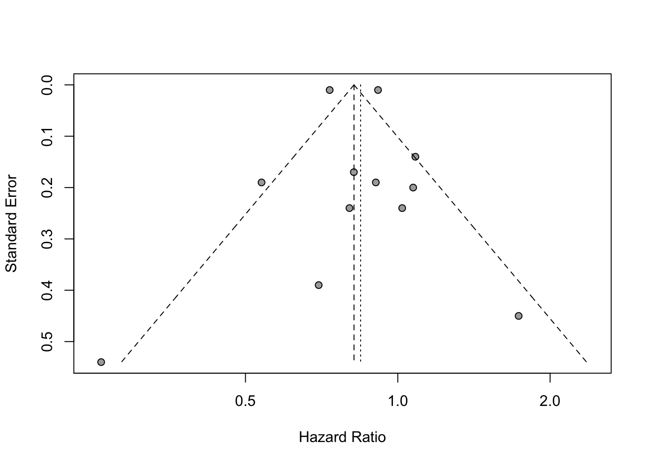
Figure 3. Funnel Plot for Disease Free Survival.

