Supplementary Material

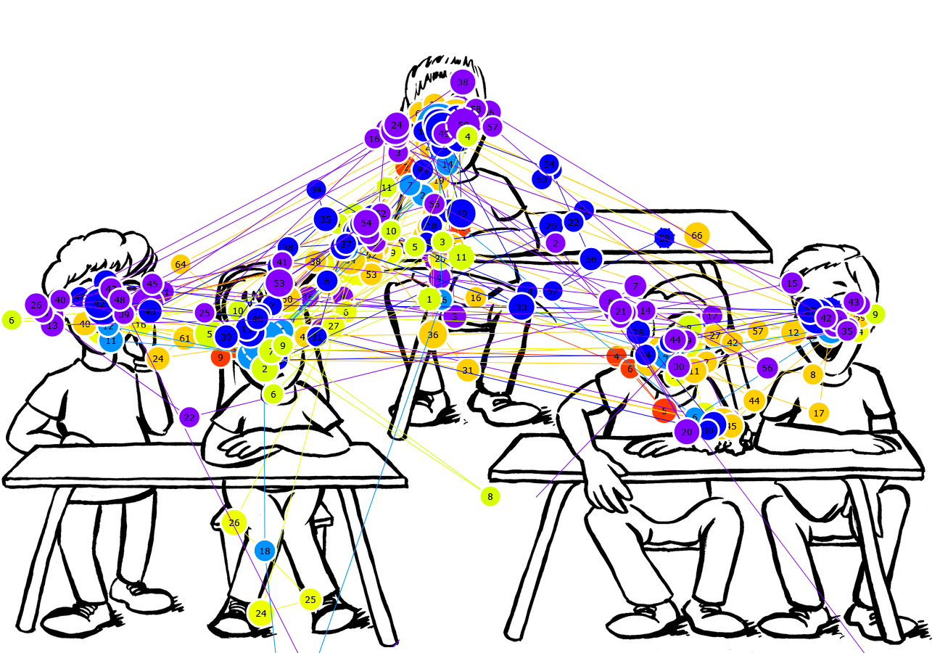

The picture shows the graphical representation of the eye movements of 10 students as they observed a vignette of physical bullying. The decision not to include the eye movements of all participants was made to avoid excessive overlap and maintain the clarity of the vignette.

