Supplementary materials

Supplementary Table S1. Tested maize inbred lines from the Mediterranean area
Lines | Pedigree | Partner provider
2369 | LPS-C7-F64-2-6-2-2-B | FRANCE
A509 | A78 × A109 | CSIC
A638 | (V3xWF9)S1WF9 | CSIC
B107 | pop Cimmyt Pool41 | FRANCE
B14a | BSSCx | FRANCE
B73 | BSSS (USA) | CSIC
BO23 (H102) | IABO78xB73 (early vig) | UNIBO
CML341* | (Pioneer X105A x H-5) x (Pioneer X304B x Agroceres 504) | FRANCE
CML538* | Suwan 1(S)C4-S8-5-3 | FRANCE
CYMM-1 | CYMMIT line | BATEM
DK4676A | 1067–1 x B-Line Composite | FRANCE
EA3076 | Rastrojero A sin 1 | FRANCE
EC334 | (NC300xA632) | FRANCE
EP1 | Lizargarate (Basque country) | CSIC
EP125 | Selection from CO125 | CSIC
EP17 | A1267 (Unknown location) | CSIC
EP2018-03 | La Oliva-6-1-1-1-1-1 | CSIC
EP141 (EP2018-04) | La Oliva-6-2-1-1-1-1 | CSIC
EP2018-07 | Tacoronte-2-2-1-1-1-1 | CSIC
EP184 (EP2018-08) | Arucas-3-3-1-1-1-1 | CSIC
EP2018-10 | Arucas-8-1-1-2-2-1 | CSIC
EP2020-21 | PI527472-2-1-1-1-1 | CSIC
EP2020-24 | PI527472-10-1-1-1-1 | CSIC
EP2020-25 | PI527472-11-1-1-1-1 | CSIC
EP2020-26 | PI527472-12-1-1-1-1 | CSIC
EP2020-28 | PI527472-12-3-1-1-1 | CSIC
EP2020-29 | PI527472-12-3-2-1-1 | CSIC
EP2020-30 | PI527472-13-1-1-1-1 | CSIC
EP2020-31 | PI527472-13-2-1-1-1 | CSIC
EP2020-32 | PI527472-21-1-1-1-1 | CSIC
EP2020-33 | PI527472-23-2-1-1-1 | CSIC
EP2020-35 | PI527472-24-1-1-1-1 | CSIC
EP2020-38 | PI542683-4-1-1-1-1 | CSIC
EP2020-39 | PI542683-11-1-1-1-1 | CSIC
EP2020-40 | PI542683-32-1-1-1-1 | CSIC
EP2020-41 | PI542683-32-2-1-1-1 | CSIC
EP2020-46 | PI527477-9-1-1-1-1 | CSIC
EP2020-51 | PI527477-21-1-1-1-1 | CSIC
EP184 (EP2020-56) | PI527477-25-2-1-1-1 | CSIC
EP2020-59 | EPS4-24-1-1-1-1-1-1 | CSIC
EP42 | Tomiño (Atlantic Spain) | CSIC
EP44 | Hembrilla/Queixalet | CSIC
EP53 | Laro (Atlantic Spain) | CSIC
EP56 | AS-A (Minnesota) | CSIC
EP67 | EPS5 (Synthetic of 16 lines Non-B14) | CSIC
EP68 | EPS5 (Synthetic of 16 lines Non-B14) | CSIC
EP74 | EPS5 (Synthetic of 16 lines Non-B14) | CSIC
EP86 | Selection from PB60, Nostrano dell’Isola (Italy) | CSIC
EPD1 | (EP125 × PB130) F2 dfat AC3-23-1-2-1-2-1 | CSIC
EPD5 | (EP125 × PB130) F2 dfat AC3-59-1-2-1-1-1 | CSIC
EPD6 | (EP125 × PB130) F2 dfat BC3-86-1-1-1-2-1 | CSIC
F2 | Lacaune | CSIC
F252 |  | FRANCE
F473 | Doré de Gomer (France) | CSIC
F618 | (A166 x B37)xB37 | FRANCE
FP1 | (F522 x F546)IHP | FRANCE
GCP-193* | LPS-C3-FS1-2-2-2-1-1-B | FRANCE
H101 | IABO78xB73 (early vig) | UNIBO
H104 | IABO78xB73 (early vig) | UNIBO
H105 | IABO78xB73 (early vig) | UNIBO
H110 | IABO78xB73 (early vig) | UNIBO
K64R | (2702H X B73) X B73. 2702H was a private hybrid of Cargill, Inc. | FRANCE
KUI3 | Yellow Tuxpan | FRANCE
LH123Ht | ZM621A-10-1-1-1-2-B | FRANCE
Lo 863 | Nostrano dell’Isola (Italy) | CREA
Lo1207 | Lo1010xLo1123 | CREA
Lo1285D | Pioneer Hybrid Rossana x Lo1010 | CREA
Lo1301 | Lo1173xLo1101 | CREA
Lo1430 | Lo1240xLo1208 | CREA
Lo1451 | Lo1279xLo1183 | CREA
Lo1453 | Lo1279xLo1301 | CREA
Lo1455 | Lo1299xLo1263 | CREA
Lo1457 | Lo1301xLo1106 | CREA
Lo1500 | KWS Hybrid Klaxon | CREA
Lo1507 | Lo1301xLo1255 | CREA
Lo1600 | Pioneer Hybrid PR32F73 | CREA
Lo1614 | LH82xVa99 | CREA
Lo185 | Lo32xLo38 | CREA
Lo38 | Scagliolo | CREA
Lo436 | Cinquantino bianchi | CREA
Lo469 | Nostrano | CREA
Lo491 | Nostrano Finardi | CREA
Lo8 | Nostrano | CREA
Lo82 | Marano | CREA
Lo88 | Scagliolo Colleoni | CREA
Lo904 | B73^2xB37 | FRANCE
ML606 | LK2 × LH38 | FRANCE
NC338 | Pioneer Hyb 3535 | FRANCE
NC358 | Recurrent selection from an all-tropical hybrid synthetic TROPHY Low Moisture C8 | FRANCE
NIL120 | IABO78xOs420 (nil-root) | UNIBO
PB130 | Rojo Vinoso de Aragón (Mediterranean Spain) | CSIC
Ph W65 | Pvp line Evaluated in TURKEY + DROPS | BATEM
SCMalawi | Subtropical white dent DT developed in Rhodesia (today Zimbabwe) in the 1960s | FRANCE
TRL12 | KT-20-4 | BATEM
TRL17 | KT-34-6 | BATEM
TRL19 | KT-35-2 | BATEM
TRL20 | KT-36-2 | BATEM
TRL22 | KT-37-3 | BATEM
TRL24 | KT-37-15 | BATEM
TRL26 | KT-38-1 | BATEM
TRL31 | KT-39-4 | BATEM
TRL5 | DJ7 | BATEM
TRL6 | KT-2-1 | BATEM
TRL8 | KT-4-1 | BATEM
Tx601 | Yellow Tuxpan | FRANCE
Va26 | OH43xK155 | FRANCE
The bold marked 6 lines were not involved in GWAS analysis due to lacking genetic data.

Supplementary Table S2. Description of image-derived traits by using IAP

Trait name | Internal Property Name | Trait description | Category
Estimated Shoot Volume | combined.geometry.vis.volume.prism..px.3. | Volume estimation according to this calculation scheme: t1 = avgTopArea; s1 =  sideArea_for_angleNearestTo0; s2 = sideArea_for_angleNearestTo45; s3 =  sideArea_for_angleNearestTo90; volume_prism = Math.sqrt(t1 * s2 * s3 / 2d *  Math.sqrt(1 - Math.pow((s2 * s2 + s3 * s3 - s1 * s1) / (2d * s2 * s3), 2))); | Biomass-related  geometry trait based on visible-light combined view[px^3]
Shoot Area | top.geometry.vis.area..px.2. | Number of foreground pixels. Therefore, projected plant area in pixels. | Biomass-related  geometry trait based on visible-light top view [px^2]
Plant Height | side.geometry.vis.height..px. | Height of the plant, measured as the vertical distance in pixels from the most top  plant pixel to the most bottom plant pixel. | Architectural-related  geometry trait based on visible-light side view [px]
Plant Width | side.geometry.vis.width..px. | Width of the plant, measured as the horizontal distance in pixels from the most left  plant pixel to the most right plant pixel. | Architectural-related  geometry trait based on visible-light side view [px]
Compactness | top.geometry.fluo.compactness.01 | 4 * Math.PI / (borderPixels * borderPixels / filledArea) | Architectural-related  geometry trait based on fluorescence top view
Lab_color_a | top.intensity.vis.lab.a.mean | Mean - first order texture property (independent of pixel neighbors). Calculated  on grayscale image derived from channel Green-Red-Parameter a* (L*a*b*). | Color-related  based on visible-light top view
Yellow to Green | top.intensity.vis.hsv.h.yellow2green | Proportion of yellow colour plant pixels (histogram bin 3) divided by the count of  green colour pixels (bins 4 to 7). This value is only valid if the bin count has not  been changed from 20, otherwise the involved bins represent different colors. | Color-related  based on visible-light top view

Supplementary Table S3. Repeatability of photosynthesis-related traits under control and stress (D-HT, combined drought and high temperature)

Control
DAS | 17 | 24 | 31 | 38
Fv/Fm | 0.79 | 0.88 | 0.91 | 0.92
ΦPSII | 0.56 | 0.83 | 0.86 | 0.82

D-HT
DAS | 18 | 22 | 25 | 29 | 32 | 36 | 39
Fv/Fm | 0.74 | 0.62 | 0.46 | 0.54 | 0.60 | 0.70 | 0.76
ΦPSII | 0.60 | 0.48 | 0.38 | 0.54 | 0.64 | 0.67 | 0.72

DAS: days after sowing; ΦPSII: PSII operating efficiency, Fv/Fm: maximum quantum efficiency of PSII

Supplementary Table S4. Stress indices (stress resistance, stress recovery and stress adaptability) of the tested 106 maize lines

Lines | Stress resistance | Stress recovery | Stress adaptability
EP184 (EP2020-56) | 0.287 | 0.699 | 0.512
EP2018-10 | 0.263 | 0.822 | 0.519
ML606 | 0.218 | 0.827 | 0.519
Lo904 | 0.258 | 0.78 | 0.521
F2 | 0.196 | 0.972 | 0.555
EPD6 | 0.263 | 0.923 | 0.56
EP141 (EP2018-04) | 0.236 | 0.889 | 0.57
PB130 | 0.368 | 0.843 | 0.574
F252 | 0.305 | 0.803 | 0.578
EP2020-40 | 0.342 | 0.818 | 0.579
EPD5 | 0.294 | 0.858 | 0.586
EP42 | 0.291 | 0.878 | 0.589
Lo1500 | 0.305 | 0.858 | 0.589
NIL120 | 0.256 | 0.943 | 0.59
LH123Ht | 0.312 | 0.871 | 0.603
TRL19 | 0.325 | 0.89 | 0.603
EP1 | 0.192 | 1.103 | 0.604
B73 | 0.275 | 0.959 | 0.608
Lo1457 | 0.25 | 0.938 | 0.609
EC334 | 0.311 | 0.903 | 0.61
NC338 | 0.398 | 0.778 | 0.61
EP68 | 0.272 | 0.928 | 0.613
FP1 | 0.293 | 1.031 | 0.617
H104 | 0.364 | 0.855 | 0.617
Lo1614 | 0.32 | 0.903 | 0.617
SCMalawi | 0.284 | 1.095 | 0.621
GCP-193* | 0.359 | 0.875 | 0.622
2369 | 0.319 | 0.948 | 0.626
EP2020-59 | 0.31 | 0.906 | 0.639
EPD1 | 0.395 | 0.903 | 0.64
H110 | 0.382 | 0.877 | 0.643
EP2020-39 | 0.325 | 0.956 | 0.644
Ph W65 | 0.326 | 0.939 | 0.644
CML341* | 0.379 | 0.917 | 0.645
TRL6 | 0.365 | 0.906 | 0.645
EP17 | 0.252 | 1.082 | 0.646
EP74 | 0.332 | 0.979 | 0.651
EP86 | 0.312 | 0.985 | 0.651
TRL5 | 0.323 | 0.997 | 0.654
Lo1451 | 0.321 | 0.989 | 0.655
H105 | 0.376 | 0.917 | 0.656
A509 | 0.255 | 1.175 | 0.657
EP2020-26 | 0.273 | 1.175 | 0.662
CYMM-1 | 0.385 | 0.932 | 0.663
EP2020-41 | 0.314 | 1.036 | 0.663
Lo491 | 0.387 | 0.932 | 0.667
Lo1507 | 0.336 | 1.013 | 0.668
Tx601 | 0.328 | 1.045 | 0.67
EP53 | 0.327 | 1.014 | 0.673
K64R | 0.347 | 1.079 | 0.673
Lo1600 | 0.312 | 0.991 | 0.673
EP2018-03 | 0.308 | 1.037 | 0.674
EP2020-25 | 0.278 | 1.23 | 0.678
EP125 | 0.38 | 0.921 | 0.68
TRL12 | 0.336 | 1.039 | 0.681
TRL17 | 0.373 | 0.984 | 0.691
EP2020-46 | 0.393 | 0.968 | 0.693
TRL8 | 0.373 | 1.071 | 0.694
EP2020-30 | 0.349 | 1.035 | 0.695
Lo1455 | 0.288 | 1.128 | 0.695
Lo88 | 0.362 | 1.017 | 0.695
A638 | 0.252 | 1.296 | 0.702
EP2020-29 | 0.356 | 1.101 | 0.709
KUI3 | 0.389 | 1.067 | 0.71
EP2020-21 | 0.307 | 1.204 | 0.718
Lo82 | 0.335 | 1.187 | 0.719
EP44 | 0.413 | 0.986 | 0.72
Lo1285D | 0.446 | 0.966 | 0.72
Lo1207 | 0.381 | 1.105 | 0.721
Lo469 | 0.366 | 1.105 | 0.723
BO23 (H102) | 0.432 | 1.015 | 0.729
DK4676A | 0.402 | 1.018 | 0.736
CML538* | 0.375 | 1.11 | 0.738
TRL26 | 0.463 | 0.955 | 0.738
EP56 | 0.339 | 1.261 | 0.739
EP2020-24 | 0.341 | 1.204 | 0.74
Lo8 | 0.372 | 1.12 | 0.743
NC358 | 0.365 | 1.156 | 0.754
EP2018-07 | 0.341 | 1.205 | 0.756
EP2020-38 | 0.348 | 1.269 | 0.756
EA3076 | 0.413 | 1.187 | 0.765
Lo38 | 0.349 | 1.199 | 0.765
TRL20 | 0.379 | 1.153 | 0.767
Va26 | 0.358 | 1.297 | 0.773
Lo 863 | 0.345 | 1.216 | 0.774
Lo1453 | 0.467 | 1.037 | 0.782
EP2020-28 | 0.402 | 1.18 | 0.787
EP2020-33 | 0.485 | 1.188 | 0.797
EP2020-32 | 0.384 | 1.263 | 0.801
Lo1301 | 0.387 | 1.255 | 0.807
Lo1430 | 0.493 | 1.28 | 0.835
Lo185 | 0.496 | 1.174 | 0.837
EP67 | 0.355 | 1.355 | 0.843
TRL31 | 0.441 | 1.275 | 0.849
F618 | 0.408 | 1.574 | 0.855
EP2020-35 | 0.392 | 1.387 | 0.861
F473 | 0.553 | 1.097 | 0.861
EP2020-31 | 0.479 | 1.24 | 0.866
EP2020-51 | 0.458 | 1.263 | 0.876
EP145 (EP2018-08) | 0.324 | 1.615 | 0.902
B14a | 0.629 | 1.146 | 0.91
H101 | 0.535 | 1.447 | 0.962
TRL22 | 0.375 | 1.602 | 0.979
B107 | 0.441 | 1.592 | 1
Lo436 | 0.509 | 1.43 | 1
TRL24 | 0.529 | 1.563 | 1.02

Supplementary Table S5. Correlations between the stress indices and RGRs (relative growth rates) of estimated shoot volume in different time intervals determined for plants exposed to stress (D-HT, n=106, all values were based on means of BLUPs).

 | Stress_resistance | Stress_recovery | Stress_adaptability
RGR11_14 | -0.144 | 0.074 | -0.031
RGR12_15 | -0.282* | -0.029 | -0.159
RGR13_16 | -0.188 | -0.115 | -0.161
RGR14_17 | -0.112 | 0.03 | -0.025
RGR16_20 | 0.06 | 0.203* | 0.154
RGR21_24 | 0.599*** | 0.081 | 0.307**
RGR23_26 | 0.591*** | 0.07 | 0.299**
RGR24_27 | 0.614*** | 0.15 | 0.364***
RGR27_30 | 0.261*** | -0.133 | 0.002
RGR28_31 | 0.25* | -0.113 | 0.028
RGR30_33 | -0.154 | -0.018 | -0.06
RGR31_34 | -0.223* | 0.097 | -0.011
RGR34_37 | -0.223* | 0.252*** | 0.117
RGR35_38 | -0.184 | 0.352*** | 0.21*
RGR37_40 | -0.126 | 0.273** | 0.196*
RGR38_41 | -0.106 | 0.255** | 0.196*
RGR41_44 | -0.061 | -0.092 | -0.017
V_30DAS | 0.17 | 0.426*** | 0.322**

The numbers after `RGR´ denote the growth interval between the days (appear as days after sowing DAS). RGR was calculated as follows: relative growth rate=(InESV2-InESV1)/(t2-t1). V_30DAS denotes the estimated shoot volume at 30 DAS under stress. The values represent the correlation coefficient. ** indicates significant at p<0.01, *** p<0.001.

Supplementary Table S6. Correlations between stress indices (resistance, recovery) and two photosynthesis related traits under D-HT conditions

 | ΦPSII |  |  |  |  | Fv/Fm |  |  |  |  | ΦPSII change rate |  | Fv/Fm change rate
 | DAS18 | DAS29 | DAS32 | DAS36 | DAS39 | DAS18 | DAS29 | DAS32 | DAS36 | DAS39 | DAS18_29 | DAS29_39 | DAS18_29 | DAS29_39
resistance | -0.0195 | 0.4426* | 0.1771 | 0.1033 | 0.0197 | -0.0159 | 0.2265* | 0.1681 | 0.0729 | -0.0045 | -0.4489*** | -0.4647** | -0.2806*** | -0.273**
recovery | 0.0467 | -0.0984 | 0.0688 | 0.0795 | 0.0792 | 0.0589 | -0.096 | -0.0478 | 0.0479 | 0.0817 | -0.1188 | 0.1461*** | -0.1769 | 0.2105*

DAS: days after sowing; ΦPSII: PSII operating efficiency, Fv/Fm: maximum quantum efficiency of PSII
Values denote correlation coefficient between the traits analyzed by Pearson correlation. *, **, *** indicate significant correlations at p< 0.5, 0.1, 0.001, respectively.

Supplementary Table S7. The distribution density of all the SNPs used on different chromosomes.

Chro | Genome Length | No. SNPs | Density (1Mb)
1 | 301,328,325 | 83066 | 27.567
2 | 236,970,231 | 62076 | 26.196
3 | 232,087,212 | 60024 | 25.863
4 | 241,389,936 | 60946 | 25.248
5 | 217,745,659 | 60450 | 27.762
6 | 169,133,569 | 40380 | 23.875
7 | 176,733,146 | 43318 | 24.510
8 | 175,775,487 | 43300 | 24.634
9 | 156,602,574 | 39068 | 24.947
10 | 149,836,931 | 35715 | 23.836
Average |  | 52834 | 25.444

Supplementary Table S8. Numbers of MTAs (marker traits associations) significantly associated with stress (combined drought and high temperature, D-HT) and recovery in maize identified by GWAS by using different models (FarmCPU, BLINK, GLM, MLM, MLMM) implemented in GAPIT.

Traits | Stress |  |  |  |  | Recovery
Traits | FarmCPU | BLINK | GLM | MLM | MLMM | FarmCPU | BLINK | GLM | MLM | MLMM
Photosynthesis-related traits | 26 | 14 | 2 | 1 | 23 | 28 | 18 | 3 | 0 | 9
ESV | 0 | 1 | 0 | 0 | 1 | 0 | 0 | 0 | 0 | 0
PH | 5 | 6 | 0 | 0 | 3 | 0 | 5 | 0 | 0 | 7
Lab_a | 14 | 20 | 0 | 0 | 13 | 0 | 0 | 0 | 0 | 4
Yellow to green | 37 | 23 | 4 | 0 | 23 | 14 | 7 | 0 | 0 | 13
RGR of shoot volume | 0 | 3 | 0 | 0 | 1 | 0 | 0 | 0 | 0 | 2
Sum | 220 |  |  |  |  | 110

ESV: estimated shoot volume; PH: plant height; RGR: relative growth rate

Supplementary Table S9. List of SNPs co-detected by multiple GAPIT models in control conditions and in non-stress conditions in the drought and high temperature stress experiment (11-18 DAS).

Traits | Experiment/ |  | SNP | Chr. | Position (bp) | MAF | Allele | Model | min P.value | DAS
Traits | Treatment
Y2G | CONTROL |  | AX-90646565 | 1 | 158,183,960.00 | 0.05 | G/C | GLM | 1.61E-07 | 42-43
 |  |  |  |  |  |  |  | MLMM | 3.06E-17 | 37, 39, 40-42
 |  |  |  |  |  |  |  | BLINK | 8.78E-20 | 36, 37, 39-44
 |  |  |  |  |  |  |  | FarmCPU | 2.19E-14 | 39-44
Y2G |  |  | AX-90805791 | 3 | 45,721,852 | 0.215 | C/T | MLMM | 6.40E-08 | 16
 |  |  |  |  |  |  |  | BLINK | 5.87E-09 | 16, 18
 |  |  |  |  |  |  |  | FarmCPU | 1.98E-14 | 16, 18
Y2G |  |  | AX-91675637 | 5 | 183,839,147 | 0.08 | C/T | GLM | 2.36E-07 | 16
 |  |  |  |  |  |  |  | MLMM | 9.49E-09 | 16, 18, 19
 |  |  |  |  |  |  |  | BLINK | 2.94E-09 | 16, 18
 |  |  |  |  |  |  |  | FarmCPU | 1.27E-13 | 16, 18
Y2G | D-HT | NS | AX-91444930 | 2 | 68,741,355 | 0.055 | T/C | MLMM | 3.91E-23 | 13
 |  |  |  |  |  |  |  | BLINK | 5.53E-11 | 12, 13
 |  |  |  |  |  |  |  | FarmCPU | 1.20E-10 | 12
Y2G | D-HT | NS | AX-90591615 | 5 | 174,291,454 | 0.05 | T/G | GLM | 1.24E-07 | 11, 12
 |  |  |  |  |  |  |  | MLMM | 2.74E-13 | 11
 |  |  |  |  |  |  |  | BLINK | 6.42E-29 | 11-13
 |  |  |  |  |  |  |  | FarmCPU | 2.99E-21 | 11-13
Y2G | D-HT | NS | AX-90629089 | 5 | 216,698,065 | 0.08 | C/T | MLMM | 4.95E-22 | 12
 |  |  |  |  |  |  |  | BLINK | 5.12E-09 | 12
 |  |  |  |  |  |  |  | FarmCPU | 1.80E-09 | 12
Y2G | D-HT | NS | AX-90922259 | 5 | 6,280,794 | 0.05 | G/T | MLMM | 1.70E-08 | 12
 |  |  |  |  |  |  |  | BLINK | 7.25E-18 | 13, 14
 |  |  |  |  |  |  |  | FarmCPU | 2.39E-15 | 13
PH | CONTROL |  | AX-90817075 | 3 | 89,827,217 | 0.14 | C/T | MLMM | 7.08E-19 | 25, 33
 |  |  |  |  |  |  |  | BLINK | 2.37E-19 | 25, 22, 33
 |  |  |  |  |  |  |  | FarmCPU | 5.50E-11 | 25
PH |  |  | AX-90973672 | 5 | 202,308,851 | 0.25 | G/A | MLMM | 5.35E-12 | 27, 28, 36, 37
 |  |  |  |  |  |  |  | BLINK | 5.96E-19 | 27-30
 |  |  |  |  |  |  |  | FarmCPU | 1.05E-13 | 27-29
PH |  |  | AX-91069867 | 8 | 4,176,411 | 0.15 | A/G | MLMM | 2.33E-29 | 16, 18, 23
 |  |  |  |  |  |  |  | BLINK | 1.08E-11 | 16
 |  |  |  |  |  |  |  | FarmCPU | 6.77E-11 | 16
PH | D-HT | NS | AX-90719990 | 1 | 266,045,444 | 0.1 | A/T | MLMM | 1.48E-07 | 13
 |  |  |  |  |  |  |  | BLINK | 2.11E-10 | 13, 23
 |  |  |  |  |  |  |  | FarmCPU | 2.43E-07 | 21
Fv/Fm | CONTROL |  | AX-91011635 | 6 | 132,409,250 | 0.11 | G/A | GLM | 1.45E-08 | 25, 32
 |  |  |  |  |  |  |  | MLMM | 6.03E-15 | 25, 32, 39
 |  |  |  |  |  |  |  | BLINK | 5.04E-09 | 25, 32, 39
 |  |  |  |  |  |  |  | FarmCPU | 8.86E-19 | 25, 32
ΦPSII | CONTROL |  | AX-91925311 | 3 | 153,930,274 | 0.145 | A/G | MLMM | 8.34E-08 | 32, 39
 |  |  |  |  |  |  |  | BLINK | 8.16E-11 | 32, 39
 |  |  |  |  |  |  |  | FarmCPU | 1.6E-07 | 39
RGR | CONTROL |  | AX-91832614 | 10 | 138,025,934 | 0.3 | G/A | MLMM | 6.50E-11 | 36_39, 37_40
 |  |  |  |  |  |  |  | BLINK | 1.51E-16 | 36_39, 37_40
 |  |  |  |  |  |  |  | FarmCPU | 1.63E-07 | 36_39, 37_40
ESV | CONTROL |  | AX-91825468 | 10 | 98,476,637 | 0.31 | A/G | MLMM | 1.62E-10 | 22, 27-29, 32-36
 |  |  |  |  |  |  |  | BLINK | 1.99E-10 | 27-37
 |  |  |  |  |  |  |  | FarmCPU | 1.86E-07 | 28, 32, 33, 36

Chr.: chromosome, MAF: minor allele frequency, min p.value: the lowest p value detected among the three models, D-HT: combined drought and high temperature stress period (from 18 to 31 DAS) in the stress experiment, NS, CONTROL: non-stress condition periods in the stress and control experiments, respectively.
ΦPSII: operation efficiency, Fv/Fm: maximum quantum efficiency of PSII. DAS: days after sowing; Y2G: yellow to green, PH: plant height, RGR: relative growth rate of shoot volume; ESV: estimated shoot volume.

Supplementary Table S10. List of candidate genes found within the confident intervals of significantly associated SNPS in stress phase under D-HT conditions. Bold SNPs denote those appeared under both stress and recovery phase. SNPs in italic are those detected at least in 3 models.

Traits | SNP | Chr. | Pos. | Name (Version2) | Gene (Version5) | Start | End | Symbol | Annotation
Y2G | AX-90533100 | 1 | 300072663 | GRMZM2G381441 | Zm00001eb065170 | 307073498 | 307074676 | ereb58 | AP2-EREBP-transcription factor 58
Y2G | AX-90653949 | 1 | 15079512 | GRMZM2G034283 | Zm00001eb005450 | 15194903 | 15196258 |  | uncharacterized
 |  |  |  | GRMZM2G034302 | Zm00001eb005460 | 15196463 | 15201827 | sut1 | sucrose transporter
Y2G | AX-90672221 | 1 | 82378573 | GRMZM2G418294 | Zm00001eb021820 | 83203425 | 83214752 |  | uncharacterized
Y2G | AX-90673339 | 1 | 86616499 | GRMZM2G424595 | Zm00001eb022740 | 87628375 | 87650737 | LOC100384314 | uncharacterized
Y2G | AX-90727829 | 1 | 294494118 | GRMZM2G177438 | Zm00001eb054190 | 271302813 | 271310455 | hin5 | harpin inducing protein
Y2G | AX-91546535 | 2 | 197935545 | GRMZM2G021587 | Zm00001eb104490 | 204550599 | 204569992 | idd21 | indeterminate domain protein
Y2G | AX-90647326 | 3 | 28334431 | GRMZM2G076104 | Zm00001eb126250 | 28455243 | 28458876 | phm2343 | uncharacterized
Y2G | AX-91554920 | 3 | 7405714 | GRMZM2G093050 | Zm00001eb121480 | 7315627 | 7323437 | eif3 | eukaryotic initiation factor3
Y2G | AX-91638474 | 4 | 223105463 | GRMZM2G003663 | Zm00001eb203860 | 230376276 | 230380115 | tbn1 | F-box protein
Y2G | AX-90545901 | 5 | 84825551 | GRMZM2G382914 | Zm00001eb233070 | 86821210 | 86825342 | pgk3 | phosphoglycerate kinase
Y2G | AX-91010399 | 6 | 128319956 | GRMZM2G044442 | Zm00001eb283010 | 139120359 | 139130010 |  | uncharacterized
Y2G | AX-91015937 | 6 | 147688947 | GRMZM2G062577 | Zm00001eb288310 | 158786966 | 158790466 | LOC100281363 | uncharacterized
Y2G | AX-91452276 | 6 | 155014762 | GRMZM2G129064 | Zm00001eb291060 | 166456221 | 166458563 | skus3 | ascorbate oxidase,multicopper oxidase
Y2G | AX-91704802 | 6 | 128056311 | GRMZM2G108714 | Zm00001eb282950 | 138872521 | 138875317 | sfat2 | sucrose ferulic acid transferase
Y2G | AX-91704897 | 6 | 128554270 | GRMZM2G027723 | Zm00001eb283110 | 139381927 | 139388728 | cesa2 | cellulose synthase
Y2G | AX-91060956 | 7 | 149603361 | GRMZM2G032336 | Zm00001eb321680 | 156055492 | 156074637 | camta2 | CAMTA-transcription factor
Y2G | AX-91070676 | 8 | 6919298 | GRMZM2G110504 | Zm00001eb334140 | 7323087 | 7323898 | nodulin-related protein 1 | ABA biosynthetic process
Y2G | AX-91389211 | 8 | 6943650 | GRMZM2G408294 | Zm00001eb334150 | 7336760 | 7347871 |  | uncharacterized
Y2G | AX-91746687 | 8 | 6934434 | GRMZM2G110504 | Zm00001eb334140 | 7323087 | 7323898 | nodulin-related protein 1 | ABA biosynthetic process
 |  |  |  |  | Zm00001eb334150 | 7336760 | 7347871 |  | uncharacterized
Y2G | AX-91157887 | 10 | 2655525 | GRMZM2G172487 | Zm00001eb405470 | 2171060 | 2172216 | myb123 | MYB-transcription factor
Y2G | AX-91822716 | 10 | 84071617 | GRMZM2G002818 | Zm00001eb416910 | 85679008 | 85694592 |  | uncharacterized
 |  |  |  |  | Zm00001eb431260 | 145265954 | 145266668 |  | uncharacterized
PH | AX-90719990 | 1 | 266045444 | GRMZM2G093849 | Zm00001eb054470 | 272633927 | 272637223 | LOC100284729 | uncharacterized
PH | AX-91744643 | 7 | 173525328 | GRMZM2G430849 | Zm00001eb330850 | 182564903 | 182567517 | nactf122 | NAC-transcription factor
 |  |  |  | GRMZM2G469380 | Zm00001eb330880 | 182614902 | 182616925 | csu632b | uncharacterized
Fv/Fm | AX-91499707 | 1 | 250202908 | GRMZM2G038988 | Zm00001eb050290 | 256341482 | 256357495 | iqd4 | IQ Domain protein,calmodulin binding protein
Fv/Fm | AX-91547206 | 2 | 201883088 | GRMZM2G180283 | Zm00001eb105580 | 208529035 | 208530699 | sm2 | rhamnosyl transferase
Fv/Fm | AX-91553079 | 2 | 234047705 | GRMZM5G871297 | Zm00001eb117220 | 240249381 | 240270028 | pco116016 | uncharacterized
Fv/Fm | AX-90646918 | 2 | 212548834 | GRMZM2G162781 | Zm00001eb109780 | 219319810 | 219324349 | LOC100191746 | uncharacterized
Fv/Fm | AX-90775557 | 2 | 171744657 | GRMZM2G018775 | Zm00001eb097300 | 176197093 | 176206154 | pco062669 | uncharacterized
 |  |  |  |  | Zm00001eb097310 | 176206442 | 176210727 | cl14620_1 | uncharacterized
 |  |  |  |  | Zm00001eb097330 | 176210987 | 176214115 | ras11E2 | ras-related protein11E2
Fv/Fm | AX-90837651 | 3 | 170022661 | GRMZM5G813651 | Zm00001eb145340 | 174644023 | 174646846 | nactf95 | NAC-transcription factor 95
Fv/Fm | AX-90906239 | 4 | 191766456 | GRMZM2G441541 | Zm00001eb197890 | 197889338 | 197894534 | rboh4 | NADPH oxidase NOX family
Fv/Fm | AX-91388338 | 4 | 168831778 | GRMZM2G041799 | Zm00001eb190610 | 173902613 | 173905762 |  | uncharacterized
Fv/Fm | AX-91634889 | 4 | 204963564 | GRMZM2G003944 | Zm00001eb200970 | 211248116 | 211249698 | tcptf2 | TCP-transcription factor 2
Fv/Fm | AX-90927380 | 5 | 24729546 | GRMZM2G033926 | Zm00001eb220920 | 25637847 | 25641667 | LOC100193515 | uncharacterized
Fv/Fm | AX-91004634 | 6 | 107809903 | GRMZM2G376809 | Zm00001eb278570 | 119414663 | 119417808 |  | uncharacterized
Fv/Fm | AX-91011635 | 6 | 132409250 | GRMZM2G328859 | Zm00001eb284180 | 143334597 | 143339057 |  | uncharacterized
Fv/Fm | AX-91015767 | 6 | 147027032 | GRMZM2G398055 | Zm00001eb288080 | 158103618 | 158108981 | glk51 | G2-like-transcription factor
Fv/Fm | AX-91059070 | 7 | 142812449 | GRMZM2G048165 | Zm00001eb319480 | 148941882 | 148945639 | cel18 | endo-1,4-Î²-d-glucanase
 |  |  |  | GRMZM2G122116 | Zm00001eb331750 | 184263715 | 184273270 | ptac2 | PPR-SMR protein family,plastid transcriptionally active chromosome protein (PTAC)
Fv/Fm | AX-91069338 | 8 | 2288716 | GRMZM2G120876 | Zm00001eb332770 | 2591782 | 2602402 | LOC110120361 | uncharacterized
ΦPSII | AX-90571068 | 1 | 85989110 | GRMZM2G453832 | Zm00001eb022650 | 87022590 | 87026372 | mgt6 | CorA/MRS2/MGT-type magnesium transporter
ΦPSII | AX-90898588 | 4 | 163317618 | GRMZM2G048045 | Zm00001eb189190 | 168380407 | 168390879 | pco143990a | uncharacterized
ΦPSII | AX-91011332 | 6 | 131410839 | GRMZM2G148964 | Zm00001eb283900 | 142327616 | 142328404 | cep5 | C-terminally encoded peptide
ΦPSII | AX-91019777 | 6 | 161013534 | GRMZM2G334658 | Zm00001eb293880 | 172484375 | 172485120 |  | uncharacterized
ΦPSII | AX-91366621 | 7 | 163597901 | GRMZM2G019373 | Zm00001eb326780 | 172664250 | 172665563 | cl32321_1 | uncharacterized
Chr.: chromosome, Pos.: position, ΦPSII: operation efficiency, Fv/Fm: maximum quantum efficiency of PSII, Y2G: yellow to green, PH: plant height

Supplementary Table S11. List of candidate genes found within the confident intervals of significantly associated SNPS in recovery phase under D-HT conditions. Bold SNPs denote those appeared under both stress and recovery phase. SNPs in italic are those detected at least in 3 models.

Traits | SNP | Chr. | Pos. | Name (Version2) | Gene (Version5) | Start | End | Symbol | Annotation
Y2G | AX-90637127 | 1 | 28447670 | GRMZM2G099797 | Zm00001eb009140 | 28362093 | 28367179 | crr8 (cytokinin response regulator8) | response regulator
Y2G | AX-90536429 | 2 | 207614351 | GRMZM2G062156 | Zm00001eb107810 | 214451753 | 214453904 | LOC100273244 | Putative polyol transporter 1/major facilitator
 |  |  |  | GRMZM2G062244 | Zm00001eb107800 | 214429546 | 214430812 | hb107 | Homeobox-transcription
Y2G | AX-91513722 | 2 | 23707143 | GRMZM2G027049 | Zm00001eb075850 | 25147081 | 25153201 | LOC103646158 | WD40 repeat
Y2G | AX-90891466 | 4 | 136091347 | GRMZM2G366392 | Zm00001eb184470 | 141151685 | 141154418 | umc1346 | S-adenosylmethionine decarboxylase proenzyme
Y2G | AX-91628350 | 4 | 168732680 | GRMZM2G347047 | Zm00001eb190570 | 173808865 | 173811609 | cdpk44 | calcium dependent protein kinase
Y2G | AX-90616860 | 6 | 161219444 | GRMZM2G158901 | Zm00001eb294000 | 172670849 | 172675892 |  | tRNA (His) guanylyltransferase 1
Y2G | AX-91060956 | 7 | 149603361 | GRMZM2G032336 | Zm00001eb321680 | 156055492 | 156074637 | camta2 | CAMTA-transcription factor
Y2G | AX-91063140 | 7 | 157579750 | GRMZM2G057380 | Zm00001eb324250 | 166626075 | 166635879 | cl29757_1b | myosin-1
 |  |  |  | GRMZM2G057475 | Zm00001eb324260 | 166647566 | 166652758 |  | Sphingosine kinase 1
 |  |  |  | GRMZM2G057535 | Zm00001eb324280 | 166656293 | 166657472 |  | uncharacterized
Y2G | AX-90575591 | 8 | 71279208 | GRMZM2G158024 | Zm00001eb343970 | 72570035 | 72574528 | era1 | E. coli Ras-like protein1
Y2G | AX-90646195 | 8 | 167014170 | GRMZM2G074462 | Zm00001eb367050 | 173539109 | 173541324 | IDP7782 | uncharacterized
Y2G | AX-91070676 | 8 | 6919298 | GRMZM2G110504 | Zm00001eb334140 | 7323087 | 7323898 | nodulin-related protein 1 | ABA biosynthetic process
Y2G | AX-91108314 | 8 | 150878647 | GRMZM2G163988 | Zm00001eb360330 | 154803493 | 154806471 | pco086004 | 30S ribosomal protein S20, chloroplastic-like
Y2G | AX-91149175 | 9 | 128177505 | GRMZM2G329144 | Zm00001eb394400 | 133993365 | 133996131 | glpx6 | glutathione peroxidase
Y2G | AX-91156408 | 9 | 153612555 | GRMZM2G092281 | Zm00001eb403660 | 160011634 | 160017390 | IDP8502 | uncharacterized
 | AX-91158475 | 10 | 5116835 | GRMZM2G159119 | Zm00001eb406610 | 4672376 | 4674582 | glk4 | G2-like-transcription factor
 |  |  |  | GRMZM2G159179 | Zm00001eb406600 | 4663775 | 4665587 | LOC103640750 | cytochrome P450 94C1
 |  |  |  | GRMZM2G159193 | Zm00001eb406590 | 4658868 | 4660860 | AtXXT3/5 ortholog | glycosyltransferase 3, Xyloglucan biosynthesis
 |  |  |  | GRMZM2G159208 | Zm00001eb406580 | 4657051 | 4658822 | IDP4524 | glycosyltransferase 3, Xyloglucan biosynthesis
Y2G | AX-91746687 | 8 | 6934434 | GRMZM2G110504 | Zm00001eb334140 | 7323087 | 7323898 | nodulin-related protein 1 | ABA biosynthetic process
 |  |  |  | GRMZM2G408294 | Zm00001eb334150 | 7336760 | 7347871 |  | uncharacterized
PH | AX-90775583 | 2 | 171816313 | GRMZM2G146685 | Zm00001eb097340 | 176288896 | 176292009 | umc1875 | uncharacterized
PH | AX-90835587 | 3 | 161644216 | GRMZM2G087032 | Zm00001eb143430 | 163836589 | 163842546 | c3h13 | C3H-transcription factor
PH | AX-91067492 | 7 | 172676200 | GRMZM2G174114 | Zm00001eb330390 | 181707793 | 181717832 |  | replication protein A 70 kDa DNA-binding subunit A
PH | AX-91782356 | 9 | 23008659 | GRMZM2G147319 | Zm00001eb378050 | 24877087 | 24879517 |  | vWA superfamily protein
Fv/Fm | AX-91493498 | 1 | 217276931 | GRMZM2G174310 | Zm00001eb042170 | 222145710 | 222146787 |  | uncharacterized
Fv/Fm | AX-90646918 | 2 | 212548834 | GRMZM2G162781 | Zm00001eb109780 | 219319810 | 219324349 | LOC100191746 | putative leucine-rich repeat protein kinase family protein
Fv/Fm | AX-91011635 | 6 | 132409250 | GRMZM2G328859 | Zm00001eb284180 | 143334597 | 143339057 |  | uncharacterized
Fv/Fm | AX-90616136 | 7 | 19352733 | GRMZM2G042627 | Zm00001eb303240 | 19919587 | 19933729 | kpp1 | kinase associated protein phosphatase,serine/threonine specific protein phosphatase
ΦPSII | AX-90666279 | 1 | 59592682 | GRMZM2G052034 | Zm00001eb016750 | 59706288 | 59710432 |  | putative RING zinc finger domain superfamily protein
 |  |  |  | GRMZM2G052148 | Zm00001eb016760 | 59711298 | 59722110 |  | nuclear pore complex protein NUP93A
 |  |  |  | GRMZM2G052206 | Zm00001eb016770 | 59722892 | 59729015 |  | uncharacterized
ΦPSII | AX-91458589 | 1 | 27757180 | GRMZM2G039968 | Zm00001eb014110 | 47293082 | 47298509 |  | NAD(P)-binding Rossmann-fold superfamily protein
 |  |  |  | GRMZM2G040052 | Zm00001eb008970 | 27719517 | 27722065 | drg3 | dark response gene3
ΦPSII | AX-90586579 | 2 | 78497488 | GRMZM2G157027 | Zm00001eb086200 | 80878644 | 80884486 | pap21 | purple acid phosphatase
ΦPSII | AX-91519829 | 2 | 57543434 | GRMZM2G146395 | Zm00001eb083950 | 59574299 | 59577014 | fdx4 | ferredoxin
ΦPSII | AX-90598763 | 3 | 219193070 | GRMZM2G081924 | Zm00001eb159970 | 224733578 | 224740462 | LOC100276743 | 3'-5' exonuclease domain-containing protein / K homology domain-containing protein / KH domain-containing protein
ΦPSII | AX-91689409 | 6 | 44823838 | GRMZM2G136857 | Zm00001eb267640 | 52826145 | 52828055 | jasmonate O-methyltransferase | SAM dependent carboxyl methyltransferase
ΦPSII | AX-90616136 | 7 | 19352733 | GRMZM2G042733 | Zm00001eb303250 | 19934845 | 19941123 | in1 | intensifier1
ΦPSII | AX-91781282 | 9 | 16682456 | GRMZM2G075488 | Zm00001eb375690 | 18311486 | 18315723 |  | alpha/beta-Hydrolases superfamily protein
Chr.: chromosome, Pos.: position, ΦPSII: operation efficiency, Fv/Fm: maximum quantum efficiency of PSII, Y2G: yellow to green, PH: plant height

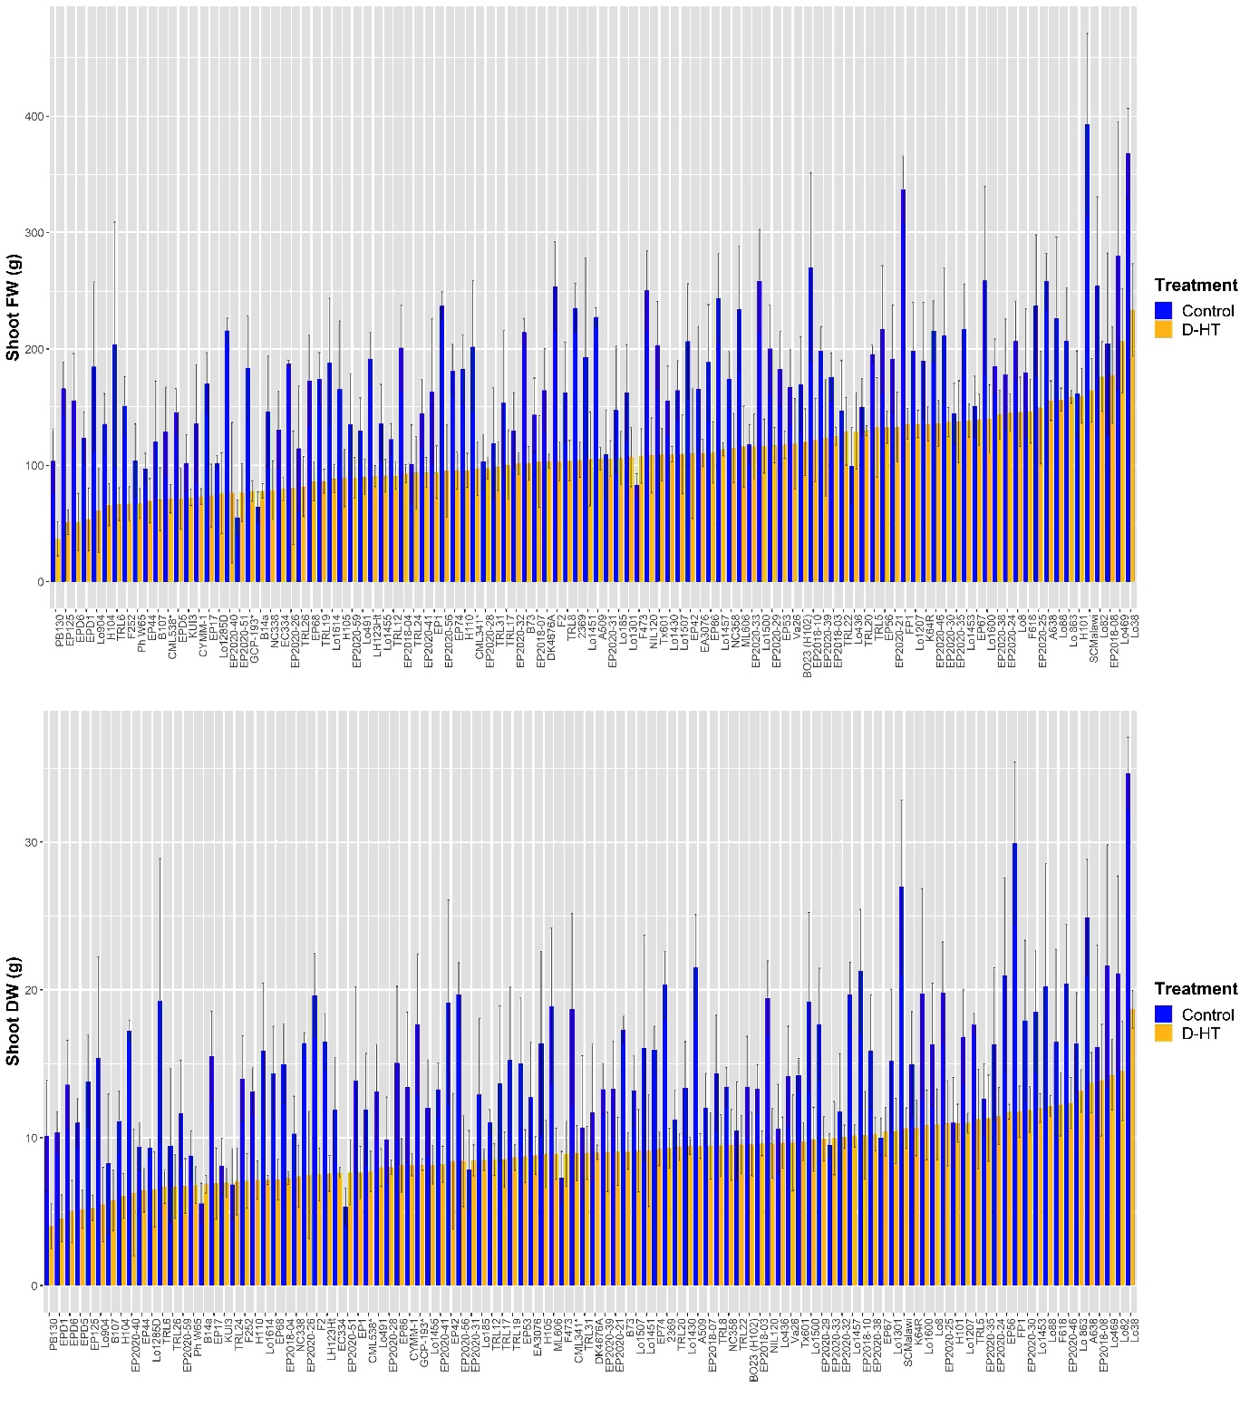

Fig.S1. Shoot FW (a) and DW (b) of 106 maize lines grown under control (non-stress) and stress (drought and high temperature: D-HT) conditions at harvest, 45 days after sowing (DAS). The values of the bars are means ± SD (n=6).

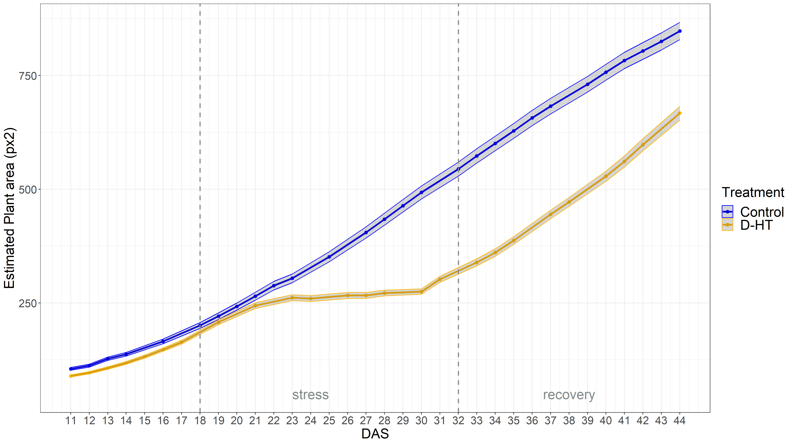

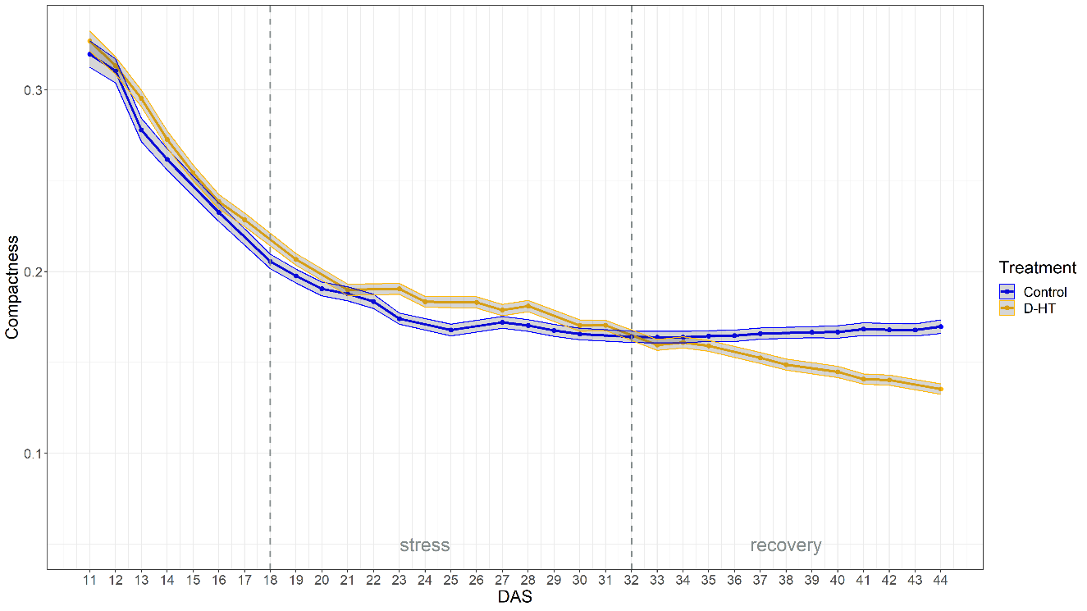

Fig.S2. Dynamic traits estimated shoot area and compactness under control and stress (D-HT, combined drought and high temperature) conditions. Based on means of BLUPs of all the 106 maize lines. The shadows describe the 95 % confidence interval; as long as the shadows of the individual lines do not overlap, the significance level of α =0.05 was reached and therefore a significant difference exists. The dashed lines denote stress-imposed time 18 DAS and the recovery-started time 32 DAS.

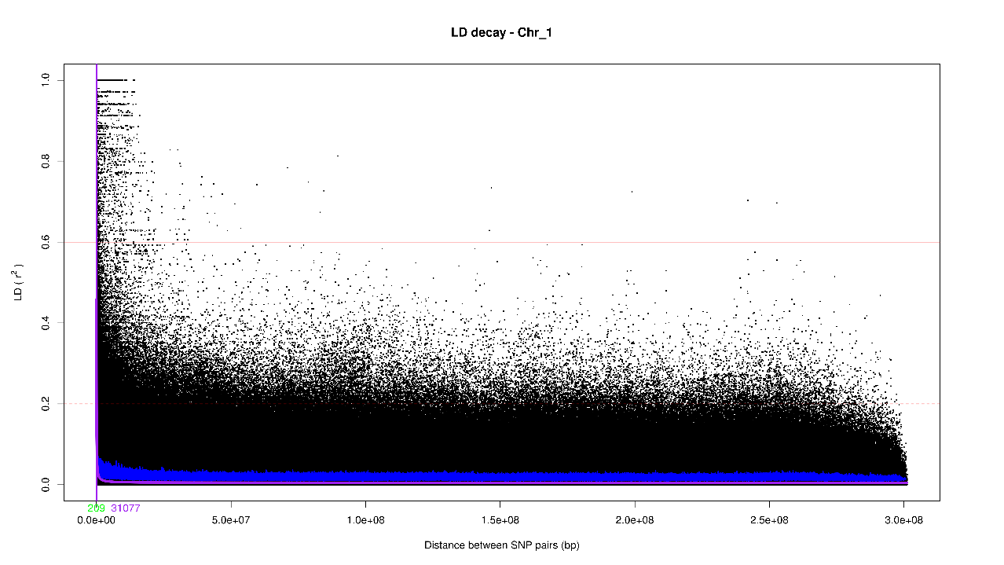
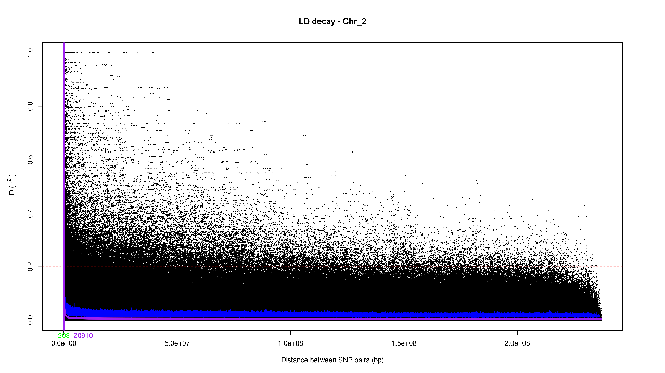
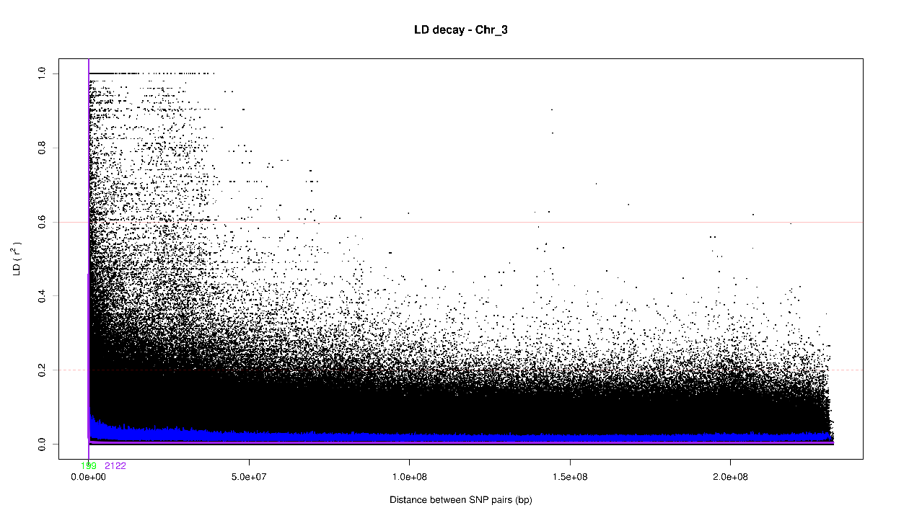

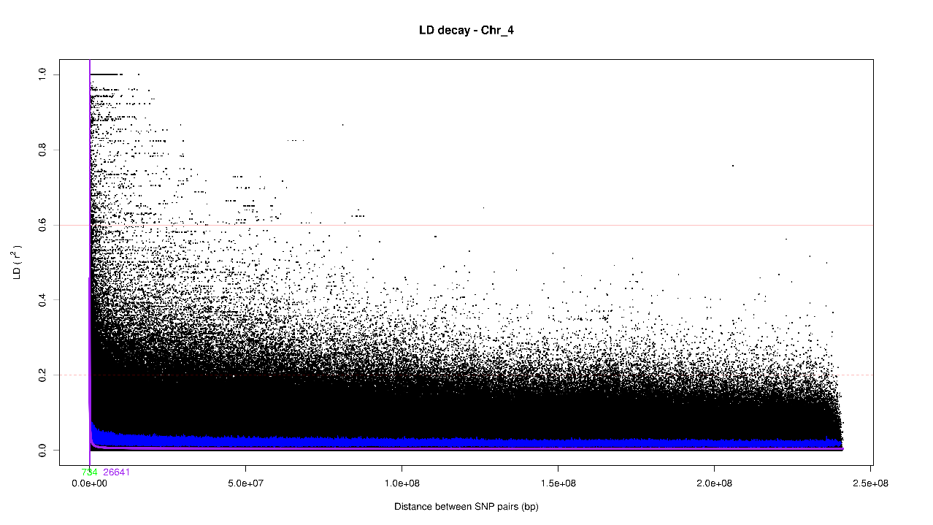
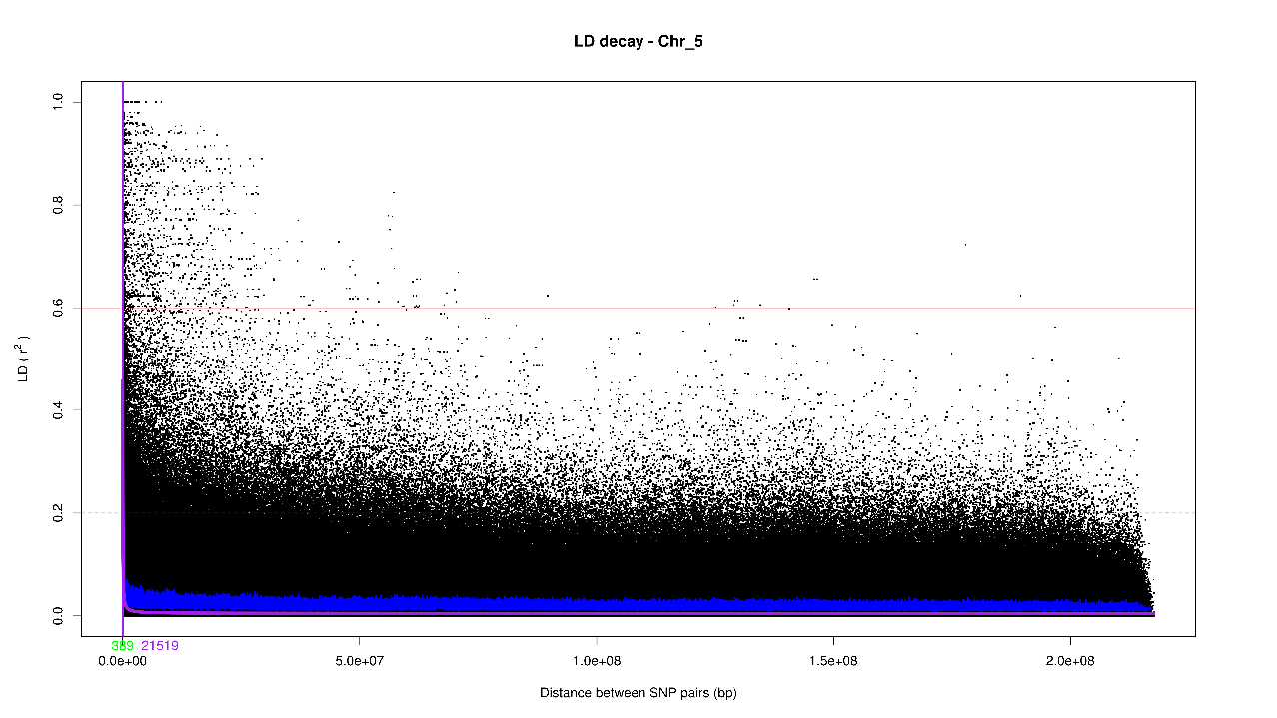
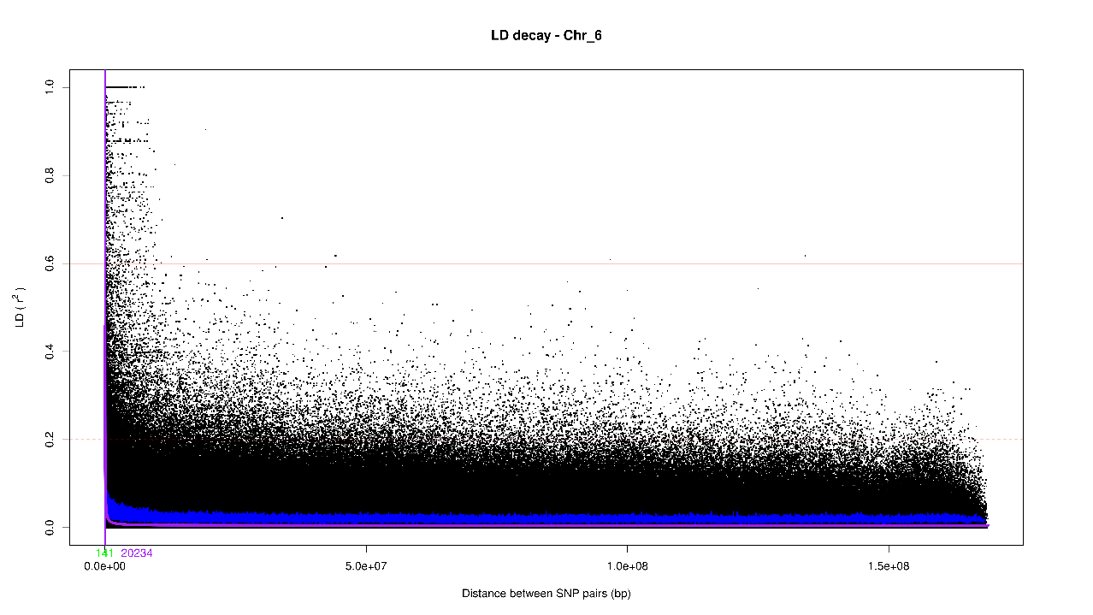

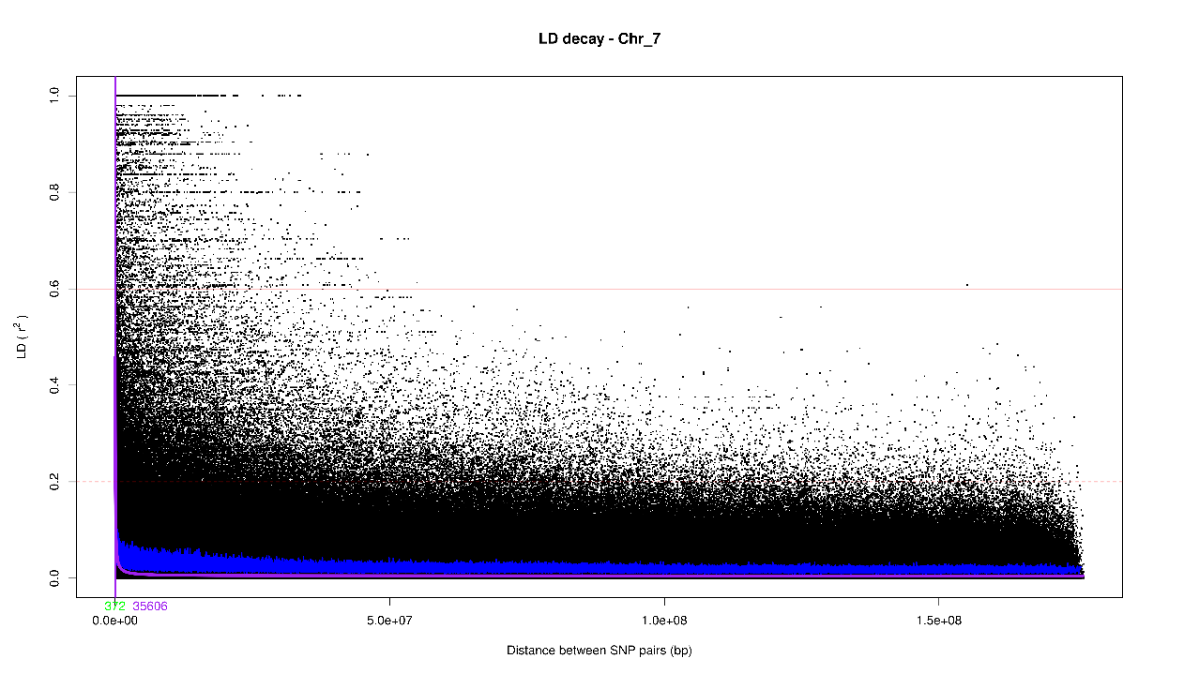
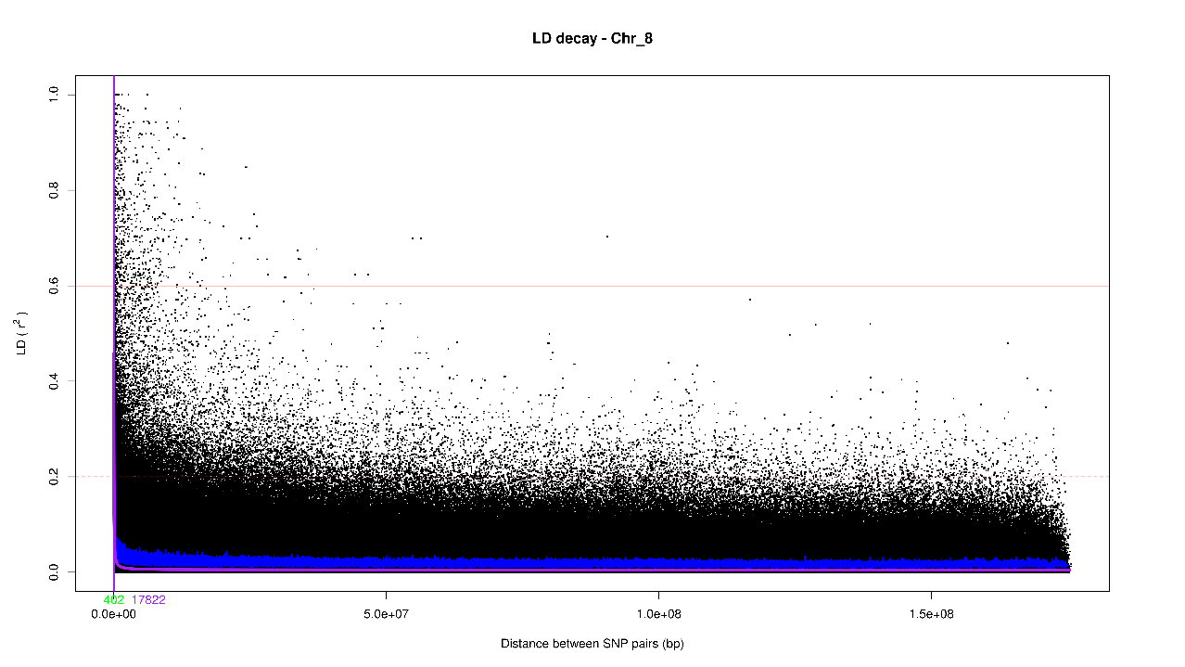
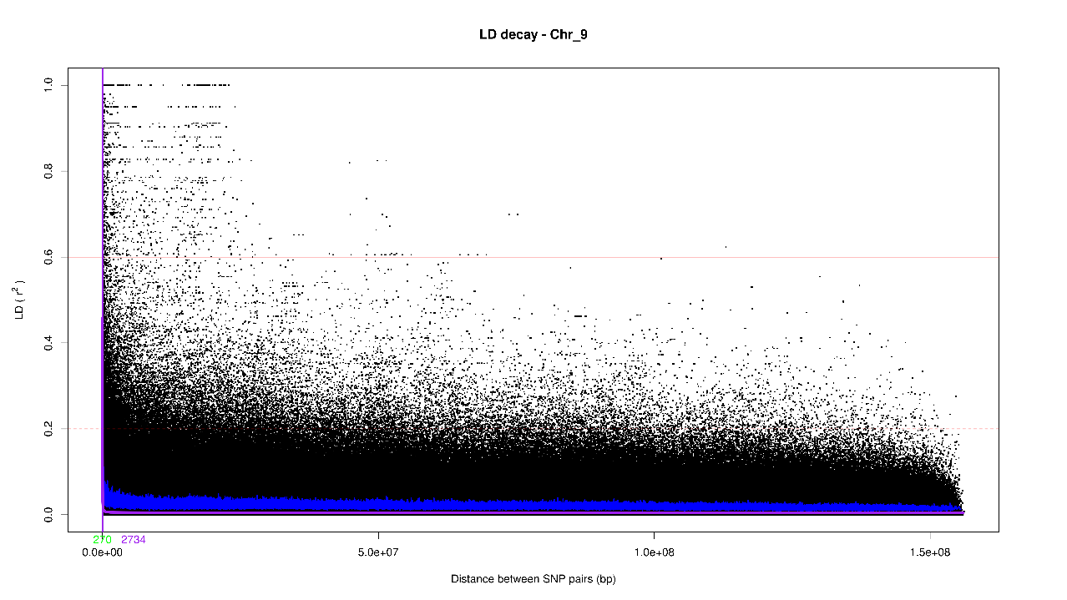

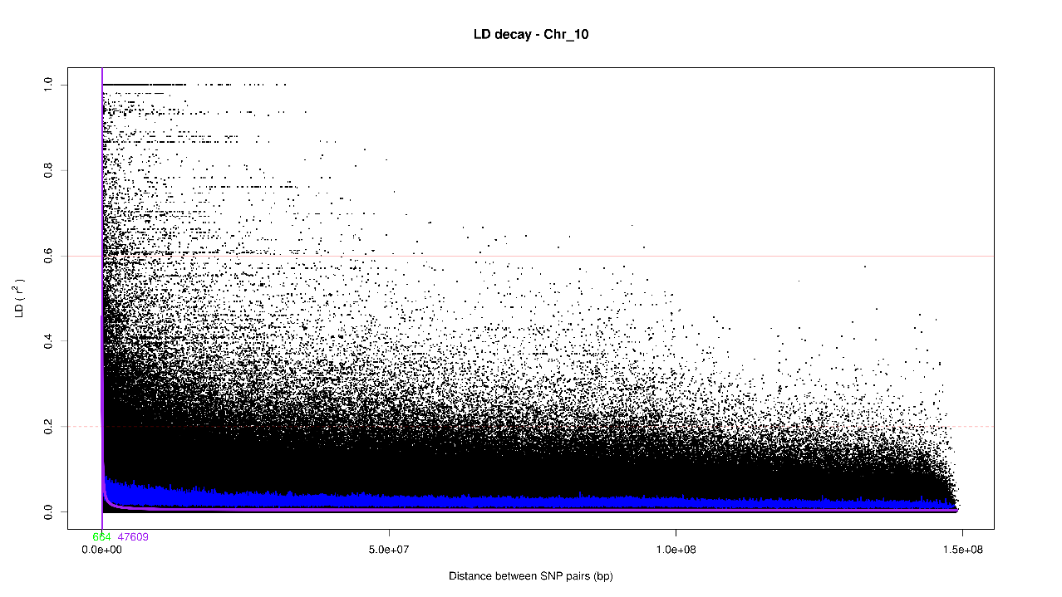

Fig.S3. Genome-wide linkage disequilibrium (LD) plotted as r² against the pairwise marker distance in bp of 191,205 homozygous markers of the maize accession panel. The blue line shows the LD decay and the green letters denote a LD value below 0.6, and the purple letters give the half maximum LD decay as a number, respectively.

